Carbon Dioxide Concentrations at Mona Loa Observatory

Adam M. Wilson

10/9/2019

# Annual Mean Carbon Dioxide Concentrations 1959-Present

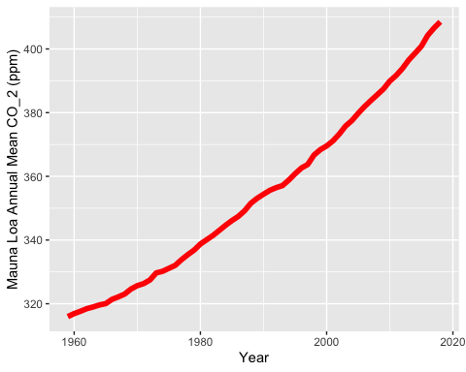

# Top Five Annual Mean Carbon Dioxide Concentrations at Mona Loa

