Carbon Dioxide Concentrations at Mona Loa Observatory

Adam M. Wilson

Table of contents

# Annual Mean Carbon Dioxide Concentrations 1959-Present

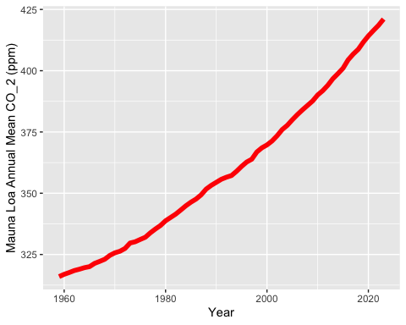

# Top Five Annual Mean Carbon Dioxide Concentrations at Mona Loa

