Mauna Loa CO2 Data

Load packages

library(readr)  
library(ggplot2)  
library(tidyverse)  
library(knitr)

Load data from website

CO2_data_MaunaLoa <- readr::read_table("https://gml.noaa.gov/webdata/ccgg/trends/co2/co2_annmean_mlo.txt", skip = 45, col_names= c("year", "mean", "unc"))

Plot CO2 levels over time

ggplot(CO2_data_MaunaLoa, aes(year, mean)) +  
 geom_line(linewidth = 1) +  
 labs(x = "Year", y = "Mean CO^2 (in ppm)",   
 title = "CO^2 Concentrations Over Time",  
 subtitle = "Measurements taken at Mauna Loa",   
 caption = "Data Source: NOAA Global Monitoring Laboratory")

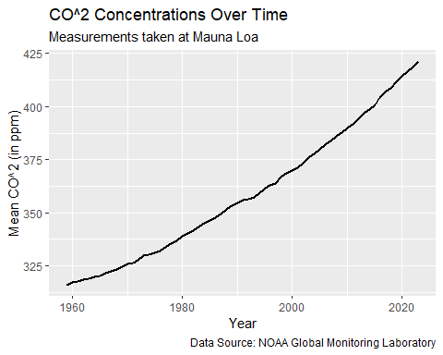

Table of data

table <- CO2_data_MaunaLoa %>%  
 arrange(desc(mean)) %>%  
 slice_head(n=5)  
  
knitr::kable(head(table))

| year | mean | unc |
| --- | --- | --- |
| 2023 | 421.08 | 0.12 |
| 2022 | 418.53 | 0.12 |
| 2021 | 416.41 | 0.12 |
| 2020 | 414.21 | 0.12 |
| 2019 | 411.65 | 0.12 |