CS_08 : Carbon Dioxide Concentrations at Mona Loa Observatory

SwethaSakhamuri

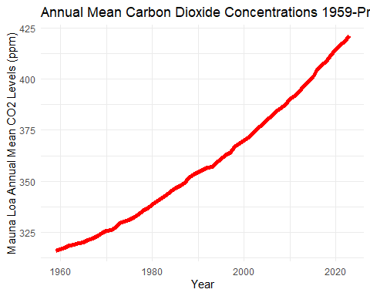

Mauna Loa CO2 Annual Mean Data

| Year | MeanCO2 |
| --- | --- |
| 2023 | 421.08 |
| 2022 | 418.53 |
| 2021 | 416.41 |
| 2020 | 414.21 |
| 2019 | 411.65 |