Mauna Loa Annual Carbon Dioxide Concentration (1959 - Present)

Stephen Sanders

2024-10-27

Get annual mean CO2 concentration data measured at Mauna Loa from NOAA website

# set url to annual co2 concentration data, then request it  
annual_data_url <- 'https://gml.noaa.gov/webdata/ccgg/trends/co2/co2_annmean_mlo.txt'  
  
httr::GET(annual_data_url)

Response [https://gml.noaa.gov/webdata/ccgg/trends/co2/co2_annmean_mlo.txt]  
 Date: 2024-10-27 05:10  
 Status: 200  
 Content-Type: text/plain; charset=UTF-8  
 Size: 3.65 kB  
# --------------------------------------------------------------------  
# USE OF NOAA GML DATA  
#   
# These data are made freely available to the public and the scientific  
# community in the belief that their wide dissemination will lead to  
# greater understanding and new scientific insights. To ensure that GML  
# receives fair credit for their work please include relevant citation  
# text in publications. We encourage users to contact the data providers,  
# who can provide detailed information about the measurements and  
# scientific insight. In cases where the data are central to a  
...

# read in data to co2_annual then rename columns  
co2_annual <- read.table(annual_data_url, skip = 45, header = FALSE)  
co2_annual <- co2_annual %>%  
 rename(year = V1, mean = V2, unc = V3)  
  
# preview co2_annual  
knitr::kable(head(co2_annual))

| year | mean | unc |
| --- | --- | --- |
| 1959 | 315.98 | 0.12 |
| 1960 | 316.91 | 0.12 |
| 1961 | 317.64 | 0.12 |
| 1962 | 318.45 | 0.12 |
| 1963 | 318.99 | 0.12 |
| 1964 | 319.62 | 0.12 |

Plot annual mean CO2 concentrations between 1959 and present

# plot time series line graph of mean co2 concentration by year  
annual_co2_plt <- ggplot(co2_annual, aes(x = year, y = mean, color = 'darkred')) +  
 geom_line(linewidth = 2) +  
 xlab('Year') +  
 ylab('Mean CO2 level (ppm)') +  
 labs(title = 'Annual Mean CO2 Concentrations (1959 - Present)',  
 subtitle = 'Measurements from Mauna Loa',  
 caption = 'Data from NOAA Global Monitoring Laboratory') +  
 theme(  
 plot.title = element_text(size = unit(24, 'pt')),  
 plot.subtitle = element_text(size = unit(12, 'pt')),  
 legend.position = 'none'  
 )  
  
annual_co2_plt

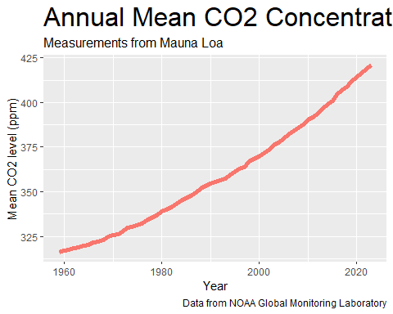

Create table of mean CO2 concentrations by decade

# create table of mean co2 concentration by decade  
co2_table <-   
 co2_annual %>%  
 mutate(decade = year - year %% 10) %>%  
 group_by(decade) %>%  
 summarize(decade_mean = mean(mean)) %>%  
 rename(mean = decade_mean) %>%  
 gt() %>%  
 tab_header(title = md('**Mean CO2 Levels by Decade**'),  
 subtitle = 'Measurements from Mauna Loa') %>%  
 cols_width(everything() ~ px(150)) %>%  
 cols_align(align = 'center', columns = everything()) %>%  
 cols_label(  
 decade = md('**Decade**'),  
 mean = md('**Mean CO2 (ppm)**')  
 ) %>%  
 fmt_number(columns = mean, decimals = 2)  
  
co2_table

Table 1: **Mean CO2 Levels by Decade**

Measurements from Mauna Loa

| **Decade** | **Mean CO2 (ppm)** |
| --- | --- |
| 1950 | 315.98 |
| 1960 | 320.29 |
| 1970 | 330.86 |
| 1980 | 345.65 |
| 1990 | 360.58 |
| 2000 | 378.77 |
| 2010 | 400.41 |
| 2020 | 417.56 |