CS_08

Data Import and Plotting
# 加载所需库
library(readr)
library(ggplot2)
library(knitr)
library(kableExtra)
# 下载并读取数据
url <- "ftp://aftp.cmdl.noaa.gov/products/trends/co2/co2_annmean_mlo.txt"
data <- read_table(url, skip = 57, col_names = c("year", "mean", "uncertainty"))
── Column specification ────────────────────────────────────────────────────────
cols(
year = col_double(),
mean = col_double(),
uncertainty = col_double()
)
# 绘制 CO2 随时间变化的折线图
plot <- ggplot(data, aes(x = year, y = mean)) +
geom_line(color = "blue") +
labs(title = "Mauna Loa CO2 Annual Mean Levels",
x = "Year",
y = "Mean CO2 (ppm)") +
theme_minimal()
print(plot)
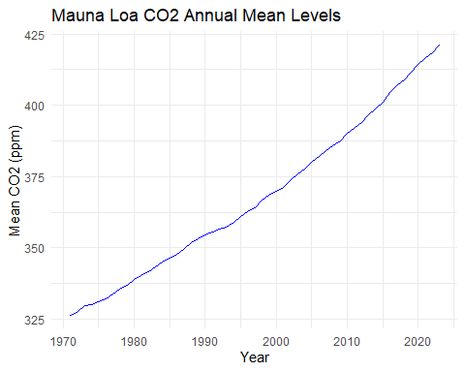

Summary Table
# 生成表格并使用 kableExtra 美化
summary_table <- data %>%
tail(5) %>%
kable() %>%
kable_styling(bootstrap_options = c("striped", "hover"), full_width = F)
# 保存表格为 HTML
save_kable(summary_table, file = "summary_table.html")
# 使用 webshot2 将 HTML 文件保存为 PNG
webshot2::webshot("summary_table.html", file = "table.png", zoom = 2)
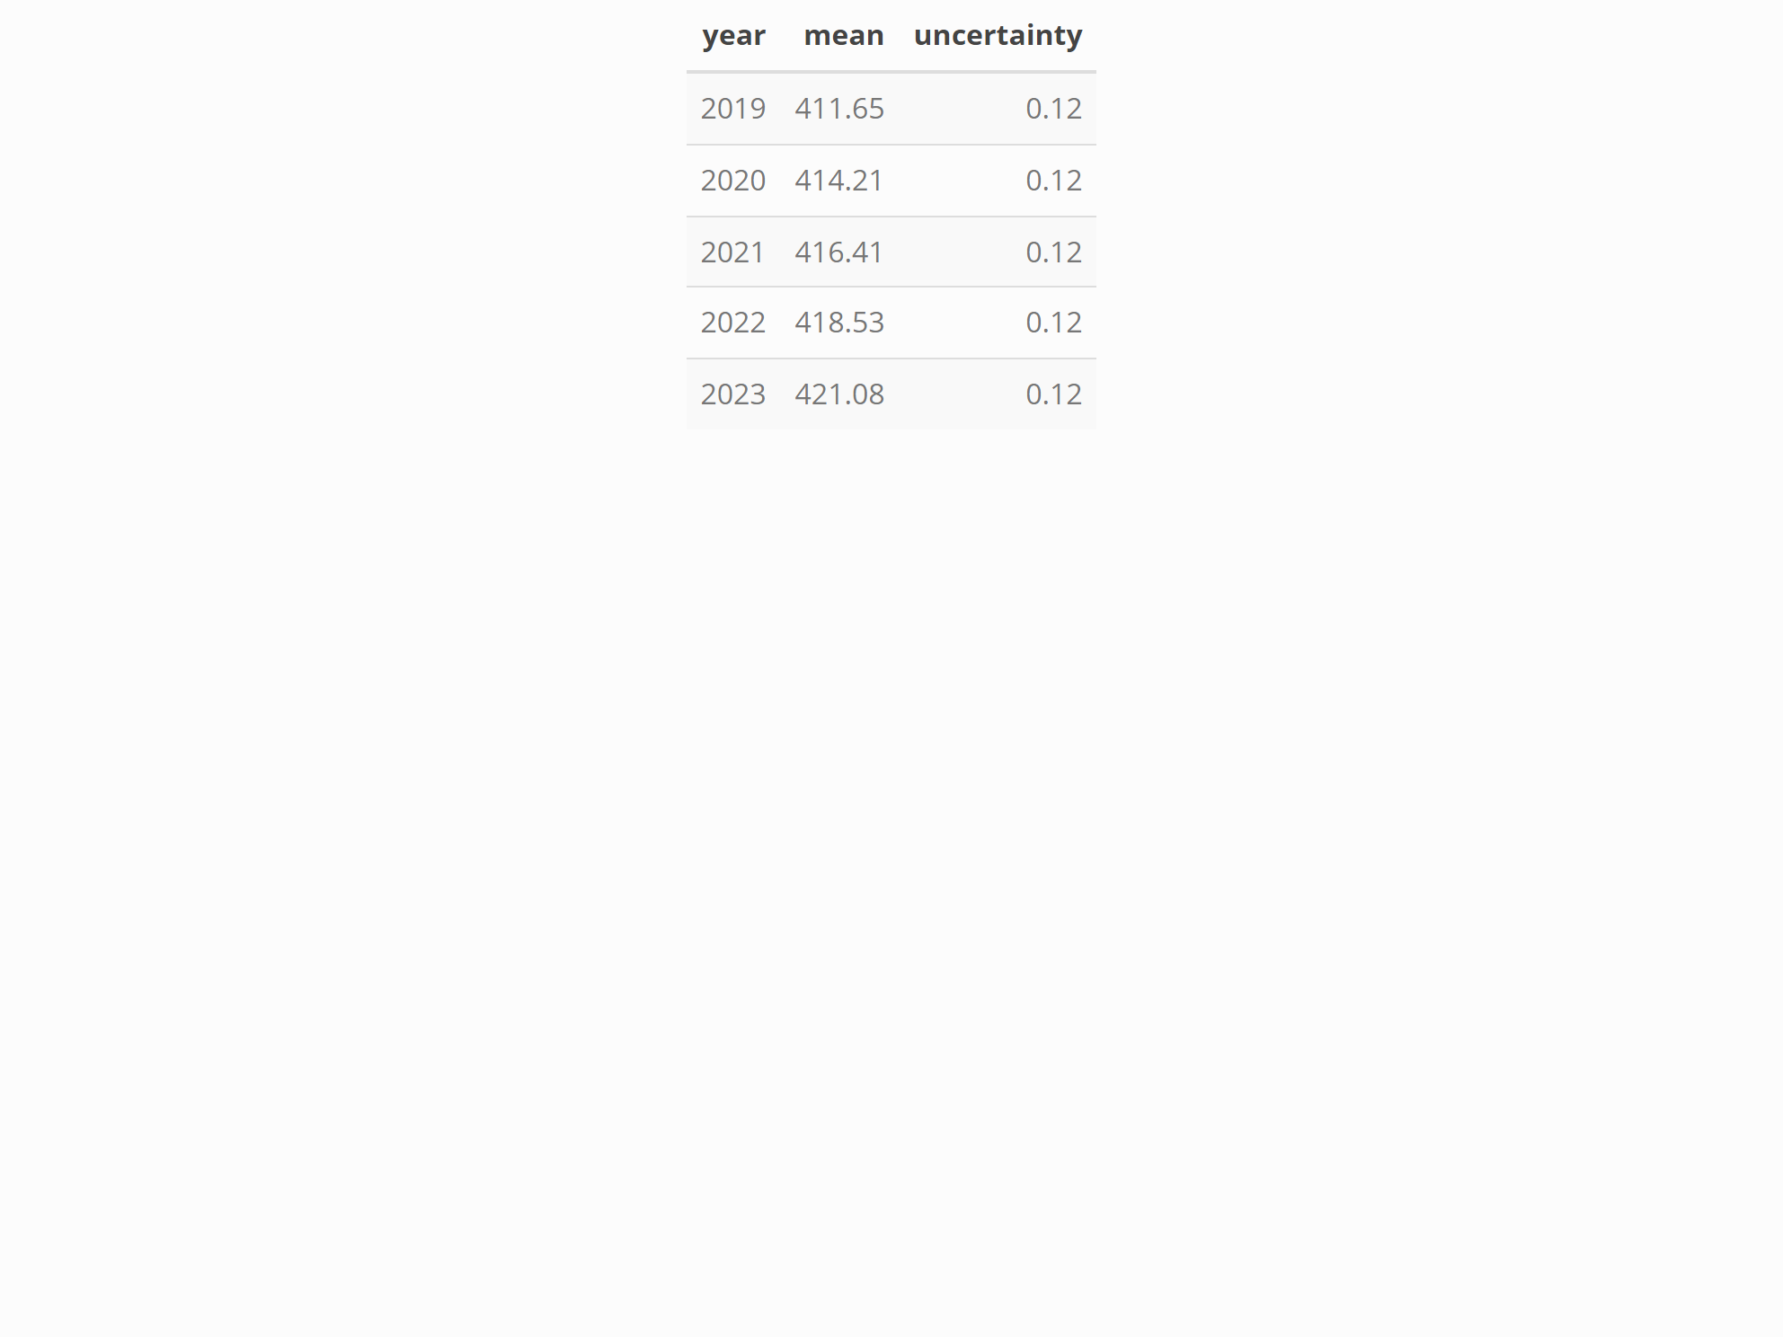

Hidden Calculations Example

