Case Study 08

Tina Ni

2024-10-22

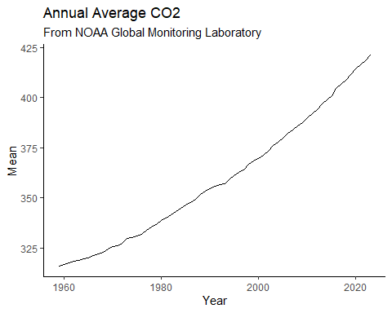

| Year | Mean | Unc |
| --- | --- | --- |
| 1959 | 315.98 | 0.12 |
| 1960 | 316.91 | 0.12 |
| 1961 | 317.64 | 0.12 |
| 1962 | 318.45 | 0.12 |
| 1963 | 318.99 | 0.12 |
| 1964 | 319.62 | 0.12 |
| 1965 | 320.04 | 0.12 |
| 1966 | 321.37 | 0.12 |
| 1967 | 322.18 | 0.12 |
| 1968 | 323.05 | 0.12 |
| 1969 | 324.62 | 0.12 |
| 1970 | 325.68 | 0.12 |
| 1971 | 326.32 | 0.12 |
| 1972 | 327.46 | 0.12 |
| 1973 | 329.68 | 0.12 |
| 1974 | 330.19 | 0.12 |
| 1975 | 331.13 | 0.12 |
| 1976 | 332.03 | 0.12 |
| 1977 | 333.84 | 0.12 |
| 1978 | 335.41 | 0.12 |
| 1979 | 336.84 | 0.12 |
| 1980 | 338.76 | 0.12 |
| 1981 | 340.12 | 0.12 |
| 1982 | 341.48 | 0.12 |
| 1983 | 343.15 | 0.12 |
| 1984 | 344.87 | 0.12 |
| 1985 | 346.35 | 0.12 |
| 1986 | 347.61 | 0.12 |
| 1987 | 349.31 | 0.12 |
| 1988 | 351.69 | 0.12 |
| 1989 | 353.20 | 0.12 |
| 1990 | 354.45 | 0.12 |
| 1991 | 355.70 | 0.12 |
| 1992 | 356.54 | 0.12 |
| 1993 | 357.21 | 0.12 |
| 1994 | 358.96 | 0.12 |
| 1995 | 360.97 | 0.12 |
| 1996 | 362.74 | 0.12 |
| 1997 | 363.88 | 0.12 |
| 1998 | 366.84 | 0.12 |
| 1999 | 368.54 | 0.12 |
| 2000 | 369.71 | 0.12 |
| 2001 | 371.32 | 0.12 |
| 2002 | 373.45 | 0.12 |
| 2003 | 375.98 | 0.12 |
| 2004 | 377.70 | 0.12 |
| 2005 | 379.98 | 0.12 |
| 2006 | 382.09 | 0.12 |
| 2007 | 384.02 | 0.12 |
| 2008 | 385.83 | 0.12 |
| 2009 | 387.64 | 0.12 |
| 2010 | 390.10 | 0.12 |
| 2011 | 391.85 | 0.12 |
| 2012 | 394.06 | 0.12 |
| 2013 | 396.74 | 0.12 |
| 2014 | 398.81 | 0.12 |
| 2015 | 401.01 | 0.12 |
| 2016 | 404.41 | 0.12 |
| 2017 | 406.76 | 0.12 |
| 2018 | 408.72 | 0.12 |
| 2019 | 411.65 | 0.12 |
| 2020 | 414.21 | 0.12 |
| 2021 | 416.41 | 0.12 |
| 2022 | 418.53 | 0.12 |
| 2023 | 421.08 | 0.12 |