### The Bloch–McConnell (BM) equations

We consider a 2–pool system, i.e., a system of two coupled spin populations, comprising pool a (the water pool) and pool b (the dilute solute pool), with forward (b 🠖 a) exchange rate kb and thermal equilibrium magnetizations M0,a and M0,b, respectively, in a static magnetic field B0 = (0, 0, B0). The ratio of these magnetizations, M0,b/M0,a = fb, is conserved by the backward (a 🠖 b) exchange rate ka = fbkb. Pool a is always the pool which is measured, here and in proton CEST it is the spin ensemble of water protons. In the case of HyperCEST, pool a is that of xenon in the solvent.

The temporal evolution of the magnetizations of the two pools during rf irradiation is well described by the BM equations for the case of exchange between pool a and b and by the BS equations for dipolar–coupled systems.

In the rotating frame of reference (x, y, z) defined by the frequency ωrf of the oscillating field B1(t), the BM equations read:

|  |  |
| --- | --- |
|  | (1) |
| with the 6–dimensional magnetization vector |  |
| . | (2) |

A is a block matrix

|  |  |
| --- | --- |
|  | (3) |

consisting of 3x3 submatrices Ki = ki∙Ι (see also eqs. (6)(8)(9)), and Li:

|  |  |
| --- | --- |
|  |  |
|  | (4) |
| where i = a, b. Finally, the constant vector C is |  |
|  | (5) |

The quantity Δω = Δωa = ωrf − ωa is the frequency offset relative to the Larmor frequency ωa of pool a (for 1H: ωa/B0 = γ = 267.5 rad/μTs). The offset of pool b: Δωb = ωrf − ωb = Δω − δbωa, is shifted by δb relative to the water proton resonance.

At field strengths of clinical MR imaging systems, longitudinal relaxation rates R1,a/b = 1/T1,a/b are in the order of s–1, while transverse relaxation rates R2,a/b = 1/T2,a/b are in the order of 10–100 s–1 for *in vivo* 1H systems. For macromolecules and bound water R2b can take values up to 106 s–1 (Stanisz et al., 2005). On resonance, the rf irradiation field B1 = (B1, 0, 0) with B1 ≈ μT, induces a precession of the magnetization with frequency ω1 = γ B1 around the x–axis in the rotating frame in the order of several 100 rad/s. In the case of off–resonant irradiation the magnetization rotates around the effective field = (ω1, 0, Δω)/γ = /γ which is tilted by the angle θ = tan-1(ω1/Δω) off the z-axis (Figure 5). The population fraction fb is assumed to be < 1 % for most MRZS experiments, hence ka is small compared to kb. In contrast, for MT fb can be as large as 19 % for cartilage, but is in the range of several percent for most tissues (Stanisz et al., 2005).

The Bloch–McConnell/–Solomon equations pick out one relaxation pathway explicitly. We therefore separate this process and define the relaxation rates excluding this specific pathway by R1’ = 1/T1’ and R2’ = 1/T2’ (Neuhaus and Williamson, 1989).

In the context of the BM equations the used relaxation rates already exclude exchange. Therefore, R1a = R1a’ and R2a = R2a’ and the same for pool b. The matrix Ka = fbKb reads

|  |  |
| --- | --- |
|  | (6) |

The proton fraction fb is

|  |  |
| --- | --- |
|  | (7) |

where [a] and [b] are the concentrations of pool a and b, respectively, and *na* and nb are the number of protons per molecule for the respective proton pools.

### Macromolecular semi-solid MT

For macromolecular MT one assumes that the transverse components are zero, which is justified since the T2 times are in the order of μs. Thus four magnetization components remain: those along the axes x, y, z for pool a and along z for the macromolecular pool (Henkelman et al 1993). The matrix A (eq. (3)) and the vector C now read

|  |  |
| --- | --- |
|  | (11) |
|  | (12) |

The matrix contains a new term Rrfb which considers the lineshape of the macromolecular pool

|  |  |
| --- | --- |
| . | (13) |

Different line shape functions g() were employed (Henkelman et al., 2001, 1993): Lorentzian functions for liquid pools

|  |  |
| --- | --- |
|  | (14) |

or Gaussian for solid–like pools. For semi–solid structures in living tissue a super–Lorentzian lineshape defined by

|  |  |
| --- | --- |
|  | (15) |

was shown to fit the experimental data at best including an additional dipolar reservoir (Morrison and Mark Henkelman, 1995; Morrison et al., 1995).

If modeling focuses on CEST and the range close to the water peak, also a Lorentzian line can be fitted instead of a super–Lorentzian. This means that MT can be treated like a broad CEST effect (Liu et al., 2012; Zaiss et al., 2011).

For a detailed description of MT we recommend the review of Henkelman (Henkelman et al., 2001). Analytical solutions of the modified equations (11) are explored in Refs. (Adler and Yeung, 1993; Henkelman et al., 1993; Morrison et al., 1995; Yeung and Swanson, 1992; Yeung et al., 1994). Finally, the different two–pool models can be combined to a multi–pool system where all effects occur simultaneously (Desmond and Stanisz, 2012; Li et al., 2008; Liu et al., 2012; Trott and Palmer, 2004).

## Numerical solution of the Bloch–McConnell equations

The BM equations are first–order ordinary differential equations with an inhomogeneous term C (equation (1)). The formal solution of the BM equations is

|  |  |
| --- | --- |
|  | (16) |

The straightforward approach to solve a higher–dimensional system of ordinary differential equations is numerical integration, e.g. Runge–Kutta methods (Butcher, 1987; Murase and Tanki, 2011). When matrix inversion and exponentiation are performed numerically the magnetization can be calculated for constant A (Murase and Tanki, 2011; Tee et al., 2012; Woessner et al., 2005). Then stepwise constant solutions can be utilized to construct a full time–dependent solution of the BM equations (Sun et al., 2011; Zu et al., 2011b).

For n-pools the system of equations (1-3) just increases in the dimensionality. E.g. equation (39 transforms to



If we also allow intramolecular transfer between the individual CEST pools we just get more off-diagonal elements. For example, in the following matrix we allow a path from pool b to pool c:



### Shaped pulses

The model was modified for the case of pulsed saturation, which was achieved by discretization of the RF field according to the time course of the saturation pulse. In principle, this is also done at the MRI scanner by the analog sampling of the pulse. We use 200 steps to divide a shaped pulse. If the pulse has a high dynamic, this can lead to sidebands in simulated Z-spectra and thus discretization must be increased in the simulation.

### Pseudo Code

function Z = NUMERIC_SIM(Sim)

%thermal Magnetization

y0 = [0 0 0 0 0 0 0 0 0 0 0 0 Sim.fA Sim.fB Sim.fC Sim.fD Sim.fE Sim.fF Sim.fG];

%parameters in x0

x0 = [ Sim.FREQ Sim.B1 Sim.MT Sim.n_cest_pool 0 0 0 0;

Sim.dwA 0 Sim.R1A Sim.R2A 0 0 0 0;

Sim.dwB Sim.kBA Sim.R1B Sim.R2B Sim.kBD Sim.kBE Sim.kBF Sim.kBG;

Sim.dwC Sim.kCA Sim.R1C Sim.R2C 0 0 0 0;

Sim.dwD Sim.kDA Sim.R1D Sim.R2D 0 Sim.kDE Sim.kDF Sim.kDG;

Sim.dwE Sim.kEA Sim.R1E Sim.R2E 0 0 Sim.kEF Sim.kEG;

Sim.dwF Sim.kFA Sim.R1F Sim.R2F 0 0 0 Sim.kFG;

Sim.dwG Sim.kGA Sim.R1G Sim.R2G 0 0 0 0

];

x0(1,2) = 0; % set B1 to zero

x00=x0; % copy parameter

%% MV is the magnetisation vector at all offsets; initialization here

MV_start = BMsolution(x0, xZspec, [0 1], z0, y0);

MV = MV_start.*Sim.Zi;

[w1 dphase theta B1q] = RF_pulse(Sim, teile); % the pulse shape gets calculated

**% XXXXXXXXXXXXXXXXXXXXXX MAIN LOOP XXXXXXXXXXXXXXXXXXXXXX**

for dd=1:Sim.dummies

SIMULATE_READOUT;

SIMULATE-RECOVERY_AFTER_READOUT

for jj=1:fix(Sin.n) % pulse train loop or LTM loop

% XXXXXXXXXXXXXXXXXXXXXX PAUSE / TRANSFER XXXXXXXXXXXXXXXXXXXXXX

% never start with a pause

if jj > 1

% relaxtion during pause

x0(1,2) = 0;

MV = BMsolution(x0, xZspec, [tpulse(numel(w1)) tpulse(numel(w1))+Sim.td], z0, y0, MV);

end;

% XXXXXXXXXXXXXXXXXX LABELING DURING PULSE XXXXXXXXXXXXXXXXXXXXXX

for ii = 1:numel(w1)-1 % discretization of the shaped pulse

% set correct B1 value in every pulse part/step

x0(1,2)=w1(ii);

[MV A_temp Ainvb_temp dia] = BMsolution(x0, xZspec, [tpulse(ii)

tpulse(ii+1)], z0, y0, MV);

end;

end

% XXXXXXXXXXXXXXXXXXXXXXXXXX SPOILING XXXXXXXXXXXXXXXXXXXXXXXXXXX

% relaxtion during spoiling

x0(1,2) = 0;

MV = BMsolution(x0, xZspec, [0 0.0045], z0, y0, MV);

MV(1:12,:) = Sim.spoilf*MV(1:12,:); % spoiling

% hier ist nach einem LTM (label transfer module)

MV_nth(jj,:,:) = MV;

end; % LTMs

end; % dummies

A.Sim = Sim;

A.x=xZspec';

A.zspec=squeeze(MV(13,:))';

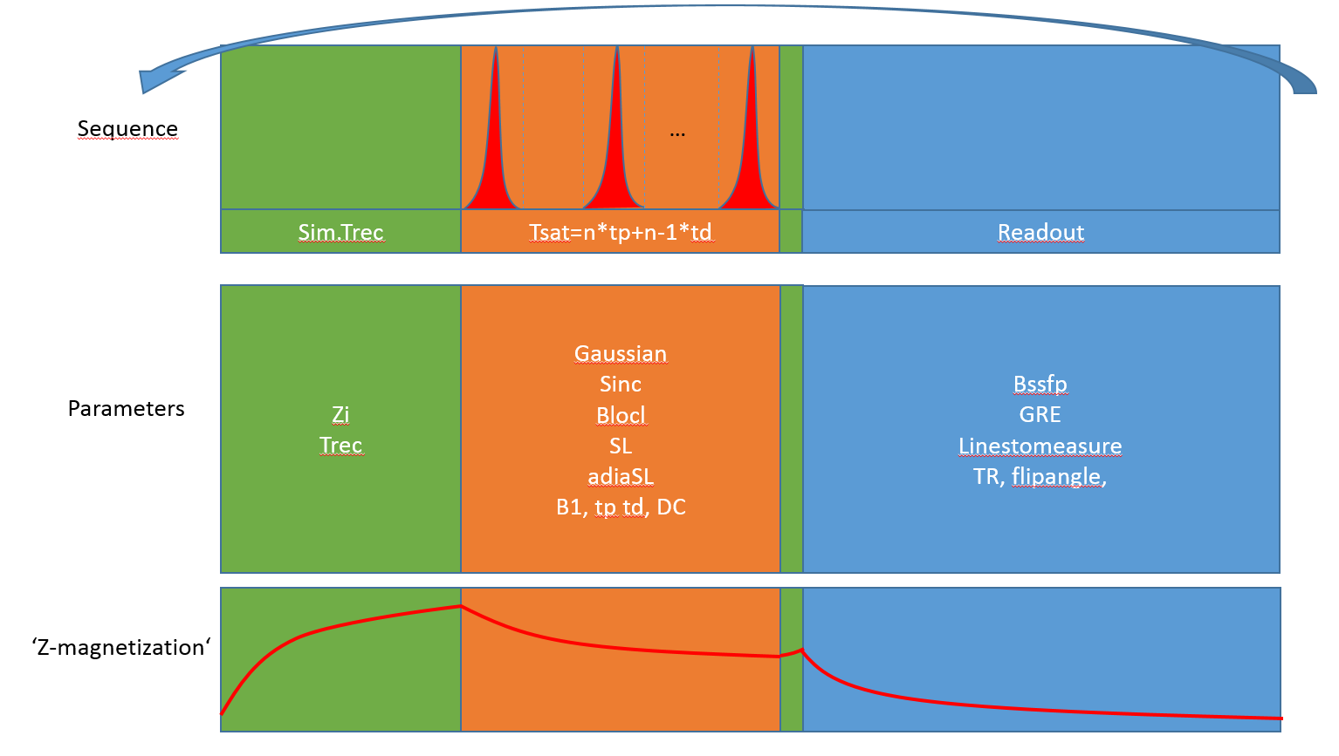

Figure 1: Visualization of Sequence, possible Parameters and dynamic of Z-magnetization