**Installation and user’s manual for the Free Waveform Encoding (FWF) sequence (s)**

Filip Szczepankiewicz (fszczepankiewicz@bwh.harvard.edu)

*Scope*

This document provides a very brief user manual to the FWF patch/sequence. For detailed information, please contact the author.

*Introduction*

The FWF sequence is based on the monopolar spin-echo diffusion encoding sequence. It removes the trapezoidal diffusion encoding waveforms and replaces them with an arbitrary waveform. The waveforms are compiled into the sequence and cannot be modified by the user.



Fig. 1 – Schematic spin-echo sequence and its timing variables. The gradient waveforms are executed between the excitation pulse, refocusing pulse, and echo-planar readout. The timing variables show the maximal time available for encoding (Tpre and Tpost), the duration of each gradient waveform (δ1 and δ2), the gradient waveform separation (Δ), the duration of the refocusing block including the crushers (T180), the total encoding time (Tenc), and the echo time (TE). The balance gradient (red) is executed at the same time as the first crusher. Note that the Stejskal-Tanner and q-space trajectory encoding gradients are shown together for visual reference but are not executed simultaneously in practice. Image adapted from [1].

*Installation of sequence*

1. Transfer the provided .dll and .so file to the customer sequence folder. This folder can be reached by writing %CustomerSeq% in the explorer window, and pressing enter, and may have a different absolute address on different systems.
2. Import the sequence into the DOT editor (main interface on host computer) by dragging it from the default customer sequence “folder”. Please see the separate manual for this step.

*First use of FWF sequence*

1. Load the sequence into the sequence editor. Check that the loaded sequence states that ‘a_ep2d_diff_fwf_simple’ is running by hoovering the cursor over the sequence type (normally seen as the string ‘epse’ in the upper right corner, see red square in Figure 1).
2. To engage the additional FWF functions, select the [Diff]-tab, and set the ‘Diffusion Scheme’ to ‘Monopolar’, instead of ‘Bipolar’ (see Fig. 2). When the ‘Monopolar’ encoding type is selected, the FWF sequence replaces the monopolar Stejskal-Tanner experiment. To run the original monopolar version, please use the standard sequence from the sequence library.
3. Go to [Sequence] – [Special] – tab. All FWF functionality is controlled from this tab. Conventional controls, such as setting the b-values, are unchanged. The special tab should look as that presented in Figure 1. If the parameter ‘MaxBVal’ is zero, something is wrong and the sequence should not be executed.
4. Change the preset b-value (normally zero) and test the sequence on a water phantom. It is a good idea to start slow, and to validate that the sequence measures the correct ADC in water. Also test the sequence in oil and note if any signal is lost (it should not be).

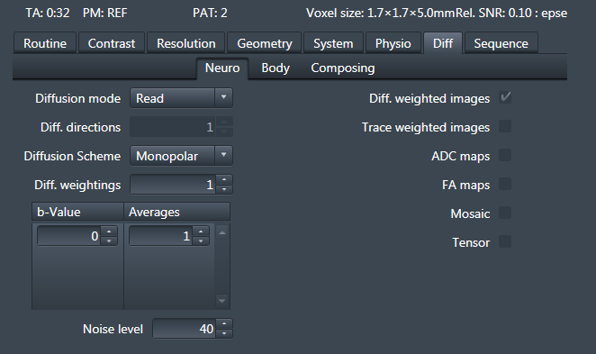

Fig. 2 – Select the “monopolar” diffusion scheme to engage the FWF sequence.

*The* [Special]-*tab*

All new functions are modified in the [Sequence] – [Special] – tab (Fig. 3); standard functions are unaltered. NOTE: additional information is available in the help pop-ups that appear when hovering over the parameter selectors. Figure 3 shows an example of the interface that is used to control the FWF functions. Hover over the ‘MaxBVal’ value to get comprehensive sequence info, and hover over either of the ‘Dur’ values to see the timing of the sequence.

In the “simple” variant of the FWF sequence, the only parameter that can be changed is the shape of the b-tensor. The drop-down menu allows for selection of linear, planar or spherical encoding (LTE, PTE, STE). Note that these are not equally efficient, an may require that other parameters be set based on the least efficient waveform (usually STE).

*Hints*

1. To get some useful information about the sequence, its timing, and the hardware specifications, you can hoover the cursor over the parameters in the special tab.
2. Do not run the waveforms at a maximal gradient amplitude (max possible b-value). Try to leave approximately 5 mT/m headroom.
3. Do not set the TE or TR at their minimal values since future software updates may change these slightly and force a change in an ongoing study.
4. Comprehensive information about the sequence is available in the real-time logging of the system.

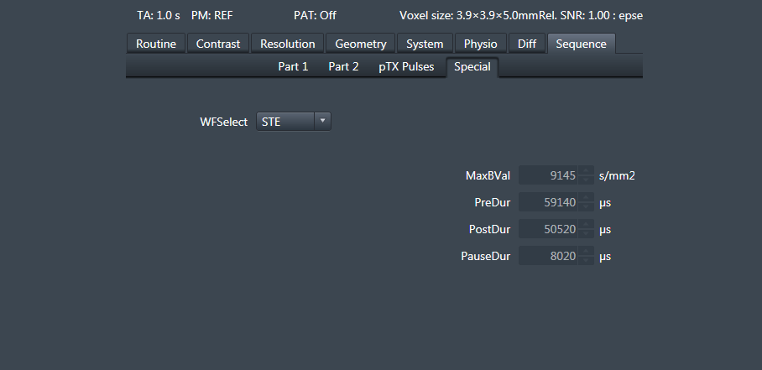

Fig. 3 – Example of the [Special]-tab in the simple sequnce. When the sequence is set to ‘Monopolar’, this tab will be active and updated. The B-matrix is all zeros because the max requested b-value is zero. Note that the system falsely reports that the requested b-value is 1 s/mm2 to avoid division by zero.

*Example setup*

Setup the imaging protocol (these are a good starting point for whole-brain imaging).

* FOV = 220x220x120 mm3
* Matrix = 110x110
* 30-50 Slices
* Resolution
  + 2×2×4 mm3
  + 2.3×2.3×2.3 mm3
* TE ≈ 85
* Partial Fourier = 6/8
* iPAT = 2 (GRAPPA)
* Bandwidth 1800 Hz/pix
* *b* = .1, .7, 1.4, and 2 ms/µm2 
  + Avoid using b = 0 images in analysis
* Num. diff. dirs = 6, 6, 12, 16 for linear encoding.
  + The same number of samples can be used for PTE or STE too
  + More directions can be added to outer shell
* Same sampling for spherical and linear encoding

*Resources*

Example protocols and sampling schemes from ref [2]:

<https://github.com/filip-szczepankiewicz/Szczepankiewicz_PONE_2019>

Analysis software [3]:

<https://github.com/markus-nilsson/md-dmri>

Extraction of FWF-specific header information from DICOM images:

<https://github.com/filip-szczepankiewicz/fwf_header_tools>

*References*

1. Szczepankiewicz, F., *Imaging diffusional variance by MRI: The role of tensor-valued diffusion encoding and tissue heterogeneity*, in *Department of Medical Radiation Physics*. 2016, Lund University.

2. Szczepankiewicz, F., et al., *Tensor-valued diffusion encoding for diffusional variance decomposition (DIVIDE): Technical feasibility in clinical MRI systems.* PLoS One, 2019. **14**(3): p. e0214238.

3. Nilsson, M., et al. *An open-source framework for analysis of multidimensional diffusion MRI data implemented in MATLAB*. in *Proc. Intl. Soc. Mag. Reson. Med. 26*. 2018. Paris, France.