By default, assume the following parameters: N=25, L=20, R=8 16 32 64 128 256 512, M=6, T=50000 provided to your program through an input.txt file. Now, plot graphs for the following scenarios where certain parameters are varying.

* (a)  Plot how channel utilization (in percentage) varies with increasing number of nodes (i.e., N varying from 5 to 500). Channel utilization is defined as the ratio of clock ticks that were used up for correct communication to the total number of clock ticks, T.
* 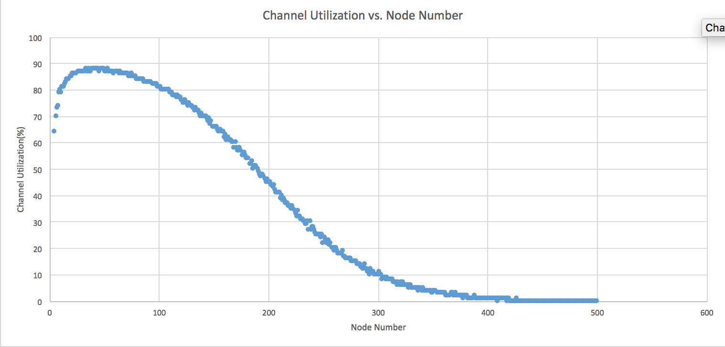
* (b)  Plot how the channel idle fraction (in percentage) varies with increasing number of nodes (i.e., N varying from 5 to 500). Channel idle fraction is defined as the ratio of unused clock ticks to the total number of clock ticks, T. Note that unused clock ticks do not include collisions.
* 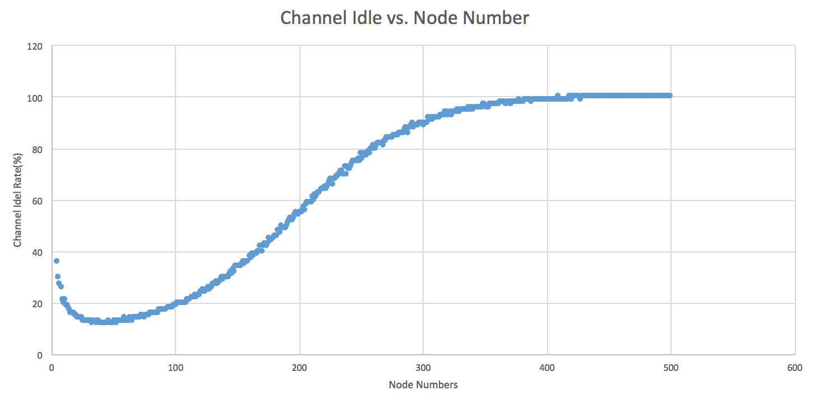
* (c)  Plotthetotalnumberofcollisionswithincreasingnumberofnodes(i.e.,Nvaryingfrom 5 to 500).
* 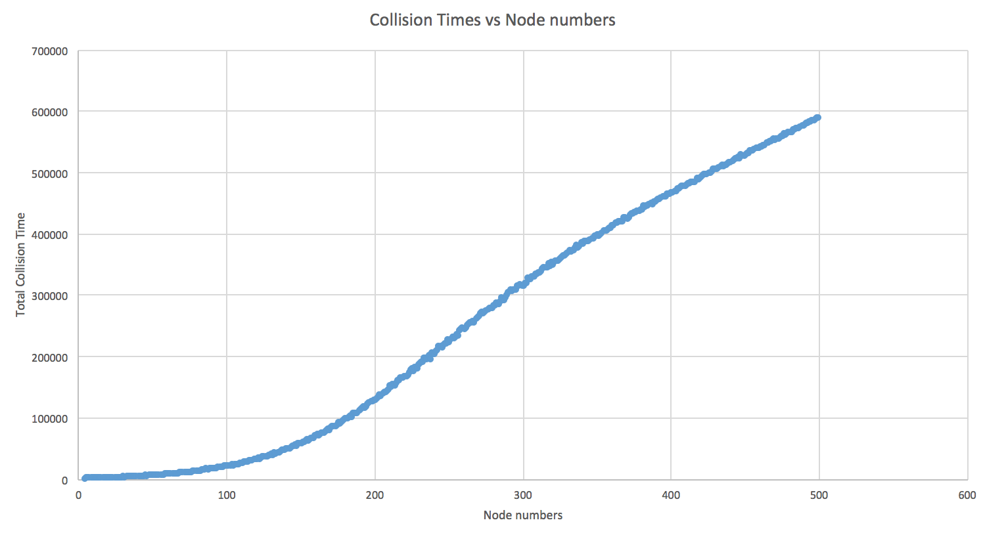
* (d)  Repeat part (a) but plot 5 curves on the same graph, each curve corresponding to different initial values of R: 1, 2, 4, 8, 16. For each of the 5 cases, let R double upon collisions.
* (e)  Repeat part (a) but plot 5 curves on the same graph, each curve corresponding to different packet lengths L: 20, 40, 60, 80, 100.
* (f)  Explain the shape of the curves in (d) and (e) by elaborating on how/why increasing value of N, R, and L impact channel utilization.