REPORT

Classes: Analog and Digital Electronic Circuits

Presenter: prof. dr hab. inż. Vasyl Martsenyuk

|  |  |
| --- | --- |
| Laboratorium No. 1  Date: 28.10.2023  Topic: „Spectral Analysis of Deterministic Signals"  Version 6 | Adam Kubliński  Informatyka  II stopień, niestacjonarne, zaoczne,  I semestr, gr. 1A |

GitHub Repository: <https://github.com/Adamadacho/Analog_and_Digital_Electronic_Circuits.git>

# Topic of the laboratory

The objective is to use discrete Fourier transform and its implementation with the help of matrix multiplication.

# Task

Synthesize a discrete-time signal by using the IDFT in matrix notation for different values of N. Show the matrices W and K. Plot the signal synthesized.

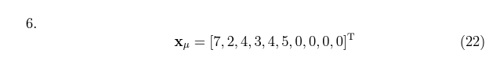

The code used to solve the task:

Marix of the synthesized discrete-time signal:

[2.5 0.0690983 0.8190983 0.1809017 0.9309017 0.5 0.9309017

0.1809017 0.8190983 0.0690983]

Plot of the synthesized signal:

# Wnioski

The goal of the laboratory was to obtain a synthesized signal for a selected example using IDFT. Created and implemented code via Jupyther Notebook and obtained both matrix and signal graph.