Letsema in partnership with Skift Advisory, for Wesgro
Unlocking Tourism Growth
A Strategy for the Western Cape to 2035
Final Research Report
Draft for discussion, version 1, November 2026
DRAFT FOR DISCUSSION. Not for circulation beyond the Wesgro project team.

Document control
Item | Detail
Title | Unlocking Tourism Growth: A Strategy for the Western Cape to 2035. Final Research Report
Client | Wesgro, the Western Cape Tourism, Trade and Investment Promotion Agency
Authors | Letsema Consulting and Advisory in partnership with Skift Advisory
Contract | Service Level Agreement, Annexure B, clause 1.1.14 (Final Research Report); clauses 1.1.4 and 1.1.10 (M&E toolkit)
Status | Draft for discussion, version 1. Every page carries the draft marking until the Steerco review
Audience | Unlocking Tourism Steerco, Wesgro Exco and Board; the written report launches at the Unlocking Tourism business outlook, February 2027
Conventions | Figures carry a source and page in the form (Demand-Side Analysis, Jun 2026, p21). Square-bracketed text marks an open item. See section 1.5

Foreword
[Foreword by the Chief Executive Officer of Wesgro, one page. To be drafted by Wesgro or ghost-written by Letsema for sign-off, SLA Annexure B clause 1.1.14.5.]

Contents
Executive summary 7
Context 8
1.2 The Western Cape tourism system today 8
Analysis summaries 15
Findings and recommendations 16
Execution plan 17
Monitoring and evaluation framework 18
Appendices 19

Figures
Figure 1.1. International passenger arrivals at Cape Town International passed their pre-pandemic peak in FY23/24 and reached 1.44m in FY24/25 and 1.57m in FY25/26. 9
Figure 1.2. Five markets supplied 63% of overseas arrivals in 2025, and the UK, Germany and the USA alone supplied 52%. 10
Figure 1.3. Average spend per visitor in 2024 ranged from R32,900 for the USA to R8,500 for Zimbabwe, a spread of 3.9 times. 11

Tables
Table 1.1. Six summer months, October to March, carry between 61% and 65% of overseas visitors' travel in the two years for which month of travel is recorded. 11
Table 1.2. The Cape Metro holds 72.5% of provincial GDPR and 40% of the province's tourism assets, and accessibility falls with each step away from it. 13
Table 1.3. Wesgro's six units sit inside a system of fifteen external organisations whose decision rights are split across three spheres of government and industry. 14

Abbreviations
Abbreviation | Meaning
ACSA | Airports Company South Africa
CAGR | Compound annual growth rate
CTAA | Cape Town Air Access
CTIA | Cape Town International Airport
CTICC | Cape Town International Convention Centre
CTT | Cape Town Tourism
DEDAT | Department of Economic Development and Tourism, Western Cape Government
DMO | Destination marketing organisation
FTE | Full-time equivalent
FY | Financial year (April to March)
G4J | Growth for Jobs Strategy, Western Cape Government, 2023
GCC | Gulf Cooperation Council
GDPR | Gross domestic product by region
GVA | Gross value added
ICCA | International Congress and Convention Association
LTO | Local tourism organisation
M&E | Monitoring and evaluation
Mero | Municipal Economic Review and Outlook
MICE | Meetings, incentives, conferences and exhibitions
OAG | Official Airline Guide (schedules and capacity data)
OSM | OpenStreetMap
OTA | Online travel agency
Pero | Provincial Economic Review and Outlook
RACI | Responsible, accountable, consulted, informed
SAT | South African Tourism
SLA | Service level agreement
SMME | Small, medium and micro enterprise
Stats SA | Statistics South Africa
TSA | Tourism Satellite Account
UIA | Union of International Associations
VFR | Visiting friends and relatives
WTTC | World Travel and Tourism Council

Executive summary
This file is a work-in-progress build of the final report, packaged on 3 November 2026 for review of the structure, the build and the first drafted section.
What this build contains and what it does not
Contains. The front matter (cover, document control, foreword placeholder, contents, lists of figures and tables, abbreviations) and section 1.2, The Western Cape tourism system today, drafted from the verified evidence extracts with three figures and three tables. Section 1.2 has not yet passed its adversarial review; a reviewer is checking every figure against the source pages.
Does not yet contain. Sections 1.1, 1.3, 1.4 and 1.5 (drafting in progress); Chapter 2 (six analysis summaries, next); Chapter 3 (20 focus-area entries, after Chapter 2); Chapters 4 and 5; the appendices; the executive summary, which is written last from the Chapter 3 toplines.
Evidence base behind it. Twelve deliverables and memos read in full and adversarially verified, figure by figure; a reconciliation log of 55 discrepancies between the structure document, the brief and the deliverables (discrepancies.md); a reconstruction of the hypothesis tree with dispositions (evidence/tree.md); fact sheets for five of the six themes, with the sixth and the audits in progress.
Conventions already in force. Every figure carries a source and page in the form (Demand-Side Analysis, Jun 2026, p21); page numbers are PDF page indices because the decks print none; square brackets mark open items; every page carries the draft marking; figures are redrawn from the extracted data rather than pasted.

Context

1.2 The Western Cape tourism system today
The Western Cape's international tourism has recovered to a record, and the system that delivered the recovery runs through five source markets, six summer months and one metro.

Arrivals and recovery
International passenger arrivals at Cape Town International reached 1.44m in FY24/25, against 1.16m in FY19/20, the last pre-pandemic year (Current State Diagnostic, Dec 2025, p25). The pre-pandemic peak of 1.19m in FY18/19 fell in FY23/24, when arrivals reached 1.36m (p25). FY25/26 added a further step to 1.57m (Demand-Side Analysis, Jun 2026, p11).
The fall and the climb were both steep. Arrivals dropped to 80,400 in FY20/21 and 378,500 in FY21/22, then returned to 1.07m in FY22/23 (Current State Diagnostic, Dec 2025, p25). Two-way international passengers reached 2.90m in FY24/25, 29% above FY17/18 (p35), and 3.3m in calendar 2025 inside a total of 11.1m, both up 7% on the year (Infrastructure Report, Jul 2026, p22).
Cape Town's recovery also ran ahead of the national one. In the first half of 2024 its air arrivals exceeded their 2019 level in eight of the ten largest markets, with the USA at 162% and Australia at 172% of 2019 (Current State Diagnostic, Dec 2025, p26). The destination did not merely recover; it gained share.
Three arrivals measures
The 1.44m is ACSA's count of international passengers arriving at Cape Town International in the fiscal year. It is the series this report uses as its recovery baseline and its monitoring base year (Current State Diagnostic, Dec 2025, p25).
South African Tourism counts tourist arrivals to the province, which the Demand-Side Analysis notes are distinct from airport passenger traffic (Demand-Side Analysis, Jun 2026, p27). The growth model in Chapter 2 runs from a third series, a 2025 base of 1,498,829 international arrivals (Market Assessment Report, May 2026, p19).
The deliverables do not reconcile the three, so the report names the measure each time it cites an arrivals figure.

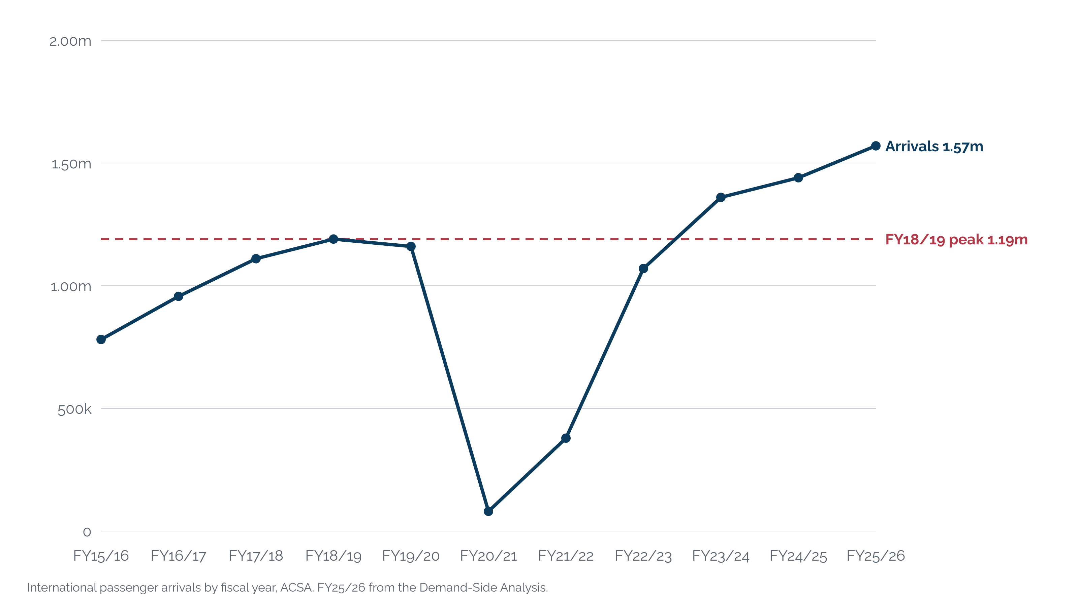
Figure 1.1. International passenger arrivals at Cape Town International passed their pre-pandemic peak in FY23/24 and reached 1.44m in FY24/25 and 1.57m in FY25/26.
Source: Current State Diagnostic, Dec 2025, p25 (FY15/16 to FY24/25); Demand-Side Analysis, Jun 2026, p11 (FY25/26). CTIA and ACSA CPT passenger statistics, international arrivals by fiscal year.

Spend and value
Foreign direct spend in the province rose from R22.7bn in FY2024 to R25.9bn in FY2025, a gain of 14% in one year (Demand-Side Analysis, Jun 2026, p11). The Western Cape earns that spend from a modest share of the national market. Across the four quarters of 2025 it took 16%, 13%, 13% and 16% of South Africa's foreign arrivals and 26%, 20%, 22% and 27% of foreign direct spend (p11).
The gap between the two shares is the province's premium. About a quarter of national spend from about a seventh of arrivals means the average foreign visitor to the Western Cape spends roughly 1.6 times the national average (computed from p11). The province earns about US$890 per international arrival, against US$500 for the rest of South Africa and US$630 for Morocco, though below Kenya's US$1,460 (Demand-Side Analysis, Jun 2026, p15).
More than a quarter of overseas visitors stay between 7 and 21 days (Demand-Side Analysis, Jun 2026, p12). The bands run 5% for 1 to 2 days, 12% for 3 to 4 days, 14% for 7 to 10 days, 3% for 11 to 14 days and 13% for 15 to 21 days (p12). The printed bands sum to 48% and the survey behind them records that 52.33% of respondents gave no length of stay, so the distribution describes half the sample (Current State Diagnostic, Dec 2025, p25).
The modal visitor spends R1,000 to R2,000 a day, is aged 36 to 50 and travels as a pair (Current State Diagnostic, Dec 2025, p25). Nearly 40% spend more than R1,000 a day (p27). Self-catering at 17.4% and guesthouses at 9.7% lead accommodation choice, ahead of hotels at 3.6% (p27).

Source markets
Five markets supply 63% of overseas arrivals. In 2025 the UK held 19%, Germany 17%, the USA 16%, the Netherlands 7% and France 4%, and the three largest alone held 52% (Demand-Side Analysis, Jun 2026, p13). The same slide prints 61% in its text; the report uses 63%, the sum of the printed shares, and logs the conflict.
Concentration is not new. On the 2024 Cape Town air-arrivals basis the same five markets held 61%, with the UK and the USA at 18% each and Germany at 15% (Current State Diagnostic, Dec 2025, p29). The growth markets remain small: India supplied about 2.6% of South Africa's overseas tourists in September 2025, the Middle East 2.3% and China 1.4% (p30).
The mature markets also pay the most. Average spend per visitor in 2024 ran from R32,900 for the USA, R26,500 for the UK and R25,600 for Germany down to R8,600 for Namibia and R8,500 for Zimbabwe (Demand-Side Analysis, Jun 2026, p14). The spread is 3.9 times, and the two regional markets compensate with stability, repeat demand and counter-seasonal volume (p14).
Most of these visitors arrive through someone else's hub. The UAE route carried 222,923 air arrivals into Cape Town in 2025, the UK 158,448, Qatar 126,078, Ethiopia 123,250 and Turkiye 89,090 (Demand-Side Analysis, Jun 2026, p13). The four Gulf and African hub routes carried 53% of arrivals on the ten largest routes (computed from p13), so Dubai, Doha, Addis Ababa and Istanbul are the province's working gateways.
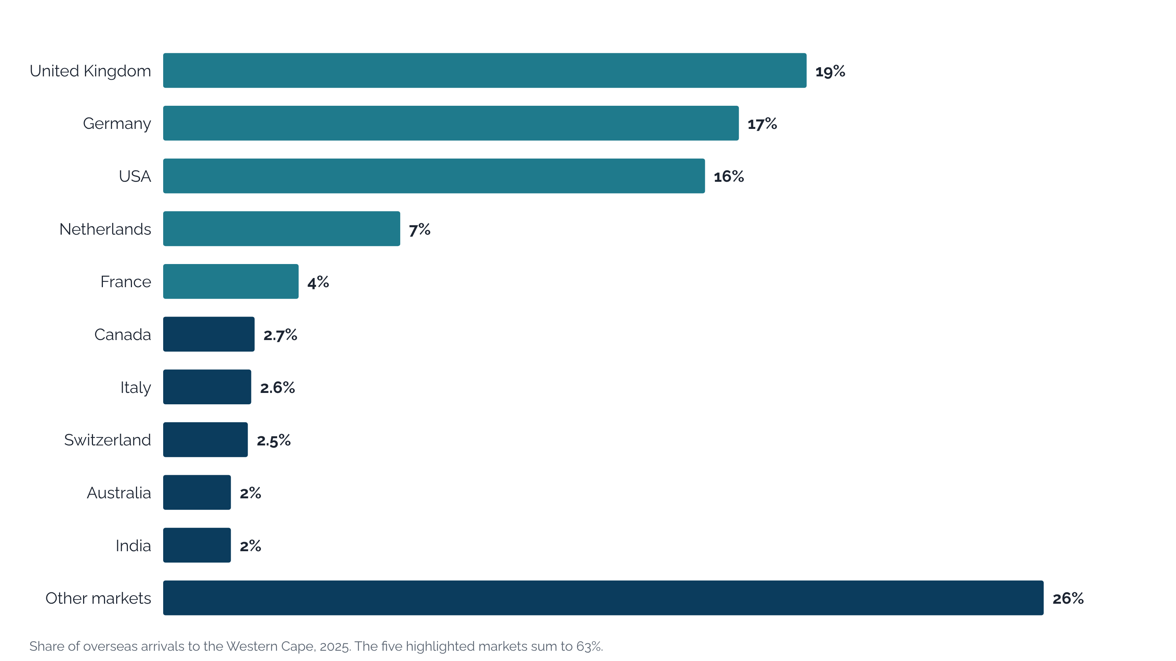
Figure 1.2. Five markets supplied 63% of overseas arrivals in 2025, and the UK, Germany and the USA alone supplied 52%.
Source: Demand-Side Analysis, Jun 2026, p13 (Stats SA and SAT International Performance Report 2025). The same slide prints 61% in its text; the five shares shown sum to 63%.
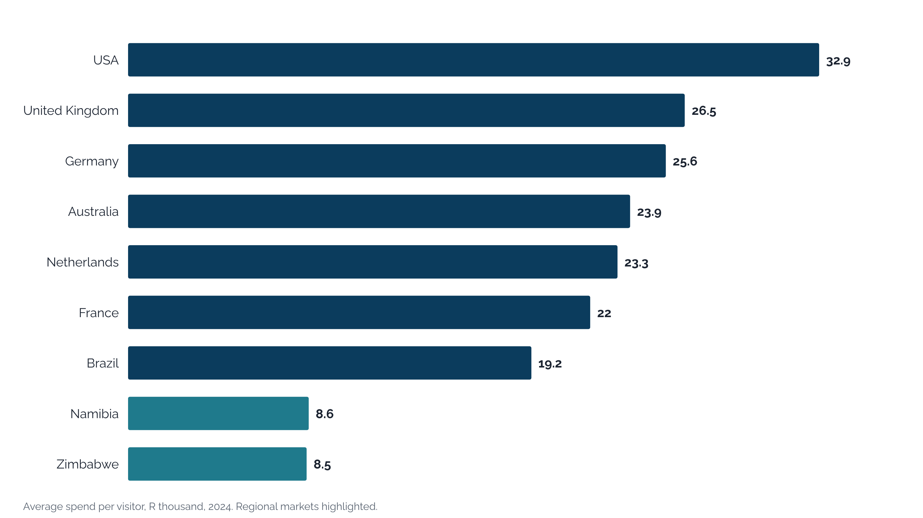
Figure 1.3. Average spend per visitor in 2024 ranged from R32,900 for the USA to R8,500 for Zimbabwe, a spread of 3.9 times.
Source: Demand-Side Analysis, Jun 2026, p14 (Stats SA and SAT International Performance Report). Average spend in the Western Cape by source market, ZAR, 2024.

Seasonality
Demand peaks in the southern summer. In 2025, 12.7% of overseas visitors travelled in December, 11.5% in January and 11.3% in November, against 6.1% in June and 6.5% in August (Demand-Side Analysis, Jun 2026, p12). October to March together account for about 65% of the year.
That 65% is derived, not printed. The twelve monthly shares on the 2025 slide sum to 104.9%, so the October to March figure is provisional and is flagged wherever this report uses it [Wesgro Research to confirm the 2025 month-of-travel shares, which sum to 104.9% as printed]. The 2024 survey, whose shares sum to 100%, gives 61% for October to March and 39% for April to September (Current State Diagnostic, Dec 2025, p32; the Market Assessment Report, May 2026, p25 notes a Cape Town overseas air-arrivals basis).
Supply follows the same curve. June carries 6.4% of 2025 international seat capacity into Cape Town (MIDAS Aviation Market Assessment, Mar 2026, "Seasonality"), and Cape Town hotel occupancy was 53% in June 2023 (Demand-Side Analysis, Jun 2026, p34). The Diagnostic drew the conclusion early: growth depends on improving conversion in April to September rather than pushing more demand into already busy peak months (Current State Diagnostic, Dec 2025, p32).
Table 1.1. Six summer months, October to March, carry between 61% and 65% of overseas visitors' travel in the two years for which month of travel is recorded.
Year | Jan | Feb | Mar | Apr | May | Jun | Jul | Aug | Sep | Oct | Nov | Dec | Oct to Mar
2024 | 9% | 13% | 12% | 8% | 7% | 4% | 6% | 7% | 7% | 10% | 10% | 7% | 61%
2025 (provisional) | 11.5% | 9.9% | 10.3% | 6.9% | 6.8% | 6.1% | 6.7% | 6.5% | 7.0% | 9.2% | 11.3% | 12.7% | 65%
Source: 2024: Current State Diagnostic, Dec 2025, p25 and p32 (Wesgro Visitor Tracking Survey 2024; shares sum to 100%). 2025: Demand-Side Analysis, Jun 2026, p12 (Stats SA and SAT 2025; the printed shares sum to 104.9%, so the 2025 row and its October to March share are provisional).

Air and sea access
Ten airlines fly to Cape Town International from Africa, nine from Europe, three from North and South America, two from the Middle East and one from Asia (Current State Diagnostic, Dec 2025, p35). The aviation assessment states the gap plainly as "the absence of any direct capacity to any of the Asian markets", India and China included (MIDAS Aviation Market Assessment, Mar 2026, "The Capetown Market"). Twenty-nine international routes serve the airport in 2026 (MIDAS Aviation Market Assessment, Mar 2026, "Executive Summary").
Cape Town International itself is now the physical ceiling. One runway with no parallel taxiway caps movements at about 30 an hour, and ACSA's programme of about R11.3bn brings relief only from about 2032 to 2034 (Infrastructure Report, Jul 2026, p101 to p103). The secondary gateways do not change the picture: George, above its design limit at 911,000 passengers in 2025, doubles by 2028 (p104, p105), and Cape Winelands Airport targets 2028 with no named carrier (p106, p107).
Cruise has grown without new berth capacity. The province hosted 70, 67 and 79 vessels in the 2022/23, 2023/24 and 2024/25 seasons, carrying 144,125, 109,884 and 127,178 passengers (Current State Diagnostic, Dec 2025, p37). The Infrastructure Report counts 83 calls at the Cape Town berth in 2024/25, 127,000 passengers and R1.79bn of economic impact (Infrastructure Report, Jul 2026, p110) [StratEcon 2024/25 cruise report to confirm whether 79 vessels and 83 calls differ by definition].
Port reliability, not berth space, is the risk. The single berth ran at about 40% of a season capacity of 150 or more calls, and its limits are a 300m ship length and the South-Easter wind (Infrastructure Report, Jul 2026, p110). The Diagnostic calls the Port of Cape Town "a binding constraint, with congestion and equipment failures affecting export and cruise reliability" (Current State Diagnostic, Dec 2025, p34).

Geography of the system
The Cape Metro generates 72.5% of provincial GDPR, a whole-economy share rather than a tourism one (Current State Diagnostic, Dec 2025, p39; Infrastructure Report, Jul 2026, p22). The Cape Winelands follows at 11.2%, the Garden Route at 7.6%, the West Coast at 4.8%, the Overberg at 3% and the Central Karoo at 0.5% (Current State Diagnostic, Dec 2025, p42 to p50). Neither deck prints the year behind the shares.
Tourism supply is concentrated in the same way. The Infrastructure Report mapped 50,332 tourism assets across the six regions, of which the Metro holds 20,281, or 40.3% (Infrastructure Report, Jul 2026, p2, p23). The Garden Route holds 9,875, the Cape Winelands 7,730, the Overberg 6,176, the West Coast 4,752 and the Central Karoo 1,518 (p34, p45, p56, p67, p78).
Cape Town is the axle of the system. The Infrastructure Report calls it "the province's global shopfront and primary dispersal hub" (p22), and the Diagnostic warns that "any capacity failure in Cape Town quickly becomes a provincial risk, not just a city problem" (Current State Diagnostic, Dec 2025, p41). International visitors land there and disperse from there, and readiness falls with each step away: accessibility scores drop from 4.7 in the Metro to 1.0 in the Central Karoo (Infrastructure Report, Jul 2026, p88 to p90).
Beyond the Metro the visitor drives. The N2 is "the only continuous inter-regional tourism corridor, creating a single point of failure", and large parts of the province outside the Metro and the Garden Route remain effectively car-only destinations (Infrastructure Report, Jul 2026, p98, p99). The further from Cape Town, the faster the infrastructure falls away (p90).
Table 1.2. The Cape Metro holds 72.5% of provincial GDPR and 40% of the province's tourism assets, and accessibility falls with each step away from it.
District | Share of provincial GDPR | Tourism assets | Share of assets | Accessibility score (1 to 5)
Cape Metro | 72.5% | 20,281 | 40.3% | 4.7
Cape Winelands | 11.2% | 7,730 | 15.4% | 3.3
Garden Route | 7.6% | 9,875 | 19.6% | 3.0
West Coast | 4.8% | 4,752 | 9.4% | 1.7
Overberg | 3% | 6,176 | 12.3% | 2.0
Central Karoo | 0.5% | 1,518 | 3.0% | 1.0
Western Cape |  | 50,332 | 100%
Source: GDPR shares: Current State Diagnostic, Dec 2025, p39, p42, p44, p46, p48, p50 (year not printed; Garden Route share is for 2023). Asset counts: Infrastructure Report, Jul 2026, p2, p23, p34, p45, p56, p67, p78 (the Winelands gauge misprints 40.3%; 7,730 of 50,332 is 15.4%). Accessibility: Infrastructure Report, Jul 2026, p88 to p90, attractions and services basis; the Metro scores 5.0 on transport.

Rail, roads and utilities
Passenger rail has collapsed as a mode. Trainsets fell from about 110 in 1995 to about 91, pushing some 400,000 commuters onto saturated roads, and congestion in the Metro costs an estimated R2.8bn a year (Current State Diagnostic, Dec 2025, p38). Metrorail still runs 460km, five lines and 104 of 121 stations, with 22.7m passenger trips in FY2025, but no line reaches the airport and it is rated functionally unusable for tourism (Infrastructure Report, Jul 2026, p100, p90).
Utilities cap the periphery before demand does. Water scarcity in high-growth nodes such as the Garden Route acts as a "hard ceiling" for visitor load, and load shedding raises costs and degrades the experience in peripheral districts (Current State Diagnostic, Dec 2025, p38). The airport has no fuel pipeline and depends on road tankers (p38), and the 2017 to 2018 water crisis left a lasting perception of resource pressure (p55).
The remedies are named but not scheduled. The Diagnostic lists four transport enablers, none dated or costed: the Cape Town Integrator, rail restoration and devolution, a high-speed city to airport link and George to Cape Winelands passenger rail (Current State Diagnostic, Dec 2025, p38). PRASA's R21.1bn programme and the City's R123bn, 30-year devolution case cover fleet and lines, and neither carries a tourism product or an airport link (Infrastructure Report, Jul 2026, p100).

Institutions
Wesgro runs the demand side of this system through six units: Cape Town Air Access, Cruise Cape Town, the Convention Bureau, Destination Marketing, Research and Tourism (Inception Report, Nov 2025, p7). Around them sit fifteen external organisations spanning three spheres of government, state-owned entities, attraction bodies and private operators (p7). The table below sets out who holds what.
The levers that bind the system sit at different tiers. National government holds visa rules, border compliance, air service agreements and route rights (Current State Diagnostic, Dec 2025, p58). The province holds jobs, inclusion and spatial outcomes, sector development and infrastructure planning; local government holds service delivery, precinct management and events readiness; industry holds route viability, demand generation and product standards (p58).
Alignment across those tiers is thin. The Diagnostic records specific dysfunctions, "SAT is in turmoil" among them, and the added pressure of a lack of fiscal space (Current State Diagnostic, Dec 2025, p58). More than twenty bodies produce tourism data and "there is no single view of visitor behaviour, making strategy reactive rather than predictive" (p57).
Stakeholders say the same. Fifteen of the sixteen organisations interviewed raised industry and government collaboration (Stakeholder Insights Report, Mar 2026, p20 to p46; the count is of organisations with at least one insight under the theme). The Department of Economic Development named restrictive bilateral air agreements and destination funding materially below peer destinations as high-impact constraints (p24, p25).
Table 1.3. Wesgro's six units sit inside a system of fifteen external organisations whose decision rights are split across three spheres of government and industry.
Group | Organisations | What sits here
Wesgro units | Cape Town Air Access; Cruise Cape Town; Convention Bureau; Destination Marketing; Research; Tourism | Route development, cruise, business events bids, destination marketing, research and tourism promotion for Cape Town and the Western Cape
Provincial and city government | Western Cape Government (Economic Development and Tourism); City of Cape Town | Provincial tier: jobs, inclusion and spatial outcomes; sector development and safety programmes; infrastructure planning and resilience. Local tier: service delivery and precinct management; events readiness and place experience; congestion, by-laws and community impact
National agencies and state-owned entities | South African Tourism; Airports Company South Africa; Transnet; South African Maritime Safety Authority | National tier: visa rules and border compliance; air service agreements and route rights; national brand and investment priorities. Airport capacity and port operations
Destination and attraction bodies | Cape Town Tourism; V&A Waterfront; CapeNature; South African National Parks; Table Mountain Aerial Cableway | Industry tier: demand generation and destination marketing; product quality and visitor experience at the flagship sites
Private operators | MSC Cruises; Cape Grace; Pullman Hotels and Resorts (Cape Town City Centre); Southern Sun | Industry tier: route and product viability and commercial performance; pricing and service standards
Source: Inception Report, Nov 2025, p7 (organisations as shown on the stakeholder map; the grouping is this report's); Current State Diagnostic, Dec 2025, p58 (functions by tier).
None of these constraints is a shortage of visitors. The runway, the single corridor, a rail network visitors cannot use, the thin winter schedule and decision rights split across three tiers all sit outside a marketing budget. The system has recovered; its constraints are now physical and institutional.

Analysis summaries

Findings and recommendations

Execution plan

Monitoring and evaluation framework

Appendices

