# Zarządzanie salami

## Introduction

The application will be used to manage information about rooms located on PJATK. The information will include, for example, the number of computers, the number teaching places, whether there is a projector, whether the room is accessible to the disabled, etc.

This information is important from the perspective of creating classes schedule for next semesters - for example, when placing classes for group WSI I.2- 12c, we want to be sure that it is placed in a class that have enough capacity.

In addition, this information is used in the process of stocktaking and checking the condition of equipment in the rooms (for ex. to check if some of the equipment is not missing).

Finally, the information is properly used throughout the year during the process of booking rooms due to various types of events, activities, etc.

Two additional functionalities worth paying attention to is the ability to save information about the layout of the tables in the room (eg tables are placed in a circle - as in language rooms, etc.) and information about what kind of software is available in different rooms.

BSS would like to be able to save information about software in specific rooms. This is important due to the ongoing support of teachers (eg inquiries about in which room they find a specific type of software) during the semester, as well as from the perspective of arranging the schedule (some subjects require specific software).

## Nonfunctional requirements

* The application should be implemented as a web application preferably using MS SQL Server (existing dziekanat_prod database), ASP.NET Web API (on .NET Core) and using React + Redux on the frontend.
* The application should be responsive. During the process of stocktaking, we want, for example, that the person checking the equipment in the classes should be able to use tablet (probably more convenient than using laptop).

## Use case diagrams

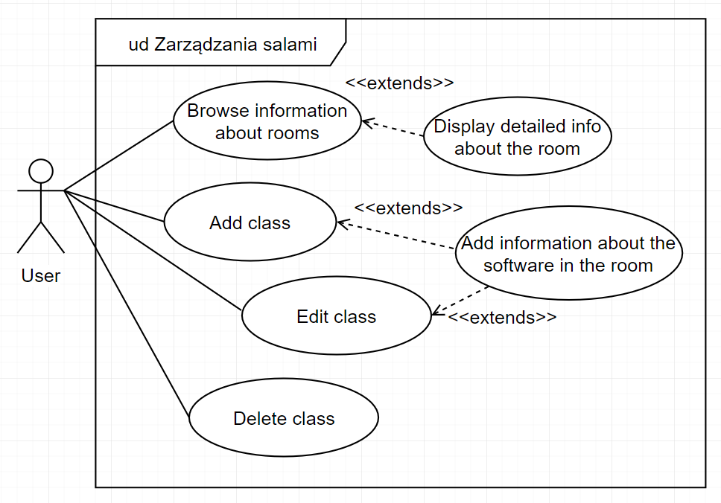

## Existing database schema (part of dziekanat_prod.sql)

