Task 1
1.1
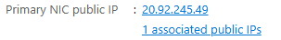
Retrieving public IP address.
1.2
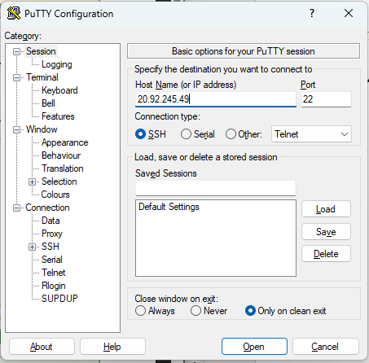
Connecting to the VM.
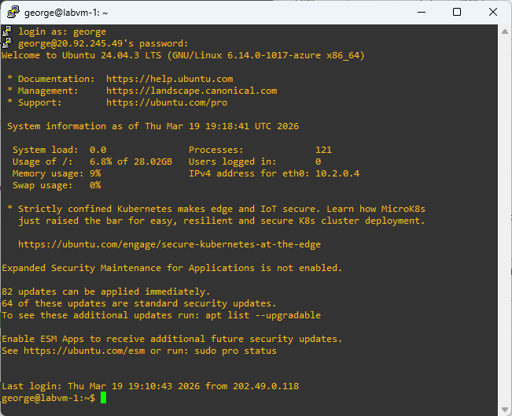
Logged into the VM.

1.3
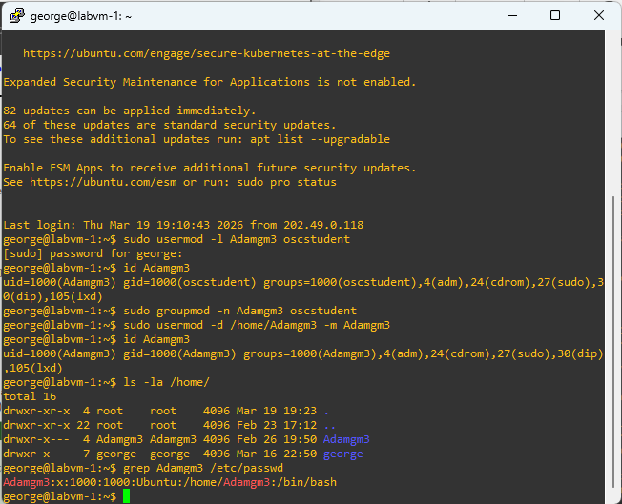
Renaming default account and group to Adamgm3 and verifying changes.

1.4
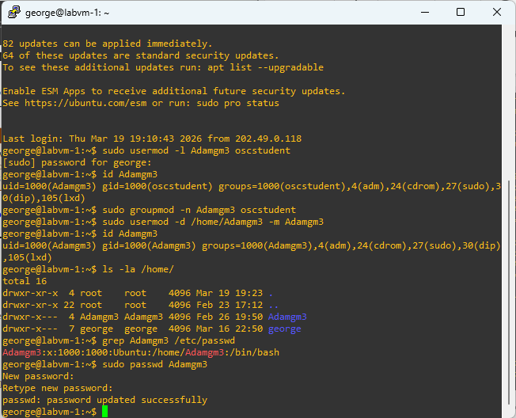
Changing password.

Task 2
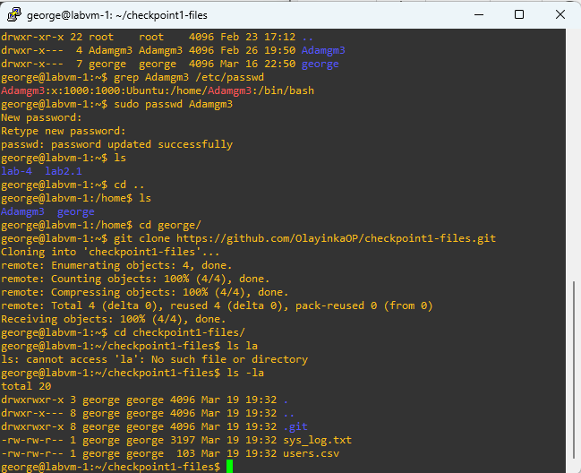
Cloning the repo and confirming the files are present.
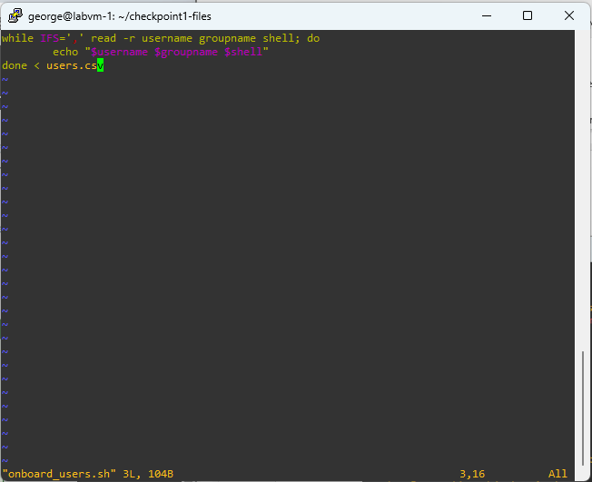
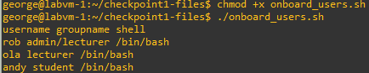
Making a simple script that reads the lines and separates them by comma.
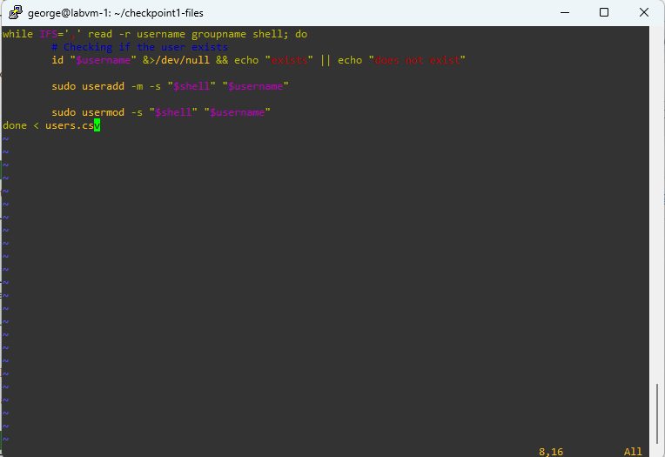
A script that checks for users and adds them is they don’t exist, and updates their shell if they do.
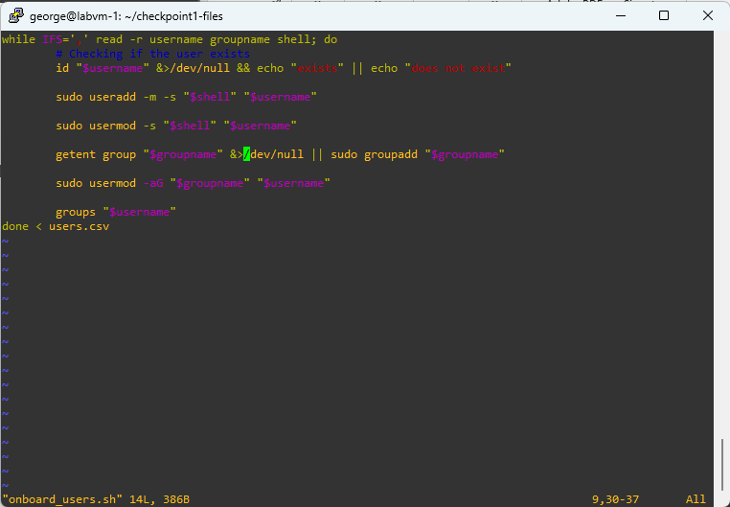
The script now does the same for groups.
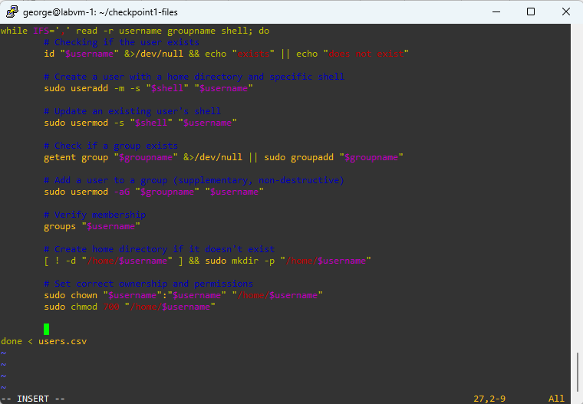
It now sets up the home directory.
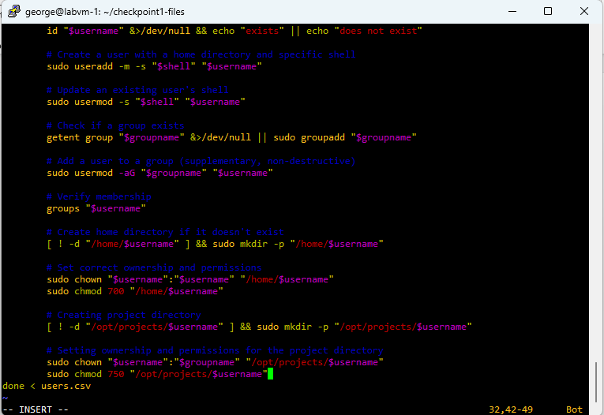
It now does the same thing for a project directory.
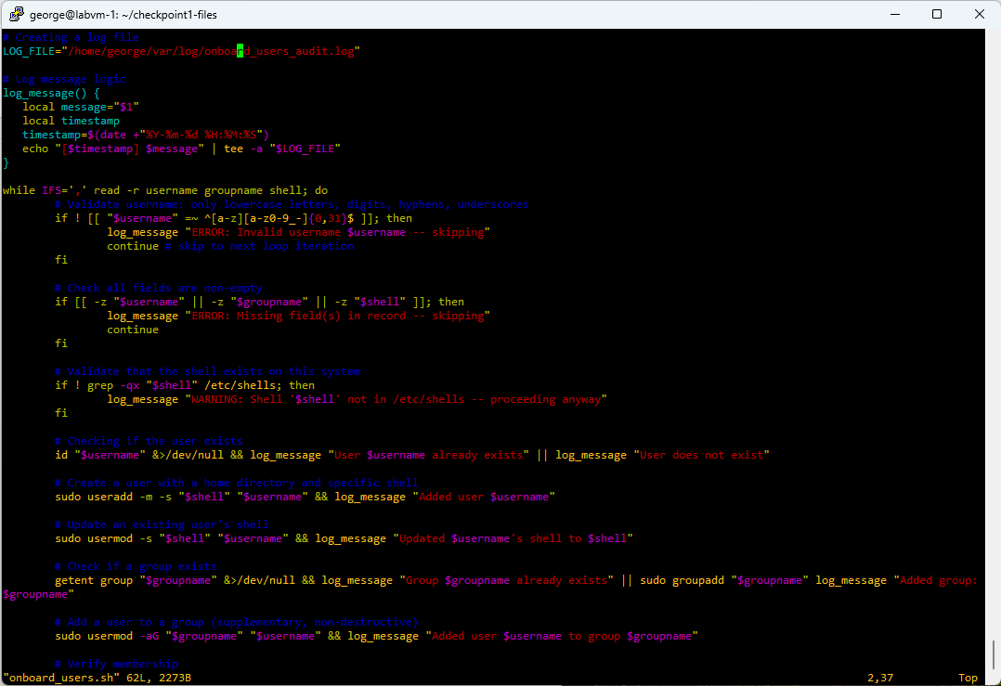
Log message logic with some messages and error handling

Task 2 Checklist:
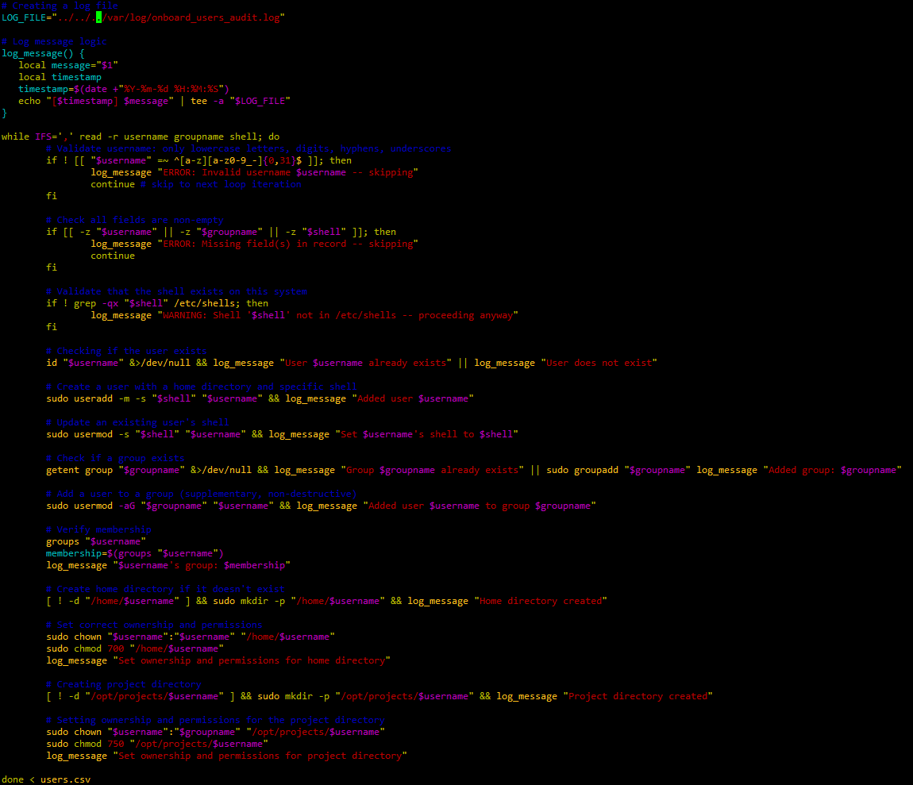
Full script
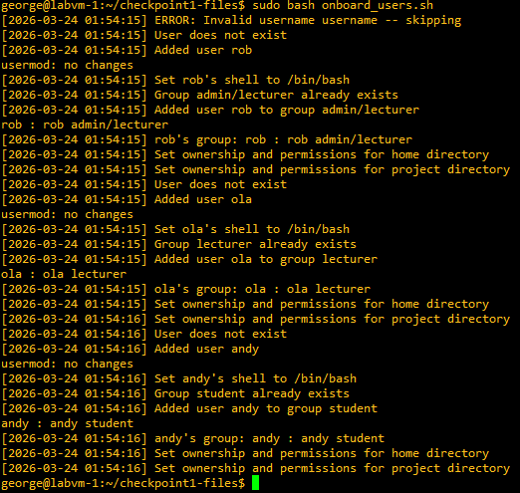
Script being run

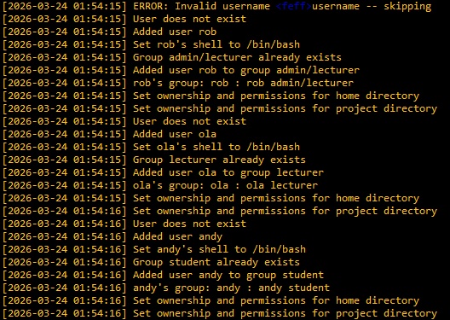
user_onboarding_audit.log output
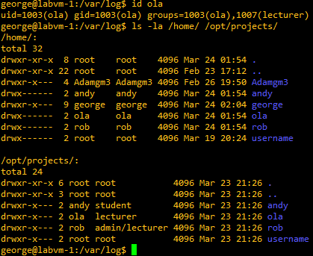
Confirming at least one user was created successfully

Task 3:
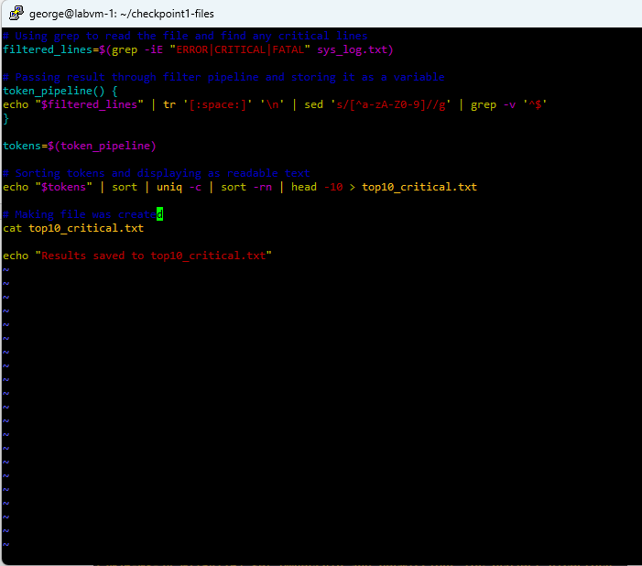
critical_log_analysis.sh
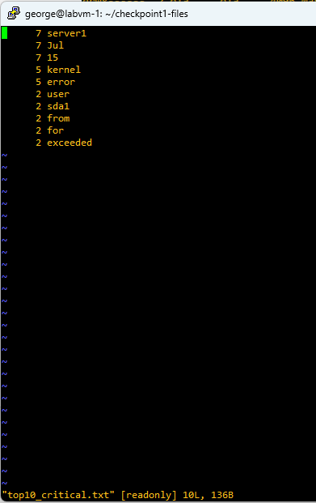
top10_critical.txt
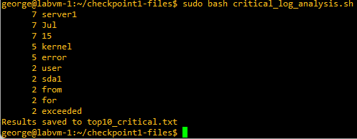
The script being run.

