COMPUTER/DIGITAL FORENSICS (CYBER FORENSICS)

Computer forensics is the application of investigation and analysis techniques to gather and preserve evidence from a particular computing suitable for presentation in a court of law. The goal of computer forensics is to perform a structured investigation while maintaining a documented chain of evidence to find out exactly what happened on a computing device and who was responsible for it.
Forensic investigators typically follow a standard set of procedures: After physically isolating the device in question to make sure it cannot be accidentally contaminated, investigators make a digital copy of the device's storage media. Once the original media has been copied, it is locked in a safe or other secure facility to maintain its pristine condition. All investigation is done on the digital copy.
Investigators use a variety of techniques and proprietary software forensic applications to examine the copy, searching hidden folders and unallocated disk space for copies of deleted, encrypted, or damaged files. Any evidence found on the digital copy is carefully documented in a "finding report" and verified with the original in preparation for legal proceedings that involve discovery, depositions, or actual litigation.

COMPUTER FORENSICS GUIDE
​The guide is aimed at a non-technical audience and provides a high-level view of computer forensics. Although the term “computer” is used, the concepts apply to any device capable of storing digital information. Where methodologies have been mentioned they are provided as examples only, and do not constitute recommendations or advice.

Uses of computer forensics

​There are few areas of crime or dispute where computer forensics cannot be applied. Law enforcement agencies have been among the earliest and heaviest users of computer forensics and consequently have often been at the forefront of developments in the field.
Computers may constitute a ‘scene of a crime’, for example with hacking or denial of service attacks or they may hold evidence of crimes conducted elsewhere in the form of emails, internet history, documents or other files relevant to crimes such as murder, kidnap, fraud and drug trafficking.
It isn't just the content of emails, documents and other files which may be of interest to investigators but also the metadata associated with those files as well. Records of a user's actions may also be stored in log files and within other applications on a computer, such as internet browsers. A computer forensic examination may reveal when a document first appeared on a computer, when it was last edited, when it was last saved or printed and which user carried out these actions.
​More recently, commercial organizations have used computer forensics to their benefit in a variety of cases such as;​
- Intellectual Property theft
- Employment disputes
- Invoice fraud, often facilitated by phishing emails
- Forgeries
- Inappropriate email and internet use in the work place
- Regulatory compliance
​​FORENSIC GUIDELINES
For evidence to be admissible it must be reliable and not prejudicial, meaning that at all stages of a computer forensic investigation admissibility should be at the forefront of the examiner’s mind. A widely used and respected set of guidelines which can guide the investigator in this area is the Association of Chief Police Officers Good Practice Guide for Digital Evidence, or ACPO Guide for short. Although the ACPO Guide is aimed at United Kingdom law enforcement, its main principles are applicable to all computer forensics.
​THE FOUR MAIN PRINCIPLES FROM THIS ARE AS FOLLOWS:
​​1. No action should change data held on a computer or storage media which may be subsequently relied upon in court.
2. In circumstances where a person finds it necessary to access original data held on a computer or storage media, that person must be competent to do so and be able to give evidence explaining the relevance and the implications of their actions.
3. An audit trail or other record of all processes applied to computer-based electronic evidence should be created and preserved. An independent third-party should be able to examine those processes and achieve the same result.
4. The person in charge of the investigation has overall responsibility for ensuring that the law and these principles are adhered to.

LIVE ACQUISITION
In what situations would changes to a suspect’s computer by a computer forensic examiner (and therefore contravening the first principal above) be necessary?
Traditionally, the computer forensic examiner would copy data from a device which is turned off. A write-blocker would be used to make an exact bit for bit copy of the original storage medium. An acquisition hash of the original medium would be created. The examiner would then work from this copy, leaving the original demonstrably unchanged.
​However, sometimes it is not possible (or desirable) to switch a computer off. It may not be possible if doing so would for example result in considerable financial or other loss for the owner. The examiner may also wish to avoid a situation whereby turning a device off may render valuable evidence to be permanently lost. In both these circumstances the computer forensic examiner would need to carry out a ‘live acquisition’ which would involve running a simple application on the suspect computer in order to copy (or acquire) the data to the examiner’s data repository.
By running such an application (and by attaching a device to the suspect computer such a USB drive), the examiner will make changes and/or additions to the state of the computer which were not present before their actions. However, the evidence produced would usually still be considered admissible if the examiner was able to show why such actions were considered necessary, and that they recorded those actions and that they are to explain to a court the consequences of those actions.

​

​STAGES OF AN EXAMINATION
The examination process has been divided into six stages, presented in order of occurrence.
​1. Readiness
Forensic readiness is an important and occasionally overlooked stage in the examination process. In commercial computer forensics it can include educating clients about system preparedness; for example, forensic examinations will provide stronger evidence if a device’s auditing features have been activated prior to an incident taking place
​For the forensic examiner, readiness includes appropriate training, testing and verification of their software and equipment, familiarity with legislation, knowing how to deal with unexpected issues (e.g., what to do if child abuse images are found during a fraud engagement) and ensuring that their data acquisition computer and associated items are adequate for the work in hand.
​2. Evaluation
The evaluation stage includes the receiving of instructions, the clarification of those instructions if unclear or ambiguous, risk analysis and the allocation of roles and resources. Risk analysis for law enforcement may include an assessment on the likelihood of physical threat on entering a suspect’s property and how best to counter it. Commercial organizations also need to be aware of health and safety issues, conflict of interest issues and of possible risks – financial and to their reputation – on accepting a particular project.
​3. Collection
If data acquisition (often called 'imaging') is to be carried out on-site rather than at the computer forensic examiner's office, then this stage would include identifying and securing devices which may store evidence and documenting the scene. Interviews or meetings with personnel who may hold information relevant to the examination (which could include the end users of the computer, and the manager and person responsible for providing computer services, such as an IT administrator) would usually be carried out at this stage.
The collection stage can also involve the labelling and bagging of items from the site which may be used in the investigation, to be sealed in numbered tamper-evident bags. Consideration should be given to securely and safely transporting the material to the examiner’s office/ laboratory.
​4. Analysis
Analysis includes the discovery and extraction of information acquired in the collection stage. The type of analysis will be dependent on the requirements of each case, and can range from the extraction of a single email to piecing together the complexities of a fraud or terrorism case. During analysis the examiner will usually provide feedback to their line manager/ client; from this dialogue the analysis may take a different path or be narrowed to specific areas. Forensic analysis must be accurate, thorough, impartial, recorded, repeatable and completed within the time-scales available and resources allocated.
​There are myriad tools available for computer forensics analysis. The examiner should use any tool they feel comfortable with as long as they can justify their choice. The main requirements of a computer forensic tool is that it does what it is meant to do and the only way for examiners to be sure of this is for them to regularly test and calibrate the tools they rely on before analysis takes place.​'Dual-tool verification' is able to confirm result integrity during analysis (if with tool ‘A’ the examiner finds artefact ‘X’ at location ‘Y’, then tool ‘B’ should replicate the same results hundred times).
​5. Presentation
This stage usually involves the examiner producing a structured report on their findings, addressing the points in the initial instructions, along with any subsequent instructions they may have received. The report should also cover any other information which the examiner deems relevant to the investigation. It must be written with the end reader in mind; in many cases the reader will be non-technical, and so reader-appropriate terminology should be used. The examiner may be required to participate in meetings or telephone conferences to discuss and elaborate on their report.
​6. Review
As with the readiness stage, the review stage is often overlooked or disregarded. This may be due to the perceived costs of doing work that is not billable, or the need ‘to get on with the next job’. However, a review stage incorporated into each examination can help save money and raise the level of quality by making future examinations more efficient and time effective. A review of an examination can be simple, quick and can begin during any of the above stages. It may include a basic analysis of what went wrong, what went well, and how the learning from this can be incorporated into future examinations. Feedback from the instructing party should also be sought. Any lessons learnt from this stage should be applied to the next examination and feed into the readiness stage.
​

ISSUES FACING COMPUTER FORENSICS
​The issues facing computer forensics examiners can be broken down into three broad categories: technical, legal and administrative.
​1. Technical Issues
​a. Encryption– Encrypted data can be impossible to view without the correct key or password. If the key is not available or the owner will not reveal it, examiners should consider that it may be stored elsewhere on the computer or on another computer which the suspect has had access to. It could also reside in the volatile memory of a computer (known as RAM) which is usually lost on computer shut-down; another reason to consider using live acquisition techniques, as outlined above.
​b. Increasing storage space – Storage media hold ever greater amounts of data, which for the examiner means that their analysis computers need to have sufficient processing power and available storage capacity to efficiently deal with searching and analysing large amounts of data.
​c. New technologies – Computing is a continually evolving field, with new hardware, software and operating systems emerging constantly. No single computer forensic examiner can be an expert on all areas, though they may frequently be expected to analyse something which they haven’t previously encountered. In order to deal with this situation, the examiner should be prepared and able to test and experiment with the behaviour of new technologies. Networking and sharing knowledge with other computer forensic examiners is very useful in this respect as it’s likely someone else has already come across the same issue.
​d. Anti-forensics – Anti-forensics is the practice of attempting to thwart computer forensic analysis. This may include encryption, the over-writing of data to make it unrecoverable, the modification of files’ metadata and file obfuscation (disguising files). As with encryption, the evidence that such methods have been used may be stored elsewhere on the computer or on another computer which the suspect has had access to. In our experience, it is very rare to see anti-forensics tools used correctly and frequently enough to totally obscure either their presence or the presence of the evidence that they were used to hide.
​2. Legal Issues
a. Legislative domains - data is often not stored on a person's computer but on remote computers which they are renting storage space on, otherwise known as the 'cloud'. The location of this data may be in a different country and therefore access to it may be via a different legislation. Access, if possible at all, can be complicated and expensive.
​b. Legal arguments - Legal issues may confuse or distract from a computer examiner’s findings. An example here would be the ‘Trojan Defence’. A Trojan is a piece of computer code disguised as something benign but which carries a hidden and malicious purpose. Trojans have many uses, and include key-logging), uploading and downloading of files and installation of viruses. A lawyer may be able to argue that actions on a computer were not carried out by a user but were automated by a Trojan without the user’s knowledge; such a Trojan Defence has been successfully used even when no trace of a Trojan or other malicious code was found on the suspect’s computer. In such cases, a competent opposing lawyer, supplied with evidence from a competent computer forensic analyst, should be able to dismiss such an argument. A good examiner will have identified and addressed possible arguments from the “opposition” while carrying out the analysis and in writing their report.
​3. Administrative Issues
a. Accepted standards – There are a plethora of standards and guidelines in computer forensics, few of which appear to be universally accepted. The reasons for this include: standard-setting bodies being tied to particular legislations; standards being aimed either at law enforcement or commercial forensics but not at both; the authors of such standards not being accepted by their peers; or high joining fees for professional bodies dissuading practitioners from participating.
​b. Fit to practice – In many jurisdictions there is no qualifying body to check the competence and integrity of computer forensics professionals. In such cases anyone may present themselves as a computer forensic expert, which may result in computer forensic examinations of questionable quality and a negative view of the profession as a whole.
​
10 Best Tools for Computer Forensics
Every computer forensic gumshoe needs a set of good, solid tools to undertake a proper investigation, and the tools you use vary according to the type of investigation you’re working on. The list of tools isn’t all-inclusive — and you may have your own favorites — but the ones we describe are the basic ones you should use.
The days of hard-core computer geeks knowing every square digital inch of an operating system are years behind us. Although computer forensic professionals can now do the drudge work of scanning for evidence using nothing more than a keyboard and a hex editor, that person has access to tools that automate the work in order to use their time more effectively. In fact, modern computer forensic software can find evidence in only minutes, whereas in the “old days” the process took hours or even days! You still have to know your way around a computer, but these tools are true time-savers.Just remember that a tool is only as good as the person who uses it.

EnCase
EnCase, the gold standard, is used by countless organizations for almost any computer forensic investigation. The power of this must-have item for your computer forensic toolbox, and your ability to customize it for unique searches, set it apart from most competitors.
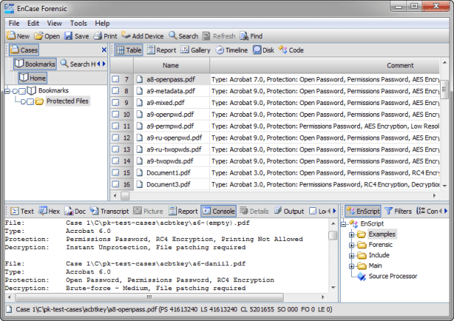
EnCase comes built-in with many forensic features, such as keyword searches, e-mail searches, and Web page carving. The numerous versions of its forensic software range from mobile device acquisitions to full-blown network forensic-analysis tools.
Two other cool features are its:
- Scripting language: You can customize searches.
- Fully automated report function: It builds reports for you quickly.
EnCase is sold by Guidance Software on its Web site. Support for EnCase is rock solid, and the technical support staff knows how to solve problems fairly quickly in addition to providing multilanguage support.

Forensic ToolKit (FTK)
AccessData has created a forensic software tool that’s fairly easy to operate because of its one-touch-button interface, and it’s also relatively inexpensive. The new version of FTK is even easier to use, and AccessData has started a forensic certification, ACE, based on its software.
FTK has automated, to a high degree, the hard, behind-the-scenes work of setting up searches. Press the Email button and out pop the e-mails. The FTK report generator does the hard work of putting a useful report into the automated hands of the forensic software while still allowing the investigator control over the report, if needed.

FTK is sold on the AcessData Web site at www.accessdata.com. Everything you need to order the software and training is on the site. Even the certification process is available for you to peruse.

Device Seizure
The Paraben forensic tools compete with the top two computer forensic software makers EnCase and FTK (described earlier in this chapter), but the company truly shines in the mobile forensic arena.Using Paraben’s Device Seizure product, you can look at most mobile devices on the market. With more cases going mobile, Device Seizure is a must-have tool.You can use Device Seizure to access and download almost all information contained in a mobile device, such as text messages or user data, and in a way that’s forensically acceptable in court.Device Seizure and all the extras that can go with it are at www.paraben.com along with other useful forensic tools.
In contrast to computer forensic software designed to extract data or evidence in a timely manner and from a logical point of view, forensic hardware is primarily used to connect the physical parts of the computer to help extract the data for use with the forensic software.
The basic idea behind forensic hardware is to facilitate the forensic transfer of digital evidence from one device to another as quickly as possible.

FRED
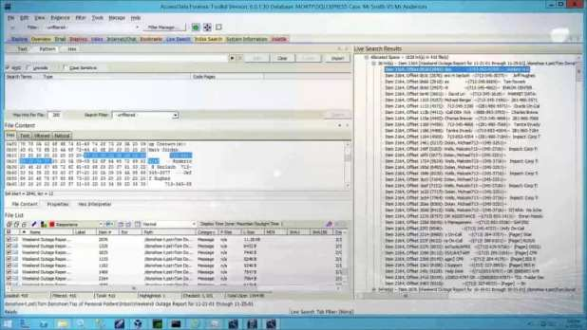
The Forensic Recovery of Evidence Device (FRED) forensic workstation from Digital Intelligence has an interface for all occasions — and then some. In addition to the laboratory version, FRED comes in mobile versions that facilitate the acquisition of evidence in the field for quick analysis.FRED combines just about every available interface into one convenient workstation so that you don’t have to connect and disconnect a toolbox full of interfaces. Another helpful FRED feature is the collection of software packages that’s loaded on it if you request it: EnCase, FTK, Paraben’s P2, and many others.Digital Intelligence, at www.digitalintelligence.com, has all the information you could ever want about the FRED systems. The company also offers training in the use of its systems and provides helpful technical support.

CRU Forensic Field Kit
When you need a small footprint and useful equipment for field use, the CRU field kit is hard to beat, figuratively and literally. Even with its small footprint, this field kit has the most popular interfaces available, and you can even customize it for your unique needs.
Using the CRU field kit, you can carry the most essential pieces of your forensic toolkit. The heart of this field kit consists of the write protect devices that WiebeTech manufactures in-house. The kits also contain interfaces for EIDE, SATA, and laptop hard drives.
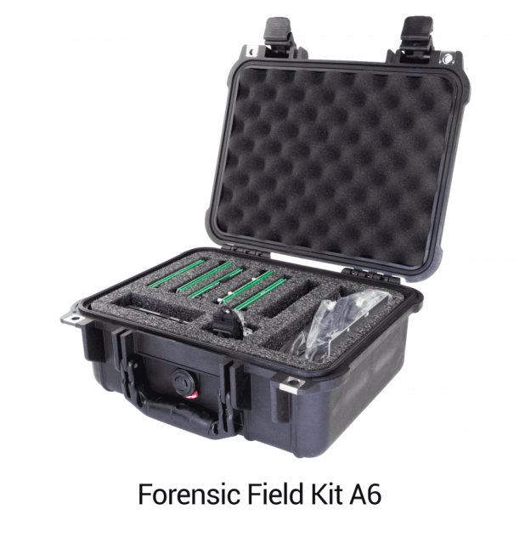
You can find CRU field kits online here, and they’re also listed at some third-party Web sites.

Logicube
Logicube offers some of the fastest disk-to-disk and disk-to-image transfer equipment now on the market. As storage devices grow larger, transferring 4 gigabytes per minute can save quite a bit of time over other methods of field data acquisition.
The Logicube data capture equipment captures data from a target media and transfers it to another disk or an image while at the same time performing an integrity check to ensure a forensic copy. The devices have various interfaces and usually come in a field kit configuration.
The Logicube Web site at www.logicube.com has information about the devices and how to order them. The company also offers other forensic products and has an in-house research-and-development team.
The computer is a reliable witness that cannot lie. Digital evidence contains an unfiltered account of a suspect’s activity, recorded in his or her direct words and actions. But, some people say that using digital information as evidence is a bad idea. If it’s easy to change computer data, how can it be used as reliable evidence?
To identify all the hidden details that are left after or during an incident, the computer forensics is used. The purpose of computer forensics techniques is to search, preserve and analyze information on computer systems to find potential evidence for a trial.

Computers are getting more powerful day by day, so the field of computer forensics must rapidly evolve. Previously, we had many computer forensic tools that were used to apply forensic techniques to the computer. However, we have listed few best forensic tools that are promising for today’s computers:

- SANS SIFT
- ProDiscover Forensic
- Volatility Framework
- The Sleuth Kit (+Autopsy)
- CAINE
- Xplico
- X-Ways Forensics

SANS SIFT:
The SANS Investigative Forensic Toolkit (SIFT) is an Ubuntu-based Live CD which includes all the tools you need to conduct an in-depth forensic or incident response investigation. The free SIFT toolkit that can match any modern incident response and forensic tool suite is also featured in SANS’ Advanced Incident Response course (FOR 508). It demonstrates that advanced investigations and responding to intrusions can be accomplished using cutting-edge open-source tools that are freely available and frequently updated.
It supports analysis of Expert Witness Format, Advanced Forensic Format (AFF), and RAW (dd) evidence formats. It also includes tools such as timeline from system logs, Scalpel for data file carving, Rifiuti for examining the recycle bin, and lots more.
Key new features of SIFT include:
- Ubuntu LTS 14.04 Base.
- 64-bit base system.
- Better memory utilization.
- Auto-DFIR package update and customizations.
- Latest forensic tools and techniques.
- VMware Appliance ready to tackle forensics.
- Cross compatibility between Linux and Windows.
- Option to install stand-alone via (.iso) or use via VMware Player/Workstation.
- Online Documentation Project at http://sift.readthedocs.org/
- Expanded Filesystem Support.

ProDiscover Forensic:
ProDiscover Forensic is a powerful computer security tool that enables computer professionals to locate all of the data on a computer disk and at the same time protect evidence and create quality evidentiary reports for use in legal proceedings.
It can recover deleted files, examine slack space, access Windows Alternate Data Streams, and dynamically allows a preview, search, and image-capture of the Hardware Protected Area (HPA) of the disk utilizing its own pioneered the technology. It is not possible to hide data from a ProDiscover Forensic because it reads the disk at the sector level.
Key features of ProDiscover Forensic include:
- Create a Bit-Stream copy of the disk to be analyzed, including hidden HPA section (patent pending), to keep original evidence safe.
- Search files or an entire disk, including slack space, HPA section, and Windows NT/2000/XP Alternate Data Streams for complete disk forensic analysis.
- Preview all files, even if hidden or deleted, without altering data on disk, including file Metadata.
- Examine and cross reference data at the file or cluster level to ensure nothing is hidden, even in slack space.
- Utilize Perl scripts to automate investigation tasks.

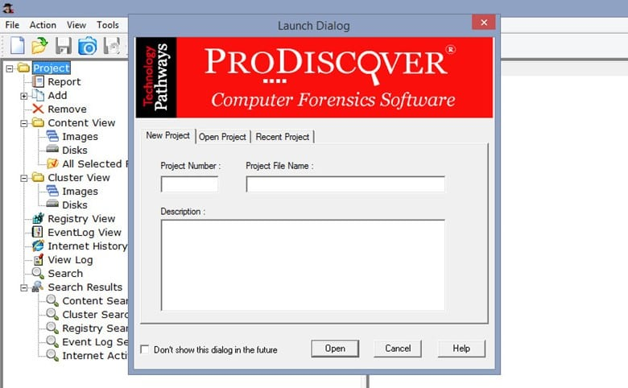

Volatility Framework:
The Volatility Framework was released publicly at the BlackHat and based on years of published academic research into advanced memory analysis and forensics. Volatility framework introduced people to the power of analyzing the runtime state of a system using the data found in volatile storage (RAM). It also provided a cross-platform, modular, and extensible platform to encourage further work in this exciting area of research.
Volatility also provides a unique platform that enables cutting-edge research to be immediately transitioned into the hands of digital investigators. It has become an indispensable digital investigation tool relied upon by law enforcement, military, academia, and commercial investigators throughout the world.

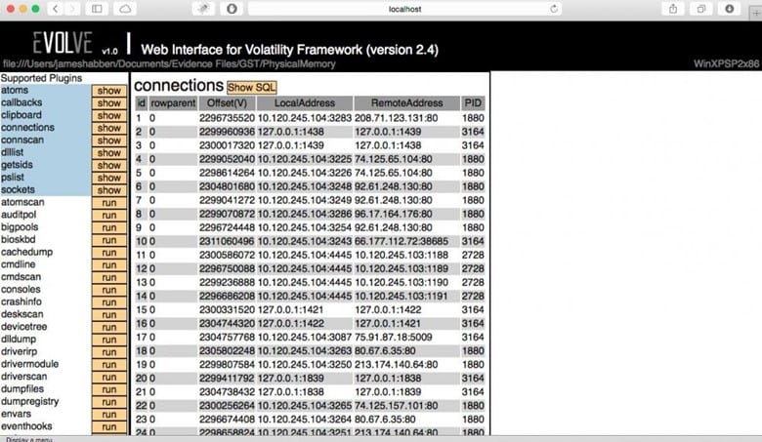

The Sleuth Kit is a collection of command line tools that allows us to analyze disk images and recover files from them. It is used behind the scenes in Autopsy and many other open source and commercial forensics tools.
The core functionality of The Sleuth Kit (TSK) allows you to analyze volume and file system data. The plug-in framework allows you to incorporate additional modules to analyze file contents and build automated systems.
An Autopsy is easy to use, a GUI-based program that allows us to analyze hard drives and smartphones efficiently. It has a plug-in architecture that helps us to find add-on modules or develop custom modules in Java or Python.Below is the list of Autopsy features:

- Multi-User Cases: Collaborate with fellow examiners on larger cases.
- Timeline Analysis: Displays system events in a graphical interface to help identify activity.
- Keyword Search: Text extraction and index searched modules enable you to find files that mention specific terms and find regular expression patterns.
- Web Artifacts: Extracts web activity from common browsers to help identify user activity.
- Registry Analysis: Uses RegRipper to identify recently accessed documents and USB devices.
- LNK File Analysis: Identifies shortcuts and accessed documents
- Email Analysis: Parses MBOX format messages, such as Thunderbird.
- EXIF: Extracts geolocation and camera information from JPEG files.
- File Type Sorting: Group files by their type to find all images or documents.
- Media Playback: View videos and images in the application and not require an external viewer.
- Thumbnail Viewer: Displays thumbnail of images to help quick view pictures.

CAINE
CAINE (Computer Aided Investigative Environment) is a Linux Live CD that contains a wealth of digital forensic tools. The latest version of Caine is based on the Ubuntu Linux LTS, MATE, and LightDM. Compared to its original version, the current version has been modified to meet the standard forensic reliability and safety standards.
Caine includes:

- Caine Interface – a user-friendly interface that brings together some well-known forensic tools, many of which are open source.
- Updated and optimized environment to conduct a forensic analysis.
- Semi-automatic report generator.

Features include a user-friendly GUI, semi-automated report creation and tools for Mobile Forensics, Network Forensics, Data Recovery and more.
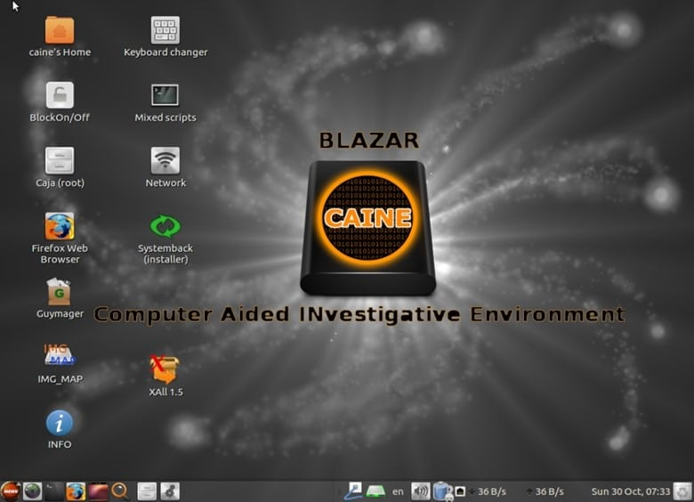

Ethical Hacking Boot Camp — 93% Exam Pass Rate

Xplico
Xplico is a network forensics analysis tool, which is software that reconstructs the contents of acquisitions performed with a packet sniffer (e.g. Wireshark, tcpdump, Netsniff-ng). Xplico is able to extract and reconstruct all the Web pages and contents (images, files, cookies, and so on).
Features of Xplico include:
- Protocols supported: HTTP, SIP, IMAP, POP, SMTP, TCP, UDP, IPv4, IPv6.
- Port Independent Protocol Identification (PIPI) for each application protocol;
- Multithreading;
- Output data and information in SQLite database or Mysql database and/or files;
- At each data reassembled by Xplico is associated an XML file that uniquely identifies the flows and the pcap containing the data reassembled;
- No size limit on data entry or the number of files entrance (the only limit is HD size);
Xplico is installed by default in the major distributions of digital forensics and penetration testing:
- Kali Linux
- BackTrack
- DEFT
- Security Onion
- Matriux
- BackBox
- CERT Linux Forensics Tools Repository

X-Ways Forensics
X-Ways Forensics is an advanced work environment for computer forensic examiners. X-Ways Forensics is efficient to use, not a resource-hungry, often runs faster, finds deleted files and offers many features that the others lack. X-Ways Forensics is fully portable, runs off a USB stick on any given Windows system without installation.
Key features of X-ray forensic include:
- Disk cloning and imaging
- Ability to read partitioning and file system structures inside raw (.dd) image files, ISO, VHD and VMDK images
- Complete access to disks, RAIDs, and images more than 2 TB in size
- Automatic identification of lost/deleted partitions
- Viewing and editing binary data structures using templates
- Recursive view of all existing and deleted files in all subdirectories

Computer Forensic Laboratories
Every good computer forensic scientist or investigator needs a place to do their work. In the ideal location to conduct an investigation, you have absolute control of security, tools, and even the physical environment.
Ideally, we’re describing your computer forensic laboratory! As in any field of science, computer forensics requires its own set of laboratory tools to get the job done.
Computer forensic data server
Any computer forensic investigative unit of any size rapidly runs into the problem of where to store cases that are in progress or that need to be archived for possible later use. A centralized data storage solution is the best and most secure solution.
A forensic data server allows you to keep forensic images in a centralized, secure, and organized manner that lets you focus more on analyzing cases than on looking for them. A server needs to have large data capacity, the ability to authenticate users for security purposes, with the capacity to perform backups of all data in case the storage devices fail.
You can find commercial-grade servers at any of the larger computer vendors, such as Dell and HP, and at forensic companies, such as Digital Intelligence.
Forensic write blockers
One basic piece of equipment that a computer forensic laboratory needs is the simple but effective write blocker. Although most software tools have built-in software write blockers, you also need an assortment of physical write blockers to cover as many situations or devices as possible.
A write blocker is used to keep an operating system from making any changes to the original or suspect media to keep from erasing or damaging potential evidence.
Software write blockers work at the operating system level and are specific to the operating system. In other words, a software write blocker works on only the operating system in which it is installed.
A physical write blocker works at the hardware level and can work with any operating system because, at the physical level, the write blocker is intercepting (or, in many cases, blocking) electrical signals to the storage device and has no concern about which operating system is in place.
The technology used by computers to read and write to storage devices is well understood and fairly straightforward — you can find dozens of manufacturers of write-protect devices.
For reliability and support, stick with these name brands in the industry:
- Digital Intelligence: The UltraKit write-block product (see www.digitalintelligence.com) follows the everything-but-the-kitchen-sink model. All standard storage device formats, such as IDE, SCSI, SATA, and USB, are supported. In addition, the cables and power supplies are furnished, to make this kit one of the most complete in the industry.

- Paraben: Paraben has taken the idea of a Faraday box and added silverlined gloves to allow an investigator to work on a wireless device located inside the box.

- The Wireless Stronghold Box (see www.paraben.com) is a must-see for any computer forensic laboratory working with wireless devices. This box, a Faraday cage, isolates any enclosed wireless device, thus making it a wireless write blocker. For added protection, all connections leading into the box are filtered.

- Wiebetech : These write-protect devices run the spectrum from field kits to RAID systems. Wiebetech products (see www.wiebetch.com) are also sold by the major forensic software makers, which adds to their credibility.

MEDIA WIPING EQUIPMENT
Whether you complete one case per year or one case per day, you need to wipe the media you work with before you even start your case, to ensure that no cross contamination between your cases occurs.Forensic data wipers ensure that no data from a previous case is still present on the media. Most data wipers don’t erase existing data per se, but instead overwrite the data with either random binary strings or a repeating pattern of bits.
You need, in addition to this capability, a report when the device is finished to prove that you wiped the drive beforehand. In a lab environment, you usually should have a dedicated device just for wiping your media so that you don’t use up valuable forensic tool resources spent wiping drives rather than analyzing evidence.
All the major computer forensic software and hardware manufacturers carry data wiping equipment. Chances are good that, wherever you bought your computer forensic software, you can also purchase a dedicated data wiping unit.Just be wary of third-party data wiping tools that don’t have a way to verify the data wipe and don’t have a data wipe report function.
Recording equipment
Human perceptions being what they are, having an unbiased way to record events and objects is essential to computer forensic investigators. The choice of which device or devices you ultimately choose is based on your needs, but you must use some form of unbiased documentation method.Using video or audio equipment to record important aspects of a case is a useful way to permanently record an unbiased view of your case. Using a video camera, you can repeatedly visit a crime scene to look for that single clue you missed.
You can document your methods directly by recording your work or even record the output of a computer screen in a pinch.Recording your thoughts in a simple manner is often best accomplished by using a simple digital recorder that essentially acts as your personal note taker! You can find digital video cameras and audio recorders in any good retail electronics store, such as Best Buy or Radio Shack, and at Internet retailers.The basic models now available are more than enough to document all your case needs, as long as you carry extra batteries and data storage capacity.

Steganography

Steganography is a means of obscuring data where secret messages are hidden inside computer files such as images, sound files, videos and even executable files so that, no one except the sender and the receiver will suspect the existence of stealth information in it. Steganography may also involve the usage of cryptography where the message is first encrypted before it is concealed in another file. Generally, the messages appear to be something else such as an image, sound or video so that the transfer of secret data remains unsuspected.
The main advantage of steganography over other methods such as cryptography is that, it will not arose suspicion even if the files fall in the hands of a third party. Unlike cryptographic messages, stegnographic messages will no way attract the attention of a third party by themselves. Thus stegnanography has an upper hand over cryptography as it involves both encryption and obscurity.

What are the Applications of Steganography?

Steganography is mainly used to obscure confidential information/data during storage or transmission. For example, one can hide a secret message in an audio file and send this to another party via email instead of sending the message in the textual format. The receiver on the other end will decrypt the hidden message using the private decryption key. In a worst case scenario, even if a third party does manage to gain access to the email, all he can find is the audio file and not the hidden data inside it. Other usage of steganography include digital watermarking of images for reasons such as copyright protection.

Even though steganography has many useful applications, some may use this technique for illegitimate purposes such as hiding a pornographic content in other large files. Rumors about terrorists using steganography for hiding and communicating their secret information and instructions are also reported. An article claiming that, al-Queda had used steganography to encode messages in images and transported them via e-mails, was reported by New York Times, in October 2019.

How do Steganography Tools Work?
Stegnography tools implement intelligent algorithms to carefully embed the encrypted text messages or data inside other larger files such as an image, audio, video or an executable file. Some tools will embed the encrypted data at the end of another file so that there will be enough room for storing larger data.

There are many steganography tools available online but only a few are able to work flawlessly. I did not find any tool that worked perfectly on both small and large data. However, I have managed to develop my own tool that can work perfectly on all types of files and all size of data. The tool is called “Stego Magic“. You can download it from the following link.
Download StegoMagic.zip
The zip file contains two versions of Stego Magic: One for encrypting the text messages and the other for encrypting binary files. StegoMagic_TXT can be used to hide text messages in other files such as an image or a sound file. StegoMagic_BIN can be used to hide one binary file in another such as an executable file inside an image or an image inside a video file.
With Stego Magic, there is no limitation on the size and type of the file that you are intending to hide. For example, you can hide a video of size 1 GB in an image of size 1 MB or hide an executable file inside a WORD document. The tool is pretty straightforward to use and requires no special understanding of the concept.
At the end of the encryption process, a secret decryption key will be generated and the same is required during the decryption process.

How to Use Stego Magic?
Suppose you want to hide a text message inside a JPG file:

Place the JPG and the text file (.txt) in the same folder as that of StegoMagic_TXT.exe

- Run StegoMagic_TXT.exe and follow the screen instructions to embed the text message inside the JPG image.
- Please note that if you’re using Windows 7/Vista, right-click the file and select “Run as Administrator”. Otherwise the tool may fail to work properly.
- Note down the secret decryption key.
- Now you can send this image to your friend via email. To decrypt the hidden message, your friend should load this JPG file onto the Stego Magic tool and use the secret decryption key.
- I hope you’ve now understood what is steganography and how to use it to hide your secret data. For queries and feedback, please pass your comments.

7 Free Ways to Hide a File or Message Inside Another File
Apart from password protecting data with an archiver or an encryption tool like VeraCrypt, another effective way of securing your files is hiding them inside other files so nobody actually knows they exist. The practice of hiding data inside other data has amazingly been around for thousands of years and is called Steganography. With computer based steganography, you can hide messages, text files, archives and almost any type of data inside images, audio files, video files, and etc.
There are also varying levels of security for steganography on your computer. These range from simply appending one file to another to full on encryption, compression, and obfuscation. If you are sending files containing hidden data to others, the recipients would need to know how to retrieve it, such as knowing passwords and the software used. Here are 7 ways to perform steganography from your PC, all were tested on Windows 7 and 10 64-bit.
1. OpenPuff
OpenPuff is one of the few steganography tools that is relatively up to date. Many other tools work fine but were abandoned years ago. It’s also a more complicated and a far more advanced program than the others here. OpenPuff is probably the most powerful free steganography tool around, it also doesn’t need installing and is completely portable.

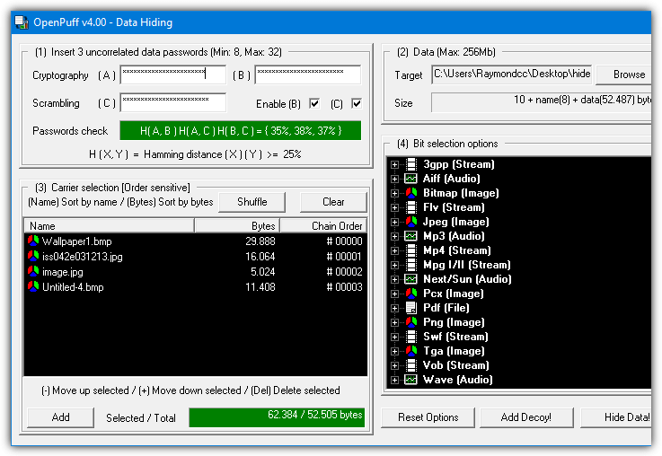

The steps to hide a file are numbered 1 – 4. By default, OpenPuff requires three separate passwords to encrypt the data. This can be reduced to two or a single password by unchecking the boxes. At step 2 browse for any type of file to hide and then at step 3 add a carrier file. Sixteen file formats are supported including MP4, MP3, MPEG2, PDF, FLV, VOB and common image and audio files.
You can also spread the hidden data file across several different carrier files, just add as many as you need (add more if the bar is red). For added security, a decoy file can even be used which will unhide the decoy instead of the real hidden data if someone actually knew how to unlock your file. The Step 4 Bit Select options are probably best left alone unless you read up on how they work.
To unhide the data file you have to supply all the passwords and put the carrier files in the correct order. OpenPuff also includes a marking feature which is useful for digitally watermarking or copyrighting your own files.

2. Our Secret
Our Secret has been discontinued and the website is now gone. However, the program itself still works fine in the latest Windows. Use the portable standalone executable link provided below as the official installer elsewhere on the internet no longer works. The last version of Our Secret was 2.5 from 2012.Hiding files in Our Secret is set out in three distinct steps. Firstly, browse for the file to carry the hidden data. The good thing is this can be any type of file you like, but obviously, small or text based files are not going to work too well. At the next step, pressing Add will give the option of entering plain text or browsing for a file to hide, a mixture and multiple entries can be included. Enter a password and finally press the Hide button.

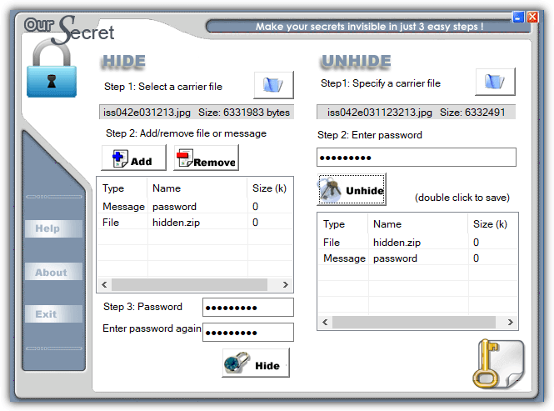
Unhiding data is done from the main window and is simply a reversal of hiding. Specify the carrier file, enter the optional password and any hidden files or text will appear in the box. Double click the entry to save the file or view the text and then optionally save as a text file.

3. SilentEye
While SilentEye looks very easy to use when you first launch it, things get more advanced during the process of embedding the data in the carrier file. It’s not too difficult though and the average user can leave most settings they don’t understand at the defaults. The number of formats that can carry the hidden data is limited to JPG, PNG, BMP, TIFF and WAV but that should be enough for hiding small files and plain text messages.Simply drop a supported media file onto the main window and press Encode. The upper half of the encode window differs depending on whether you are using an image or audio file. The media options can be left alone if you are unsure what they do, just change the destination folder. Type a short message into the box or add any type of file by pressing the large button. Optional AES encryption is enabled by checking the box at the bottom and entering the password twice.

Drop the media file onto the window and press Decode if you want to retrieve the hidden data. Make sure to use the same options and password (if used) or the hidden data will not be extracted.

4. Clotho
Unfortunately, Clotho is another program that is no longer supported or updated. Like OurSecret, the last version is from 2012 but it does work fine when used in the latest Windows. To install this program make sure that you right click and run the setup installer as administrator. Alternatively, unpack the installer with 7Zip or Universal Extractor as only the Cloth.exe is required.
What makes Clotho interesting is you can select a complete folder full of files to hide in one go. Obviously, the carrier file has to be large enough to effectively hide a folder’s worth of data. The interface is self-explanatory, select the file to use as the mask (carrier), select the file or folder to hide, choose a save as name and optional parameters and press Pack. Most common types of file can be used as a carrier, including image, audio, video, archive and executable.
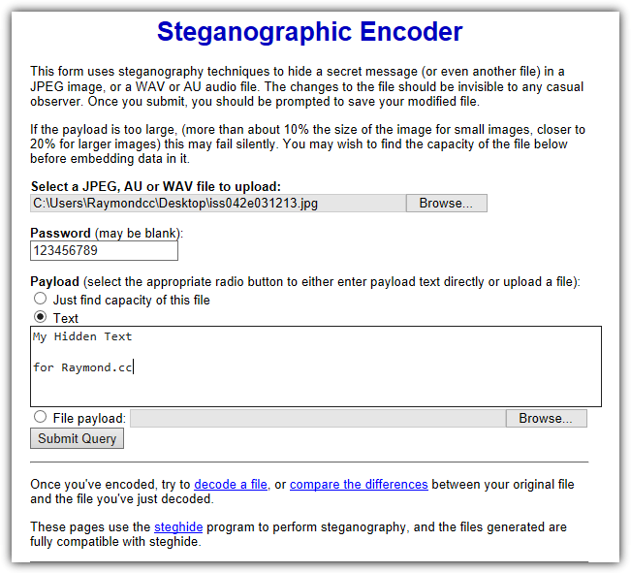
The options include adding a password and/or encryption, compressing the output file, performing extra obfuscation methods and making the hidden file(s) extractable with WinRAR. None of those options are enabled by default. A useful unpack option is cleaning the source file of hidden data so it is restored back to a normal file.

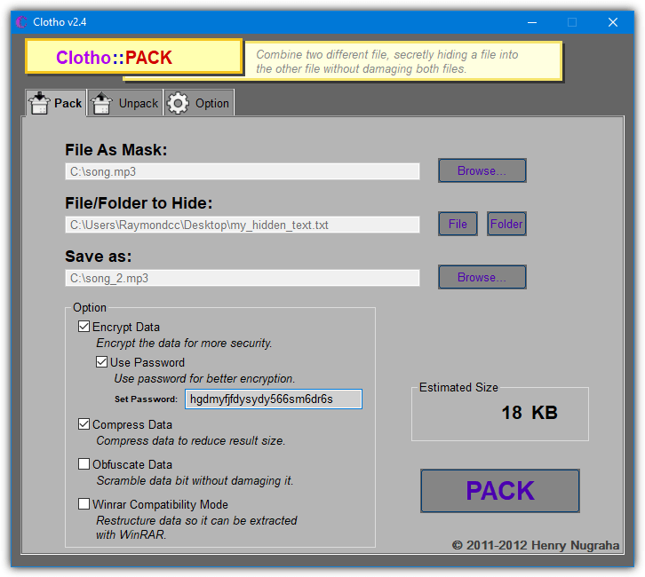
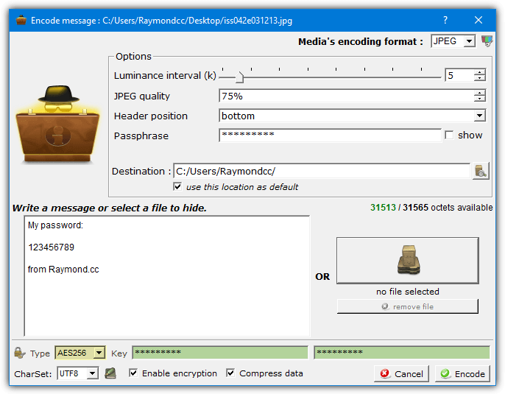

5. Steganography Tools (Online)

While the decoding process on the “Decode an image” page is mostly straightforward, it’s not too smart in knowing exactly what you encoded in the first place. If it was plain text, it’s easy. If it was something else like an archive you may have to rename the file correctly once downloaded. The Compare two images page shows before and after images side by side showing you roughly where on the image the hidden data is situated.

6. Steghide UI 3
Steghide UI is a user interface frontend for the same Steghide command line tool used on the webpage above. The Steghide tool itself hasn’t been updated since 2003 but this open source frontend program dates to 2011. Both work fine on the latest versions of Windows. Two image formats (JPG, BMP) and two audio formats (WAV, AU) are supported
The whole process is quite simple, browse for the Cover file (media file to hide the data in), browse for the embed file (the file to hide), choose an output location and filename. There are several password encryption types available although Rijndael 128/192/256 should be fine (commonly known as AES encryption). Optionally add a compression level of 1 – 9 to compress the embed file and finally press the Embed button.
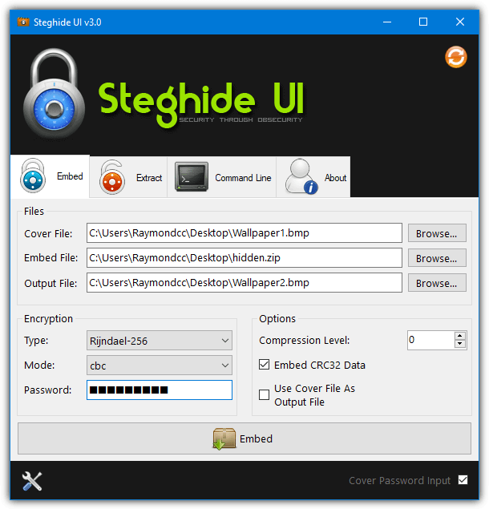

Extracting the hidden data is very simple. Supply the media filename, the output filename and a password if the data was hidden using one. There is also a command line tab if you know how to use Steghide commands manually. The Options window can add a context menu entry into Explorer, set the default encryption type, compression level, and output folder.

7. Using Built-in Windows Commands
It’s possible to perform simple steganography by using nothing more than the included tools found in Windows. While it’s not the most secure method, the process works and no third party software is needed. Hiding data inside files this way is done through the Command prompt using the Windows Copy command.In addition to transfers, Copy can also join files together, which is how this process works. The hidden file is not encrypted or compressed by Copy, so you should archive the file to ZIP, 7ZIP or RAR first using a password. Then add that as the hidden file to the carrier file. The command syntax is as follows:
Copy Carrierfile /b + Hiddenfile /b Outputfile
The /b argument tells Copy it is dealing with binary files. As an example, to attach Hidden.zip to Song.mp3 and save a file called Hiddeninsong.mp3, you would use:
Copy Song.mp3 /b + Hidden.zip /b Hiddeninsong.mp3

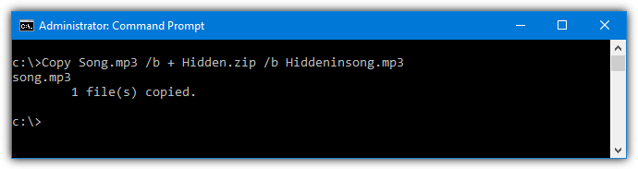
The output file is playable in a music player like Windows Media Player, but the hidden file will also open in an archiver such as 7-Zip or WinRAR if you know the password.
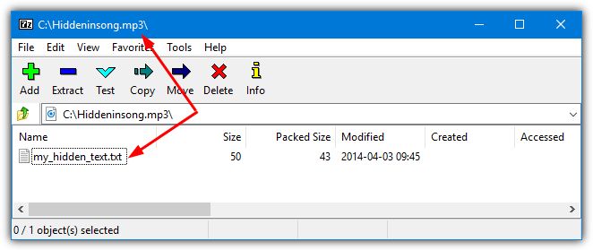

How to Hack WhatsApp Account
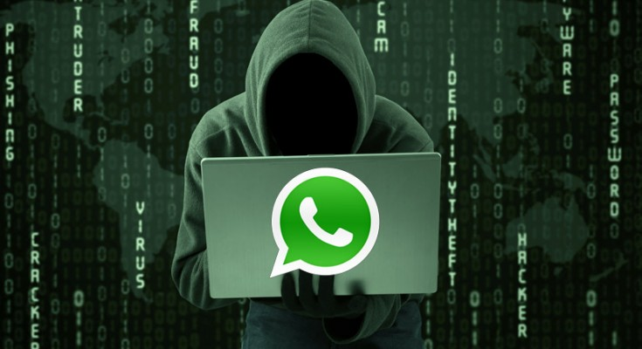
How to hack WhatsApp in simple steps. Since WhatsApp has become one of the popular app to share messages and media instantly, it has also become a favorite place for many to engage in illicit activities. Therefore, in order to investigate the truth people are left with no choice other than to hack WhatsApp account.

1. WhatsApp Hack using a Spying App: The Easiest Way
Even though there are several ways to hack WhatsApp, using a spy app is by far the most simple and easiest way. This method requires no prior hacking knowledge or technical skills to carry out and hence more suitable for common people. Installing a spy app to hack WhatsApp is as simple as installing any other app on mobile. Out of several apps out there, mSpy Premium is one of my favorite one to hack WhatsApp:




How to Hack WhatsApp with this App?
- Install the spy app on the target WhatsApp phone which takes a few minutes to complete.
- After this is done, the app silently records all WhatsApp conversation in hidden mode.
- All the WhatsApp chat records are sent to your online account.
- View all the information from anywhere at anytime with your online account.

mSpy Premium Features:

- Runs in Hidden Mode and remains Undetected on the target phone!
- Hack phone Calls and Text Messages.
- Hack WhatsApp, Skype and other popular messengers.
- Track Real-Time Location with GPS Tracker.
- Spy on Contact List and Web Browsing activities.
- Monitor Emails, Pictures and Videos.
- No Rooting Required!

2. How to Read Someone’s Whatsapp Messages from your phone
Still thinking how you can read, download and send messages, pictures, videos even documents on someone else whatsapp account on your phone? think no more as i am about to show the easiest way to be able read someone’s whatsapp chats.
To be able to read someone’s whatsapp messages on your mobile just follow this 2 easy steps:
Step 1: Install and Setup Whatscan for whatsweb
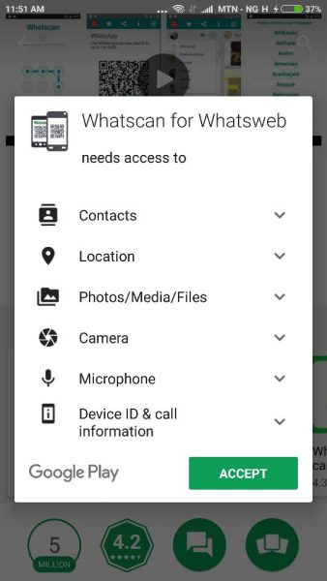
- You will need to download and install Whatscan app on your device, it is available for both Android and IOS.
  - Android Version
  - IOS Version
- Open the app on your phone and select your language, that’s all.

Step 2: Scan QR code on Whatscan with your victims whatsapp
- This is the part where you will have to get hold of your victims phone physically to scan the QR code generated by the app. So get your victims phone open their whatsapp and use it to scan the QR code on the whatscan app on your phone.
  - Android: Open Whatsapp > Menu > WhatsApp Web
  - iPhone:Open WhatsApp > Settings > WhatsApp Web
  - Windows Phone: Open WhatsApp > Menu > WhatsApp Web
- After scanning the QR Code, Whatscan will now display your victims whatsapp, you can now do all you want on your phone with your victims WhatsApp account like:
  - Read messages
  - Send messages
  - Change profile picture
  - Change Profile status
  - Send voice note
  - Download galleries, files etc to your phone and lots more.
You can choose to secure your Whatscan app using a password.
Now you can see how easy it is to read someone’s whatsapp chat on your phone, share with friends!
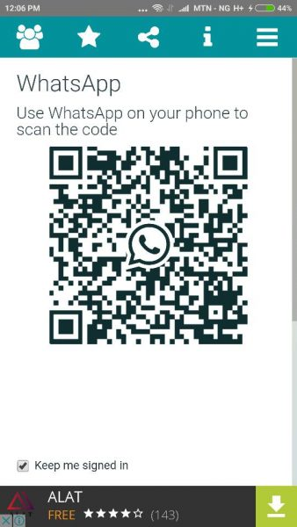

Hack Friend's WhatsApp with these Simple Tricks You just need the WhatsApp number you want to hack and spy on and you are there! Here's how any and every iOS and Android smartphone users can try these free and online tricks to hack any WhatsApp account in less than 5 min. WhatsApp group admins can restrict members from sending messages.

STEP 1:

Go to your phone's app store and download WhatsApp Sniffer & Spy Tool 2016 How to Check Someone's WhatsApp Messages Without Touching their Phone

STEP 2:

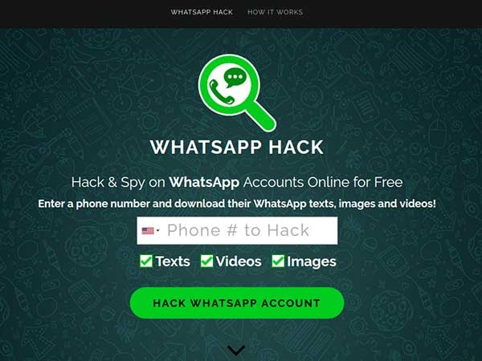
Open the app, enter the person's number, whose account you wish to hack

STEP 3:

Wait for 2-3 min for the hacking to be processed and then click on 'Verify option'

STEP 4:

Now you can get access to your friend's messages, images, videos, or any other information that he has stored over the last 30 days instantly. WhatsApp to update its privacy policy prior Payments launch in India Get ready for some interesting and exciting read!



Prevent Your Phone From Hacking | Android Secret Codes

Today I share with you some codes to check and prevent your android device from hacking: Data the most important factor of everyone life. No one does want that his/her personal data are gone in wrong hand. In today world, where the technology is become more and more advanced. Where it’s latest cracks and vulnerabilities are also introduced daily. We also download many applications in our Android phones. Some are from authentic sources and some are from unauthentic sources, where the risk of malwares and breach of personal data are become 90%. Because the attackers attached the malicious files with pirated softwares and when the user download it. The attackers make control on their victim device and transfer all personal data to their devices.

