# Tersh

An Online Marketplace for Tertiary Students.

A flutter Application.

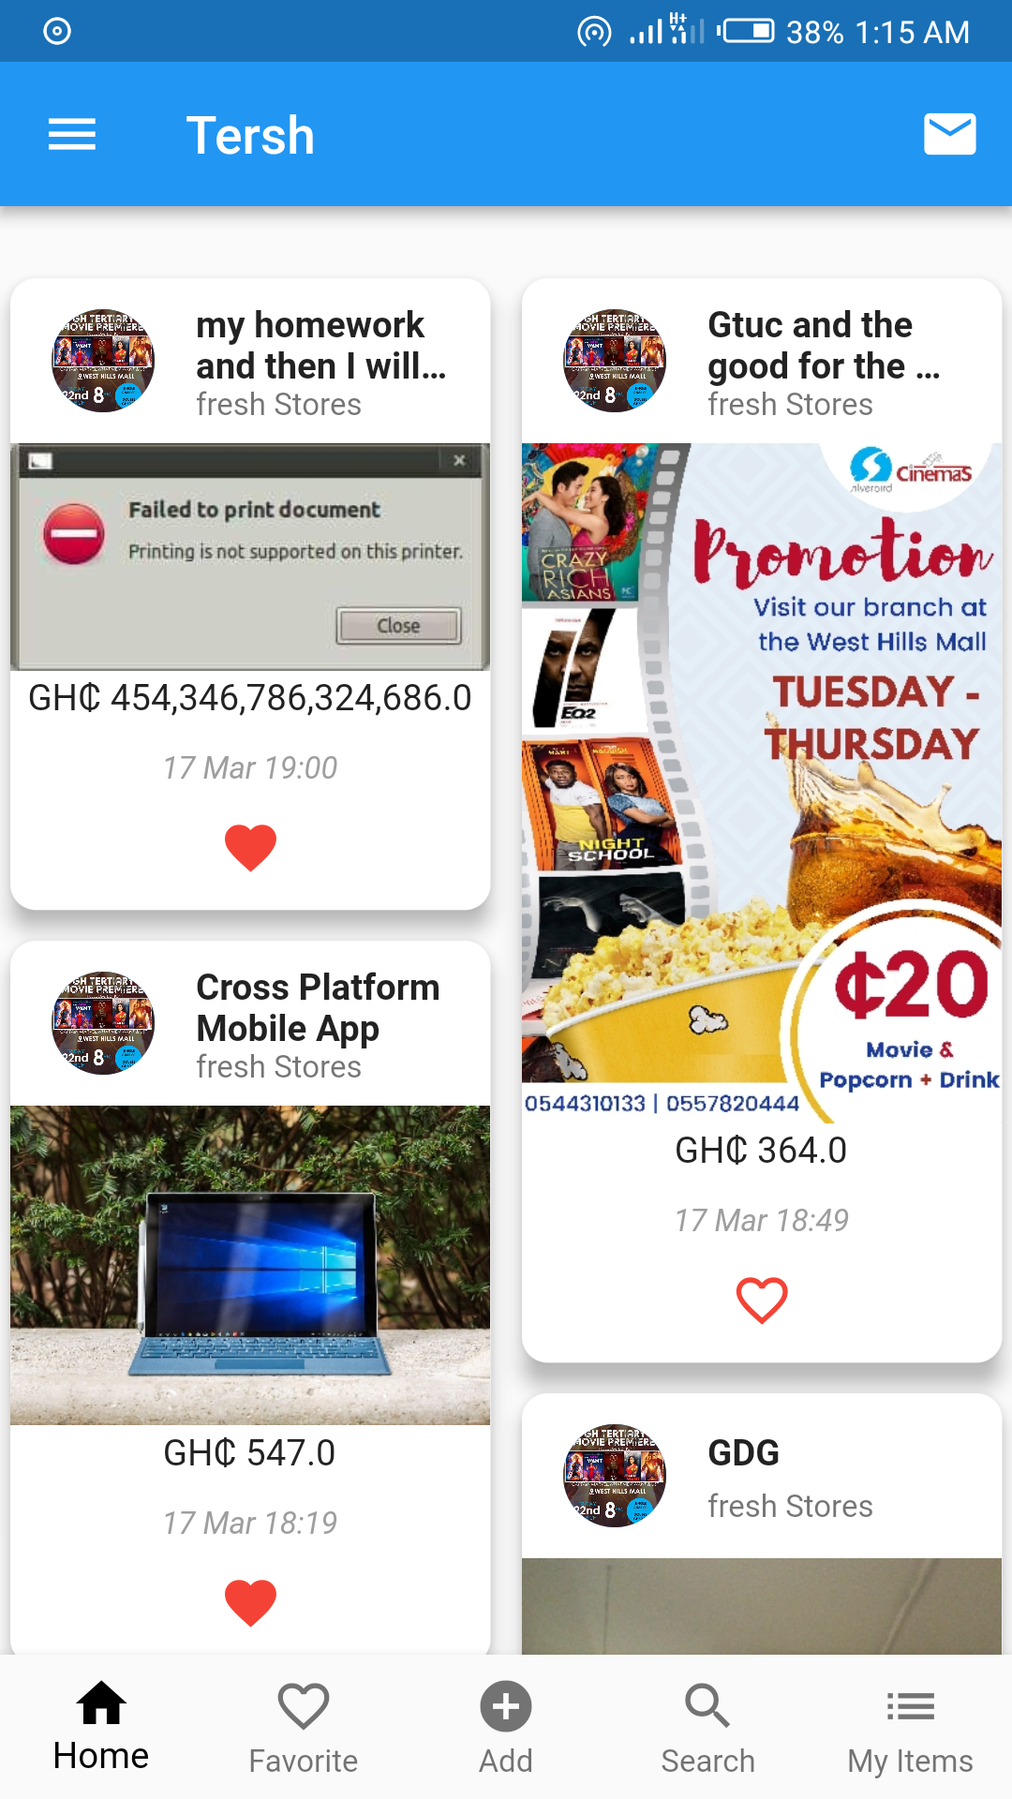

## Getting Started

This project is a starting point for a Flutter application.

A few resources to get you started if this is your first Flutter project:

- [Lab: Write your first Flutter app](https://flutter.io/docs/get-started/codelab)

- [Cookbook: Useful Flutter samples](https://flutter.io/docs/cookbook)

For help getting started with Flutter, view our

[online documentation](https://flutter.io/docs), which offers tutorials,

samples, guidance on mobile development, and a full API reference.