Software paper for submission to MEDSCI 736 University of Auckland

To complete this template, please replace the blue text with your own. The paper has three main sections: (1) Overview; (2) Availability; (3) Reuse potential.

Please submit the completed paper to: f.kubke@auckland.ac.nz

(1) Overview

Title
Decision tree classifier: Cell type identification by cell characteristics.

Paper Authors
1. Ahmed Adam

Paper Author Roles and Affiliations
1. Ahmed Adam: Software developer, School of Medical Sciences, University of Auckland.

Abstract
Classification by feature can one many important aspects in the field of biology. Using Python language, the current software utilises machine learning algorithm (Decision tree classifier) to identify and predict the cell type based
on previously learned cell characteristics from a given data set. The software allows the user to input the file name (excel spreadsheet) and the range of cell characteristics to be tested. The software hence predicts, classifies and return
the cell type and prediction accuracy. This allows biologists to easily distinguish different types of cells based on intrinsic cell properties. The software is licensed under the MIT License and the source code is freely available for use and modification at: https://github.com/UOA-MEDSCI-736/Adamthe1st-green-cortex

Keywords
Python, Machine learning, Multi-class classification, Decision Tree Classifier.

Introduction

An overview of the software, how it was produced, and the research for which it has been used, including references to relevant research articles. A short comparison with software which implements similar functionality should be included in this section. Please refer to http://openresearchsoftware.metajnl.com/articles/ for exemplars.

Implementation and architecture
The current classification software was implemented using Python version 3.5.2 in a Linux platform. Python was chosen because it is supported by many free open source libraries as well as for its wide use among the scientific community. The software is command line operated. When the programme is opened, the user has to upload their dataset by inputting the name of the dataset and the cell range from desired. The software can alternatively read the entire dataset by inputting “all” instead of cell range. In order to get a prediction of cell type, the user needs to first specify both the training and testing values. perform the following:
1. Train the classifier: this is done by specifying both the raining

this is done by providing the range of cells (holding feature values) from the software needs to learn in order to predict
train_ds:
train_tgt: this stands for training target (i.e. cell type)
2. test the first by giving the range of characteristics from the dataset, while leaving out some characteristics for the testing and prediction stage. software uses the following:

user then needs to identify

How the software was implemented, with details of the architecture where relevant. Use of relevant diagrams is appropriate. Please also describe any variants and associated implementation differences.

Quality control

Quality control of the software was conducted using the The Test-driven Development (DDT) process (Fig.1).
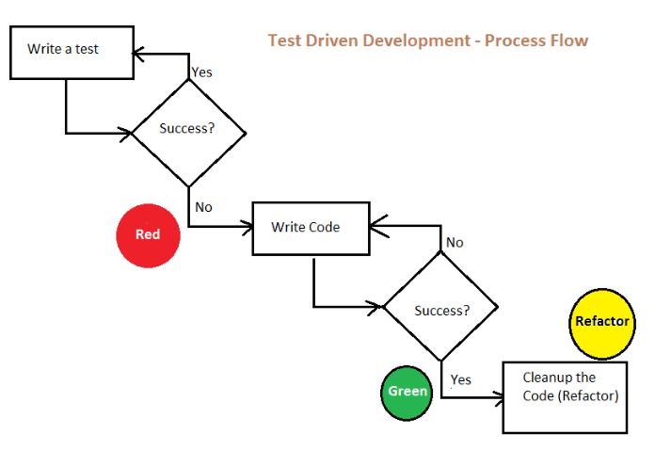

Fig.1.Test-driven Development flow process. Attribution: Fascinating World of Agile by Amit Kulkarni. Licensed under GPLv2.

Functional testing was conducted by manually creating a collection of metadata, used as a test bench for validation.

The DDT is an iterative flow process in which both the software development and testing run in parallel to ensure functionality of the software. It enables the development of simple working code which at the same time, has the flexibility to adapt to possible changes in requirements. Functional testing was conducted by manually generating a collection of metadata, used as a test bench for validation. Further validation of functions was carried out using pytest version 2.9.2 to assess both success and stress test case scenarios. A successful test case scenario is when a function returns a value based on a valid input (argument) and hence resulting in a ‘passed’ pytest. Stress test case scenarios on the other hand occur when an invalid argument is passed to the function (e.g. passing a string instead of list as parameter), in which case the function would normally returns an error and the pytest fails. Under such circumstances, the function is modified to handle the stress by returning a value (e.g None) and the pytest passes.
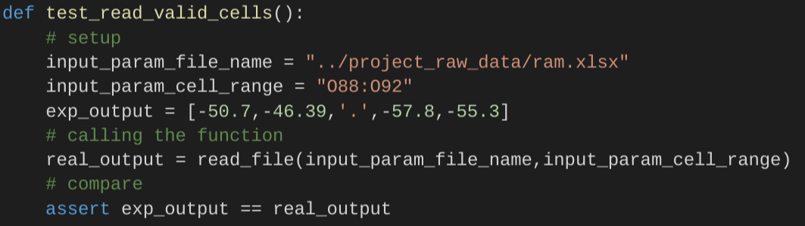
Example of a successful test case:

In this example, the function tested is called ‘read_file’ and the test for it is called ‘test_read_valid_cells():’ which takes in two
parameters:‘input_param_file_name’ and input_param_cell_range’. At the set up stage, the file name/path is specified and the cell range is given. The expected output is a variable which contains a list of the actual cell values of the cell range “088:092” (manually extracted from ram.xlsx). The variable ‘real_output’ contains the function ‘read_file’ along with its two parameters. The final step includes the assertion that the expected output is equivalent to the real output (i.e. the function would return the expected output).

Example of stress test scenario:
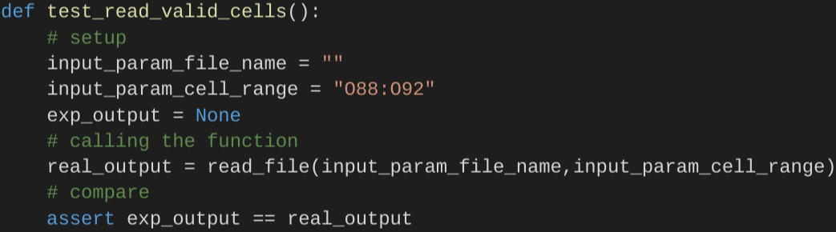
This example illustrates a stress case scenario where ‘the input_param_file_name’ was left empty leading to an error message. The function was hence modified to handle this situation by returning a value of ‘None’ and the pytest then passes.

Example of successful (passed) pytest:
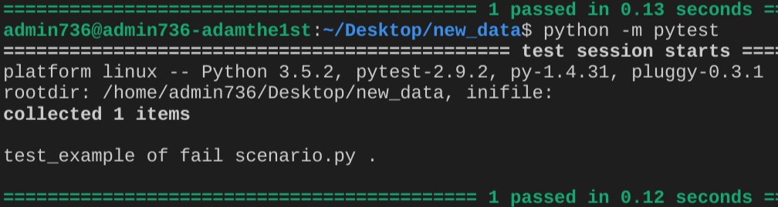

Running of the pytests was done by typing ‘~$ python -m pytest’ in the directory which contains the ‘test_example.py’ file. Functional testing can be verified by end users by downloading ‘basic_functions.py, test_read_data.py, ML.py and ram.xlsx files and running pytest as mentioned previously. All the necessary files to run the code, as well as examples of running the software can be found in the following address:
https://github.com/UOA-MEDSCI-736/Adamthe1st-green-cortex

(2) Availability

Operating system
ubuntu 16.04 LTS | 64-bit, macOS Sierra 10.12, Windows 10.

Programming language
python 3.5.2

Additional system requirements
None

Dependencies
Anaconda 4.1.1, Open source libraries: Openpyxl, Scikit-learn and Numpy.

List of contributors
Dr Fabiana Kubke: staff, Faculy of Science, University of Auckland – f.kubke@auckland.ac.nz
Jerome Plumat: staff, Faculy of Science, University of Auckland – j.plumat@auckland.ac.nz
Manish Kukreja: staff, faculy of computer science, University of Auckland – mkuk073@aucklanduni.ac.nz

Software location:
Archive
Name: The name of the archive
Persistent identifier: e.g. DOI, handle, PURL, etc.
Licence: MIT
Publisher: Ahmed Adam
Version published: The version number of the software archived
Date published: dd/mm/yy
Code repository
Name: UOA-MEDSCI-736/Adamthe1st-green-cortex
Identifier: https://github.com/UOA-MEDSCI-736/Adamthe1st-green-cortex.
Licence: MIT
Date published: 27/10/2016

Language
English

(3) Reuse potential

The software has a high capacity for potential reuse since it is scripted in python, a widely used and highly compatible programming language. The software also comes with elaborated documentations to allow end users to follow through running the software and understanding its code. Initial knowledge of command line is assumed to run the software however not mandatory if the user follows through the documentation of the software. At the current stage, the software is able to read data from any given excel spreadsheet. End user should specify the following in order for the software to run:
1. specify the excel file name and cell range wanted.
2. specify training values.
3. specify test values.
4. Run the classifier to obtain prediction accuracy.

The code is licensed under the MIT License and hence can be freely obtained, modified or distributed. Although the software may has the potential to serve those within the medical science field, the software can also be implemented in other areas where classification of type by features maybe used.

The software is available at: https://github.com/UOA-MEDSCI-736/Adamthe1st-green-cortex . Technical issues and/or suggestions are welcomed and can be made via the GitHub issue tracker. Additionally, contributions can be made by forking and submitting a pull request to the software.

Acknowledgements
I would like to thank the course coordinator and the rest of the staff and class members for their help and support. Special gratitude for Manish Kukreja for his coding guidance and continuous support.

Funding statement
Vice Chancellors Strategic Development Fund 2015, University of Auckland.

Competing interests
The authors declare that they they have no competing interests.

References
Please enter references in the Harvard style and include a DOI where available, citing them in the text with a number in square brackets, e.g.

[1] Piwowar, H A 2011 Who Shares? Who Doesn't? Factors Associated with Openly Archiving Raw Research Data. PLoS ONE 6(7): e18657. DOI: http://dx.doi.org/10.1371/journal.pone.0018657.

Copyright Notice
Authors who publish with this journal agree to the following terms:

Authors retain copyright with the work simultaneously licensed under a Creative Commons Attribution License that allows others to share the work with an acknowledgement of the work's authorship and initial publication in this journal.

Authors are able to enter into separate, additional contractual arrangements for the non-exclusive distribution of the journal's published version of the work (e.g., post it to an institutional repository or publish it in a book), with an acknowledgement of its initial publication in this journal.

By submitting this paper you agree to the terms of this Copyright Notice, which will apply to this submission if and when it is published by this journal.

