Report: Analysis of Web-based Systems – Project 2

Authors:
- Adam Ćwikliński, No. 273055
- Jakub Kamiński, No. 273107

Introduction and Project Objective
The aim of this project is to analyze user behavior and the purchasing process for the Google Merchandise Store (https://shop.merch.google/) using a Google Analytics demo account. The analysis focuses on understanding customer acquisition, engagement, and the final conversion path.

Analysis Methodology
The data used for this report covers the following periods:
a) Full Day Analysis: [17.04.2026 r.].
b) Hourly Analysis: [4:00 PM - 5:00 PM UTC].

a) Full Day Analysis: [17.04.2026 r.].

Customer Acquisition Analysis

Detailed Geographic Revenue & Engagement Analysis
This analysis identifies the primary geographic markets and their efficiency in progressing through the final checkout stages.
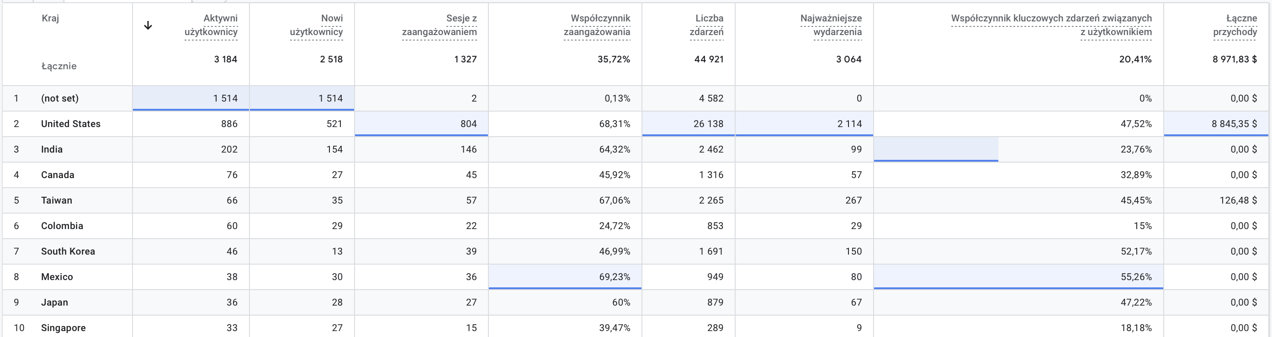
Key Observations:
- Market Leadership: The United States is the absolute leader in revenue, generating $8,845.35, which constitutes over 98.5% of the total revenue recorded in this view.
- Active User Base: While the total number of active users is 3,184, nearly half (1,514) are categorized as (not set), indicating users whose location could not be identified.
- High-Quality Engagement: Users from the United States exhibit a high engagement rate of 68.31% and a significant key event rate of 47.52%.
- Emerging Revenue: Taiwan is the only other identified market with recorded revenue, contributing $126.48 despite having a relatively small base of 66 active users.
- Global Traffic vs. Sales: Countries like India (202 users) and Canada (76 users) show active engagement with the store (over 45% engagement rate) but did not complete any transactions during this specific period.
- Interaction Intensity: The United States generated the vast majority of site interactions with 26,138 events and 2,114 key events.

Technology Performance Analysis
This section evaluates the effectiveness of different device categories—Mobile, Desktop, and Tablet—based on user engagement and revenue generation.
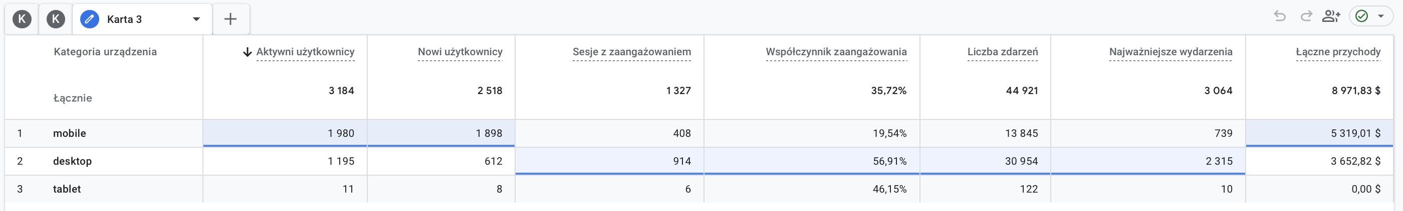
Key Observations:
- Traffic Volume: Mobile is the leading device category in terms of reach, attracting 1,980 active users and 1,898 new users.
- Engagement Quality: Desktop users demonstrate significantly higher engagement quality, with a 56.91% engagement rate compared to only 19.54% for mobile users.
- Revenue Distribution: Despite having lower traffic volume, Mobile devices generated the highest total revenue of $5,319.01, while Desktop contributed $3,652.82.
- Conversion Power: Desktop users were more active in completing key actions, generating 2,315 key events from 30,954 total events, whereas mobile users generated 739 key events from 13,845 total events.
- Tablet Performance: Tablets represent a minor segment with only 11 active users and $0.00 revenue, though they maintain a respectable engagement rate of 46.15%.

Browsers: Analysis of the most popular Browsers used by customers.
This section examines the distribution of traffic and revenue across different web browsers used by customers. The data highlights technical preferences and reveals which platforms contribute most effectively to the store's financial performance.
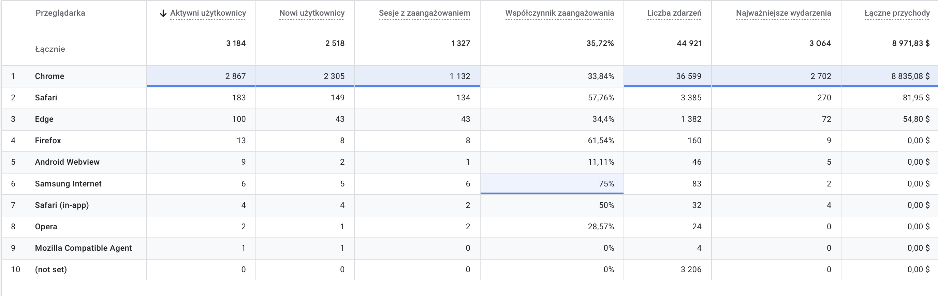
Key Observations:
- Browser Dominance: Chrome is the primary browser, accounting for 88.4% of active users (2,867) and 98.5% of total revenue ($8,835.08).
- Revenue Leaders: Only three browsers generated revenue: Chrome ($8,835.08), Safari ($81.95), and Edge ($54.80).
- Engagement Quality: Although Samsung Internet has very few users (6), it shows the highest engagement rate at 75%, followed by Firefox at 61.54%.
- Volume vs. Conversion: Browsers like Firefox and Opera show zero revenue despite recorded active sessions, indicating a focus on desktop Chrome for actual purchasing power.

Operating Systems
This section evaluates the performance of the Google Merchandise Store across various operating systems. The data identifies which platforms drive the highest user volume and which segments are most effective in terms of revenue and engagement.
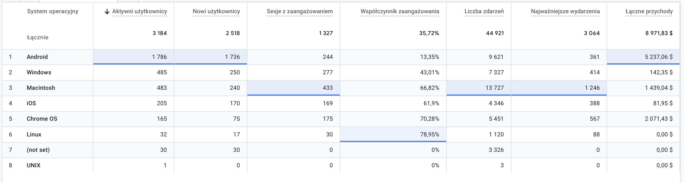

Key Observations:
- Top Traffic Source: Android is the most widely used system with 1,786 active users.
- Revenue Leader: Android also generated the highest revenue, contributing $5,237.06 (approx. 58% of total).
- High-Value Segments: Chrome OS ($2,071.43) and Macintosh ($1,439.04) represent significant high-value traffic despite having fewer users than Windows.
- Engagement Efficiency: Linux shows the highest engagement rate at 78.95%, but generated $0.00 in revenue.
- Active Events: Macintosh users were the most active per capita, generating 13,727 events and 1,246 key events despite having only 483 users.

Traffic Acquisition Analysis
This table presents the distribution of users across different traffic acquisition channels in the Google Merchandise Store.
The analysis evaluates how users entered the store and compares the effectiveness and engagement quality of different traffic sources.
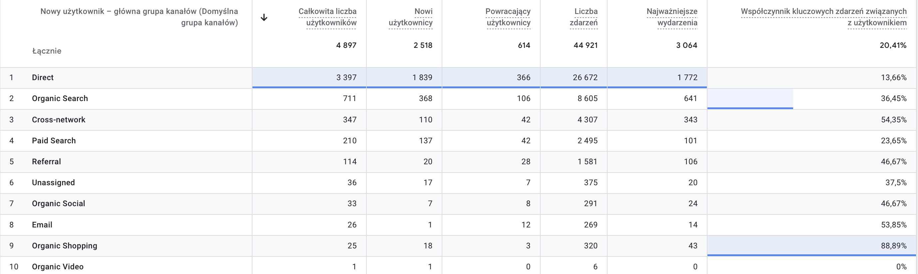
Key Observations:
- Direct traffic was the dominant acquisition channel, accounting for approximately 69% of all users (3,397 users).
However, despite the high traffic volume, the average engagement time was relatively low (38 seconds).
- Organic Search generated 711 users and demonstrated significantly better engagement quality, with an average engagement time of 1 minute 18 seconds.
- Cross-network traffic showed one of the strongest engagement performances, achieving an average engagement time of 2 minutes 1 second, despite contributing a smaller number of users.
- Paid Search accounted for only 4.29% of total users (210 users), but users arriving through advertisements showed relatively high engagement and purchase intent.
- Referral traffic achieved the highest average engagement time (2 minutes 44 seconds), suggesting that users coming from external websites were highly interested in the store content.
- The analysis also highlights the presence of returning users, which may indicate customer retention and repeated interaction with the ecommerce platform.

Customer Engagement Analysis & Site structure
Here is the technical analysis of the website content performance. This section covers the "Pages with the highest number of views" requirement.
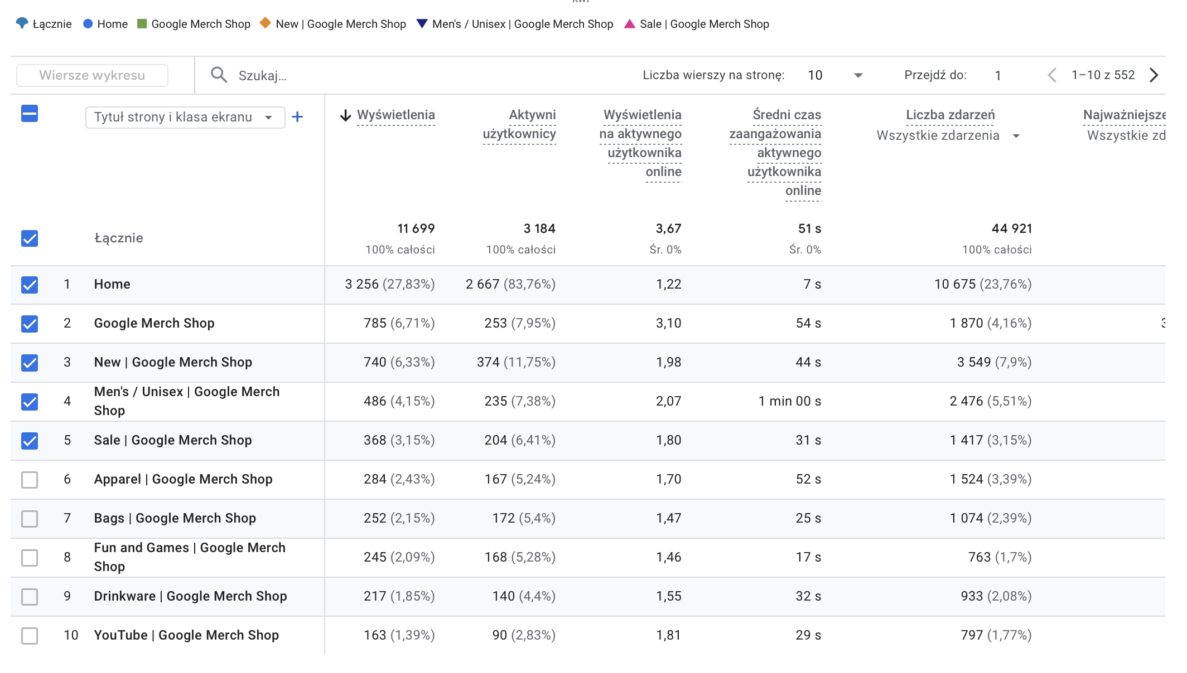Key Observations:
- Total Volume: The website recorded a total of 11,699 views and 44,921 events across all pages.
- Most Viewed Page: The Home page is the primary entry point, accounting for 3,256 views (27.83%) and the highest number of active users (2,667).
- Top Product Categories: The Google Merch Shop main landing page (785 views) and the "New" category (740 views) are the most popular sections after the homepage.
- Highest Engagement Time: The Men's / Unisex section shows the deepest engagement, with an average engagement time of 1 minute 00 seconds per user.
- Event Activity: The Home page also generated the most interactions, totaling 10,675 events (23.76% of total site activity).

User Path Exploration Analysis
This analysis tracks the specific steps users take upon entering the store to understand navigation patterns and interest levels.
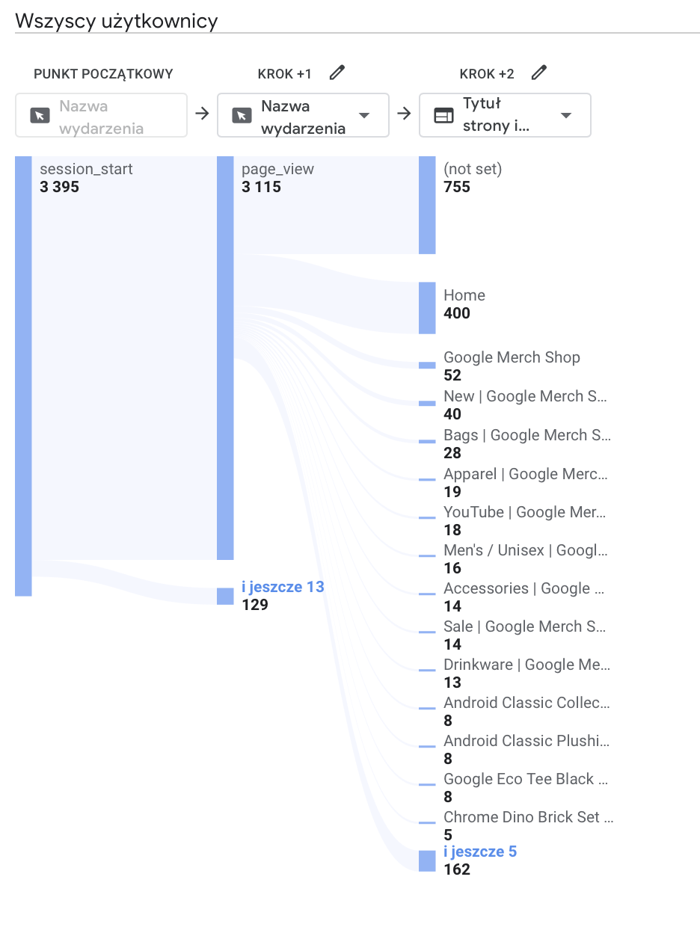
Key Observations:
- Starting Point: The analyzed journey begins with 3,395 session_start events.
- Step +1 (Immediate Engagement): A high retention rate is observed, with 3,115 users (over 91%) proceeding directly to a page_view.
- Step +2 (Navigation Hubs): The Home page acts as the primary secondary destination for identified users (400 views), while a significant segment remains in a (not set) state (755 views), indicating unlinked page titles or background events.
- Interest Diversification: Users branch out into various categories, with the Google Merch Shop landing page (52) and the New category (40) being the most popular specific destinations after the homepage.
- Drop-off Point: The visualization shows a steep decline in volume as users move deeper into specific product sub-categories, such as Drinkware (13) or specific sets (5), suggesting a wide but shallow browsing behavior.
Key Takeaway: While top-of-funnel engagement is strong, the conversion to the checkout phase is extremely low.

Active Users
This table presents the number of active users across the most visited pages in the Google Merchandise Store.
It also includes page views, event activity, and generated revenue, allowing the evaluation of user engagement and page popularity.
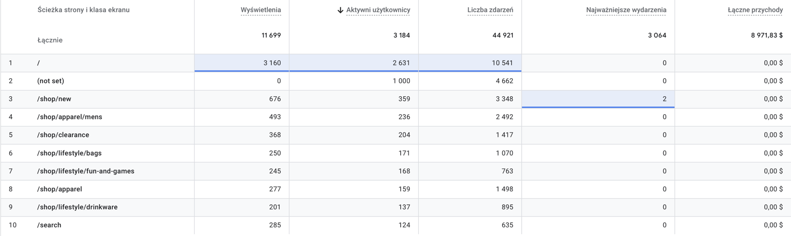
Key Observations:
- The homepage ( / ) attracted the highest number of active users (2,631 users) and generated the largest number of events (10,541 events).
- The /shop/new page was the second most active page, indicating strong interest in new products.
- Product category pages such as:
  - /shop/apparel/mens
  - /shop/clearance
  - /shop/lifestyle/bags
showed relatively high user engagement and browsing activity.
- The /search page generated fewer active users, but still produced a significant number of events, suggesting active product searching behavior.
- Most category and browsing pages generated little or no direct revenue, as their primary purpose is product exploration rather than direct purchasing.

Number of events
This table presents the number of events generated across the most visited pages in the Google Merchandise Store.
The analysis evaluates user interaction intensity and overall engagement on different pages within the ecommerce platform.
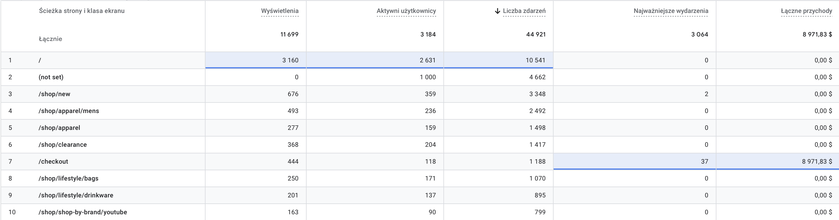

Key Observations:
- The homepage ( / ) generated the highest number of events (10,541 events), confirming that it is the main interaction point within the store.
- The /shop/new page generated over 3,300 events, indicating strong user interest in newly available products.
- Product category pages such as:
  - /shop/apparel/mens
  - /shop/clearance
  - /shop/apparel
Also produced large numbers of events, showing high browsing activity and customer interaction.
- The /checkout page generated fewer overall events compared to browsing pages, but it produced the highest business value by generating all recorded revenue and key purchase events.

Engagement Time
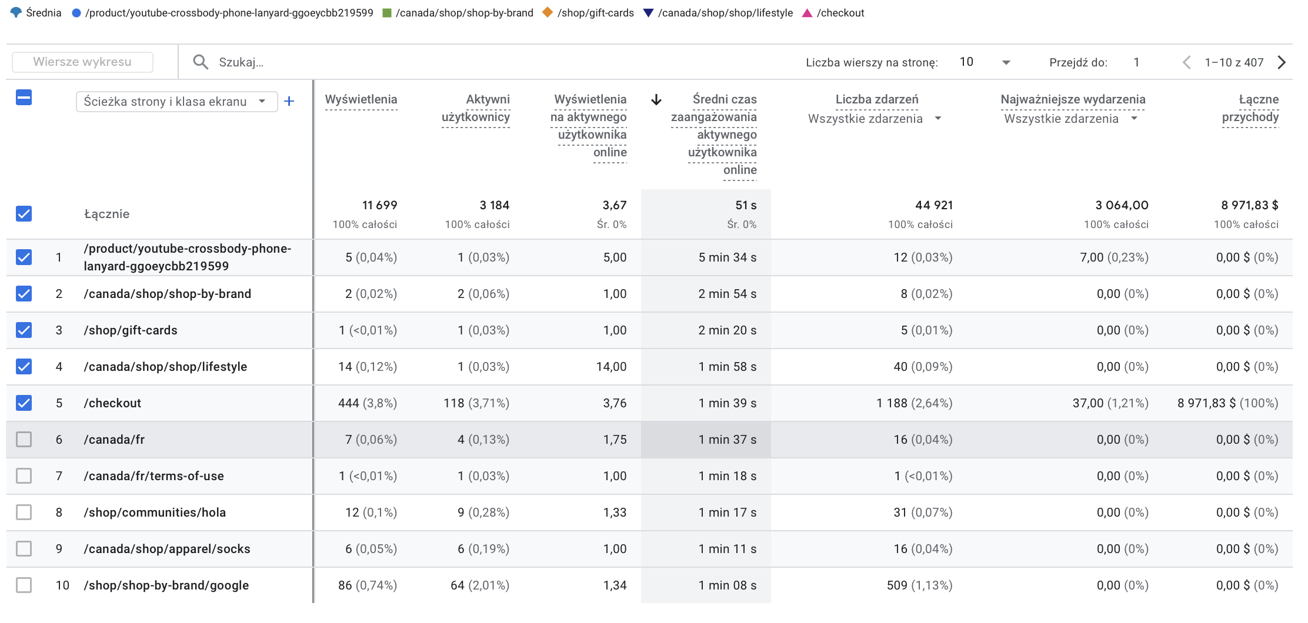
This table presents pages with the highest average engagement time in the Google Merchandise Store.
The analysis evaluates how long users interacted with specific pages and how engagement relates to user activity and revenue generation.

Key Observations:
- The page
/product/youtube-crossbody-phone-lanyard-ggoeycbb219599
achieved the highest average engagement time (5 minutes 34 seconds), indicating very strong user interest in the product content despite low traffic volume.
- Several niche pages such as:
  - /canada/shop/shop-by-brand
  - /shop/gift-cards
  - /canada/shop/shop/lifestyle
also demonstrated high engagement times, suggesting focused browsing behavior among a smaller number of users.
- The /checkout page generated the highest business value, producing:
  - 37 key events
  - nearly $8,972 revenue
while maintaining a high engagement time of 1 minute 39 seconds.
- Some pages generated high engagement despite very small numbers of users, indicating that users who reached these pages were highly interested and actively interacting with the content.
- The analysis shows that pages with the highest engagement time are not necessarily the pages with the highest traffic volume.

Revenue for the whole day:
The following table illustrates the sales performance of specific items, primarily ranked by the total revenue each product generated. This breakdown highlights which products are the most significant financial drivers for the store and identifies trends in high-volume purchasing behavior.
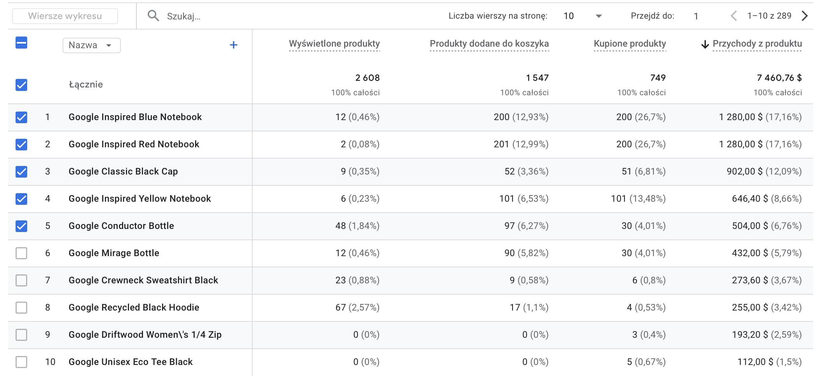

Summary of Sales and Engagement Analysis (April 17, 2026)
Key Observations:
- The analysis for the selected period shows a total product revenue of $7,460.76 from 749 items purchased.
- Highest Revenue Products: The Google Inspired Blue Notebook and Google Inspired Red Notebook are the top revenue generators, each bringing in $1,280.00 (17.16% of total revenue each).
- Most Frequently Purchased: Both the Blue and Red Inspired Notebooks were the most frequently purchased items, with 200 units sold for each product.
- Customer Engagement Insight: There is a significant gap between product views and purchases for top items. For instance, the Google Inspired Red Notebook had only 2 views but resulted in 200 purchases, suggesting customers are adding these items to their carts directly from category pages or promotional links without visiting individual product pages.

Product Interest & Visibility
This table categorizes products based on their visibility, specifically sorting them by the total number of views each item received. It provides insight into which products attract the most initial interest and how that translates into cart additions and final sales.
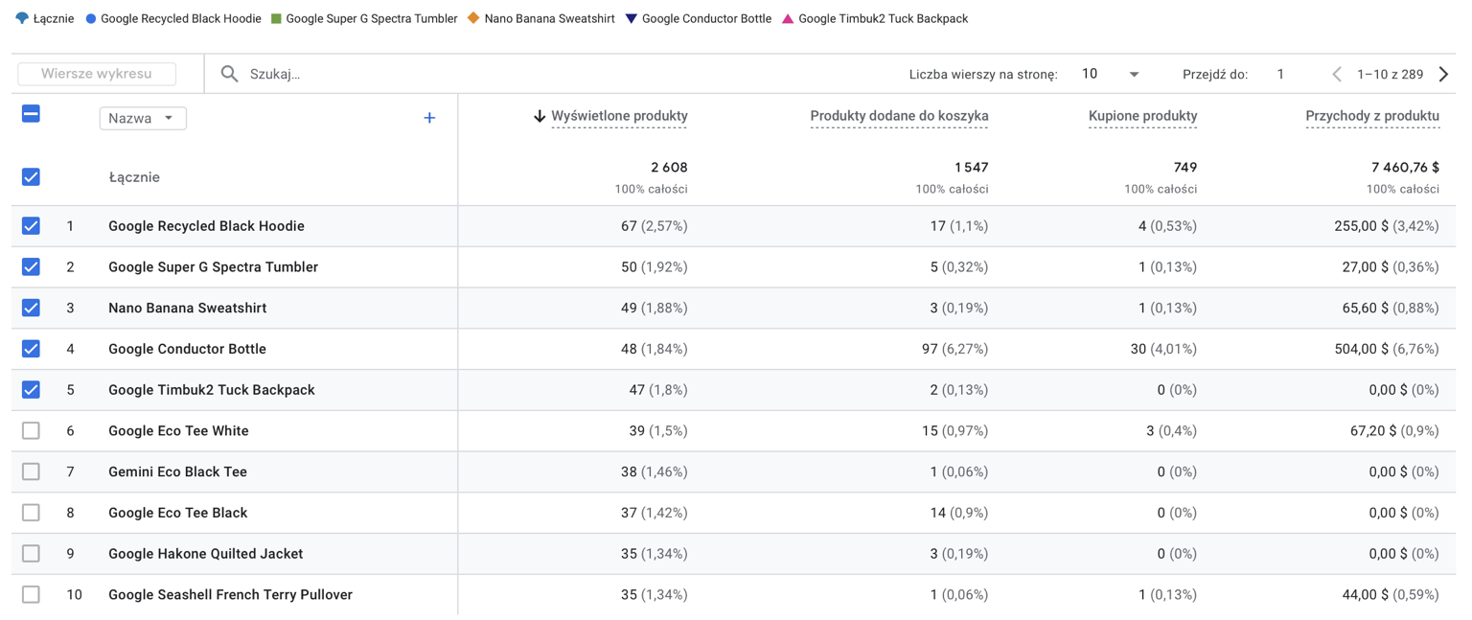
S

- Google Recycled Black Hoodie was the most viewed product (67 views) and generated $255 revenue from 4 purchases.
- Google Conductor Bottle achieved the strongest sales performance:
  - Only 48 views (in that day)
  - 97 add-to-cart events
  - 30 purchases
  - over $504 revenue
making it the best-performing product in the analyzed dataset.
- Several products generated high numbers of views but resulted in little or no revenue, indicating weak purchase conversion despite customer interest.
- Google Timbuk2 Tuck Backpack received 47 product views, but generated 0 purchases and no revenue.
- Products such as:
  - Google Eco Tee White
  - Google Seashell French Terry Pullover
generated moderate revenue despite relatively smaller traffic volumes.
- The analysis demonstrates that high product visibility does not always lead to high purchase conversion or revenue generation.

Purchase funnel
This funnel presents the progression of users through the ecommerce purchasing process in the Google Merchandise Store.
The analysis illustrates how users move from entering the website to completing a purchase and identifies the main drop-off points within the sales funnel.
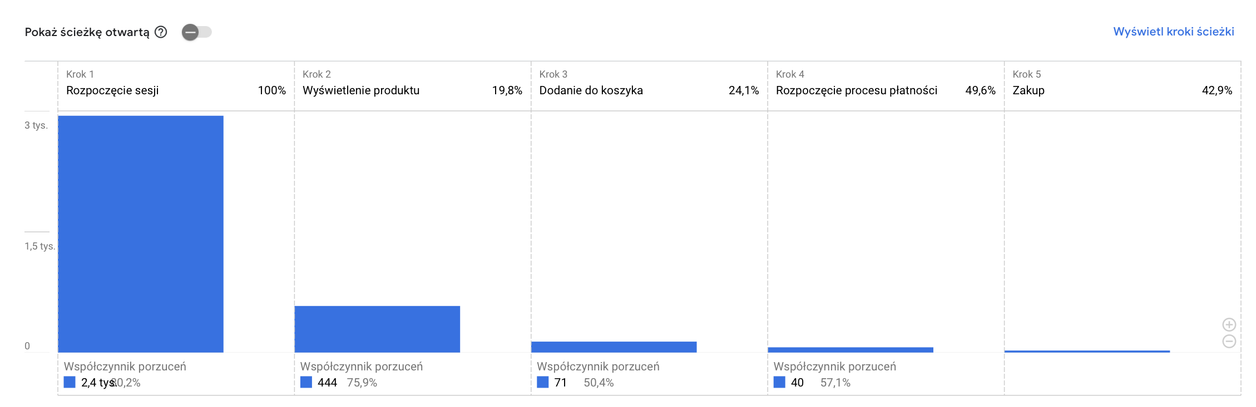

Key observations:
- The funnel began with approximately 2,955 session starts, representing all users entering the store.
- The largest drop-off occurred between:
  - Session Start
  - and Product View
where over 80% of users left the journey before viewing a product.
- Only 19.8% of users progressed from entering the website to viewing a product page.
- Approximately 24.1% of users who viewed products added items to the cart, indicating relatively strong purchase intent among engaged users.
- Nearly 49.6% of users who added products to the cart proceeded to the checkout process.
- The final checkout-to-purchase conversion rate reached 42.9%, suggesting that users who reached the checkout stage were highly likely to complete a purchase.

Customer retention
Data Limitation: Due to the analysis being focused on a single-day snapshot (April 17, 2026), long-term retention trends and cohort behaviors cannot be fully established.

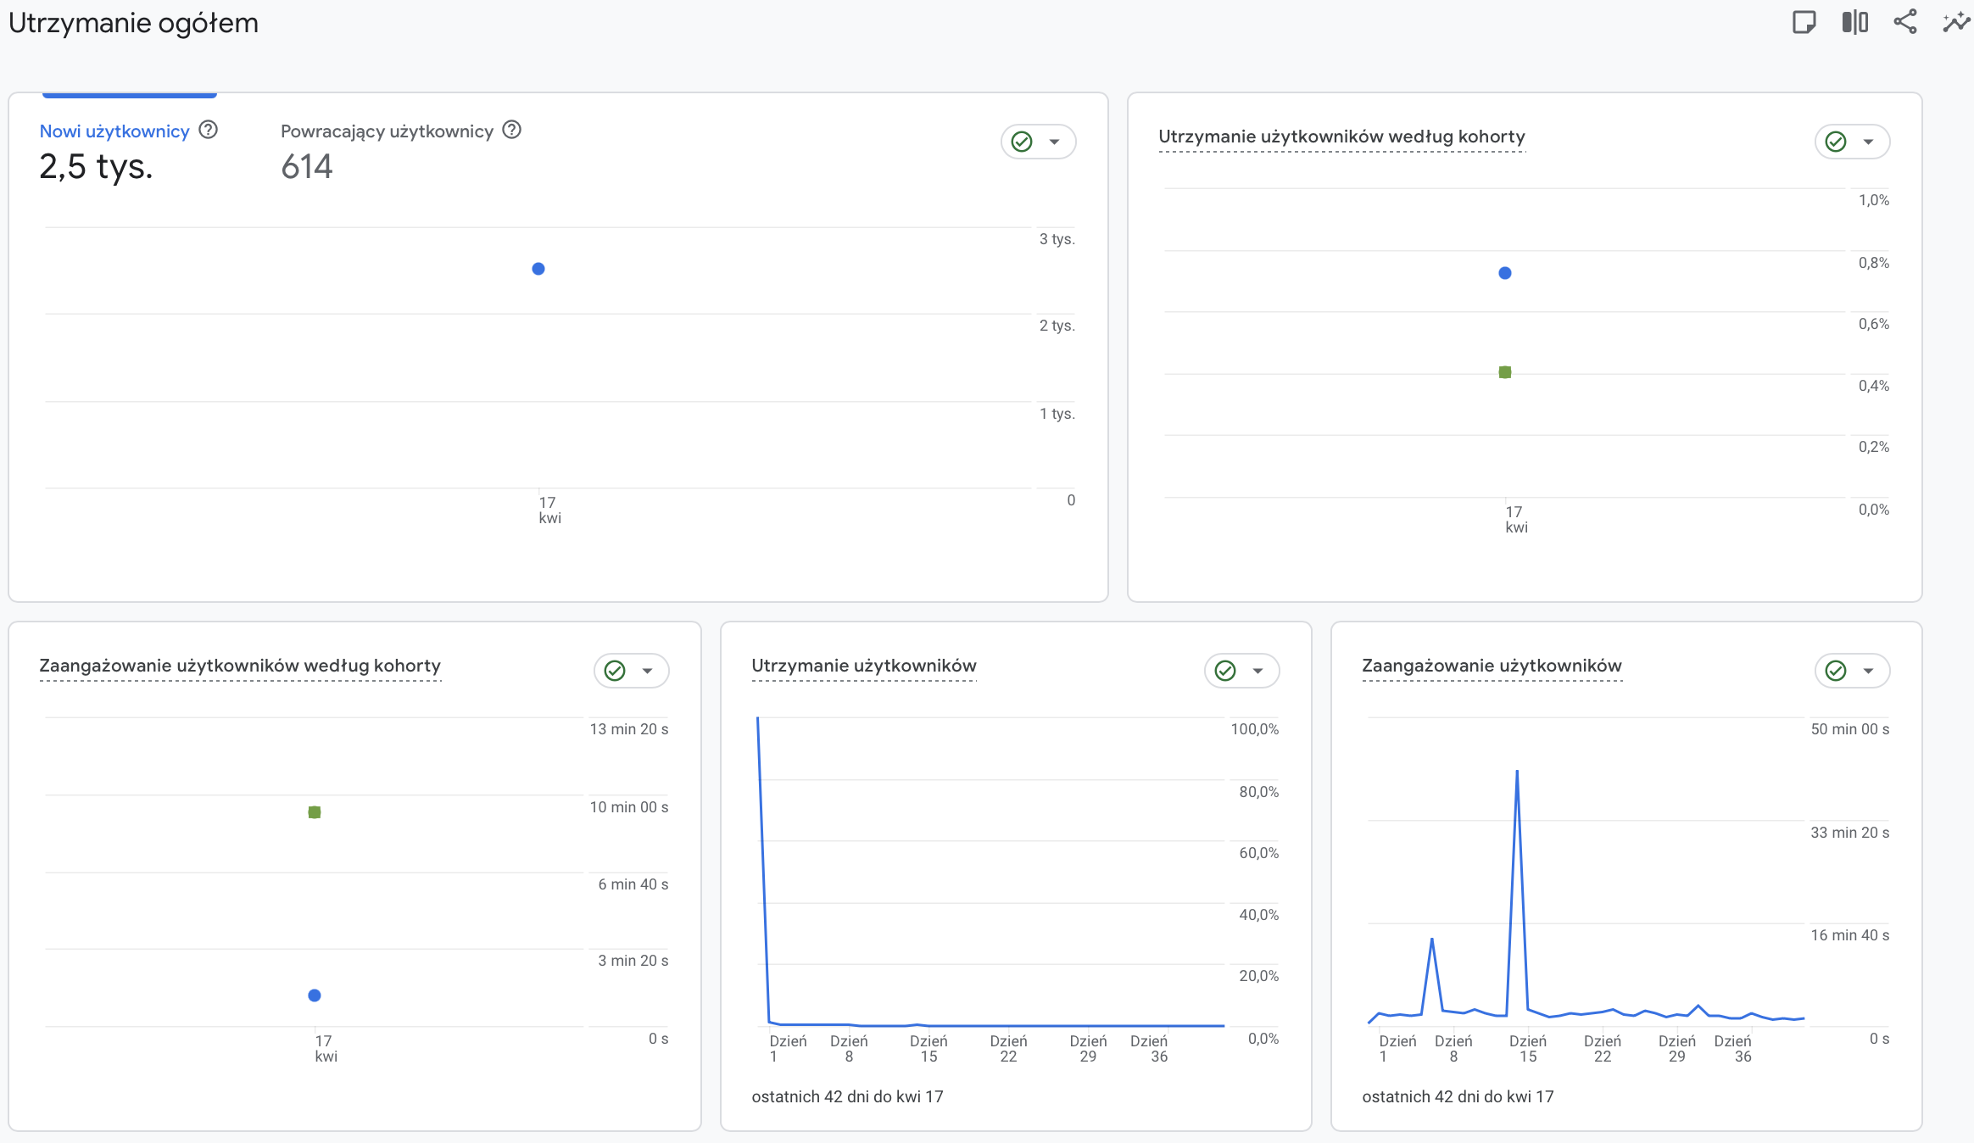

Conclusions
The conducted analysis of the Google Merchandise Store using Google Analytics provided valuable insights into customer behavior, traffic acquisition, engagement quality, and the overall ecommerce purchasing process.
The results showed that the store attracted a large volume of users, primarily through Direct traffic and mobile devices. However, high traffic volume did not always translate into effective purchase conversion. Organic Search, Referral, and Cross-network traffic sources generated significantly better engagement quality and stronger purchase intent despite lower user counts.
The purchase funnel analysis revealed that the largest user drop-off occurred during the early stage of the customer journey, specifically between session start and product view. More than 80% of users abandoned the website before interacting with product pages. On the other hand, users who reached the checkout phase demonstrated relatively high purchase intent and strong final conversion rates.
The analysis also highlighted important behavioral differences between technologies and devices. Desktop users generated the majority of purchases, while mobile devices produced the largest amount of traffic but very low conversion efficiency. Chrome remained the dominant browser in terms of traffic, engagement, and generated revenue.
Product analysis demonstrated that product popularity and revenue generation are not always directly related. Some products achieved high visibility but weak conversion, while others generated strong revenue despite relatively low view counts. This indicates that customer purchase behavior is strongly influenced by factors such as product intent, navigation patterns, and promotional visibility.
Overall, the project demonstrated how Google Analytics can be used to analyze customer acquisition, customer engagement, revenue generation, and user purchasing behavior within an ecommerce environment. The performed analysis may support future optimization of marketing strategies, website structure, and conversion efficiency.

b) Hourly Analysis: [4:00 PM - 5:00 PM UTC].

Customer Acquisition Analysis

Geographic Analysis of the Purchase Journey
This analysis identifies the primary geographic markets and their efficiency in progressing through the final checkout stages.

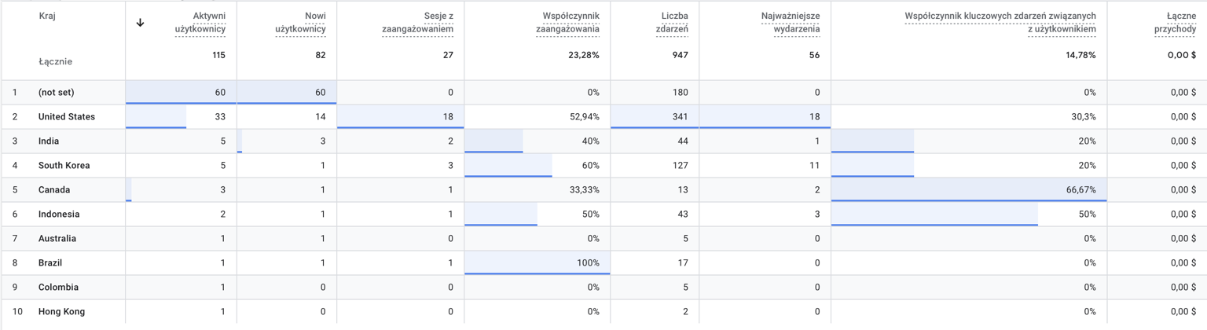

Key observations
- The United States dominated the analyzed hourly period, generating:
  - 33 active users
  - 18 engaged sessions
  - 341 events
  - and the highest number of key events (18).
- Users from the United States also achieved a relatively high engagement rate (52.94%), confirming strong user activity during the selected hour.
- South Korea demonstrated the highest engagement quality among larger traffic groups, reaching a 60% engagement rate and generating 11 key events despite only 5 active users.
- Canada achieved the highest key-event conversion efficiency (66.67%), indicating very strong interaction quality from a small user group.
- Several countries such as:
  - Australia
  - Colombia
  - Hong Kong
generated little or no meaningful engagement during the analyzed timeframe.
- Despite measurable activity and event generation, no revenue was recorded during this specific hourly interval.

Technologies Used

Device Performance Analysis
This section evaluates how different device categories—Mobile and Desktop—impacted user engagement and financial performance during the analyzed hour.
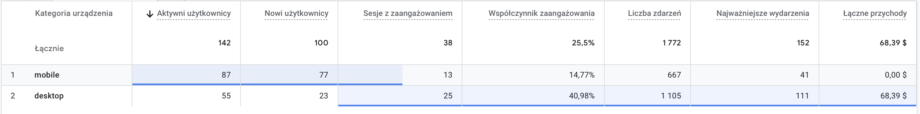
Key observations
- Traffic Volume: Mobile devices were the primary source of traffic, with 87 active users compared to 55 on Desktop.
- Engagement Quality: Desktop users demonstrated significantly higher engagement quality, with a 40.98% engagement rate, while mobile users recorded only 14.77%.
- Revenue Generation: Despite having lower traffic, Desktop users were responsible for all recorded revenue ($68.39) during this window.
- Interaction Intensity: Desktop sessions were more productive, generating 111 key events and 1,105 total events, whereas mobile sessions resulted in 41 key events and 667 total events.
The data suggests that while the store attracts more users via mobile, the actual purchasing power and deep engagement are driven almost exclusively by desktop users.

Browsers: Analysis of the most popular Browsers used by customers.
This section analyzes browser performance during a specific hour, identifying which platforms drive user activity and revenue in a short-term window.
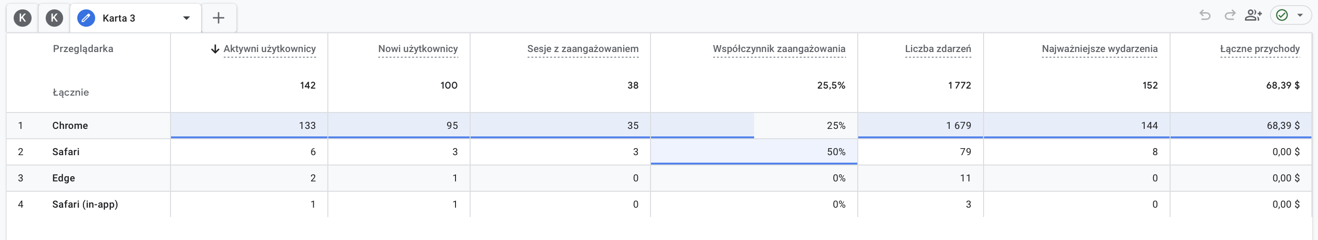

Key observations:

- Chrome was the dominant browser, accounting for:
  - 133 active users
  - 1,679 events
  - 144 key events
  - and all generated revenue ($68.39).
- Chrome also represented the vast majority of new users (95 users) and engaged sessions (35 sessions), confirming its dominance across all activity metrics.
- Safari had a relatively small user base (6 users) but achieved the highest engagement rate (50%), suggesting stronger interaction quality among Safari users.
- Edge and Safari (in-app) generated very low activity levels and produced no recorded revenue during the analyzed timeframe.
The analysis demonstrates that browser popularity strongly influenced overall interaction volume and ecommerce activity within the platform.

User Systems Performance
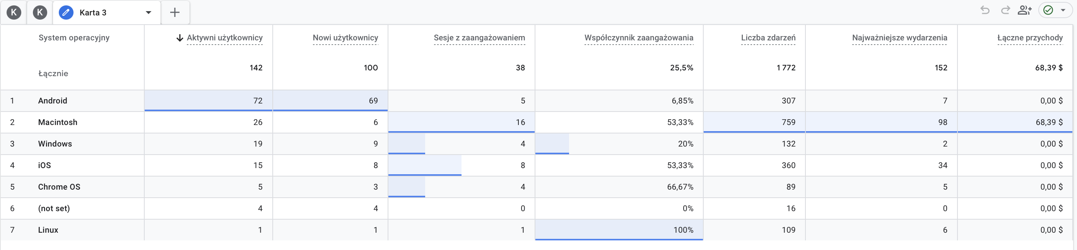
Key observations
- Android was the most widely used operating system, generating:
  - 72 active users
  - 69 new users
  - and 307 events.
- Despite generating the highest traffic volume, Android showed relatively weak engagement performance with only:
  - 5 engaged sessions
  - and a low engagement rate of 6.85%.
- Macintosh demonstrated the strongest business performance:
  - 759 events
  - 98 key events
  - and all recorded revenue ($68.39).
- iOS achieved strong engagement quality, reaching:
  - 53.33% engagement rate
  - and 34 key events despite a relatively small user base.
- Chrome OS also demonstrated high engagement efficiency with a 66.67% engagement rate.
- Linux showed the highest engagement rate (100%), although it represented only a single active user and therefore has limited statistical significance.
- Windows generated moderate activity levels but produced no recorded revenue during the analyzed period.

Traffic Acquisition Analysis
This section identifies the specific sources that drove users to the store, helping to distinguish between those who entered directly, via search engines, or through advertisements. By analyzing these channels, we can determine which traffic sources attract the most engaged visitors and potential customers.
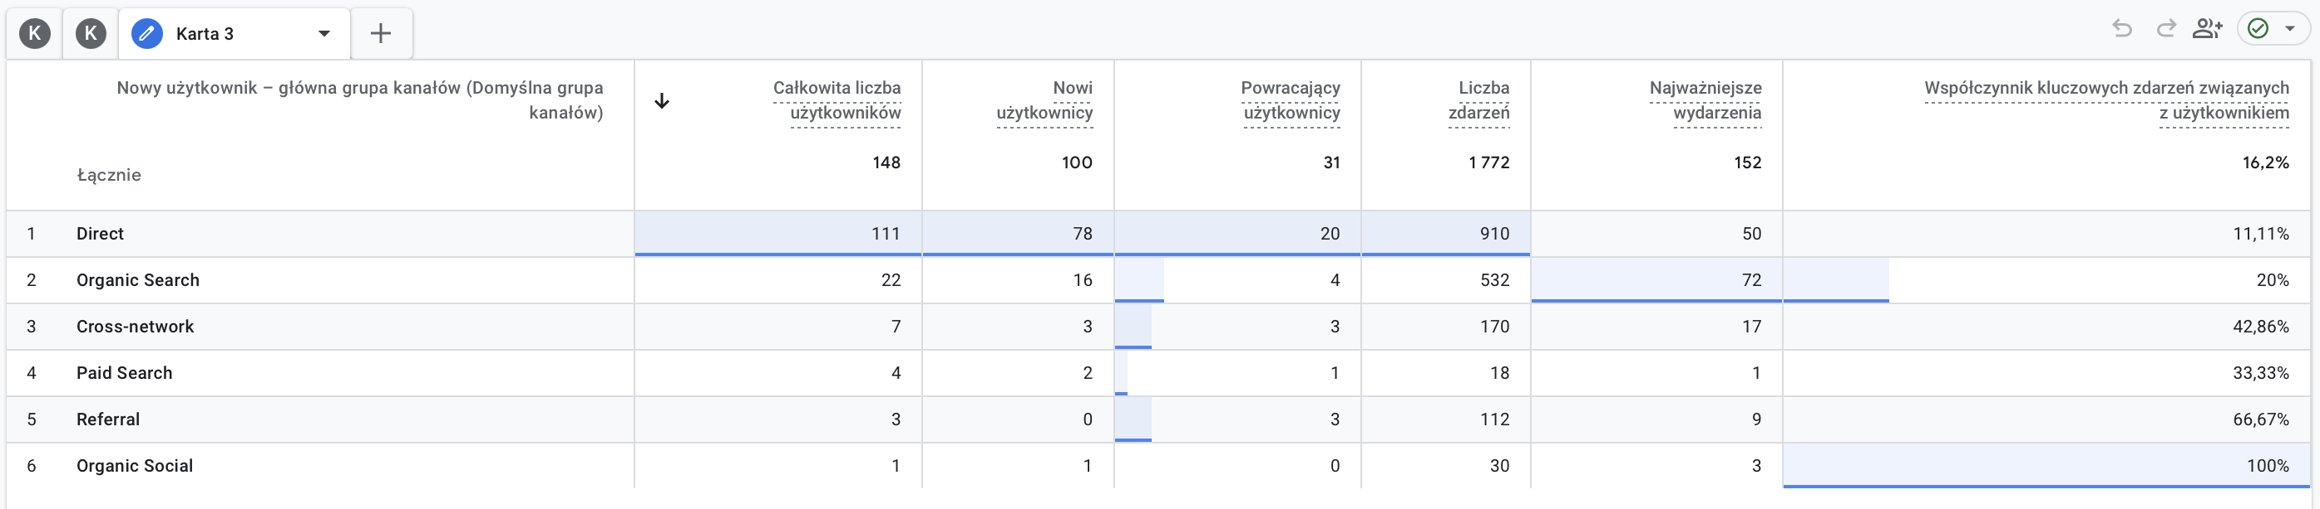

Key observations
- Direct traffic dominated the analyzed period, generating:
  - 111 total users
  - 78 new users
  - and 910 events.
- Despite its high traffic volume, Direct traffic achieved a relatively low key-event conversion rate (11.11%) compared to other acquisition channels.
- Organic Search demonstrated significantly stronger engagement quality:
  - 532 events
  - 72 key events
  - and a 20% key-event conversion rate.
- Cross-network traffic showed strong conversion efficiency with a 42.86% key-event rate, despite a relatively small number of users.
- Referral traffic achieved one of the highest performance indicators, reaching a 66.67% key-event conversion rate, suggesting highly valuable external traffic sources.
- Organic Social generated very small traffic volume but achieved a 100% key-event conversion rate; however, this result is based on only a single user and has limited statistical significance.
The analysis demonstrates that smaller traffic channels often generated stronger engagement and conversion efficiency than high-volume Direct traffic.

Customer Engagement Analysis & Site structure
This section examines the performance of specific website pages during the analyzed hour to identify which content attracts the most users attention.
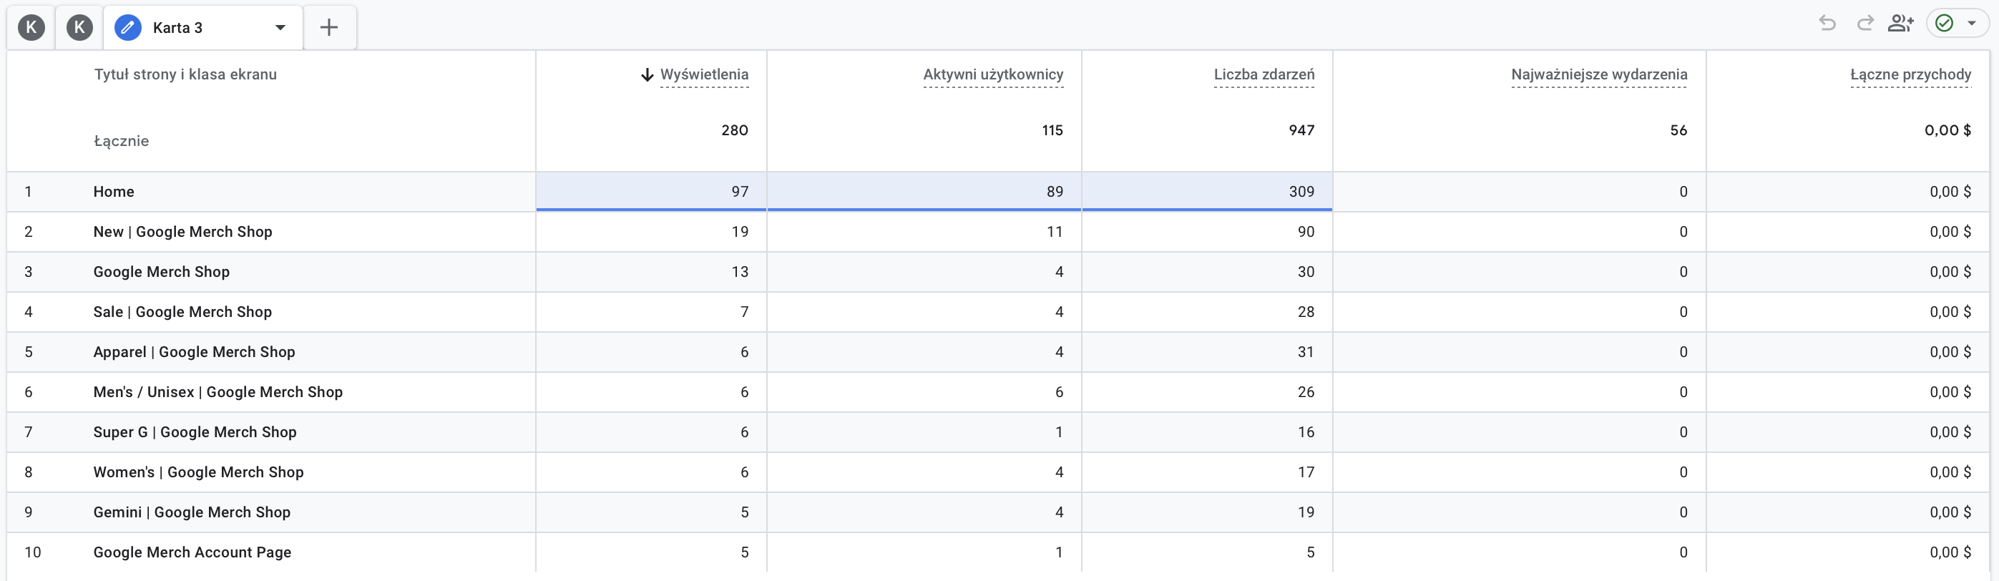

Key observations
- The Home page was the dominant entry point of the website, generating:
  - 97 page views
  - 89 active users
  - and 309 events.
- The New | Google Merch Shop section was the second most visited page, indicating strong user interest in newly available products.
- Product category pages such as:
  - Apparel
  - Men’s / Unisex
  - Women’s
  - Sale
maintained moderate levels of user activity and browsing engagement.
- The Men’s / Unisex section achieved relatively strong engagement efficiency, generating:
  - 6 active users
  - and 26 events
from only 6 page views, suggesting highly active interactions from visitors.
- The analysis period generated no recorded revenue, indicating that users mainly focused on browsing and exploration rather than completing purchases during the selected timeframe.
- Event activity remained concentrated around the homepage and major product-category pages, highlighting their importance in customer navigation behavior.

User Path Exploration Analysis
This analysis visualizes the initial steps taken by users during this specific hour to identify immediate engagement patterns.
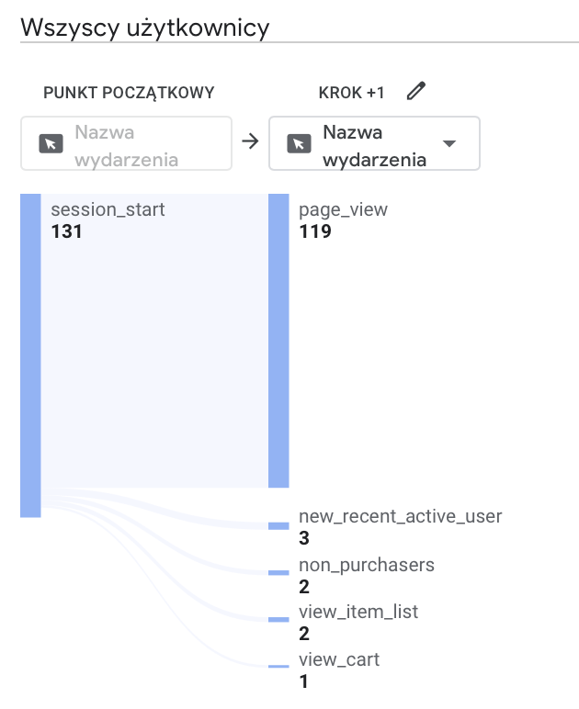

Key observations
- The customer journey began with 131 session_start events, representing all users entering the website during the selected hourly period.
- The overwhelming majority of users continued directly to the page_view stage with 119 occurrences, indicating strong initial browsing activity immediately after entering the website.
- Only a very small number of users progressed toward deeper ecommerce interactions such as:
  - view_item_list
  - view_cart
- The appearance of the non_purchasers event confirms that some users abandoned the shopping process before reaching conversion stages.
- Cart-related interactions remained extremely limited, with only 1 recorded view_cart event, indicating weak purchase progression during the analyzed hour.
Key Takeaway: During this hour, users showed a very linear behavior, with nearly 91% of sessions moving directly from start to browsing pages without immediate drop-offs.

Active Users
This section evaluates user distribution across specific site paths and identifies pages that successfully convert interactions into business value during this hourly window.
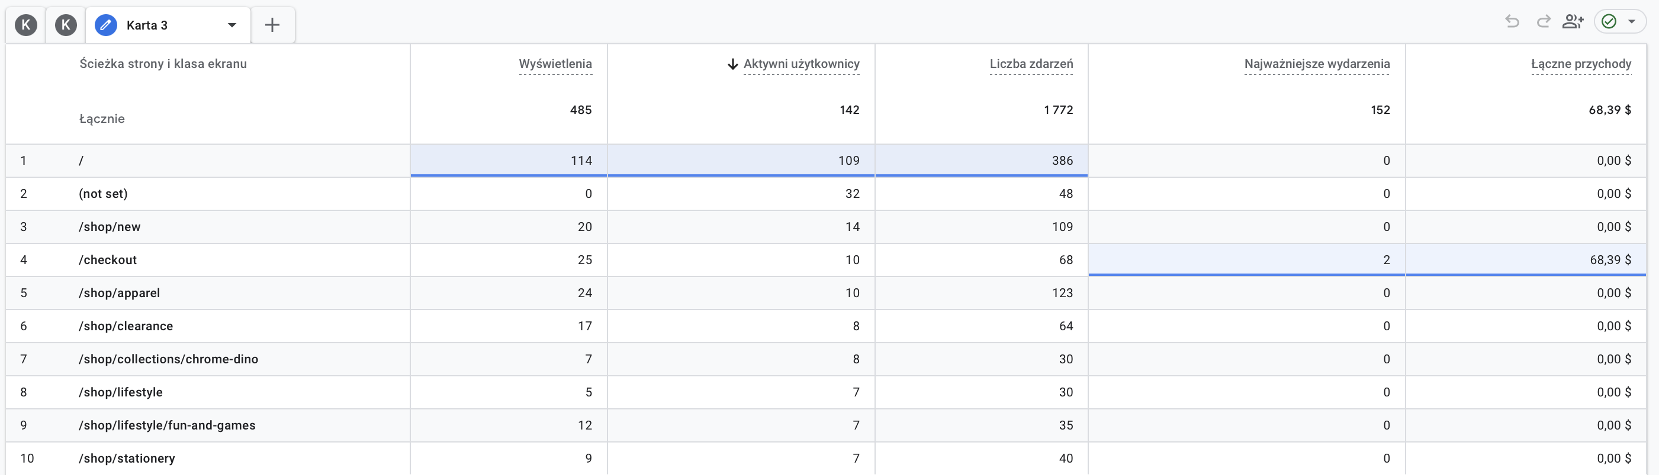

Key observations
- The Home page remained the primary entry point during the analyzed hour, generating the highest number of:
  - page views,
  - active users,
  - and events.
- The New | Google Merch Shop page attracted the second-highest number of active users, indicating continued interest in newly available products.
- Product category pages such as:
  - Apparel,
  - Men’s / Unisex,
  - Women’s,
  - and Sale
generated moderate browsing activity and user interaction.
- The Men’s / Unisex section demonstrated relatively strong engagement efficiency, producing a high number of events relative to the number of views.
- Most users interacted primarily with browsing and category pages rather than transactional sections such as checkout or payment pages.
- No revenue was generated during the analyzed hourly period, suggesting that user activity was focused mainly on exploration and product discovery.

Number of events
This section evaluates the volume of user interactions across different pages, highlighting where the most activity occurs within a single hour.
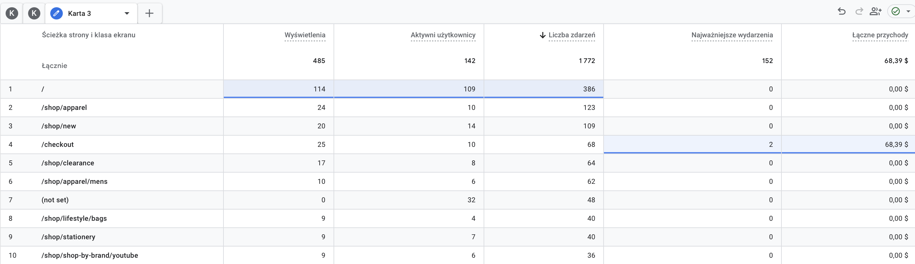
Key observations
- The homepage ( / ) generated the highest interaction activity during the analyzed hour, producing:
  - 386 events
  - 109 active users
  - and 114 page views.
- The /shop/apparel page was the second most interactive section, generating 123 events, indicating strong browsing interest in apparel-related products.
- The /shop/new page also maintained high activity levels with 109 events, confirming continued user interest in newly available products.
- The /checkout page generated:
  - 68 events
  - 2 key events
  - and all recorded revenue ($68.39),
making it the most important transactional page during the analyzed timeframe.
- Product-category pages such as:
  - /shop/clearance
  - /shop/apparel/mens
  - /shop/lifestyle/bags
also generated moderate event activity, showing ongoing product exploration behavior.
- Several pages generated relatively high event counts despite smaller numbers of active users, suggesting more intensive interaction behavior among engaged visitors.

Engagement Time
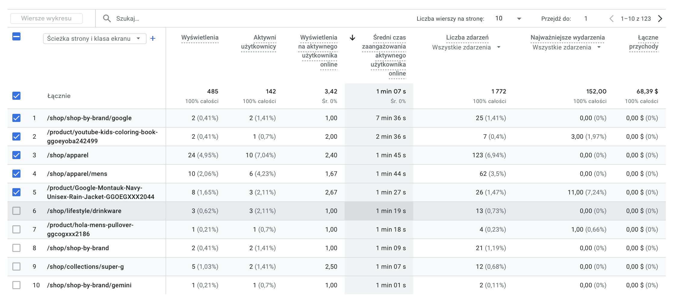

Key observations
- /shop/shop-by-brand/google
achieved the highest average engagement time (7 minutes 36 seconds), indicating extremely strong user attention despite very low traffic volume.
- Product pages such as:
  - /product/youtube-kids-coloring-book-ggoeyoba242499
  - /product/Google-Montauk-Navy-Unisex-Rain-Jacket-GGOEGXXX2044
also demonstrated high engagement times, suggesting focused product exploration behavior.
- The /shop/apparel and /shop/apparel/mens sections generated:
  - relatively high page views,
  - strong event activity,
  - and engagement times exceeding 1 minute 40 seconds,
indicating active browsing behavior within apparel-related categories.
- The product page:
Google-Montauk-Navy-Unisex-Rain-Jacket
generated 11 key events, representing one of the strongest product-level interaction performances during the analyzed hour.
- Several pages achieved high engagement times despite very small numbers of users, suggesting highly concentrated interaction among interested visitors.
- No significant revenue was generated directly from most highly engaged pages during the selected hourly period.

Revenue for the whole day:
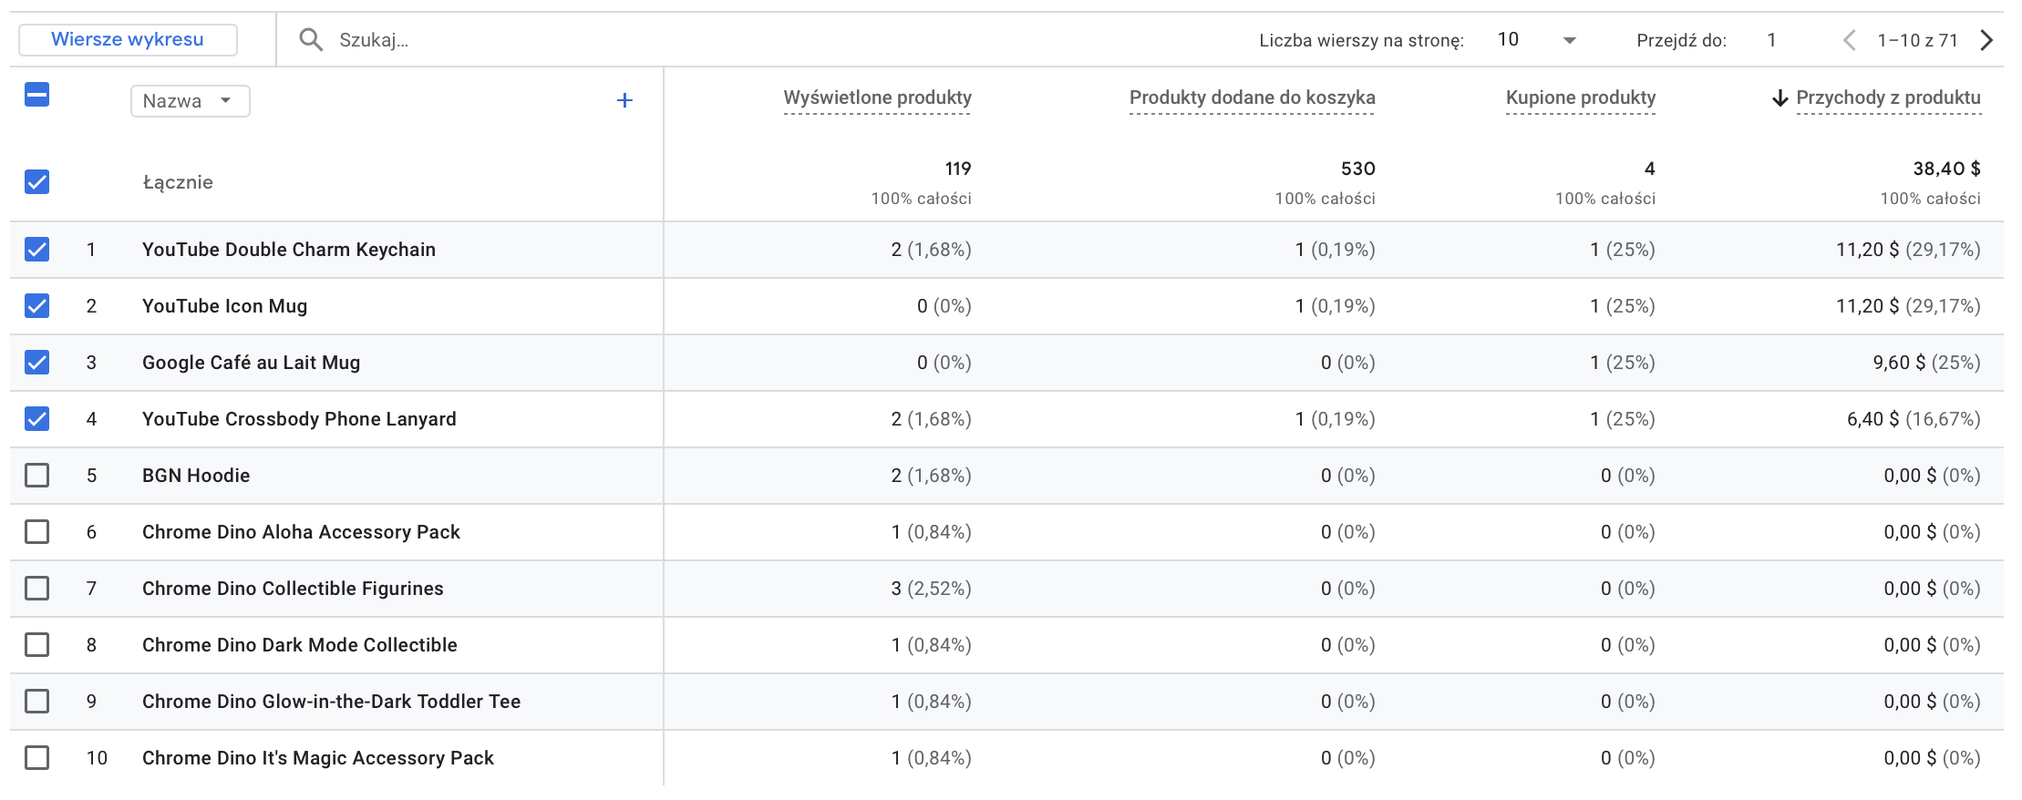
Key observations
- The analyzed hour generated a total product revenue of $38.40 from 4 purchased products.
- The products:
  - YouTube Double Charm Keychain
  - YouTube Icon Mug
generated the highest revenue, each contributing:
  - $11.20
  - and approximately 29.17% of total revenue.
- The Google Café au Lait Mug generated:
  - $9.60
  - accounting for 25% of total revenue during the analyzed hour.
- The YouTube Crossbody Phone Lanyard generated:
  - $6.40
  - contributing approximately 16.67% of total revenue.
- Several products achieved purchases despite extremely low numbers of product views, indicating efficient conversion behavior among a small number of highly interested users.
- Many viewed products, particularly within the Chrome Dino product series, generated no purchases or revenue despite receiving product views.
- The analysis demonstrates that only a very limited subset of products converted successfully into purchases during the selected hourly period.

Product Interest & Visibility

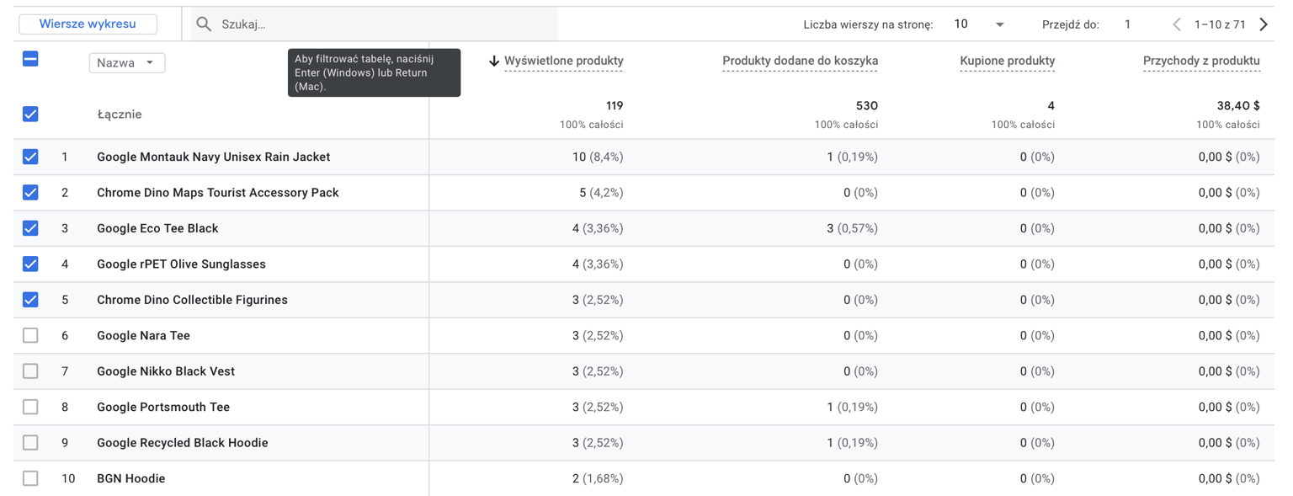

Key observations
- The Google Montauk Navy Unisex Rain Jacket was the most viewed product during the analyzed hour, generating:
  - 10 product views
  - and 1 add-to-cart action.
- Products such as:
  - Chrome Dino Maps Tourist Accessory Pack
  - Google Eco Tee Black
  - Google rPET Olive Sunglasses
also attracted notable browsing activity.
- Despite receiving multiple views, the majority of products generated:
  - no purchases,
  - and no direct revenue.
- The Google Eco Tee Black demonstrated relatively stronger shopping intent, generating:
  - 3 add-to-cart actions
despite having only 4 product views.
- Several viewed products achieved no cart activity at all, suggesting that users explored products without progressing toward purchase behavior.
- None of the most viewed products were ultimately purchased during the selected hourly period.
- The analysis indicates a clear gap between browsing activity and successful conversion outcomes.

Purchase funnel
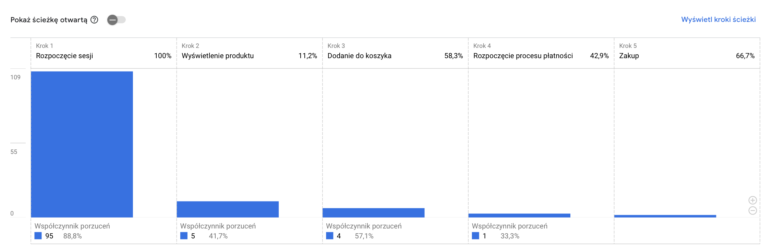
Key observations
- The purchasing journey started with 109 session_start events, representing all users entering the website during the analyzed hour.
- Only 11.2% of users progressed from session start to the product view stage, indicating that most visitors left the site before exploring products.
- Users who reached product pages showed relatively strong shopping intent:
  - 58.3% progressed to the add-to-cart stage.
- The transition from:
add_to_cart → begin_checkout
achieved a conversion rate of 42.9%, indicating moderate continuation toward purchase completion.
- The final transition from:
begin_checkout → purchase
reached 66.7%, representing the strongest conversion stage in the funnel.
- The largest drop-off occurred at the very beginning of the customer journey:
95 users (88.8%) abandoned the process before reaching product-view interactions.
- Only a very small number of users completed the full purchasing journey during the analyzed hourly period.

Customer retention
Data Limitation: Due to the analysis being focused on a single-hour snapshot, long-term retention trends and cohort behaviors cannot be fully established.
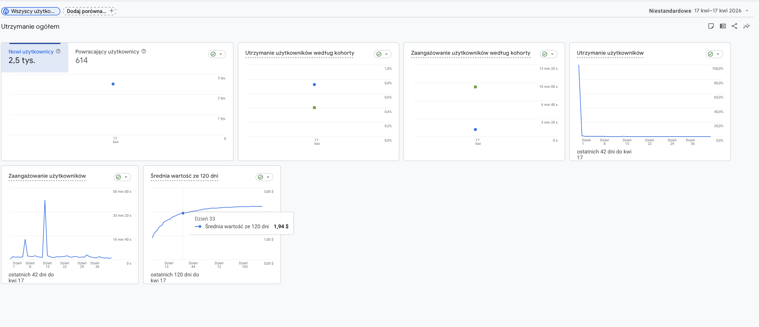

Conclusions
The hourly analysis of the Google Merchandise Store provided a detailed view of short-term customer behavior and purchasing activity within a specific one-hour timeframe.
The results showed that user activity during the analyzed period was dominated by browsing behavior rather than deep transactional engagement. Most users interacted primarily with homepage and category pages, while only a small percentage progressed toward the final purchase stages.
The analysis demonstrated that Chrome overwhelmingly dominated the ecosystem during the selected hour, generating nearly all traffic, events, key interactions, and all recorded revenue. At the same time, Safari users showed stronger engagement quality despite their significantly smaller user base. Operating-system analysis revealed clear behavioral differences between platforms: Android generated the highest traffic volume, while Macintosh users produced the strongest business value and all recorded revenue during the analyzed timeframe.
Traffic acquisition analysis showed that Direct traffic generated the largest number of users and events, but smaller channels such as Referral, Cross-network, and Organic Search achieved substantially stronger conversion efficiency and engagement quality. This indicates that high traffic volume alone does not guarantee effective ecommerce performance.
The purchase funnel revealed that the largest customer drop-off occurred at the very beginning of the journey. Nearly 89% of users abandoned the process before reaching the product-view stage. However, users who entered deeper funnel stages demonstrated relatively strong purchase intent, especially during the checkout-to-purchase transition, which achieved the highest conversion rate within the funnel.
Product analysis showed that revenue generation during the analyzed hour was concentrated around only a few products. Several products generated purchases despite very low view counts, suggesting that some users may have entered product pages directly or arrived through focused promotional traffic. At the same time, many highly viewed products failed to generate purchases, highlighting a clear difference between browsing interest and actual buying behavior.
Overall, the hourly analysis demonstrated that user engagement within a short time window is highly dynamic and strongly dependent on traffic quality, device type, browser usage, and user intent. The results confirm that even within a single hour, Google Analytics can provide valuable insights into customer acquisition, browsing behavior, conversion efficiency, and ecommerce performance optimization opportunities.

