Analysis of Web-based Systems – Project nr 3

Done by: Jakub Kamiński 273107 and Adam Ćwikliński 273055

Table of Contents
1 Part 1 – architecture of the online shopping process 3
1.1 Part 1 – Exercise 1 3
1.2 High – level shopping process flow 4
1.3 Dev Tools event logs analysis 5
1.3.1 Technology Stack 6
1.4 Detailed Event Handling Analysis 8
1.4.1 creating a shopping cart and modifying products in it 8
1.4.2 selecting a pickup location 11
1.4.3 selecting a tPay payment method and selecting a bank. 11
1.5 Part 1 – Exercise 2 12
2 Part 2 – measurement of value and analysis of performance indicators of websites and online services 13
2.1 First URL – novatech shop 14
2.2 Second URL – Amazon Shop 15
2.3 Third URL – Official PWR’s W4n website 16
2.4 Fourth URL – PWR’s article 17
2.5 Comparison 18
3 Part 3 – e2e tests 19
4 Conclusions 22

Part 1 – architecture of the online shopping process

Description:
The purpose of the executed scenario was to simulate a typical customer purchasing process in the Novatech online store while recording network traffic and user events. The user browsed and filtered 4K UHD monitors, selected and reviewed a product, and added it to the shopping cart. A wireless mouse was then searched, filtered, reviewed, and added to the cart as a second product.
In the final stage, the user opened the shopping cart, increased the monitor quantity from one to two units, selected the Economy Delivery option, and proceeded to Secure Checkout. This scenario covered the key stages of an e-commerce transaction, including product browsing, cart creation and modification, delivery selection, and checkout initiation, providing a representative dataset for further analysis of browser-server communication and application behavior.

Part 1 – Exercise 1

The objective of Exercise 1 was to analyze the architecture and communication mechanisms of an e-commerce application by recording and examining network traffic generated during a complete shopping process. The analysis was performed using Chrome DevTools and Proxyman.
The collected event logs were used to investigate browser-server communication, identify the technologies used by the website, and understand how user actions are handled by the application. Particular attention was given to shopping cart creation and modification, delivery selection, checkout initiation, and the exchange of requests and responses between the client and the server.
Tools used:
- Dev Tools
- Proxyman

We used Google Chrome Web Browser for this exercise.

High – level shopping process flow
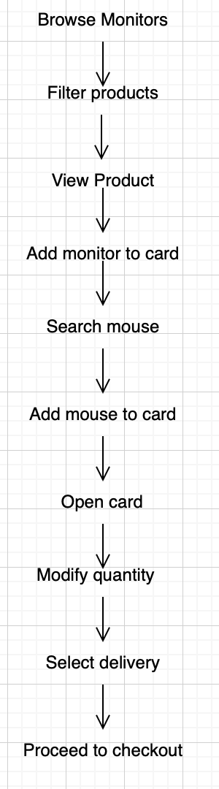

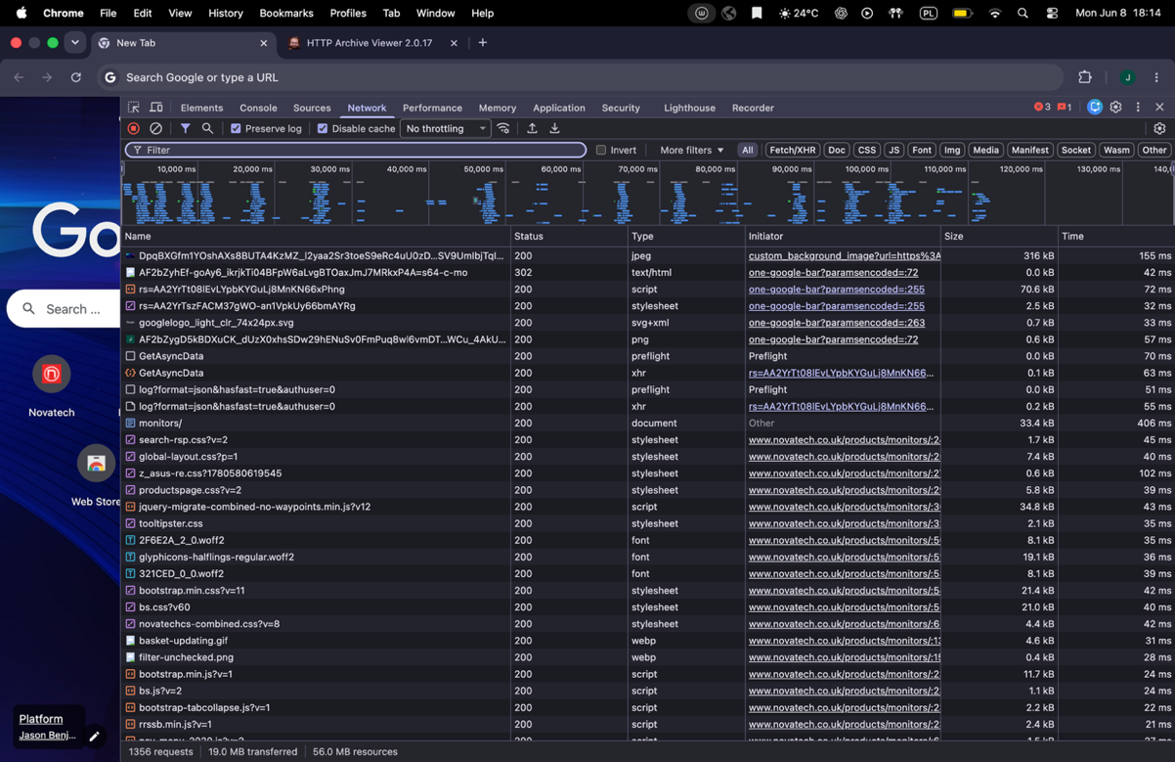
Dev Tools event logs analysis

Dev Tools network tab view
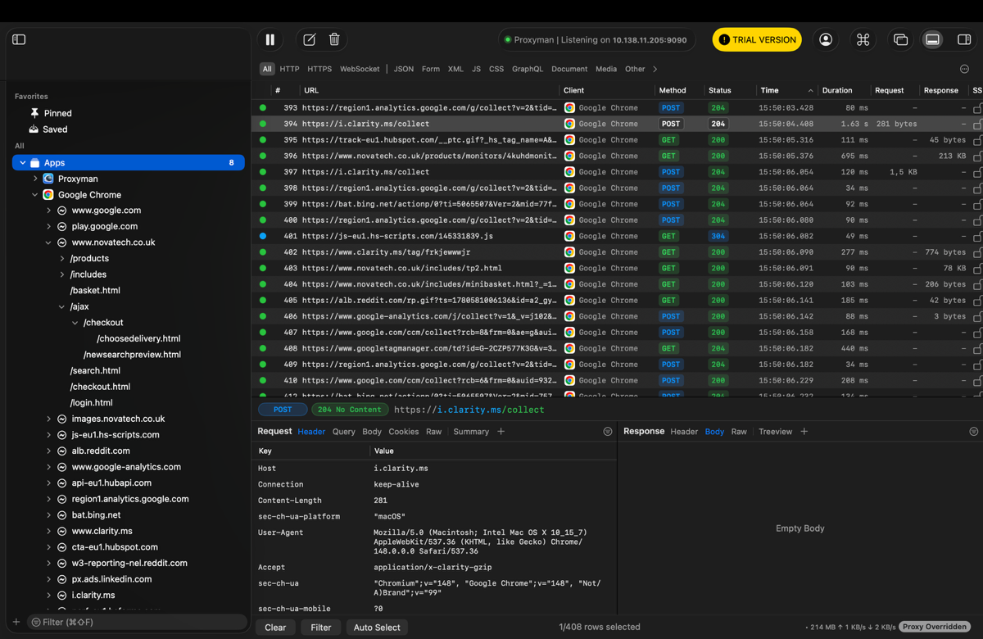
Proxyman tab view

Technology Stack

Technologies found:
- Cloudflare

- AJAX

- HTTPS and TLS encryption

- HTML Responses

- Bootstrap

- jQuery

- ToolTipster


- Google Analytics

- Google Tag Manager

- Hub Spot

- Bing Ads

- Microsoft Clarity

Detailed Event Handling Analysis
This section presents a detailed analysis of selected user interactions captured during the shopping process. Using the collected event logs, the communication between the browser and the server is examined for three key scenarios: creating and modifying a shopping cart, selecting a pickup location, and choosing the tPay payment method together with a bank selection. For each scenario, the corresponding requests, responses, and data exchanges are analyzed to illustrate how user actions are processed by the application.

creating a shopping cart and modifying products in it

During the shopping scenario, multiple HTTP requests to /includes/minibasket.html were captured in the network logs.
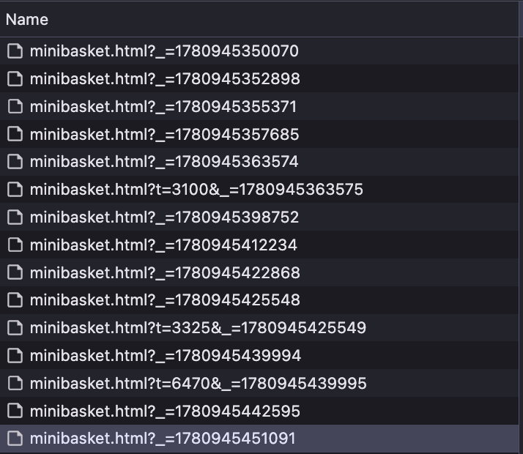

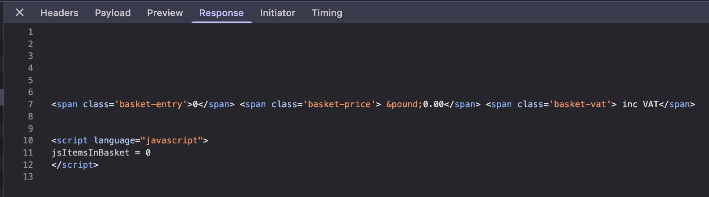
Initial state of cart

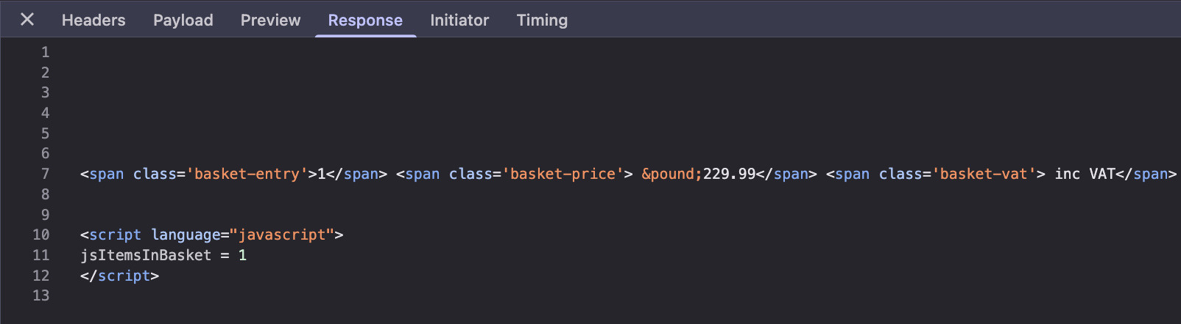
Cart state after adding 1 monitor

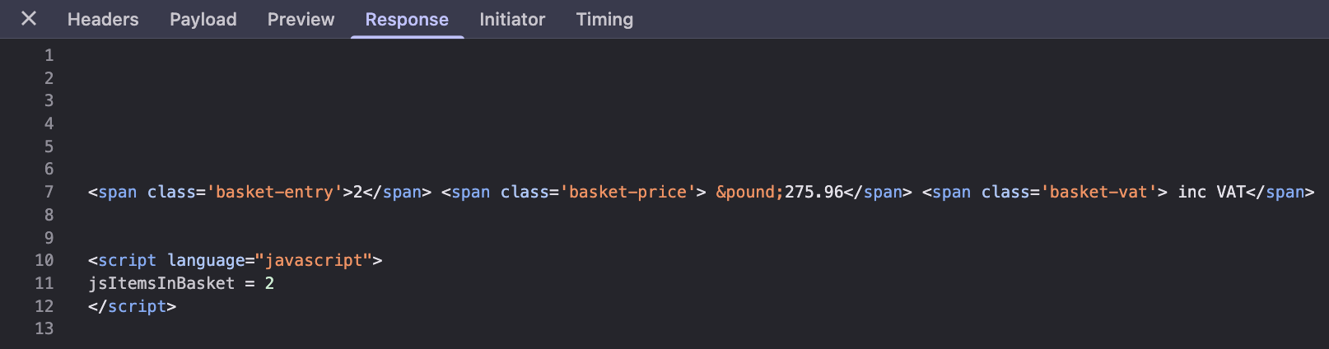
Cart state after adding second item (mouse)

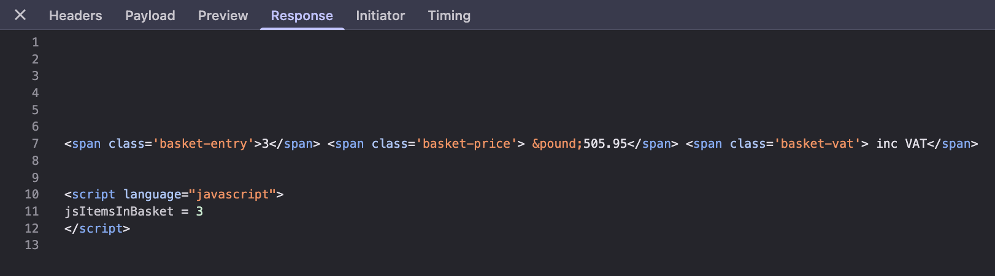

Figure 1 Cart state after modyfication (adding next monitor)

Responses returned the current basket state, including the number of products and the total basket value. Four consecutive basket states were identified:

- 0 items – basket value: £0.00
- 1 item – basket value: £229.99
- 2 items – basket value: £275.96
- 3 items – basket value: £505.95

The increasing number of items and basket value confirms that the server successfully processed each cart modification. After every user action, the browser requested the updated mini-basket content from the server. The server responded with an HTML fragment containing the basket information (jsItemsInBasket and total price), which was then used to update the user interface without reloading the entire page.

The observed packet exchange can be summarized as follows:
User action (Add to Basket / Modify Quantity) → Server updates shopping cart session → Browser sends GET request to /includes/minibasket.html → Server returns updated basket data → Mini-basket is refreshed in the browser.

selecting a pickup location


Delivery method information lies under chooseelivery.html request as shown below.

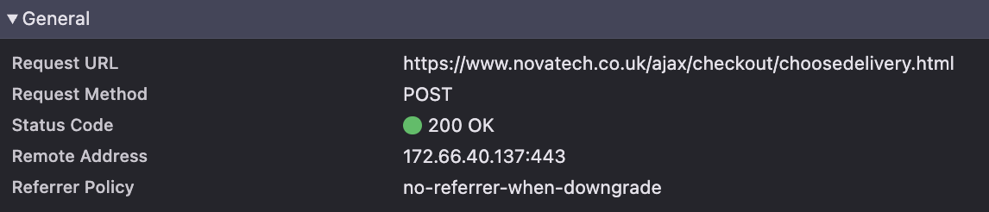
HTTP POST request sent to the /choosedelivery.html endpoint after selecting the Economy Delivery option, successfully processed by the server (HTTP 200 OK).

selecting a tPay payment method and selecting a bank.

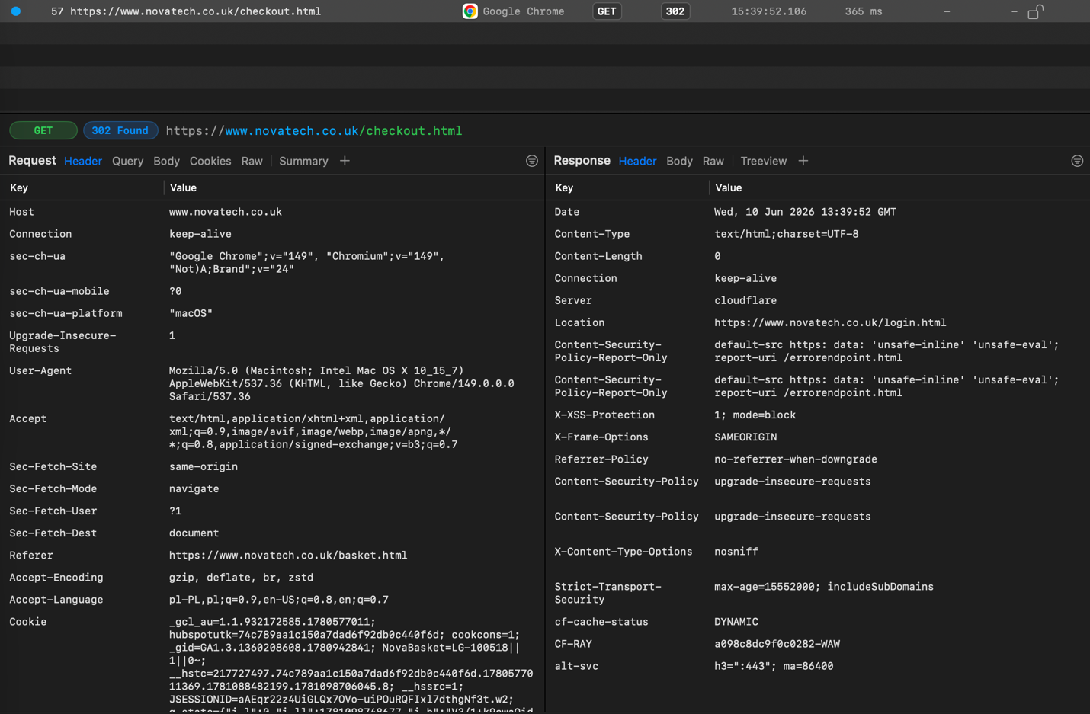
Secure checkout information lies under checkout.html request as shown below.
HTTP GET request sent to /checkout.html; server responded with HTTP 302 (Found) and redirected the user to the login page.

Part 1 – Exercise 2
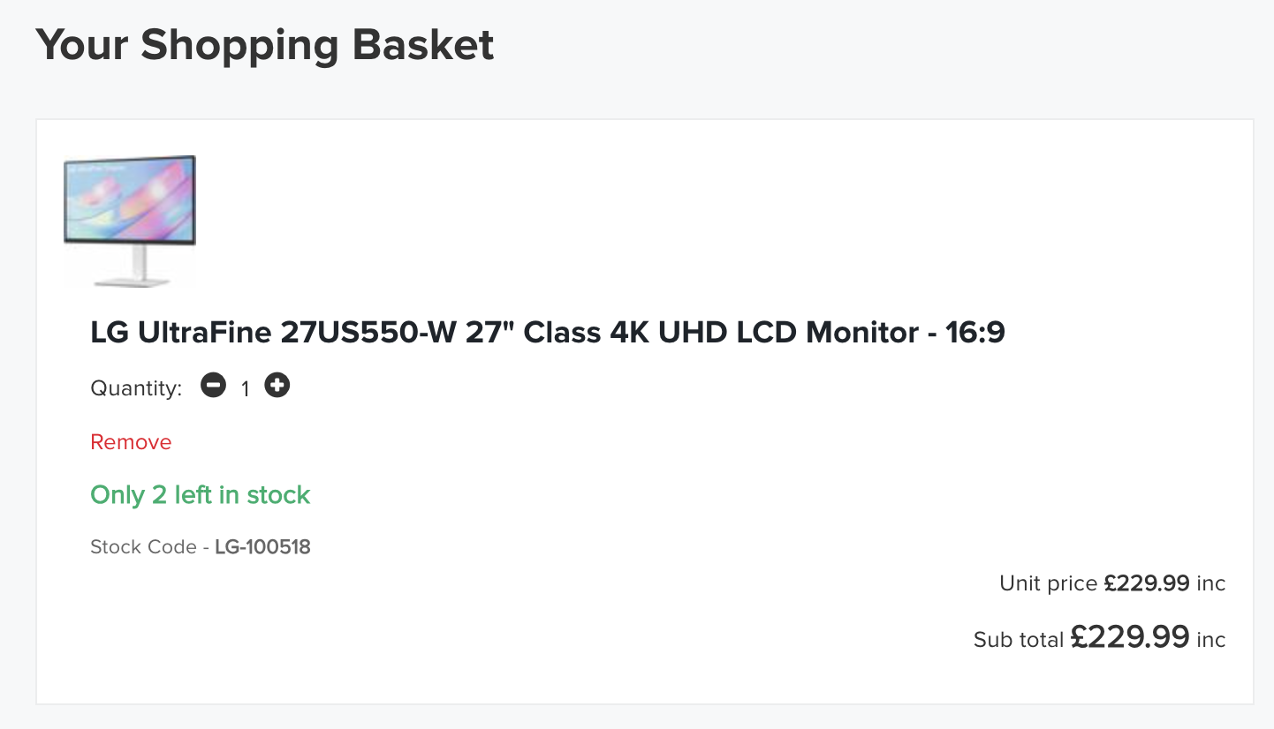
Add a monitor to the empty shopping cart as in point 1 in the quantity of 1 pc., but try to interfere with the content of the package and change the price of the computer monitor to a lower one by £ 50.

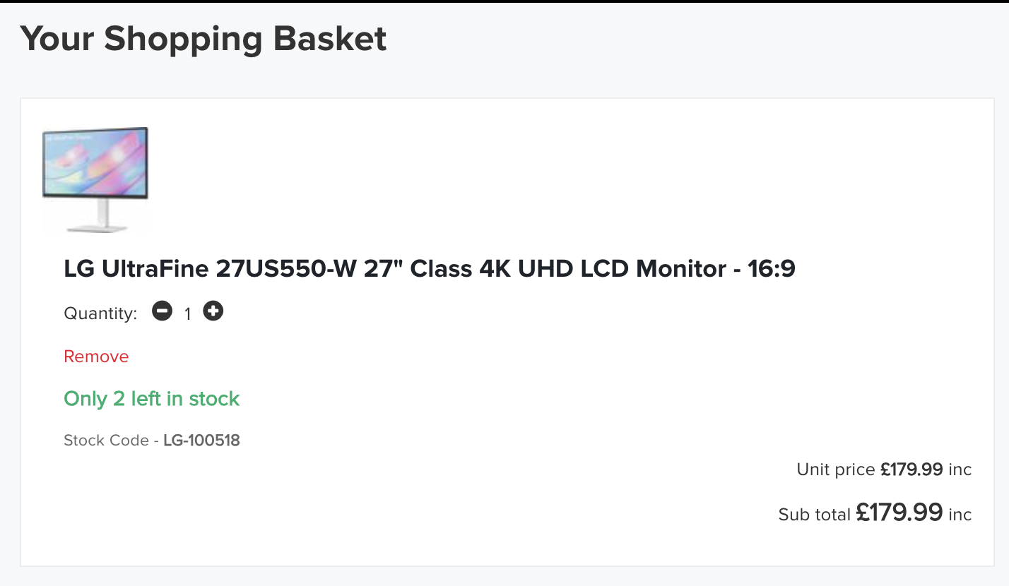
Monitor price before modifying
Monitor price after modifying
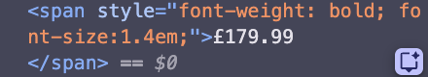
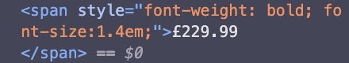

Description:
To test whether the application allows client-side price manipulation, a monitor was added to the shopping cart and the displayed price was modified using the browser’s Developer Tools (Elements tab). The original price of £229.99 was manually changed to £179.99, reducing it by £50 as required by the exercise. The modification was successfully reflected in the shopping cart view; however, the change affected only the HTML content displayed in the browser and did not modify any server-side data. After refreshing the page, the original price was restored, indicating that the application calculates and validates product prices on the server side and is not vulnerable to simple client-side price tampering.

Part 2 – measurement of value and analysis of performance indicators of websites and online services

This part focuses on evaluating the performance of selected websites and online services using Lighthouse metrics available in Google Chrome DevTools. For each URL, key performance indicators are measured and analyzed. The obtained results are then compared to identify strengths, weaknesses, and potential areas for optimization.
Key performance indicators:
First Contentful Paint (FCP): Time until the first visible content appears on the screen.
Total Blocking Time (TBT): Total time during which the page is blocked and cannot respond to user input.
Speed Index (SI): How quickly the visible content of the page is displayed.
Largest Contentful Paint (LCP): Time until the largest visible element on the page is fully loaded.
Cumulative Layout Shift (CLS): Measures unexpected visual shifts of page elements during loading (lower is better).

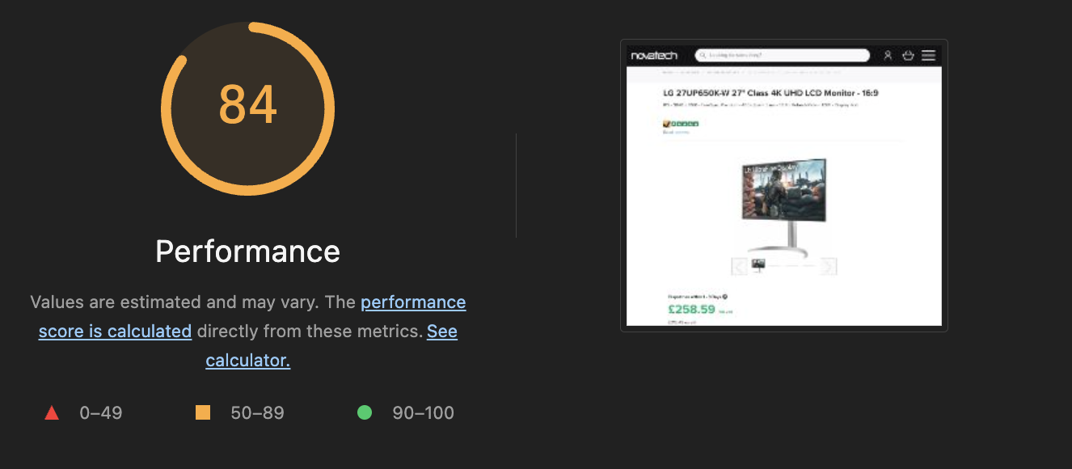
First URL – novatech shop

Overall performance measurement for URL: https://www.novatech.co.uk/products/lg-27up650k-w-27-inch-class-4k-uhd-lcd-monitor-169/27up650k-w.aek.html

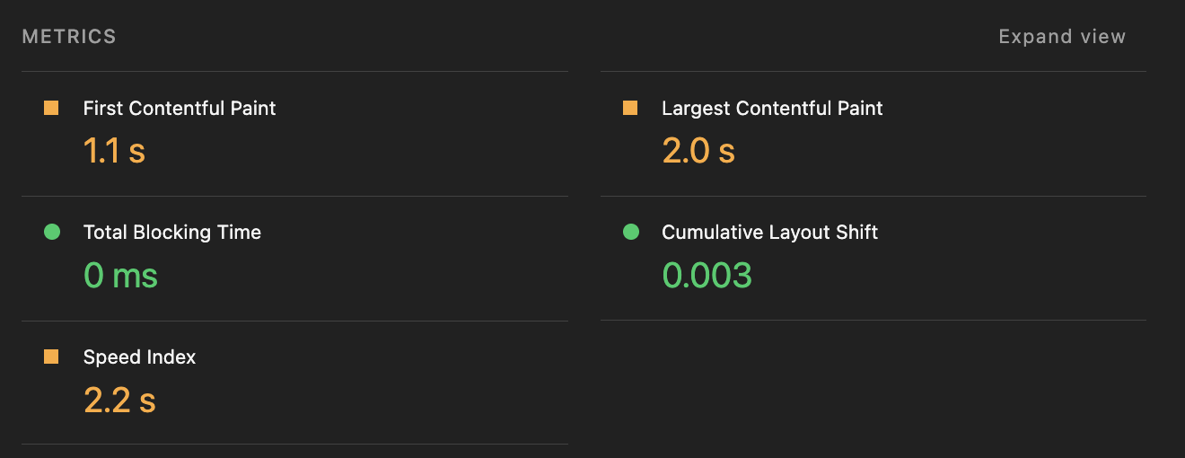
Lighthouse metrics

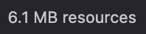
Page size: 6,1 MB

Second URL – Amazon Shop
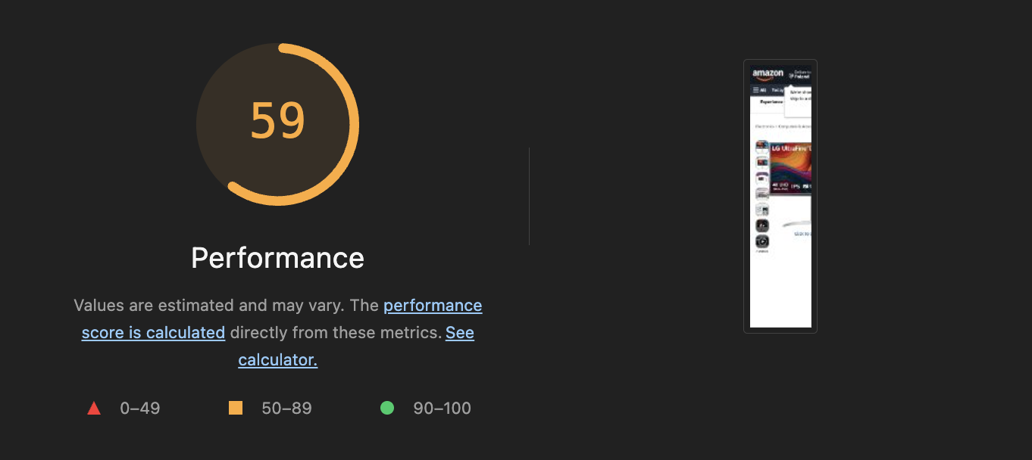
Overall performance measurement for URL: https://www.amazon.com/LG-27UP650K-W-DisplayHDR-DisplayPort-Adjustable/dp/B0DS2TCW9L

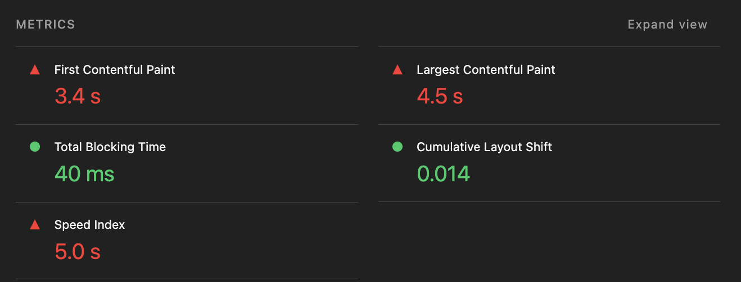

Lighthouse metrics

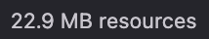
Page size: 22,9 MB

Third URL – Official PWR’s W4n website
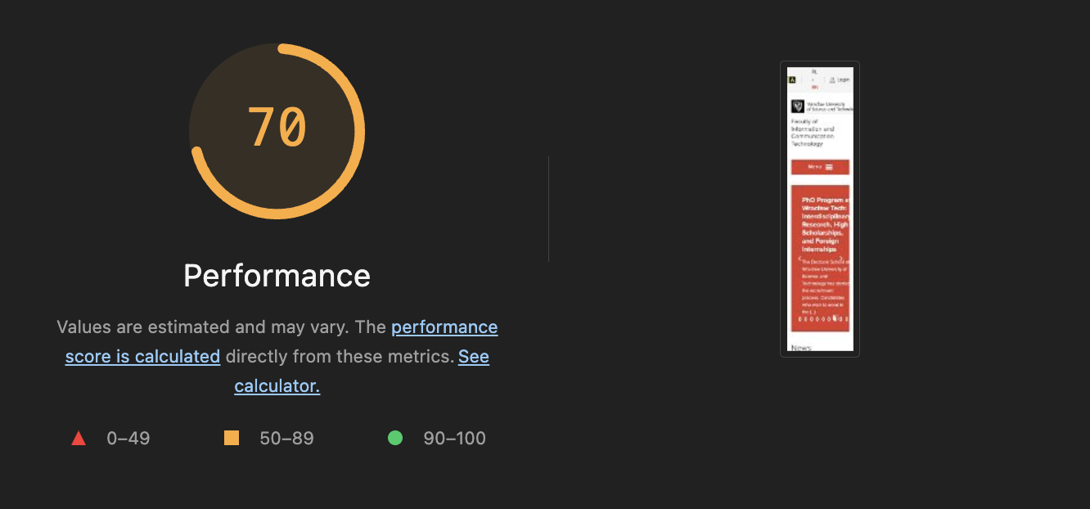

Overall performance measurement for URL: https://wit.pwr.edu.pl/en/

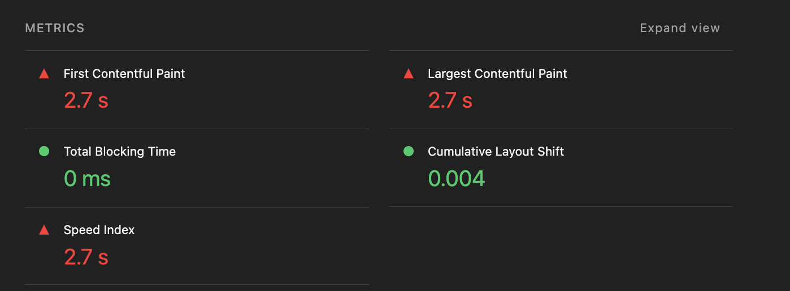

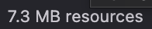
Lighthouse metrics

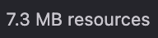
Page size: 7,3 MB

Fourth URL – PWR’s article

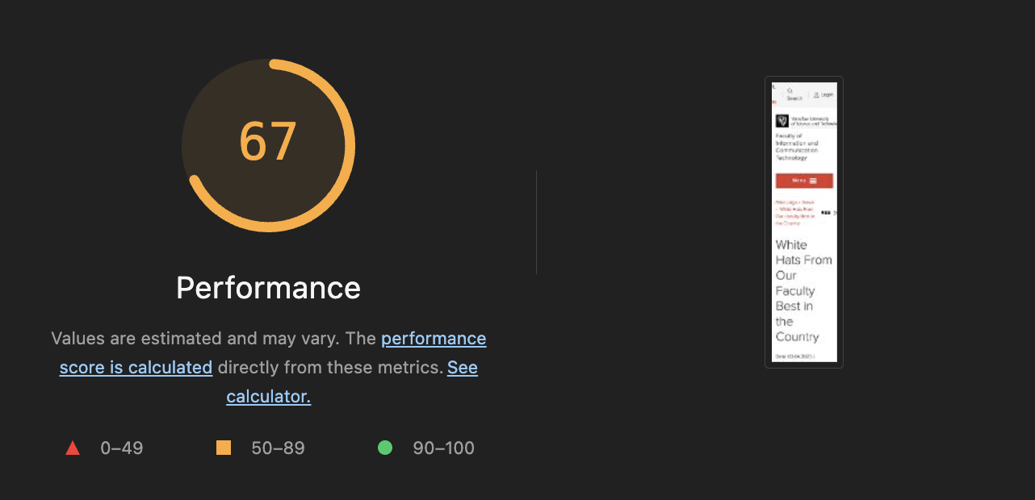
Overall performance measurement for URL: https://wit.pwr.edu.pl/en/news/white-hats-from-our-faculty-best-in-the-country-278.html

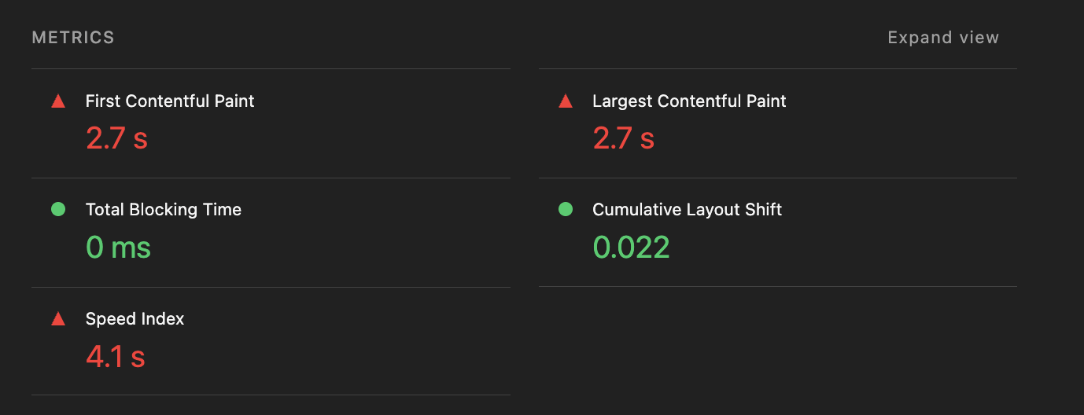

Lighthouse metrics

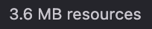
Page size: 3,6 MB

Comparison

URL | FCP | LCP | TBT | SI | CLS
A - Novatech | 1.1 | 2.0 | 0 | 2.2 | 0.003
B - Amazon | 3.4 | 4.5 | 40 | 5.0 | 0.014
C – WIT Main page | 2.7 | 2.7 | 0 | 2.7 | 0.004
D – WIT news page | 2.7 | 2.7 | 0 | 4.1 | 0.022
Lighthouse performance metrics table

URL | Page size
A - Novatech | 6,1 MB
B - Amazon | 22,9 MB
C – WIT Main page | 7,3 MB
D – WIT news page | 3,6 MB
Page sizes comparison

The comparison indicates that the Novatech product page achieved the best overall performance despite not having the smallest page size. It recorded the lowest loading times and the most stable layout. The Amazon product page had the largest page size (22.9 MB), which is reflected in the highest FCP, LCP, and Speed Index values. The WIT main page and news page showed similar loading times, although the news page had the smallest page size (3.6 MB) but a higher Speed Index and CLS value. This demonstrates that page size alone does not determine website performance, as factors such as page structure, scripts, and resource optimization also have a significant impact on user experience.

Part 3 – e2e tests

For this exercise, an end-to-end (E2E) test was implemented using the Playwright framework in Visual Studio Code. The automated test reproduces the complete user scenario defined in Exercise 1, including product browsing, filtering, adding products to the shopping cart, modifying product quantity, selecting the delivery method, and proceeding to secure checkout. The purpose of the test is to verify that the website functionality works correctly from the user’s perspective and that the entire purchasing workflow can be executed automatically without manual interaction.

Playwright Codegen was used to record the user interactions performed on the Novatech website. During the recording process, the tool automatically generated test actions corresponding to the executed scenario.
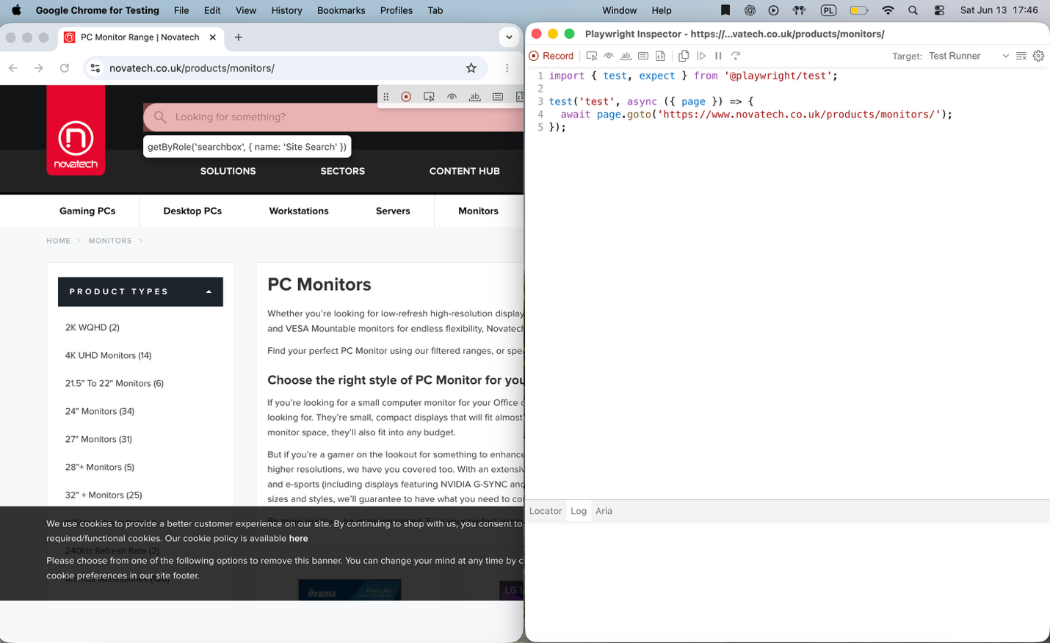
Playwright Code Generation

The generated Playwright code was reviewed and completed in Visual Studio Code. The test automates the entire purchasing scenario, including product selection, filtering, adding items to the basket, choosing a delivery method, and proceeding to secure checkout.
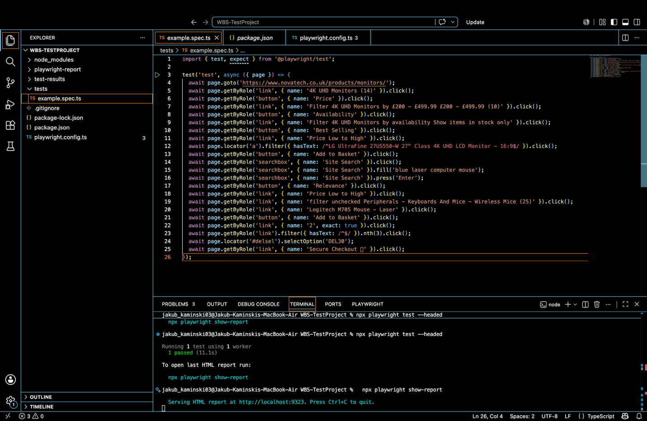

Automated Test Implementation

The Playwright HTML report confirms the successful execution of the automated test. All steps of the scenario were completed without errors, and detailed execution times were recorded for each action.
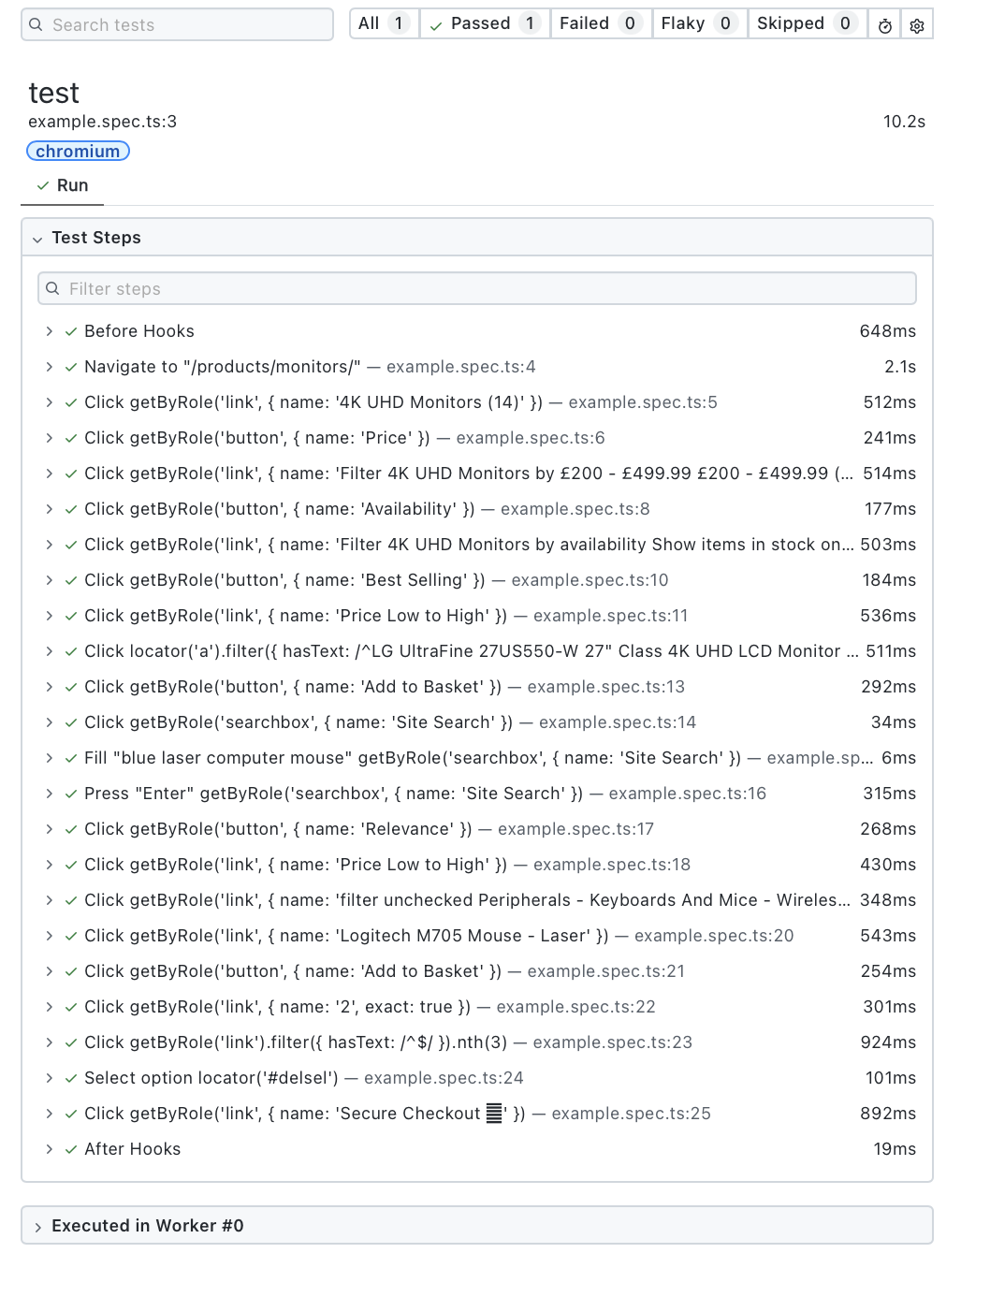

Test Execution Report

Conclusions

The project demonstrated the analysis of a modern e-commerce application using browser developer tools, network traffic monitoring, performance measurement techniques, and automated end-to-end testing. The recorded network logs made it possible to examine browser-server communication during key stages of the shopping process, including shopping cart management, delivery selection, and checkout initiation.
The security-related exercise showed that modifying product prices through browser developer tools affects only the client-side presentation and does not alter server-side data, confirming that price validation is performed on the server. The performance analysis revealed noticeable differences between the examined websites, with the Novatech product page achieving the best overall Lighthouse results, while Amazon exhibited the highest resource consumption and loading times.
Finally, the complete shopping scenario was successfully automated using the Playwright framework. The generated and executed E2E test confirmed that the purchasing workflow can be reliably reproduced and validated without manual interaction. Overall, the project provided practical experience in web application analysis, performance evaluation, and automated testing.

