

Instituto Politecnico Nacional

Escuela Superior de Computacion

Class: Distributed Data Base

Group: 3cm4

Profesor: Hernandez Contreras Euler

Alumno: Urban Reyes Adan

Boleta: 2012630450

Email: [ayanializita@gmail.com](mailto:ayanializita@gmail.com)

Tema: Session Laboratory One (Electra)

Table of Contents

Theoretical framework 3

Feature Set 4

Set Relations 4

Cardinality 5

Relational model 6

Instructions and ScreanShot 7

--1. In that state there are branches of electra? 9

--2. Many customers (in number) last name Hernandez 10

--3. Show the branch name the state where they were discharged from customers who last name Urban 10

--4. What is the amount of credit you have customers who make more than $ 10,000 11

--5. That exist in the product categories to show (name and product category) 11

--6. Rename relationship and call the store branch; 12

--7. Add a field in the branch connection to store the telephone extention 13

--8. Rename the name field in the client relationship associated call 14

--9. Increase the size of the mark data type field in the output ratio and allows to store 60 characters 15

10. Structurar customer relations to store multiple emails and 16

associate with customer 16

Conclusions 17

References 17

Theoretical framework

The database concept arises from the need to organize and store large amounts of information and then queries effectively.  
Today industries generate a great deal of information which must be possible to analyze and modify if necessary, quickly anaffordably.  
A database is a collection of related data, designed to meet the information needs of an organization.

A database system is a form of organization that through a computer might contain records, that is a collection of data files which can perform multiple operations.  
The data record is permanently in multiple files and various applications are used to extract records or consultations or add records to the appropriate files.

Basic Concepts

The entity-relationship model is a model consisting of objects called entities  
which they are a collection of data in the real world, and relationships  
between these. It was developed to represent the logical structure of the data by way of a scheme of the company and its struct. The importance of the entity-relationship model is the representation of the meaning of the data.  
The data model uses three basic concepts for its development, which are the entity sets, sets of relationships and attributes.

Feature Set

An entity is an object that is distinct from all other objects, has a set of features that make the object itself and assigned some values for some set of properties which can identify another object uniquely.  
An entity is represented by a set of attributes, those attributes describe characteristics that each object has a set of entities. By designating an attribute for each set of entities, it appears that the database stores information of the same species and that concerns every entity set of entities, however  
Each entity has its own value for each of its attributes.  
A set of entities, should be the same type and characteristics are that share the same properties or attributes.

Set Relations

A relationship is an association between different entities; a set of relationships is an association of relations of the same type can have 2 or more sets of entities.  
The sets of entities involved in a set of relations generally  
are different, this means that the role of each is not usually specified, but there are sets of entities involved in a relationship more than once with different roles, such set of relationships, usually called recursive and must be specified the role of each entity as part of the relationship.

Cardinality

One to One

An entity of A only associated with an entity B, and entity B  
only associated with an entity of A.

One to Many

A entity is associated with any entity B, but B entity can only be associated with a single entity A.

Many to Many

An entity A can be associated with any entity of the entities B and B They can be associated with any entity in A.

Relational model

A relational database is a set of tables which are assigned a unique name. Each table represents a relationship between a set value, this implies that a table is equivalent to a relationship of the entity relationship model.

The relational model is responsible for the structure of the information, ma  
manipulation of information and data integrity, and this is done through two important concepts, relational algebra and relational calculus.

Instructions and ScreanShot

mysql -u root -p

Enter password: (here enter password of mysql)

create schema electra;

use electra;

source /home/ayan/distributeDataBase/labs/electra/electra.sql

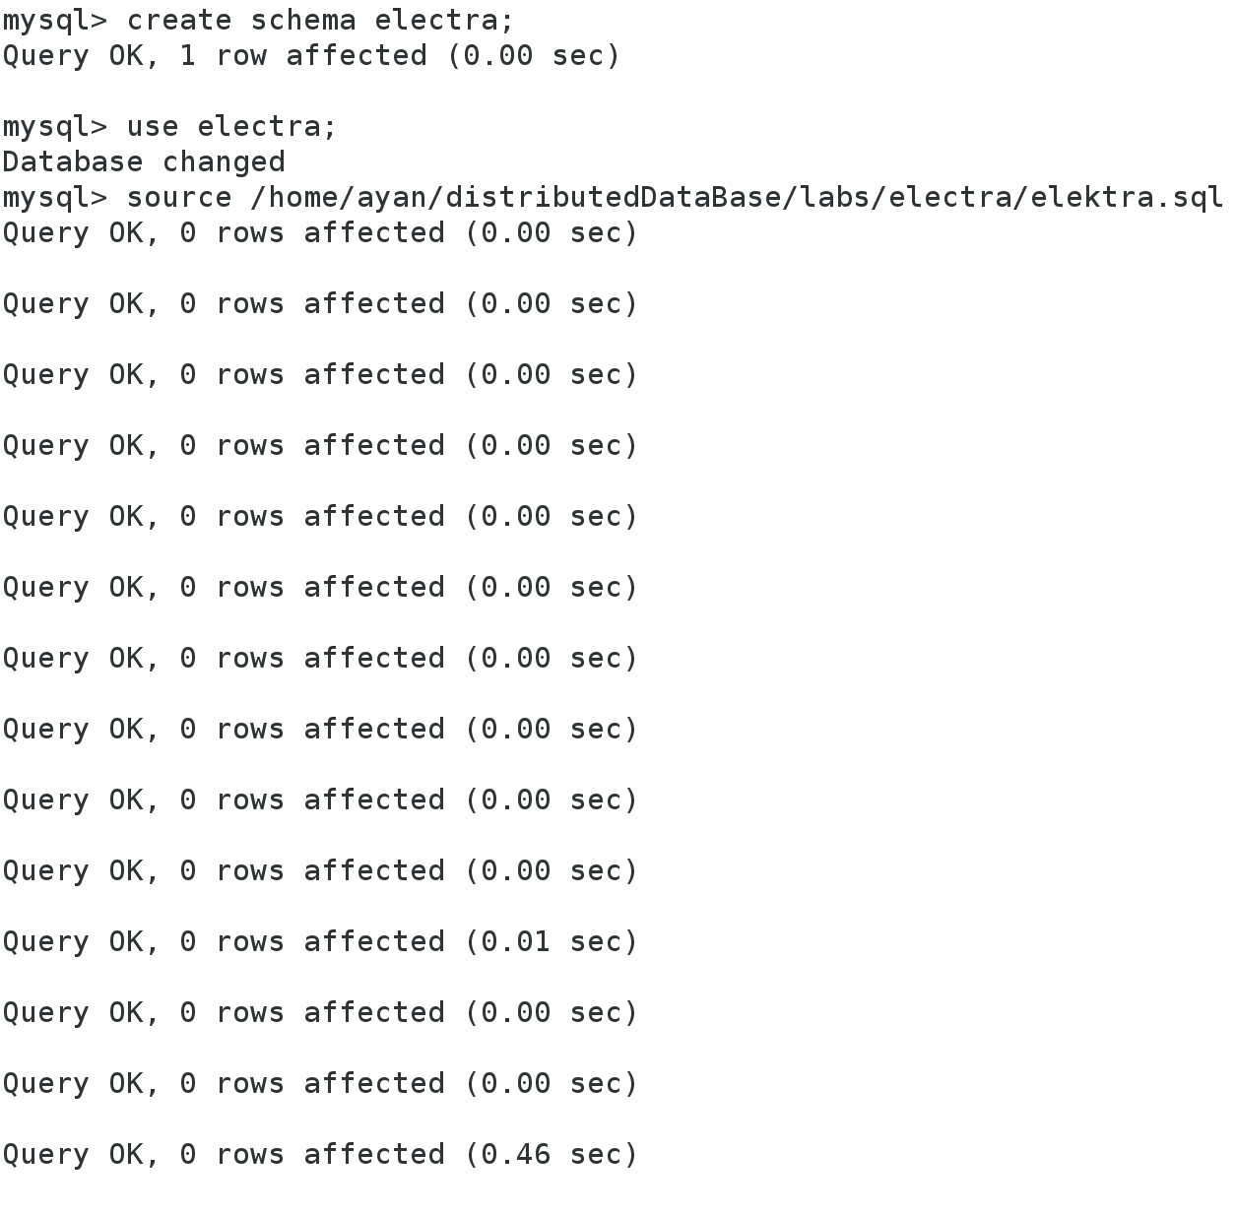

--1. In that state there are branches of electra?

select distinct estado from tienda order by estado;-- sequential read so takes longer

select estado from tienda group by estado;--sequential read indexes so less time

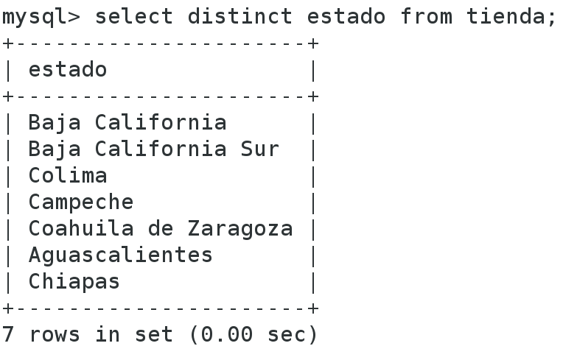

--2. Many customers (in number) last name Hernandez

select count(*) from cliente where apPaterno='Hernandez';

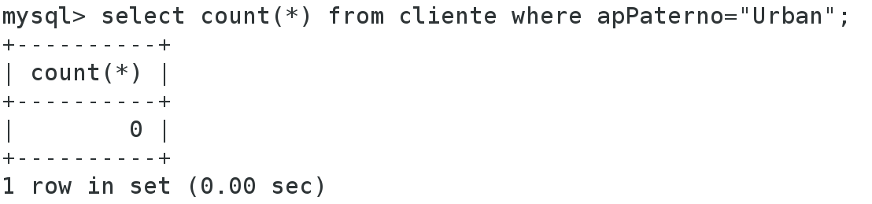

--3. Show the branch name the state where they were discharged from customers who last name Urban

select s.nombre s.estado from tienda s, cliente c, pago p where c.idCliente=p.idCliente and p.idTienda=s.idTienda and c.apPaterno="Urban";

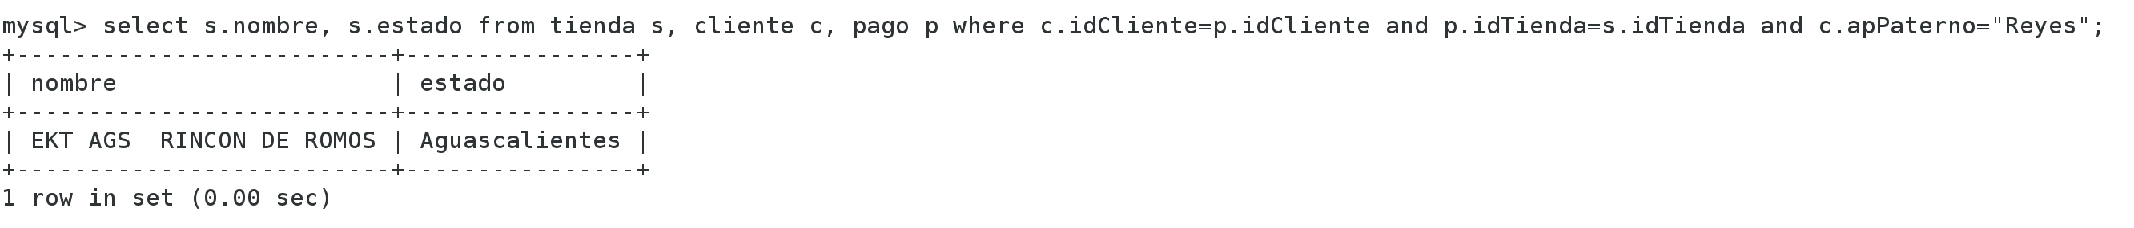

--4. What is the amount of credit you have customers who make more than $ 10,000

select cr.monto from cliente c, credito cr, pago p where c.idcliente=p.idcliente and cr.idcredito=p.idcredito and c.salario>10000;

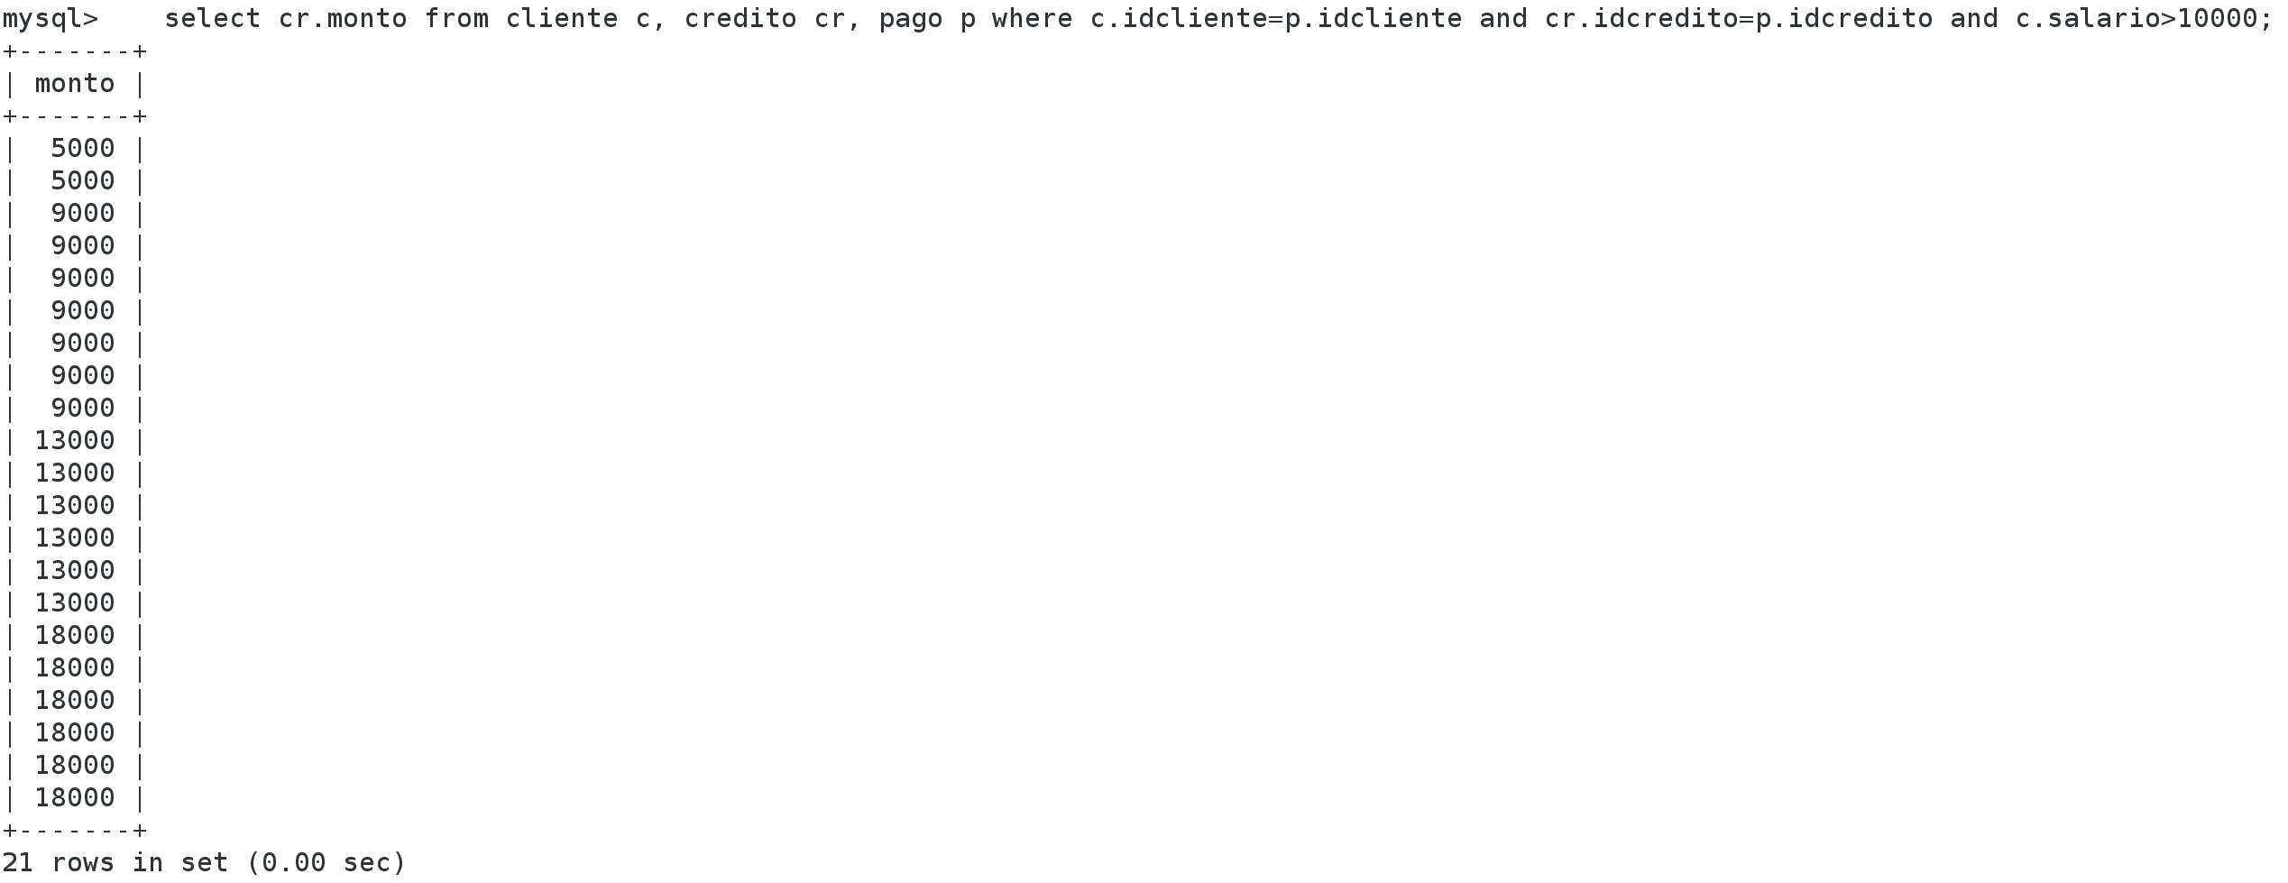

--5. That exist in the product categories to show (name and product category)

select p.nombre as producto, c.nombre as categoria from categoria c, producto p, subcategoria sc where p.idsubcategoria=sc.idsubcategoria and sc.idcategoria=c.idcategoria;

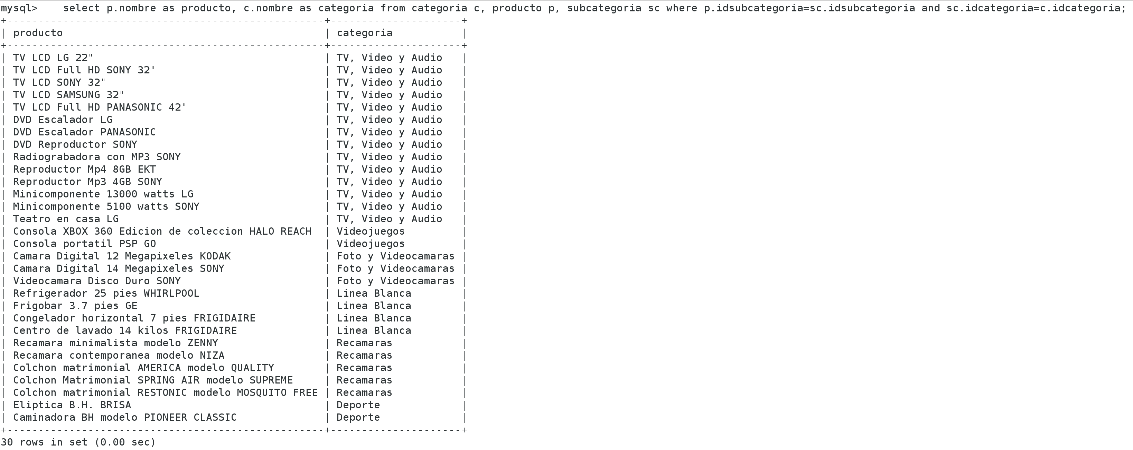

--6. Rename relationship and call the store branch;

show tables;

alter table tienda rename as sucursal;

show tables;

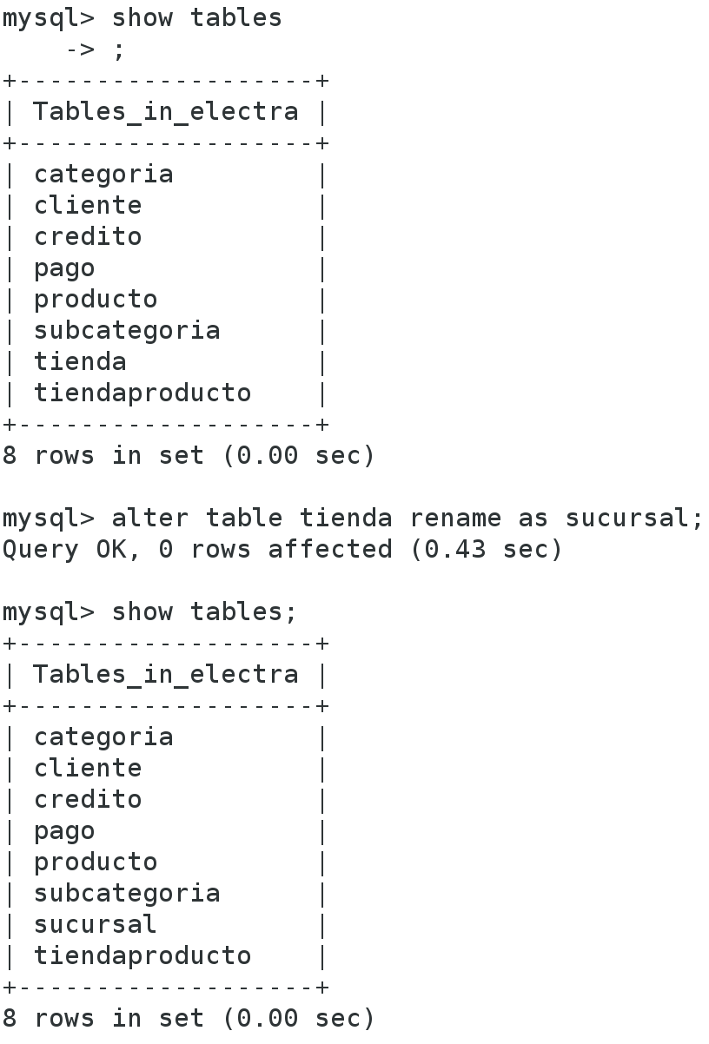

--7. Add a field in the branch connection to store the telephone extention

describe sucursal;

alter table sucursal add column extencion varchar(15);

describe sucursal;

-- alter table nameTable add column nameNewColumn typeofNewColumn

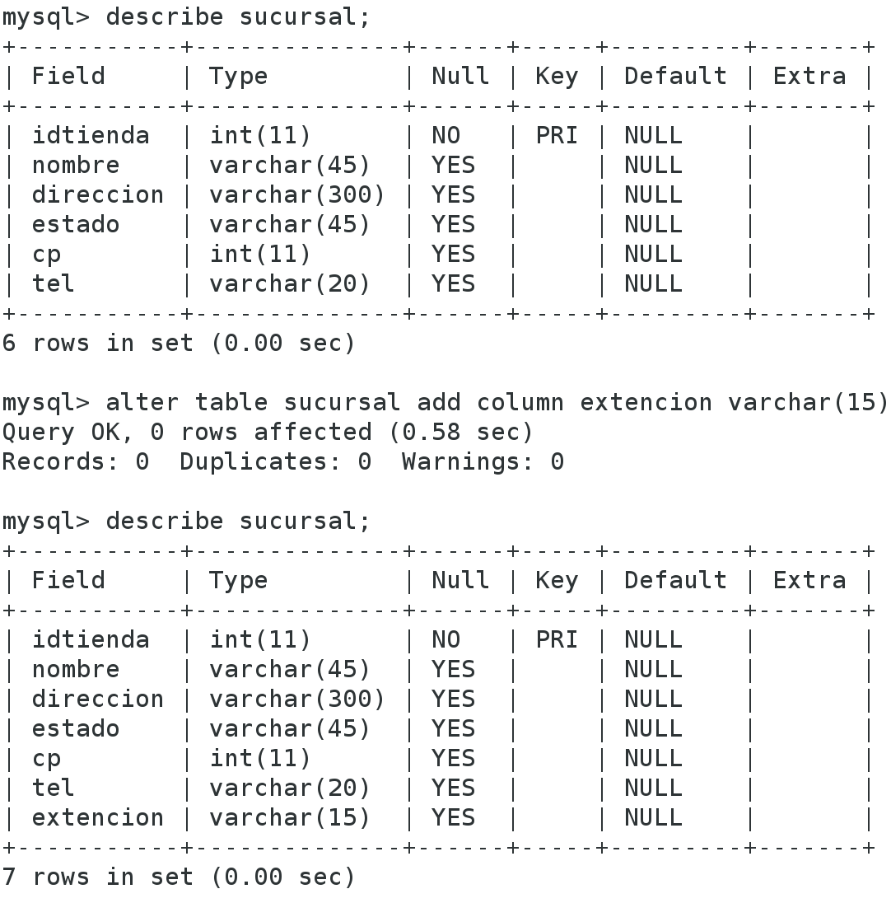

--8. Rename the name field in the client relationship associated call

describe cliente;

alter table cliente change column nombre asociado varchar(45);

describe cliente;

-- alter table nameTable change column oldNameColumn newNameColumn typeDataofOldNameColumn;

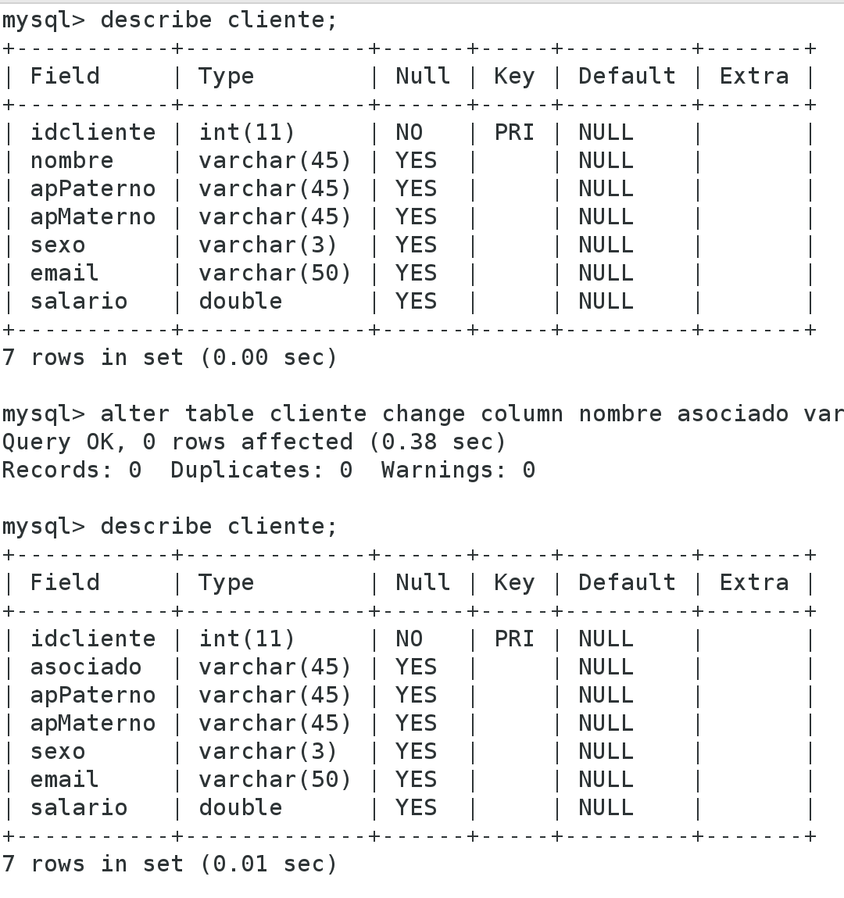

--9. Increase the size of the mark data type field in the output ratio and allows to store 60 characters

alter table producto modify column marca varchar(60);

-- alter table nameTable modify column nameColumn changes;

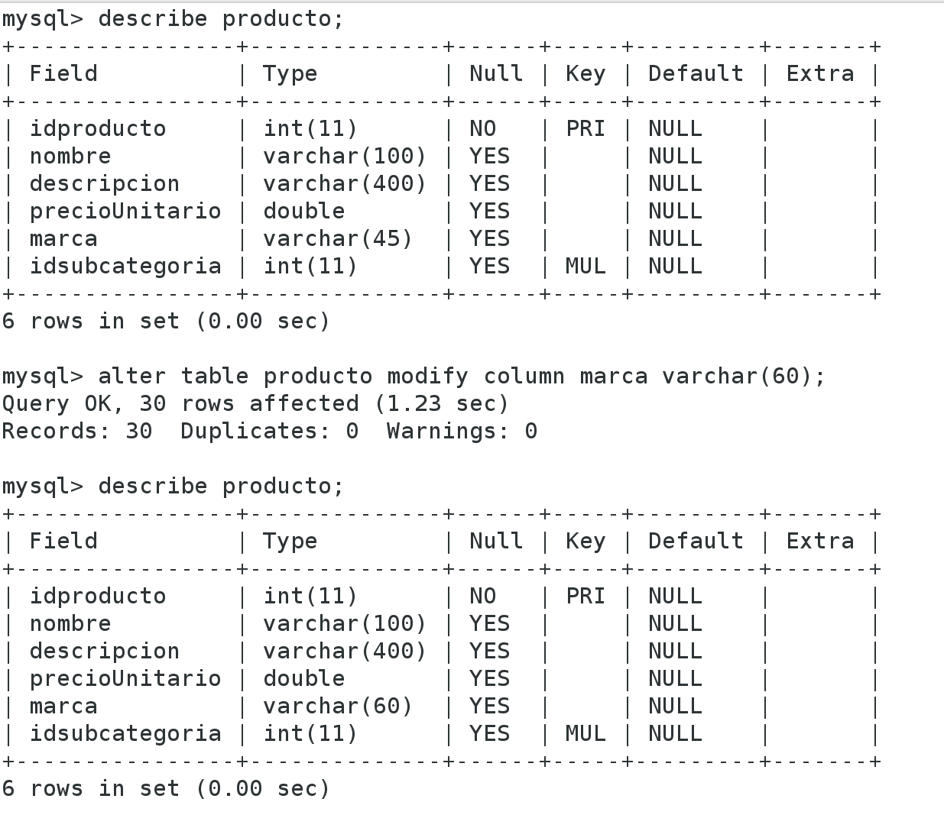

–

10. Structurar customer relations to store multiple emails and

associate with customer

create table emailClient(idClient int not null, email varchar(50) not null, primary key(idClient,email), foreign key(idClient) references cliente(idcliente) on delete cascade on update cascade);

insert into emailClient(select idcliente,email from cliente where email is not NULL and email not like "NULL%");

alter table cliente drop column email;

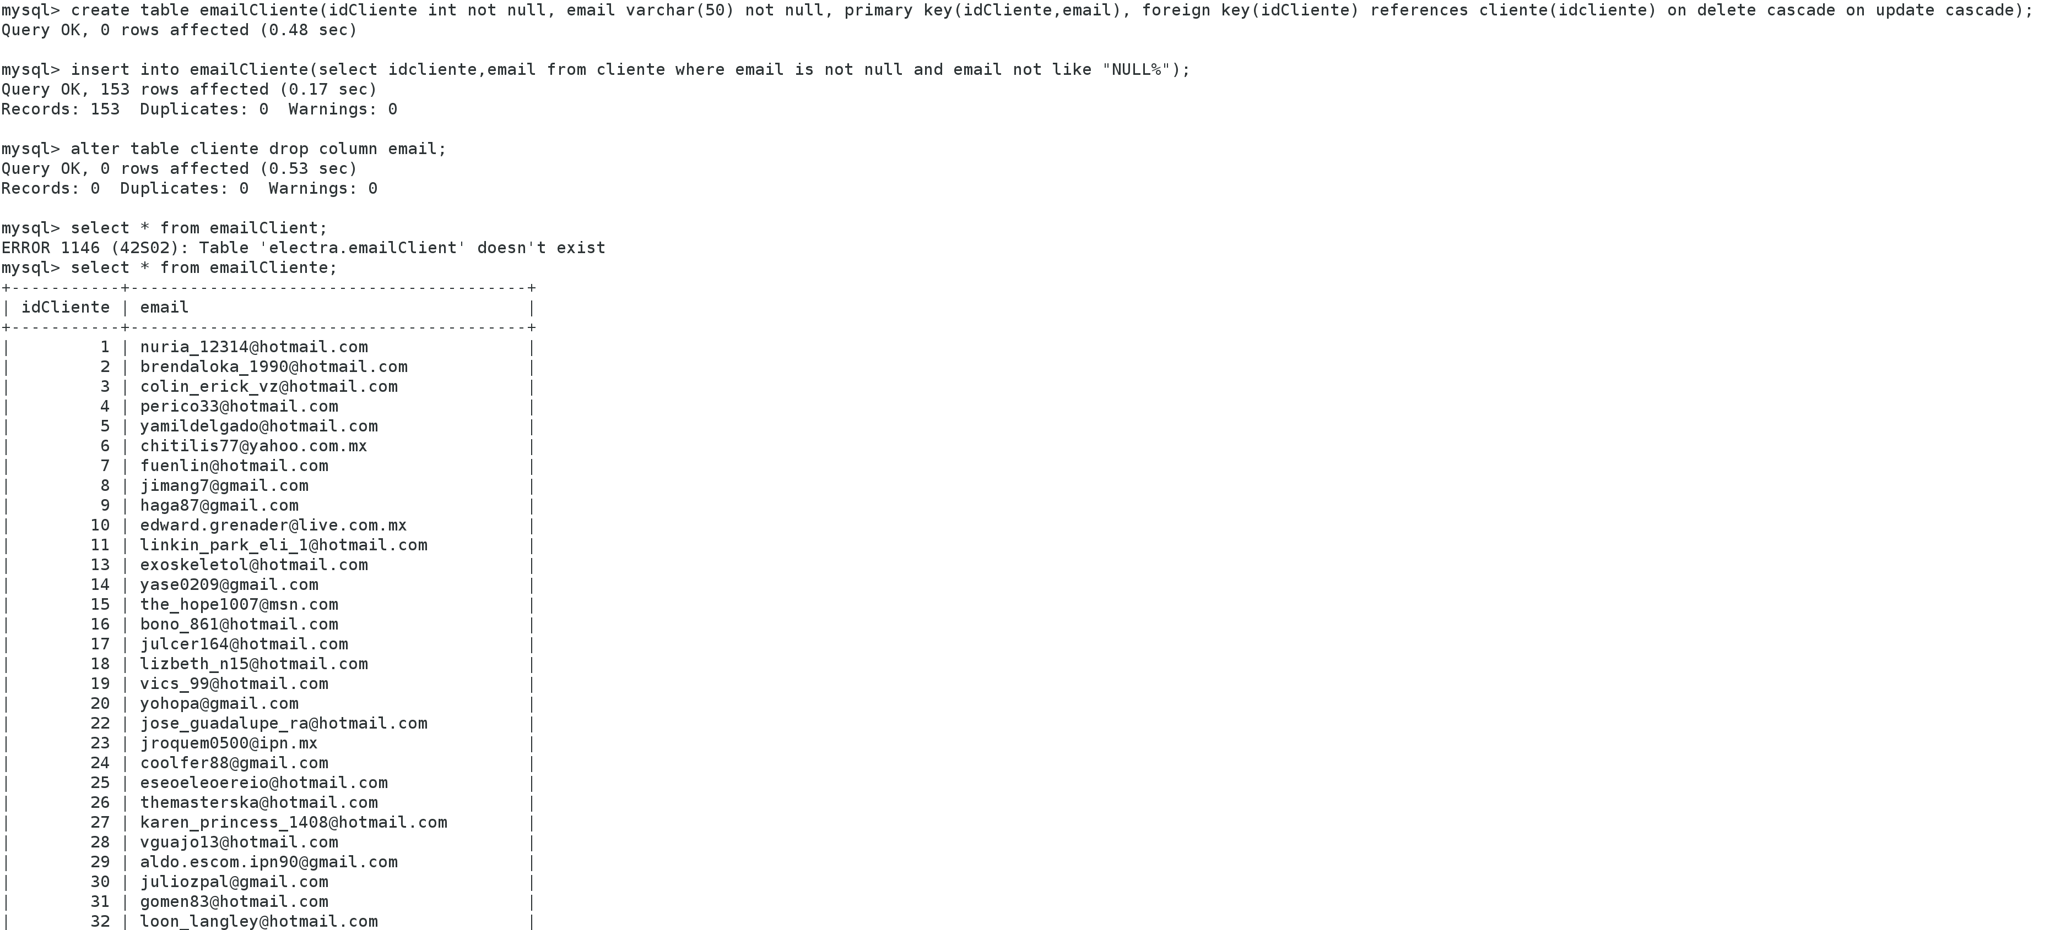

Conclusions

You can see in some cases, the questions can be solved in different ways, being that some are better in terms of cost or time.  
The steps to resolve a query least for me would be:  
See tables related to this consultation.  
See that attribute the joins these tables  
Apply the SQL statements and conditions for these tables.

References

http://www.ptolomeo.unam.mx:8080/xmlui/bitstream/handle/132.248.52.100/228/A4.pdf?sequence=4