

Instituto Politecnico Nacional

Escuela Superior de Computacion

Class: Distributed Data Base

Group: 3cm4

Profesor: Hernandez Contreras Euler

Alumno: Urban Reyes Adan

Boleta: 2012630450

Email: [ayanializita@gmail.com](mailto:ayanializita@gmail.com)

Tema: Session Laboratory Three (MixUp)

Table of Contents

Instructions and ScreanShot 2

--1. show the item name and the department to which it belongs 3

--2. display the name of the partner and the branch to which he was discharged 5

3.- show item name and unit price of items 7

4.- show items that cost between 500 and 2000 pesos 8

5.- show the data of partners Garcia last name 9

6.- mixup which are found in the df 10

7.- the associated display data that were discharged in Cuernavaca arrange them alphabetically 11

8.- display the name of the location of branches and those that have the zip code 11510 and 58270,27001.7760 11

9. few items (in number) have in their description "iPhone 6" 12

10. that departments have branches located in Queretaro 12

11. add 2 members and assign them to Acapulco & mixup tuxtla mixup galleries 13

Conclusions 14

References 14

Instructions and ScreanShot

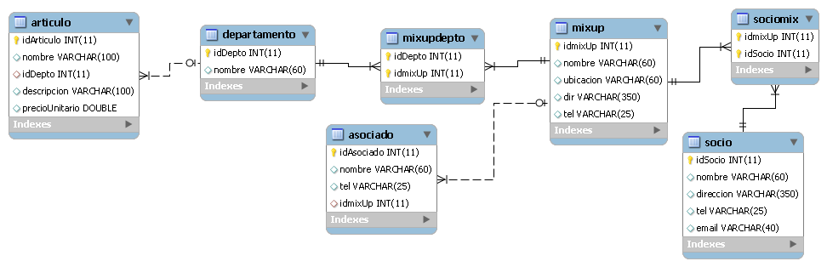

mysql -u root -p

Enter password: (here enter password of mysql)

create schema mixup;

use mixup;

source /home/ayan/distributeDataBase/labs/mixup/mixup.sql

--1. show the item name and the department to which it belongs

select a.nombre as articulo, d.nombre as departamento from articulo a join departamento d on a.idDepto=d.idDepto order by d.nombre,a.nombre;

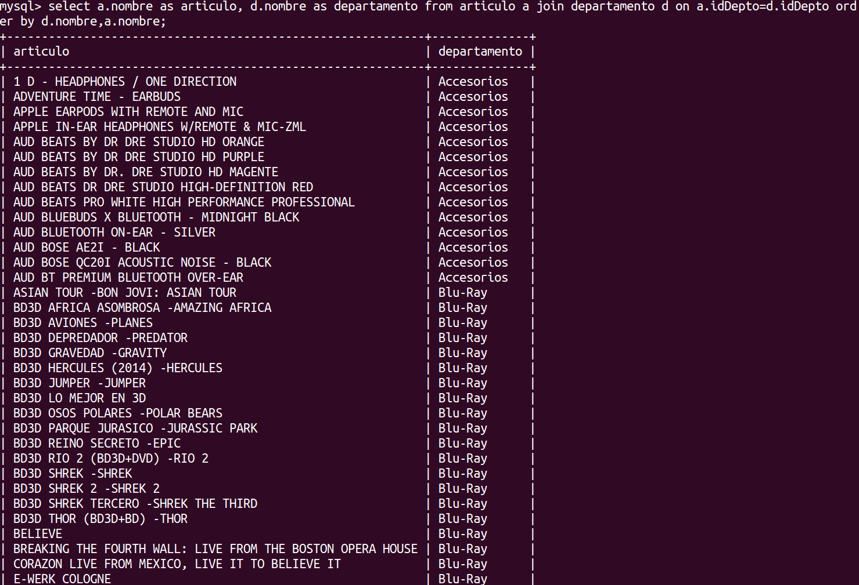

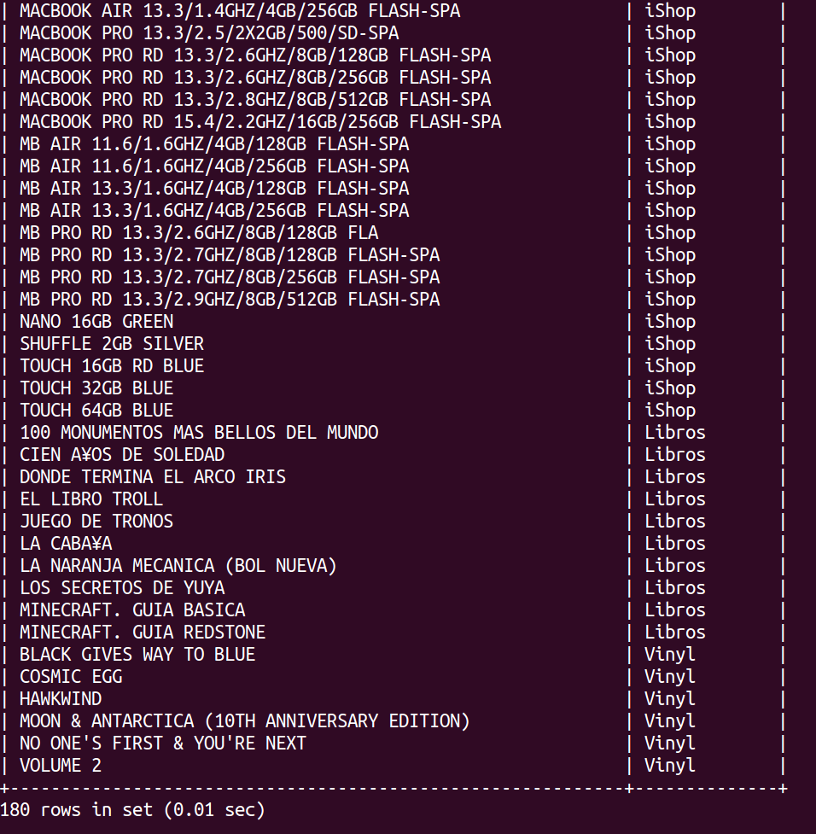

--2. display the name of the partner and the branch to which he was discharged

select s.nombre as socio, m.nombre from socio s join sociomix sm on s.idsocio=sm.idsocio join mixup m on m.idmixup=sm.idmixup order by m.nombre, s.nombre desc;

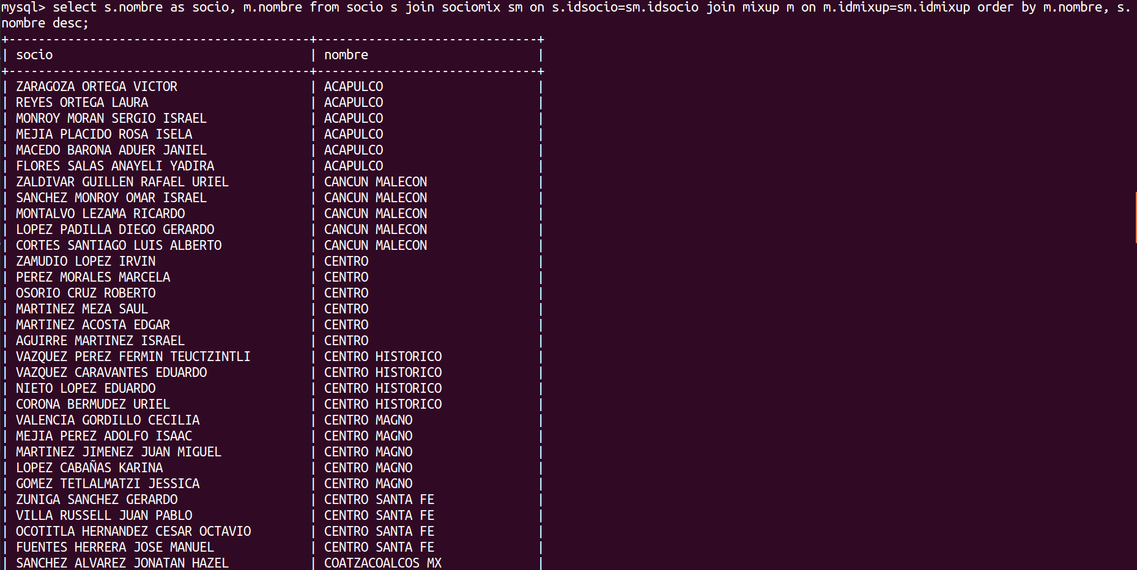

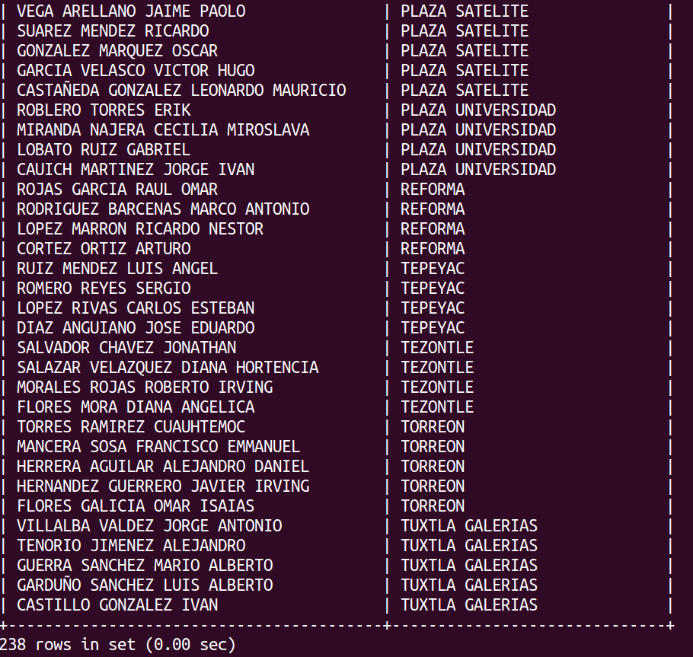

3.- show item name and unit price of items

select a.nombre, a.precioUnitario from articulo a join departamento d on a.iddepto=d.iddepto where d.nombre like "%accesorios%" order by a.preciounitario;

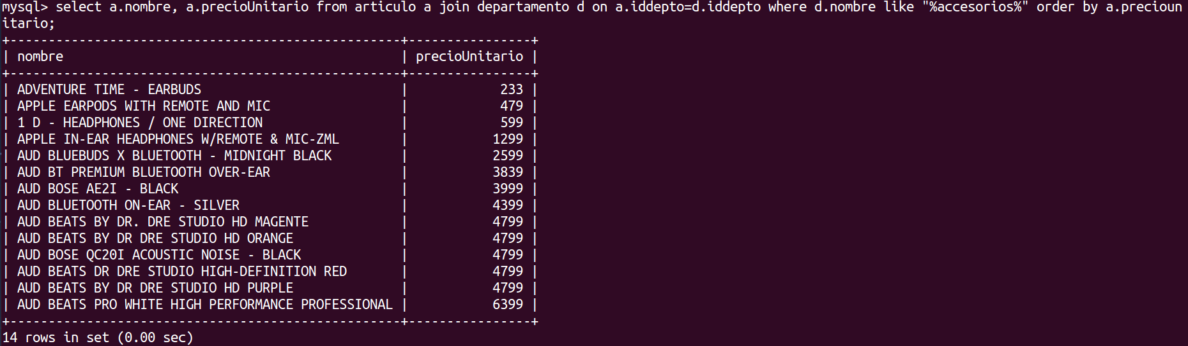

4.- show items that cost between 500 and 2000 pesos

select a.nombre as articulo, a.precioUnitario as precio from articulo a where a.preciounitario between 500 and 2000 order by a.preciounitario;

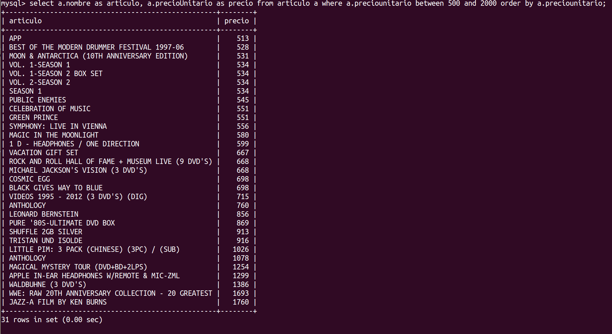

5.- show the data of partners Garcia last name

select * from asociado where nombre like "%Garc_a%";

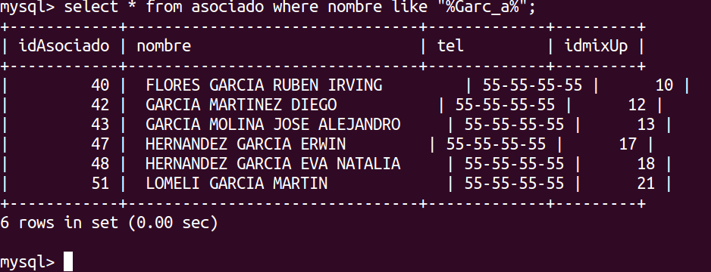

6.- mixup which are found in the df

select nombre,ubicacion from mixup where ubicacion like "%DF%" order by nombre;

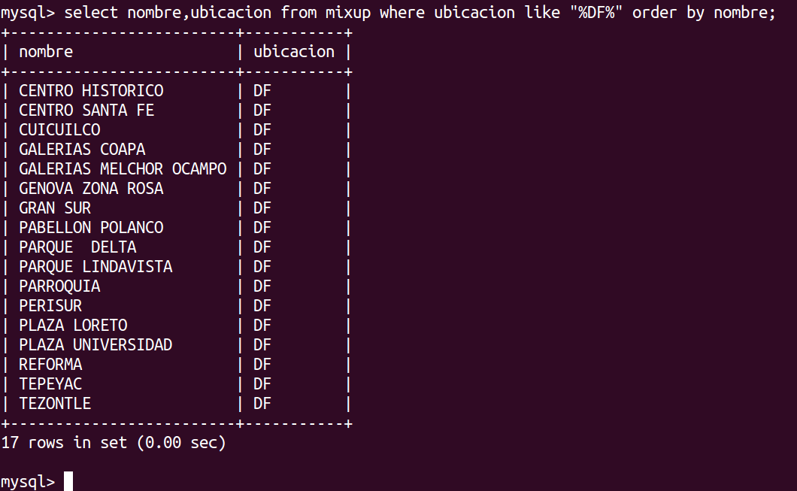

7.- the associated display data that were discharged in Cuernavaca arrange them alphabetically

select a.*, m.nombre from asociado a join mixup m on a.idmixup=m.idmixup where m.ubicacion like "%Cuenta%" order by a.nombre;

8.- display the name of the location of branches and those that have the zip code 11510 and 58270,27001.7760

select nombre, ubicacion from mixup where dir like "%58270%" or dir like "%27001%" or dir like "%7760%" or dir like "%11510%";

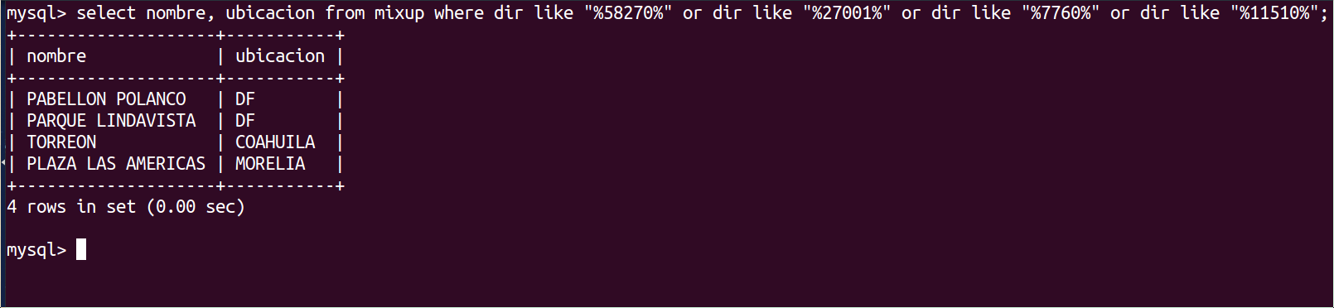

9. few items (in number) have in their description "iPhone 6"

select count(*) as iphones from articulo where descripcion like "%iphone 6%";

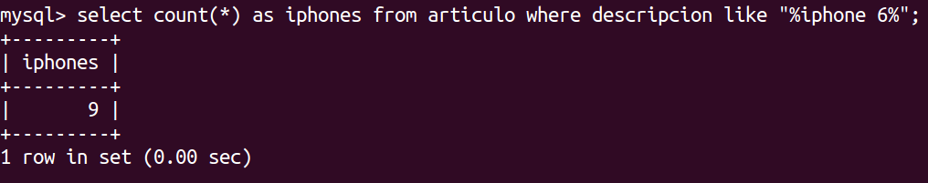

10. that departments have branches located in Queretaro

select distinct d.nombre from departamento d join mixupdepto md on md.iddepto=d.iddepto join mixup m on m.idmixup=md.idmixup where m.ubicacion like "Queretar%" order by d.nombre;

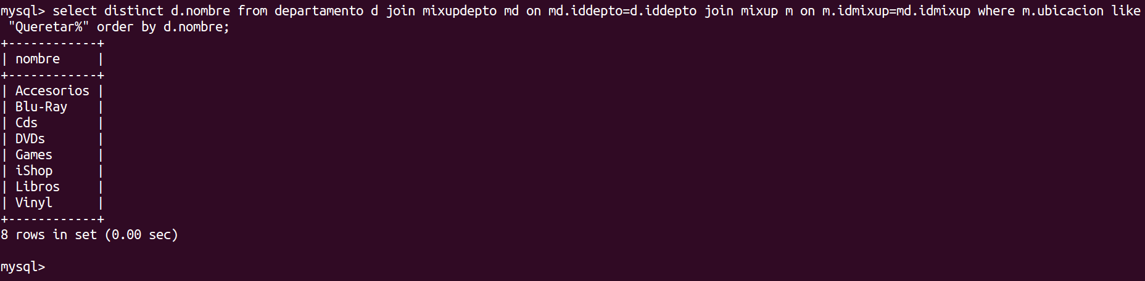

11. add 2 members and assign them to Acapulco & mixup tuxtla mixup galleries

insert into asociado values(2000,"PEREZ PEREZ PANCHITO","55-40-02-77-62",(select idmixup from mixup where nombre like "Acapulc%")),(2001,"CRUZ CRUZ XIMENA","55-18-89-59-98",(select idmixup from mixup where nombre like "Tuxtla Galeri%"));

select * from asociado where idasociado in(2000,2001);

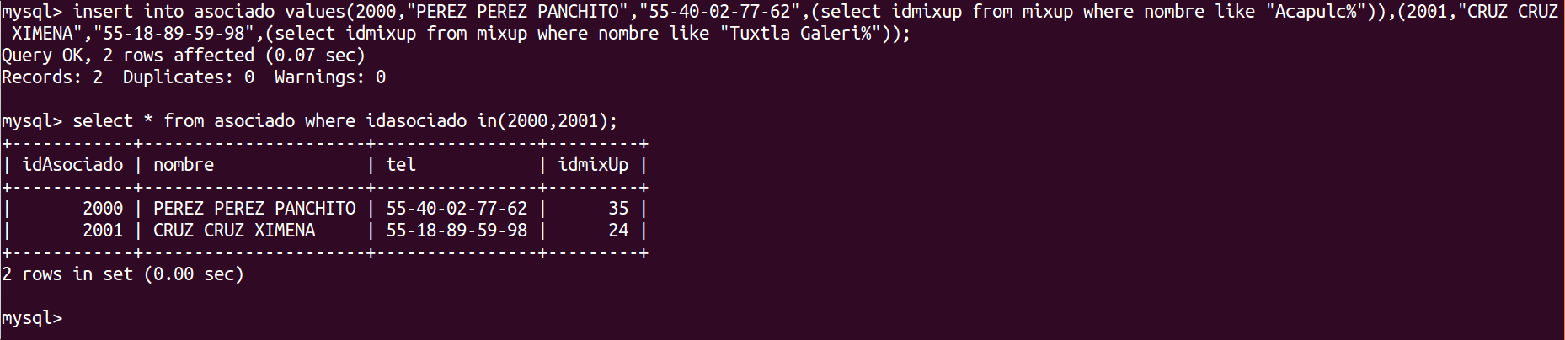

Conclusions

In this practice of laboratory I can learn best how make update of tables.

This was a repast of all practices past then I don not have much conclusions.

References

<http://www.ptolomeo.unam.mx:8080/xmlui/bitstream/handle/132.248.52.100/228/A4.pdf?sequence=4>

<http://uno-de-piera.com/introduccion-las-vistas-en-mysql/>

https://es.wikipedia.org/wiki/Vista_%28base_de_datos%29