

Instituto Politecnico Nacional

Escuela Superior de Computo

Class: Distributed Data Base

Group: 3cm4

Professor: Hernandez Contreras Euler

Student: Urban Reyes Adan

Boleta: 2012630450

Email: [ayanializita@gmail.com](mailto:ayanializita@gmail.com)

Team: Stored Procedure

Indice

Theoretical Framework 3

Instructions 4

Store Procedure 1 4

Store Procedure 2 4

Store Procedure 3 5

Store Procedure 4 5

Store Procedure 5 6

Store Procedure 6 7

Screan Shot 8

Stored Procedure 1 8

Stored Procedure 2 9

Stored Procedure 3 10

Stored Procedure 4 11

Stored Procedure 5 12

Stored Procedure 6 13

Referencias 14

Theoretical Framework

A stored procedure is a method to encapsulate repetitive tasks. They allow for variable declarations, flow control and other useful programming techniques.

The “academic” position on this is quite clear and supports the extensive use of stored procedures. On the other hand, when you consider the opinions of those who work with them day in, day out, you'll notice that reactions vary from complete, unwavering support to utter hate. Keep these in mind.

Stored Procedures in MySQL

MySQL is known as the most popular open source RDBMS which is widely used by both community and enterprise. However, during the first decade of its existence, it did not support stored procedures, sotred functions , triggers, and events. Since MySQL version 5.0, those features were added to MySQL database engine to make it more flexible and powerful.

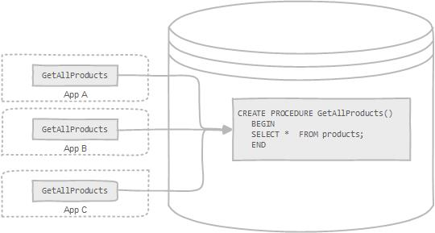

Instructions

Store Procedure 1

Get all teachers that they have like surname "Henandez"

delimiter #

create procedure pwsh()

begin

select * from profesor

where apPaterno like "Hern_ndez%"

order by apMaterno;

end #

delimiter ;

Store Procedure 2

Get all terminal works supervised by professor Fabiola Ocampo

delimiter &

create procedure twsbfo()

begin

select t.*

from tt t, dirige d, profesor p

where t.nott=d.nott

and d.idprof=p.idprof

and p.nombre like "Fabio%"

and p.apPaterno like "Ocampo%"

order by t.nott;

end &

delimiter ;

Store Procedure 3

Get the count termial work present on month of december 2009 so data of terminal work (terminal work join professor)

delimiter $

create procedure twomd2009()

begin

select count(*) as numberTerminalWorksPresented

from presentacion

where fecha like "2009-12%";

select t.nott, p.nombre, p.apPaterno, p.apMaterno

from tt t, profesor p,dirige d, presentacion x

where x.nott=t.nott

and t.nott=d.nott

and d.idprof=p.idprof

and x.fecha like "2009-12%"

order by x.fecha;

end $

delimiter ;

Store Procedure 4

Get the number of terminal work where the sinodal was the professor Andres Ortigoza so the presented

delimiter /

create procedure twpwsao()

begin

select t.nott

from tt t, sinodalia s, profesor p

where t.nott=s.nott

and (s.s1=p.idprof or s.s2=p.idprof or s.s3=p.idprof)

and p.nombre like "Andr_s%"

and p.apPaterno like "Ortigoz%"

order by t.nott;

select t.nott

from tt t, sinodalia s, profesor p, presentacion x

where t.nott=s.nott

and (s.s1=p.idprof or s.s2=p.idprof or s.s3=p.idprof)

and t.nott=x.nott

and p.nombre like "Andr_s%"

and p.apPaterno like "Ortigoz%"

order by x.fecha,t.nott;

end /

delimiter ;

Store Procedure 5

Get professor so information of terminal work where title is Redes Neuronales so his description

delimiter &#

create procedure twrn()

begin

select t.*, p.nombre, p.apPaterno

from tt t, profesor p, dirige d

where t.nott=d.nott

and d.idprof=p.idprof

and t.titulo like "%Redes Neuronales%"

order by p.apPaterno;

select p.nombre, p.apPaterno, ge.descripcion

from tt t, profesor p, dirige d, gradoprof gp, gradoestudios ge

where t.nott=d.nott

and d.idprof=p.idprof

and p.idprof=gp.idprof

and gp.idgrado=ge.idgrado

and t.titulo like "%Redes Neuronales%"

order by p.apPaterno;

end &#

delimiter ;

Store Procedure 6

Get terminal works remediales so the professor

delimiter ##

create procedure twrwp()

begin

select p.nott, p.fecha, p.califRevisor

from presentacion p

where p.tipo="TT R";

select p.nott, ps.nombre, ps.apPaterno

from presentacion p, tt t, sinodalia s, profesor ps

where p.nott=t.nott

and t.nott=s.nott

and (s.s1=ps.idprof or s.s2=ps.idprof or s.s3=ps.idprof)

and p.tipo="TT R";

end ##

delimiter ;

Screan Shot

Stored Procedure 1

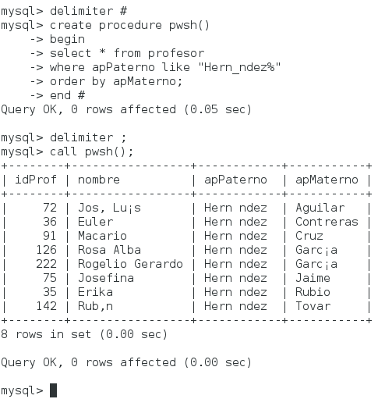

Stored Procedure 2

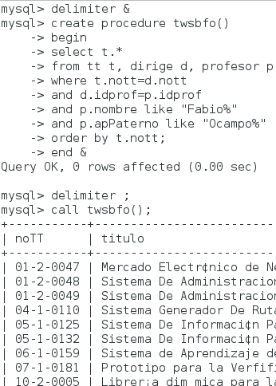

Stored Procedure 3

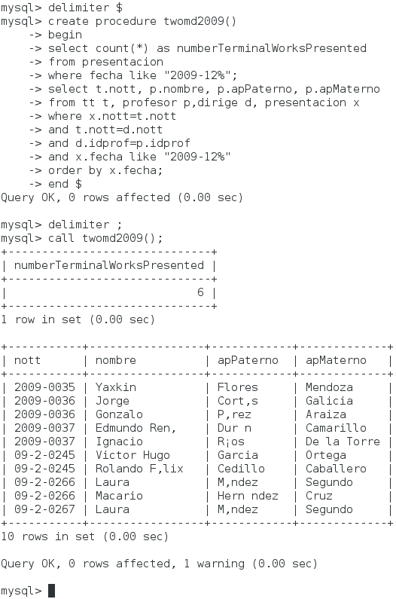

Stored Procedure 4

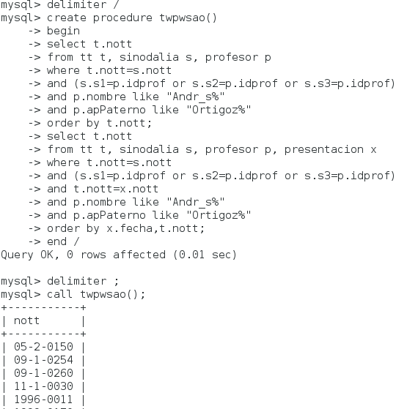

Stored Procedure 5

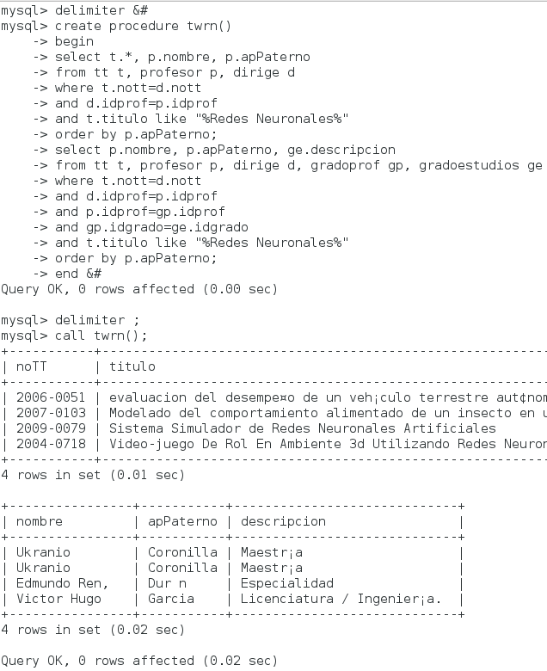

Stored Procedure 6

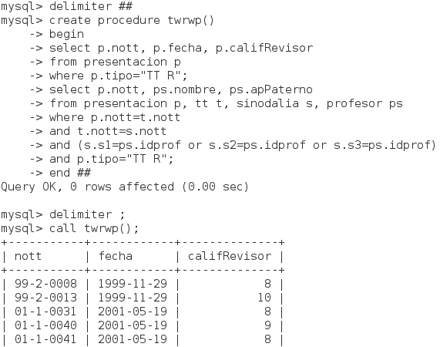

Referencias

<http://code.tutsplus.com/articles/an-introduction-to-stored-procedures-in-mysql-5--net-17843>

<http://www.mysqltutorial.org/introduction-to-sql-stored-procedures.aspx>

https://en.wikipedia.org/wiki/Stored_procedure