

Instituto Politecnico Nacional

Escuela Superior de Computo

Class: Distributed Data Base

Group: 3cm4

Professor: Hernandez Contreras Euler

Student: Urban Reyes Adan

Boleta: 2012630450

Email: [ayanializita@gmail.com](mailto:ayanializita@gmail.com)

Team: Stored Procedure

Index

Theoretical Framework 3

Instructions 4

Store Procedure 1 4

Store Procedure 2 4

Store Procedure 3 5

Store Procedure 4 5

Store Procedure 5 5

Store Procedure 6 6

Store Procedure 7 6

Store Procedure 8 7

Store Procedure 9 7

Store Procedure 10 8

Screan Shot 9

Load Data Base 9

Stored Procedure 1 9

Stored Procedure 2 10

Stored Procedure 3 10

Stored Procedure 4 11

Stored Procedure 5 12

Stored Procedure 6 13

Stored Procedure 7 13

Stored Procedure 8 14

Stored Procedure 9 15

Stored Procedure 10 16

References 17

Theoretical Framework

When we develop an application (for safety) to be vigilant with validations, you avoid the user having to enter the least amount of data possible. Efforts are needed to reduce server load, split the job, get the most effective way of carrying out the procedures, etc.

A stored procedure is a method to encapsulate repetitive tasks. They allow for variable declarations, flow control and other useful programming techniques.

The “academic” position on this is quite clear and supports the extensive use of stored procedures. On the other hand, when you consider the opinions of those who work with them day in, day out, you'll notice that reactions vary from complete, unwavering support to utter hate. Keep these in mind.

Stored Procedures in MySQL

MySQL is known as the most popular open source RDBMS which is widely used by both community and enterprise. However, during the first decade of its existence, it did not support stored procedures, sotred functions , triggers, and events. Since MySQL version 5.0, those features were added to MySQL database engine to make it more flexible and powerful.

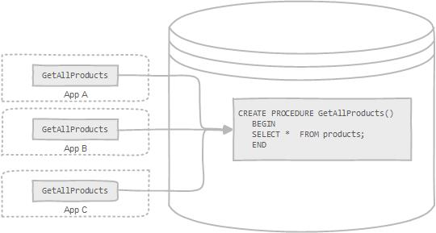

Instructions

Store Procedure 1

Get full name, sex and name of home depot of employers that have a surname determinant

delimiter $

create procedure eh(in surname varchar(30))

begin

select e.nombre, e.sexo, h.nombre

from asociado e, homedepot h

where h.idHD=e.HomeDepot_idHD

and e.nombre like concat(surname,'%')

order by h.nombre, e.nombre;

end $

delimiter ;

Store Procedure 2

Get name, card and amount credit for each socio registered on sucursal determined

delimiter /

create procedure ss(in sucursal varchar(60))

begin

select s.nombre, t.nombre, s.credito

from socio s, tarjeta t, homedepot h, hdsocio x

where s.idSocio=t.Socio_idSocio

and x.Socio_idSocio=s.idSocio

and h.idHD=x.HomeDepot_idHD

and h.nombre like concat(sucursal,'%')

order by s.credito, s.nombre;

end /

delimiter ;

Store Procedure 3

Get name,address for existent sucursales on a state

delimiter #

create procedure se(in contry varchar(40))

begin

select h.nombre, h.direccion

from homedepot h

where h.estado like concat(contry,'%')

order by h.estado, h.nombre;

end #

delimiter ;

Store Procedure 4

Get name, email of socios that have determined card

delimiter &

create procedure st(in tarjet varchar(50))

begin

select s.nombre, s.email

from socio s, tarjeta t

where s.idSocio=t.Socio_idSocio

and t.nombre like concat(tarjet,'%')

order by s.nombre;

end &

delimiter ;

Store Procedure 5

Get name of asociado and home depot for each asociado with gender determined

delimiter $

create procedure ag(in gener varchar(30))

begin

select a.nombre, h.nombre

from asociado a, homedepot h

where a.HomeDepot_idHD=h.idHD

and a.sexo like concat(gener,'%')

order by a.nombre;

end $

delimiter ;

Store Procedure 6

Get apartments that have a sucursal determined

delimiter $

create procedure ds(in sucursal varchar(60))

begin

select d.nombre

from depto d, hddepto hdd, homedepot h

where d.idDepto=hdd.Depto_idDepto

and h.idHD=hdd.HomeDepot_idHD

and h.nombre like concat(sucursal,'%')

order by d.nombre;

end $

delimiter ;

Store Procedure 7

Get name and country of sucursales that have a id determinate

delimiter #

create procedure si(in id varchar(20))

begin

select nombre, estado

from homedepot

where idHD=id;

end #

delimiter ;

Store Procedure 8

Get name, phone and amount credit besides name of sucursal where was assigned a socio with id determined

delimiter $

create procedure si2(in id varchar(20))

begin

select s.nombre, s.tel, s.credito, h.nombre

from socio s, homedepot h, hdsocio x

where s.idsocio=x.socio_idsocio

and x.homedepot_idhd=h.idhd

and s.idsocio=id

order by h.nombre, s.nombre;

end $

delimiter ;

Store Procedure 9

Get name of socio that have registered sucursal determinant

delimiter *

create procedure ss2(in sucursal varchar(60))

begin

select s.nombre

from socio s, homedepot h, hdsocio hds

where s.idSocio=hds.Socio_idSocio

and h.idHD=hds.HomeDepot_idHD

and h.nombre like concat(sucursal,'%')

order by s.nombre;

end *

delimiter ;

Store Procedure 10

With base a amount determined get id, nombre of socio besides name, phone of sucursal where was registered

delimiter #

create procedure sm(in monto int)

begin

select s.idSocio, s.nombre, h.nombre, h.tel

from socio s, homedepot h,hdsocio hds

where s.idSocio=hds.Socio_idSocio

and h.idHD=hds.HomeDepot_idHD

and s.credito=monto

order by s.nombre;

end #

delimiter ;

Screan Shot

Load Data Base

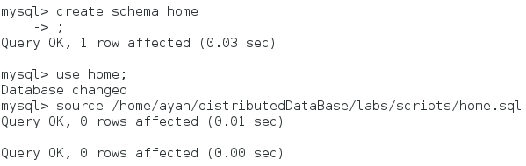

Stored Procedure 1

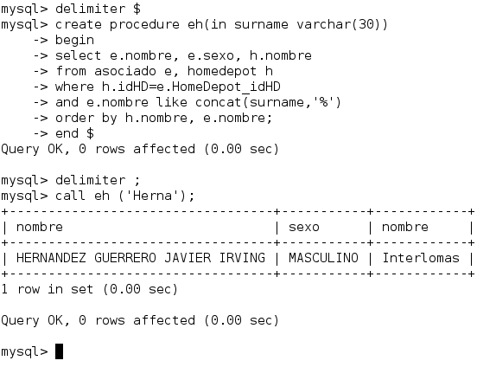

Stored Procedure 2

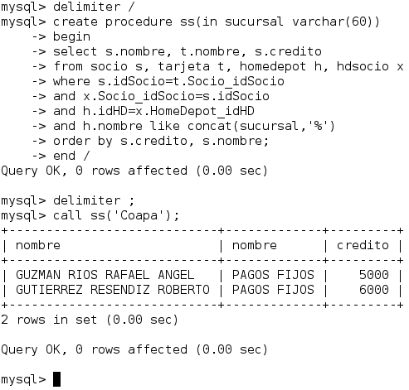

Stored Procedure 3

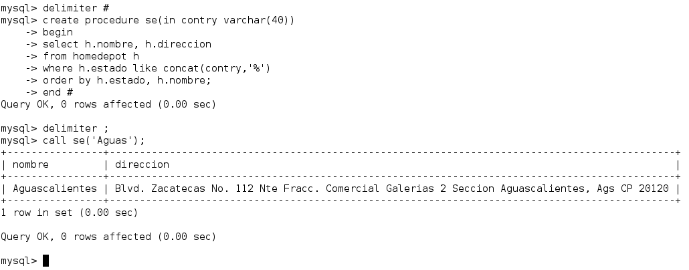

Stored Procedure 4

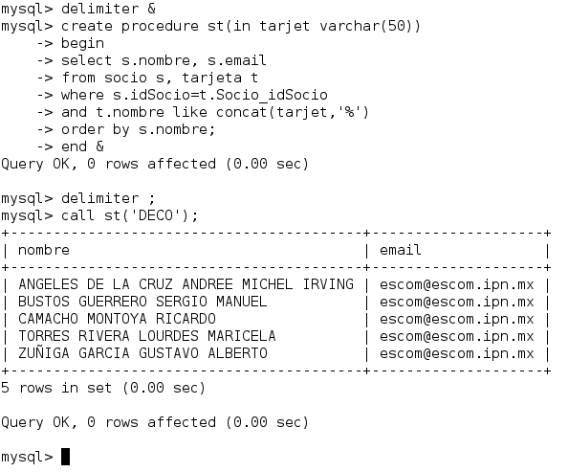

Stored Procedure 5

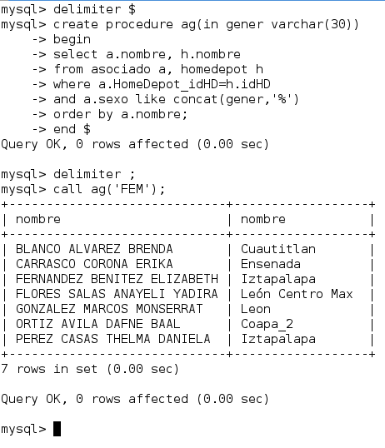

Stored Procedure 6

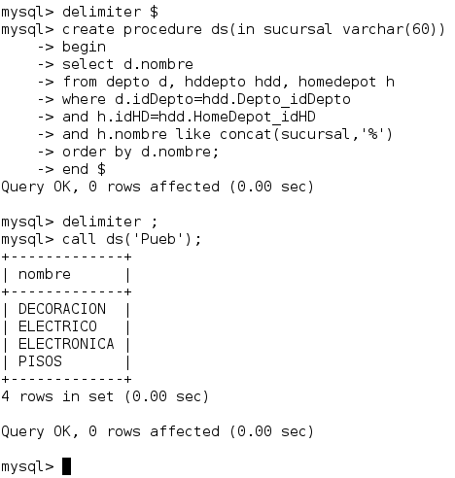

Stored Procedure 7

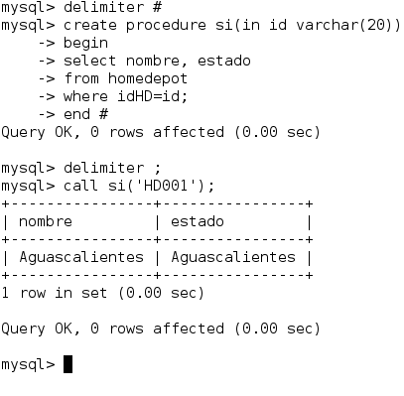

Stored Procedure 8

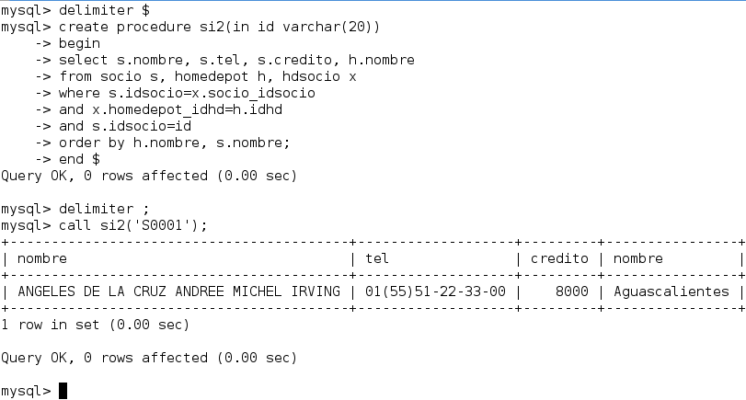

Stored Procedure 9

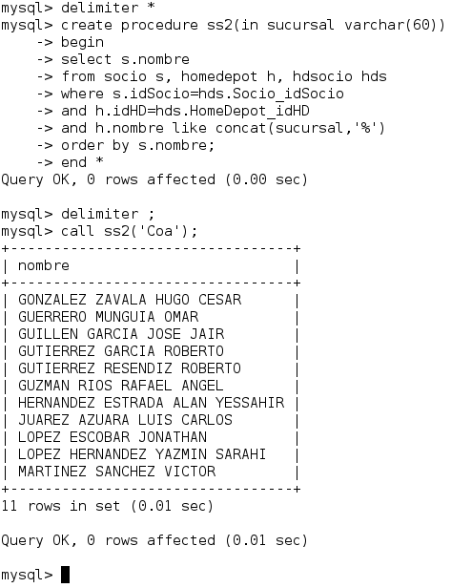

Stored Procedure 10

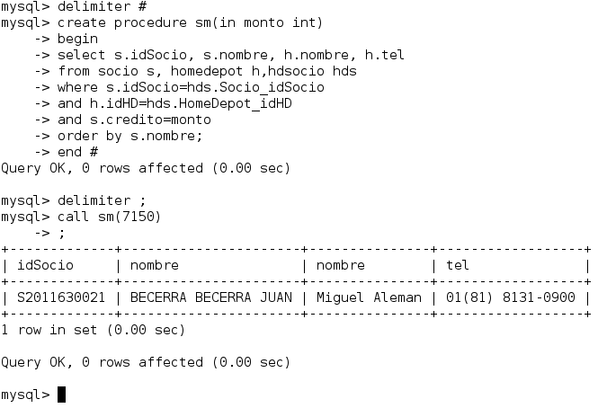

References

<http://code.tutsplus.com/articles/an-introduction-to-stored-procedures-in-mysql-5--net-17843>

<http://www.mysqltutorial.org/introduction-to-sql-stored-procedures.aspx>

<https://en.wikipedia.org/wiki/Stored_procedure>

<http://cassianinet.blogspot.mx/2011/05/stored-procedure-en-mysql-parte-1.html>