

Instituto Politecnico Nacional

Escuela Superior de Computacion

Class: Distributed Data Base

Group: 3cm4

Profesor: Hernandez Contreras Euler

Alumno: Urban Reyes Adan

Boleta: 2012630450

Email: [ayanializita@gmail.com](mailto:ayanializita@gmail.com)

Tema: Session Laboratory Two (Sams)

Table of Contents

Theoretical framework 3

Instructions and ScreanShot 5

--1. create view that displays the name of the manager and the club to which is assigned 6

create view v1 as select g.nombre as gerente, c.nombre as club from gerente g,club c where g.idclub=c.idclub order by g.nombre; 6

--2. create view that displays the provider and products 7

create view v2 as select p.nombre as proveedor, pr.nombre as producto from proveedor p, producto pr where p.idproveedor=pr.idproveedor order by p.nombre,pr.nombre; 7

--3. create vew that displays club and her state 7

create view v3 as select c.nombre as club, e.nombre as estado from club c, estado e where c.idedo=e.idedo order by e.nombre, c.nombre desc; 7

--4. create view that display name of socio and club that his was assing 7

create view v4 as select s.nombre as socio, c.nombre as club from socio s, club c, socioclub sc where s.idsocio=sc.idsocio and sc.idclub=c.idclub order by c.nombre, s.nombre; 7

--5. create view showing club name, service name 7

create view v5 as select c.nombre as club, s.nombre as servicio from club c, servicio s, servicioclub sc where s.idservicio=sc.idservicio and sc.idclub=c.idclub order by c.nombre, s.nombre; 7

--6. create view showing club supplier 8

create view v6 as select c.nombre as club, p.nombre as proveedor from club c, proveedor p, proveedorsams ps where c.idclub=ps.idclub and ps.idproveedor= p.idproveedor order by c.nombre, p.nombre; 8

--7. from the views created solve the following queries 8

--7.1 display the name of the partners, club to which they were assigned and designated managers at the club, where members HERNANDEZ last name. 8

select v4.*, v1.gerente from v4,v1 where v4.club=v1.club and v4.socio like "Hern_ndez%"; 9

--7.2 display the name of suppliers providing products exixtentes cluves in the state of Mexico 9

select v6.* from v6, v3 where v3.club=v6.club and v3.estado like "%M_xico%"; 9

--7.3 that service clubs have jewelry display the name of the club and the state where the club is located 10

select v3.* from v3,v5 where v3.club=v5.club and v5.servicio like "Joyer_a%"; 10

--7.4 display the name of the products that are supplied in the club VILLA GARDEN 11

select v2.producto from v2,v6 where v2.proveedor=v6.proveedor and v6.club like "%VILLA JARDIN%"; 11

--7.5 display the name of club managers who GARCIA last name plus both the state where the clubs are located 12

select v1.*, v3.estado from v1,v3 where v1.club=v3.club and v1.gerente like "%Garcia%"; 12

Conclusions 13

References 13

Theoretical framework

A view is a virtual table mysql with a structure that we define but no data.

In theory databases, a view is a query that is presented as a (virtual) table from a set of tables in a relational database.  
  
The views have the same structure as a table: rows and columns. The only difference is that only the definition stored in them, not the data. The data retrieved by querying a view is presented like a table. In fact, if you do not know who you are working with a view, nothing to suggest that it is. As is the case with a table, you can insert, update, delete, and select data in a view. While it is always possible to select data from a view, in some conditions there are restrictions to perform other operations on views.  
  
A view is specified through a query expression (a SELECT statement) that calculates and that can be performed on one or more tables. On a set of relational tables you can work with any number of views.  
  
Most DBMS support creating and manipulating views. The views are created when several judgments need to be made to return a final table.

What can help us view ?. The answers are many, and sure there are many unknown to me, but I understand directly are:  
  
They are stored on the server so that resource consumption and efficiency always be more optimal.  
On security issues is always better to use views instead of allowing anyone to access the data directly, we show the rest of the data we want developers.  
We can easily call in a query and use clauses against them, now we will see some examples.  
There may be inexperienced developers and hard to do complex queries, we can give them the option of simply calling a view to obtain the data.  
A view is a simple way to save complex selection queries in our database.  
One difference between views and stored procedures is that the former do not accept parameters, not the case with stored procedures, which if accepted.  
A stored procedure is usually used when it is not enough a simple SQL query. Stored procedures contain variables, loops, and calls to other stored procedures.

Instructions and ScreanShot

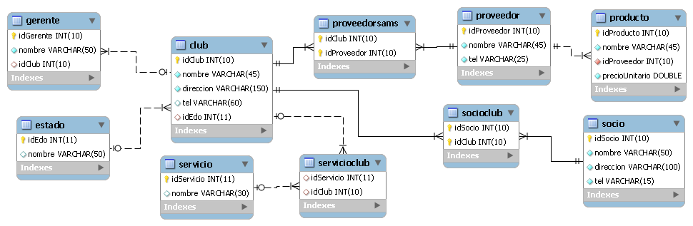

mysql -u root -p

Enter password: (here enter password of mysql)

create schema sams;

use sams;

source /home/ayan/distributeDataBase/labs/sams/sams.sql

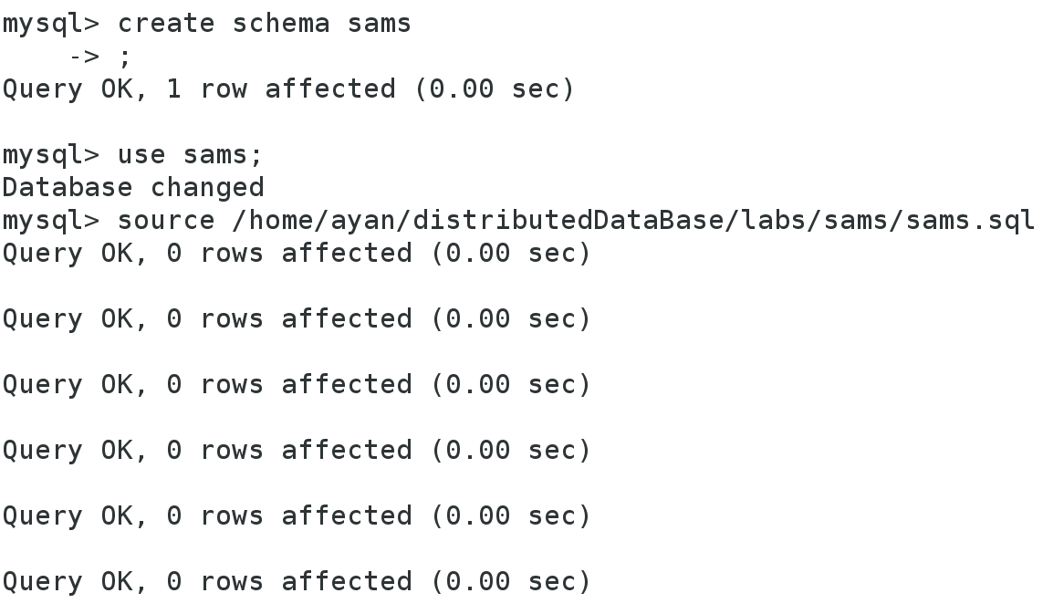

--1. create view that displays the name of the manager and the club to which is assigned

create view v1 as select g.nombre as gerente, c.nombre as club from gerente g,club c where g.idclub=c.idclub order by g.nombre;

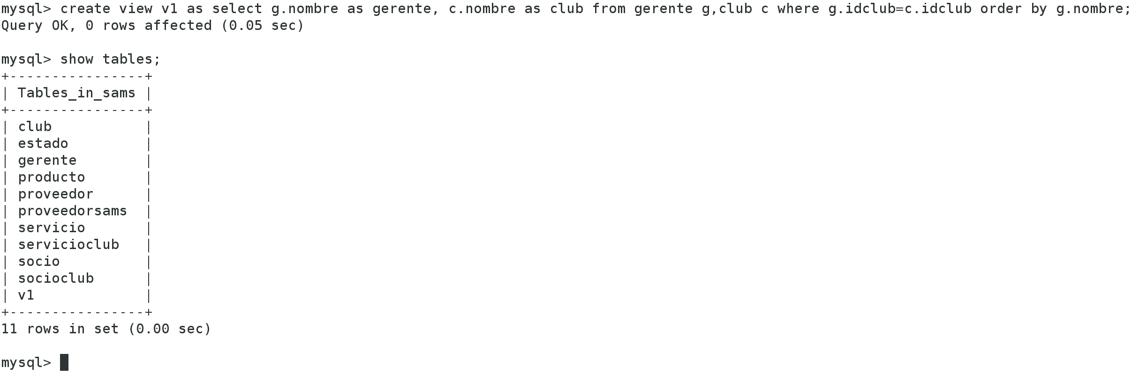

--2. create view that displays the provider and products

create view v2 as select p.nombre as proveedor, pr.nombre as producto from proveedor p, producto pr where p.idproveedor=pr.idproveedor order by p.nombre,pr.nombre;

--3. create vew that displays club and her state

create view v3 as select c.nombre as club, e.nombre as estado from club c, estado e where c.idedo=e.idedo order by e.nombre, c.nombre desc;

--4. create view that display name of socio and club that his was assing

create view v4 as select s.nombre as socio, c.nombre as club from socio s, club c, socioclub sc where s.idsocio=sc.idsocio and sc.idclub=c.idclub order by c.nombre, s.nombre;

--5. create view showing club name, service name

create view v5 as select c.nombre as club, s.nombre as servicio from club c, servicio s, servicioclub sc where s.idservicio=sc.idservicio and sc.idclub=c.idclub order by c.nombre, s.nombre;

--6. create view showing club supplier

create view v6 as select c.nombre as club, p.nombre as proveedor from club c, proveedor p, proveedorsams ps where c.idclub=ps.idclub and ps.idproveedor= p.idproveedor order by c.nombre, p.nombre;

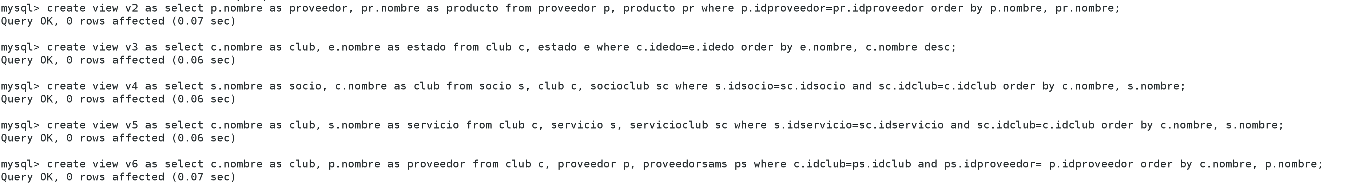

--7. from the views created solve the following queries

--7.1 display the name of the partners, club to which they were assigned and designated managers at the club, where members HERNANDEZ last name.

select v4.*, v1.gerente from v4,v1 where v4.club=v1.club and v4.socio like "Hern_ndez%";

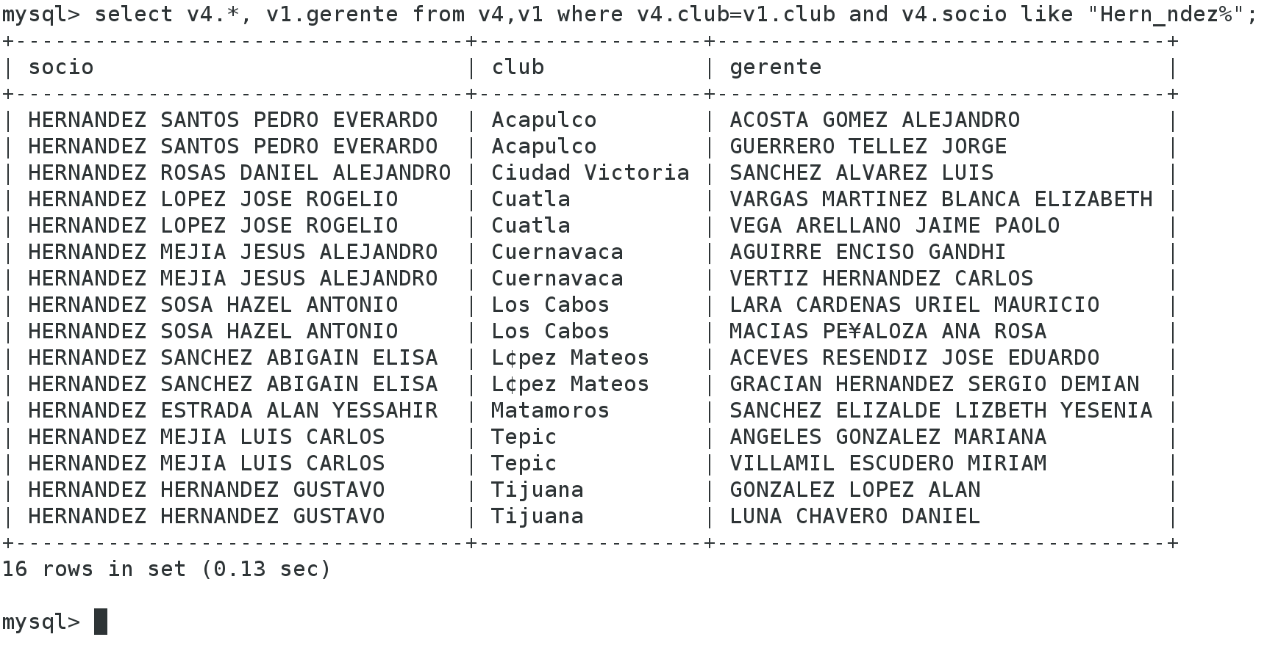

--7.2 display the name of suppliers providing products exixtentes cluves in the state of Mexico

select v6.* from v6, v3 where v3.club=v6.club and v3.estado like "%M_xico%";

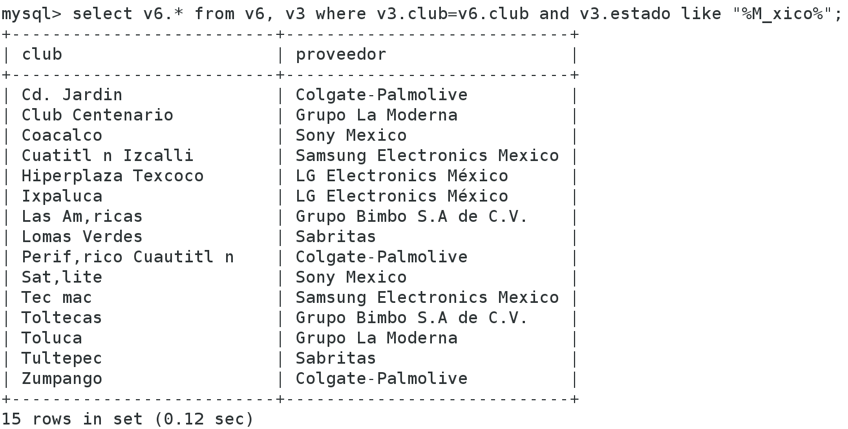

--7.3 that service clubs have jewelry display the name of the club and the state where the club is located

select v3.* from v3,v5 where v3.club=v5.club and v5.servicio like "Joyer_a%";

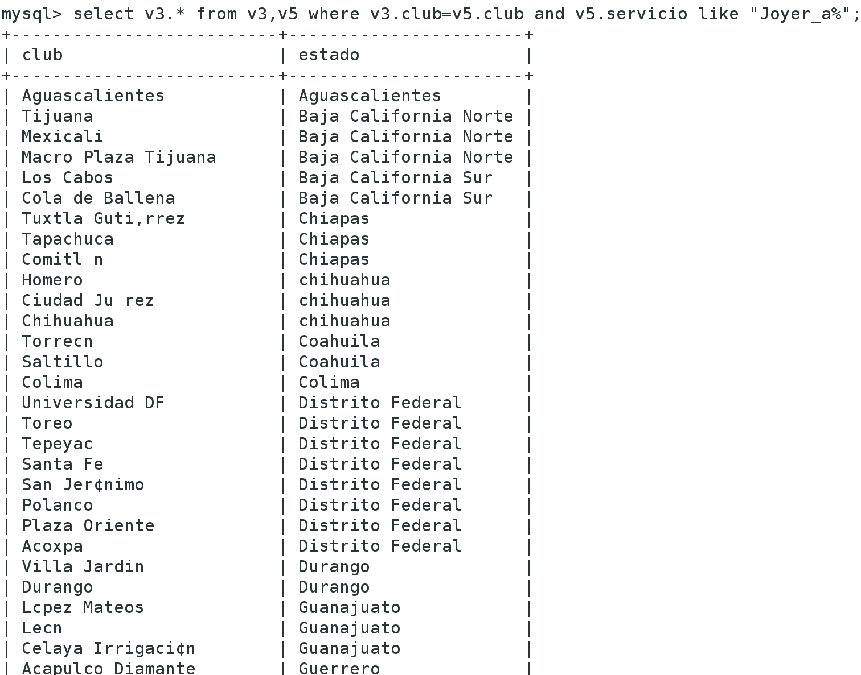

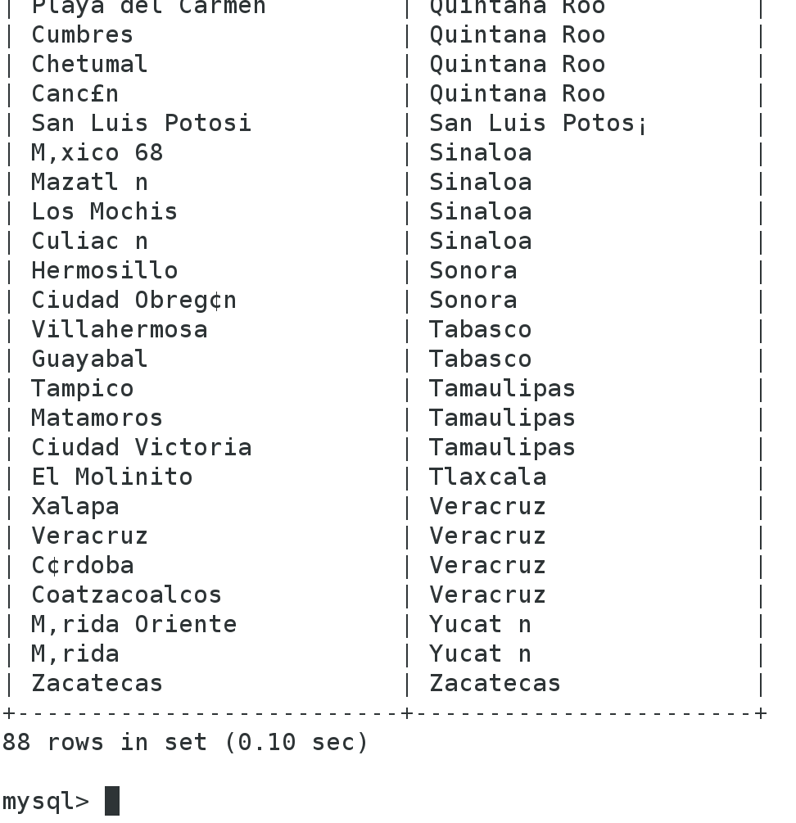

--7.4 display the name of the products that are supplied in the club VILLA GARDEN

select v2.producto from v2,v6 where v2.proveedor=v6.proveedor and v6.club like "%VILLA JARDIN%";

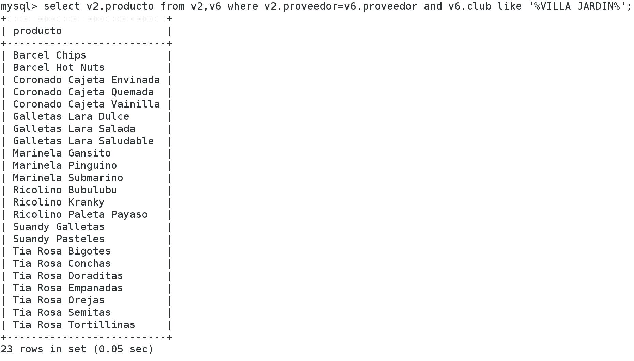

--7.5 display the name of club managers who GARCIA last name plus both the state where the clubs are located

select v1.*, v3.estado from v1,v3 where v1.club=v3.club and v1.gerente like "%Garcia%";

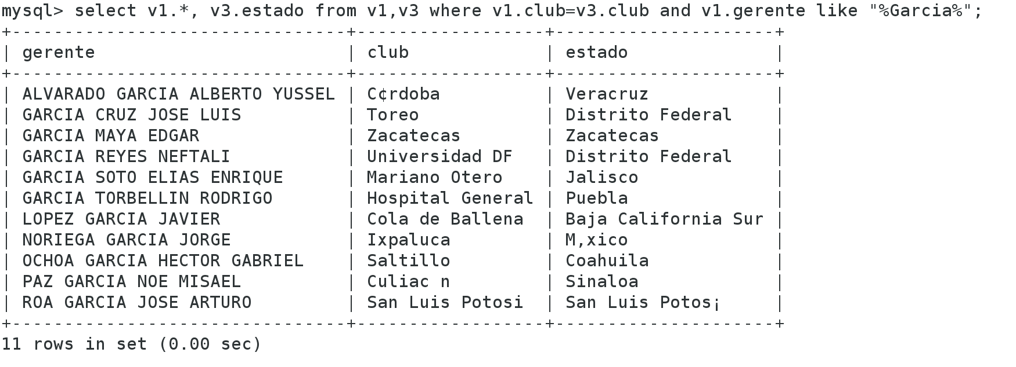

Conclusions

The views help us expedite or have prepared the "structures" or "macros" which we take to solve more easily some queries because they are a very complicated query the can be separated into small pieces and go creating views and after use to resolve the consultations being

References

<http://www.ptolomeo.unam.mx:8080/xmlui/bitstream/handle/132.248.52.100/228/A4.pdf?sequence=4>

<http://uno-de-piera.com/introduccion-las-vistas-en-mysql/>

https://es.wikipedia.org/wiki/Vista_%28base_de_datos%29