Some days ago, we created a Node.js site in the office using SQL Server 2012 and IIS 8.
In the same line, my office serves an application Canoa (you my remember Canoa for AdpataBrasil project).
Canoa is written by me in Python. Today’s task is to use the certificate for domains we recently get from Let's Encrypt, to get a 'bump' on Canoa’s security, and move it from http://satelier.dev.br:45445 (were it lives now) and https://canoa.satelier.dev.br

I created a new site:
Name canoa
Type: https:*: 443
Host name: satelier.dev.br
[ ] Require Serve Name Indication
SSL Certicate: [IIS*} subdomains satetlier.
I created a record: cname canoa.satelier.dev.br

I
Fix it:
- IIS → Site canoa → Bindings
- Edit HTTPS binding:
  - Host name: canoa.satelier.dev.br
  - Port: 443
  - Type: https
  - SSL Certificate: your Let’s Encrypt wildcard / subdomain cert
  - ✔️ Require SNI (recommended, especially if you host multiple HTTPS sites)
Your CNAME record is correct 👍
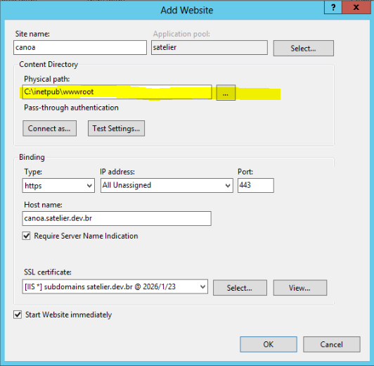

In
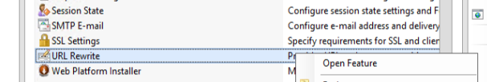

Add rrule(s)

