



|  |
| --- |
| X-Road: Protocol for Downloading Configuration  **Technical Specification** |
| Version: 2.4  09.11.2015  26 pages  Doc. ID: PR-GCONF |

|  |  |  |  |
| --- | --- | --- | --- |
| Date | Version | Description | Author |
| 04.09.2015 | 1.4 | Minor fixes | Siim Annuk |
| 09.09.2015 | 2.0 | Editorial changes made | Imbi Nõgisto |
| 23.10.2015 | 2.1 | Shared-parameters schema updated | Siim Annuk |
| 28.10.2015 | 2.2 | Typos fixed | Siim Annuk |
| 09.11.2015 | 2.3 | More typos | Margus Freudenthal |
| 17.12.2015 | 2.4 | Added description of monitoring parameters | Janne Mattila |

Table of Contents

License 4

1 Introduction 5

1.1 Terms and Abbreviations 5

1.2 References 6

2 Protocol for Downloading Configuration 7

2.1 General 7

2.2 Format of Configuration Anchor 7

2.3 Format of Signed Configuration 8

2.4 Format of Directory 8

2.5 List of Content Identifiers 9

2.6 Downloading and Verifying the Configuration 9

3 Deploying the Protocol 10

3.1 The Simplest Case 10

3.2 Detached Shared Parameters 10

3.3 Simple Federated Installation 11

3.4 Federated Installation with Proxies 12

Annex A Examples 15

Annex B shared-parameters.xsd 16

Annex C private-parameters.xsd 22

Annex D monitoring-conf.xsd 25

Annex E configuration-anchor.xsd 26

# License

This work is licensed under the Creative Commons Attribution-ShareAlike 3.0 Unported License. To view a copy of this license, visit http://creativecommons.org/licenses/by-sa/3.0/.

# Introduction

This specification describes protocol that is used to distribute configuration to security servers of an X-Road installation. Additionally, the same protocol is used to distribute configuration between two federated X-Road instances.

This protocol is based on HTTP and MIME protocols and supports refreshing the configuration meta-info without having to download the actual configuration files. The configuration parameters are distributed in XML format and described using XML Schema [XMLSCM1], [XMLSCM2].

This protocol builds on existing transport and message encoding mechanisms. Therefore, this specification does not cover the technical details and error conditions related to downloading information over HTTP and decoding MIME messages. These concerns are discussed in detail in their respective standards.

Chapter 2 as well as appendices [Annex B ], [Annex C ] and [Annex E ] of this specification contain normative information. All the other sections are informative in nature. All the references are normative.

This specification does not include option for partially implementing the protocol – the conformant implementation must implement the entire specification.

The key words "MUST", "MUST NOT", "REQUIRED", "SHALL", "SHALL NOT", "SHOULD", "SHOULD NOT", "RECOMMENDED", "MAY", and "OPTIONAL" in this document (in uppercase, as shown) are to be interpreted as described in [RFC2119].

## Terms and Abbreviations

Figure 1 contains a class diagram that illustrates important concepts used in this specification.

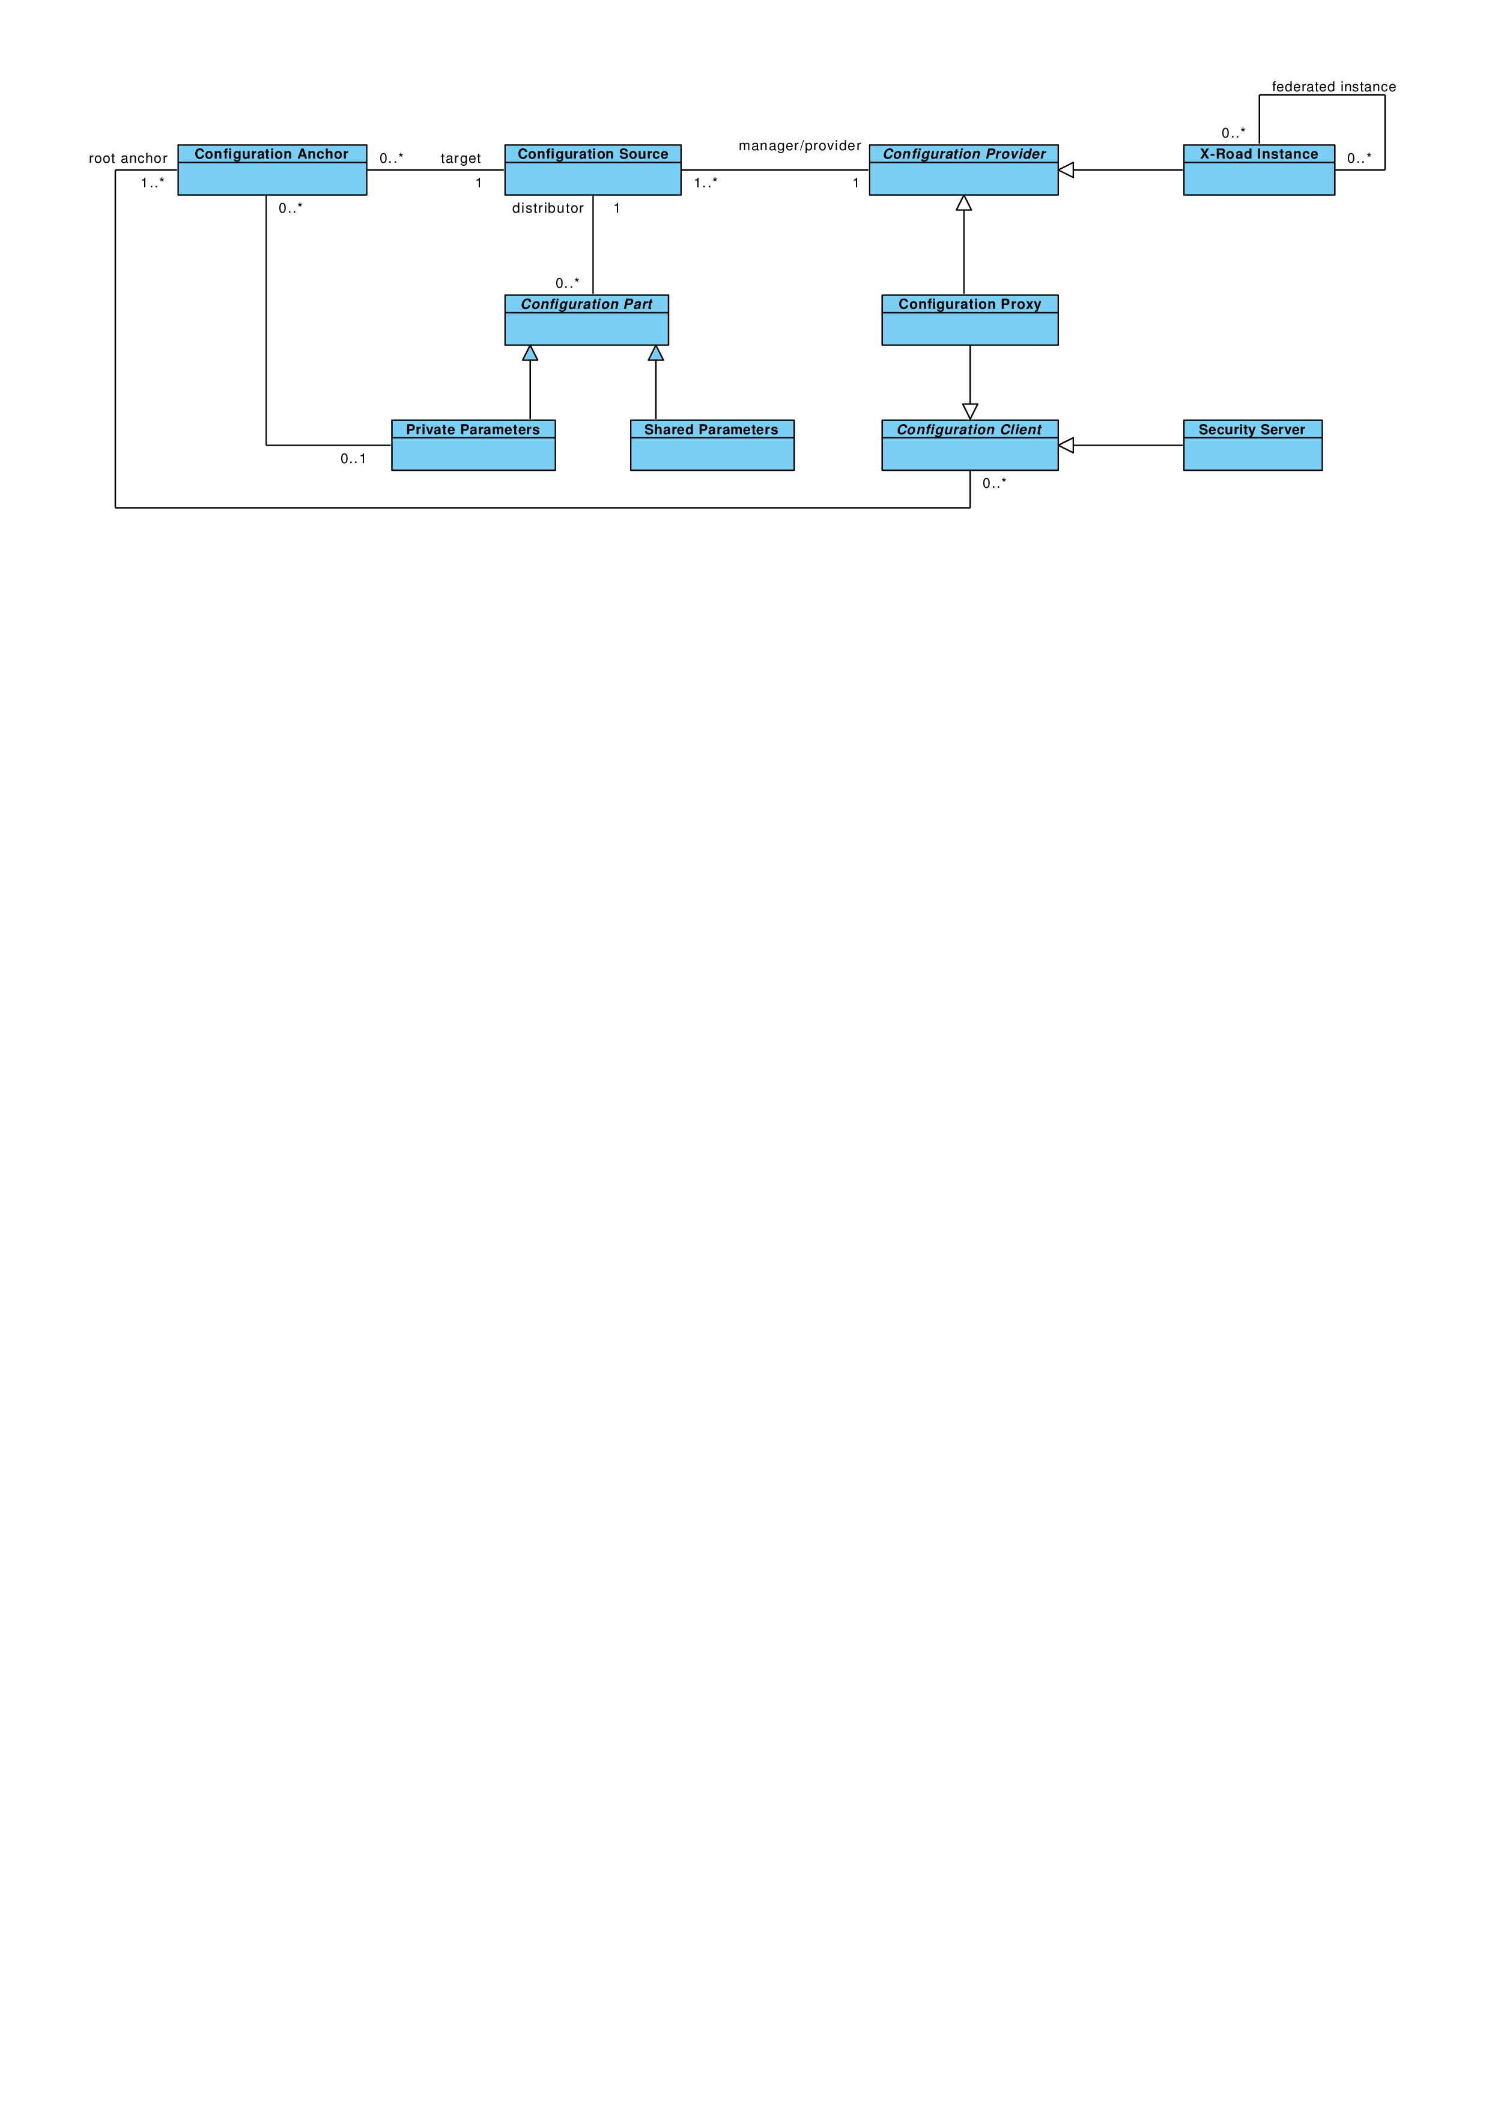

Figure 1. Concept diagram for configuration distribution protocol

* **Configuration Provider** – Entity that maintains a configuration. Configuration provider maintains one or more configuration sources that are used to distribute the configuration.
* **Configuration Source** – Component that distributes configuration to configuration clients. Configuration source can be either governing authority of an X-Road instance or a configuration proxy.
* **Configuration Anchor** – Set of information that can be used to download and verify information from a configuration provider. For each source the configuration anchor contains URL and a public key certificate that is used to verify integrity of the downloaded configuration. Configuration anchors are distributed by configuration providers as XML files.
* **Configuration Client** – Entity that uses configuration anchors for downloading configuration from configuration sources. Configuration clients can be either security servers or configuration proxies.
* **Configuration Proxy** – Entity that downloads configuration from a configuration source and redistributes them (thus the configuration proxy acts as a configuration source). Typically, the configuration proxy simply caches the configuration. When required, the proxy can also transform the configuration, e.g. by filtering out some data items.
* **Configuration** – Set of parameters that are distributed by a configuration source. Configuration consists of one or more configuration parts that contain groups of related parameters.
* **Private Parameters** – Set of parameters that are used only by members of this X-Road instance.
* **Shared Parameters** – Set of parameters that are used by members of this X-Road instance and other federated instances.
* **Monitoring Parameters** – (not pictured) Set of parameters that control monitoring of security servers
* **X-Road Instance** – Installation of the X-Road system. X-Road instances can interact with each other. X-Road instance is run by a governing authority that is responsible for managing members of the X-Road instance and distributing the configuration.
* **Governing Authority** – Authority that maintains the X-Road instance, registers X-Road members and security servers, and distributes this information to the X-Road members.

## References

[XMLSCM1] XML Schema Part 1: Structures Second Edition, 2004.

[XMLSCM2] XML Schema Part 2: Datatypes Second Edition, 2004.

[RFC2119] Key words for use in RFCs to Indicate Requirement Levels, Internet  
 Engineering Task Force, 1997.

[X509] Internet X.509 Public Key Infrastructure Certificate and Certificate Revocation List (CRL) Profile, Internet Engineering Task Force, 2008.

[MPREL] The MIME Multipart/Related Content-type, Internet Engineering Task Force, 1998.

[XMLDSIG] XML Signature Syntax and Processing Version 2.0, 2013.

[ISO8601] Data Elements and Interchange Formats – Information Interchange – Representation of Dates and Times, International Organization for Standardization, 2004.

# Protocol for Downloading Configuration

## General

Configuration clients download configuration using HTTP protocol (HTTP GET). Configuration source signs the configuration to protect it against modification. The configuration clients receive (via out of band means) configuration anchor containing information needed to successfully download and verify the configuration.

The configuration consists of a signed directory that references individual configuration parts. The signature has expiry date and thus the signed directory must be continuously refreshed by the configuration client. The clients can use the hash values contained in the directory to download the referenced configuration parts only when they are changed.

## Format of Configuration Anchor

Configuration anchor is used to distribute information about configuration sources to configuration clients. Because configuration anchor is used to verify authenticity of the downloaded configuration, it must be protected against modification. Example means are digitally signing the file or distributing the fingerprint of the file to the client in person.

The configuration anchor is stored in an XML file containing a *configurationAnchor* element defined in Annex E . It contains the following fields:

* *generatedAt* – date when the anchor was generated. Can be used to check whether correct version of the anchor is used;
* *instanceIdentifier* – identifies the X-Road instance that provides configuration to this configuration source;
* *source* – describes a single configuration source. The *source* element contains the following fields:
  + *downloadURL –* HTTP URL that can be used to download signed configuration (see Section 2.3 for format of the downloaded file);
  + *verificationCert –* public key that can be used to verify the signed configuration, presented as X.509 [X509] certificate[1].

Annex  A.2 contains an example configuration anchor file.

## Format of Signed Configuration

Configuration client can download the configuration by making HTTP GET request to the configuration source. The content type of the response is *multipart/related* [MPREL]. The response is a MIME multipart that MUST consist of two parts:

1. Directory of configuration files. The directory is a nested MIME multipart. The format of this directory is specified in Section 2.4 .
2. Signature of the directory, created using private key of the configuration source. The signature is calculated over the body of the first MIME part.

The signature part MUST have the following MIME headers:

* *Content-type* – the value MUST be “*application/octet-stream*”.
* *Content-transfer-encoding* – the value MUST be “*base64*”.
* *Signature-algorithm-id* – the value MUST identify the signature algorithm used to create the signature. This specification supports algorithm identifiers listed in XML Signature specification [XMLDSIG], Section 6.4.
* *Verification-certificate-hash* – the hash of the certificate that was used to sign this configuration. The value of the header MUST also include parameter *hash-algorithm-id* whose value is the hash algorithm identifier used to calculate the verification certificate hash.

The body of the signature part MUST be the value of the signature calculated using the signature algorithm identified in the *Signature-algorithm-id* header.

## Format of Directory

The first entry in the directory MUST be a header-only entry with the header *Expire-date* that contains date and UTC time in ISO 8601 format [ISO8601]. This header specifies the end of validity time of the directory – after the validity time has passed, the configuration client MUST consider the configuration as invalid and should attempt to download fresh configuration.

The directory contains references to the individual configuration files. In addition to download URI, each directory item contains hash of the file that can be used to verify integrity of the downloaded file.

The directory is a MIME multipart (content type is *multipart/mixed*) where each part represents one configuration file. Each part MUST have the following MIME headers:

* *Content-type* – the value MUST be “*application/octet-stream*”.
* *Content-transfer-encoding –* encoding of the body of the part. The value MUST be “*base64*”.
* *Content-location* – URL that can be used to download the configuration file referenced by this directory item. The URL can be relative (the base is the location of the signed configuration).
* *Hash-algorithm-id –* identifies the hash algorithm used to create the content of the directory item. This specification supports algorithm identifiers listed in XML Signature specification [XMLDSIG], Section 6.2.

Each directory part CAN have the following MIME headers:

* *Content-identifier –* identifies the type of the configuration part. Example types can be private parameters and shared parameters. Section 2.5 lists predefined content identifiers. In addition to these, each X-Road installation is free to add additional content to the configuration.
* *Content-file-name –* additional information about the configuration part. The configuration client CAN use value of this header as a hint about what name to use when saving this configuration part to a file.

The content of a directory part MUST be digest of the configuration part. The digest algorithm is specified in the *Hash-algorithm-id* MIME header. The input to the digest calculation is body of the file that can be downloaded from the URL specified in the *Content-location* MIME header.

Annex A.2 contains an example of a signed directory.

## List of Content Identifiers

This specification defines the following content identifiers. The X-Road implementations are free to define additional types of configuration parts that are distributed to configuration clients.

* *PRIVATE-PARAMETERS –* XML file conforming to private-parameters.xsd (see Annex C ).
* *SHARED-PARAMETERS* – XML file conforming to shared-parameters.xsd (see Annex B ). The configuration source can distribute several files of type *SHARED-PARAMETERS*. In this case each of the shared parameters files MUST describe separate X-Road instance.

In both of these cases, the implementation MUST include parameter *instance* whose value is the identifier for X-Road instance described by the configuration part. For example:

Content-Identifier: SHARED-PARAMETERS; instance="EE"

## Downloading and Verifying the Configuration

A configuration client can download the configuration by making HTTP GET requests to the configuration source. To download and verify the entire configuration, the client can follow these steps.

1. Parse the configuration anchor and read the download URI (pointing to the configuration directory) and the verification certificate.
2. Download the configuration directory from the URI and parse it.
3. Verify the signature of the configuration directory using the public key of the verification certificate. The signature algorithm identifier is specified by the MIME header *Signature-algorithm-id* of the MIME part containing the signature.
4. For each directory part,
   1. download the configuration file from the URL indicated in the *Content-location* MIME header;
   2. verify the integrity of the downloaded file by comparing the hash of the file with the hash contained in the directory (the hash algorithm is specified in MIME header *Hash-algorithm-id*).
5. For each configuration anchor in the private parameters file, download and verify the configuration using this set of rules.

# Deploying the Protocol

The protocol described in the previous section can be deployed in various ways. In particular, the difference is how the Governing Authority distributes several configuration parts between configuration sources and how the configuration from the federated X-Road instances is distributed to the members.

## The Simplest Case

This scenario involves a standalone X-Road instance that is not federated with any other X‑Road instances. In this case, the simplest configuration involves one configuration source that distributes all the necessary configuration (see Figure 2):

* private parameters (content identifier *PRIVATE-PARAMETERS*);
* shared parameters (content identifier *SHARED-PARAMETERS*); and
* optionally any additional configuration parts that are specific to this X-Road installation. *Monitoring parameters* belong to this category.

Because the shared parameters are distributed in the main configuration, the private parameters part does not contain any additional configuration sources.

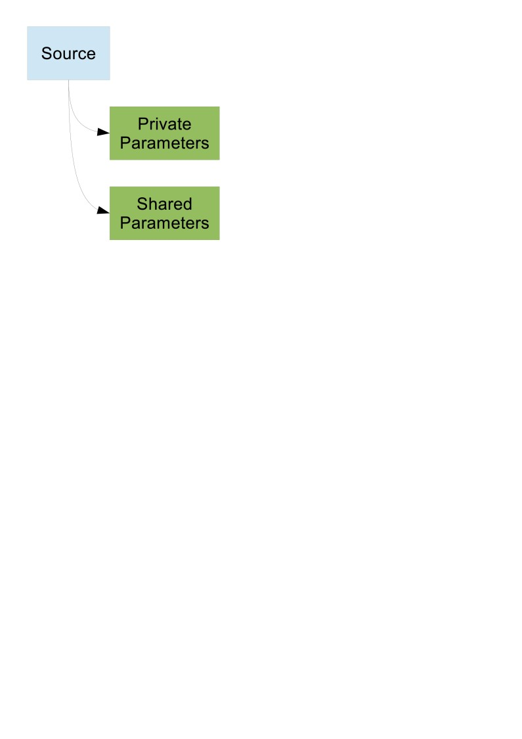

Figure 2. X-Road installation with single configuration source

## Detached Shared Parameters

This scenario involves a standalone X-Road instance that uses different configuration sources for private and shared parameters.

In this case the X-Road governing authority manages two configuration sources. The first source contains the private parameters and, optionally, other configuration parts that are specific to this X-Road instance. The second source contains shared parameters. The private parameters part contains anchor for the second configuration source. Figure 3 illustrates this situation.

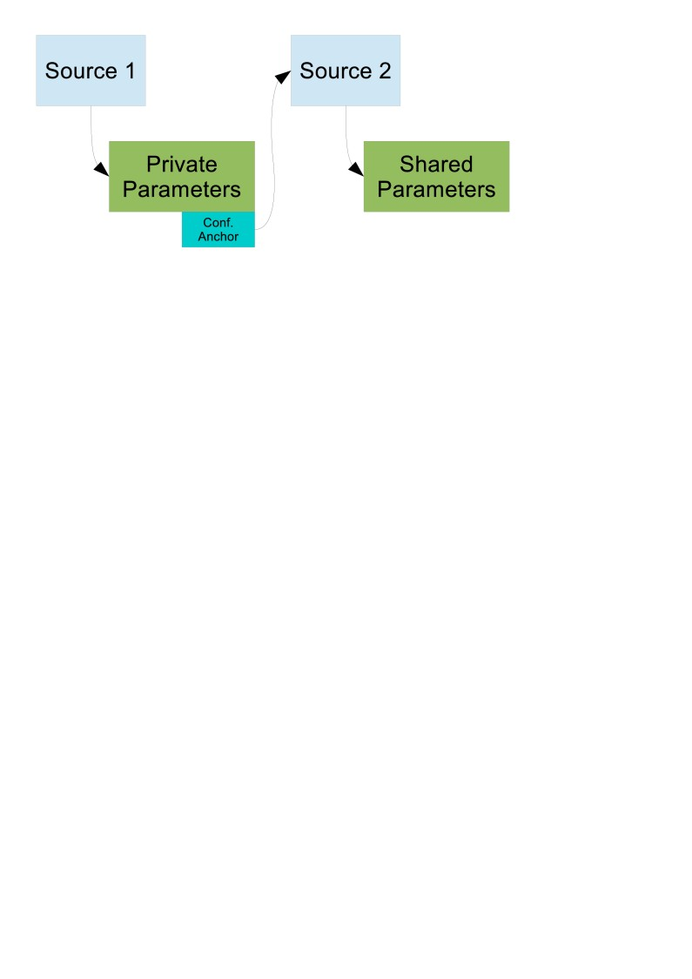

Figure 3. X-Road installation with detached shared parameters

Compared to the simplest case, the configuration authority must maintain two separate configuration sources. Additionally, the configuration clients must make additional HTTP requests to download the directory from *Source 2*. For a non-federated installation, this solution does not offer significant benefits, but it is a good starting point for building a federated X-Road infrastructure.

## Simple Federated Installation

This scenario involves two federated X-Road installations. Both installations are set up according to Section 3.2 . Figure 4 describes the setup. Both X-Road installations maintain two configuration sources, one for private parameters, the other one for shared parameters. For both installations, the private parameters part contains configuration anchors for both of the sources that distribute shared parameters.

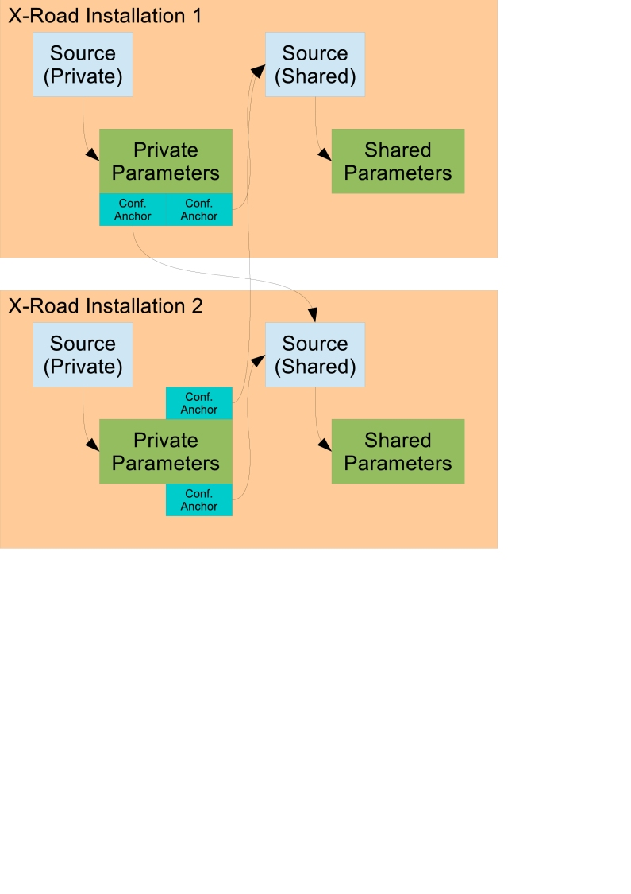

Figure 4. Two federated X-Road installations

Members of the X-Road installations are initialized with configuration anchor pointing to private configuration source of their governing installation. This source is then used to download private parameters that contains configuration anchors for the sources that distribute shared parameters.

## Federated Installation with Proxies

Scenario from Section 3.3 can be further developed by using configuration proxies. Figure 5 shows a setup where one X-Road installation uses proxies to cache both the incoming and outgoing shared parameters. Proxy is configured with a configuration anchor and it downloads and caches configuration from the source described by the anchor. Additionally, proxy acts as a configuration source and allows clients to download the cached configuration.

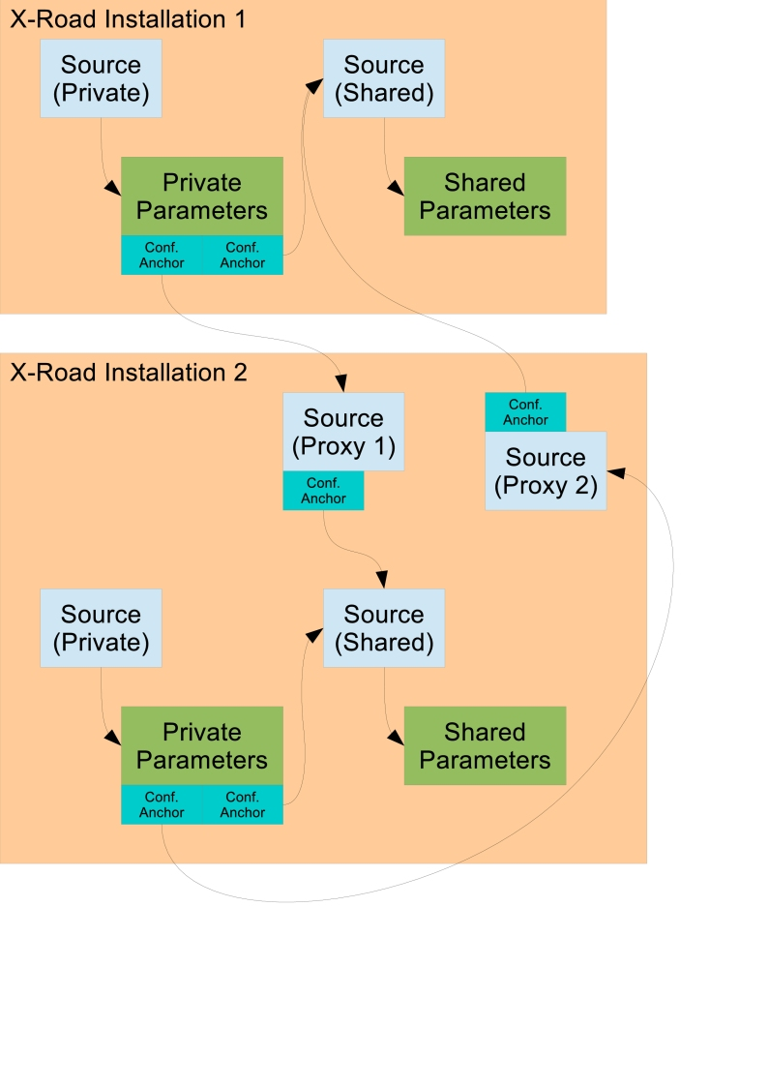

Figure 5. Two federated X-Road installations with configuration proxies

Instead of direct references from private parameters of one installation to shared configuration source of the other installation, the X-Road installation 2 sets up two proxies. Proxy 1 downloads shared parameters of X-Road installation 2 and redistributes them to other X-Road installations. Proxy 2 downloads shared parameters of another X-Road installation (1 in this example) and distributes them to members of X-Road installation 2.

In this setup, the X-Road 2 has complete control over configuration that is exchanged with other X-Road installations – both incoming and outgoing. Using a proxy can improve availability of the shared parameters and reduce load on shared configuration sources of both X-Road installations. In addition, the proxies can transform the configuration, e.g. by filtering out some member classes[2].

# Examples

A.1 Example of Configuration Anchor

<?xml version="1.0" encoding="UTF-8"?>

<tns:configurationAnchor xmlns:tns="http://x-road.eu/xsd/xroad.xsd">

<generatedAt>2014-05-20T16:42:55Z<generatedAt>

<instanceIdentifier>EE</instanceIdentifier>

<source>

<downloadURI>http://10.10.10.10/conf</downloadURI>

<verificationCert>ZGVmYXVsdA==</verificationCert>

</source>

</tns:configurationAnchor>

A.2 Example of Signed Directory

This example directory contains two parts. The first part contains private parameters and the second part contains shared parameters.

Content-Type: multipart/related; charset=UTF-8;

boundary=envelopeboundary

--envelopeboundary

Content-Type: multipart/mixed; charset=UTF-8;

boundary=innerboundary

--innerboundary

Expire-date: 2014-05-20T17:42:55Z

--innerboundary

Content-type: application/octet-stream

Content-transfer-encoding: base64

Content-identifier: PRIVATE-PARAMETERS; instance="EE"

Content-location: /private-parameters.xml

Hash-algorithm-id: http://www.w3.org/2001/04/xmlenc#sha512

qgD1gNt3i/eDMCy0s6lTig6TD5h4=

--innerboundary

Content-type: application/octet-stream

Content-transfer-encoding: base64

Content-identifier: SHARED-PARAMETERS; instance="EE"

Content-location: /shared-parameters.xml

Hash-algorithm-id: http://www.w3.org/2001/04/xmlenc#sha512

qgD1gNt3i/eDMCy0s6lTig6TD5h4=

--innerboundary--

--envelopeboundary

Content-type: application/octet-stream

Content-transfer-encoding: base64

Signature-algorithm-id: http://www.w3.org/2001/04/xmldsig-more#rsa-sha512

Verification-certificate-hash: trng71M3bScT0fkc1TBWUaG+D28zTo;

hash-algorithm-id="http://www.w3.org/2001/04/xmlenc#sha512"

D1XfU3UXTFxS8s8iVW9+ePJhcuYTgpN4+Ze4oZgjbt...=

--envelopeboundary--

# shared-parameters.xsd

<?xml version="1.0" encoding="UTF-8"?>

<schema xmlns="http://www.w3.org/2001/XMLSchema"

xmlns:tns="http://x-road.eu/xsd/xroad.xsd"

targetNamespace="http://x-road.eu/xsd/xroad.xsd"

xmlns:id="http://x-road.eu/xsd/identifiers">

<import namespace="http://x-road.eu/xsd/identifiers"

schemaLocation="http://x-road.eu/xsd/identifiers.xsd" id="id"/>

<element name="conf" type="tns:SharedParametersType">

<annotation>

<documentation> Set of configuration parameters that are

used by members of this X-Road instance and other

federated instances. </documentation>

</annotation>

</element>

<complexType name="SharedParametersType">

<sequence>

<element name="instanceIdentifier" type="string">

<annotation>

<documentation> Code that uniquely identifies this

instance of the X-Road system within a

federation of systems. </documentation>

</annotation>

</element>

<element name="approvedCA" type="tns:ApprovedCAType"

minOccurs="0" maxOccurs="unbounded">

<annotation>

<documentation> Certification authority approved

by the Governing Authority of providing

certification services for members of this

X-Road instance. </documentation>

</annotation>

</element>

<element name="approvedTSA" type="tns:ApprovedTSAType"

minOccurs="0" maxOccurs="unbounded">

<annotation>

<documentation> Time-stamping authority approved

by the Governing Authority of providing

time-stamping services for members of this

X-Road instance. </documentation>

</annotation>

</element>

<element name="member" type="tns:MemberType" minOccurs="0"

maxOccurs="unbounded">

<annotation>

<documentation> Registered member of this X-Road

system. </documentation>

</annotation>

</element>

<element name="securityServer"

type="tns:SecurityServerType" minOccurs="0"

maxOccurs="unbounded">

<annotation>

<documentation> Security server registered in this

X-Road system. </documentation>

</annotation>

</element>

<element name="globalGroup" type="tns:GlobalGroupType"

minOccurs="0" maxOccurs="unbounded">

<annotation>

<documentation> Group of access rights subjects,

defined by the Governing Authority. An access

rights subject can be either a member or a

subsystem. </documentation>

</annotation>

</element>

<element name="centralService"

type="tns:CentralServiceType" minOccurs="0"

maxOccurs="unbounded">

<annotation>

<documentation> Central service, defined by the

Governing Authority. </documentation>

</annotation>

</element>

<element name="globalSettings"

type="tns:GlobalSettingsType">

<annotation>

<documentation> Classifiers and security policy

settings used in this X-Road instance.

</documentation>

</annotation>

</element>

</sequence>

</complexType>

<complexType name="MemberType">

<sequence>

<element name="memberClass" type="tns:MemberClassType">

<annotation>

<documentation> Member class of the member.

</documentation>

</annotation>

</element>

<element name="memberCode" type="string">

<annotation>

<documentation> Code that uniquely identifies the

member within the given member class.

</documentation>

</annotation>

</element>

<element name="name" type="string">

<annotation>

<documentation> Full, official name of the member,

used in user interfaces. </documentation>

</annotation>

</element>

<element name="subsystem" type="tns:SubsystemType"

minOccurs="0" maxOccurs="unbounded">

<annotation>

<documentation> Represents information about a

part of the member's information system that

is acting as an independent service consumer

or provider in the X-Road system.

</documentation>

</annotation>

</element>

</sequence>

<attribute name="id" type="ID"/>

</complexType>

<complexType name="SecurityServerType">

<sequence>

<element name="owner" type="IDREF">

<annotation>

<documentation> Identifier of the member who is

responsible for the security server.

</documentation>

</annotation>

</element>

<element name="serverCode" type="string">

<annotation>

<documentation> Code that uniquely identifies this

server within servers owned by the same

member. </documentation>

</annotation>

</element>

<element name="address" type="string" minOccurs="0">

<annotation>

<documentation> Externally visible address of the

security server. </documentation>

</annotation>

</element>

<element name="authCertHash" type="base64Binary"

minOccurs="0" maxOccurs="unbounded">

<annotation>

<documentation> Hash of the authentication

certificate used by the security server.

</documentation>

</annotation>

</element>

<element name="client" type="IDREF" minOccurs="0"

maxOccurs="unbounded">

<annotation>

<documentation> Identifier a registered client of

this security server. Client can be either a

member or a subsystem. </documentation>

</annotation>

</element>

</sequence>

</complexType>

<complexType name="ApprovedCAType">

<sequence>

<element name="name" type="string">

<annotation>

<documentation> Name of the CA, used in user

interfaces. </documentation>

</annotation>

</element>

<element name="authenticationOnly" type="boolean"

minOccurs="0">

<annotation>

<documentation> If present and true, indicates

that certificates issued by this CA can only

be used for TLS authentication and not for

creating and verifying digital

signatures/seals. </documentation>

</annotation>

</element>

<element name="topCA" type="tns:CaInfoType">

<annotation>

<documentation> Topmost (usually self-signed) CA

that is used as trust anchor. </documentation>

</annotation>

</element>

<element name="intermediateCA" type="tns:CaInfoType"

minOccurs="0" maxOccurs="unbounded">

<annotation>

<documentation> Intermediate CA. This information

can be used for certificate path building and

finding OCSP responders. </documentation>

</annotation>

</element>

<element name="certificateProfileInfo" type="string">

<annotation>

<documentation>

Fully qualified class name implementing the ee.ria.xroad.common.certificateprofile.CertificateProfileInfoProvider interface.

</documentation>

</annotation>

</element>

</sequence>

</complexType>

<complexType name="GlobalGroupType">

<sequence>

<element name="groupCode" type="string">

<annotation>

<documentation> Code that uniquely identifies the

group within an X-Road instance.

</documentation>

</annotation>

</element>

<element name="description" type="string">

<annotation>

<documentation> Description of the group.

</documentation>

</annotation>

</element>

<element name="groupMember"

type="id:XRoadClientIdentifierType" minOccurs="0"

maxOccurs="unbounded">

<annotation>

<documentation> Identifier of an X-Road member or

a subsystem belonging to this group.

</documentation>

</annotation>

</element>

</sequence>

</complexType>

<complexType name="OcspInfoType">

<annotation>

<documentation> Information about an OCSP provider.

</documentation>

</annotation>

<sequence>

<element name="url" type="string">

<annotation>

<documentation> URL of the OSCP server.

</documentation>

</annotation>

</element>

<element name="cert" type="base64Binary" minOccurs="0">

<annotation>

<documentation> Certificate used by the OCSP

server to sign OCSP responses.

</documentation>

</annotation>

</element>

</sequence>

</complexType>

<complexType name="ApprovedTSAType">

<sequence>

<element name="name" type="string">

<annotation>

<documentation> Name of the time-stamping

authority, used in user interfaces.

</documentation>

</annotation>

</element>

<element name="url" type="string">

<annotation>

<documentation> URL of the time-stamping service.

</documentation>

</annotation>

</element>

<element name="cert" type="base64Binary">

<annotation>

<documentation> Certificate used by the

time-stamping server to sign responses.

</documentation>

</annotation>

</element>

</sequence>

</complexType>

<complexType name="CaInfoType">

<annotation>

<documentation> This type encapsulates information about a

certification authority. </documentation>

</annotation>

<sequence>

<element name="cert" type="base64Binary">

<annotation>

<documentation> The CA certificate value.

</documentation>

</annotation>

</element>

<element name="ocsp" type="tns:OcspInfoType" minOccurs="0"

maxOccurs="unbounded">

<annotation>

<documentation> List of OCSP responders that

provide status of certificates issued by this

CA. </documentation>

</annotation>

</element>

</sequence>

</complexType>

<complexType name="SubsystemType">

<sequence>

<element name="subsystemCode" type="string">

<annotation>

<documentation> Code that uniquely identifies this

subsystem within the subsystems of its

parent-member. </documentation>

</annotation>

</element>

</sequence>

<attribute name="id" type="ID"/>

</complexType>

<complexType name="MemberClassType">

<sequence>

<element name="code" type="string">

<annotation>

<documentation> Code that uniquely identifies the

member class in this X-Road instance.

</documentation>

</annotation>

</element>

<element name="description" type="string">

<annotation>

<documentation> Description of the member class.

</documentation>

</annotation>

</element>

</sequence>

</complexType>

<complexType name="CentralServiceType">

<sequence>

<element name="serviceCode" type="string">

<annotation>

<documentation> Code that uniquely identifies a

central service in this X-Road instance.

</documentation>

</annotation>

</element>

<element name="implementingService"

type="id:XRoadServiceIdentifierType" minOccurs="0">

<annotation>

<documentation> Identifier of the service that

implements the central service.

</documentation>

</annotation>

</element>

</sequence>

</complexType>

<complexType name="GlobalSettingsType">

<sequence>

<element name="memberClass" type="tns:MemberClassType"

minOccurs="0" maxOccurs="unbounded">

<annotation>

<documentation> Lists the member classes used in

this X-Road instance. </documentation>

</annotation>

</element>

<element name="ocspFreshnessSeconds" type="integer">

<annotation>

<documentation> Maximum allowed validity time of

OCSP responses. If producedAt field of an OCSP

response is older than ocspFreshnessSeconds

seconds, it is no longer valid.

</documentation>

</annotation>

</element>

</sequence>

</complexType>

</schema>

# private-parameters.xsd

<?xml version="1.0" encoding="UTF-8"?>

<schema xmlns="http://www.w3.org/2001/XMLSchema"

xmlns:tns="http://x-road.eu/xsd/xroad.xsd"

targetNamespace="http://x-road.eu/xsd/xroad.xsd"

xmlns:id="http://x-road.eu/xsd/identifiers">

<import namespace="http://x-road.eu/xsd/identifiers"

schemaLocation="http://x-road.eu/xsd/identifiers.xsd" id="id"/>

<element name="conf" type="tns:PrivateParametersType">

<annotation>

<documentation> Set of configuration parameters that are

used only by members of this X-Road instance.

</documentation>

</annotation>

</element>

<element name="configurationAnchor"

type="tns:ConfigurationAnchorType">

<annotation>

<documentation> Information about a source of

configuration. </documentation>

</annotation>

</element>

<complexType name="PrivateParametersType">

<sequence>

<element name="instanceIdentifier" type="string">

<annotation>

<documentation> Code that uniquely identifies this

instance of the X-Road system within a

federation of systems. </documentation>

</annotation>

</element>

<element name="configurationAnchor"

type="tns:ConfigurationAnchorType" minOccurs="0"

maxOccurs="unbounded">

<annotation>

<documentation> Information about a source of

configuration. </documentation>

</annotation>

</element>

<element name="managementService"

type="tns:ManagementServiceType">

<annotation>

<documentation> Parameters of management services

called by the security servers.

</documentation>

</annotation>

</element>

<element name="timeStampingIntervalSeconds" type="integer">

<annotation>

<documentation> Time interval (in seconds) after

which a logged signature should be

time-stamped. This ensures that the

time-stamped signature can be used as evidence

at some later date. </documentation>

</annotation>

</element>

</sequence>

</complexType>

<complexType name="ManagementServiceType">

<sequence>

<element name="authCertRegServiceAddress" type="string">

<annotation>

<documentation> Address of the authentication

certificate registration service that can be

called by the security servers.

</documentation>

</annotation>

</element>

<element name="authCertRegServiceCert" type="base64Binary"

minOccurs="0">

<annotation>

<documentation> Server certificate that is used to

authenticate TLS connection to the

authentication certificate registration

service. </documentation>

</annotation>

</element>

<element name="managementRequestServiceProviderId"

type="id:XRoadClientIdentifierType">

<annotation>

<documentation> Identifier of the X-Road member or

subsystem providing the management request

services. </documentation>

</annotation>

</element>

</sequence>

</complexType>

<complexType name="ConfigurationAnchorType">

<sequence>

<element name="generatedAt" minOccurs="0" type="dateTime">

<annotation>

<documentation>Date when this anchor was produced

</documentation>

</annotation>

</element>

<element name="instanceIdentifier" type="string">

<annotation>

<documentation> Code of the X-Road instance that

provides configuration to this configuration

source. </documentation>

</annotation>

</element>

<element name="source"

type="tns:ConfigurationSourceType"

maxOccurs="unbounded">

<annotation>

<documentation>

Describes one configuration source.

</documentation>

</annotation>

</element>

</sequence>

</complexType>

<complexType name="ConfigurationSourceType">

<sequence>

<element name="downloadURL" type="string">

<annotation>

<documentation> HTTP URL that can be used to

download signed configuration.

</documentation>

</annotation>

</element>

<element name="verificationCert" type="base64Binary"

maxOccurs="unbounded">

<annotation>

<documentation> Public key that can be used to

verify the signed configuration, presented as

X.509 certificate. </documentation>

</annotation>

</element>

</sequence>

</complexType>

</schema>

# monitoring-conf.xsd

<?xml version="1.0" encoding="UTF-8"?>

<schema xmlns="http://www.w3.org/2001/XMLSchema"

xmlns:tns="http://x-road.eu/xsd/xroad.xsd"

targetNamespace="http://x-road.eu/xsd/xroad.xsd"

xmlns:id="http://x-road.eu/xsd/identifiers">

<import namespace="http://x-road.eu/xsd/identifiers"

schemaLocation="identifiers.xsd" id="id"/>

<element name="conf" type="tns:MonitoringParametersType">

<annotation>

<documentation>

Configuration parameters that define how distributed central monitoring works.

</documentation>

</annotation>

</element>

<complexType name="MonitoringParametersType">

<sequence>

<element name="monitoringClient"

type="tns:MonitoringClientType">

<annotation>

<documentation>

Monitoring client, which is athorized to query monitoring data from all security servers.

</documentation>

</annotation>

</element>

</sequence>

</complexType>

<complexType name="MonitoringClientType">

<sequence>

<element name="monitoringClientId"

minOccurs="0"

type="id:XroadClientIdentifierType">

<annotation>

<documentation>

Identifier of the X-Road member or subsystem which is athorized to query monitoring data from all security servers.

</documentation>

</annotation>

</element>

</sequence>

</complexType>

</schema>

# configuration-anchor.xsd

<?xml version="1.0" encoding="UTF-8"?>

<schema xmlns="http://www.w3.org/2001/XMLSchema"

xmlns:tns="http://x-road.eu/xsd/xroad.xsd"

targetNamespace="http://x-road.eu/xsd/xroad.xsd">

<element name="configurationAnchor"

type="tns:ConfigurationAnchorType">

<annotation>

<documentation> Information about a source of

configuration. </documentation>

</annotation>

</element>

<complexType name="ConfigurationAnchorType">

<sequence>

<element name="generatedAt" minOccurs="0" type="dateTime">

<annotation>

<documentation>Date when this anchor was produced

</documentation>

</annotation>

</element>

<element name="instanceIdentifier" type="string">

<annotation>

<documentation> Code of the X-Road instance that

provides configuration to this configuration

source. </documentation>

</annotation>

</element>

<element name="source"

type="tns:ConfigurationSourceType"

maxOccurs="unbounded">

<annotation>

<documentation>

Describes one configuration source.

</documentation>

</annotation>

</element>

</sequence>

</complexType>

<complexType name="ConfigurationSourceType">

<sequence>

<element name="downloadURL" type="string">

<annotation>

<documentation> HTTP URL that can be used to

download signed configuration.

</documentation>

</annotation>

</element>

<element name="verificationCert" type="base64Binary"

maxOccurs="unbounded">

<annotation>

<documentation> Public key that can be used to

verify the signed configuration, presented as

X.509 certificate. </documentation>

</annotation>

</element>

</sequence>

</complexType>

</schema>

1. The certificate is only used as a container for the public key. The configuration client should not make any assumptions about other fields of the certificate.
2. However, the filtering should be declared in the federation agreement to avoid any confusion among the members of the federated X-Road installations.