Database for Product Service:

ERD:

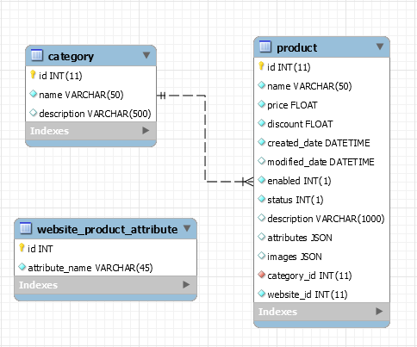

**Edit**:

‘**attribute_name’**: Data type changed from ‘varchar’ to ‘JSON’.

Table ‘**product**’:

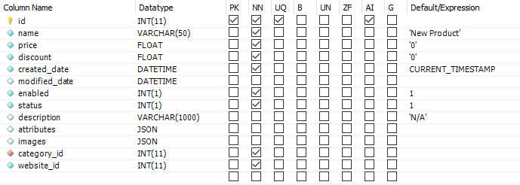

* **id** (int – auto increment): ID of the Product.
* **name** (varchar): name of the Product.
* **price** (float): price of the Product.
* **discount** (float): the discounted amount of the Product, store **DECIMAL NUMBER** (e.g. **0.5** instead of 50%).
* **created_date** (datetime): Product’s created date, use **TimeStamp** in code.
* **modified_date** (datetime): Product’s latest modified date – null by default, use **TimeStamp** in code.
* **enabled** (int):
  + - 1 (default): Product is **enabled.**
    - 0: Product is **disabled.**
* **description** (varchar).
* **website_id** (int): ID of the Website that this Product belongs to.
* **category_id** (int): ID of the Category of this Product.
* **attributes** (JSON): Attributes’ values of Product.

JSON format:

**{**

**"Đèn LED": "RGB",**

**"Bảo hành": "24 tháng",**

**"Tình trạng": "Mới 100% - Full box",**

**"Nhà sản xuất": "Razer"**

**}**

* **images** (JSON): Store URLs of Product’s images.

JSON format:

**[**

**"http://product.hstatic.net/1000026716/product/lancew.jpg",**

**"http://product.hstatic.net/1000026716/product/gearvn-razer-lancehead-wireless-3.jpg",**

**"http://product.hstatic.net/1000026716/product/gearvn-razer-lancehead-wireless-1.jpg",**

**"http://product.hstatic.net/1000026716/product/rzr_lancehead_dongle_v01-14x9inch.png"**

**]**

* **status** (int):

Example:

* + - 1 (default): Còn hang
    - 2: Hết hàng
    - 3: Liên hệ
    - 4: Sắp về

…

Table ‘**category**’:

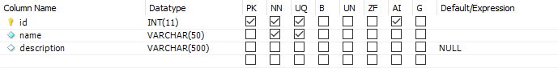

* **id** (int – auto increment): ID of the Category.
* **name** (varchar): name of the Category.
* **description** (varchar).

Table ‘**website_product_attribute**’:

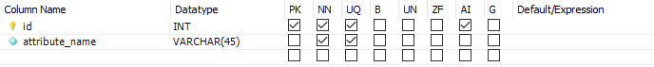

* **id** (int – auto increment): ID of the Attribute.
* **attribute_name** (JSON): Attribute name fields.

JSON format:

**[**

**"Nhà sản xuất",**

**"Tình trạng",**

**"Đèn LED",**

**"Bảo hành"**

**]**