Database for Product Service:

ERD:

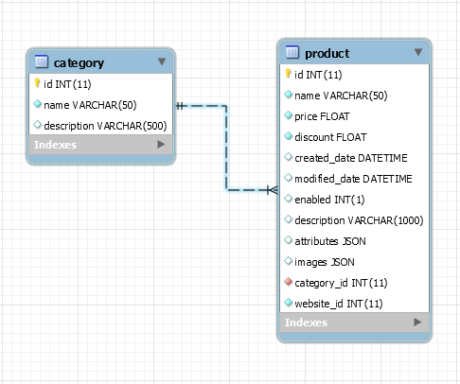

Table ‘**product**’:

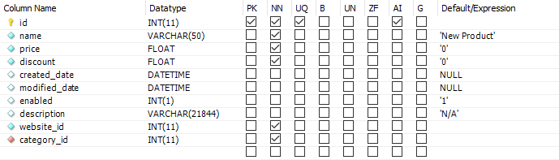

* **id** (int – auto increment): ID of the Product.
* **name** (varchar): name of the Product.
* **price** (float): price of the Product.
* **discount** (float): the discounted amount of the Product, store **DECIMAL NUMBER** (e.g. **0.5** instead of 50%).
* **created_date** (datetime): Product’s created date, use **TimeStamp** in code.
* **modified_date** (datetime): Product’s latest modified date – null by default, use **TimeStamp** in code.
* **enabled** (int):
  + - 1 (default): Product is **enabled.**
    - 0: Product is **disabled.**
* **description** (varchar).
* **website_id** (int): ID of the Website that this Product belongs to.
* **category_id** (int): ID of the Category of this Product.

**Edited**:

* Remove column ‘**producer**’.
* Added new column ‘**attributes**’ (JSON): Replace table ‘product_info’.

JSON format:

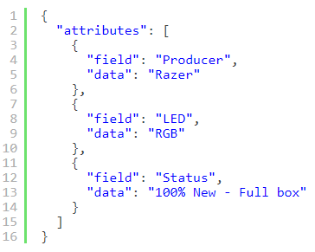

* Added new column ‘**images**’ (JSON): Store URLs of Product’s images.

JSON format:

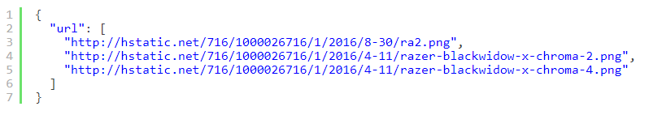

Table ‘**category**’:

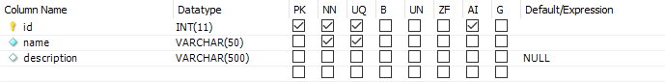

* **id** (int – auto increment): ID of the Category.
* **name** (varchar): name of the Category.
* **description** (varchar).