ABSTRACT

In todays fast -changing business environment, it’s extremely important to be able to respond to client needs in the most effective and timely manner. If your customers wish to see your business online and have instant access to your products or services.

Online Shopping is a lifestyle e-commerce web application, which retails various fashion and lifestyle products (Currently Men’s Wear). This project allows viewing various products available enables registered users to purchase desired products instantly using PayPal payment processor (Instant Pay) and also can place order by using Cash on Delivery (Pay Later) option.

This project provides an easy access to Administrators and Managers to view orders placed using Pay Later and Instant Pay options.

In order to develop an e-commerce website, a number of Technologies must be studied and understood. These include multi-tiered architecture, server and client side scripting techniques, implementation technologies such as ASP.NET, programming language (such as C#) and relational databases. This is a project with the objective to develop a basic website where a consumer is provided with a shopping cart application and also to know about the technologies used to develop such an application.

OBJECTIVE

In these days it becomes the mandate of the companies to double its customers, and this can be done by rendering the value add service and maintaining the quality. Hence, it is also one of the primary objectives of the companies The various objectives of the e-commerce can be laid down as follows:

1. Development of Business-Relationship:

The business development can be done through the e-commerce being the primary and the basic object. As their direct contact in between the company and the consumer, their business relationship will be enhanced. Hence the area of the market can be increased.

2. Better-Customer Service:

As it is done round the clock, the customer will always have online help regarding the products. As all the information is furnished to the customer, it becomes easy to him to choose the best product among all other alternatives. As even the service can also be done through the net immediately, the customer service will be ballooned. By highlighting the customer service, the companies are trying to subjugate a lion-share in the market.

3. Getting more Customers:

In these days it becomes the mandate of the companies to double its customers, and this can be done by rendering the value add service and maintaining the quality. Hence, it is also one of the primary objectives of the companies which supply impetus for the robust growth in sales and overall profit

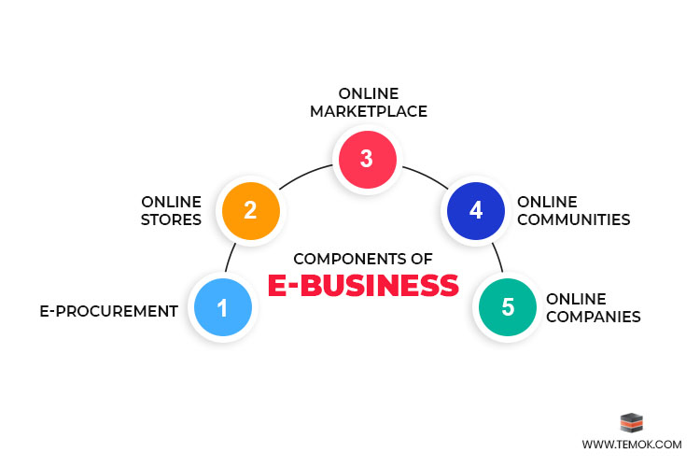

CODE

<!DOCTYPE html>

<html lang="en">

<head>

<meta charset="UTF-8">

<meta http-equiv="X-UA-Compatible" content="IE=edge">

<meta name="viewport" content="width=device-width, initial-scale=1.0">

<title>Document</title>

<link rel="stylesheet" href="./ecommerce.css">

<link href="https://unpkg.com/ionicons@4.5.10-0/dist/css/ionicons.min.css" rel="stylesheet">

</head>

<body>

<header>

<div class="logo"><a href="#">ShoPperZ</a></div>

<div class="menu">

<a href=""><ion-icon name="close" class="close"></ion-icon></a>

<ul>

<li><a href="#" class="under">HOME</a></li>

<li><a href="#" class="under">SHOP</a></li>

<li><a href="#" class="under">OUR PRODUCTS</a></li>

<li><a href="#" class="under">CONTACT US</a></li>

<li><a href="#" class="under">ABOUT US</a></li>

</ul>

</div>

<div class="search">

<a href=""><input type="text" placeholder="search products" id="input">

<ion-icon class="s" name="search"></ion-icon>

</a>

</div>

<div class="heading">

<ul>

<li><a href="#" class="under">HOME</a></li>

<li><a href="#" class="under">SHOP</a></li>

<li><a href="#" class="under">OUR PRODUCTS</a></li>

<li><a href="#" class="under">CONTACT US</a></li>

<li><a href="#" class="under">ABOUT US</a></li>

</ul>

</div>

<div class="heading1">

<ion-icon name="menu" class="ham"></ion-icon>

</div>

</header>

<section>

<div class="section">

<div class="section1">

<div class="img-slider">

<img src="https://images.pexels.com/photos/6347888/pexels-photo-6347888.jpeg?auto=compress&cs=tinysrgb&dpr=2&h=750&w=1260"

alt="" class="img">

<img src="https://images.pexels.com/photos/3962294/pexels-photo-3962294.jpeg?auto=compress&cs=tinysrgb&dpr=2&h=750&w=1260"

alt="" class="img">

<img src="https://images.pexels.com/photos/2292953/pexels-photo-2292953.jpeg?auto=compress&cs=tinysrgb&dpr=2&w=500"

alt="" class="img">

<img src="https://images.pexels.com/photos/1229861/pexels-photo-1229861.jpeg?auto=compress&cs=tinysrgb&dpr=2&h=750&w=1260"

alt="" class="img">

<img src="https://images.pexels.com/photos/1598505/pexels-photo-1598505.jpeg?auto=compress&cs=tinysrgb&dpr=2&h=750&w=1260"

alt="" class="img">

</div>

</div>

<div class="section2">

<div class="container">

<div class="items">

<div class="img img1"><img

src="https://images.pexels.com/photos/1464625/pexels-photo-1464625.jpeg?auto=compress&cs=tinysrgb&dpr=2&h=650&w=940"

alt=""></div>

<div class="name">SHOES</div>

<div class="price">$5</div>

<div class="info">Lorem ipsum dolor sit amet consectetur.</div>

</div>

<div class="items">

<div class="img img2"><img

src="https://images.pexels.com/photos/3649765/pexels-photo-3649765.jpeg?auto=compress&cs=tinysrgb&dpr=1&w=500"

alt=""></div>

<div class="name">MEN's T-SHIRT</div>

<div class="price">$6.34</div>

<div class="info">Lorem ipsum dolor sit.</div>

</div>

<div class="items">

<div class="img img3"><img

src="https://media.istockphoto.com/photos/folded-blue-jeans-on-a-white-background-modern-casual-clothing-flat-picture-id1281304280"

alt=""></div>

<div class="name">JEANS</div>

<div class="price">$9</div>

<div class="info">Lorem ipsum dolor sit amet.</div>

</div>

<div class="items">

<div class="img img1"><img

src="https://images.pexels.com/photos/8839887/pexels-photo-8839887.jpeg?auto=compress&cs=tinysrgb&dpr=2&h=650&w=940"

alt=""></div>

<div class="name">WATCH</div>

<div class="price">$9.1</div>

<div class="info">Lorem ipsum dolor sit.</div>

</div>

<div class="items">

<div class="img img1"><img

src="https://images.pexels.com/photos/6858618/pexels-photo-6858618.jpeg?auto=compress&cs=tinysrgb&dpr=2&h=650&w=940"

alt=""></div>

<div class="name">SMART PHONE</div>

<div class="price">$20</div>

<div class="info">Lorem ipsum dolor sit.</div>

</div>

<div class="items">

<div class="img img1"><img

src="https://images.pexels.com/photos/5552789/pexels-photo-5552789.jpeg?auto=compress&cs=tinysrgb&dpr=2&h=650&w=940"

alt=""></div>

<div class="name">TELEVISION</div>

<div class="price">$18</div>

<div class="info">Lorem ipsum dolor sit amet consectetur.</div>

</div>

<div class="items">

<div class="img img1"><img

src="https://images.pexels.com/photos/4295985/pexels-photo-4295985.jpeg?auto=compress&cs=tinysrgb&dpr=1&w=500"

alt=""></div>

<div class="name">HOODIES</div>

<div class="price">$6.7</div>

<div class="info">Lorem ipsum dolor sit.</div>

</div>

<div class="items">

<div class="img img1"><img

src="https://media.istockphoto.com/photos/vintage-plates-with-silver-teaspoons-picture-id184363070"

alt=""></div>

<div class="name">DINNER SET</div>

<div class="price">$10</div>

<div class="info">Lorem ipsum dolor sit amet consectetur adipisicing elit.</div>

</div>

<div class="items">

<div class="img img1"><img

src="https://images.pexels.com/photos/6463348/pexels-photo-6463348.jpeg?auto=compress&cs=tinysrgb&dpr=1&w=500"

alt=""></div>

<div class="name">BLANKETS</div>

<div class="price">$9.9</div>

<div class="info">Lorem ipsum dolor sit amet consectetur adipisicing.</div>

</div>

<div class="items">

<div class="img img1"><img

src="https://images.pexels.com/photos/2659939/pexels-photo-2659939.jpeg?auto=compress&cs=tinysrgb&dpr=1&w=500"

alt=""></div>

<div class="name">LAPTOP</div>

<div class="price">$99</div>

<div class="info">Lorem ipsum dolor sit amet consectetur, adipisicing elit.</div>

</div>

<div class="items">

<div class="img img1"><img

src="https://media.istockphoto.com/photos/modern-kitchen-microwave-oven-picture-id1144960519"

alt=""></div>

<div class="name">MICROWAVE</div>

<div class="price">$30</div>

<div class="info">Lorem ipsum dolor sit amet consectetur, adipisicing elit.</div>

</div>

<div class="items">

<div class="img img1"><img

src="https://media.istockphoto.com/photos/black-coffee-maker-with-green-led-lights-picture-id177395430"

alt=""></div>

<div class="name">COFFEE MAKER</div>

<div class="price">$29.7</div>

<div class="info">Lorem ipsum dolor sit amet consectetur, adipisicing elit.</div>

</div>

<div class="items">

<div class="img img1"><img

src="https://images.pexels.com/photos/6606354/pexels-photo-6606354.jpeg?auto=compress&cs=tinysrgb&dpr=1&w=500"

alt=""></div>

<div class="name">BED</div>

<div class="price">$100</div>

<div class="info">Lorem ipsum dolor sit amet consectetur, adipisicing elit.</div>

</div>

<div class="items">

<div class="img img1"><img

src="https://media.istockphoto.com/photos/woman-turning-on-air-conditioner-picture-id1325708905"

alt=""></div>

<div class="name">AIR CONDITIONER</div>

<div class="price">$78</div>

<div class="info">Lorem ipsum dolor sit amet consectetur, adipisicing elit.</div>

</div>

<div class="items">

<div class="img img1"><img

src="https://images.pexels.com/photos/5834/nature-grass-leaf-green.jpg?auto=compress&cs=tinysrgb&dpr=2&h=650&w=940"

alt=""></div>

<div class="name">BOOK</div>

<div class="price">$9</div>

<div class="info">Lorem ipsum dolor sit amet consectetur, adipisicing elit.</div>

</div>

<div class="items">

<div class="img img1"><img

src="https://images.pexels.com/photos/4339598/pexels-photo-4339598.jpeg?auto=compress&cs=tinysrgb&dpr=2&h=650&w=940"

alt=""></div>

<div class="name">BAG</div>

<div class="price">$36.5</div>

<div class="info">Lorem ipsum dolor sit amet consectetur, adipisicing elit.</div>

</div>

<div class="items">

<div class="img img1"><img

src="https://media.istockphoto.com/photos/hand-of-a-lady-selecting-yellow-colored-saree-in-a-shop-picture-id1301740530"

alt=""></div>

<div class="name">SAREES</div>

<div class="price">$25.6</div>

<div class="info">Lorem ipsum dolor sit amet consectetur, adipisicing elit.</div>

</div>

<div class="items">

<div class="img img1"><img

src="https://images.pexels.com/photos/5816934/pexels-photo-5816934.jpeg?auto=compress&cs=tinysrgb&dpr=2&h=650&w=940"

alt=""></div>

<div class="name">WASHING MACHINE</div>

<div class="price">$56</div>

<div class="info">Lorem ipsum dolor sit amet consectetur, adipisicing elit.</div>

</div>

</div>

</div>

</div>

</section>

<footer>

<div class="footer0">

<h1>ShoPperZ</h1>

</div>

<div class="footer1 ">

Connect with us at<div class="social-media">

<a href="#">

<ion-icon name="logo-facebook"></ion-icon>

</a>

<a href="#">

<ion-icon name="logo-linkedin"></ion-icon>

</a>

<a href="#">

<ion-icon name="logo-youtube"></ion-icon>

</a>

<a href="#">

<ion-icon name="logo-instagram"></ion-icon>

</a>

<a href="#">

<ion-icon name="logo-twitter"></ion-icon>

</a>

</div>

</div>

<div class="footer2">

<div class="product">

<div class="heading">Products</div>

<div class="div">Sell your Products</div>

<div class="div">Advertise</div>

<div class="div">Pricing</div>

<div class="div">Product Buisness</div>

</div>

<div class="services">

<div class="heading">Services</div>

<div class="div">Return</div>

<div class="div">Cash Back</div>

<div class="div">Affiliate Marketing</div>

<div class="div">Others</div>

</div>

<div class="Company">

<div class="heading">Company</div>

<div class="div">Complaint</div>

<div class="div">Careers</div>

<div class="div">Affiliate Marketing</div>

<div class="div">Support</div>

</div>

<div class="Get Help">

<div class="heading">Get Help</div>

<div class="div">Help Center</div>

<div class="div">Privacy Policy</div>

<div class="div">Terms</div>

<div class="div">Login</div>

</div>

</div>

<div class="footer3">Copyright © <h4>ShoPperZ</h4> 2021-2028</div>

</footer>

<script src="https://unpkg.com/ionicons@4.5.10-0/dist/ionicons.js"></script>

<script src="./ecommerce.js"></script>

</body>

</html>

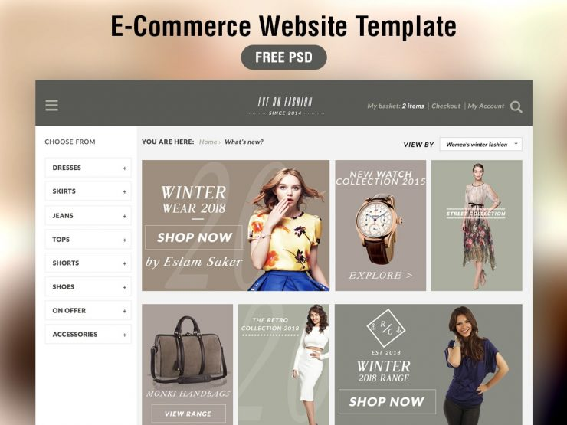

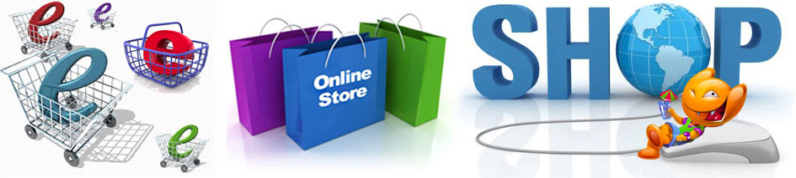

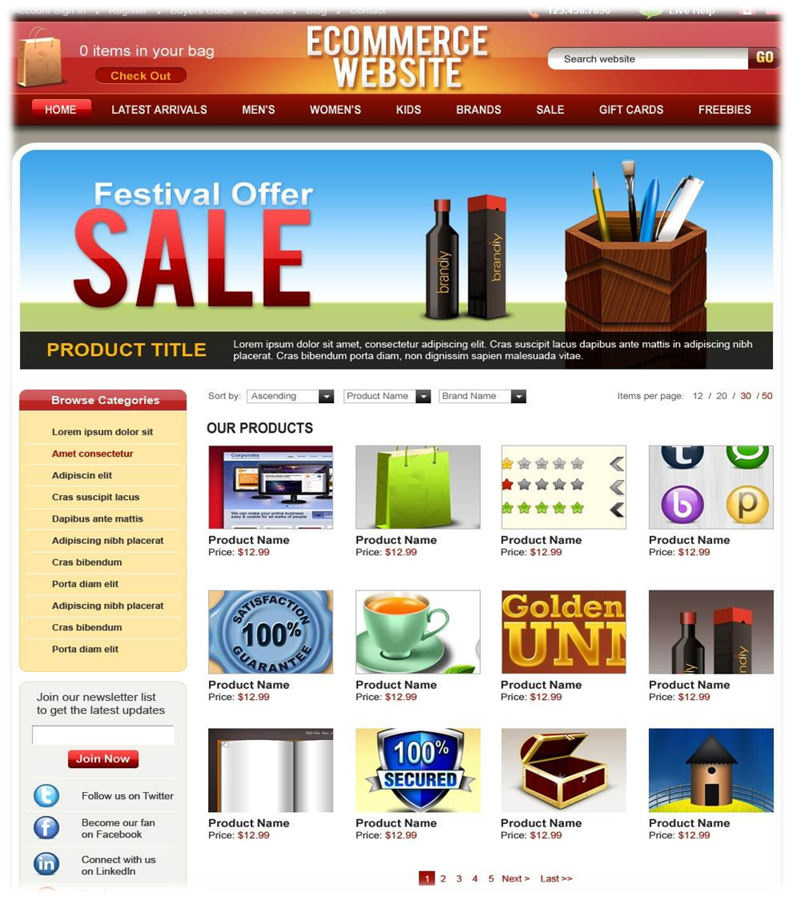

METHODOLOGY

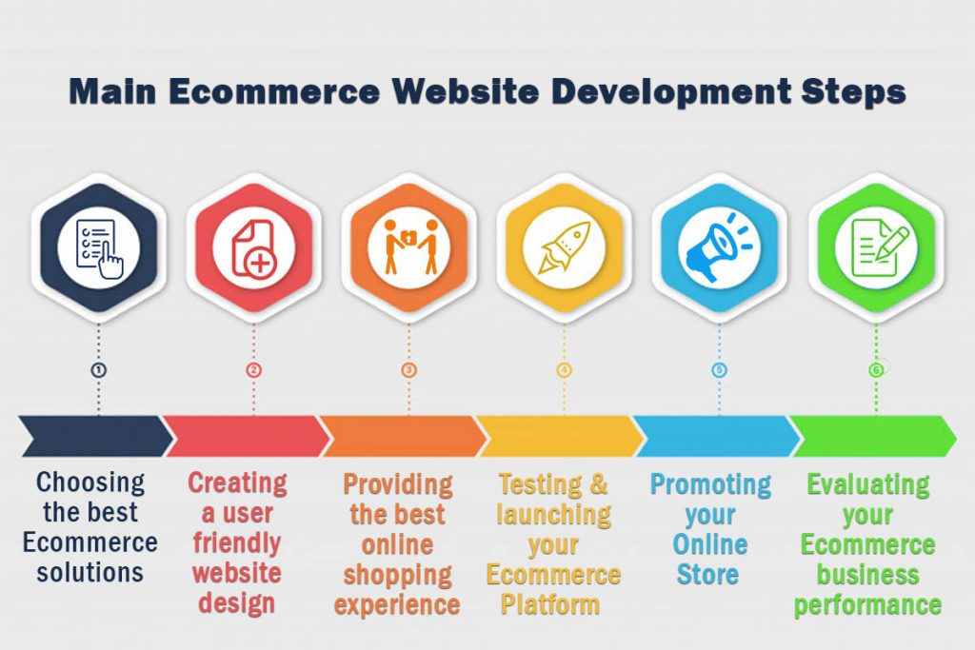

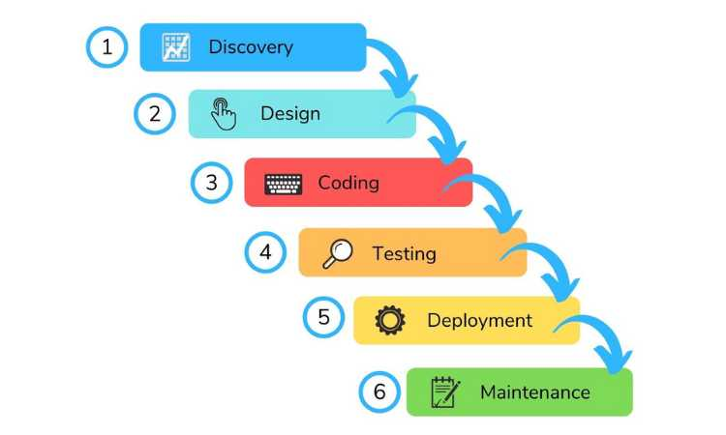

ADVANTAGES

1. Faster buying process

2. Store and product listing creation

3. Cost reduction

4. Affordable advertising and marketing

5. Flexibility for customers

6. No reach limitations

7. Product and price comparison

8. Faster response to buyer/market demands

9. Several payment modes

10. Enables easy exports

Advantages in detail

1. Faster buying process

Customers can spend less time shopping for what they want. They can easily browse through many items at a time and buy what they like. When online, customers can find items that are available in physical stores far away from them or not found in their locality.

For example - Rajesh is a customer who goes to a store to buy a washing machine. After searching, he realises that he cannot find the product he needs. He logs onto a popular ecommerce marketplace and finds the washing machine. What is even better is that there is a special offer price and it can be delivered to his home.This is where ecommerce comes to the rescue for many shoppers. They go online, search for an item, get a fast response and can buy it just as quickly.

Advantages of e-business include helping one to choose from a wide range of products and get the order delivered too. Searching for an item, seeing the description, adding to cart – all steps happen in no time at all. In the end, the buyer is happy because he has the item and didn’t have to travel far.

2. Store and product listing creation

A product listing is what the customer sees when they search for an item. This is one advantage in ecommerce meant for the seller. This online business plus point is that you can personalise your product listing after creating them. The best part? Creating a listing takes very little time, all you require is your product name or codes like EAN, UPC, ISBN or ASIN.

Sellers can add many images, a description, product category, price, shipping fee and delivery date. So, in just one step you can tell the customer many things about the item. Creating your listing shows the buyers what you have.

Rules for product listing

• Use high quality resolution images. Blurry images distract and confuse customers.

• Maintain image dimensions. Usually ecommerce marketplaces will recommend a resolution format.

• Provide multiple product views. Some sites even let you include a 360-degree view of items.

• When adding product variants – such as lipsticks in different shades – ensure each variant has its specific image.

Customising listings makes them attractive and appealing. Here are that it is free to upload and fast

3. Cost reduction

One of the biggest advantages of ecommerce to business that keep sellers interested in online selling is cost reduction. Many sellers have to pay lots to maintain their physical store. They may need to pay extra up front costs like rent, repairs, store design, inventory etc. In many cases, even after investing in services, stock, maintenance and workforce, sellers don’t receive desired profits and ROI.

4. Affordable advertising and marketing

Sellers don’t have to spend a lot of money to promote their items. The world of ecommerce has several affordable, quick ways to market online. Ecommerce marketplaces are visual channels – and sellers can really show off their product. For example, Amazon sellers can use Advertising tools to add videos, infographics, good quality resolution images.

5. Flexibility for customers

An important advantage of ecommerce to business is that sellers can provide flexibility to customers. One highlight is that the product and services are ready 24x7. The result is that seller can offer his item any place, any time.

6. Product and price comparison

In ecommerce, sellers can compare the products using tools or on their own. This gives them a good idea of product alternatives available, the standard rates, if a product need is unfulfilled.This is one more benefit for the customer too. When people see many items ready for purchase, they feel more confident about spending.

7. No reach limitations

A seller with a physical store may only be able to reach a certain number of buyers. They can deliver to the customers’ homes but there can be distance limitations. Several e-commerce marketplaces have their own logistics and delivery system.

8. Faster response to buyer/market demands

Every interaction is faster when you begin selling online. Ecommerce marketplaces offer you a streamlined logistics or delivery system. What this means is that the buyers order gets delivered efficiently. Product returns management is one more plus point that can be handled quickly – you either refund the payments or give a replacement.

9. Several payment modes

Buyers like personalisation – the same goes for paying for their orders. Ecommerce marketplaces permit multiple payment modes that include UPI, cash on delivery, card on delivery, net banking, EMIs on credit or debit card and pay-later credit facility.

10. Enables easy exports

E-commerce exports assists sellers to directly sell to international customers in global marketplaces, allowing them to transcend beyond national boundaries and expand abroad. With e-commerce, sellers don’t have to invest in a physical setup to reach customers. Instead, they can use attractive product listing and acquire new customers internationally with ease. For aspiring entrepreneurs and growing businesses, e-commerce exports can be a very profitable model to adapt for global expansion and increased revenue.

DISADVANTAGES

1. Security

The biggest drawback of e-commerce is the issue of security. People fear to provide personal and financial information, even though several improvements have been made in relation to data encryption. Certain websites do not have capabilities to conduct authentic transactions. Fear of providing credit card information and risk of identity limit the growth of e-commerce.

2. Lack of privacy

Many websites do not have high encryption for secure online transaction or to protect online identity. Some websites illegally collect statistics on consumers without their

permission. Lack of privacy discourages people to use internet for conducting commercial transactions.

3. Tax issue

Sales tax is another bigger issue when the buyer and seller are situated in different locations. Computation of sales tax poses problems when the buyer and seller are in different states. Another factor is that physical stores will lose business if web purchases are free from tax.

4. Fear

People fear to operate in a paperless and faceless electronic world. Some of the business organizations do not have physical existence, People do not know with whom they are conducting commercial transactions. This aspect makes people to opt physical stores for purchases.

CONCLUSION

* The growth in e-commerce has a few negative social consequences as well. E-Commerce has resulted in Me-Oriented society in which the main focus is on personal growth and decline in family values. E-Commerce has adversely affected the earnings of various micro retail traders. E-Commerce, if used properly can prove to be beneficial to the society otherwise it may be the reason of spoiling the environment for forth coming generations.