

**Module Code & Module Title**

**CC4057NI Introduction to Information Systems**

**Assessment Weightage & Type**

**30% Individual Coursework**

**Year and Semester**

**2021 Spring**

**Student Name: Aadarsha Muni Shakya**

**Group: N1**

**London Met ID:**

**College ID:NP01NT4S210023**

**Assignment Due Date: April 30, 2021**

**Assignment Submission Date: April 29, 2021**

*I confirm that I understand my coursework needs to be submitted online via Google Classroom under the relevant module page before the deadline in order for my assignment to be accepted and marked. I am fully aware that late submissions will be treated as non-submission and a marks of zero will be awarded*

Table of Contents

**Introduction** 1

**Database Model** 2

**Relational Model** 3

Suppliers 4

Ice Cream 5

Customers 6

Ice-cream Supplier Details(ISD) 8

Ice-cream Customer Details(ICD) 9

**Data Dictionary** 12

**Queries** 13

**Conclusion** 21

**References** 22

**List of Figure**

Figure 1: Entity Relation Model 2

Figure 2: Relational Diagram 3

Figure 3: Creating Suppliers Table 4

Figure 4: Describing Suppliers Table 4

Figure 5: Inserting into Suppliers Table 4

Figure 6: Selecting Suppliers Table 5

Figure 7: Creating Ice Cream Table 5

Figure 8: Describing Ice Cream Table 5

Figure 9: Inserting into Ice Cream Table 6

Figure 10: Selecting Ice Cream Table 6

Figure 11: Creating Customers Table 6

Figure 12: Describing Customers Table 7

Figure 13: Inserting into Customers Table 7

Figure 14: Selecting Customers Table 7

Figure 15: Creating ISD Table 8

Figure 16: Describing ISD Table 8

Figure 17: Inserting into ISD Table 8

Figure 18: Selecting ISD Table 9

Figure 19: Creating ICD Table 10

Figure 20: Describing ICD Table 10

Figure 21: Inserting into ICD Table 10

Figure 22: Selecting ICD Table 11

Figure 23: Query 1 13

Figure 24: Query 2 13

Figure 25: Query 3 14

Figure 26: Query 4 14

Figure 27: Query 5 15

Figure 28: Query 6 16

Figure 29: Query 7 17

Figure 30: Query 8 18

Figure 31: Query 9 19

Figure 32: Query 10 20

**List of Tables**

Table 1: Data Dictionary(Suppliers) 12

Table 2: Data Dictionary(Ice Cream) 12

Table 3: Data Dictionary(Customers) 12

Table 4 Data Dictionary(ISD) 12

Table 5: Data Dictionary(ICD) 12

Table 6: Querie1 13

Table 7 Query 2 13

Table 8 Query 3 14

Table 9 Query 4 14

Table 10 Query 5 15

Table 11: Query 6 16

Table 12: Query 7 17

Table 13: Query 8 18

Table 14: Query 9 19

Table 15: Query 10 20

# **Introduction**

Databases are the collection of raw data which is processed to form information which is kept in an organised manner for quick and east assess. Moreover, Data is unprocessed and unorganized facts that are random and might not carry any significant meaning. Whereas, information is the processed data which delivers a certain meaning and is displayed according to the need of the user.

Talking about the business the ice cream store serves each-an-every type of ice cream found in Nepal. Namely, Ice Cream Cone, Ice Cream Bowl, Chocolate Bar, Soft Serve, and Kulfi. Not just the type, but all brands of ice cream is accessible. Those brand name include Nepal Dairy, Lovebirds, Azzabko, Snow Fun, Martin, and Baskin Robbins.

Moreover, the goal of Ice cream store is to fulfil the needs and wants of the new as well as existing customers. Customers can purchase as much ice cream as they need. Also, the same ice cream can be sold to all customers. By doing so the business goal is met.

# **Database Model**

The business rule of ice cream store is all customers can buy ice cream of various brands and types. By this business rule many-to-many relation is formed between Suppliers, Ice Cream and Customers, Ice Cream so, two separate bridge entities are formed.

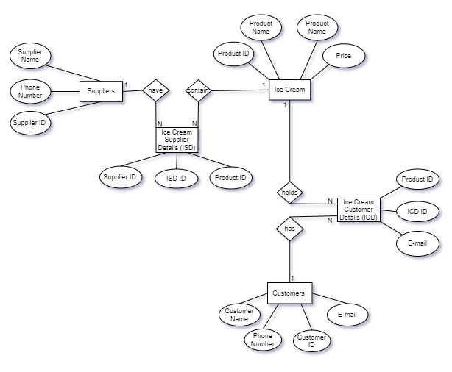

Figure 1: Entity Relation Model

# **Relational Model**

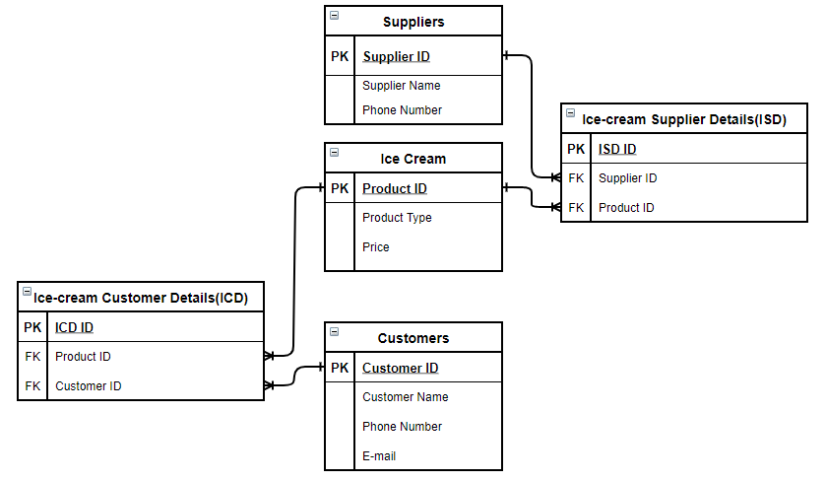

Figure 2: Relational Diagram

## Suppliers

Table suppliers is created to store records of ice-cream suppliers of the business. In this table Supplier ID, Supplier Name and Phone Number as created to store its attributes. Supplier ID is the primary of the table which uniquely identifies other attributes. Similarly, Supplier Name and Phone Number stores the name of supplier and their phone number for any need of stock.



Figure 3: Creating Suppliers Table

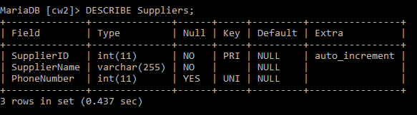

Figure 4: Describing Suppliers Table

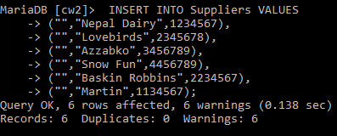

Figure 5: Inserting into Suppliers Table

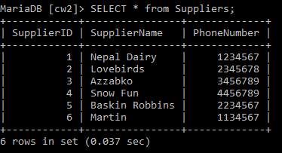

Figure 6: Selecting Suppliers Table

## Ice Cream

Table Ice Cream is created to store records of different type of ice-cream served by the business. In this table Product ID, Product Type and Price is created to store its attributes. Product ID is the primary of the table which uniquely identifies other attributes. Similarly, Product Type and Price stores the type of ice-cream and its price.



Figure 7: Creating Ice Cream Table

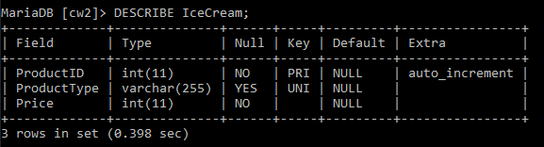

Figure 8: Describing Ice Cream Table

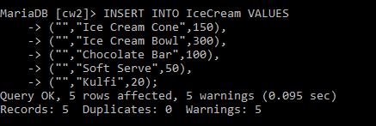

Figure 9: Inserting into Ice Cream Table

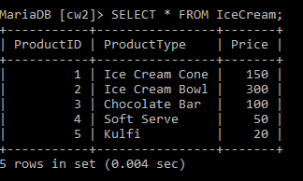

Figure 10: Selecting Ice Cream Table

## Customers

Table Customers is created to store records of the customer who purchases ice-cream from the business. In this table Customer ID, Customer Name, E-mail and Phone Number as created to store its attributes. Customer ID is the primary of the table which uniquely identifies other attributes. Also, Customer Name, E-mail and Phone Number stores information about customers to make the business user friendly.



Figure 11: Creating Customers Table

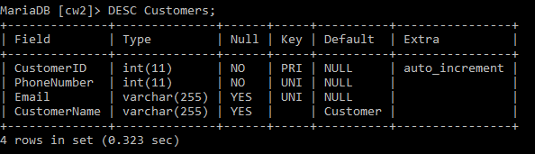

Figure 12: Describing Customers Table

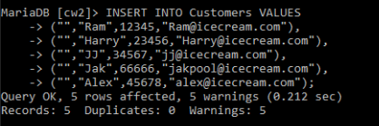

Figure 13: Inserting into Customers Table

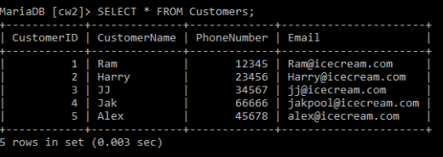

Figure 14: Selecting Customers Table

## Ice-cream Supplier Details(ISD)

Table Ice-Cream Supplier Details(ISD) is created as a bridge entity which avoids the many-to-many relation between two tables. In this table ISD ID is the primary key; Supplier ID, and Product ID are the foreign keys with reference from Suppliers and Ice Cream tables.



Figure 15: Creating ISD Table

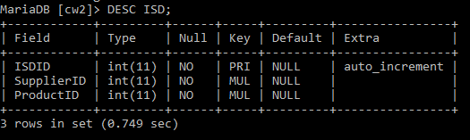

Figure 16: Describing ISD Table

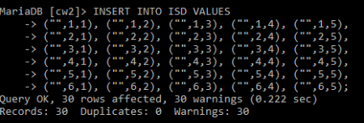

Figure 17: Inserting into ISD Table

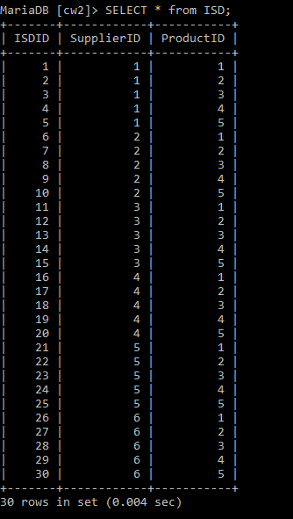

Figure 18: Selecting ISD Table

## Ice-cream Customer Details(ICD)

Similarly, table Ice-Cream Customer Details(ICD) is created as a bridge entity which avoids the many-to-many relation between Ice-cream and Customers tables. In this table ICD ID is the primary key; Customer ID, and Product ID are the foreign keys with reference from Customers and Ice Cream tables.



Figure 19: Creating ICD Table

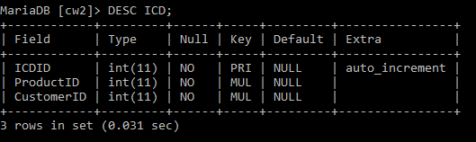

Figure 20: Describing ICD Table

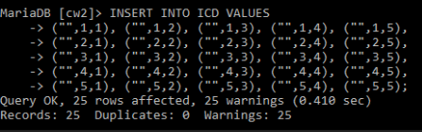

Figure 21: Inserting into ICD Table

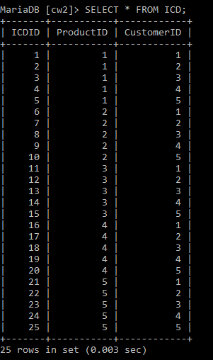

Figure 22: Selecting ICD Table

# **Data Dictionary**

Table 1: Data Dictionary(Suppliers)



Table 2: Data Dictionary(Ice Cream)



Table 3: Data Dictionary(Customers)



Table 4 Data Dictionary(ISD)



Table 5: Data Dictionary(ICD)



# **Queries**

Table 6: Querie1

|  |  |
| --- | --- |
| Query Number | Query 1 |
| Query | SELECT * FROM Customers ORDER BY CustomerName DESC; |
| Keywords Used | SELECT, FROM, ORDER BY, DESC |
| Purpose/Result | Selecting Customers name in descending |

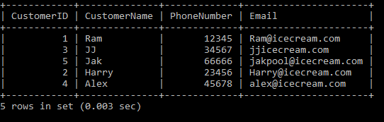

Figure 23: Query 1

Table 7 Query 2

|  |  |
| --- | --- |
| Query Number | Query 2 |
| Query | SELECT * FROM Suppliers LIMIT 3; |
| Keywords Used | SELECT, FROM, LIMIT |
| Purpose/Result | Selecting top 3 data from Suppliers table |

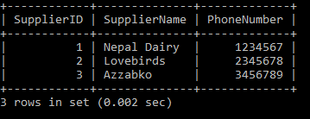

Figure 24: Query 2

Table 8 Query 3

|  |  |
| --- | --- |
| Query Number | Query 3 |
| Query | SELECT DISTINCT(Price) FROM Icecream; |
| Keywords Used | SELECT, DISTINCT(), FROM |
| Purpose/Result | Selecting unique price from Icecream table |

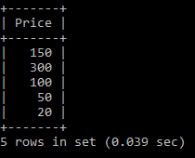

Figure 25: Query 3

Table 9 Query 4

|  |  |
| --- | --- |
| Query Number | Query 4 |
| Query | SELECT COUNT(*) AS total_items FROM ISD; |
| Keywords Used | SELECT, COUNT, AS, FROM |
| Purpose/Result | Counting total number of items from ISD table |

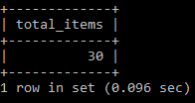

Figure 26: Query 4

Table 10 Query 5

|  |  |
| --- | --- |
| Query Number | Query 5 |
| Query | SELECT * FROM Icecream WHERE Price BETWEEN 100 AND 300; |
| Keywords Used | SELECT, FROM, WHERE, BETWEEN, AND |
| Purpose/Result | Selecting ice-cream which price is between 100 to 300 |

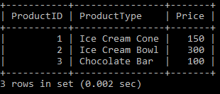

Figure 27: Query 5

Table 11: Query 6

|  |  |
| --- | --- |
| Query Number | Query 6 |
| Query | SELECT * FROM ICD WHERE CustomerID IN(1,2,3); |
| Keywords Used | SELECT, FROM, WHERE, IN |
| Purpose/Result | Selecting data that have CustomerID 1,2 and 3 |

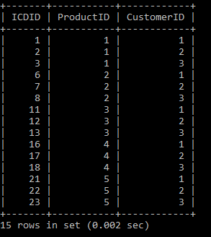

Figure 28: Query 6

Table 12: Query 7

|  |  |
| --- | --- |
| Query Number | Query 7 |
| Query | SELECT * FROM Customers WHERE CustomerName LIKE '_a%'; |
| Keywords Used | SELECT, FROM, WHERE , LIKE |
| Purpose/Result | Selecting Customers who’s second character is ‘a’ |

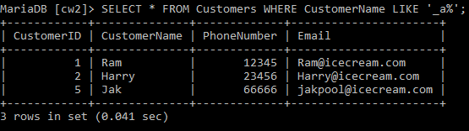

Figure 29: Query 7

Table 13: Query 8

|  |  |
| --- | --- |
| Query Number | Query 8 |
| Query | SELECT ProductID,COUNT(*) AS TotalProduct FROM ISD GROUP BY ProductID; |
| Keywords Used | SELECT, COUNT, AS, FROM, GROUP BY |
| Purpose/Result | Selecting SupplierID and Counting total number of product offered by a supplier |

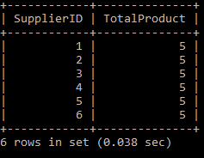

Figure 30: Query 8

Table 14: Query 9

|  |  |
| --- | --- |
| Query Number | Query 9 |
| Query | SELECT ProductID,Count(CustomerID) AS TotalCustomers FROM ICD GROUP BY ProductID HAVING ProductID = 1; |
| Keywords Used | SELECT, Count, AS, FROM, GROUP BY, HAVING |
| Purpose/Result | Selecting ProductID and counting number of customers who can have ice-cream with ProductID 1 |

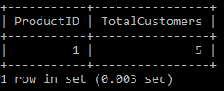

Figure 31: Query 9

Table 15: Query 10

|  |  |
| --- | --- |
| Query Number | Query 10 |
| Query | SELECT * FROM Suppliers JOIN ISD ON Suppliers.SupplierID = ISD.SupplierID; |
| Keywords Used | SELECT, FROM, JOIN, ON |
| Purpose/Result | Joining two Tables with similar SupplierID |

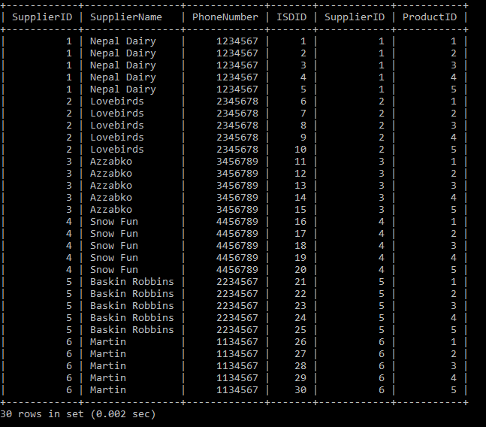

Figure 32: Query 10

# **Conclusion**

For conclusion, Databases are the collection of raw data which is processed to form information which is kept in an organised manner for quick and east assess. Then those data are stored in different tables as entities. Before creating database, Relational Diagram and Entity Relation Diagram are created for visual representations which makes it less complex. Moreover, Data dictionary also helps in understanding the database; The details about the database like Entity name, Column name, Data type, Primary key, Foreign key, Null able Unique and many more can help to understand the database.

# **References**

Zwass, V., 2016. *Encyclopedia Britannica.* [Online]   
Available at: https://www.britannica.com/technology/data-processing  
[Accessed 11 April 2021].

# 