Program-7
Pretrained Convolution neural network for imageclassification
Aim:Use a pretrained Convolution neural network LeNet/AlexNet for image classification.
Introduction to VGG16:
VGG16 was developed by the Visual Geometry Group at the University of Oxford. It famously won the 2014 ImageNet competition by proving that a "deeper" network with very small filters performs better than a "shallower" network with large filters.The "16" in its name refers to the 16 weight layers (13 convolutional layers and 3 fully connected layers).
VGG16 is known for its extreme simplicity and symmetry. It follows a very predictable pattern:
- Uniform Filters: It uses only 3 x 3 convolutional filters throughout the entire network.
- Max Pooling: Every few layers, it uses a 2 x 2 Max Pooling layer to shrink the image dimensions (height and width) by half.
- Increasing Depth: Every time the image size is halved, the number of filters doubles (from 64→128→256→512).
- The "Tail": At the very end, it has three "Fully Connected" (Dense) layers that act like a standard classifier to decide what the image actually is.
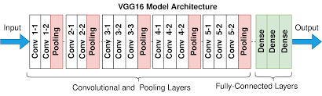
Fig. 1 VGG16 Model Architecture
Introduction to ImageNet Dataset:
The ImageNet-1K dataset (formally part of the ILSVRC challenge) is the industry-standard benchmark for training and evaluating computer vision models. While the full ImageNet project contains over 14 million images, the "1000 categories" version is what almost all pretrained models, including the VGG16 you used, are built upon. The 1,000 classes are not random; they follow a "Noun" hierarchy.
The dataset is famous for being very specific. The 1,000 categories contain:
- Animals (~40%): A massive portion of the dataset, including 120 dog breeds, cats, birds, fish, and insects.
- Vehicles: Like the "sports car," "convertible," and "racer" classes, it contains trains, boats, and airplanes.
- Household Objects: Everything from "coffee mugs" and "refrigerators" to "hammer" and "remote control."
- Food Items: Fruits, vegetables, and prepared dishes like "pizza" or "cheeseburger."
- Scenery/Structures: "Amusement park," "church," "library," etc.
- Training images : 1.28 Million (approx. 1300 images per class)
- Validation images : 50,000 (50 images per class)
- Test images : 1,00,000.
Program: (Suggested to run for two different categories of objects)
import tensorflow as tf
from tensorflow.keras.applications.vgg16 import VGG16, preprocess_input, decode_predictions
from tensorflow.keras.preprocessing import image
import numpy as np
# 1. Load the model
model = VGG16(weights='imagenet')
# 2. Define the path to your image here!
my_image_path = '/content/sample_data/Car-Wallpaper1.jpg'
def classify_image(img_path):
try:
# Load and resize
img = image.load_img(img_path, target_size=(224, 224))
# Convert to array and add batch dimension
x = image.img_to_array(img)
x = np.expand_dims(x, axis=0)
# Pre-process
x = preprocess_input(x)
# Predict
preds = model.predict(x)
# Show results
print('Results:')
for x in decode_predictions(preds, top=3)[0]:
print(f"- {x[1]}: {x[2]*100:.2f}%")
except Exception as e:
print(f"Error: Could not find or load the image. Check the path! \nDetails: {e}")
# 3. Run the function
classify_image(my_image_path)
Image-1:
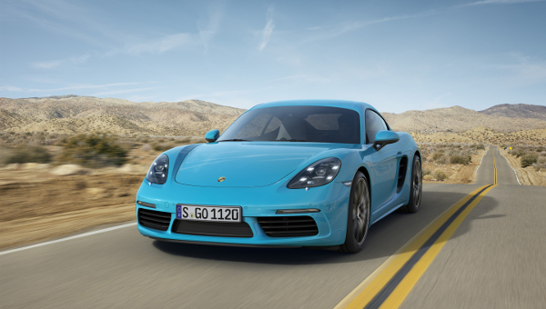
Output:
Results:sports_car: 39.17%, racer: 24.51%, convertible: 11.32%, minivan: 4.89%, beach_wagon: 3.19%
Image-2:
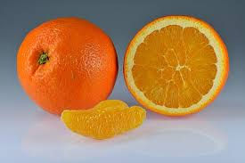
Output:
Results:orange: 99.34%, lemon: 0.46%, banana: 0.04%, jack-o'-lantern: 0.03%, pomegranate: 0.02%

