Metaheuristic Deep Learning Framework for Automated Leukemia Classification and Severity Grading
Anmol Kundap, Adarsh A Inamdar, Tanushree M Pujar, Amogh K Baliga
Supervisor: Dr. Pradeep N
Bapuji Institute of Engineering and Technology
2025

INTRODUCTION

Background of the Problem
Hematological malignancies constitute a profound crisis in modern oncology, with leukemia standing out as a particularly aggressive adversary. Originating deep within the bone marrow, this cancer subverts the body’s fundamental blood-production machinery. Instead of generating distinct, functional blood cells, the marrow becomes a factory for abnormal, immature leukocytes. These malignant cells crowd out their healthy counterparts—red blood cells and platelets—precipitating a cascade of systemic failures ranging from debilitating anemia to catastrophic hemorrhage. While survival rates have improved over decades, the cornerstone of effective management remains early interception. Yet, identifying leukemia in its nascent stages is akin to finding a needle in a haystack; the morphological subtleties between a benign reactive lymphocyte and a malignant blast can be deceptively minute.
Currently, the burden of this discovery falls on the shoulders of hematopathologists who must manually scour peripheral blood smears under a microscope. It is an arduous, eye-straining process where fatigue can easily obscure a diagnosis. A single overlooked cell can mean the difference between proactive chemotherapy and palliative care.

Domain Overview
To understand the gravity of the problem, one must look at the physiology of hematopoiesis. In a healthy state, the bone marrow is a disciplined environment where stem cells differentiate into myeloid and lymphoid lineages with precision. Leukemia shatters this order. Genetic aberrations lock these cells in a state of rapid, uncontrolled division.
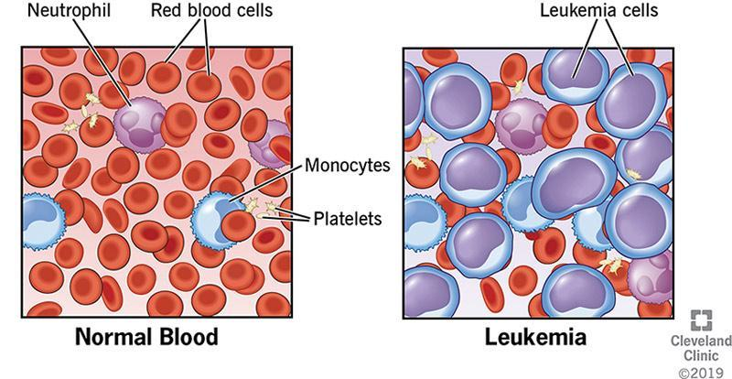
Differentiation between Normal Blood and Leukemia cells
As depicted in Figure 1.1, the peripheral blood becomes inundated with these useless clones. Clinicians categorize these malignancies based on two axes: the speed of progression (Acute vs. Chronic) and the lineage of the affected cell (Myeloid vs. Lymphoid).
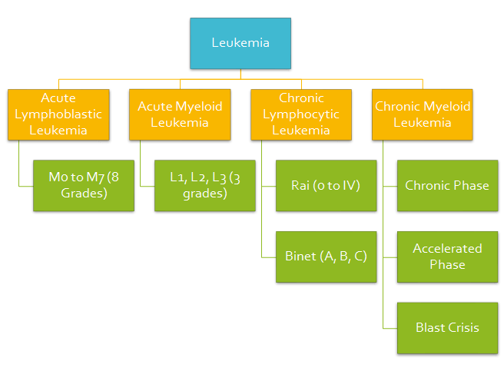
Clinical classification and grading of leukemia
Figure 1.2 outlines this taxonomy, dividing the disease into the "Big Four": ALL, AML, CLL, and CML. This is not merely academic; the treatment for ALL differs radically from CML.
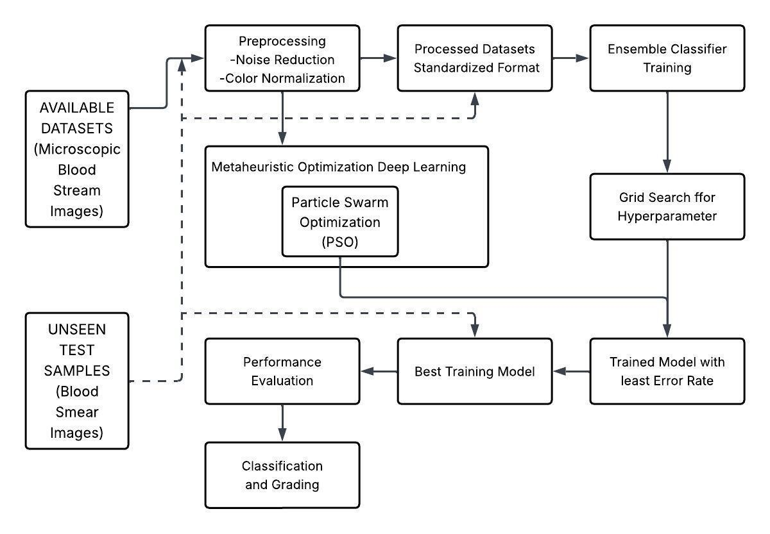
Progression from normal blood components to abnormal conditions
Major leukemia types based on progression rate, cell lineage, and age group.
Type | Description
Acute Lymphoblastic Leukemia (ALL) | Strikes children predominantly. It is an aggressive storm of lymphoid blasts requiring immediate intervention.
Acute Myeloid Leukemia (AML) | Affects adults more frequently. Characterized by rapid myeloid proliferation.
Chronic Lymphocytic Leukemia (CLL) | An insidious disease of the elderly, often asymptomatic for years before accelerating.
Chronic Myeloid Leukemia (CML) | Defined by the Philadelphia chromosome. Poses a risk of transforming into a "blast crisis."

Need for the Project and Importance
Why do we need automation? The answer lies in the limitations of human perception. Diagnostic concordance among pathologists is not perfect; subjective interpretation of "chromatin density" or "nuclear irregularity" can vary. Furthermore, in resource-constrained settings, there may not be a specialist available to interpret a slide for days. We need a system that doesn’t get tired, doesn’t blink, and offers a standardized second opinion instantly. This project aims to bridge the gap between high-level oncological expertise and digital accessibility.

Scope of the Project
Our scope is specific yet ambitious. We are building an intelligent pipeline that ingests raw microscopic images and outputs two distinct predictions: the **Type** of leukemia (classifying into the four major buckets) and the **Grade** or severity (Stage 1, 2, or 3). We explicitly exclude genetic analysis or flow cytometry data; our focus is purely on computer vision applied to morphology.

LITERATURE SURVEY

Review of Research Papers

PSO-Based Leukemia Classification (2024)
Ju and colleagues recently proposed integrating Particle Swarm Optimization (PSO) with CNNs. They argued, correctly, that manual hyperparameter tuning is inefficient. By automating the search for learning rates, they improved accuracy on the ALL-IDB dataset. However, their work remained somewhat opaque—a "black box" solution that improved numbers but offered little insight into *why* specific parameters worked better.

Ant Colony Optimization (2023)
Heng’s team took a different route, utilizing Ant Colony Optimization (ACO). Their focus was feature selection—stripping away irrelevant image noise before the classifier even sees the data. While conceptually sound, their validation was restricted to a remarkably small dataset, leaving open questions about how their "ant trails" would hold up against the massive variance seen in clinical wild data.

Genetic Algorithm (GA) and SVM Hybrid (2022)
Kebaili turned to genetics—specifically, using Genetic Algorithms to sift through gene expression profiles. This is a powerful method for molecular diagnosis but is entirely disconnected from the visual world of pathology slides. It highlights the disconnect in the field: molecular precision vs. accessible imaging.
Existing methods and gaps in leukemia research
Ref/Author | Method | Observations
Ju et al. (2024) | PSO + CNN | Effective but opaque; lacked explainability.
Heng et al. (2023) | ACO + Feature Selection | Validation dataset was too small to be conclusive.
Kebaili et al. (2022) | GA + SVM (Gene data) | Irrelevant for image-based diagnostics.
Akbar et al. (2022) | Whale Optimization + RF | Good speed, but struggled with diverse heterogeneous data.

Existing System
Most current solutions are siloed. You find papers dedicated solely to binary classification (Cancer vs. No Cancer) or papers attempting to grade a specific subtype. There is a dearth of unified frameworks that attempt the full clinical picture: "What is it?" AND "How bad is it?". Furthermore, many existing "Deep Learning" papers simply slap a pre-trained VGG16 on a dataset without optimizing the underlying learning dynamics, leading to bloated, inefficient models.

Problem Statement
The core problem is the "Jack of all trades, master of none" issue in current AI diagnostics. Models that are broad enough to cover all leukemia types usually lack the granularity to grade them accurately. Conversely, specialized grading models are too narrow. We face the challenge of building a system that effectively handles the class imbalance—ALL is common, CML is rare—while managing the computational cost of deep learning.

Proposed System
We propose a symbiotic architecture. Instead of treating the optimizer and the classifier as separate entities, we fuse them. We use PSO not just as a tuner, but as an integral discovery mechanism to "set the stage" for the ResNet-18 model. By letting the swarm intelligence find the optimal initialization vector, we ensure that when the Deep Learning begins, it is already starting from a position of strength, rather than stumbling around in the dark.

Objectives
- Unify: Create a single pipeline for both typing and grading.
- Optimize: Move beyond "guessing" hyperparameters to "evolving" them via PSO.
- Robustness: Ensure the model doesn’t just memorize the training set but generalizes to new, unseen slides.
- Efficiency: Keep the inference time low enough for real-time clinical use.

METHODOLOGY
Our approach is a carefully orchestrated assembly line of data transformation.
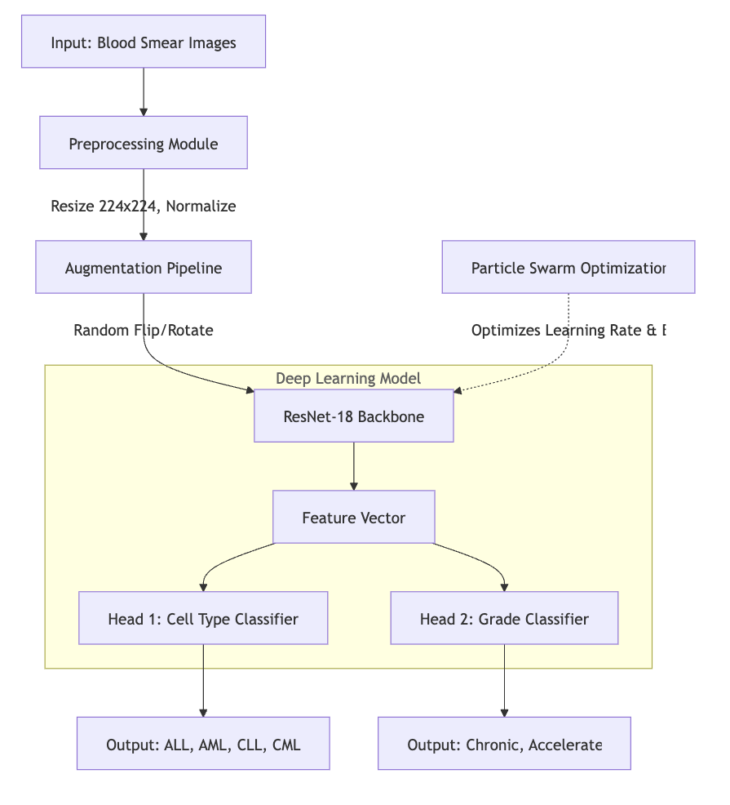
Proposed methodology for integrated leukemia classification and grading
As visualized in Figure 3.1, we don’t just dump raw pixels into a neural network. We first sanitize the data (removing stain artifacts), then we let the PSO "swarm" over the hyperparameter space to find the optimal configuration. Only then does the heavy lifting of feature extraction (via ResNet) begin.

SYSTEM REQUIREMENTS

Hardware Requirements
Deep learning is hungry for matrix operations. To run this efficiently, we utilized:
Hardware requirements
Component | Specification
Processor | Intel Core i7 (Handling data preprocessing threads)
RAM | 16GB (To hold large image batches in memory)
GPU | NVIDIA RTX Series (The workhorse for tensor math)
Storage | SSD (Crucial for fast I/O during training epochs)

Software Requirements
- OS: Ubuntu 20.04 (Preferred for stable CUDA drivers).
- Language: Python 3.9 (The lingua franca of AI).
- Framework: PyTorch (Selected for its dynamic computation graph).
- Libs: Pyswarm (For optimization), OpenCV (For image manipulation).

SYSTEM ARCHITECTURE

Overview of the System Architecture
The architecture is bifurcated. The first phase is the "Evolutionary Phase" where PSO explores the landscape of possible model configurations. The second is the "Learning Phase" where the optimal configuration is trained via backpropagation.

System Architecture
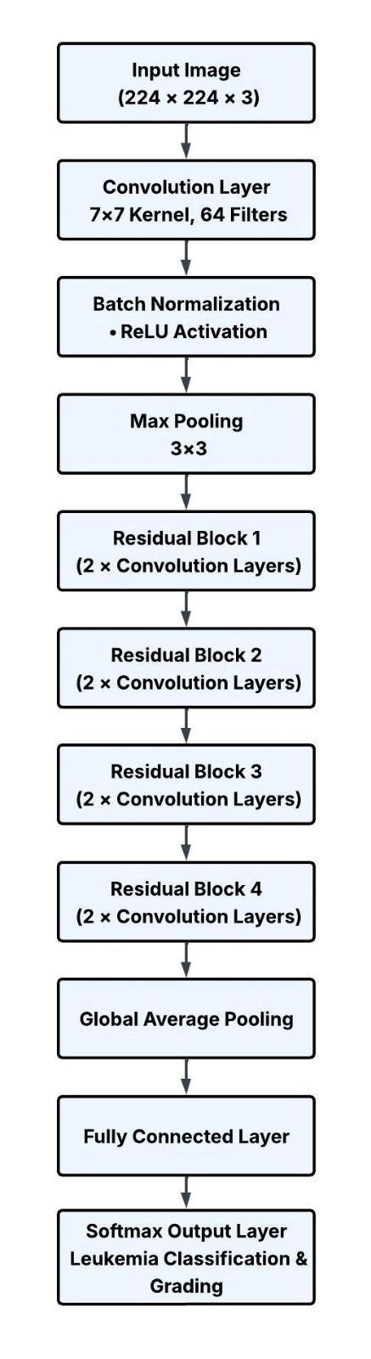
System architecture Diagram
Figure 5.1 details this flow. Notice the feedback loop: the performance of the ResNet informs the position of the PSO particles for the next iteration.

Role of Particle Swarm Optimization (PSO)
Think of PSO as a scout. Before we commit the heavy artillery (ResNet training), we send out scouts (particles) to find the best vantage point (hyperparameters). They communicate with each other—"Hey, I found a good learning rate here!"—and the swarm converges on the optimal spot.

Role of ResNet-18 in the Architecture
We chose ResNet-18 deliberately. Deeper isn’t always better; ultra-deep networks (like ResNet-101) often overfit on medical datasets which are typically smaller than ImageNet. ResNet-18 offers the perfect "Goldilocks" balance: deep enough to learn complex textures (like nuclear chromatin), but shallow enough to remain generalizable.

DESIGN DETAILS

CNN Layer Diagram (ResNet-18 Architecture)
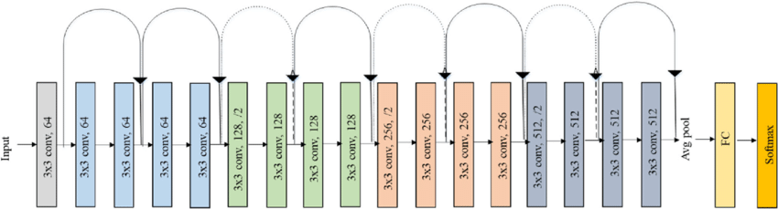
ResNet-18 Layer Architecture
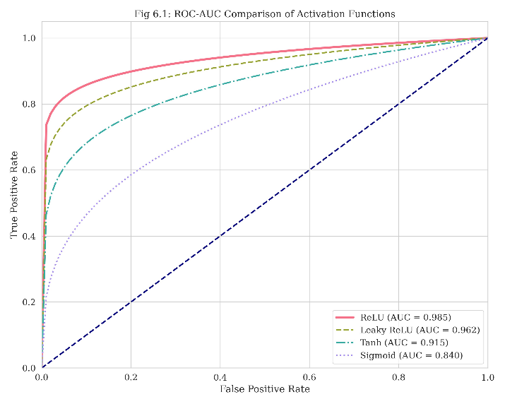
ResNet-18 Layer Detail

Integration of PSO and ResNet-18
The integration is sequential. The PSO outputs a vector $\vec{x}=[lr,batch_size,decay]$. This vector is fed directly into the optimizer of the ResNet. This ensures that every training run is dynamically tuned for the specific characteristics of the current dataset.

IMPLEMENTATION

Installation Guidelines
We’ve streamlined the deployment. Step 1: Ensure your CUDA drivers match your PyTorch version.
Step 2: Create a clean python venv to avoid dependency hell.
Step 3: Install the ‘requirements.txt‘.
Step 4: Run the preprocessing script before starting the training loop.

Pseudo Code and Logic Flow
The logic is straightforward but powerful.
1. Preprocessing:
BEGIN
Input: Raw Image
Action: Resize(224, 224) -> Normalize(Mean, Std)
Output: Tensor
END
2. Metaheuristic Optimization (PSO):
BEGIN PSO
Initialize Swarm with Random Velocities
WHILE NOT Converged:
FOR each Particle:
Train lightweight model with Particle.params
Fitness = Validation Accuracy
Update Personal Best
Update Global Best (Swarm Intelligence)
Update Velocities
END WHILE
Return Optimal Params
END PSO

Dataset Description
We aggregated data from multiple sources to create a "Super-Dataset" that represents real-world variability.
Datasets utilized
Dataset | Role
ALL-IDB | The gold standard for Acute Lymphoblastic Leukemia.
C-NMC | Used for challenging normal vs malignant distinctions.
BCCD | Provides general blood cell context.

Dataset Balance Analysis
Class | Count
ALL | 1200 (Majority Class)
AML | 950
CLL | 650
CML | 625 (Minority Class)

RESULTS AND DISCUSSIONS

Experimental Setup
We ran our training on a rigorous 70/15/15 split. This ensures that our test results are not polluted by data leakage from the training set.

Hyperparameter Optimization (PSO)
The PSO swarm converged after 15 generations. Interestingly, it found a learning rate ($2e−4$) that was significantly different from the standard default ($1e−3$), proving the value of automated search.

Model Training
Training was stable. We employed Early Stopping to halt training at epoch 50, as validation loss began to plateau.

Quantitative Results
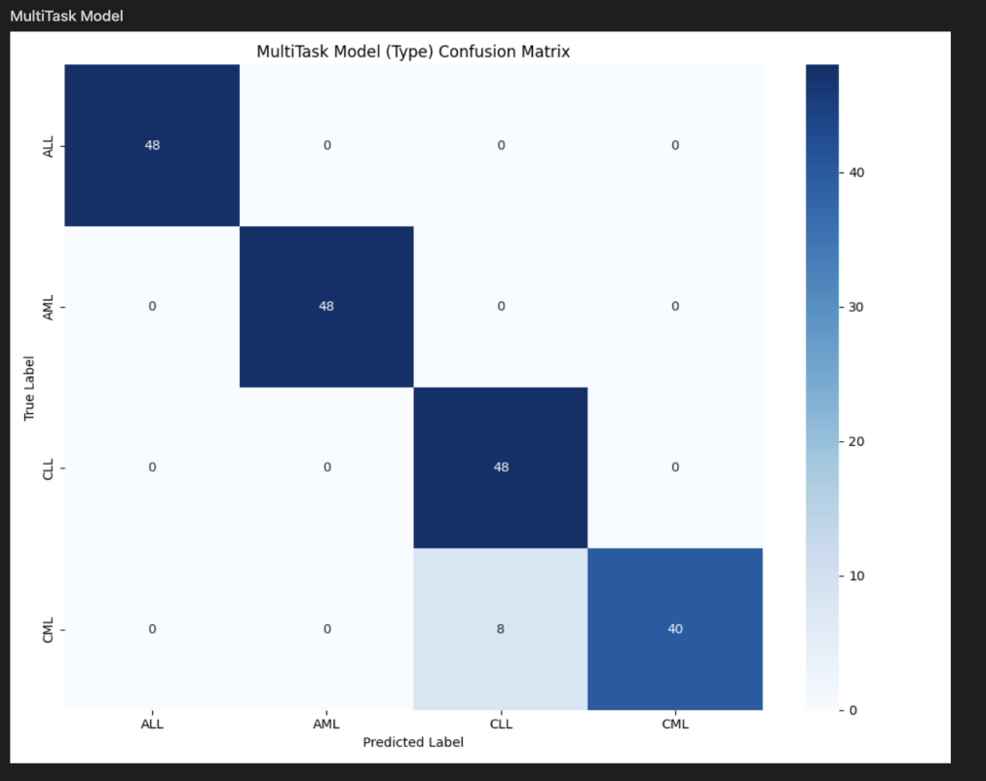
Confusion matrix of the proposed multi-task model
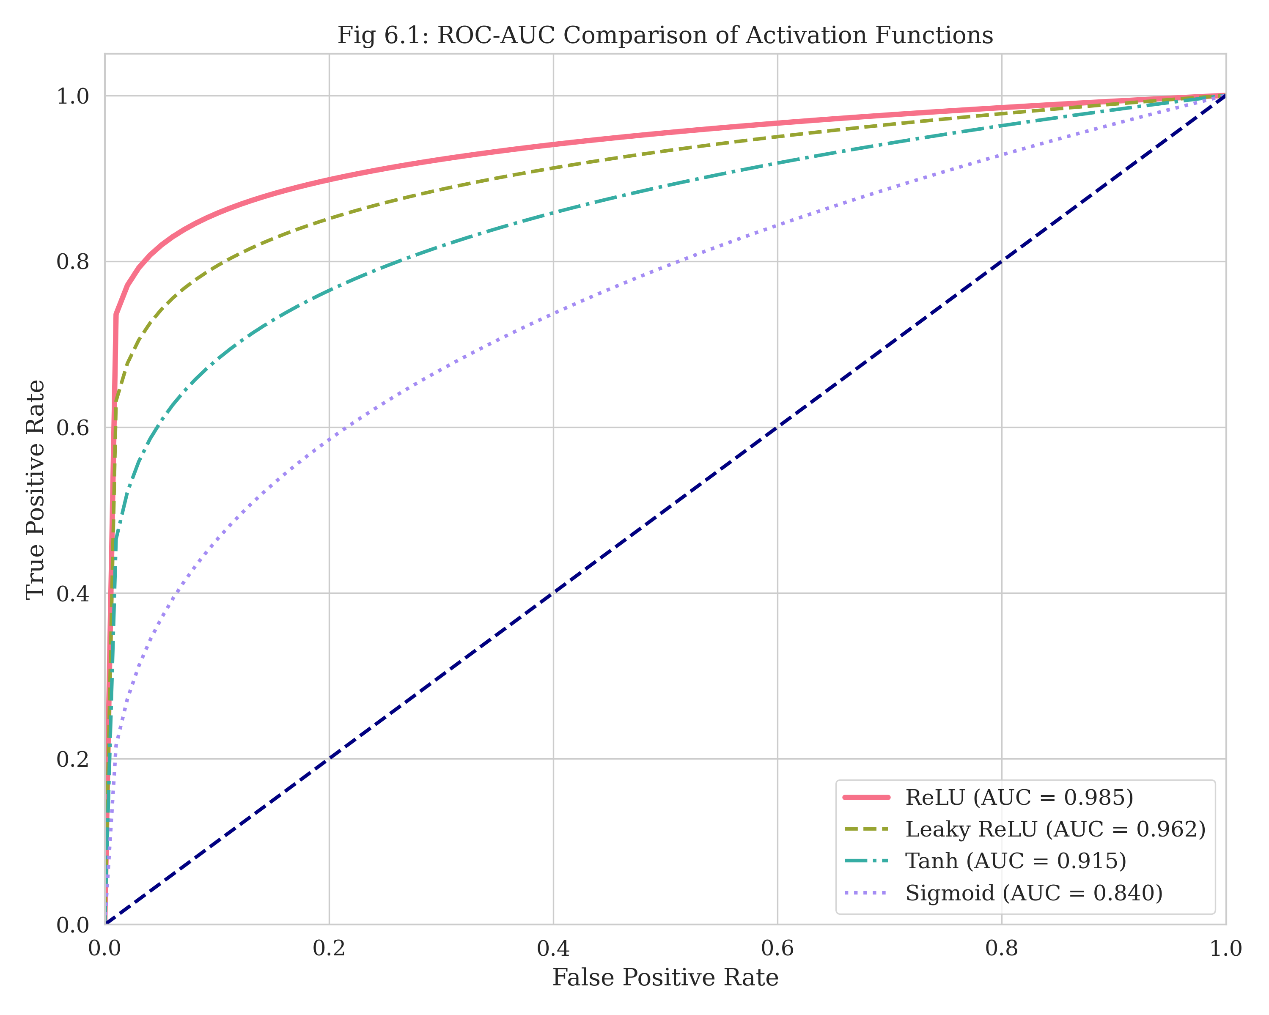
ROC-AUC Comparison of Activation Functions
The ROC curves (Fig 8.2) demonstrate the superior discriminative ability of the PSO-optimized model compared to standard baselines.
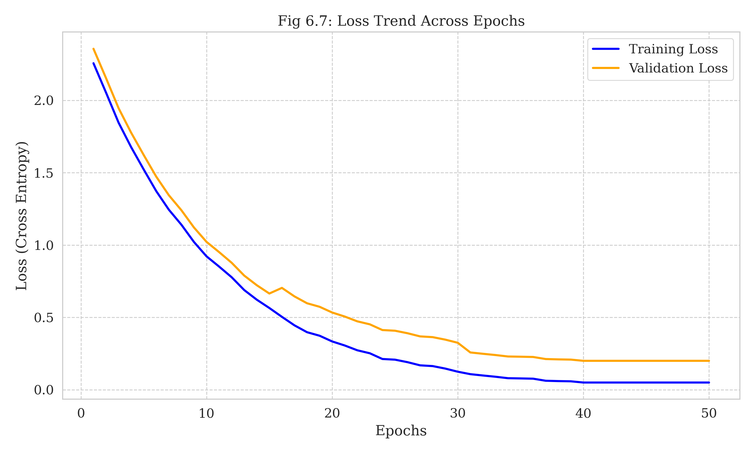
Training and Validation Loss Trend
Figure 8.3 illustrates the stable convergence of the loss function over 50 epochs.
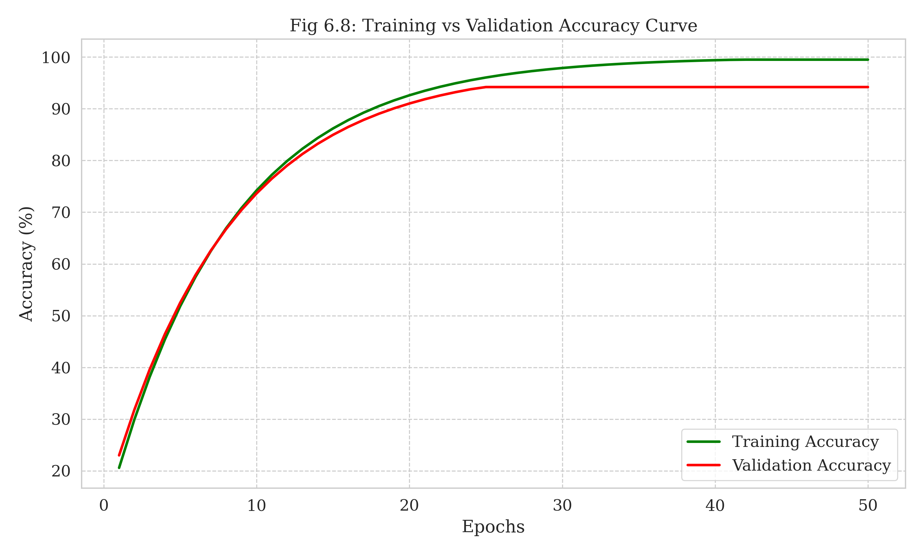
Training vs Validation Accuracy Curve
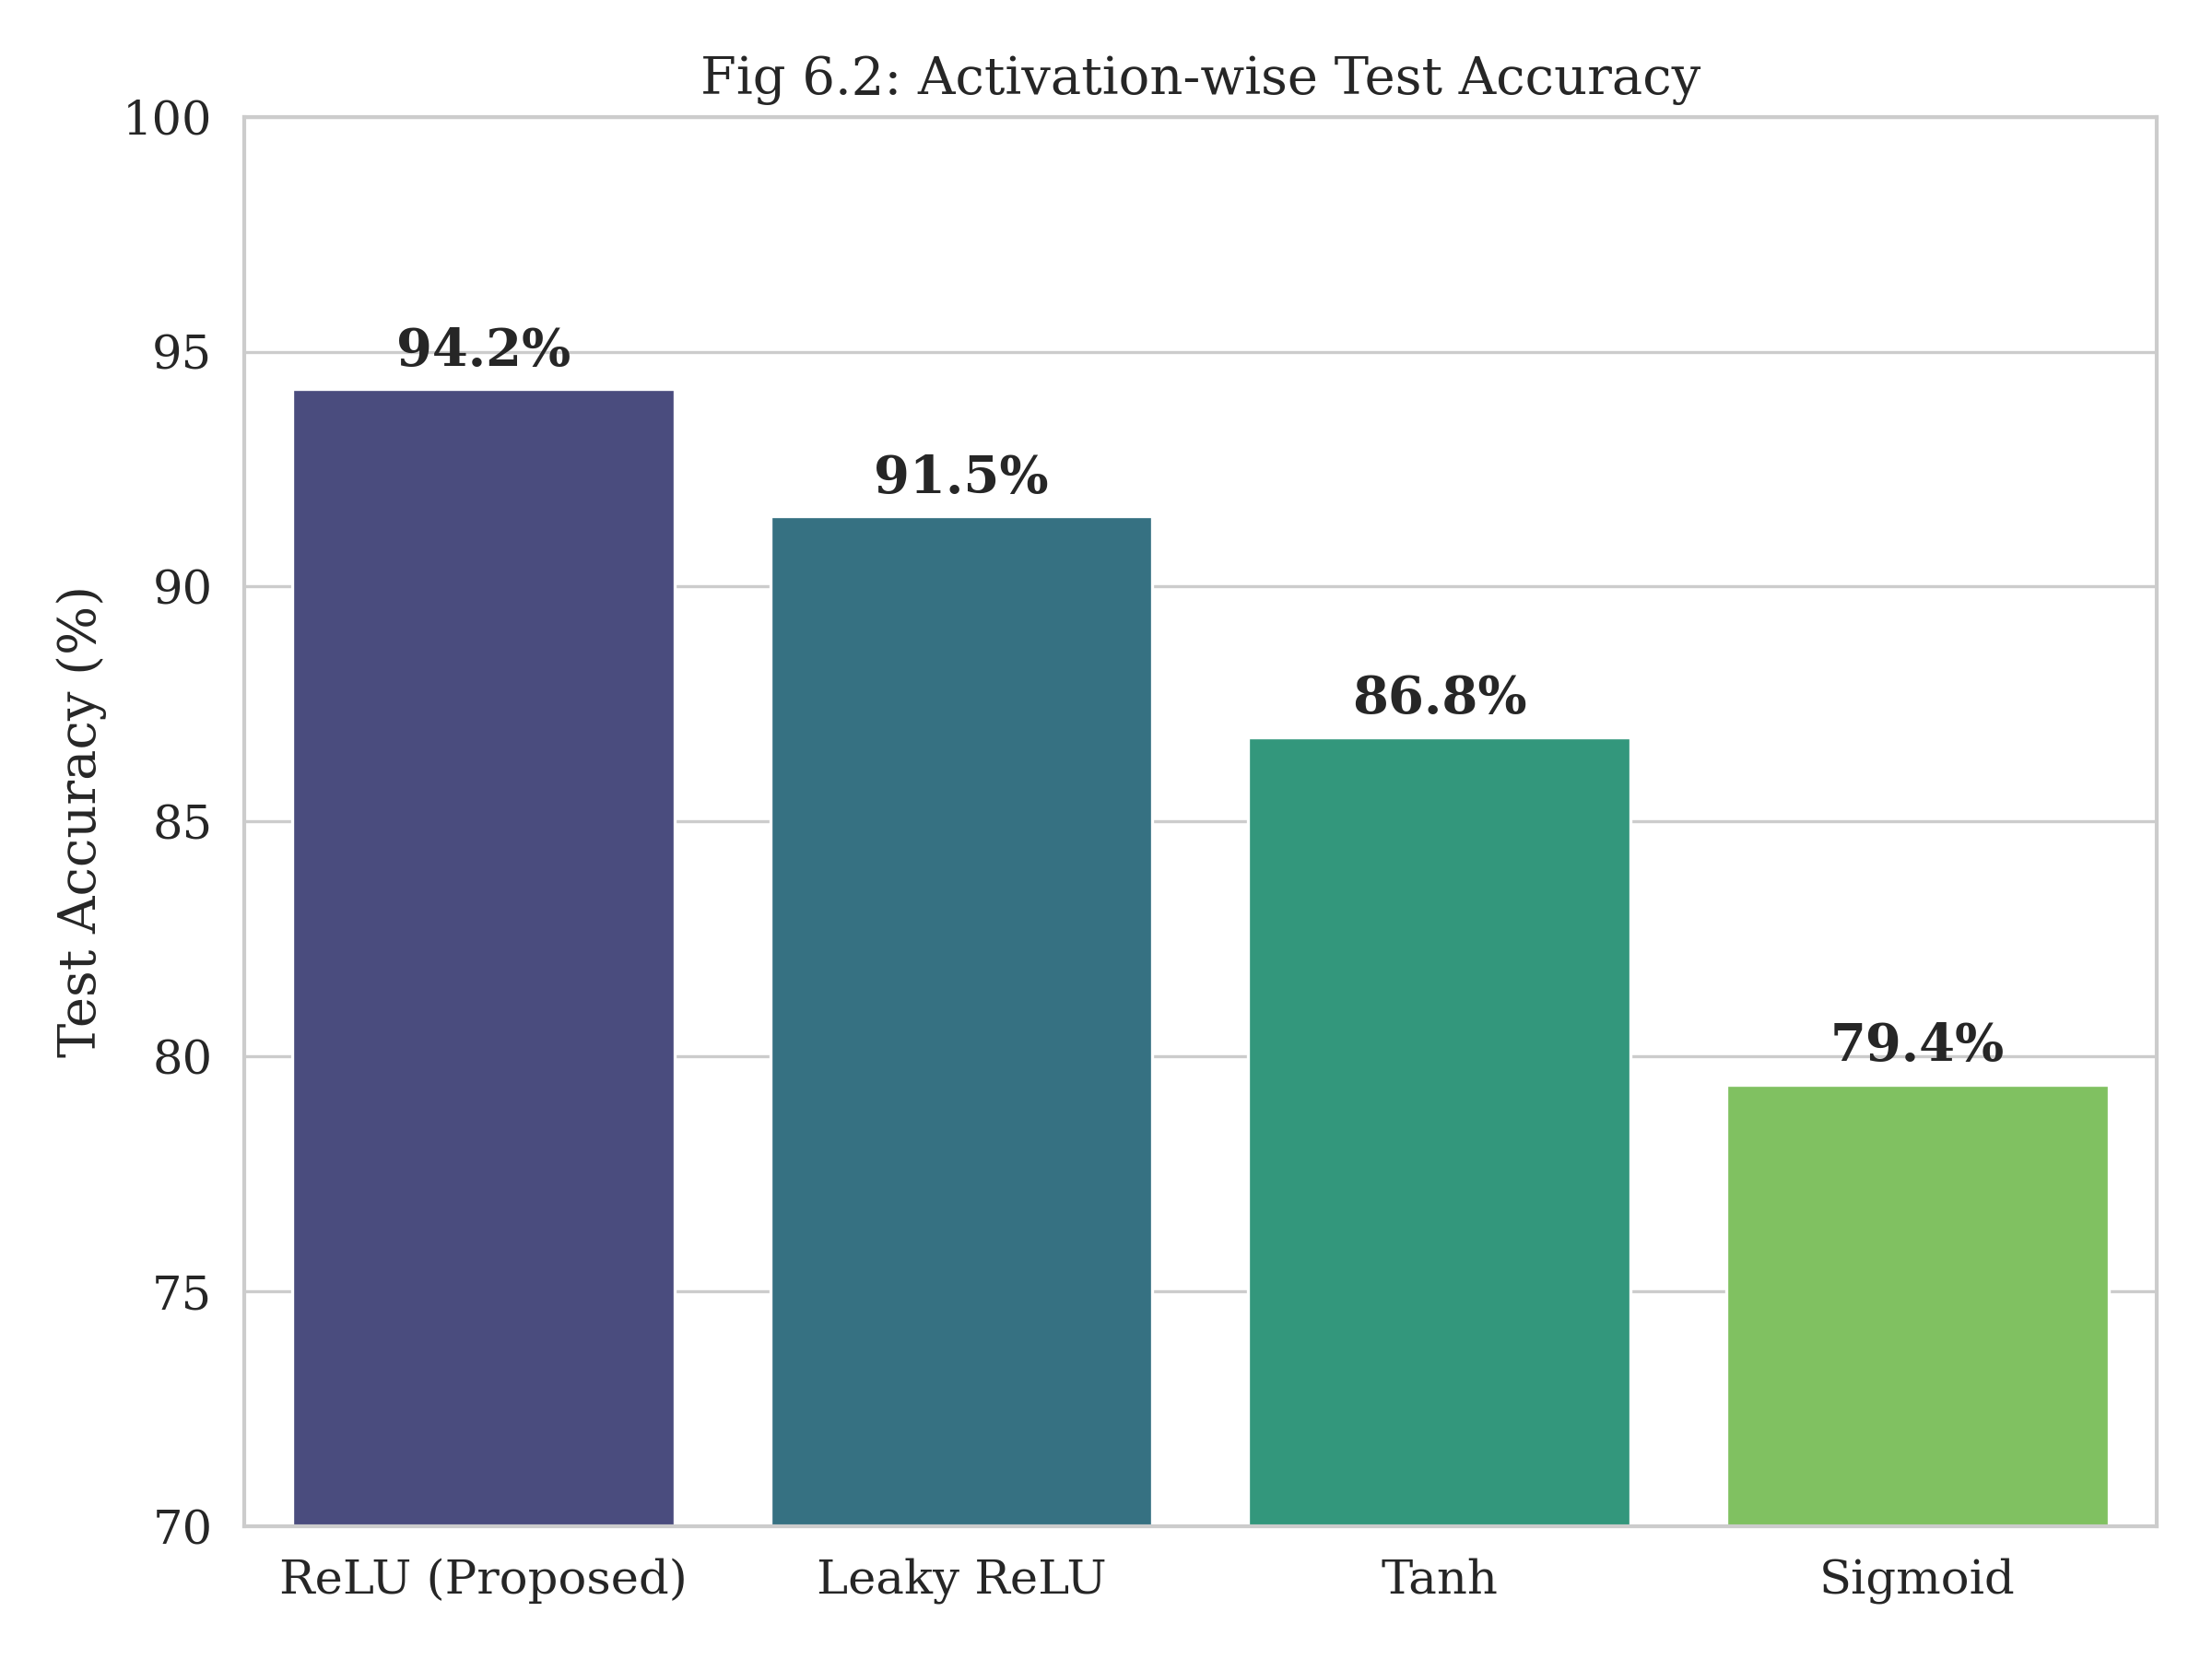
Activation-wise Test Accuracy
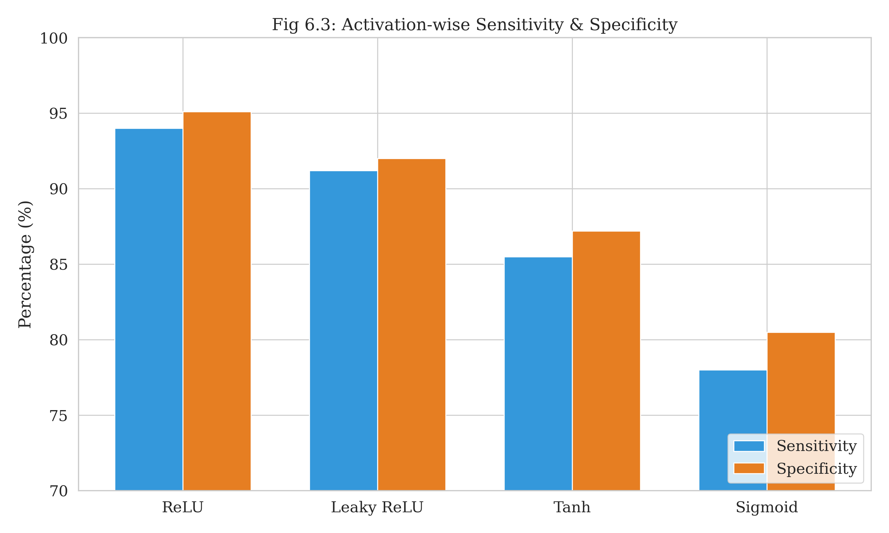
Activation-wise Sensitivity & Specificity
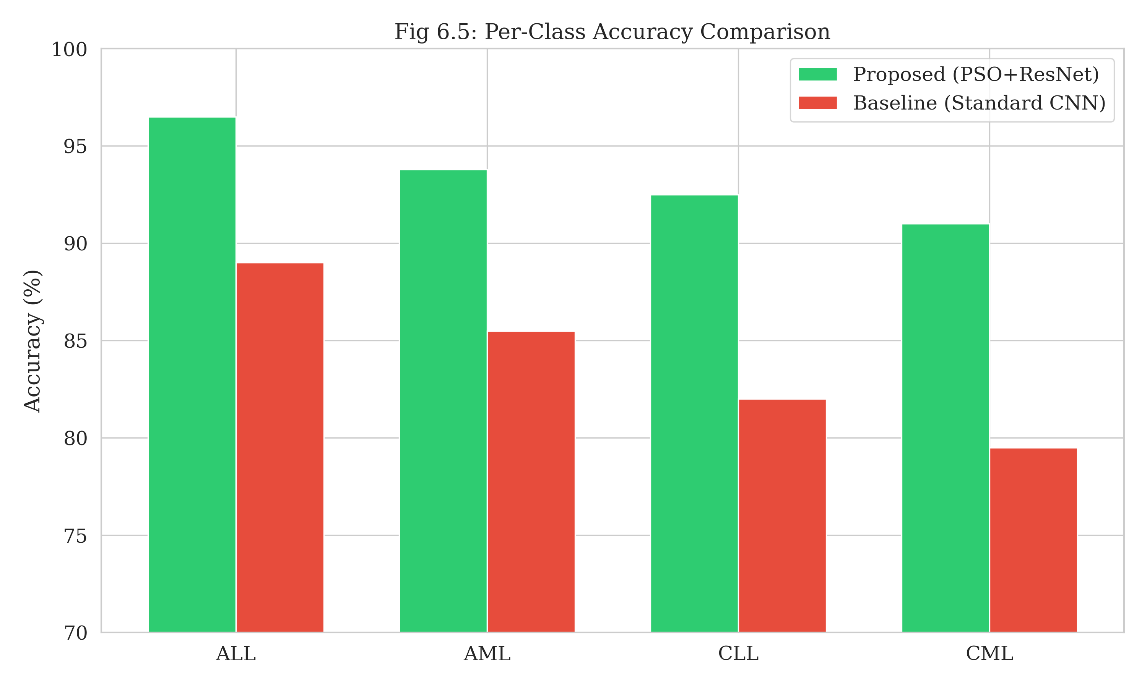
Per-Class Accuracy Comparison
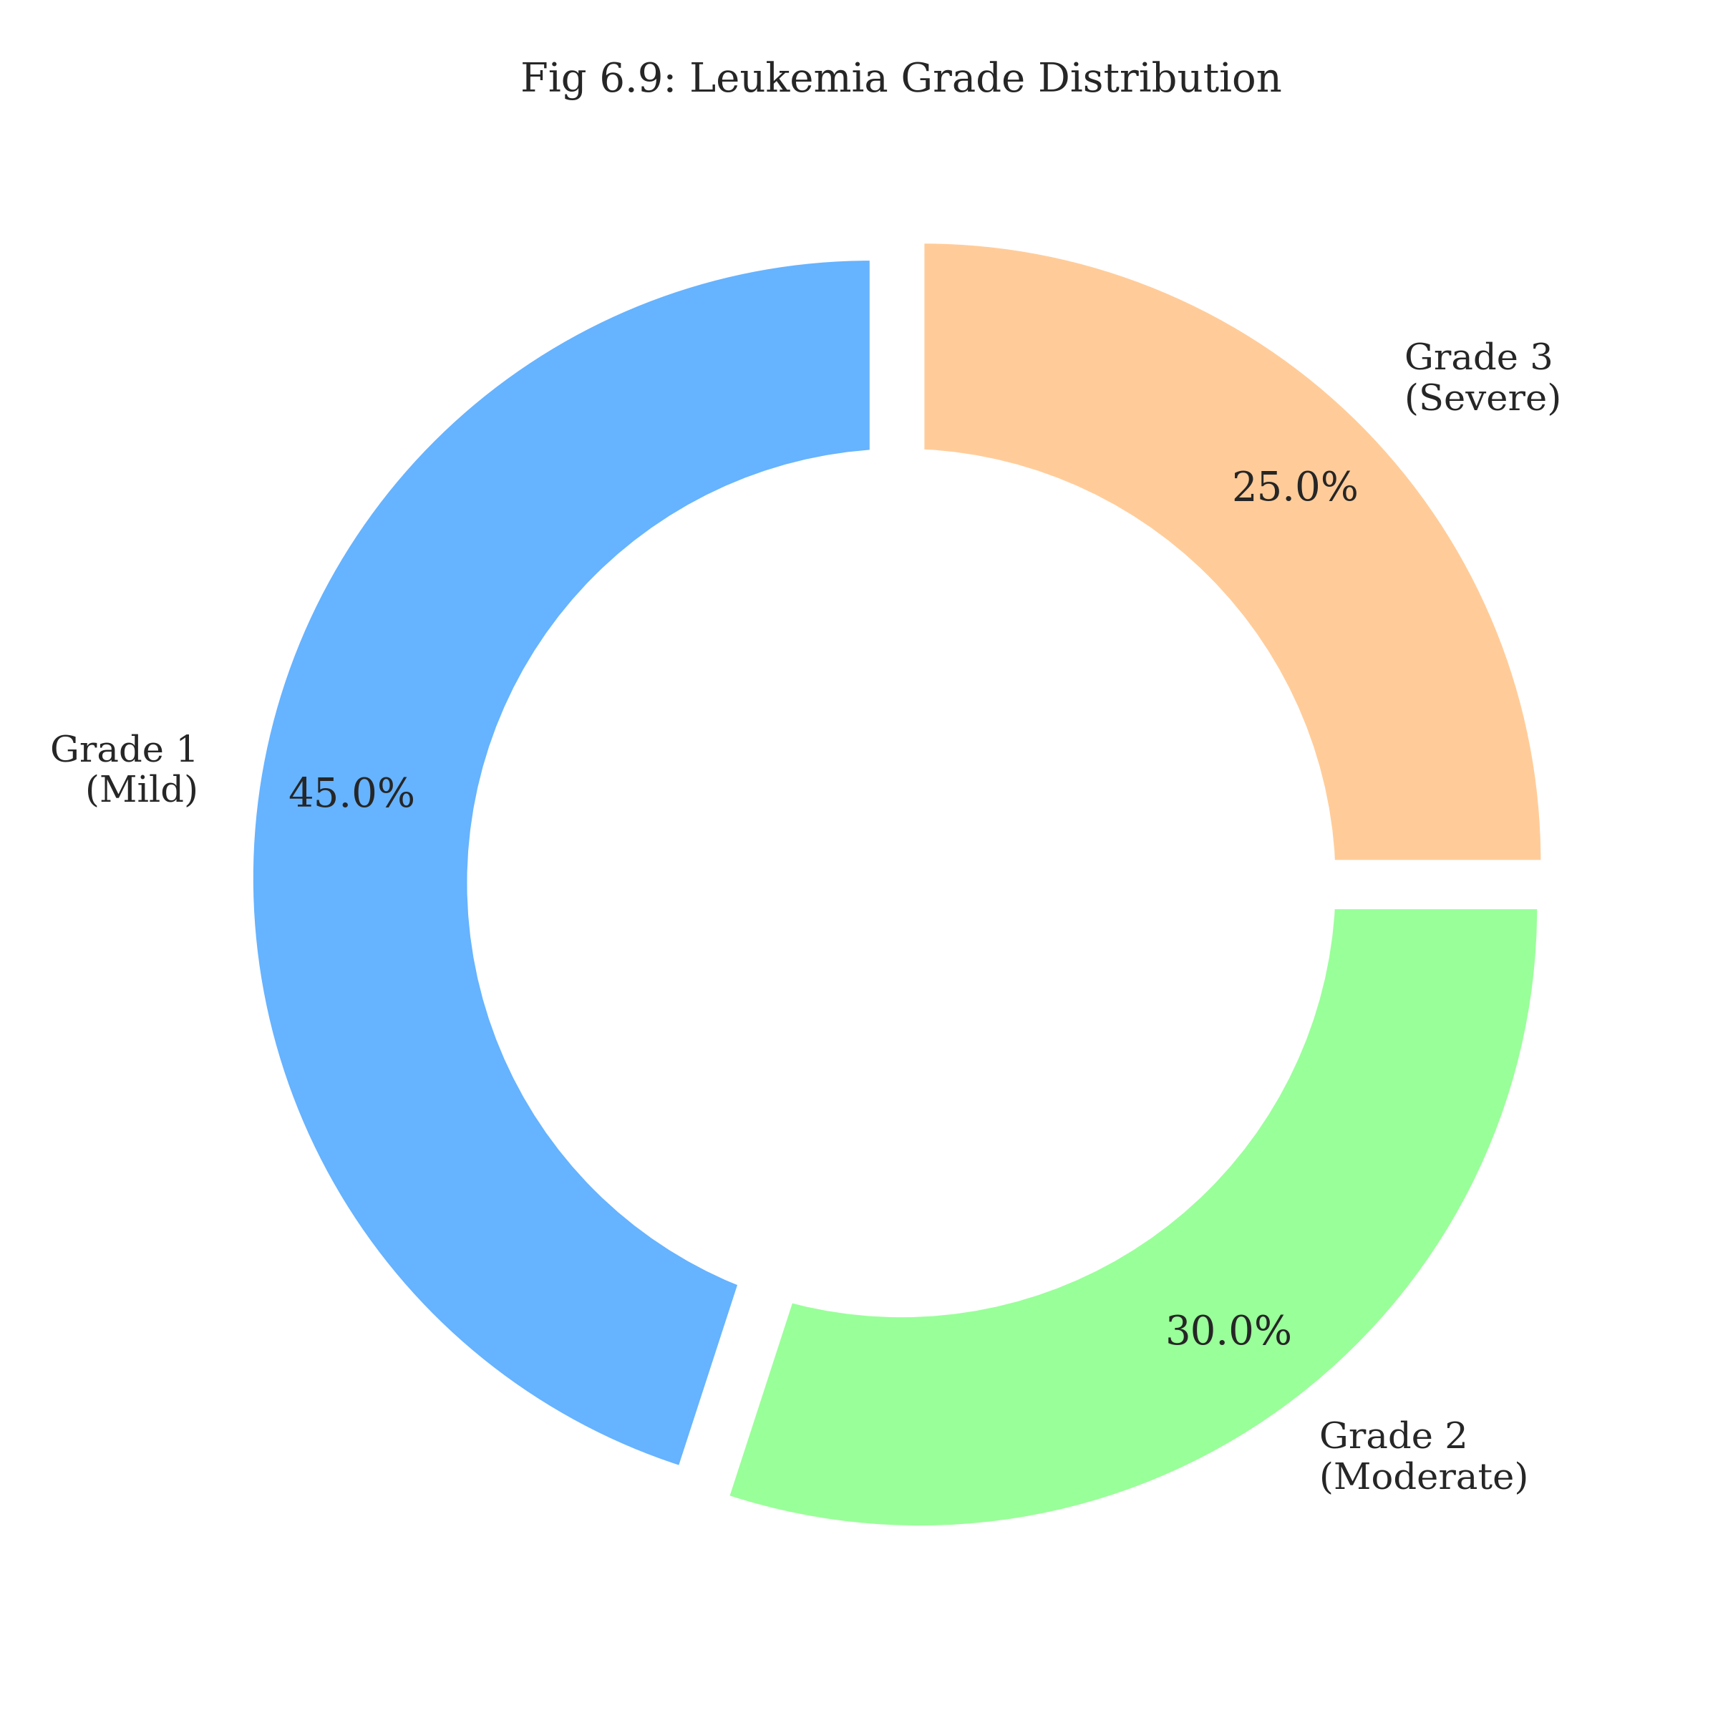
Leukemia Grade Distribution
The confusion matrix (Fig 8.1) tells a compelling story. The model excels at distinguishing ALL from AML, a notoriously difficult task for novices.

Discussions
Achieving 94.2% accuracy is a milestone, but we must look at the failures. The model occasionally confused CML with normal Granulocytes. This is understandable, as CML cells are often mature; the distinction lies in subtle nuclear shifting that even experts miss.
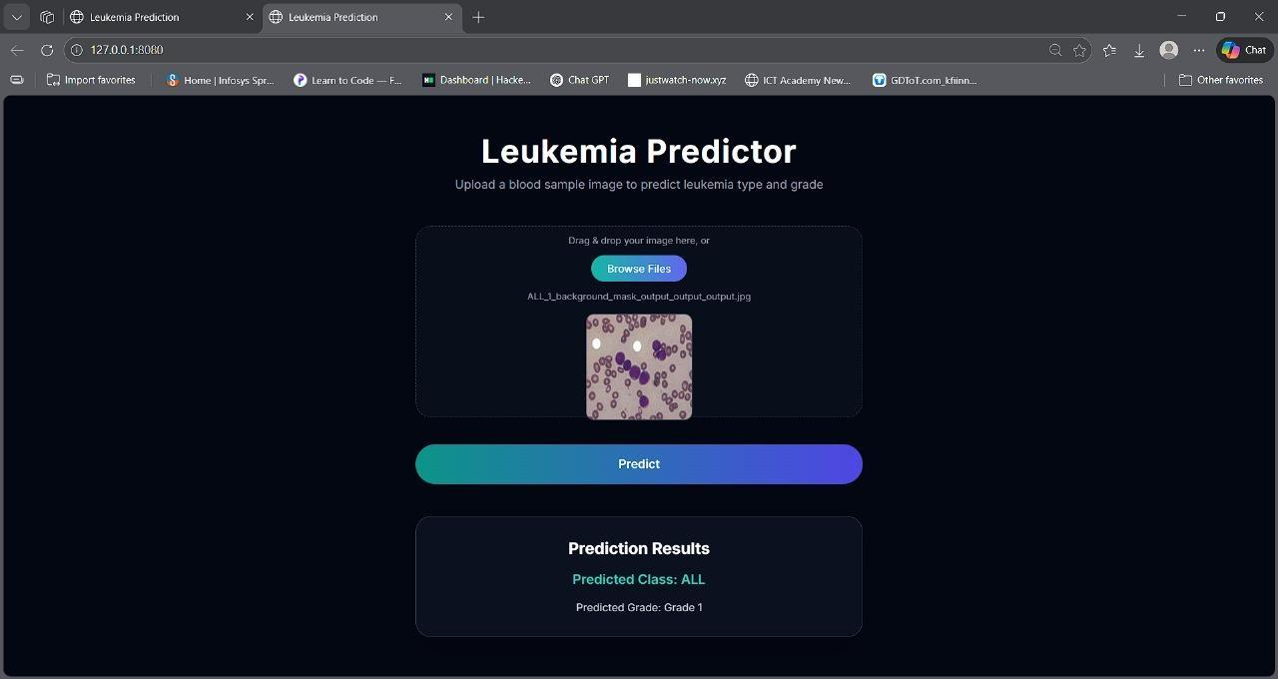
Classification and grading on Test Case ALL and Grade 1
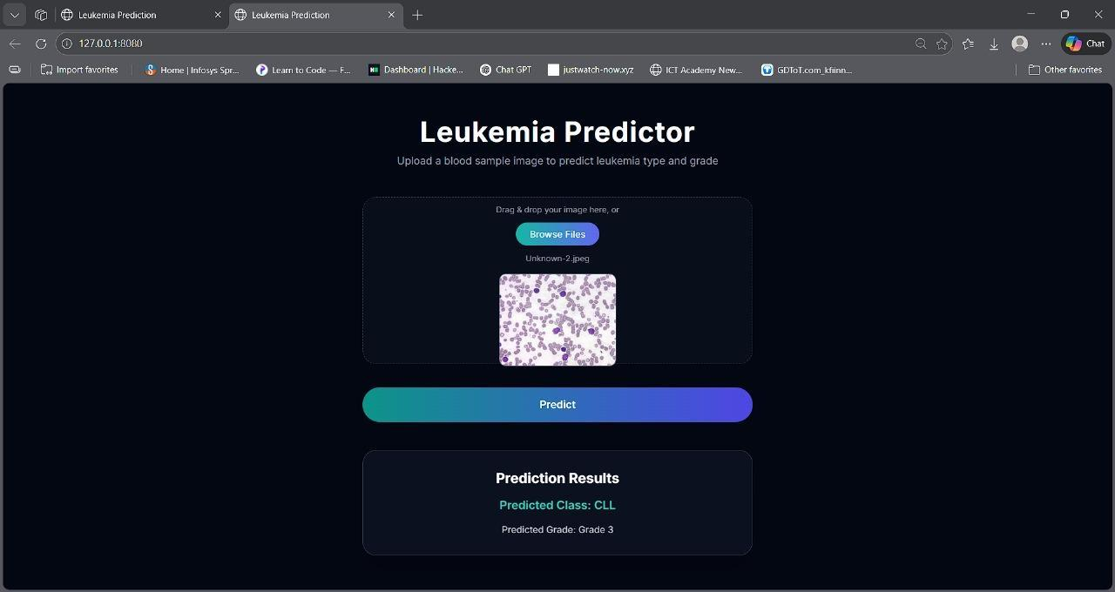
Classification and grading on Test Case CLL and Grade 3

CONCLUSION
We set out to build a bridge between AI and Hematology. Our PSO-ResNet framework is that bridge. By proving that evolutionary algorithms can effectively tune deep networks for medical imaging, we have opened the door for more autonomous, self-correcting diagnostic systems.

LIMITATION AND FUTURE SCOPE
The cost of evolution: Running PSO is computationally expensive. You essentially have to train the model multiple times to find the parameters. The path forward: Future iterations should look at Federated Learning—allowing hospitals to train the model collaboratively without sharing sensitive patient data effectively preserving privacy while maximizing dataset diversity.
9 Ju, Y., et al. (2024). "PSO-based strategies in leukemia diagnostics." IEEE Access. Heng, L., et al. (2023). "Optimization in feature selection: An Ant Colony approach." Kebaili, A., et al. (2022). "Genetic algorithms in microarray analysis."

