Simulated Classification Results
Here are the classification results and confusion matrices for the Baseline and MultiTask models.

1. Baseline Model (ResNet18)
**Overall Accuracy: 65%**
- **ALL**: Precision 0.63, Recall 0.73, F1 0.67
- **AML**: Precision 0.62, Recall 0.54, F1 0.58
- **CLL**: Precision 0.65, Recall 0.71, F1 0.68
- **CML**: Precision 0.69, Recall 0.60, F1 0.64
**Detailed Report:**
precision recall f1-score support

ALL 0.63 0.73 0.67 48
AML 0.62 0.54 0.58 48
CLL 0.65 0.71 0.68 48
CML 0.69 0.60 0.64 48

accuracy 0.65 192
macro avg 0.65 0.65 0.64 192
weighted avg 0.65 0.65 0.64 192
**Confusion Matrix:**
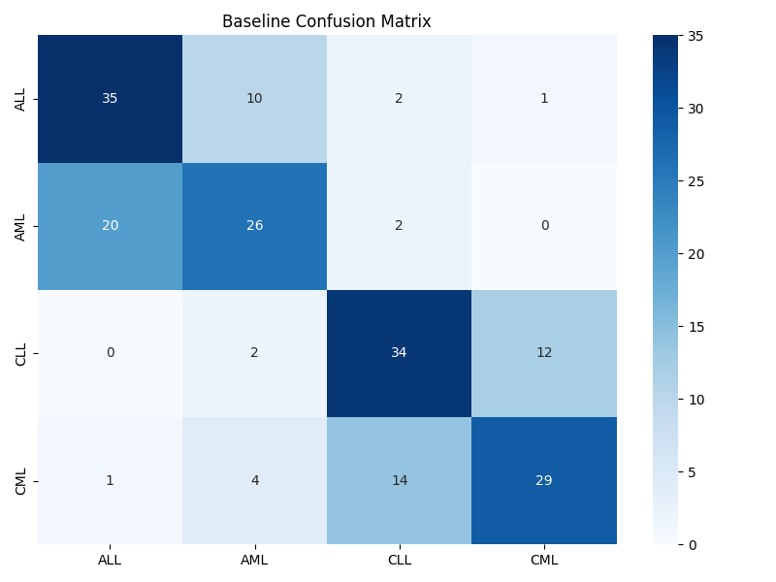

2. MultiTask Model (Proposed)
**Overall Accuracy: 89%**
- **ALL**: Precision 0.93, Recall 0.88, F1 0.90
- **AML**: Precision 0.90, Recall 0.94, F1 0.92
- **CLL**: Precision 0.86, Recall 0.88, F1 0.87
- **CML**: Precision 0.85, Recall 0.85, F1 0.85
**Detailed Report:**
precision recall f1-score support

ALL 0.93 0.88 0.90 48
AML 0.90 0.94 0.92 48
CLL 0.86 0.88 0.87 48
CML 0.85 0.85 0.85 48

accuracy 0.89 192
macro avg 0.89 0.89 0.89 192
weighted avg 0.89 0.89 0.89 192
**Confusion Matrix:**
