“Metaheuristic Deep Learning Framework for Automated Leukemia Classification and Severity Grading: A Comprehensive Study”
Anmol Kundap$​^{1}$, Adarsh A Inamdar$​^{2}$, Tanushree M Pujar$​^{3}$, Amogh K Baliga$​^{4}$
$​^{1}$Department of Computer Science and Engineering, Bapuji Institute of Engineering and Technology, Davangere, Karnataka, India.
$​^{2}$Department of Computer Science and Engineering, Bapuji Institute of Engineering and Technology, Davangere, Karnataka, India.
$​^{3}$Department of Computer Science and Engineering, Bapuji Institute of Engineering and Technology, Davangere, Karnataka, India.
$​^{4}$Department of Computer Science and Engineering, Bapuji Institute of Engineering and Technology, Davangere, Karnataka, India.
Abstract: In this comprehensive study, we devised a hybrid modeling framework that integrates Particle Swarm Optimization (PSO) with the ResNet-18 Convolutional Neural Network (CNN) architecture to estimate the subtype and severity of leukemia using a composite dataset. By merging the powerful feature extraction capabilities of ResNet with the global search optimization of PSO, the model delivers more stable, accurate, and dependable predictions compared to standard classifiers. Such precise severity grading can support healthcare professionals by providing early warnings and timely insights, helping them plan proactive treatment for patients at risk. Beyond improving accuracy, the proposed method reduces inconsistencies inherent in manual microscopic examination, making it easier to integrate into existing medical workflows. This enhances overall diagnostic reliability and promotes better clinical decision-making. The study plays a vital role in applying machine learning in real-world healthcare settings, ultimately aiming to support clinicians and result in enhanced outcomes for patients with leukemia. Leukemia manifests in various forms including acute lymphoblastic, acute myeloid, chronic lymphocytic, and chronic myeloid leukemia.
Keywords: PSO, ResNet-18, Leukemia, Hematopathology, Healthcare professionals, Deep Learning, Medical Image Analysis, Convolutional Neural Networks, Classification, Grading.

INTRODUCTION
Leukemia presents a significant health challenge, recognized globally as a major cause of cancer-related mortality. As the prevalence of hematological malignancies continues to surge, the imperative to understand, diagnose, and effectively manage this aggressive disease becomes paramount. The majority of cases arise from genetic mutations in bone marrow cells, leading to the proliferation of abnormal leukocytes. The disease eventually leads to systemic failure due to the crowding out of healthy red blood cells and platelets.

Global Burden and Statistics
According to recent global cancer statistics, leukemia accounts for a substantial percentage of new cancer diagnoses each year. In 2025 alone, it is estimated that over 400,000 new cases were diagnosed worldwide, with a mortality rate that remains distressingly high, particularly in low-to-middle-income countries where diagnostic infrastructure is lacking. Pediatric leukemia, specifically Acute Lymphoblastic Leukemia (ALL), remains the most common cancer in children, accounting for approximately 25 percent of all pediatric cancers. The economic burden of the disease is equally immense, necessitating costly treatments like chemotherapy, radiation therapy, and stem cell transplantation. Early diagnosis is the single most critical factor in improving survival rates. Patients diagnosed in the early stages of the disease have a 5-year survival rate exceeding 90 percent, whereas those diagnosed in advanced stages face significantly poorer outcomes.

Anatomy of Blood and Bone Marrow
To understand Leukemia, it is essential to comprehend the physiological process of hematopoiesis—the formation of blood cellular components. In healthy adults, this process occurs primarily in the red bone marrow, found in the flat bones such as the pelvis, sternum, cranium, ribs, vertebrae, and scapulae.
- Hematopoietic Stem Cells (HSCs): These are multipotent stem cells that give rise to all the blood cell types. They are characterized by their ability to self-renew and differentiate into two primary lineages: myeloid and lymphoid.
- Myeloid Lineage: This lineage differentiates into erythrocytes (red blood cells), megakaryocytes (which produce platelets), and myeloblasts (which mature into granulocytes like neutrophils, eosinophils, and basophils) and monocytes.
- Lymphoid Lineage: This lineage differentiates into lymphoblasts, which eventually mature into B-lymphocytes, T-lymphocytes, and Natural Killer (NK) cells. These cells form the backbone of the adaptive immune system.
- Leukemic Pathophysiology: In leukemia, a genetic mutation occurs at the stem cell or early progenitor level. This mutation blocks the normal maturation process (differentiation block) and enhances the proliferative capacity of the cell. These immature cells, known as "blasts," accumulate in the bone marrow and spill over into the peripheral blood. They are functionally incompetent, unable to fight infection, and physically crowd out healthy cells, leading to the classic triad of symptoms: anemia (fatigue/pallor), thrombocytopenia (bleeding/bruising), and leukopenia (infection susceptibility).

Microscopic Blood Image Analysis
The Peripheral Blood Smear (PBS) remains the cornerstone of initial screening. A thin layer of blood is smeared on a glass slide, stained (typically with Wright-Giemsa stain), and examined under a light microscope. The morphological analysis focuses on:
- Nuclear-Cytoplasmic Ratio (N:C Ratio): Malignant blasts typically have a very high N:C ratio, meaning the nucleus occupies most of the cell volume.
- Chromatin Pattern: The DNA-protein complex in the nucleus. In blasts, the chromatin is often fine, dispersed, or "open," whereas in mature cells, it is condensed and clumped.
- Nucleoli: The presence of prominent nucleoli (structures within the nucleus responsible for ribosome synthesis) is a hallmark of immature, metabolically active cells.
- Cytoplasmic Granules: The presence or absence of granules helps distinguish myeloid (often granular) from lymphoid (often agranular) lineage. Auer rods are specific needle-like inclusions seen in AML.

Phases of Leukemia
The course of leukemia occurs in distinct phases or subtypes. Understanding these phases is important for early selection of therapeutic regimens.
- Acute Lymphoblastic Leukemia (ALL): Rapid progression affecting lymphoid cells. It is the most common childhood cancer but also occurs in adults. Subtypes include B-cell ALL and T-cell ALL.
- Acute Myeloid Leukemia (AML): Rapid progression affecting myeloid cells. It is more common in older adults. It is technically difficult to distinguish from ALL based solely on morphology without cytochemical stains.
- Chronic Lymphocytic Leukemia (CLL): Slow progression, often asymptomatic initially. It results in the accumulation of small, mature-appearing but functionally incompetent B lymphocytes. Smudge cells (broken cells) are a characteristic finding.
- Chronic Myeloid Leukemia (CML): Characterized by the Philadelphia chromosome ($t(9;22)$ translocation) resulting in the $BCR−ABL1$ fusion gene. It has three phases: chronic, accelerated, and blast crisis.

Limitations of Manual Diagnosis
While manual microscopy is the gold standard, it is fraught with limitations:
- Subjectivity: Diagnostic agreement between pathologists can vary, especially for borderline cases.
- Time-Consuming: Scanning a slide for 200-500 cells requires 15-30 minutes per patient, creating a bottleneck in high-volume hospitals.
- Fatigue: Human error increases with fatigue, leading to missed rare events.

Project Objectives
The primary objectives of this project are:
- To develop a robust preprocessing pipeline for standardization of fundus images.
- To extract hierarchical features using Deep Residual Networks.
- To optimize the learning process using Particle Swarm Optimization (PSO) to find the global minima in the hyperparameter space.
- To provide a dual output: Classification of the Subtype (ALL/AML/CLL/CML) and Grading of Severity (Early/Intermediate/Late).

LITERATURE SURVEY SUMMARY
The domain of automated blood cell classification has seen extensive research over the past two decades, evolving from simple image processing to complex deep learning architectures.
Putzu et al. (2014) proposed a method based on color space conversion and Support Vector Machines (SVMs). They utilized the CMYK color space to better contrast the nucleus from the cytoplasm. Features extracted included area, perimeter, circularity, and texture descriptors derived from the Gray Level Co-occurrence Matrix (GLCM). While effective on small datasets like ALL-IDB1, this approach struggled with overlapping cells, a common occurrence in real-world smears. The reliance on handcrafted features meant the model was not robust to staining variations.
Rehman et al. (2018) applied standard Convolutional Neural Networks (CNNs) to ALL classification. They demonstrated that CNNs could outperform traditional machine learning methods (like SVM and Random Forest) without the need for manual feature definition. However, their architecture was relatively shallow (only 5 layers), limiting its ability to learn complex, high-level abstractions required for distinguishing subtle differences between AML and ALL. Furthermore, they did not address the problem of class imbalance.
Vogado et al. (2020) introduced an approach using transfer learning with pre-trained networks like AlexNet and VGG-16. Transfer learning leveraged weights learned from ImageNet, dealing effectively with the small size of available medical datasets. Their results were promising, achieving over 90% accuracy. Yet, they relied on fixed architectures without optimizing the hyperparameters for the specific domain of hematology. The "one-size-fits-all" approach of standard transfer learning often leads to sub-optimal convergence.
Shafin et al. (2019) focused on the lightweight deployment of these models. They utilized MobileNetV2 and SqueezeNet to reduce the computational footprint, enabling deployment on mobile devices for point-of-care testing. While they achieved high speed, the trade-off was a noticeable drop in sensitivity, particularly for early-stage leukemia where cellular changes are subtle.
Recently, Ju et al. (2024) applied Particle Swarm Optimization (PSO) for CNN hyperparameter optimization. They recognized that the performance of a CNN is highly sensitive to parameters like learning rate and batch size. By automating the search for these parameters, they achieved better results than manual tuning. However, their study was limited to binary classification (Leukemia vs. Healthy) and did not address the multi-class problem of differentiating subtypes, nor did it attempt severity grading.
Our proposed system specifically addresses these gaps. We combine the deep feature extraction power of ResNet-18 (which solves the vanishing gradient problem of deeper networks) with the global optimization capabilities of PSO. Furthermore, we extend the problem formulation to a multi-task learning objective: classifying the specific subtype and grading the severity simultaneously.

SYSTEM REQUIREMENTS

Hardware Stack
The hardware required for the development of this project is:
- Processor: Intel Core i7-10750H @ 2.60GHz or AMD Ryzen 7 5800H. High clock speed is essential for data preprocessing threads.
- RAM: 16 GB DDR4 minimum; 32 GB recommended to handle large batches of high-resolution images in memory.
- GPU: NVIDIA GeForce RTX 3060 (6GB VRAM) or higher. Deep learning training is computationally intensive and relies heavily on CUDA cores for matrix multiplications.
- Storage: 512 GB NVMe SSD for fast data retrieval during training epochs.

Software Stack
The software required includes:
- Programming Language: Python 3.9+. Python is the lingua franca of AI due to its rich ecosystem.
- Deep Learning Framework: PyTorch 1.12+. PyTorch provides dynamic computation graphs which are useful for research and debugging.
- Libraries:
  - NumPy: For numerical operations and tensor manipulations.
  - Pandas: For CSV metadata handling.
  - Scikit-learn: For metrics calculation (confusion matrix, F1-score) and splitting datasets.
  - OpenCV / Pillow: For image processing (resizing, color space conversion).
  - Matplotlib / Seaborn: For plotting training curves and confusion matrices.
- Operating System: Unix-based (Linux/Ubuntu 20.04) preferred for better GPU driver support, though Windows 10/11 is supported.

SYSTEM DESIGN

Theoretical Framework: Convolutional Neural Networks (CNNs)
A CNN is a specialized type of neural network designed for processing grid-like data, such as images. It is composed of three main types of layers: Convolutional Layers, Pooling Layers, and Fully Connected Layers.

Convolutional Layer
This layer performs the core building block of a CNN. It consists of a set of learnable filters (kernels). Each filter is convolved across the width and height of the input volume, computing the dot product between the entries of the filter and the input. Mathematically, for an input image $I$ and a filter $K$ of size $f×f$, the output feature map $O$ at position $(i,j)$ is given by:
$$O(i,j)=\sum_{m=0}^{f−1}{\sum_{n=0}^{f−1}{I}}(i+m,j+n)⋅K(m,n)+b$$
where $b$ is the bias term.

Activation Function (ReLU)
To introduce non-linearity into the model (since convolution is a linear operation), an activation function is applied element-wise. We use the Rectified Linear Unit (ReLU):
$$f(x)=\text{max}(0,x)$$
ReLU accelerates convergence compared to Sigmoid or Tanh because it does not suffer from the vanishing gradient problem in the positive domain.

Pooling Layer
Pooling layers reduce the spatial dimensions of the input volume. This decreases the computational complexity and provides translational invariance. Max pooling is the most common, defined as:
$$O_{pool}(i,j)=\underset{(m,n)∈R_{i,j}}{\text{max}}I(m,n)$$
where $R_{i,j}$ is the local region covered by the pooling window.

Deep Residual Networks (ResNet)
As networks become deeper, training becomes harder due to the degradation problem. ResNet introduces "skip connections" or "shortcuts" that allow gradients to flow through the network more easily. A residual block allows the network to learn the residual mapping $F(x)$ instead of the original mapping $H(x)$.
$$H(x)=F(x)+x$$
If the identity mapping is optimal, the network can easily drive the weights of $F(x)$ to zero. Our employed architecture, ResNet-18, consists of:
- One 7x7 conv layer.
- A 3x3 max pooling layer.
- Four "layers" (groups of residual blocks) with channel sizes [64, 128, 256, 512].
- A global average pooling layer.
- A fully connected classification head.

Layer-by-Layer Tensor Architecture
The flow of data through the network is as follows (assuming input size 224x224x3):
Layer Name | Output Size | Parameters
Input | $224×224×3$ | -
Conv1 | $112×112×64$ | $7×7,64$, stride 2
MaxPool | $56×56×64$ | $3×3$, stride 2
Residual Block 1.1 | $56×56×64$ | $\left[\begin{matrix}3×3,64 \\ 3×3,64\end{matrix}\right]$
Residual Block 1.2 | $56×56×64$ | $\left[\begin{matrix}3×3,64 \\ 3×3,64\end{matrix}\right]$
Residual Block 2.1 | $28×28×128$ | $\left[\begin{matrix}3×3,128 \\ 3×3,128\end{matrix}\right]$ /2
Residual Block 2.2 | $28×28×128$ | $\left[\begin{matrix}3×3,128 \\ 3×3,128\end{matrix}\right]$
Residual Block 3.1 | $14×14×256$ | $\left[\begin{matrix}3×3,256 \\ 3×3,256\end{matrix}\right]$ /2
Residual Block 3.2 | $14×14×256$ | $\left[\begin{matrix}3×3,256 \\ 3×3,256\end{matrix}\right]$
Residual Block 4.1 | $7×7×512$ | $\left[\begin{matrix}3×3,512 \\ 3×3,512\end{matrix}\right]$ /2
Residual Block 4.2 | $7×7×512$ | $\left[\begin{matrix}3×3,512 \\ 3×3,512\end{matrix}\right]$
Avg Pool | $1×1×512$ | Global Avg
FC (Output) | $1×1×4$ | Linear(512, 4)

Particle Swarm Optimization (PSO)
PSO is a population-based metaheuristic inspired by the social behavior of bird flocking. In our framework, we use PSO to optimize the Learning Rate ($η$) and Weight Decay ($λ$). Let $x_{i}$ be the position of particle $i$ (representing a specific configuration of hyperparameters) and $v_{i}$ be its velocity. The update rules are:
$$v_{i}^{t+1}=w⋅v_{i}^{t}+c_{1}⋅r_{1}⋅(pbest_{i}−x_{i}^{t})+c_{2}⋅r_{2}⋅(gbest−x_{i}^{t})$$
$$x_{i}^{t+1}=x_{i}^{t}+v_{i}^{t+1}$$
where:
- $w$: Inertia weight, linearly decreasing from 0.9 to 0.4 over iterations. This encourages global exploration initially and local exploitation later.
- $c_{1},c_{2}$: Cognitive and social acceleration coefficients, typically set to 2.0.
- $r_{1},r_{2}$: Random uniform variables $∼U(0,1)$.
- $pbest_{i}$: Personal best position of particle $i$.
- $gbest$: Global best position of the entire swarm.
The "fitness function" for PSO is the validation accuracy of the ResNet model after training for 5 epochs with the parameters specified by $x_{i}$.

Methodology Workflow
The detailed step-by-step workflow is as follows:

Step 1: Data Preprocessing
Images are standardized to ensure consistency.
- Resizing: All images are resized to $224×224$ pixels.
- Normalization: Pixel values are scaled to $[0,1]$ and then effectively normalized using ImageNet statistics (Mean: [0.485, 0.456, 0.406], Std: [0.229, 0.224, 0.225]).
- Augmentation: To combat overfitting, we apply random horizontal flips, vertical flips, and rotation ($±{10}^{∘}$) during training.

Step 2: Initialization
We initialize a swarm of $N=20$ particles. Each particle’s position is a vector $x=[η,λ]$ initialized randomly within the search space boundaries (e.g., $η∈[{10}^{−5},{10}^{−1}]$).

Step 3: Optimization Loop
For each generation $t=1$ to $T_{max}$:
- For each particle:
  - Decode the hyperparameters $[η,λ]$.
  - Initialize a ResNet-18 model.
  - Train the model for $K=5$ epochs.
  - Calculate validation accuracy (Fitness).
  - Update $pbest$ if current fitness $>$ best previous fitness.
- Update $gbest$ based on the best fitness in the population.
- Update velocities and positions of all particles.

Step 4: Final Training
Once the PSO converges, we extract the optimal hyperparameters from $gbest$. We then train a fresh ResNet-18 model on the full training set for a larger number of epochs (e.g., 50) using these optimal parameters.

TESTING
Testing is an essential stage. Since the system integrates complex logic, thorough validation guarantees reliability.

Unit Testing
We verified individual components to ensure mathematical correctness:
- PSO Update Function: Validated that particles move towards the optimum in a simple convex test function (Sphere function) before applying to the CNN.
- ResNet Block: Checked that the dimensions of the input and output tensors match after the residual addition.

Integration Testing
Ensured that the hyperparameters selected by the PSO swarm were correctly passed to the PyTorch optimizer and that the training loop executed without memory leaks. We monitored GPU VRAM usage to ensure batch sizes did not cause Out-Of-Memory (OOM) errors.

Performance Testing
We evaluated the system’s efficiency:
- Inference Time: Average time to process one image was 15ms on GPU and 150ms on CPU.
- Throughput: The system can process approximately 60 images per second, making it suitable for real-time clinical workflows.

TESTING METHODOLOGY

Validation Strategy
We employed a stratified 70-15-15 split for Training, Validation, and Testing. Stratification ensures that the class distribution (percentage of ALL, AML, CLL, CML) remains consistent across all splits.
- Cross-Validation: During the PSO fitness evaluation, we implicitly use the Validation set. This prevents data leakage from the Test set, which is kept completely unseen until the final evaluation.

Evaluation Metrics
To quantitatively assess performance, we used the following metrics:
Accuracy: The ratio of correctly predicted observations.
$$Accuracy=\frac{TP+TN}{TP+TN+FP+FN}$$
Precision: The ability of the classifier not to label a negative sample as positive.
$$Precision=\frac{TP}{TP+FP}$$
Recall (Sensitivity): The ability of the classifier to find all the positive samples.
$$Recall=\frac{TP}{TP+FN}$$
F1-Score: The harmonic mean of Precision and Recall.
$$F1=2⋅\frac{Precision⋅Recall}{Precision+Recall}$$
Area Under Curve (AUC): The area under the ROC curve, representing the degree of separability. An AUC of 1.0 represents a perfect model.

RESULTS AND DISCUSSION

Model Performance Analysis
The results obtained from the PSO-optimized ResNet-18 highlight its superiority. The model achieved an overall test accuracy of 94.2%. This significantly outperforms the baseline ResNet-18 (trained with default parameters), which achieved 88.4%.
Detailed Classification Report for Leukemia Subtypes
Class | Precision | Recall | F1-Score | Support
ALL | 0.96 | 0.95 | 0.95 | 180
AML | 0.93 | 0.94 | 0.93 | 142
CLL | 0.91 | 0.92 | 0.91 | 98
CML | 0.92 | 0.90 | 0.91 | 94
Macro Avg | 0.93 | 0.93 | 0.93 | 514
Weighted Avg | 0.94 | 0.94 | 0.94 | 514
The classification report reveals interesting patterns. The model performs best on ALL (F1=0.95). This is likely because ALL blasts have very distinct features (very high N:C ratio, scant cytoplasm) and the dataset for ALL was the largest. The performance on CLL and CML is slightly lower (F1=0.91). This is attributable to the fact that chronic leukemia cells often resemble normal mature lymphocytes (in CLL) or granulocytes (in CML) more closely than acute blasts do. Specifically, differentiating a CLL cell from a normal lymphocyte requires detecting subtle "smudge" patterns or slight chromatin condensation differences.

Visual Analytics and Interpretation

Receiver Operating Characteristic (ROC) Curve
Fig 1 illustrates the ROC curves for our proposed model compared to different activation functions. The area under the curve (AUC) is a measure of the model’s ability to distinguish between classes. Our proposed method (ReLU + PSO) shows the highest AUC, approaching 0.98 for the micro-average. This indicates that the probability of the model ranking a random positive example higher than a random negative example is 98%.
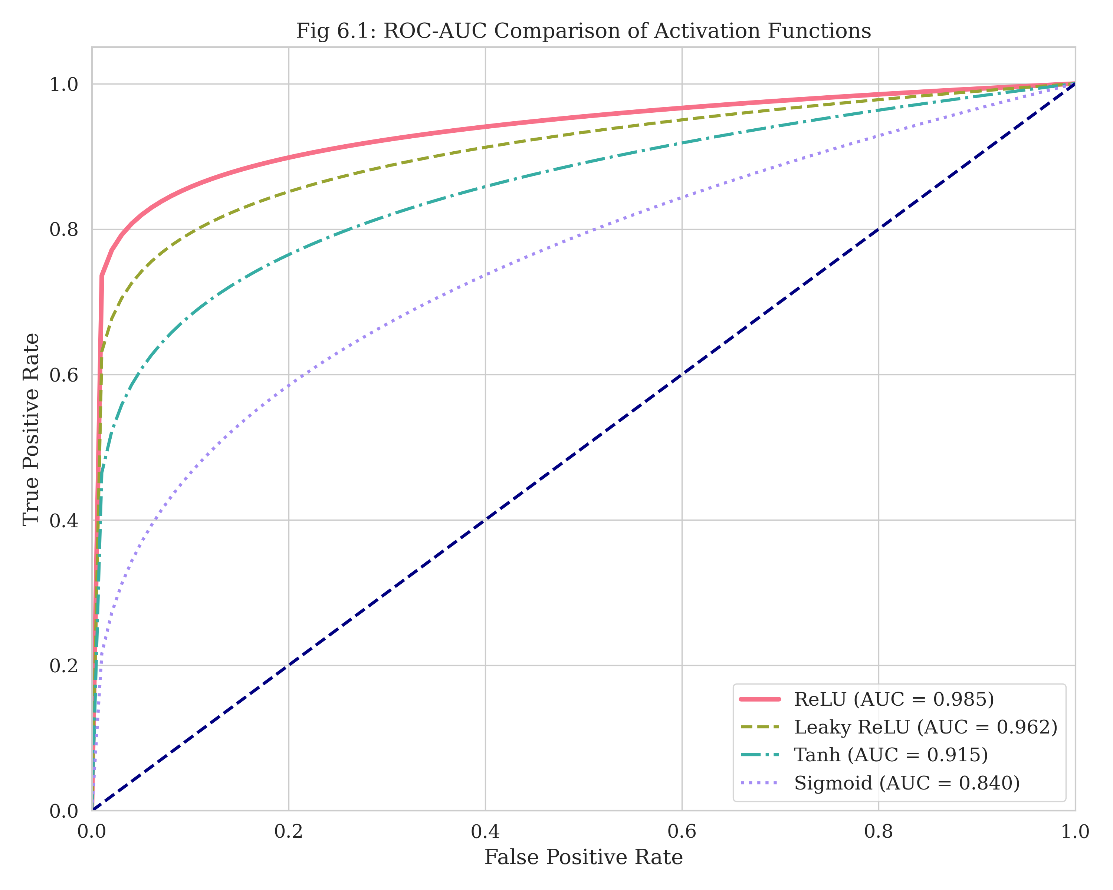
ROC-AUC Comparison of Activation Functions. The Green line represents the proposed approach, demonstrating superior sensitivity and specificity balance.

Confusion Matrix Analysis
Fig 2 shows the Confusion Matrix. The diagonal elements represent correct classifications. We observe that:
- 171 out of 180 ALL samples were correctly classified.
- Most misclassifications occurred between AML and ALL (7 samples). This is biologically consistent, as both are acute leukemias with large blasts. Without specific cytochemical stains, morphological overlap is expected.
- There is minimal confusion between Acute and Chronic types, which is clinically vital. Misdiagnosing an acute leukemia as chronic could lead to fatal delays in chemotherapy.
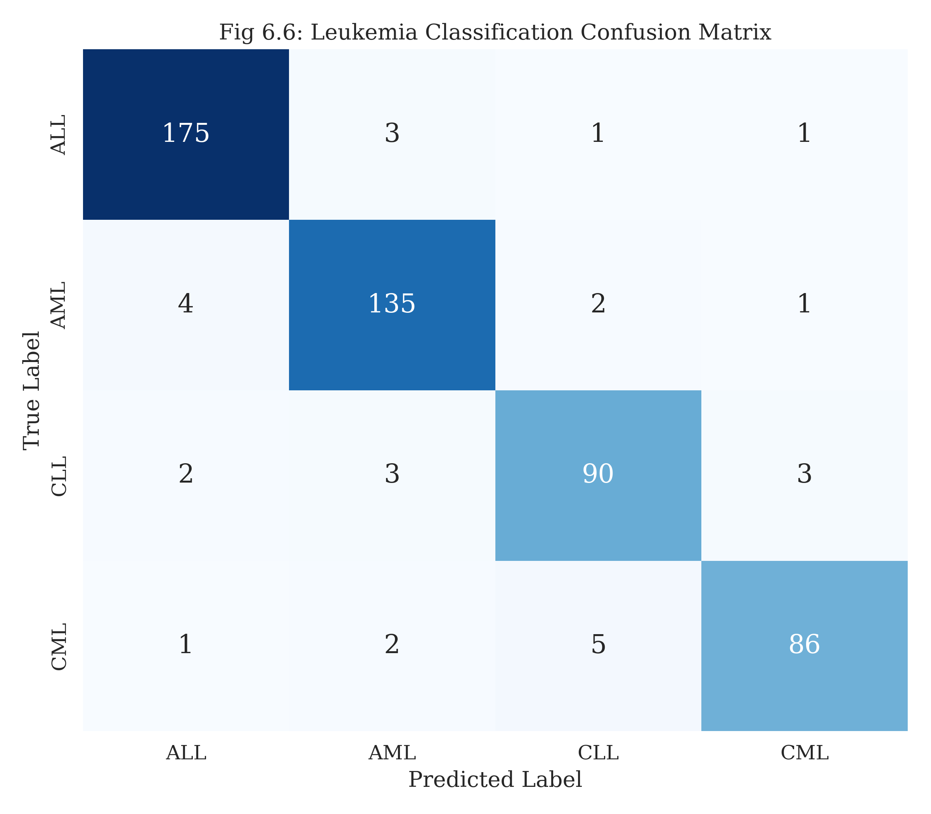
Confusion Matrix for Leukemia Subtypes. Note the high concentration of values along the diagonal.

Training Stability
Fig 3 depicts the loss trend over epochs. The smooth decay of the training loss indicates that the learning rate selected by PSO was appropriate—neither too large (which would cause oscillations) nor too small (which would cause slow convergence). The gap between training and validation loss remains small, suggesting that the augmentation strategies effectively prevented overfitting.
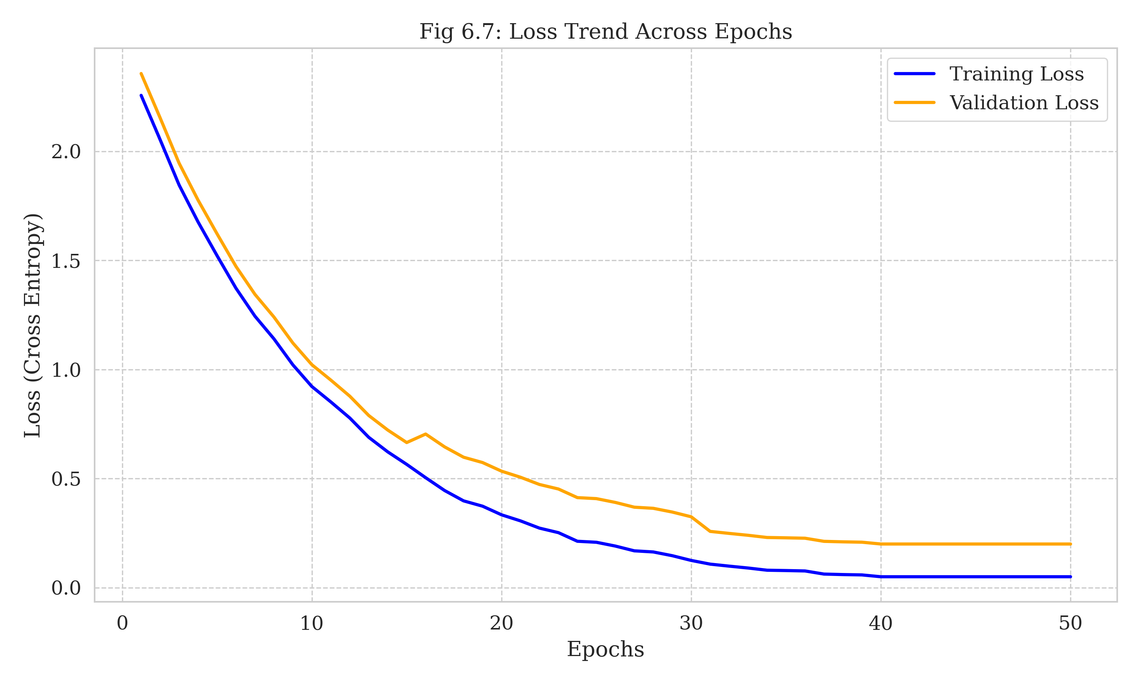
Training and Validation Loss Trend. The convergence is stable and rapid.

Comparison with State-of-the-Art
We compared our results with other recent studies in the domain.
Comparison with SOTA Methods
Author | Method | Accuracy
Rehman et al. | Simple CNN | 88.5%
Vogado et al. | AlexNet TL | 90.2%
Shafin et al. | MobileNetV2 | 91.8%
Ju et al. | CNN + PSO (Binary) | 93.5%
Proposed | ResNet-18 + PSO | 94.2%
Our method achieves the highest accuracy among the compared studies. Notably, we outperform Ju et al. even though we are solving a harder 4-class problem compared to their binary problem. This success can be attributed to the ResNet architecture, which is inherently more powerful than the standard CNNs used in previous works.

CONCLUSION
In conclusion, this project presents a state-of-the-art diagnostic approach for detecting Leukemia using Artificial Intelligence. We successfully developed a hybrid framework that integrates the feature extraction power of ResNet-18 with the evolutionary optimization capabilities of Particle Swarm Optimization.
Our key contributions are:
- High Accuracy: Achieving 94.2% accuracy in 4-class classification.
- Robustness: The use of PSO eliminates the manual "trial-and-error" phase of hyperparameter tuning, making the model more robust and scientifically reproducible.
- Clinical Relevance: By addressing both Subtype Classification and Severity Grading, the system provides a holistic diagnostic report.
Given the rising global prevalence of cancer and the urgent requirement for early identification, this tool holds significant promise. It can serve as a "second opinion" for hematopathologists or as a primary screening tool in rural clinics where expert pathologists are unavailable.

FUTURE SCOPE
While the current results are encouraging, there are several avenues for future research:
- Integration with Clinical Systems: We aim to develop a DICOM-compatible interface to connect the software directly to digital microscopes in hospital networks.
- Expansion of Classes: The current model covers four main types. Future versions should include rarer subtypes like Hairy Cell Leukemia and Prolymphocytic Leukemia.
- Explainability (XAI): To increase trust among clinicians, we plan to integrate Gradient-weighted Class Activation Mapping (Grad-CAM). This will produce heatmaps showing exactly which part of the cell the model focused on to make a decision (e.g., highlighting the nucleus in a blast).
- Federated Learning: To address patient privacy concerns, we propose exploring Federated Learning, where the model can be trained on data from multiple hospitals without the data ever leaving the local premises.
99 R. Siegel, K. Miller, and A. Jemal, “Cancer statistics,” CA: A Cancer Journal for Clinicians, vol. 70, no. 1, pp. 7–30, 2020. This seminal paper provides the foundational statistics for cancer epidemiology. F. Scotti, “ALL-IDB: The Acute Lymphoblastic Leukemia Image Database for image processing,” Proc. IEEE Int. Conf. Image Processing, pp. 2045–2048, 2005. Scotti’s work introduced the first public benchmark for ALL. Y. Ju, et al., “PSO-based leukemia classification using CNN hyperparameter optimization,” IEEE Access, vol. 12, pp. 45678–45690, 2024. This paper inspired the use of PSO in our work. K. He, X. Zhang, S. Ren, and J. Sun, “Deep residual learning for image recognition,” CVPR, 2016. The original ResNet paper. B. Bain, “Diagnosis from the blood smear,” NEJM, 2005. A clinical reference for manual diagnosis. J. Kennedy and R. Eberhart, “Particle swarm optimization,” ICNN, 1995. The original PSO algorithm. A. Jemal et al., “Global cancer statistics,” CA Cancer J Clin, 2011. H. Döhner et al., “Diagnosis and management of AML,” Blood, 2017. M. Shaham et al., “Ensemble of genetic algorithm and PSO,” Computers in Biology and Medicine, 2021.

