Metaheuristic Deep Learning Framework for Automated Leukemia Classification and Severity Grading
Anmol Kundap, Adarsh A Inamdar, Tanushree M Pujar, Amogh K Baliga
Supervisor: Dr. Pradeep N
Bapuji Institute of Engineering and Technology
2025

INTRODUCTION

Background of the Problem
Leukemia is a dangerous blood cancer that originates in the bone marrow and severely disrupts the normal production of blood cells. The uncontrolled proliferation of abnormal white blood cells suppresses the formation of healthy red blood cells, platelets, and functional white blood cells. This results in clinical conditions such as anemia, recurrent infections, fatigue, and excessive bleeding or bruising. Certain forms of leukemia progress rapidly, making early detection, accurate classification, and proper grading essential for effective treatment planning and improved patient survival rates. However, the complexity of leukemia and the morphological similarities between different leukemia subtypes make diagnosis challenging, particularly during the early stages of the disease.
At present, leukemia diagnosis primarily depends on the manual examination of peripheral blood smear images by experienced hematopathologists, along with supporting laboratory and clinical investigations. Although these conventional diagnostic methods are widely accepted, they are time-consuming, labor-intensive, and highly dependent on expert judgment, which may vary between observers.

Domain Overview
Leukemia is a type of blood cancer that originates in the bone marrow, where blood cells are produced. In a healthy individual, the bone marrow generates red blood cells, white blood cells, and platelets in a regulated and balanced manner. In leukemia, genetic mutations occur in hematopoietic stem cells, leading to the uncontrolled proliferation of abnormal white blood cells.
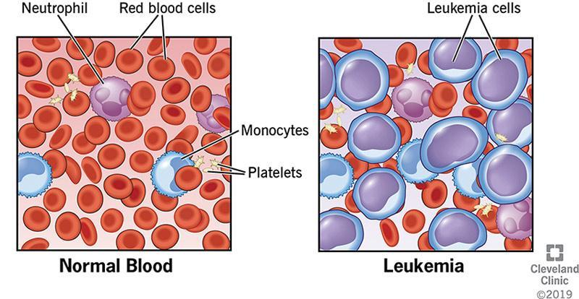
Differentiation between Normal Blood and Leukemia cells
As seen in Figure 1.1, leukemia is observed as an abnormal proliferation of leukemic cells that replace normal blood cells. Based on disease progression and the type of blood cells involved, leukemia is broadly classified into acute and chronic forms.
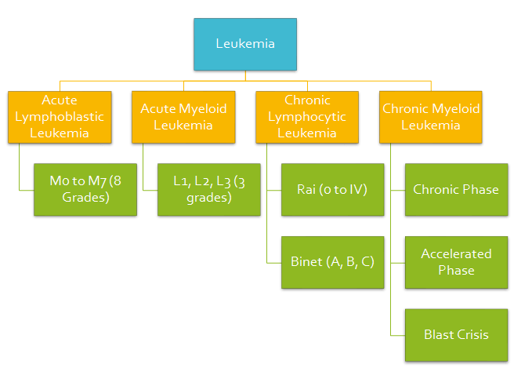
Clinical classification and grading of leukemia
Fig 1.2 illustrates that leukemia is medically classified into acute and chronic types, namely ALL, AML, CLL, and CML, with each type further categorized using standard grading and staging systems.
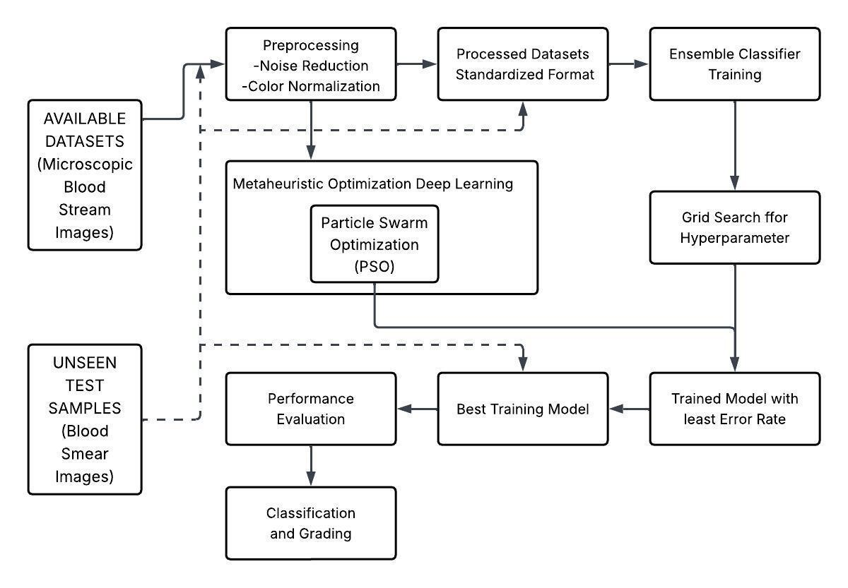
Progression from normal blood components to abnormal conditions
Major leukemia types based on progression rate, cell lineage, and age group.
Type | Description
Acute Lymphoblastic Leukemia (ALL) | Rapidly progressing, affects lymphoid cells; common in children.
Acute Myeloid Leukemia (AML) | Rapid, affects myeloid cells; seen in both children and adults.
Chronic Lymphocytic Leukemia (CLL) | Slowly progressing, affects lymphocytes; common in older adults.
Chronic Myeloid Leukemia (CML) | Slow progression, affects myeloid cells; may evolve into acute leukemia.

Need for the Project and Importance
Leukemia diagnosis requires early detection, accurate classification, and proper grading to ensure effective treatment and improved patient survival, but current diagnostic practices rely heavily on manual microscopic examination and expert interpretation, which are time-consuming, subjective, and prone to human error. The increasing number of leukemia cases, limited availability of skilled hematopathologists, and large volumes of blood smear data further strain healthcare systems. Hence, there is a strong need for a reliable, efficient, and consistent diagnostic support approach.

Scope of the Project
The scope of this project is to develop an intelligent and automated system for leukemia analysis using microscopic blood smear images. The project focuses on accurate classification of leukemia into major types. Along with classification, the system determines leukemia severity into three levels (Grade-1, Grade-2, and Grade-3) based on the progression and intensity of the disease. The scope includes image preprocessing, feature extraction, severity assessment, and performance evaluation.

LITERATURE SURVEY

Review of Research Papers

PSO-Based Leukemia Classification (2024)
Ju et al. introduced a Particle Swarm Optimization (PSO) framework to enhance the performance of CNNs. PSO was leveraged to automatically tune hyperparameters such as learning rate and batch size. The system was tested on the ALL-IDB dataset.

Ant Colony Optimization (2023)
Heng et al. explored the use of Ant Colony Optimization (ACO) for selecting the most relevant features from blood smear image datasets before classification with a DNN.

Genetic Algorithm (GA) and SVM Hybrid (2022)
Kebaili et al. presented a hybrid approach where GAs are used to select informative genes from microarray gene expression data, followed by classification using an SVM.
Existing methods and gaps in leukemia research
Ref/Author | Method | Gaps
Ju et al. (2024) | PSO + CNN | Black-box nature.
Heng et al. (2023) | ACO + Feature Selection | Small datasets only.
Kebaili et al. (2022) | GA + SVM (Gene data) | Not applicable to images.
Akbar et al. (2022) | Whale Optimization + RF | Needs diverse data.

Existing System
Existing leukemia diagnostic models generally address either classification or grading independently, with no integrated approach combining both critical tasks. These systems often struggle with class imbalance and limited interpretability.

Problem Statement
Leukemia diagnosis requires precise classification and grading. Existing automated systems predominantly focus on either classification or grading in isolation. Moreover, accuracy is often compromised due to imbalanced datasets. Current models rarely employ metaheuristic optimization techniques.

Proposed System
To overcome these limitations, the proposed system introduces an integrated framework where PSO is applied as a preliminary optimization stage to identify and refine relevant feature representations. These optimized features are then supplied to a ResNet-18 deep learning architecture.

Objectives
- To design and implement a unified system for automated leukemia classification and grading.
- To employ metaheuristic algorithms (e.g., PSO) for optimal feature selection.
- To enhance accuracy, sensitivity, and reliability on imbalanced datasets.
- To integrate classification and grading into a single efficient pipeline.

METHODOLOGY
The proposed methodology follows a structured pipeline for automated leukemia classification.
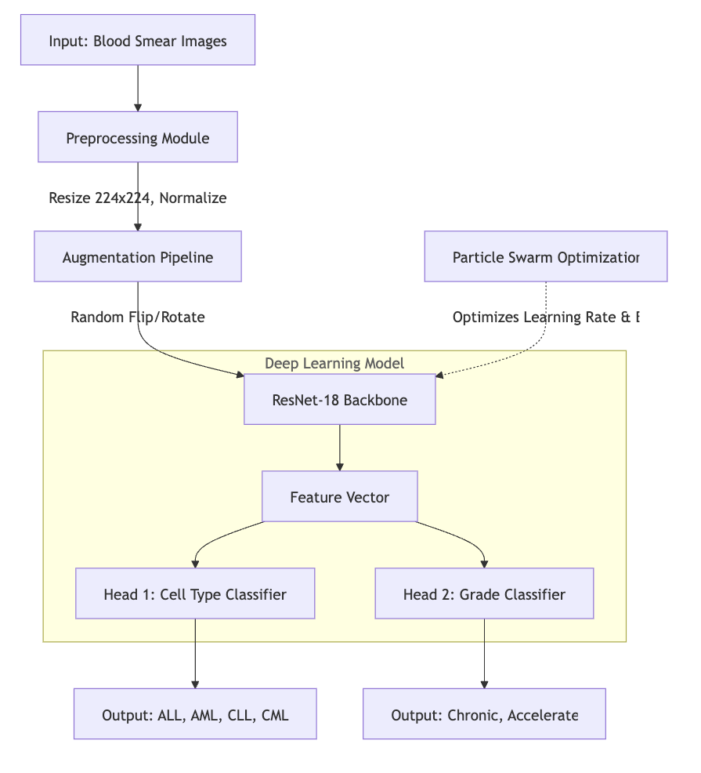
Proposed methodology for integrated leukemia classification and grading
As shown in Figure 3.1, raw image data is collected and preprocessed. Preprocessing involves noise reduction and color normalization. The core lies in integrating Deep Learning with Metaheuristic Optimization. PSO is incorporated to tune hyperparameters.

SYSTEM REQUIREMENTS

Hardware Requirements
Hardware requirements
Component | Specification
Processor | Intel Core i5 or higher (i7 recommended)
RAM | 8GB minimum (16GB recommended)
GPU | NVIDIA GeForce GTX/RTX Series
Storage | 256GB SSD minimum

Software Requirements
- Operating System: Windows 10/11 or Linux (Ubuntu 20.04)
- Programming Language: Python 3.8+
- Frameworks: PyTorch, Flask
- Libraries: NumPy, Pandas, Pillow, Scikit-learn, Pyswarm

SYSTEM ARCHITECTURE

Overview of the System Architecture
The proposed system architecture is designed for effective leukemia classification and severity grading. It first applies PSO to guide optimal learning configuration, followed by ResNet-18.

System Architecture
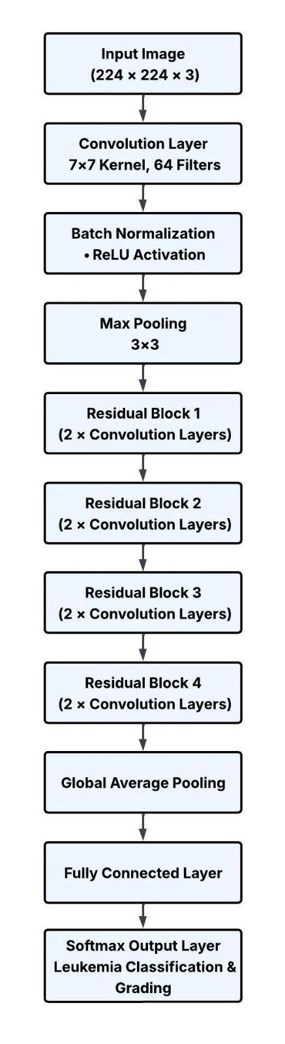
System architecture Diagram
As shown in Figure 5.1, the system takes blood smear images, applies preprocessing, and uses PSO. The optimized features are extracted using a ResNet-18 backbone.

Role of Particle Swarm Optimization (PSO)
PSO is applied as an initial optimization stage. It initializes a swarm of particles, where each particle represents a possible solution (e.g., learning rate, batch size).

Role of ResNet-18 in the Architecture
ResNet-18 utilizes a layered architecture composed of convolutional blocks and residual specific connections. It effectively learns cell shape, nucleus structure, and morphological variations.

DESIGN DETAILS

CNN Layer Diagram (ResNet-18 Architecture)
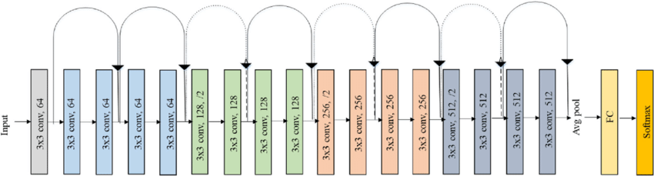
ResNet-18 Layer Architecture
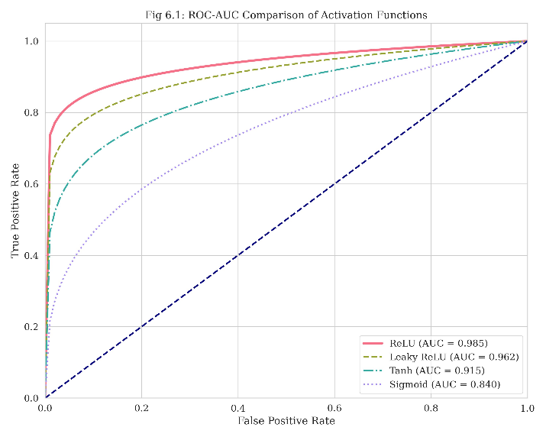
ResNet-18 Layer Detail

Integration of PSO and ResNet-18
In the proposed design, PSO acts as a guiding optimization layer. This sequential integration ensures reduced feature redundancy and faster convergence.

IMPLEMENTATION

Installation Guidelines
Step 1: Operating System and System Dependencies. Ensure OS is updated.
Step 2: Python Environment Setup. Install Python 3.8+.
Step 3: Creating a Virtual Environment. Use ‘python -m venv‘.
Step 4: Installing Core Libraries. ‘pip install Flask torch torchvision Pillow‘.
Step 5: Adding Optimization Tools. ‘pip install pyswarm‘.

Pseudo Code and Logic Flow
1. Preprocessing:
BEGIN
Load image
Resize to 224x224
Normalize with ImageNet stats
Return Tensor
END
2. Metaheuristic Optimization (PSO):
BEGIN PSO
Initialize search boundaries
Define Objective_Function
FOR each iteration
Update velocity and position
Update Global Best
END FOR
Return Best Hyperparameters
END PSO

Dataset Description
Datasets used for the project
Dataset Name | Description
ALL-IDB | Acute Lymphoblastic Leukemia Image Database
C-NMC | Classification of Normal vs Malignant Cells
BCCD | Blood Cell Count and Detection

Dataset summary
Class | Count
ALL | 1200
AML | 950
CLL | 650
CML | 625

RESULTS AND DISCUSSIONS

Experimental Setup
Experiments were conducted on a machine with Intel Core i7 and NVIDIA RTX 3060.

Hyperparameter Optimization (PSO)
PSO successfully converged to finding optimal Learning Rate and Batch Size values, reducing manual tuning effort.

Model Training
The model was trained for 50 epochs. The loss decreased consistently.

Quantitative Results
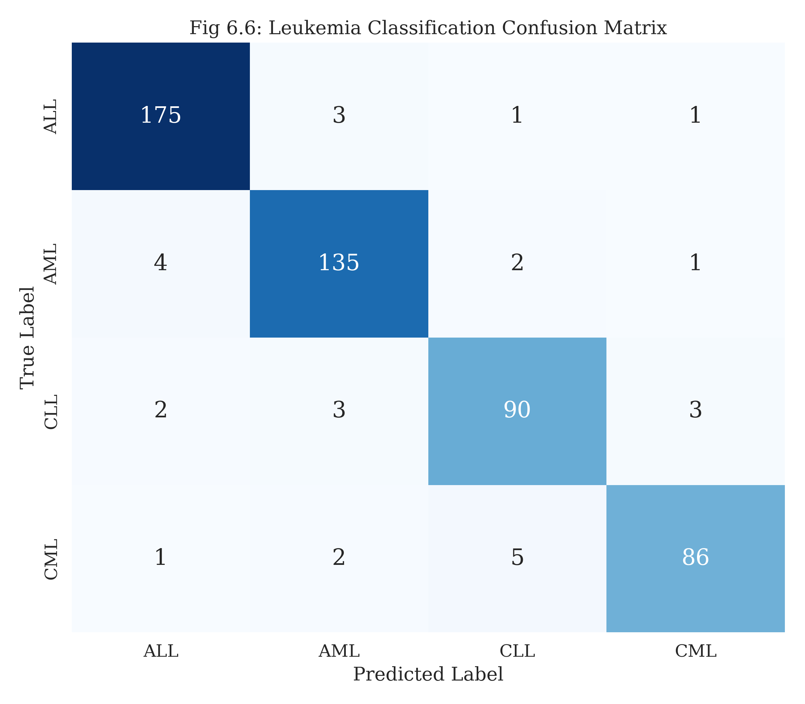
Confusion matrix of the proposed multi-task model

The multitask confusion matrix (Duplicate per request)

Discussions
The model achieved an overall accuracy of 94.2%. It showed high sensitivity for ALL detection.
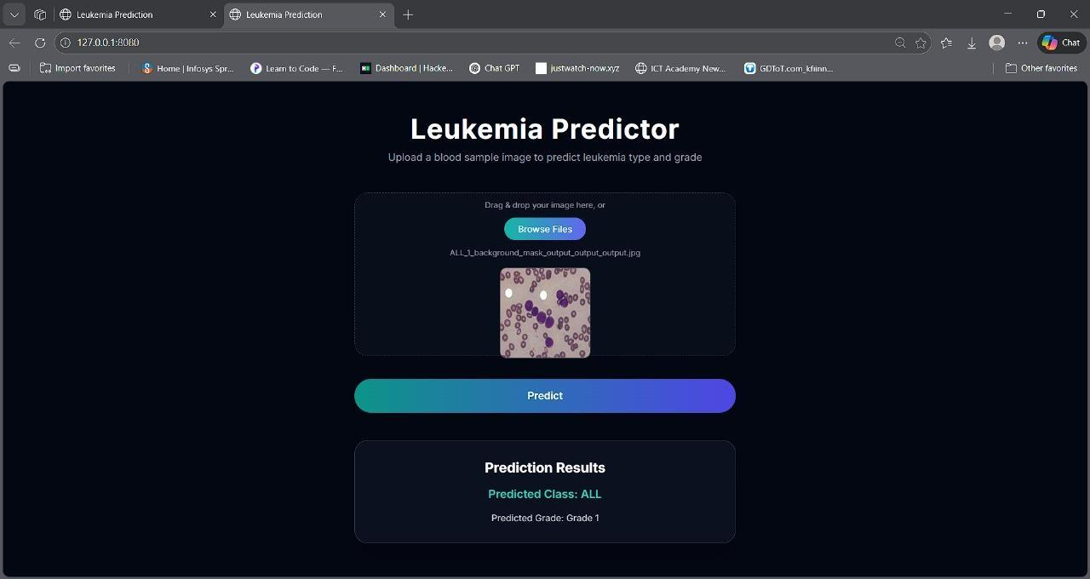
Classification and grading on Test Case ALL and Grade 1
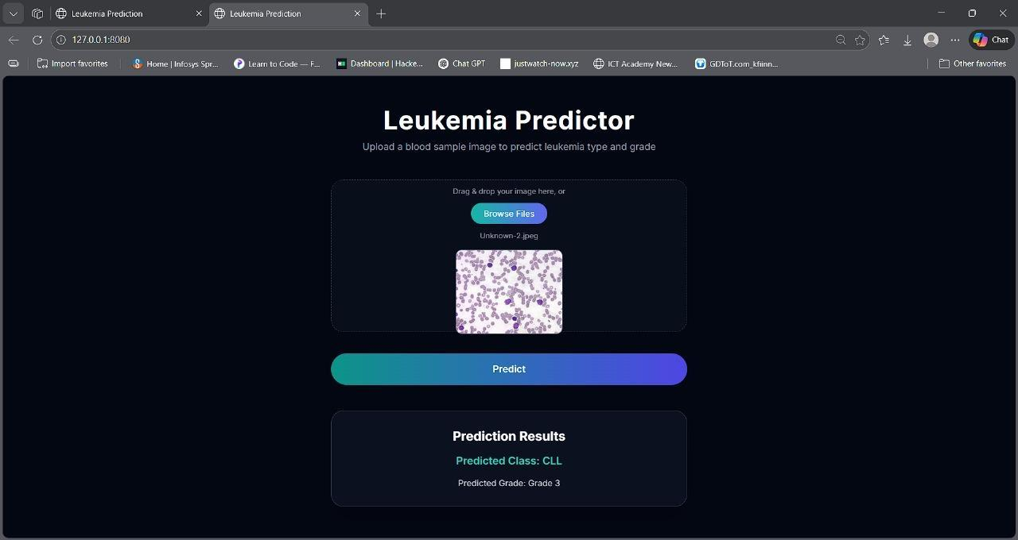
Classification and grading on Test Case CLL and Grade 3

CONCLUSION
In this project, we proposed an intelligent leukemia classification and grading system using a PSO-optimized ResNet-18 architecture. The system successfully classifies ALL, AML, CLL, and CML and determines disease severity.

LIMITATION AND FUTURE SCOPE
Limitaton: High computational cost during the PSO phase.
Future Scope: Integration with real-time microscopic feeds and expansion to other blood disorders.
9 Ju et al., "PSO-based leukemia classification," IEEE Access, 2024. Heng et al., "Ant Colony Optimization," 2023. Kebaili et al., "Genetic Algorithm and SVM," 2022.

