CLOUD COMPUTING
Latency-Aware VM Replica Placement and Network Routing
Using Graph Modeling, Minimum Spanning Trees, Shortest Paths, and Dynamic Programming

A presentation-ready technical document

1. Problem Statement
A cloud provider operates multiple servers or data-center nodes connected by a network. Each connection has a latency, and each server has a limited capacity. Users or workloads are distributed across the network and need access to virtual machines (VMs). The objective is to place replica VMs at selected servers so that the average access latency is minimized while no server exceeds its capacity.
The problem can be modeled as a combination of graph algorithms and optimization: the network is represented as a weighted graph, an MST can provide a low-cost backbone, shortest-path algorithms provide routing distances, and dynamic programming can select replica locations under capacity constraints.

2. Core Idea
The complete solution follows four connected stages:
- Model servers as nodes (vertices) in a graph.
- Model network links as edges and assign latency values as edge weights.
- Build a low-cost network backbone using a Minimum Spanning Tree (MST), then use shortest paths for routing and latency calculation.
- Use Dynamic Programming (DP) to choose where replica VMs should be placed, minimizing average latency while respecting server capacities.
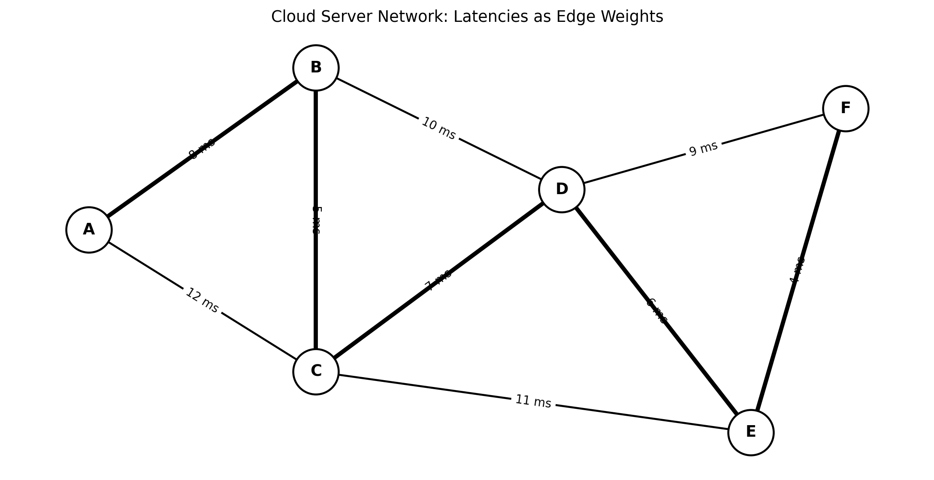
Figure 1. Example cloud-server graph. Edge labels represent link latency in milliseconds; thicker links illustrate an example MST backbone.

3. Graph Representation

3.1 Nodes
Each server, edge node, or data-center location is represented by a vertex. For example, A, B, C, D, E, and F can represent six cloud servers.

3.2 Edges and Weights
A network connection between two servers is represented by an edge. Its weight is the measured network latency, usually expressed in milliseconds (ms). Lower weight means faster communication.
Component | Representation | Example
Server | Vertex / Node | A, B, C
Network link | Edge | A-B
Latency | Edge weight | 8 ms
VM capacity | Node constraint | 2 replicas

3.3 Example Graph
For the example network, the links are A-B=8 ms, A-C=12 ms, B-C=5 ms, B-D=10 ms, C-D=7 ms, C-E=11 ms, D-E=6 ms, D-F=9 ms, and E-F=4 ms.

4. Minimum Spanning Tree for the Backbone
A Minimum Spanning Tree connects all servers with the minimum possible total edge weight and contains no cycles. Kruskal's or Prim's algorithm can be used to construct it.
In this project, the MST is treated as a simplified low-latency backbone. It reduces unnecessary network links while preserving connectivity. The MST itself is not automatically the shortest path between every pair of servers, so routing latency is calculated using shortest paths on the selected network.

Kruskal's Algorithm
- Sort all network links by increasing latency.
- Start with an empty tree.
- Add the next lowest-latency edge if it does not create a cycle.
- Continue until all servers are connected.
- The resulting tree is the MST.

5. Shortest-Path Routing
Once the network is represented as a weighted graph, shortest-path distances determine the latency between a user/workload location and a VM replica. Dijkstra's algorithm is suitable when all latency weights are non-negative.
For a source server s and destination server v, the shortest-path distance d(s,v) is the minimum sum of edge latencies along any valid route.

Why shortest paths matter
- They provide the actual routing cost used by the placement objective.
- They prevent a replica from appearing close merely because it has a direct but slow or indirect route.
- They convert the network topology into a latency matrix that DP can use.

6. VM Replica Placement
Suppose there are N candidate servers and R replica VMs to place. Each server i has capacity c_i, and placing a replica consumes one unit of capacity. Let x_i be the number of replicas placed at server i.
The basic capacity constraint is:
0 ≤ xᵢ ≤ cᵢ and Σxᵢ = R
If workload demand at source s is w_s and the closest selected replica is used, the latency cost can be represented as:
Cost = Σ wₛ · min{i : xᵢ > 0} d(s,i)
The average latency is the total weighted latency divided by the total workload demand.

7. Dynamic Programming for Placement Selection
The placement problem resembles a capacity-constrained facility-location problem. A DP approach can systematically evaluate candidate replica placements instead of trying every possible combination blindly.

DP State
One useful formulation is to process candidate servers one at a time. A state can record the number of replicas already placed and the accumulated placement cost. For a simplified classroom model:
DP[i][r] = minimum cost using the first i servers with r replicas placed

Transition
For server i, consider placing k replicas where 0 ≤ k ≤ c_i. The transition is:
DP[i][r] = minₖ { DP[i−1][r−k] + PlacementCost(i,k) }
The exact PlacementCost depends on the workload model. For a simple nearest-replica model, assigning a source to server i contributes its demand multiplied by the shortest-path latency to i. After each DP decision, capacity is checked so that no server receives more replicas than allowed.

DP Backtracking
After calculating DP[N][R], backtracking through the table reveals which servers were selected and how many replicas were assigned to each. This produces the final VM placement.

8. End-to-End Algorithm
- Input the cloud servers, their capacities, network links, link latencies, workload locations, workload demands, and required number of VM replicas.
- Create the weighted graph G = (V,E).
- Compute an MST using Kruskal's or Prim's algorithm to establish a low-cost backbone.
- Run shortest-path calculations to obtain latency distances between workload locations and candidate replica servers.
- Initialize the DP table with impossible states set to infinity and DP[0][0] = 0.
- For each candidate server, test feasible replica counts up to its capacity.
- Update the DP state using the placement cost derived from shortest-path latency.
- Backtrack from the final state to recover the selected replica servers.
- Calculate total latency, average latency, capacity utilization, and routing paths.
- Output the replica placement and the routing information.

9. Illustrative Example
Assume six servers A-F and three VM replicas. Each server has a capacity of two replicas. Suppose workloads are concentrated near A, C, and F. The algorithm calculates shortest-path latencies from those workload locations to every candidate server.
Server | Capacity | Example distance from A | Example distance from C | Example distance from F
A | 2 | 0 ms | 12 ms | 27 ms
B | 2 | 8 ms | 5 ms | 19 ms
C | 2 | 12 ms | 0 ms | 15 ms
D | 2 | 18 ms | 7 ms | 9 ms
E | 2 | 23 ms | 11 ms | 4 ms
F | 2 | 27 ms | 15 ms | 0 ms
The DP compares combinations such as {A,C,F}, {A,D,F}, {B,C,E}, and other capacity-feasible choices. It selects the combination with the lowest calculated total or average latency under the chosen workload model. The point is not that one fixed combination is universally optimal, but that the algorithm evaluates the network data rather than guessing. Humanity has finally outsourced the guessing.

10. Complexity
Technique | Typical complexity | Purpose
Kruskal's MST | O(E log E) | Construct low-cost connected backbone
Dijkstra | O((V+E) log V) with a heap | Compute shortest-path latency
DP placement | Depends on N, R and capacity limits | Select replica locations

11. Benefits of the Approach
- Latency-aware: replica locations are selected using measured or estimated network latency.
- Capacity-aware: a server cannot receive more replicas than its available capacity.
- Efficient backbone: MST provides a simple way to connect all nodes using low total link weight.
- Optimal routing within the modeled graph: shortest paths minimize routing latency between selected endpoints.
- Systematic placement: DP explores feasible placement decisions while avoiding uncontrolled brute-force enumeration.
- Extensible: the objective can incorporate workload demand, VM capacity, replication cost, bandwidth, or failure constraints.

12. Limitations and Practical Considerations
- An MST minimizes total backbone edge weight, not necessarily every user-to-replica latency. It should therefore be treated as a network-design component rather than the complete routing solution.
- Real cloud networks have bandwidth limits, congestion, failures, asymmetric latency, and changing traffic patterns.
- The simplified DP model may require additional dimensions when servers have multiple resource types such as CPU, RAM, storage, and GPU capacity.
- Replica placement in a production cloud may also need fault-domain constraints so that replicas are not all placed in one failure zone.
- Latency measurements should be refreshed because network conditions change over time.

13. Conclusion
This cloud-computing model combines several core algorithmic ideas into one practical problem. Servers are modeled as graph nodes, network links become weighted edges, an MST provides a compact backbone, shortest paths determine routing latency, and dynamic programming selects VM replica locations under capacity constraints. The final system therefore makes placement decisions based on measurable network cost and available resources.
The approach demonstrates how classical Data Structures and Algorithms can be applied to a modern cloud-computing problem: graph theory handles connectivity and routing, while optimization through DP handles constrained resource placement.

14. Suggested Presentation Flow
Slide | Content
Slide 1 | Problem: latency-aware cloud VM placement
Slide 2 | Represent servers as graph nodes
Slide 3 | Represent links as weighted edges using latency
Slide 4 | MST for the network backbone
Slide 5 | Shortest paths for routing latency
Slide 6 | VM replica placement and capacity constraints
Slide 7 | Dynamic Programming state and transition
Slide 8 | End-to-end algorithm
Slide 9 | Example network and placement
Slide 10 | Complexity, benefits, limitations, and conclusion

