Designing and Implementing a Mini Project on

LUNG CANCER DETECTION
Numerical Data Classification and Cloud Deployment
Submitted to the
Savitribai Phule Pune University
In partial fulfillment for the award of the Degree of
Bachelor of Engineering
in Information Technology
by
Abhijeet Kumar (Roll No.: 4301)
Adarsh Raj Chaudhary (Roll No.: 4302)
Adarsh Singh (Roll No.: 4303)
Adith K P (Roll No.: 4304)
Under the guidance of
Prof. Y N Gholap
Department of Information Technology
Army Institute of Technology, Dighi Hills, Pune – 411 015
Academic Year 2026–2027

CERTIFICATE
This is to certify that Abhijeet Kumar (Roll No. 4301), Adarsh Raj Chaudhary (Roll No. 4302), Adarsh Singh (Roll No. 4303), and Adith K P (Roll No. 4304) have submitted their mini project entitled “Lung Cancer Detection: Numerical Data Classification and Cloud Deployment” at Army Institute of Technology, Department of Information Technology, during the academic year 2026–2027, Semester I, in partial fulfillment of the requirements prescribed by Savitribai Phule Pune University for the Bachelor of Engineering degree in Information Technology.
The project work has been carried out under the guidance of Prof. Y N Gholap, Department of Information Technology, Army Institute of Technology, Pune.

____________________ | ____________________
Prof. Y N Gholap | Dr. (Mrs.) Sangeeta Jadhav
Project Guide  Department of Information Technology | Head of Department  Department of Information Technology

ACKNOWLEDGEMENT
We express our sincere gratitude to Prof. Y N Gholap, our project guide, for his guidance and support throughout this mini project. The project helped us connect numerical machine-learning methods with application development and cloud provisioning, while evaluating the limitations of the resulting classifier.
We thank Dr. (Mrs.) Sangeeta Jadhav, Head of the Department of Information Technology, Army Institute of Technology, Pune, and the faculty and laboratory staff for the academic environment and facilities supporting the project.
We acknowledge the work of the dataset publisher and the maintainers of Python, scikit-learn and Streamlit. We also thank our colleagues for their feedback during interface development and testing. All four team members contributed to the preparation and presentation of the project.
Abhijeet Kumar (Roll No. 4301)
Adarsh Raj Chaudhary (Roll No. 4302)
Adarsh Singh (Roll No. 4303)
Adith K P (Roll No. 4304)

INDEX
Chapter / Section | Title
Front matter | Certificate, Acknowledgement, Index, Lists, Acronyms, Abstract
1 | Introduction
2 | Feasibility Study
3 | Proposed System
4 | System Design
5 | Implementation and Coding
6 | Snapshots Testing and Results
7 | Conclusion and Future Scope
8 | References

LIST OF TABLES AND FIGURES
No. | Title
Table 2.1 | Feasibility assessment
Table 3.1 | Functional modules
Table 4.1 | Technology and deployment components
Table 4.2 | Dataset and split statistics
Table 4.3 | Training cross-validation comparison
Table 5.1 | Repository structure
Table 5.2 | Operational diagnostics and evidence
Table 6.1 | Held-out test performance
Table 6.2 | Confusion matrix
Table 6.3 | Testing and verification
Figure 4.1 | AWS application architecture
Figure 4.2 | Training and prediction workflows
Figure 6.1 | Demographic and questionnaire input controls
Figure 6.2 | Evaluation metric cards and comparison table
Figure 6.3 | ROC curve from saved test predictions

ACRONYMS
Acronym | Full form
AWS | Amazon Web Services
EC2 | Elastic Compute Cloud
EBS | Elastic Block Store
VPC | Virtual Private Cloud
ML | Machine Learning
CV | Cross-Validation
CSV | Comma-Separated Values
JSON | JavaScript Object Notation
ROC | Receiver Operating Characteristic
AUC | Area Under the Curve
F1 | Harmonic mean of precision and recall
IaaS | Infrastructure as a Service

ABSTRACT
Lung Cancer Detection is an academic application for classifying numerical questionnaire records using a supervised machine-learning pipeline. It accepts age, gender code and thirteen coded questionnaire fields, and predicts the NO or YES label used in the selected Kaggle dataset. The project studies the full workflow from data validation and reproducible model selection to browser-based inference and AWS deployment preparation. It is an experimental dataset-label classifier rather than a clinically validated diagnostic system.
The selected dataset contains 3,000 records. Two duplicate rows and four rows with conflicting labels are excluded, leaving 2,994 usable records. A fixed stratified split assigns 2,395 records to training and 599 to testing. Five candidate configurations are compared using five-fold training-only cross-validation. Histogram Gradient Boosting is selected, and its fitted StandardScaler and classifier are saved as one reusable pipeline.
On the held-out test partition, the selected model achieves 50.92% accuracy, 51.70% YES-class precision, 45.21% YES-class recall and an F1 score of 0.4824. Macro F1 is 0.5079 and ROC AUC is 0.5309. The majority-label baseline obtains 50.58% accuracy. These measurements indicate near-chance performance and do not establish clinically useful predictive ability.
The Streamlit application supports complete single-record entry, explicit-encoding CSV uploads, model-score displays, downloadable results and a separate Evaluation dashboard. Fifteen automated tests pass, with additional browser and package checks recorded. An AWS CloudFormation template provisions an EC2 host running Streamlit behind Nginx. The latest recorded AWS event remains CREATE_IN_PROGRESS with CONFIGURATION_COMPLETE; a ready AWS endpoint and public prediction check have not yet been confirmed.
Keywords: Numerical Classification, Streamlit, Histogram Gradient Boosting, Data Validation, AWS EC2, CloudFormation, Model Evaluation.

Chapter 1 INTRODUCTION

1.1 Background
The project combines numerical classification, a browser interface and repeatable cloud provisioning. Users can examine inputs, predictions and evaluation evidence in one application. The title reflects the selected dataset topic; the implemented output is its NO or YES record label [1, 2].

1.2 Problem Statement
Standalone scripts require correctly encoded columns and manual interpretation. Incomplete inputs, incorrect feature order and stale results can mislead users. The project provides shared input validation, saved-model inference and traceable results, while reporting measured performance and its limitations.

1.3 Project Objectives
- Audit the dataset and preserve a reproducible training and test split.
- Select a classifier using training-only CV and save its preprocessing.
- Develop validated single-record and CSV prediction interfaces.
- Display class scores, downloadable outputs and model identity.
- Present held-out results, baseline performance and CV evidence.
- Prepare repeatable AWS EC2 provisioning and automatic startup.
- Test data handling, navigation, model loading and result state.

1.4 Scope
The academic demonstration accepts fifteen numerical features from one dataset. It excludes images, patient accounts, clinical records and medical recommendations. Its scores describe dataset-label classification rather than a verified individual probability of disease.

1.5 Importance of Cloud Computing
EC2 hosts the application centrally so users need only a browser. Nginx forwards HTTP and WebSocket traffic, systemd manages the Python process, and CloudFormation describes the infrastructure. This demonstrates infrastructure as a service and centrally delivered software.

Chapter 2 FEASIBILITY STUDY

2.1 Existing Approach and Limitations
A notebook-based workflow can train a model and calculate metrics, but it gives limited guidance to a user entering new records. Manual preprocessing can introduce inconsistent codes or incorrect feature order. Repeated inspection of a test partition can also encourage model selection based on test performance. The proposed application therefore shares validation and prediction code across its input modes and separates training CV evidence from saved test results.

2.2 Technical Feasibility
Python 3.12, Streamlit, pandas and scikit-learn run on CPU. Saved artifacts permit inference without downloading training data. The initial training and evaluation run took 7.02 seconds on the development CPU; timing varies by machine. All nine pinned direct dependencies have Python 3.12 Linux wheels.

2.3 Economic Feasibility
The open-source software uses one t3.micro host, an encrypted 8 GiB gp3 disk and a public IPv4 address. These resources normally incur charges. The verified AWS Free account plan consumes credits and ends when credits or its period expire. No paid-plan upgrade is authorised [8].

2.4 Operational and Security Feasibility
The form, CSV upload and downloads support a browser demonstration. Validation messages and automatic clearing of stale results guide users. Nginx accepts HTTP and forwards to loopback Streamlit. The template requires IMDSv2 and no inbound SSH rule. Private-record use requires HTTPS and access controls.
Table 2.1 Feasibility assessment
Dimension | Implementation evidence | Qualification
Technical | CPU pipeline, pinned dependencies, saved artifacts | Predictive skill remains near chance
Cost | Single small host and open-source libraries | Free account plan is temporary
Operational | Form, batch, examples and downloads | No clinical workflow validation
Security | Strict schema, model checks, encrypted disk | HTTPS and access controls need configuration
Maintainability | Shared predictor, modules and tests | Single-server deployment

2.5 Risks and Mitigations
- Weak predictive signal: compare with a majority-label baseline and state that the observed results remain near chance.
- Unverified labels and code meanings: preserve source mappings and obtain a verified clinical codebook before extending the claims.
- Invalid inputs: enforce the complete schema, numerical ranges and explicit encoding before inference.
- Stale predictions: associate results with an input-and-model fingerprint and clear them after relevant changes.
- Cloud cost and availability: retain the verified Free plan, monitor credits and preserve the repository independently of the temporary cloud account.

Chapter 3 PROPOSED SYSTEM

3.1 System Overview
The proposed system provides two input paths into one prediction function. A browser form creates a single-row DataFrame; a CSV upload creates a multi-row DataFrame. Both paths apply the same validation and source-code conversion, arrange features in the trained order, and invoke the saved pipeline. Results are displayed in the current session and can be downloaded. Evaluation screens read saved evidence instead of fitting a model when a page opens.

3.2 Main Modules
Table 3.1 Functional modules
Module | Function
Data audit | Validate source, encode features, deduplicate and preserve fixed splits
Training | Compare candidates on training folds and save the selected pipeline
Single-record prediction | Collect complete numerical inputs and produce one traceable result
CSV prediction | Read explicit encodings, validate records and export predictions
Evaluation | Present saved test, baseline, class and CV evidence
Session management | Preserve inputs and clear results after relevant changes
AWS provisioning | Define the network, EC2 host, startup service and reverse proxy

3.3 Input Modes
- Single-record entry collects all fifteen fields through a bounded age input and binary dropdowns. The Predict button is enabled only when the form is complete.
- Numeric CSV mode requires age in whole years, gender encoded as F=0 or M=1, and other binary features encoded as 0 or 1.
- Original survey CSV mode accepts F/M gender and source binary codes 1/2. It explicitly maps source 1 to 0 and source 2 to 1.
- Example records and downloadable templates support demonstration and reduce column-format mistakes. Uploaded files are limited to 10 MB and 10,000 records.
The application does not infer the encoding from the data. It rejects missing values, unexpected columns, unsupported codes and non-finite numbers. Uploaded records are processed in memory and are not written to an application database.

3.4 Classification Logic
The pipeline computes a score for each output class. A YES score of at least 0.5 produces the YES dataset label; a lower score produces NO. The complementary score is displayed for NO. Each output records the active model run and artifact hash. These values provide traceability, while the interface explicitly avoids presenting them as calibrated personal cancer-risk estimates.

3.5 User and Operator Responsibilities
The user enters records, selects CSV encoding, requests predictions and inspects results. The operator maintains the saved model and its metadata, runs training as a separate workflow, controls cloud provisioning and verifies deployment health. The application contains no registration or persistent user-profile subsystem. Session state supports the current browser interaction rather than a durable patient record.

3.6 Application Advantages
- A shared predictor keeps form, batch and command-line inference consistent.
- Explicit validation prevents unsupported or incomplete records from reaching the model.
- Separate model-selection and test-result views make evaluation easier to interpret.
- Cached loading reuses the saved model, while session state preserves useful form inputs.
- Downloads, example records and reproducible startup scripts support academic demonstration and review.

Chapter 4 SYSTEM DESIGN

4.1 Overall Architecture
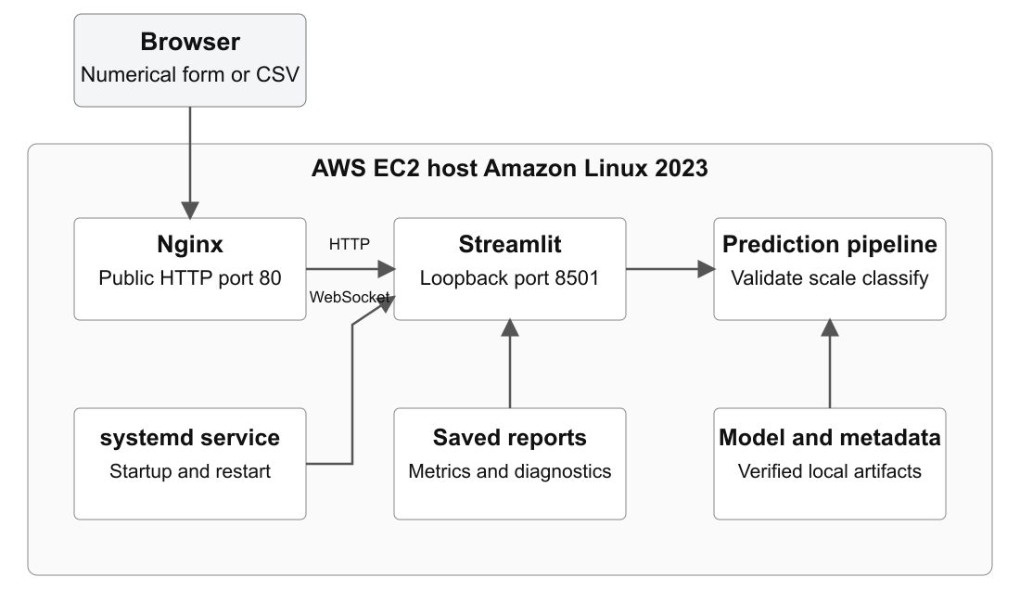
Figure 4.1 Application architecture for the AWS EC2 deployment
A browser connects to Nginx on public port 80. Nginx forwards HTTP and WebSocket traffic to Streamlit on 127.0.0.1:8501. The Python application validates records and invokes the locally stored preprocessing and classifier pipeline. Saved metadata supplies evaluation views. A systemd service starts the application after boot and restarts it after failure. The deployment uses the existing model artifacts and does not train during provisioning.

4.2 Technology and Deployment Components
Table 4.1 Technology and deployment components
Component | Responsibility
Python and Streamlit | Execute page logic, widgets, session state and inference
pandas and scikit-learn | Represent validated records and run the fitted pipeline
joblib and metadata | Load saved artifacts and check compatibility and identity
Altair and Matplotlib | Present comparison charts, ROC information and confusion matrices
Amazon EC2 and EBS | Provide the Linux host and encrypted 8 GiB root disk
Nginx and systemd | Proxy HTTP/WebSockets and manage application startup
AWS CloudFormation | Provision the template-defined infrastructure and wait for health

4.3 Dataset and Input Schema
The project uses version 2 of Akash Nath’s Lung Cancer Dataset on Kaggle [2]. It contains AGE, GENDER and thirteen questionnaire columns, with LUNG_CANCER as the target. The questionnaire columns are SMOKING, YELLOW_FINGERS, ANXIETY, PEER_PRESSURE, CHRONIC_DISEASE, FATIGUE, ALLERGY, WHEEZING, ALCOHOL_CONSUMING, COUGHING, SHORTNESS_OF_BREATH, SWALLOWING_DIFFICULTY and CHEST_PAIN. The supported prediction age range is 30–80 years. Source clinical labels, patient identity and collection procedures have not been independently verified.
Table 4.2 Dataset and split statistics
Dataset statistic | Value
Raw source records | 3,000
Duplicate rows removed | 2
Conflicting rows excluded | 4 in 2 feature groups
Usable records | 2,994
Training records | 2,395 (NO 1,183; YES 1,212)
Held-out test records | 599 (NO 296; YES 303)
Input features and target | 15 features; LUNG_CANCER target
Supported age range | 30–80 whole years

4.4 Data Preparation and Preprocessing
Column names and codes are validated; NO/YES maps to 0/1. Feature hashes identify duplicates and conflicting labels. Two duplicates and four conflicting rows are excluded. A seed-42 stratified split reserves 20% for testing. StandardScaler fits only training records within CV and the final fit [4, 5].

4.5 Model Selection
Five candidates use mean five-fold training macro F1: Logistic Regression at C=0.1 and C=1, Random Forest at depth 6 and unrestricted depth, and Histogram Gradient Boosting. The last wins with macro F1 0.5236. It uses histogram-based tree splits, 120 iterations, learning rate 0.05, at most 7 leaves and L2 regularisation 2 [3].
Table 4.3 Five-fold training-only cross-validation
Candidate | Macro F1 | Balanced accuracy | ROC AUC
Histogram Gradient Boosting | 0.5236 | 0.5242 | 0.5309
Logistic Regression C=0.1 | 0.5129 | 0.5131 | 0.5114
Logistic Regression C=1 | 0.5125 | 0.5127 | 0.5115
Random Forest full depth | 0.5093 | 0.5093 | 0.5194
Random Forest depth 6 | 0.5089 | 0.5090 | 0.5215

4.6 Training and Inference Workflow
- Receive a complete numerical record or an explicitly encoded CSV.
- Normalise column names and validate the exact fifteen-feature schema.
- Convert source codes and return columns in the trained feature order.
- Apply the saved StandardScaler and Histogram Gradient Boosting classifier.
- Use the fixed 0.5 threshold to obtain NO or YES and retain both model scores.
- Display the result, attach model identity and provide a JSON or CSV download.
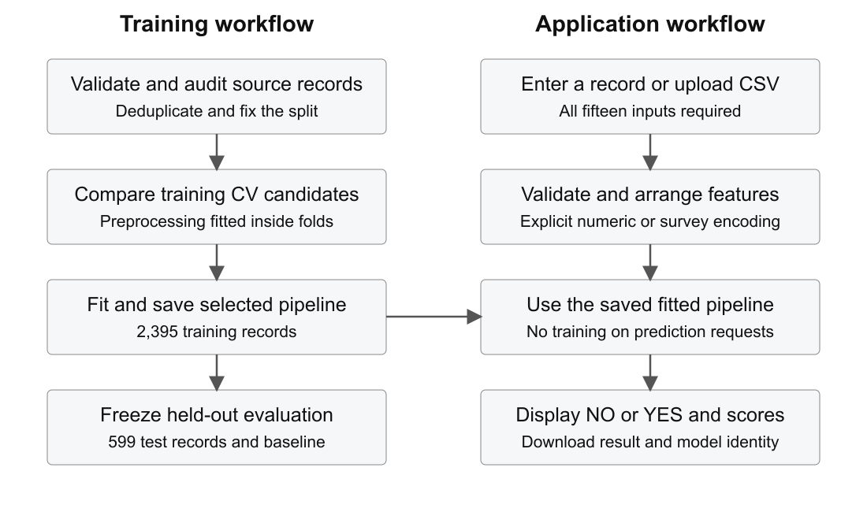
Figure 4.2 Separate training and application prediction workflows

4.7 Data and Session Organisation
Folders separate source data, splits, models and reports. active.json selects the run; metadata.json records schema, versions, hashes and metrics. Session state retains inputs and clears results when inputs or models change.

4.8 Validation and Security Design
Validation rejects missing values, invalid codes and target columns. Model loading checks hashes, schema and version; uploaded models are rejected. The encrypted host runs an unprivileged process. Private use requires HTTPS and access controls.

Chapter 5 IMPLEMENTATION AND CODING

5.1 Repository Structure
Table 5.1 Repository structure
Path | Purpose
app.py | Page setup, styling, model cache and sidebar navigation
ui_pages/ | Eight page entry files
lung_tabular/ui.py | Forms, CSV workflow, results and evaluation screens
lung_tabular/data.py | Schema validation, encoding, cleaning and split audit
lung_tabular/model.py | Candidates, training, model checks and shared inference
lung_tabular/evaluation.py | Saved-result and cross-validation presentation helpers
lung_tabular/diagnostics.py | Training-only permutation-reliance diagnostics
artifacts/numerical/ | Active pointer, saved pipeline, metadata and CV evidence
reports/numerical/ | Split records, exclusions, evaluation, plots and verification
samples/numerical/ | Example records and CSV input files
deploy/aws/ | CloudFormation template, guide and validation record
setup.ps1 and run.ps1 | Environment setup and local application startup
tests/ | Schema, data, model and application tests

5.2 Local Execution
Open the project folder in VS Code and use PowerShell. On a fresh Python 3.12 installation, run setup.ps1 to create the virtual environment and install pinned dependencies. The existing trained model can then be used immediately:
powershell -ExecutionPolicy Bypass -File .\run.ps1
Open http://localhost:8501. The run script selects the project interpreter and binds locally. A different port can be supplied with -Port 8502. The server uses the saved pipeline; opening pages or requesting predictions does not retrain it.

5.3 AWS EC2 Deployment Procedure
- Verify in AWS Billing that the account is on the Free plan, and retain that plan to meet the zero-charge condition.
- Open CloudFormation in ap-northeast-1 and upload deploy/aws/cloudformation.yaml.
- Name the stack lung-numerical-demo and review t3.micro, the 8 GiB encrypted gp3 disk and the pinned code revision.
- Keep the optional CloudFormation service-role field empty. The template creates its network and host without an IAM administration role.
- Submit the stack. User data installs Python 3.12 and dependencies, verifies the model, configures Nginx and enables the systemd service.
- Wait for the readiness signal and CREATE_COMPLETE, then open ApplicationUrl and test numerical prediction. Deployment is not verified solely by CONFIGURATION_COMPLETE.
Runtime request path:
Browser -> Nginx port 80 -> Streamlit loopback port 8501 -> saved pipeline
The latest recorded console screenshot shows CREATE_IN_PROGRESS and CONFIGURATION_COMPLETE. It establishes that provisioning was initiated; it does not establish a ready public application. A completed stack and a successful external prediction remain the deployment acceptance criteria.

5.4 Application Development
app.py sets page configuration, styling, cached model loading and grouped navigation. Small ui_pages entry files call rendering functions in lung_tabular/ui.py. The sidebar groups Overview, Build the model and Use the model. Streamlit widgets collect values and rerun the Python script after interactions. st.session_state preserves per-session inputs and results, while st.cache_resource reuses the loaded model. CSS provides consistent icon columns, centred labels, card heights and button widths.

5.5 Evaluation and Operational Diagnostics
Table 5.2 Operational diagnostics and evidence
Diagnostic | Implemented evidence or use
Model compatibility | Check schema, feature/class order, version and artifact hash
Prediction validation | Reject incomplete records, unexpected columns and unsupported codes
Input-state fingerprint | Clear results when values, file, encoding or model identity change
Application health | Use /_stcore/health for startup readiness
Process recovery | systemd starts on boot and restarts after failure
Bootstrap output | Record setup output in the instance console and bootstrap log
Cloud status | Latest screenshot is in progress; public readiness unconfirmed

The Evaluation page has Metrics, Confusion matrices, ROC, Feature importance, Class breakdown and Cross-validation tabs. It derives tables and plots from saved evidence. The averaging control switches YES-class precision, recall and F1 to macro averages without changing predictions. Feature diagnostics use 512 training records and five permutations, and are presented as in-sample reliance rather than clinical relevance.

5.6 Training and Saved Model Integration
train_run builds a StandardScaler-plus-classifier pipeline for each candidate and evaluates it using five stratified training folds. The highest mean macro F1 determines the final training fit. joblib serialises the fitted pipeline, and reload consistency is checked. The first selected run is evaluated on the held-out partition. Later runs preserve the already viewed test report and publish CV-only results unless independent evaluation data is obtained.

5.7 Shared Prediction and Result State
Both input modes call predict_records, which invokes encode_features, obtains predict_proba scores, checks score validity and assigns the fixed-threshold label. Single-record results are linked to a hash of current values plus model identity. Batch results use a hash of file bytes, encoding and model identity. A changed fingerprint clears old output. JSON and CSV downloads include the numerical prediction and traceable model information.

5.8 Deployment and Cost Control
The Free account plan consumes credits and ends after its allowed period or credit depletion; it is not permanent free hosting [8]. No paid-plan upgrade is required or authorised for this demonstration. The template creates no load balancer, NAT gateway, Elastic IP or IAM role. Operators must review retained resources before cleanup and configure a domain with HTTPS before processing private records. The repository and saved model remain available independently of the cloud account.

Chapter 6 SNAPSHOTS TESTING AND RESULTS

6.1 Application Snapshots
The following figures show the numerical application and its saved evaluation plot. The input-form image shows representative fields; all fifteen inputs are described in Section 4.3.

6.1.1 Numerical Input Form
The form uses a whole-year age input, explicit gender code and binary questionnaire dropdowns. Example loading and incomplete-record validation support the demonstration workflow.
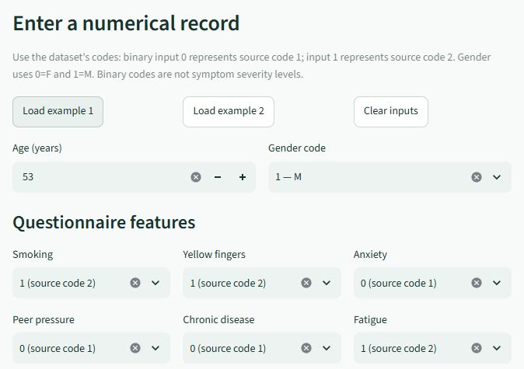
Figure 6.1 Demographic and questionnaire input controls

6.1.2 Evaluation Dashboard
The dashboard displays the selected model’s saved test metrics and its majority-label baseline. The screenshot focuses on the metric cards and comparison table.
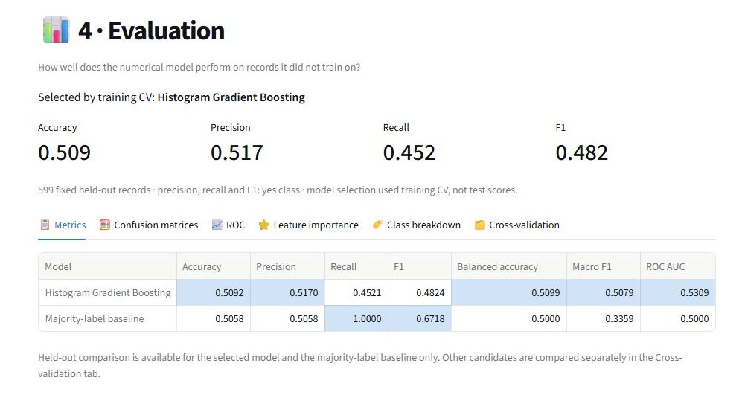
Figure 6.2 Evaluation metric cards and saved comparison table

6.1.3 Receiver Operating Characteristic
The saved ROC curve compares the model’s test ranking behaviour with chance. Its AUC of 0.5309 is close to the chance reference of 0.5.
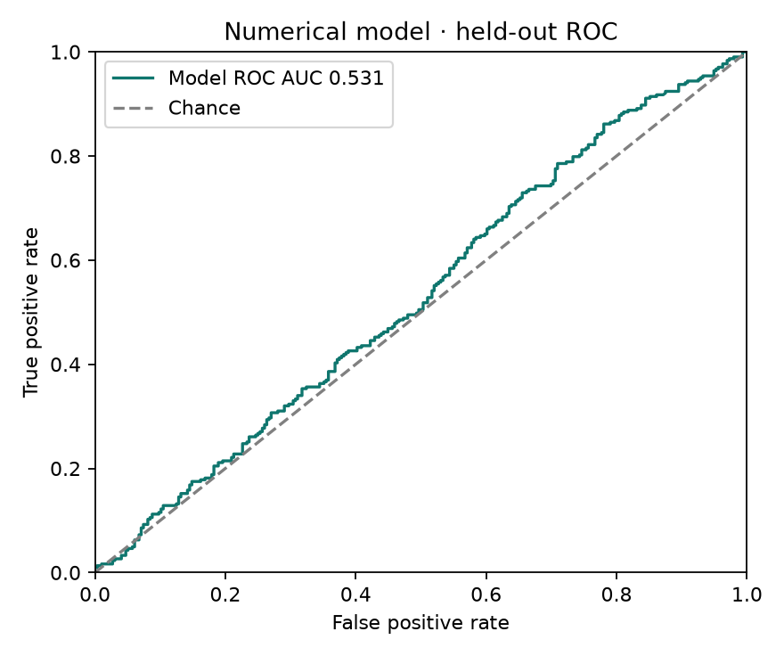
Figure 6.3 ROC curve from the frozen test predictions

6.1.4 AWS Provisioning Status
AWS CloudFormation provisioning was initiated in Tokyo. The recorded stack status is CREATE_IN_PROGRESS, with CONFIGURATION_COMPLETE events for the stack and AppInstance. Public application readiness remains unconfirmed until CREATE_COMPLETE, ApplicationUrl access and a successful remote prediction are verified.
The application screenshot figures demonstrate the numerical interface; they are not evidence of completed AWS hosting.

6.2 Held Out Test Results
The frozen evaluation uses 599 records. Table 6.1 reports the selected model and the majority-label baseline. Precision, recall and F1 refer to the YES dataset class; ROC AUC uses the YES model scores. Other candidates are not assigned invented test scores.
Table 6.1 Held-out test performance with YES as positive
Model | Accuracy | Precision | Recall | F1 | ROC AUC
Selected HGB | 0.5092 | 0.5170 | 0.4521 | 0.4824 | 0.5309
Majority baseline | 0.5058 | 0.5058 | 1.0000 | 0.6718 | 0.5000

The baseline predicts YES for every test record. Its YES recall is therefore 1.0, but it correctly identifies no NO records. Its macro F1 is only 0.3359, compared with 0.5079 for the selected model. A high score for one class alone can therefore give an incomplete view of performance.
Table 6.2 Confusion matrix on 599 held-out records
Actual label | Predicted NO | Predicted YES
NO | 168 | 128
YES | 166 | 137

6.3 Evaluation Metric Definitions
With YES treated as positive, TP=137, TN=168, FP=128 and FN=166. Accuracy=(TP+TN)/N. Precision=TP/(TP+FP), recall=TP/(TP+FN), and F1=2PR/(P+R). Macro F1 gives equal weight to the separately calculated NO and YES F1 scores. ROC AUC evaluates ranking across thresholds rather than only the fixed 0.5 decision. These are source-label measurements, not independently verified patient outcomes.

6.4 Interpretation of Results
The model correctly classifies 305 of 599 records, versus 303 for the majority-label baseline. The accuracy difference is approximately 0.33 percentage points. YES recall of 45.21% means 166 of the 303 YES-labelled records were predicted NO. These results provide little evidence of useful discrimination. The saved 95% Wilson interval for accuracy is approximately 46.92%–54.90%, and ROC AUC remains near 0.5.
Weak test performance can reflect limited usable signal, unverified labels or other dataset limitations; the report does not identify a proven cause. The appropriate next step is to verify provenance and labels and obtain independent evaluation data. Repeatedly tuning against the same observed test partition would not establish external validity.

6.5 Testing and Verification
Table 6.3 Testing and verification
Check area | Recorded result
Automated suite | 15 passed, 0 failed
Single-record state | Completeness, prediction and stale-result reset checked
CSV behaviour | Shared prediction and invalid-upload result clearing checked
Numerical/model validation | Explicit encoding, schema, split and reload checks passed
Browser layout | Desktop and phone navigation alignment checked
Package portability | Eight pages and prediction checked after fresh extraction
AWS template | cfn-lint 1.58.0 and Bash syntax checks passed
AWS public application | Provisioning initiated; live endpoint and prediction unverified

6.6 Reproducibility and Demonstration
The fixed split, seed, feature order and source/model hashes support reproducibility. Automated checks cover schema rejection, explicit encodings, duplicate/conflict handling, model reload, frozen-test preservation, prediction state and batch errors. Browser checks verify alignment at desktop and phone widths. A freshly extracted package was checked across all eight screens and a saved-model prediction. Runtime cloud throughput, uptime and successful public AWS prediction are not yet measured.

Chapter 7 CONCLUSION AND FUTURE SCOPE

7.1 Conclusion
Lung Cancer Detection demonstrates audited data preparation, training-only model selection, saved preprocessing and browser inference. Single-record and CSV inputs share validation. The Evaluation dashboard separates held-out results, candidate CV scores and training-only feature reliance.
Tests support its use as an educational software demonstration. Accuracy of 50.92% and ROC AUC of 0.5309 remain near chance and do not establish clinical detection. AWS provisioning has started; completion and public prediction require verification.

7.2 Limitations
- Source clinical labels, collection procedures and individual patient identities are not independently verified.
- The current model has not demonstrated useful predictive skill or calibrated individual risk estimates.
- The fixed row-level split cannot establish patient-level independence or generalisation to a separate clinical cohort.
- The application has no persistent patient database, authentication layer or measured multi-instance scaling.
- The initial AWS template provides HTTP demonstration access; HTTPS and successful public inference remain acceptance items.

7.3 Future Enhancements
- Obtain a verified clinical codebook and appropriately governed, independently labelled data.
- Evaluate on a genuinely independent cohort and report class performance, uncertainty and calibration.
- Improve the data-quality audit before expanding model searches or making stronger detection claims.
- Complete public AWS acceptance tests and measure startup time, memory use and inference latency.
- Configure HTTPS, access controls, upload rate limits and an appropriate data-retention policy for any private-record use.
- Add monitored deployment updates and documented recovery procedures within approved costs.

Chapter 8 REFERENCES
- Project repository. Lung Cancer Detection numerical application. https://github.com/Adarsh-Singh-21/AIML (branch codex/numerical-project).
- Akash Nath. Lung Cancer Dataset, Kaggle, version 2. https://www.kaggle.com/datasets/akashnath29/lung-cancer-dataset . Source attribution and applicable dataset terms are retained.
- Scikit-learn documentation. HistGradientBoostingClassifier. https://scikit-learn.org/stable/modules/generated/sklearn.ensemble.HistGradientBoostingClassifier.html .
- Scikit-learn documentation. Pipeline. https://scikit-learn.org/stable/modules/generated/sklearn.pipeline.Pipeline .
- Scikit-learn documentation. StandardScaler. https://scikit-learn.org/stable/modules/generated/sklearn.preprocessing.StandardScaler.html .
- Streamlit documentation. Client-server architecture. https://docs.streamlit.io/develop/concepts/architecture/architecture .
- AWS documentation. CloudFormation cfn-signal and application deployment. https://docs.aws.amazon.com/AWSCloudFormation/latest/TemplateReference/cfn-signal.html .
- AWS documentation. Choosing a Free or Paid account plan. https://docs.aws.amazon.com/awsaccountbilling/latest/aboutv2/free-tier-plans.html .
- Project evidence. reports/numerical/dataset_summary.json, test_evaluation.json and VERIFICATION.json; artifacts/numerical/numerical_v1/metadata.json and cv_comparison.csv.
- Deployment evidence. deploy/aws/cloudformation.yaml and validation records; AWS console provisioning screenshot recorded on 26 October 2026. CREATE_COMPLETE and live AWS prediction are not yet verified.

