Name – Isha(12315382)

Roll Number – A11

CA1

Course – CAP 770

Ques

**Odd: Scenario:** You're working on a social media application where users' posts are stored in an array. A user decides to post a new message, which should appear at the top of their feed. Later, the user finds an old post they no longer like and decides to delete it.

**Task:**

1. Implement a function to insert a new post at the beginning of the array.
2. Implement a function to delete a specific post given its ID from the array.
3. After both operations, display the updated array of posts.

Code(Odd):

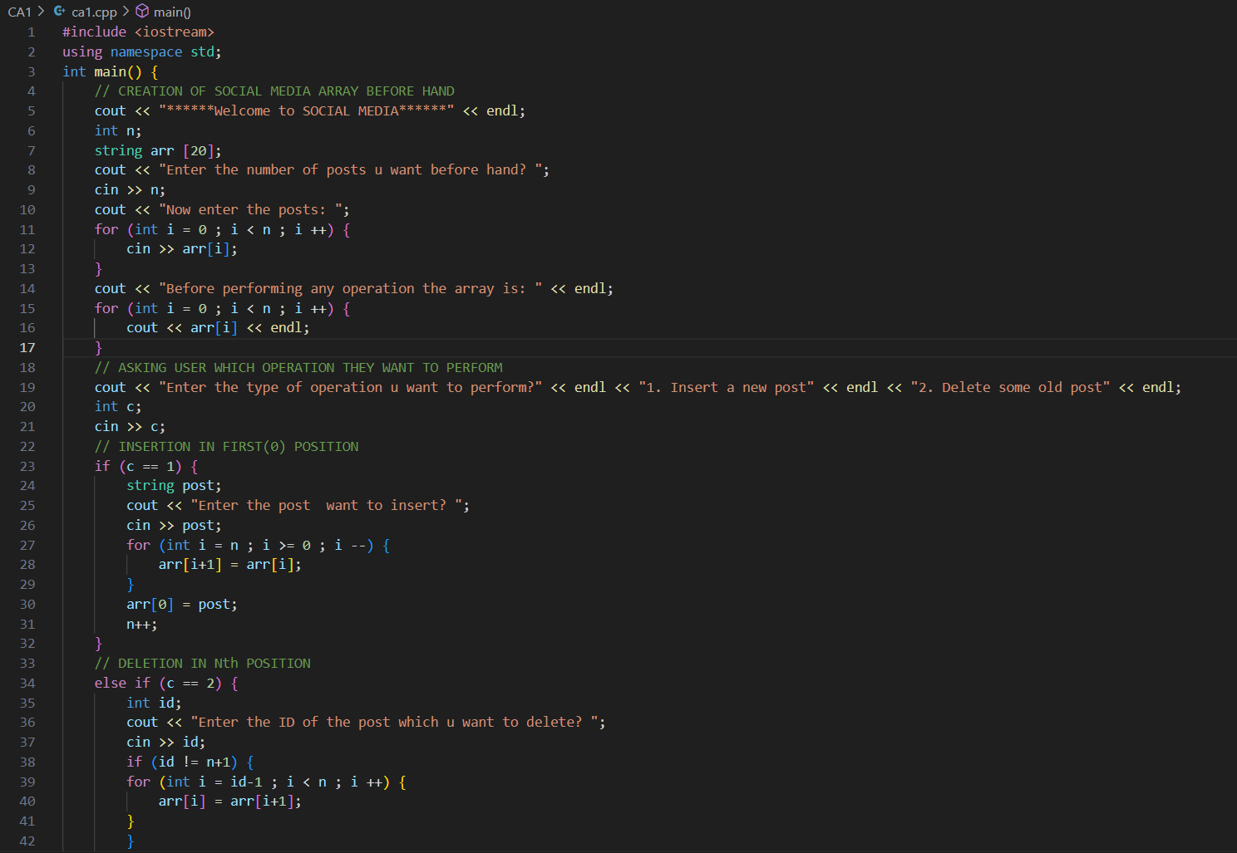

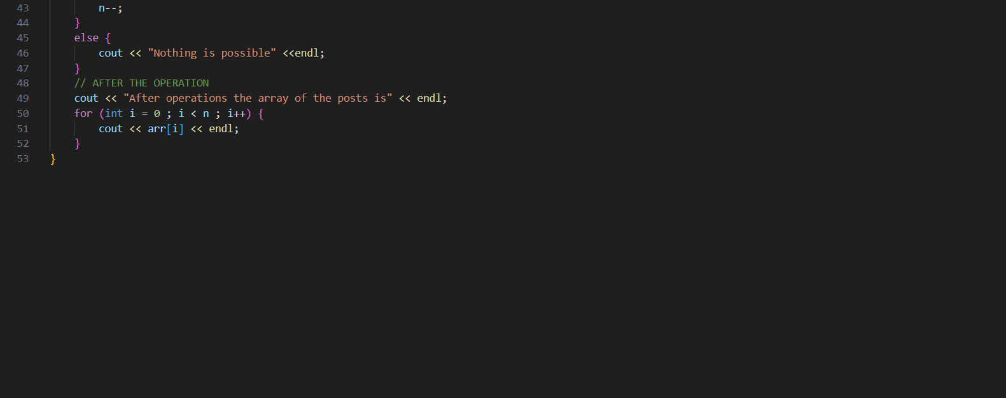

Output 1

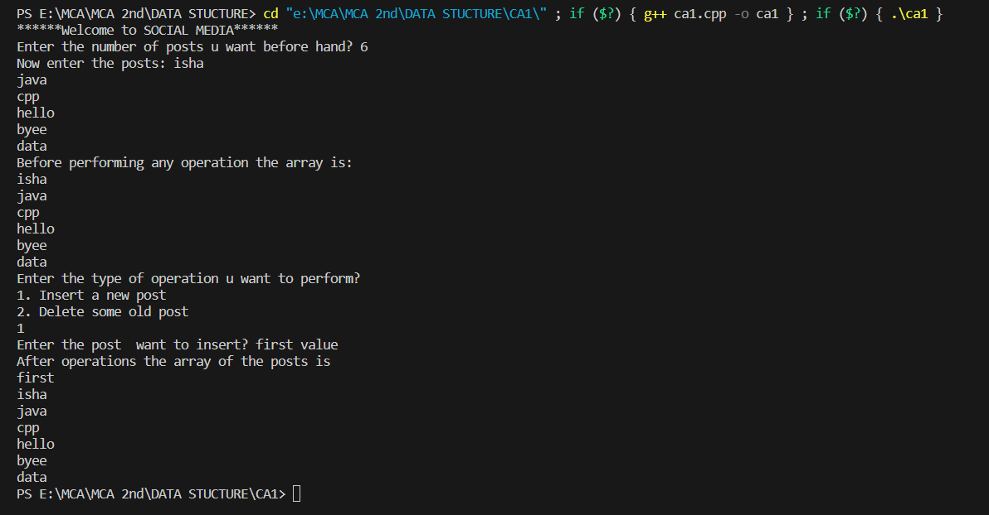

Output 2

