Understanding Buffer Overflow Attack and its Countermeasures

Adarsh Sharma
Department of Computer Science and Engineering
Sikkim Manipal Institute of Technology
Majhitar, Sikkim, India
adarsh_202000529@smit.smu.edu.in
Harshul Parashar
Department of Computer Science and Engineering
Sikkim Manipal Institute of Technology
Majhitar, Sikkim, India
harshul_202000429@smit.smu.edu.in
Rajeev Lochan Subedi
Department of Computer Science and Engineering
Sikkim Manipal Institute of Technology
Majhitar, Sikkim, India
rajeev_202000393@smit.smu.edu.in

Abstract—A threat aimed at individuals to obtain access to and control over networks and data is exponentially growing with the expansion of Internet access. Buffer overflow is one of the most occurring security vulnerabilities in the computer world. Buffer overflow attacks, whether by software error or an attack, is one of the most important security problems that represent a common vulnerability of software security and Cyber risks. The project is aimed at understanding how buffer overflow occurs and its impact on system level programming. The study is also focused on using randomization to decrease the predictability of machines codes expected at run time.(Abstract)
Keywords—buffer, vulnerability, randomization, predictability

Introduction
A buffer overflow attack is a type of security vulnerability that can occur in software applications when a program tries to store more data in a buffer (a temporary storage area in computer memory) than it was designed to hold [1]. If an attacker can find a way to exploit this vulnerability, they can potentially inject malicious code into the buffer, causing the program to behave in unexpected and dangerous ways.
The attacker identifies a vulnerable application that can be exploited. This can be done through various means, such as scanning for open ports on a network or searching for known vulnerabilities in a specific application [2].
The attacker sends a large amount of data to the application in an attempt to overflow the buffer. This data can be crafted to include specific instructions or commands that the attacker wants the program to execute.
If the buffer overflow is successful, the attacker's code will be executed by the program, potentially allowing them to take control of the system or access sensitive information.
In Buffer overflow the buffer size will be overflowed and extra input will get allocated beside the designated buffer [3]. Buffer overflow is a condition when a program writes more data than it is actually supposed to take. The extra input will go to the system and get executed. This is where the problem will begin [4]. For example, a buffer for log-in credentials may be designed to expect username and password inputs of 8 bytes, so if a transaction involves an input of 10 bytes (that is, 2 bytes more than expected), the program may write the excess data past the buffer boundary.

Literature survey
This literature survey includes publications from the last several years that discuss about buffer overflow attack and its preventive measures.

Sabah M Alzahrani et al, [5] This paper gives a brief introduction to buffer overflow attacks and the different mitigation techniques. In Buffer overflow, the weakness is created by the vulnerability in cases where memory near a buffer is overwritten.

Most attackers carry out buffer overflow attack to overwrite the stack’s essential values so that their malevolent unsigned codes can be executed. Stack based buffer overflows and heap-based buffer overflows can have devastating effects on the functioning of computers.

Sachin B. Jadhav, [6] This paper gives us a general overview of a scheme. With advancement in technology, the buffer overflow vulnerability remains a major problem. In some works related to this domain, proposed SigFree, an online signature-free out-of-the-box application-layer method for blocking code-injection buffer overflow attack messages targeting at various Internet services such as web service. A framework for protecting against buffer overflow attack was also proposed. For example a robust kernel based solution, called AURORA to control-hijacking buffer overflow attacks.

Hector Marco-Gisbert and Ismael Ripoll Ripoll, [7] This paper gives an idea about ASLR and its function to the buffer overflow attack. Unlike other security methods, the security provided by ASLR is based on several factors, including how predictable the random memory layout of a program is, how tolerant an exploitation technique is to variations in memory layout and how many attempts an attacker can make practically. This paper also talks about ASLRA, a tool to automatically analyze and detect ASLR weaknesses. It also presents the weaknesses found in Linux, PaX and OSX. It then describes the constraints that must be taken into account when designing a practical ASLR.
-

BUFFER OVERFLOW ATTACK TECHNIQUES

Stack-Based BufferOverflow
A stack-based buffer overflow is a type of security vulnerability that occurs when a program writes more data into a buffer on the stack than it can hold. The stack is a region of memory used to store local variables and function call information. When a program fails to validate the size of input data before copying it into a buffer, an attacker can craft malicious input to overwrite adjacent memory locations.[8] By carefully overwriting specific parts of the stack, such as function return addresses, the attacker can gain control over the program's execution flow. This can lead to the execution of arbitrary code that the attacker injects into the stack, potentially enabling unauthorized access, privilege escalation, or the execution of malicious commands. To exploit a stack-based buffer overflow, an attacker typically crafts input data containing carefully constructed payloads, including shellcode, which is a small piece of assembly code designed to grant unauthorized access to the system. Once the vulnerable program processes the malicious input, it can inadvertently execute the injected code, leading to a complete compromise of the system.

A. Code Execution by Shellcode Injection
Shellcode injection is a technique where an attacker exploits a buffer overflow or similar vulnerability to insert malicious code, known as shellcode, into a program's memory space. This injected code aims to take advantage of the program's execution flow and execute arbitrary commands or malicious payloads.
The process of shellcode injection involves identifying a target application with a buffer overflow vulnerability. The attacker crafts specially designed input, usually exceeding the buffer's capacity, leading to the overflow. By overwriting adjacent memory, including the return address on the stack, the attacker gains control over the program's execution flow. Instead of returning to the legitimate code, the program unwittingly executes the injected shellcode. Shellcode is typically written in assembly language or machine code, designed to be compact and efficient. It may contain sequences of instructions to perform various actions, such as opening a remote shell, downloading additional malware, or compromising the system's security. Researchers and security experts use shellcode injection to assess the robustness of software applications and identify potential weaknesses. By studying how attackers can exploit these vulnerabilities, developers can strengthen their code and implement security measures to prevent such attacks.
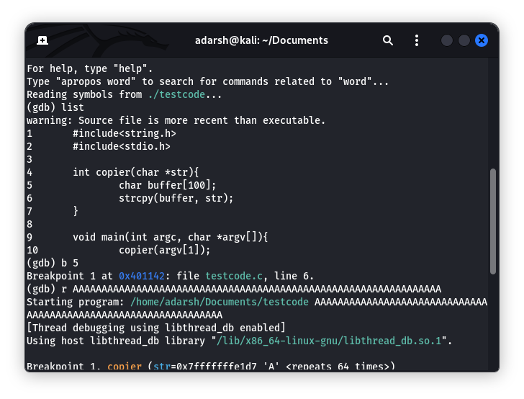
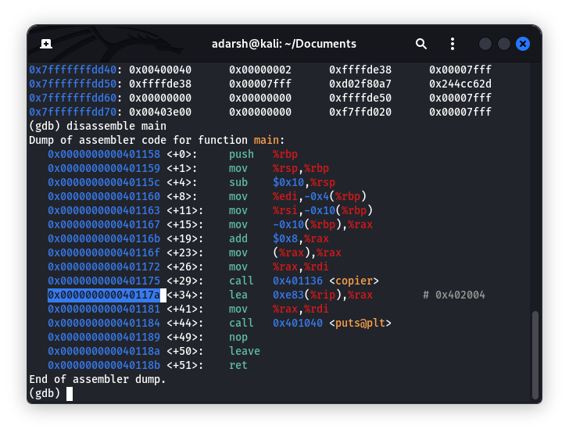
Fig 1: Input exceeding the buffer size Fig2: Stack memory shown in gdb debugger
However, it is crucial to approach this topic responsibly and avoid any illegal or unethical practices. Engaging in unauthorized shellcode injection or any form of hacking is against the law and can have severe consequences. Ethical use of these techniques for research purposes or as part of a cybersecurity assessment is essential to maintain a safe and secure digital environment.
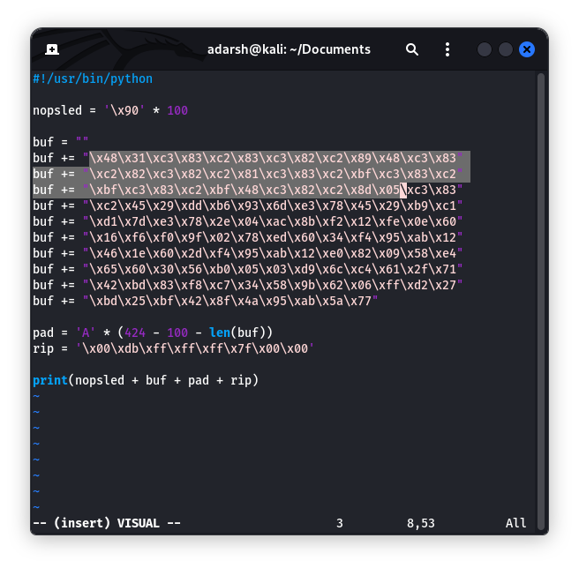
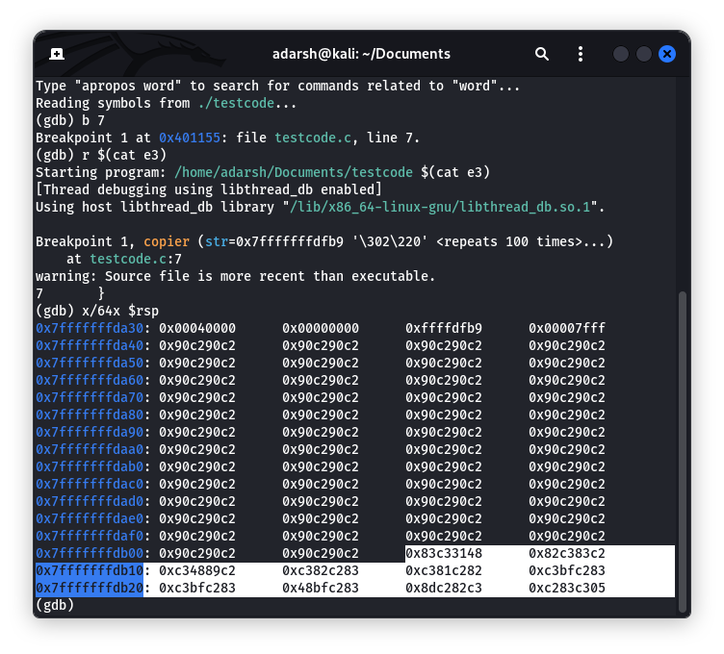
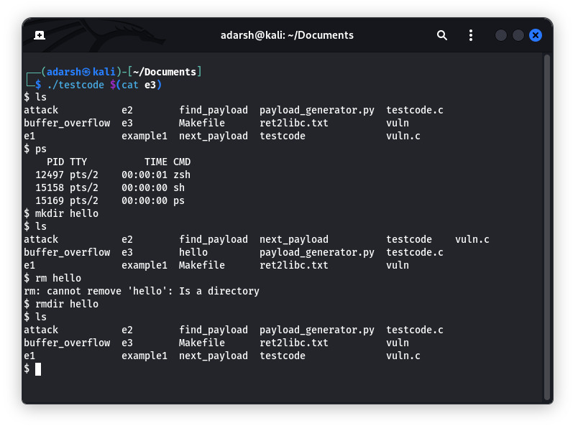

2. Heap-Based buffer overflow
A heap-based buffer overflow is a type of software vulnerability that occurs when a program writes more data than can be accommodated in a dynamically allocated buffer in the heap. The heap is a region of memory used for dynamic memory allocation during a program's execution. When a program dynamically allocates memory on the heap without proper bounds checking, it can lead to buffer overflows.
In a heap-based overflow, an attacker typically exploits incorrect memory management in a program to overwrite adjacent heap memory or critical data structures, potentially altering the program's behavior. The consequences of a heap-based buffer overflow can be severe, including crashes, unauthorized access to sensitive information, or even remote code execution. Exploiting such vulnerabilities requires a good understanding of memory layout and the ability to carefully craft input to trigger the overflow.
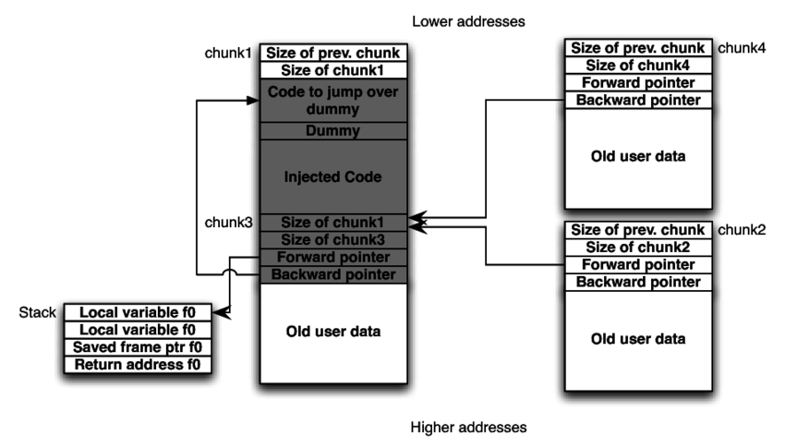

Some Common Mistakes
- The word “data” is plural, not singular.
- The subscript for the permeability of vacuum μ₀, and other common scientific constants, is zero with subscript formatting, not a lowercase letter “o”.
- In American English, commas, semicolons, periods, question and exclamation marks are located within quotation marks only when a complete thought or name is cited, such as a title or full quotation. When quotation marks are used, instead of a bold or italic typeface, to highlight a word or phrase, punctuation should appear outside of the quotation marks. A parenthetical phrase or statement at the end of a sentence is punctuated outside of the closing parenthesis (like this). (A parenthetical sentence is punctuated within the parentheses.)
- A graph within a graph is an “inset”, not an “insert”. The word alternatively is preferred to the word “alternately” (unless you really mean something that alternates).
- Do not use the word “essentially” to mean “approximately” or “effectively”.
- In your paper title, if the words “that uses” can accurately replace the word “using”, capitalize the “u”; if not, keep using lower-cased.
- Be aware of the different meanings of the homophones “affect” and “effect”, “complement” and “compliment”, “discreet” and “discrete”, “principal” and “principle”.
- Do not confuse “imply” and “infer”.
- The prefix “non” is not a word; it should be joined to the word it modifies, usually without a hyphen.
- There is no period after the “et” in the Latin abbreviation “et al.”.
- The abbreviation “i.e.” means “that is”, and the abbreviation “e.g.” means “for example”.
An excellent style manual for science writers is [7].

Using the Template
After the text edit has been completed, the paper is ready for the template. Duplicate the template file by using the Save As command, and use the naming convention prescribed by your conference for the name of your paper. In this newly created file, highlight all of the contents and import your prepared text file. You are now ready to style your paper; use the scroll down window on the left of the MS Word Formatting toolbar.

Authors and Affiliations
The template is designed for, but not limited to, six authors. A minimum of one author is required for all conference articles. Author names should be listed starting from left to right and then moving down to the next line. This is the author sequence that will be used in future citations and by indexing services. Names should not be listed in columns nor group by affiliation. Please keep your affiliations as succinct as possible (for example, do not differentiate among departments of the same organization).

For papers with more than six authors: Add author names horizontally, moving to a third row if needed for more than 8 authors.

For papers with less than six authors: To change the default, adjust the template as follows.

Selection: Highlight all author and affiliation lines.

Change number of columns: Select the Columns icon from the MS Word Standard toolbar and then select the correct number of columns from the selection palette.

Deletion: Delete the author and affiliation lines for the extra authors.

Identify the Headings
Headings, or heads, are organizational devices that guide the reader through your paper. There are two types: component heads and text heads.
Component heads identify the different components of your paper and are not topically subordinate to each other. Examples include Acknowledgments and References and, for these, the correct style to use is “Heading 5”. Use “figure caption” for your Figure captions, and “table head” for your table title. Run-in heads, such as “Abstract”, will require you to apply a style (in this case, italic) in addition to the style provided by the drop down menu to differentiate the head from the text.
Text heads organize the topics on a relational, hierarchical basis. For example, the paper title is the primary text head because all subsequent material relates and elaborates on this one topic. If there are two or more sub-topics, the next level head (uppercase Roman numerals) should be used and, conversely, if there are not at least two sub-topics, then no subheads should be introduced. Styles named “Heading 1”, “Heading 2”, “Heading 3”, and “Heading 4” are prescribed.

Figures and Tables

Positioning Figures and Tables: Place figures and tables at the top and bottom of columns. Avoid placing them in the middle of columns. Large figures and tables may span across both columns. Figure captions should be below the figures; table heads should appear above the tables. Insert figures and tables after they are cited in the text. Use the abbreviation “Fig. 1”, even at the beginning of a sentence.
- Table Type Styles
Table Head | Table Column Head
Table Head | Table column subhead | Subhead | Subhead
copy | More table copyª
- Sample of a Table footnote. (Table footnote)
- Example of a figure caption. (figure caption)
Figure Labels: Use 8 point Times New Roman for Figure labels. Use words rather than symbols or abbreviations when writing Figure axis labels to avoid confusing the reader. As an example, write the quantity “Magnetization”, or “Magnetization, M”, not just “M”. If including units in the label, present them within parentheses. Do not label axes only with units. In the example, write “Magnetization (A/m)” or “Magnetization {A[m(1)]}”, not just “A/m”. Do not label axes with a ratio of quantities and units. For example, write “Temperature (K)”, not “Temperature/K”.

Acknowledgment (Heading 5)
The preferred spelling of the word “acknowledgment” in America is without an “e” after the “g”. Avoid the stilted expression “one of us (R. B. G.) thanks ...”. Instead, try “R. B. G. thanks...”. Put sponsor acknowledgments in the unnumbered footnote on the first page.

References
The template will number citations consecutively within brackets [1]. The sentence punctuation follows the bracket [2]. Refer simply to the reference number, as in [3]—do not use “Ref. [3]” or “reference [3]” except at the beginning of a sentence: “Reference [3] was the first ...”
Number footnotes separately in superscripts. Place the actual footnote at the bottom of the column in which it was cited. Do not put footnotes in the abstract or reference list. Use letters for table footnotes.
Unless there are six authors or more give all authors’ names; do not use “et al.”. Papers that have not been published, even if they have been submitted for publication, should be cited as “unpublished” [4]. Papers that have been accepted for publication should be cited as “in press” [5]. Capitalize only the first word in a paper title, except for proper nouns and element symbols.
For papers published in translation journals, please give the English citation first, followed by the original foreign-language citation [6].

- G. Eason, B. Noble, and I. N. Sneddon, “On certain integrals of Lipschitz-Hankel type involving products of Bessel functions,” Phil. Trans. Roy. Soc. London, vol. A247, pp. 529–551, April 1955. (references)
- J. Clerk Maxwell, A Treatise on Electricity and Magnetism, 3rd ed., vol. 2. Oxford: Clarendon, 1892, pp.68–73.
- I. S. Jacobs and C. P. Bean, “Fine particles, thin films and exchange anisotropy,” in Magnetism, vol. III, G. T. Rado and H. Suhl, Eds. New York: Academic, 1963, pp. 271–350.
- K. Elissa, “Title of paper if known,” unpublished.
- R. Nicole, “Title of paper with only first word capitalized,” J. Name Stand. Abbrev., in press.
- Y. Yorozu, M. Hirano, K. Oka, and Y. Tagawa, “Electron spectroscopy studies on magneto-optical media and plastic substrate interface,” IEEE Transl. J. Magn. Japan, vol. 2, pp. 740–741, August 1987 [Digests 9th Annual Conf. Magnetics Japan, p. 301, 1982].
- M. Young, The Technical Writer’s Handbook. Mill Valley, CA: University Science, 1989.

IEEE conference templates contain guidance text for composing and formatting conference papers. Please ensure that all template text is removed from your conference paper prior to submission to the conference. Failure to remove template text from your paper may result in your paper not being published.
We suggest that you use a text box to insert a graphic (which is ideally a 300 dpi TIFF or EPS file, with all fonts embedded) because, in an MSW document, this method is somewhat more stable than directly inserting a picture.
To have non-visible rules on your frame, use the MSWord “Format” pull-down menu, select Text Box > Colors and Lines to choose No Fill and No Line.

