1. Mean vs Median:

\*The mean (average) of a data set is found by adding all numbers in the data set and then dividing by the number of values in the set.

\* The median is the middle value when a data set is ordered from least to greatest.

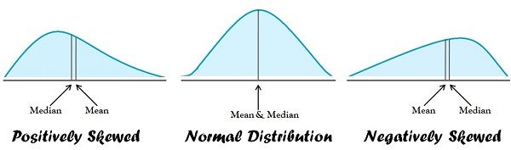

1. Mode analysis in distribution:

\*In statistics, the mode is the value that is repeatedly occurring in a given set. We can also say that the value or number in a data set, which has a high frequency or appears more frequently, is called mode or modal value. It is one of the three measures of central tendency, apart from mean and median. For example, the mode of the set {3, 7, 8, 8, 9}, is 8. Therefore, for a finite number of observations, we can easily find the mode. A set of values may have one mode or more than one mode or no mode at all.

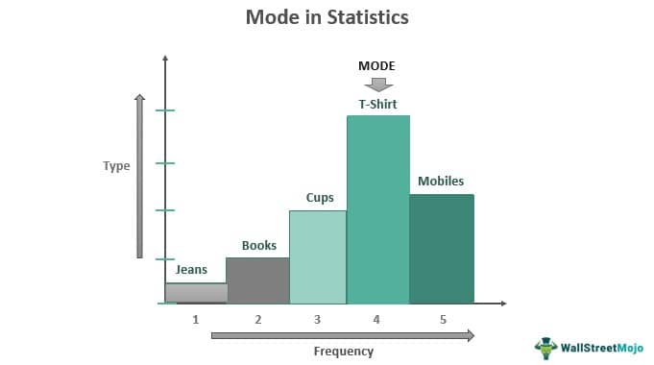

3. Types of distributions:

