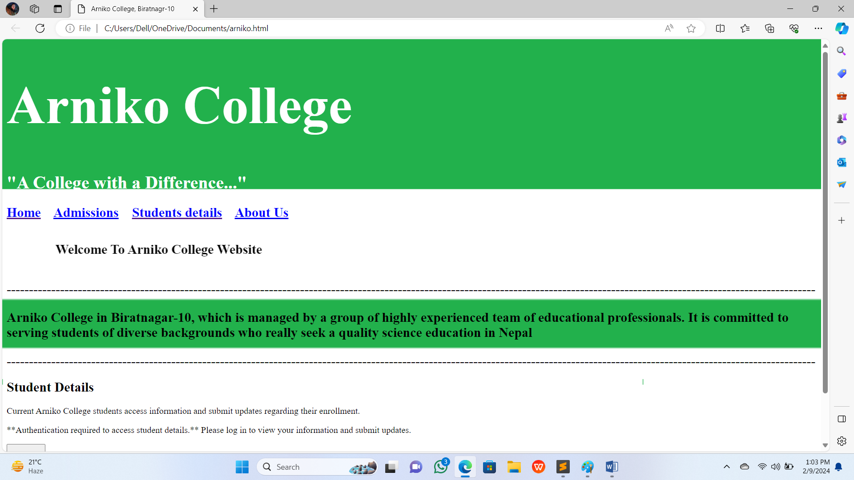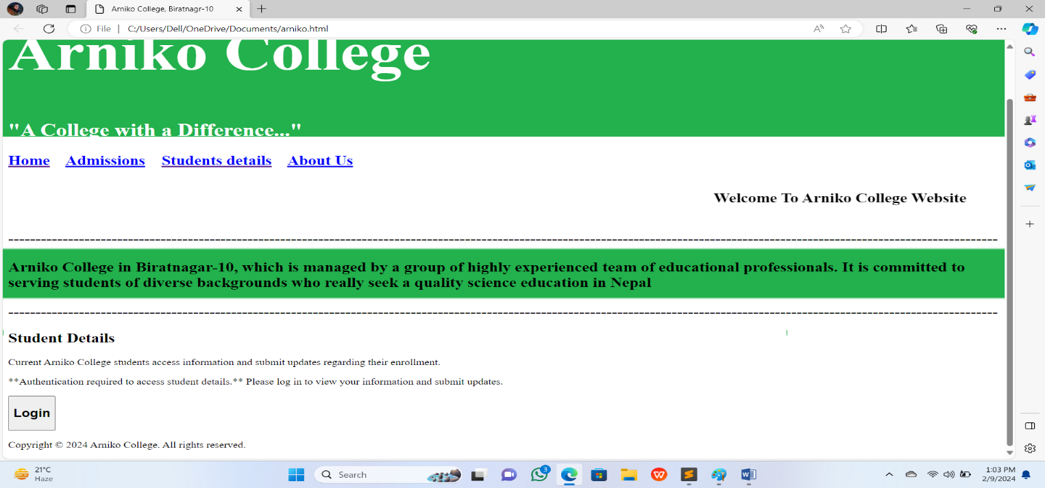

**When you will click “Home” button it will reload the page**

**When you will click “Admission” button**

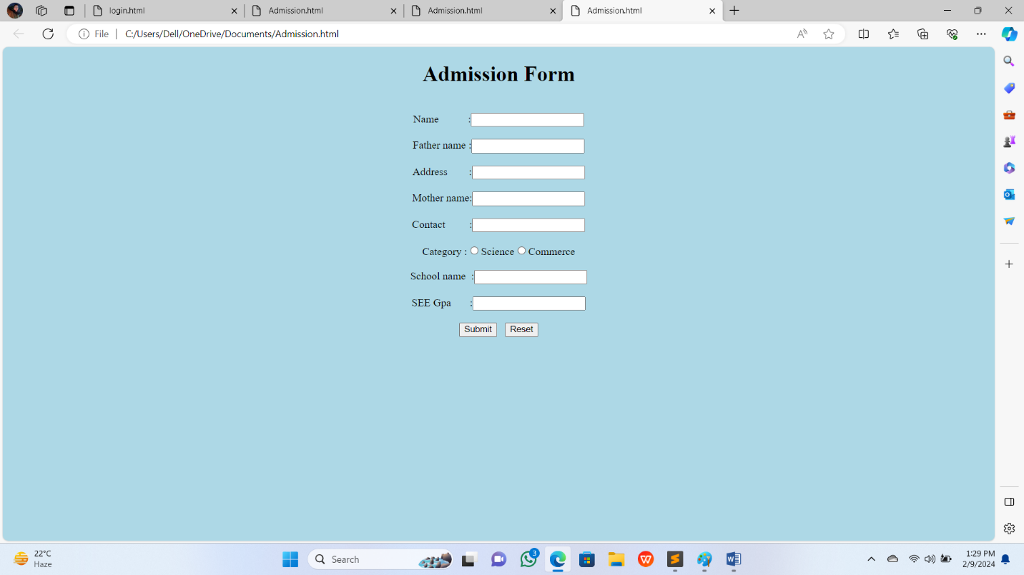

**When you will “Submit” button it will submit the form and “reset” button will reset the form**

When you will click “Student details” button then

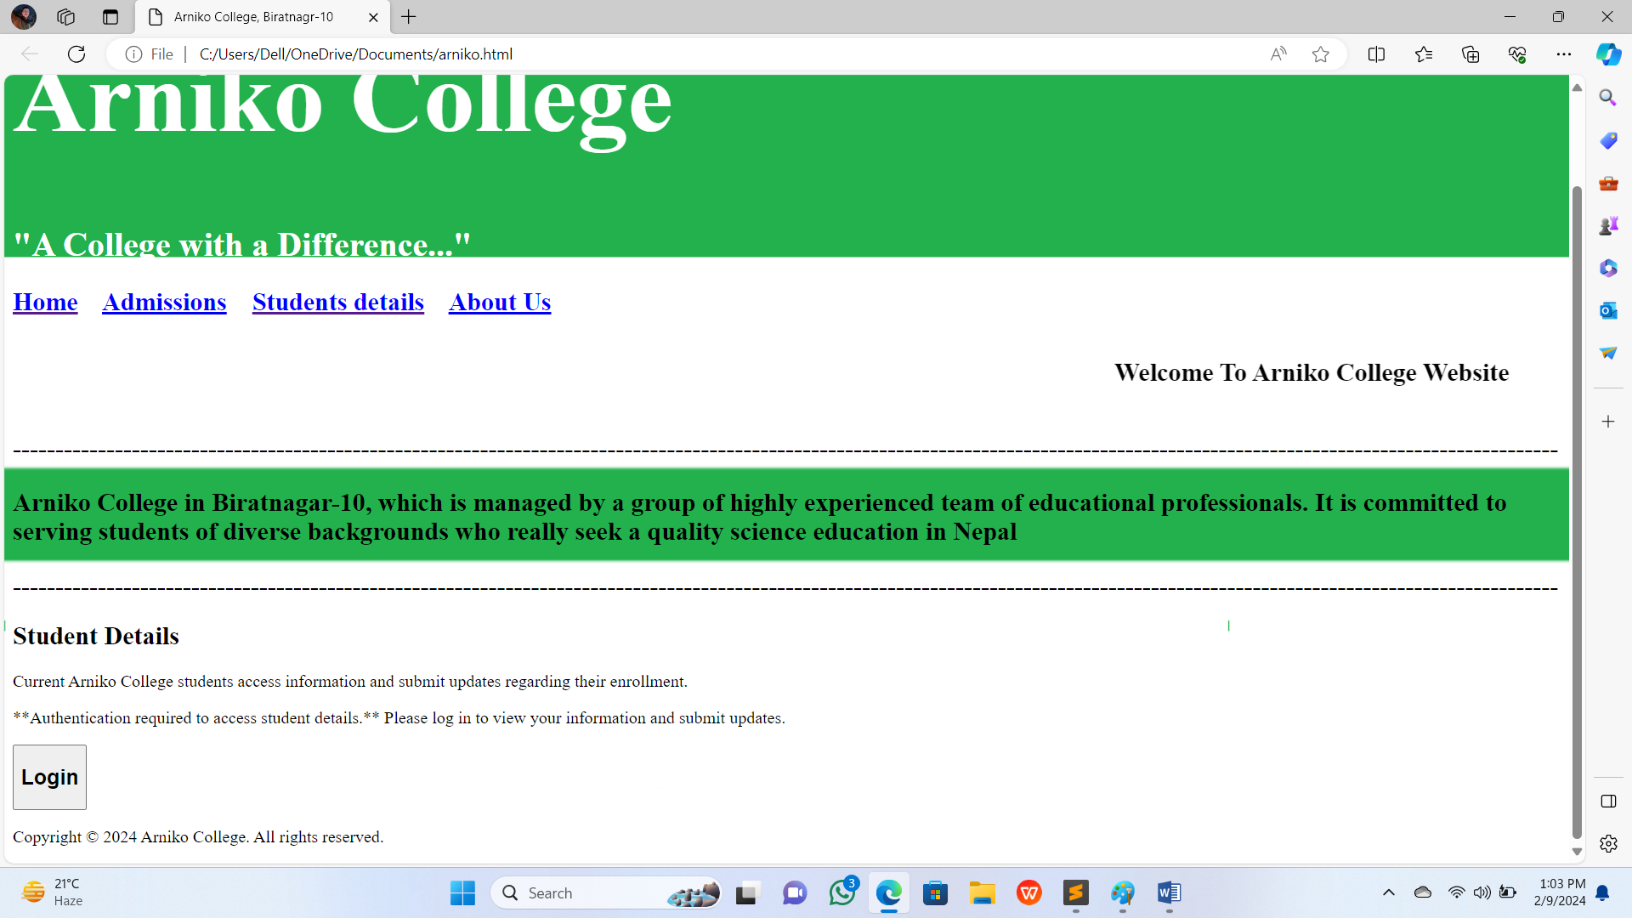

**When you will click “Login” button then**

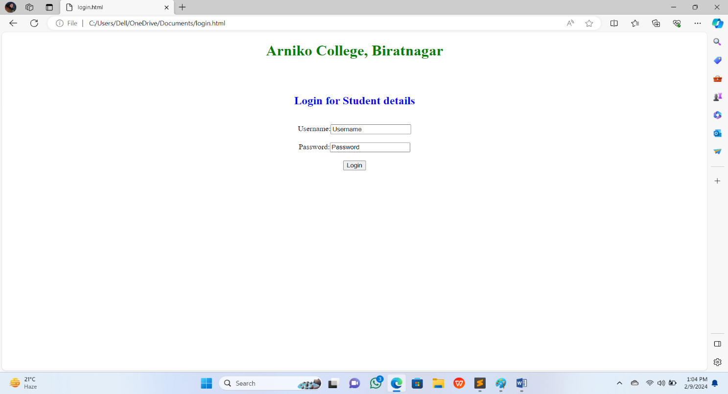

When you will click “About us” button then

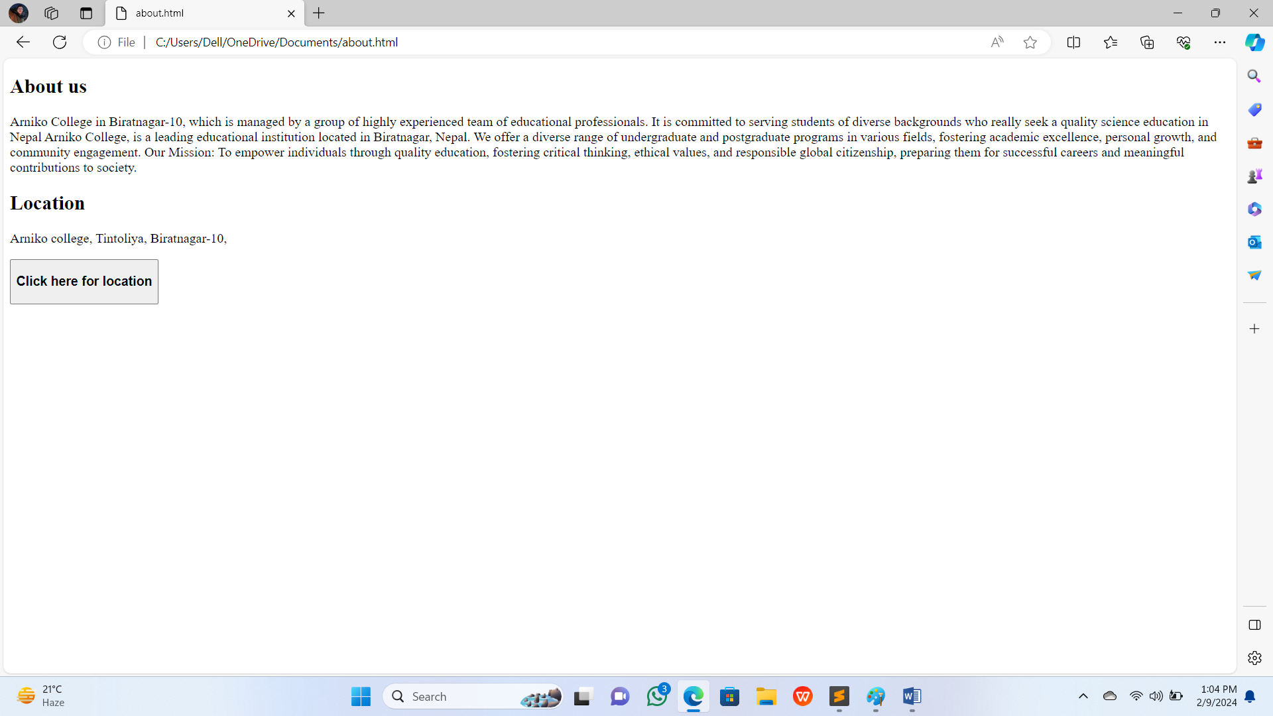

**When you will click “Click here for location” button then**

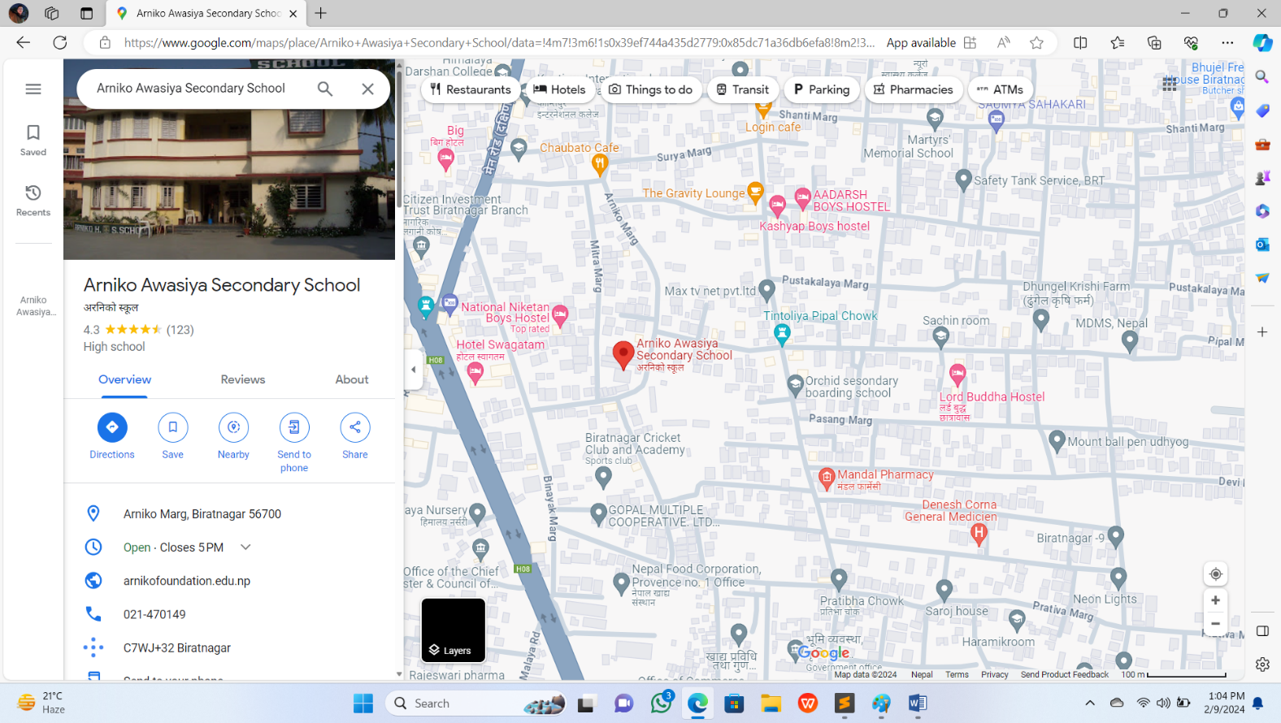

**\*\*\*\*\*Thank you\*\*\*\***