**#Retrieve the list of all blog**

URL: [http://localhost:8000/get-blogs/](http://localhost:8000/blogs/)

Method : GET

Response :

{

“type”:”success”,

“data”:””,

"message": "Successfully Fetched"

}

Sample Response:

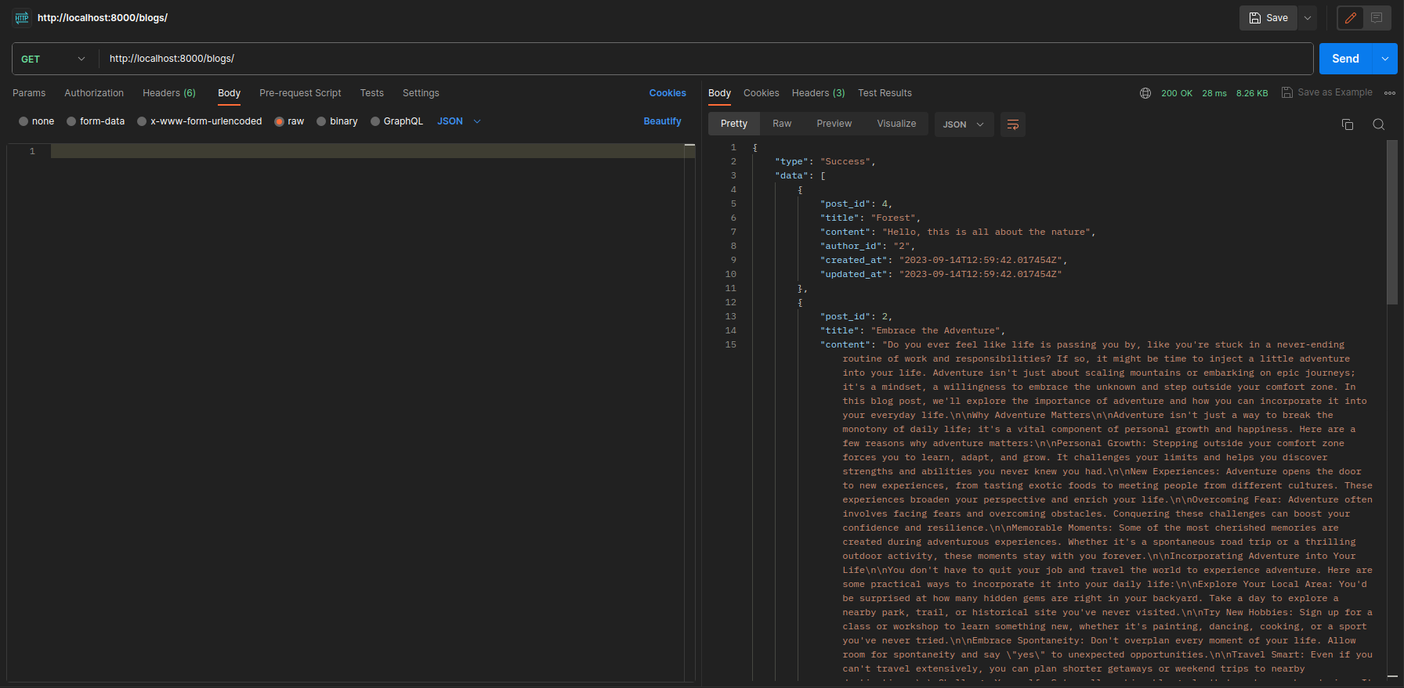

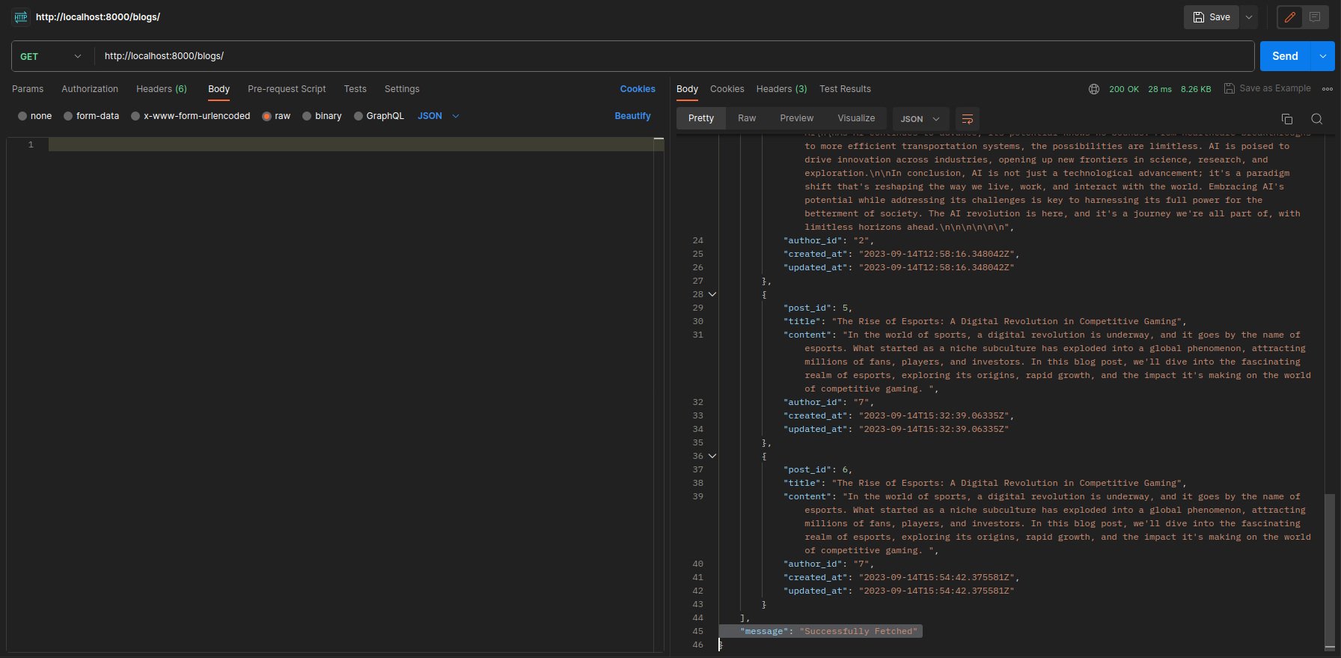

**#Retrieve the blog post by id**

URL: [http://localhost:8000/get-blogsbyid/6](http://localhost:8000/blogsbyid/6)

Method: GET

Response:

{

"type": "Success",

"data": [

{

"post_id": 6,

"title": "The Rise of Esports: A Digital Revolution in Competitive

Gaming",

"content": "In the world of sports, a digital revolution is underway,

and it goes by the name of esports. What started as a niche

subculture has exploded into a global phenomenon, attracting

millions of fans, players, and investors. In this blog post, we'll dive

into the fascinating realm of esports, exploring its origins, rapid

growth, and the impact it's making on the world of competitive

gaming. ",

"author_id": "7",

"created_at": "2023-09-14T15:54:42.375581Z",

"updated_at": "2023-09-14T15:54:42.375581Z"

}

],

"message": "Successfully Fetched"

}

**#Create Blog Post API**

URL: [http://localhost:8000/add-blogs/](http://localhost:8000/blogs/)

Method: POST

Parameter:

{

"title":"The Rise of Esports: A Digital Revolution in Competitive Gaming",

"content":"In the world of sports, a digital revolution is underway, and it

goes by the name of esports. What started as a niche subculture has

exploded into a global phenomenon, attracting millions of fans,players,

and investors. In this blog post, we'll dive into the fascinating realm of

esports, exploring its origins, rapid growth, and the impact it's making on

the world of competitive gaming. ",

"author_id":"7"

}

Response:

{

"type": "success",

"message": "The blog has been inserted successfully!"

}

http://localhost:8000/blogs/{

"title": "The Rise of Esports:

A Digital Revolution in Competitive Gaming",

"content": "In the world of sports, a digital revolution is underway, and it goes by the name of esports. What started as a niche subculture has exploded into a global phenomenon, attracting millions of fans, players, and investors. In this blog post, we'll di

Reve into the fascinating realm of esports, exploring its origins, rapid growth, and the impact it's making on the world of competitive gaming. ",

D"author_id": "7"

}

**#Delete Blog By Id**

URL: <http://localhost:8000/delete-blogsbyid/8>

Method: DELETE

Response

{

"type": "success",

"message": "The Blog has been deleted successfully!"

}

**#Update Blog By Id**

URL: <http://localhost:8000/update-blogsbyid/6>

Metod: POST

Payload:

{

"title": "The Rise of Esports",

"content": "updated okkk ",

"author_id": "7"

}

Response:

{

"type": "success",

"message": "The blog has been updated successfully!"

}