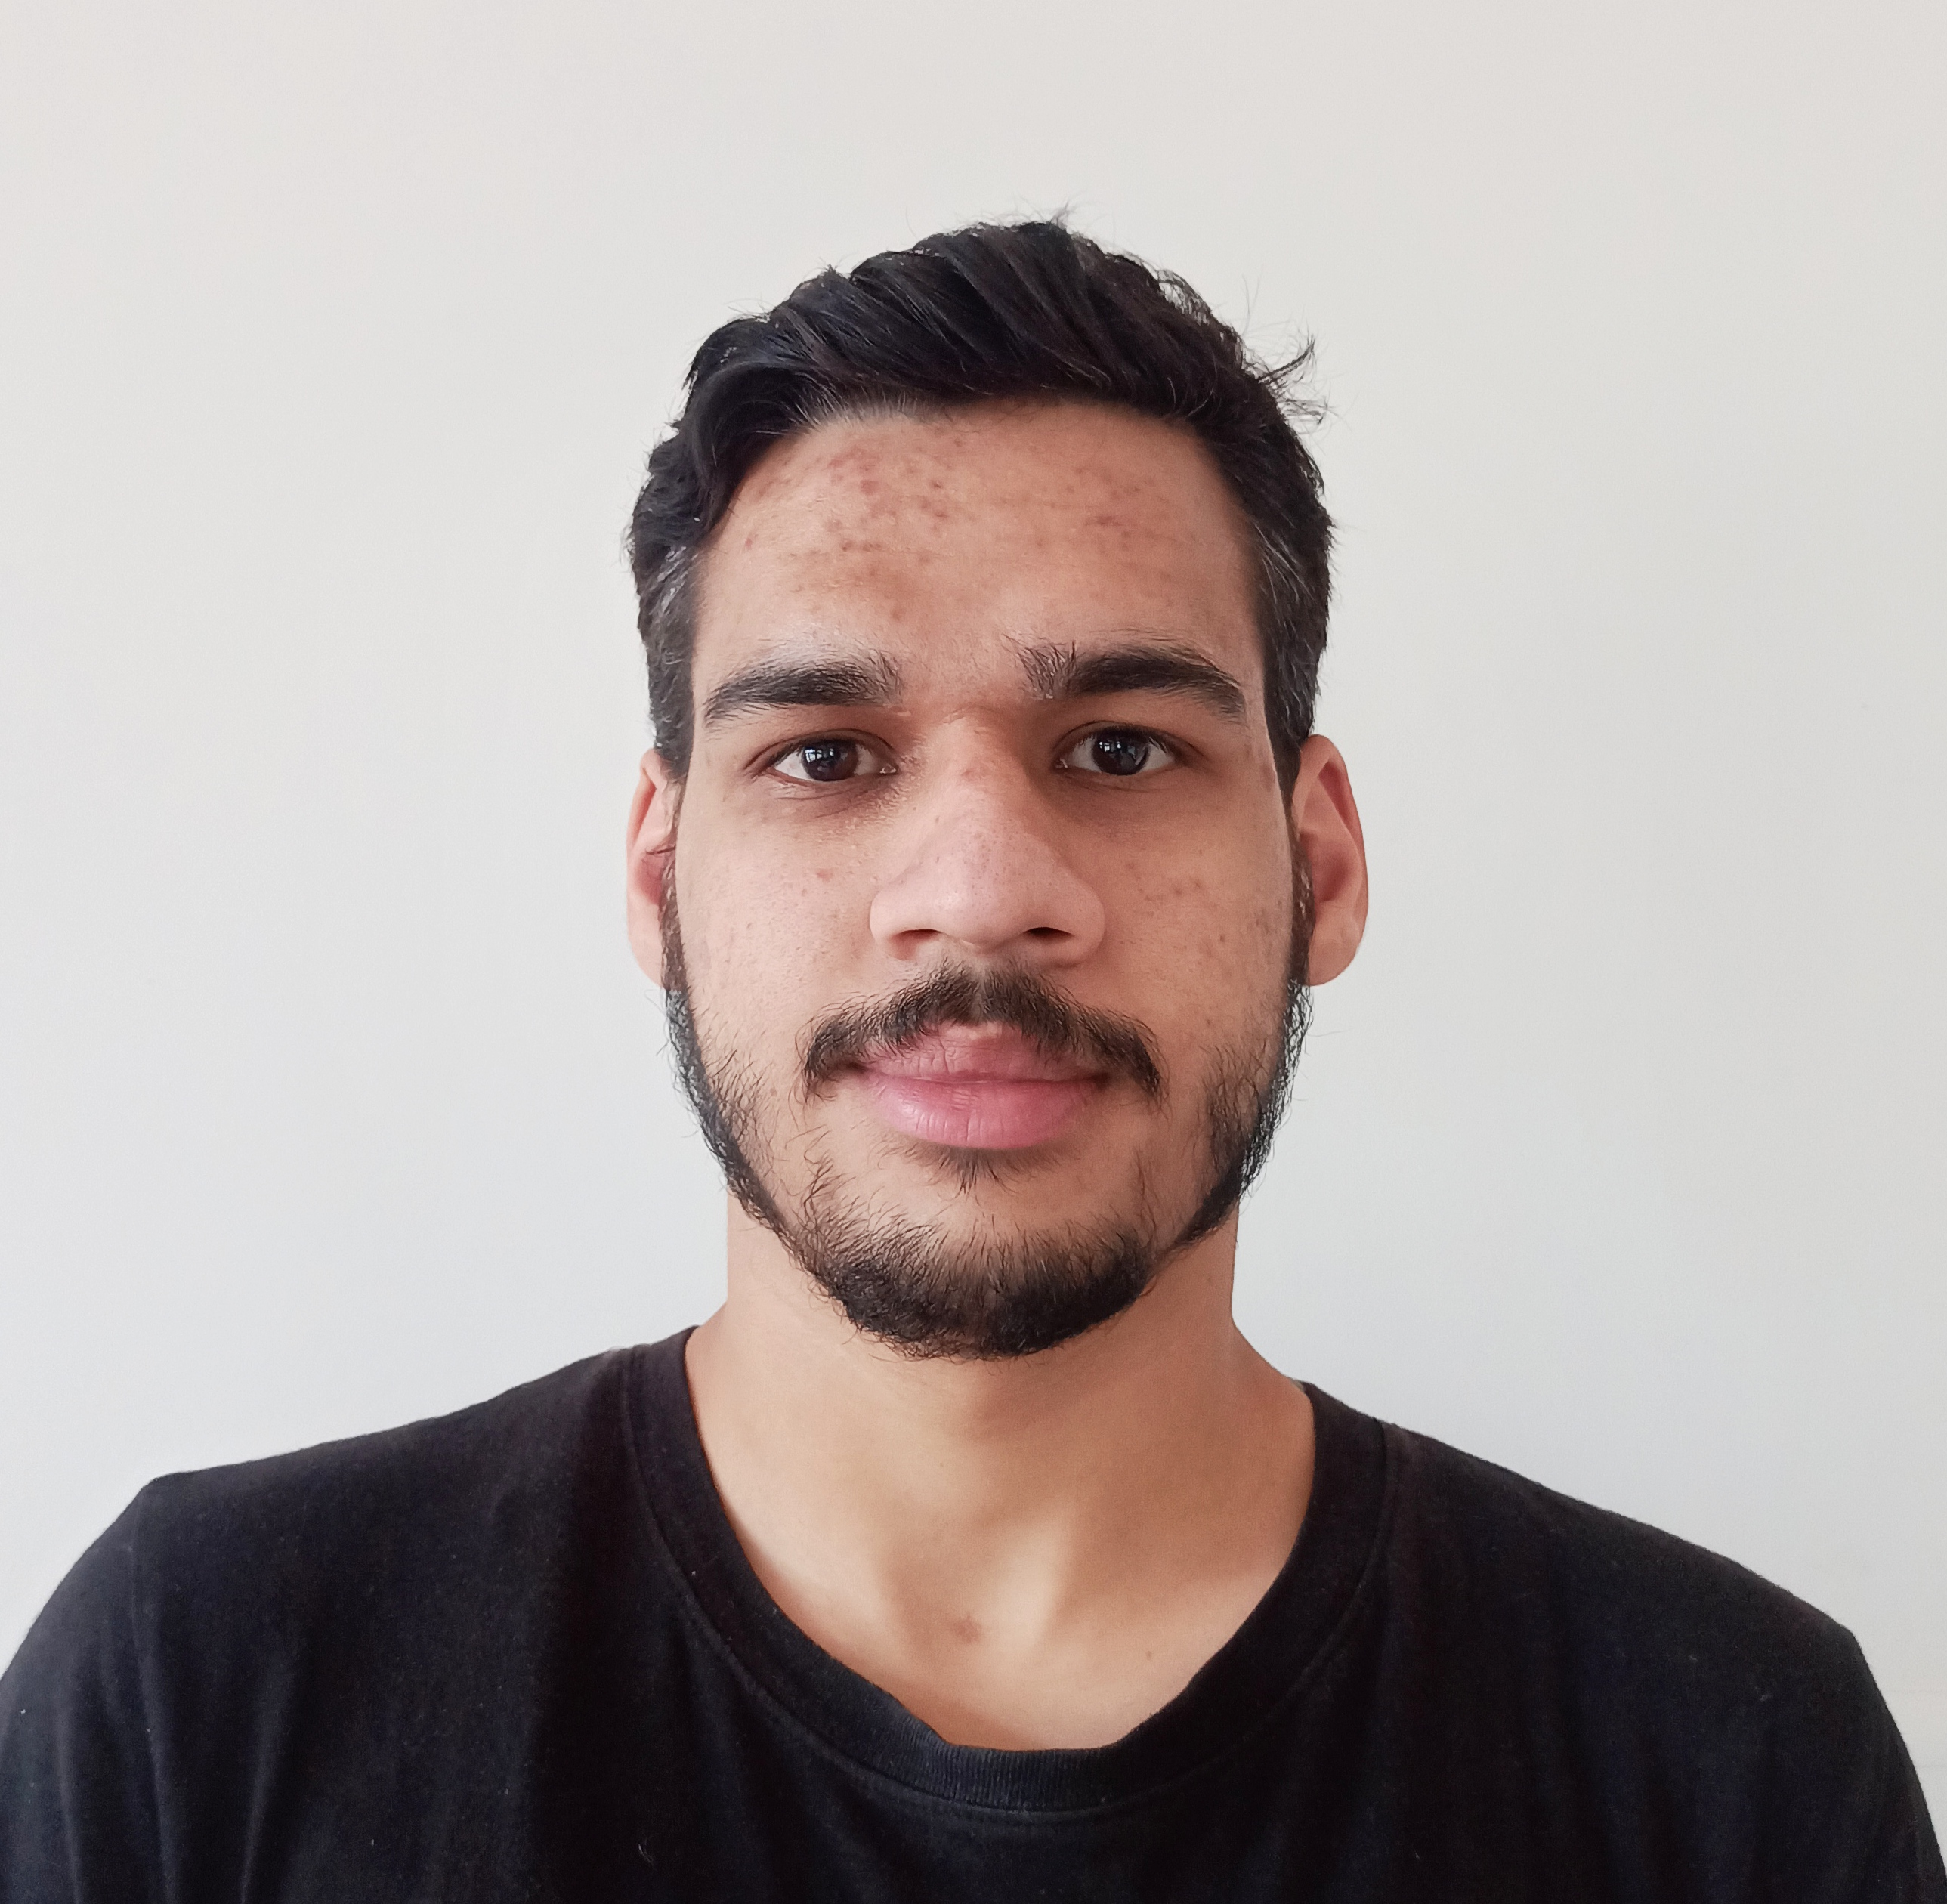

Contact

**Address:**

V.P.O Kanaid teh Sundernagar Distt Mandi Himachal Pradesh (175019)

**Phone:**

+91 7018307964

**Email:**

[adarshmahajan263@gmail.com](mailto:adarshmahajan263@gmail.com)

**LinkedIn:**

<https://www.linkedin.com/in/adarsh-mahajan-9b9885192/>

**Website:**

[adarshmahajan.gq](http://adarshmahajan.gq/?i=1)

Languages

English

Hindi

Hobbies

* Writing
* Sketching
* Photography
* Design

Summary

Hello! I am a professional web designer from Himachal Pradesh.  
I have ample amount of knowledge in Html, CSS for the designing purpose & PHP for the development purpose. Well-versed in numerous programming languages including HTML5, PHP OOP, JavaScript, CSS, MySQL. Strong background in project management and customer relations.

Skill Highlights

|  |  |
| --- | --- |
| * Project management * Strong decision maker * Complex problem solver | * Creative design * Innovative * Service-focused |

E-COMMERCE WEBSITE

[restaurantreservation.gq](https://restaurantreservation.gq/)

We create a E-commerce website. For fontend we use HTML5 and CSS3 and for backend we can use PHP and MySQL. There was 4 member in the project. I worked on frontend as well as backend.

Education

CRAFTS INSTRUCTOR TRAINING SCEME

Computer Software Application (2018-2019)

**Industrial Training Institute**

Computer Operator & Programming Assistant(2016-2017)

**Class 12th**

12th from HP BOARD DHARMSHALA , HP(2015-2016)

ACHIEVEMENTS

SKILL BUILD COURSE

I have completed many skill build course. I have learned many new skills through this course like Data Analysis , Data Visualization with Python and so many skills.

Adarsh Mahajan