SpaceJourneys

Software Requirements Specification

20th April, 2024

Adarsh Karn
12211818

Prepared for
Continuous Assessment 3
Spring 2024

Revision History

Date | Description | Author | Comments
21-03-2024 | Index.html | Adarsh Karn | Created the home Interface for website
30-03-2024 | Basic.js | Adarsh Karn | Created the ContactUs and Feedback form
12-04-2024 | Script.js | Adarsh Karn | Used JSON and Bootstrap
19-04-2024 | Package.json | Adarsh Karn | I fetched the API from the NASA website for the Astronomy Picture of the Day, Red Planet, Space Library.

Acknowledgement

We would like to express our sincere gratitude to the following individuals and organizations whose contributions have been invaluable in the development of this software requirements specification (SRS) documentation:
- NASA (National Aeronautics and Space Administration):For their pioneering work in space exploration, research, and technology. Their commitment to advancing our understanding of the cosmos has inspired our project.
- Astronomy Picture of the Day (APOD): A daily resource that shares captivating images and information about the universe. Their dedication to showcasing the beauty and wonder of space has enriched our research.
- The Red Planet: The Red Wonder Mars, with its rusty-red appearance, has captivated astronomers and dreamers for centuries. Its reddish hue arises from iron oxide (rust) covering its surface, creating a striking contrast against the dark void of space.
- Educational Institutions and Research Centers: For fostering an environment of learning, curiosity, and innovation. Their research findings and educational resources have informed our SRS.

We appreciate their commitment to excellence and shared vision. Thank you to everyone who has contributed to this project. Your impact extends beyond these pages, and we are grateful for your influence on our journey. 🌌🚀
Table of Contents

Revision History ii
CLIENT Approval ii
1. Introduction 1
1.1 Purpose 1
1.2 Scope 1
1.3 Definitions, Acronyms, and Abbreviations 1
1.4 References 1
1.5 Overview 1
2. General Description 2
2.1 Product Perspective 2
2.2 Product Functions 2
2.3 User Characteristics 2
2.4 General Constraints 2
2.5 Assumptions and Dependencies 2
3. Specific Requirements 2
3.1 External Interface Requirements 3
3.1.1 User Interfaces 3
3.1.2 Hardware Interfaces 3
3.1.3 Software Interfaces 3
3.1.4 Communications Interfaces 3
3.2 Functional Requirements 3
3.2.1 <Functional Requirement or Feature #1> 3
3.2.2 <Functional Requirement or Feature #2> 3
3.5 Non-Functional Requirements 4
3.5.1 Performance 4
3.5.2 Reliability 4
3.5.3 Availability 4
3.5.4 Security 4
3.5.5 Maintainability 4
3.5.6 Portability 4
3.7 Design Constraints 4
3.9 Other Requirements 4
4. Analysis Models 4
4.1 Data Flow Diagrams (DFD) 5
5. Github link…………………………………………………………………………………………………….5
5. CLIENT APPROVAL PROOF……………..…………………………………………………………………….5
A. Appendices 5
A.1 Appenidix 1 5
A.2 Appendix 2 5

1. Introduction

Welcome to the Software Requirement Specification (SRS) document -- a comprehensive guide that outlines the essential details for designing and implementing our software product. As software engineers, we rely on this document to navigate the development process effectively. Here’s what you’ll find within these pages:

Purpose and Scope: We define the purpose of our software, its intended audience, and the scope of functionalities it will encompass. This SRS serves as a roadmap for our development journey. System

Overview: We provide a high-level view of the software system, including its components, interactions, and interfaces. Understanding the system context is crucial for successful implementation.

Functional Requirements: Detailed descriptions of what the software must do. These requirements guide our design and coding efforts.

Non-Functional Requirements: Beyond functionality, we address performance, security, usability, and other quality attributes. These aspects ensure a robust and user-friendly system. Constraints and

Assumptions: We acknowledge any limitations, constraints, or assumptions that impact our development process. Transparency is key.

References and Definitions: We cite relevant sources and clarify terminology used throughout the document. Clarity and consistency are paramount. Our commitment to excellence begins here.

Let’s embark on this software journey together! 🚀📝

1.1 Purpose
The purpose of this Software Requirement Specification (SRS) document is to provide a comprehensive overview of the software project. It serves as a detailed guide for software engineers, designers, and developers involved in designing and implementing the specified software product. The SRS outlines the functional and non-functional requirements, constraints, and assumptions necessary for successful development. Intended Audience The primary audience for this SRS includes: Software Engineers: To understand the system requirements and design the software accordingly. Developers: To implement the features and functionalities based on the specified requirements. Project Managers: To track progress and ensure alignment with project goals. Stakeholders: To gain insight into the project scope and deliverables. This document ensures clear communication and alignment among all stakeholders throughout the software development lifecycle. 📝🌟

1.2 Scope
The scope of this software product encompasses several key aspects:
- Software Product Identification: Our software product, named SpaceJourneys, aims to provide an immersive experience for space enthusiasts and learners. It serves as a gateway to explore the cosmos, learn about celestial bodies, and access multimedia resources.
- Functionality: SpaceJourneys will: Provide daily astronomy images through NASA’s Astronomy Picture of the Day (APOD) API. Offer captivating Mars rover photos via NASA’s Mars Rover Photo API. Grant access to NASA’s Image and Video Library for educational purposes. SpaceJourneys will not: Perform financial transactions or personal data collection.
- Application: SpaceJourneys caters to: Space enthusiasts seeking awe-inspiring visuals and educational content. Educators and students interested in astronomy and planetary exploration. Anyone curious about the wonders of the universe.
- Goals and Objectives: Provide parameter-driven, user-definable reports with a 2-hour turnaround. Enable on-line entry of user parameters for customized experiences. Foster a sense of wonder and curiosity about space exploration.
- Consistency with Higher-Level Specifications: Our scope aligns with the broader goals outlined in the System Requirement Specification (SRS).
SpaceJourneys invites users to embark on cosmic adventures, learn, and marvel at the mysteries beyond our planet. 🌌🚀

1.3 Definitions, Acronyms, and Abbreviations
The NASA API-based astronomy app aims to provide users with a highly intelligent and adaptable experience by fetching data from NASA's Astronomy Picture of the Day, Red Planet, and Space to Universe APIs. The app will prioritize personalization and user-friendliness to set itself apart in the space exploration and astronomy domain. To ensure clarity and precise interpretation of this Software Requirement Specification (SRS), we provide the following definitions, acronyms, and abbreviations:
- API: Application Programming Interface A set of rules and protocols that allows different software applications to communicate with each other.
- APOD: Astronomy Picture of the Day A daily resource by NASA that features captivating images or photographs of our universe, accompanied by explanations from professional astronomers.
- SRS: Software Requirement Specification This document itself, which outlines the requirements for our software product.
- NASA: National Aeronautics and Space Administration The United States government agency responsible for space exploration, scientific research, and aeronautics.
- GUI: Graphical User Interface The visual interface that allows users to interact with software using icons, buttons, and menus.
- API: Application Programming Interface A set of rules and protocols that allows different software applications to communicate with each other.
These definitions will aid in understanding the terminology used throughout this SRS. 🌟📚

1.4 References
The following references provide essential context and information for this Software Requirement Specification (SRS):
- NASA’s Astronomy Picture of the Day (APOD) API Documentation Published by: NASA Accessible at: APOD API Documentation
- NASA’s Mars Rover Photo API Documentation Published by: NASA Accessible at: Mars Rover Photo API Documentation
- NASA’s Image and Video Library Published by: NASA Accessible at: NASA Image and Video Library
These references serve as valuable resources for understanding the celestial content and multimedia resources integrated into our software product, SpaceJourneys. 🌠📚

1.5 Overview
Overview section in the Software Requirements Specification (SRS) serves as a crucial guide for readers, providing insights into the document’s structure and content. Here are the key takeaways:
- Purpose: The Overview succinctly outlines the SRS’s purpose and scope.
- Content Summary: It briefly describes the subsequent sections, highlighting their focus and relevance.
- Organization: The Overview acts as a roadmap, helping readers navigate through requirements, use cases, system architecture, and other critical aspects. Remember, this section sets the stage for a comprehensive understanding of the entire SRS. 🚀

2. General Description
This section of the Software Requirements Specification (SRS) serves to describe the overarching factors that influence the product and its requirements. It's essential to note that this section doesn't delineate specific requirements; rather, it aims to make understanding those requirements more accessible.

2.1 Product Perspective
This subsection of the SRS contextualizes the product within the landscape of related products or projects. By placing the product in perspective, stakeholders can better understand its role and significance within the broader context. Reference to the IEEE Guide to SRS offers more detailed insights.

2.2 Product Functions
Within this section of the SRS, a comprehensive summary of the software's intended functions is provided. These functions encapsulate the core operations the software is designed to perform, offering stakeholders a clear overview of its capabilities.

2.3 User Characteristics
The User Characteristics subsection of the SRS outlines the general traits and behaviors of the eventual users of the product. Understanding these characteristics is crucial as they directly impact the specific requirements of the software. For further elaboration, the IEEE Guide to SRS offers more detailed guidance.

2.4 General Constraints
In this subsection of the SRS, a general description of any limiting factors that affect the developer’s design options is provided. These constraints might encompass technological, budgetary, or regulatory limitations, among others. For a partial list of possible general constraints, the IEEE Guide to SRS can be referenced.

2.5 Assumptions and Dependencies
The Assumptions and Dependencies subsection of the SRS enumerates the various factors that influence the requirements stated in the document. Unlike design constraints, these factors represent any changes that could affect the requirements outlined in the SRS. For instance, an assumption could be the availability of a specific operating system on the hardware designated for the software product. Should this operating system not be available, the SRS would need to be revised accordingly.

2.5.1 API Integration

To enrich the software with dynamic content, an Application Programming Interface (API) from NASA's website has been integrated. This API facilitates access to a vast repository of multimedia content related to astronomy, space exploration, and scientific research.

2.5.1.1 Astronomy Picture of the Day (APOD)

One significant feature enabled by the NASA API integration is access to the Astronomy Picture of the Day (APOD). This feature fetches the daily astronomy picture along with its accompanying description, providing users with a captivating glimpse into the cosmos.

2.5.1.2 Red Planet Exploration

Another key aspect of the NASA API integration is the ability to retrieve images and data related to Mars, often referred to as the "Red Planet." Users can explore a plethora of images and information gathered from various Mars missions, including the Curiosity rover and the Mars Reconnaissance Orbiter.

2.5.1.3 Space Image Library

Additionally, the integration of NASA's API grants users access to an extensive Space Image Library. This library contains a wealth of high-quality images capturing celestial objects, planetary landscapes, galaxies, and nebulae, among other astronomical phenomena.

2.5.1.4 Enhancing User Experience

By leveraging the NASA API, the software not only enriches user experience but also provides an educational and awe-inspiring journey through the wonders of the universe. From stunning images of distant galaxies to close-up views of celestial bodies within our solar system, users can embark on a virtual exploration of space without leaving the comfort of their screens.

2.5.1.5 Continual Updates

Furthermore, the integration of the NASA API ensures that the software remains dynamic and up-to-date with the latest discoveries and developments in the field of astronomy and space exploration. With new content regularly added to NASA's database, users can continually explore and learn about the mysteries of the universe.

Specific Requirements
Certainly! Let’s delve into the Specific Requirements section of the Software Requirements Specification (SRS). This section is pivotal, as it outlines the detailed requirements that will guide the software design, implementation, and testing. Here are the key considerations for each requirement:
- Correctness:
  - Each requirement must accurately reflect the desired functionality.
  - Precision is crucial to avoid ambiguity.
- Traceability:
  - Requirements should be linked both forward and backward to related artifacts.
  - This ensures a clear path from customer needs to software implementation.
- Unambiguity:
  - Avoid vague language or multiple interpretations.
  - Clarity is essential for effective communication.
- Verifiability (Testability):
  - Every requirement should be testable.
  - Verification ensures that the software meets specified criteria.
- Prioritization:
  - Assign priorities based on importance and stability.
  - Focus on critical features first.
- Completeness:
  - Cover all necessary aspects.
  - Omissions can lead to gaps in functionality.
- Consistency:
  - Ensure coherence across requirements.
  - Avoid contradictions or conflicting statements.
- Uniqueness:
  - Use a numbering system (e.g., 3.4.5.6) to uniquely identify each requirement.
  - This aids in cross-referencing and organization.
Remember, this section is not the software design document; it provides the foundation for subsequent development. 🚀

3.1 External Interface Requirements
The External Interface Requirements section in the Software Requirements Specification (SRS) focuses on interactions between the software and external entities. Let’s break it down:
- User Interfaces (UI):
  - Describes how users will interact with the software.
  - Includes graphical interfaces, command-line interfaces, or any other means of communication.
  - Think of it as the bridge connecting users to the software.
- Hardware Interfaces:
  - Specifies how the software interacts with hardware components.
  - Examples: sensors, displays, input devices, etc.
  - Ensures seamless communication between software and hardware.
- Software Interfaces:
  - Defines interactions with other software systems or modules.
  - APIs, libraries, databases, and external services fall under this category.
  - Ensures compatibility and data exchange.
- Communications Interfaces:
  - Addresses communication protocols and data exchange mechanisms.
  - Includes network protocols, APIs, and data formats.
  - Ensures smooth communication between distributed components.
Remember, these interfaces are the gateways through which the software interacts with the world beyond its code. 🌐🔌

3.2 Functional Requirements
The Functional Requirements section in the Software Requirements Specification (SRS) dives into specific features of the software project. Let’s explore further:
- Introduction:
  - Each functional requirement begins with an introduction.
  - This sets the context and purpose for the subsequent details.
- Inputs:
  - Describes the data or information required by the software.
  - What does the system need to process or work with?
- Processing:
  - Details the steps or logic the software follows.
  - How does it manipulate inputs to produce desired outputs?
- Outputs:
  - Specifies what the software produces or provides.
  - What results can users expect?
- Error Handling:
  - Addresses how the system deals with unexpected situations.
  - How does it handle errors, exceptions, or invalid inputs?
Remember, these functional requirements form the backbone of your software’s behavior. 🚀

3.5 Non-Functional Requirements
The Non-Functional Requirements section in the Software Requirements Specification (SRS) addresses critical attributes that impact the system as a whole. Let’s explore these measurable requirements:
- Performance:
  - Specify response times, throughput, and resource utilization.
  - Example: “95% of transactions shall be processed in less than a second.”
- Availability:
  - Define system uptime and downtime limits.
  - Example: “System downtime may not exceed 1 minute per day.”
- Reliability:
  - Set expectations for system stability and failure rates.
  - Example: “MTBF (Mean Time Between Failures) value must exceed 30 days.”
- Security:
  - Address access controls, encryption, and data protection.
  - Example: “User authentication must follow industry standards.”
- Usability:
  - Describe user experience, accessibility, and intuitiveness.
  - Example: “The interface shall be intuitive for novice users.”
- Scalability:
  - Specify how the system handles growth or increased load.
  - Example: “The system must scale to accommodate 10,000 concurrent users.”
Remember, these non-functional requirements shape the system’s overall behavior and quality. 📊🔍

3.7 Design Constraints
Design constraints play a crucial role in shaping the software project. These limitations, often imposed by external factors, guide the development process. Here are some examples of design constraints:
- Hardware Limitations:
  - Consider memory, processing power, storage, and network capabilities.
  - Example: “The software must run on devices with a minimum of 2GB RAM.”
- Company Policies:
  - Adhere to organizational guidelines, security protocols, and best practices.
  - Example: “The software must comply with data privacy regulations.”
- Industry Standards:
  - Follow established norms and conventions.
  - Example: “The user interface must adhere to WCAG accessibility guidelines.”
- Legal Requirements:
  - Comply with copyright, licensing, and intellectual property laws.
  - Example: “The software must not infringe on third-party patents.”
- Environmental Constraints:
  - Account for factors like temperature, humidity, and physical conditions.
  - Example: “The software must operate in temperatures between 0°C and 40°C.”
Remember, these constraints shape the software’s boundaries and influence its design decisions. 🛠️🔍

Analysis Models
Certainly! In the context of software development, analysis models play a crucial role in understanding, designing, and validating system requirements. Let’s explore some common analysis models:
- Use Case Diagrams:
  - Introduction: Use case diagrams depict interactions between actors (users or external systems) and the system.
  - Narrative Description: These diagrams illustrate the system’s functionality from a user’s perspective. They show how different actors interact with the system through specific use cases (scenarios).
  - Traceability: Each use case corresponds to specific functional requirements in the SRS.
- Activity Diagrams:
  - Introduction: Activity diagrams represent the flow of activities or processes within the system.
  - Narrative Description: These diagrams show the sequence of actions, decisions, and parallel processes. They help visualize the dynamic behavior of the system.
  - Traceability: Activities in the diagram align with specific functional requirements or processes.
- Sequence Diagrams:
  - Introduction: Sequence diagrams capture interactions between objects or components over time.
  - Narrative Description: These diagrams illustrate the order of messages exchanged between objects during a specific use case. They highlight collaboration and communication patterns.
  - Traceability: Each sequence corresponds to specific interactions described in the SRS.
- State Machine Diagrams:
  - Introduction: State machine diagrams model the behavior of an object or system in response to events.
  - Narrative Description: These diagrams represent the transitions between different states of an object. They help analyze system behavior and state changes.
  - Traceability: States and transitions align with specific requirements or system behavior.
- Entity-Relationship Diagrams (ERDs):
  - Introduction: ERDs depict the relationships between entities (tables) in a database.
  - Narrative Description: These diagrams show how data is organized, connected, and stored. They help define the data model.
  - Traceability: Entities and relationships map to data-related requirements.
Remember, these analysis models serve as powerful tools for understanding and communicating system requirements. 📊🔍

Data Flow Diagrams (DFD)
- @startuml
- title Website Data Flow Diagram

- entity "User" as User
- entity "NASA API" as API
- entity "Astronomy Picture of the Day" as APOD
- entity "Red Planet Data" as RedPlanet
- entity "Space to Universe Data" as SpaceUniverse

- User --> API : Request data
- API --> APOD : Fetch APOD data
- API --> RedPlanet : Fetch Red Planet data
- API --> SpaceUniverse : Fetch Space to Universe data

- @enduml
- The data flow diagram illustrates the flow of data in a website using the NASA API to fetch data from Astronomy Picture of the Day, Red Planet, and Space to Universe.
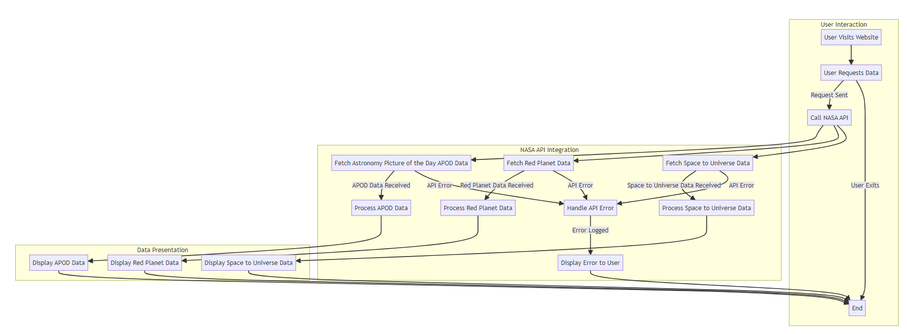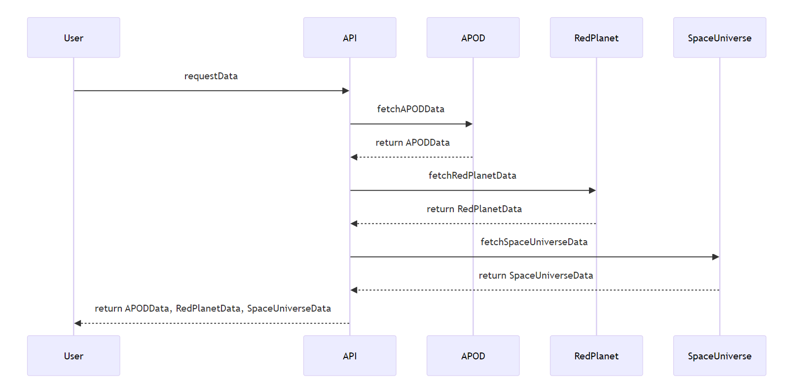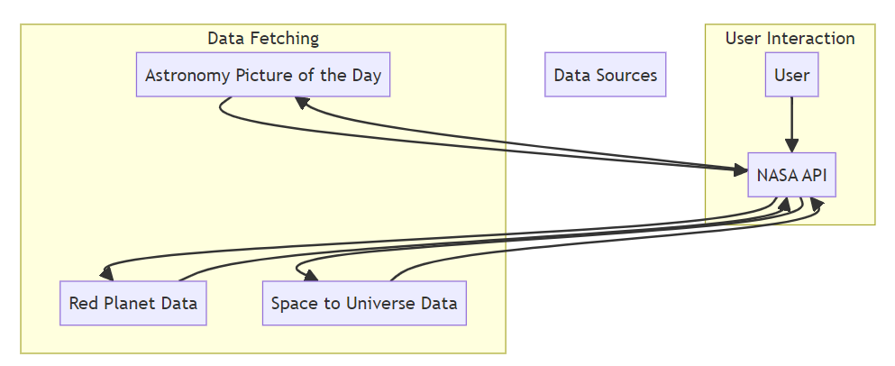

A. Appendices
Certainly! The Appendices section in the Software Requirements Specification (SRS) provides additional information that complements the main requirements. Here are some examples of what could be included in the appendices:
- Conceptual Documents:
  - Initial documents outlining the project’s vision, goals, and high-level concepts.
  - These might include project charters, vision statements, or concept papers.
- Marketing Materials:
  - Brochures, flyers, or promotional content related to the software.
  - Information that helps stakeholders understand the product’s value proposition.
- Meeting Minutes:
  - Records of meetings with customers, stakeholders, or development teams.
  - These capture decisions, discussions, and action items.
- Prototypes or Wireframes:
  - Visual representations of the user interface or system flow.
  - Helps convey design ideas and user interactions.
- Glossary of Terms:
  - Definitions for domain-specific or technical terms used in the SRS.
  - Ensures a common understanding among all stakeholders.
Remember, the appendices enhance the SRS by providing context, background, and supplementary materials. 📚🔍

Thank You!!!

