Open the attached project with Unity 2018.4 version. There you will find an unfinished replica of the original Mario game. Your task is to do the following:

1. Fix the errors in the Console window
   1. Enter the Play mode to see them
   2. Explore how the game behaves in different scenarios (for ex. what happens when you collect a certain amount of points)
2. Finish the Level
   1. Use Tilemap to fill in the missing parts
   2. Make sure that “BrickBreak” GameObjects are destroyed when they are no longer used to produce the Brick Block breaking effect
3. Create the Hidden Block (<https://www.mariowiki.com/Hidden_Block>)
   1. You shouldn’t be able to jump on the block while it’s invisible, use one of the 2D components to achieve that
4. Make the Goal Pole animation using Timeline for the core parts (<https://www.mariowiki.com/Goal_Pole>)
   1. Mario should slide down the pole and walk to the castle
   2. There should be flag coming out of the castle and the fireworks around it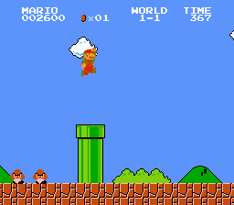
5. Create the UI of the game and arrange it according to the image
   1. There is an object called “ScoreManagerObj” which has a Script “ScoreManager” that tracks time, score and coins count
   2. Target the UI for Standalone (512x512) resolution but make sure it scales well for different resolutions too

After you finish this task, send us the zipped (.zip) Unity project named “MarioTask_<name>_<surname>” or a link to your repository together with a small changelog file briefly describing on how did you tackle each task, how much time did it take for you to finish it. Also, please let us know your comments or feedback on the task itself!

Please note that this task should be tackled with a mindset of a tester. Focus on quality and attention to detail aspects of development. Thus, don’t let any possible issues slip through.

P.s. The provided project doesn’t necessarily follow the best practices of game development. Our users together with their bug reports send us various different projects of different complexity and level of quality. Hence, it’s important to know how to deal with such projects.

Good luck!