At Tvastra – Wings to Your Creativity, we believe every child has the ability to create, imagine and express themselves through art.
Our kids art classes in Thane West are designed for children from 4 years onwards, with age-appropriate programs covering drawing, colouring, painting, canvas art, watercolours, poster colours and memory drawing.
Rather than simply asking children to copy a picture, our courses focus on developing observation, imagination, creativity, colour understanding, drawing skills and artistic confidence through structured, step-by-step learning.

Kids Art Program – Beginners Level 1 & 2
Age Group: 4–7 Years
A creative foundation program specially designed for young children taking their first steps into the world of art.
Through fun and age-appropriate drawing and colouring activities, children learn basic shapes, lines, patterns, colours and simple compositions. The course gradually develops their hand control, observation and ability to express their own ideas visually.

What Children Learn
- Basic lines and shapes
- Simple object drawing
- Colour recognition and combinations
- Crayon and colouring techniques
- Basic composition
- Pattern and texture activities
- Creative drawing
- Imagination-based artwork
- Fine motor and hand-eye coordination
Level 1 introduces the basic building blocks of drawing and colouring, while Level 2 gradually moves children towards more detailed compositions and independent creative work.
Ideal for parents searching for: beginner drawing classes for kids in Thane, art classes for 4–7 year olds, colouring classes for kids, creative art classes for children and kids drawing classes in Thane West. 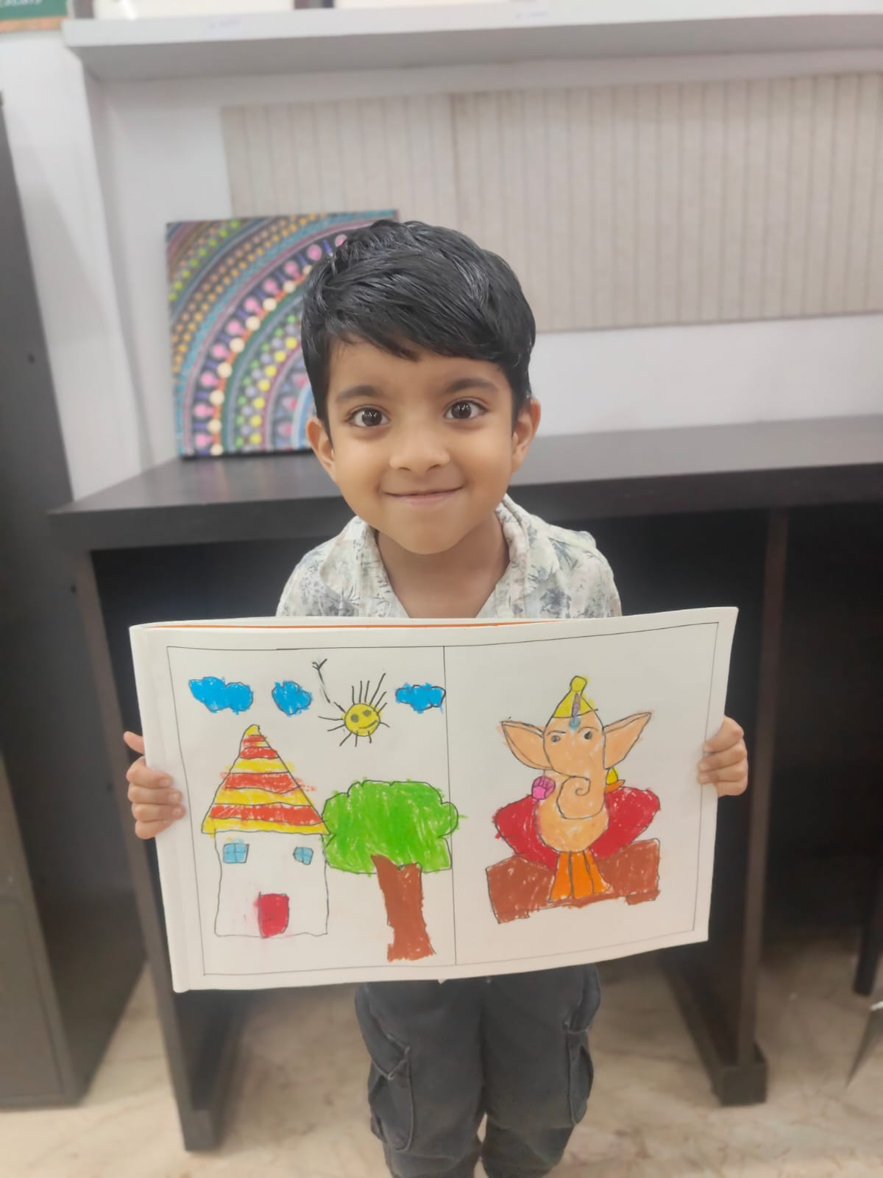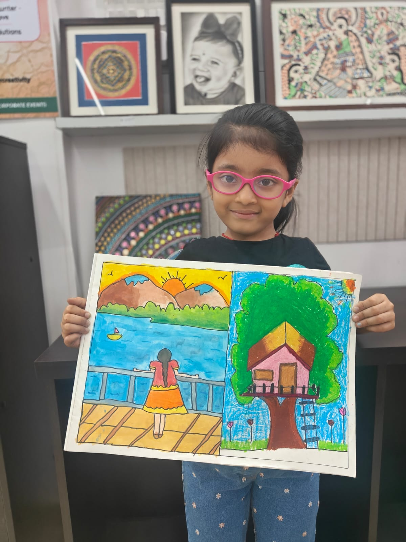

🖌️ Kids Art Program – Advanced Level 1 & 2
Age Group: 8–12 Years
Our Advanced Kids Art Program is designed for children who are ready to move beyond basic drawing and develop stronger artistic skills.
Students learn drawing, composition, colouring, shading, perspective and creative interpretation through structured projects. The focus is not only on completing beautiful artwork but also on understanding how an artwork is planned and created.

What Children Learn
- Advanced drawing techniques
- Object and nature drawing
- Composition
- Proportion and placement
- Shading and tonal values
- Colour theory and colour combinations
- Perspective basics
- Creative and imaginative drawing
- Different colouring and painting techniques
- Independent artwork development
The Level 1 and Level 2 format allows students to progress systematically from intermediate concepts towards more confident and detailed artwork.
Ideal for parents searching for: advanced art classes for kids in Thane, drawing and painting classes for 8–12 year olds, art courses for children in Thane West and creative drawing classes near Kolshet Road.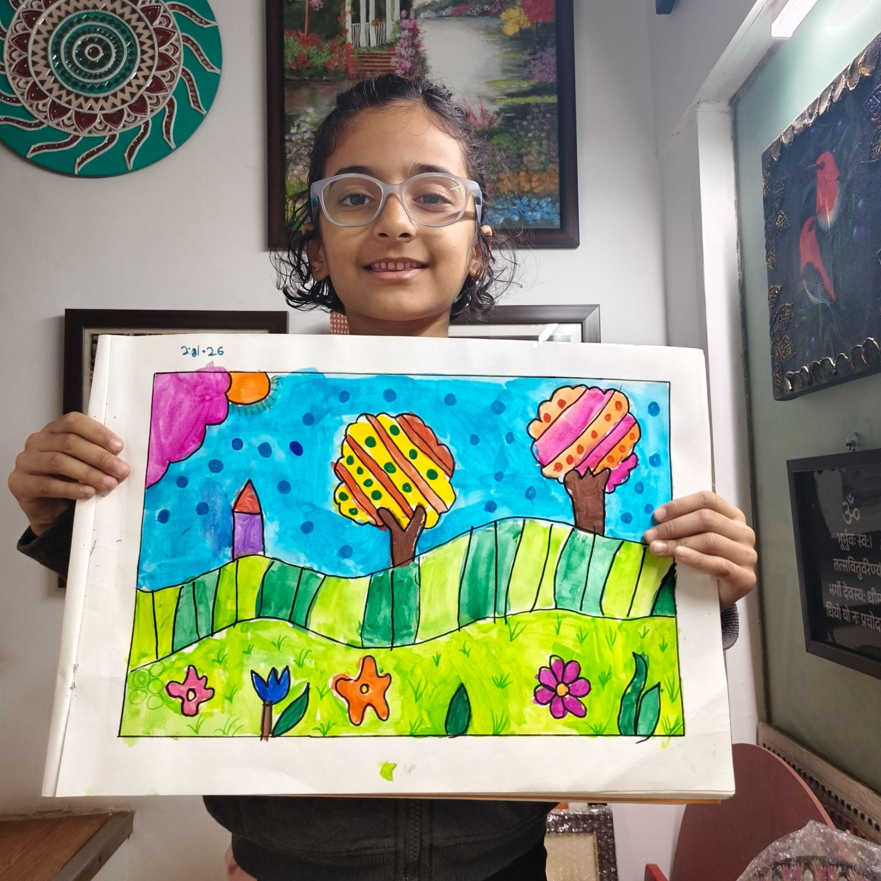

🎨 Kids Watercolour & Poster Colour Painting – Level 1 & 2
Age Group: 8–12 Years
This structured painting course introduces children to two versatile mediums — watercolours and poster colours.
Children first understand their materials, brushes, colour mixing and application techniques before progressing towards complete paintings.

What Children Learn
- Introduction to watercolour and poster colours
- Understanding brushes and art materials
- Colour wheel and colour mixing
- Primary, secondary and complementary colours
- Water control in watercolour painting
- Flat wash and graded wash
- Wet-on-wet and wet-on-dry techniques
- Layering and blending
- Poster colour application
- Creating textures and effects
- Landscape, nature and object-based paintings
- Composition and finishing techniques
Level 1 builds the foundation, while Level 2 introduces more detailed paintings and encourages children to develop their individual painting style.
Ideal for parents searching for: watercolour classes for kids in Thane, poster colour painting classes, kids painting classes in Thane West, watercolour classes for 8–12 year olds and painting courses near Kolshet Road.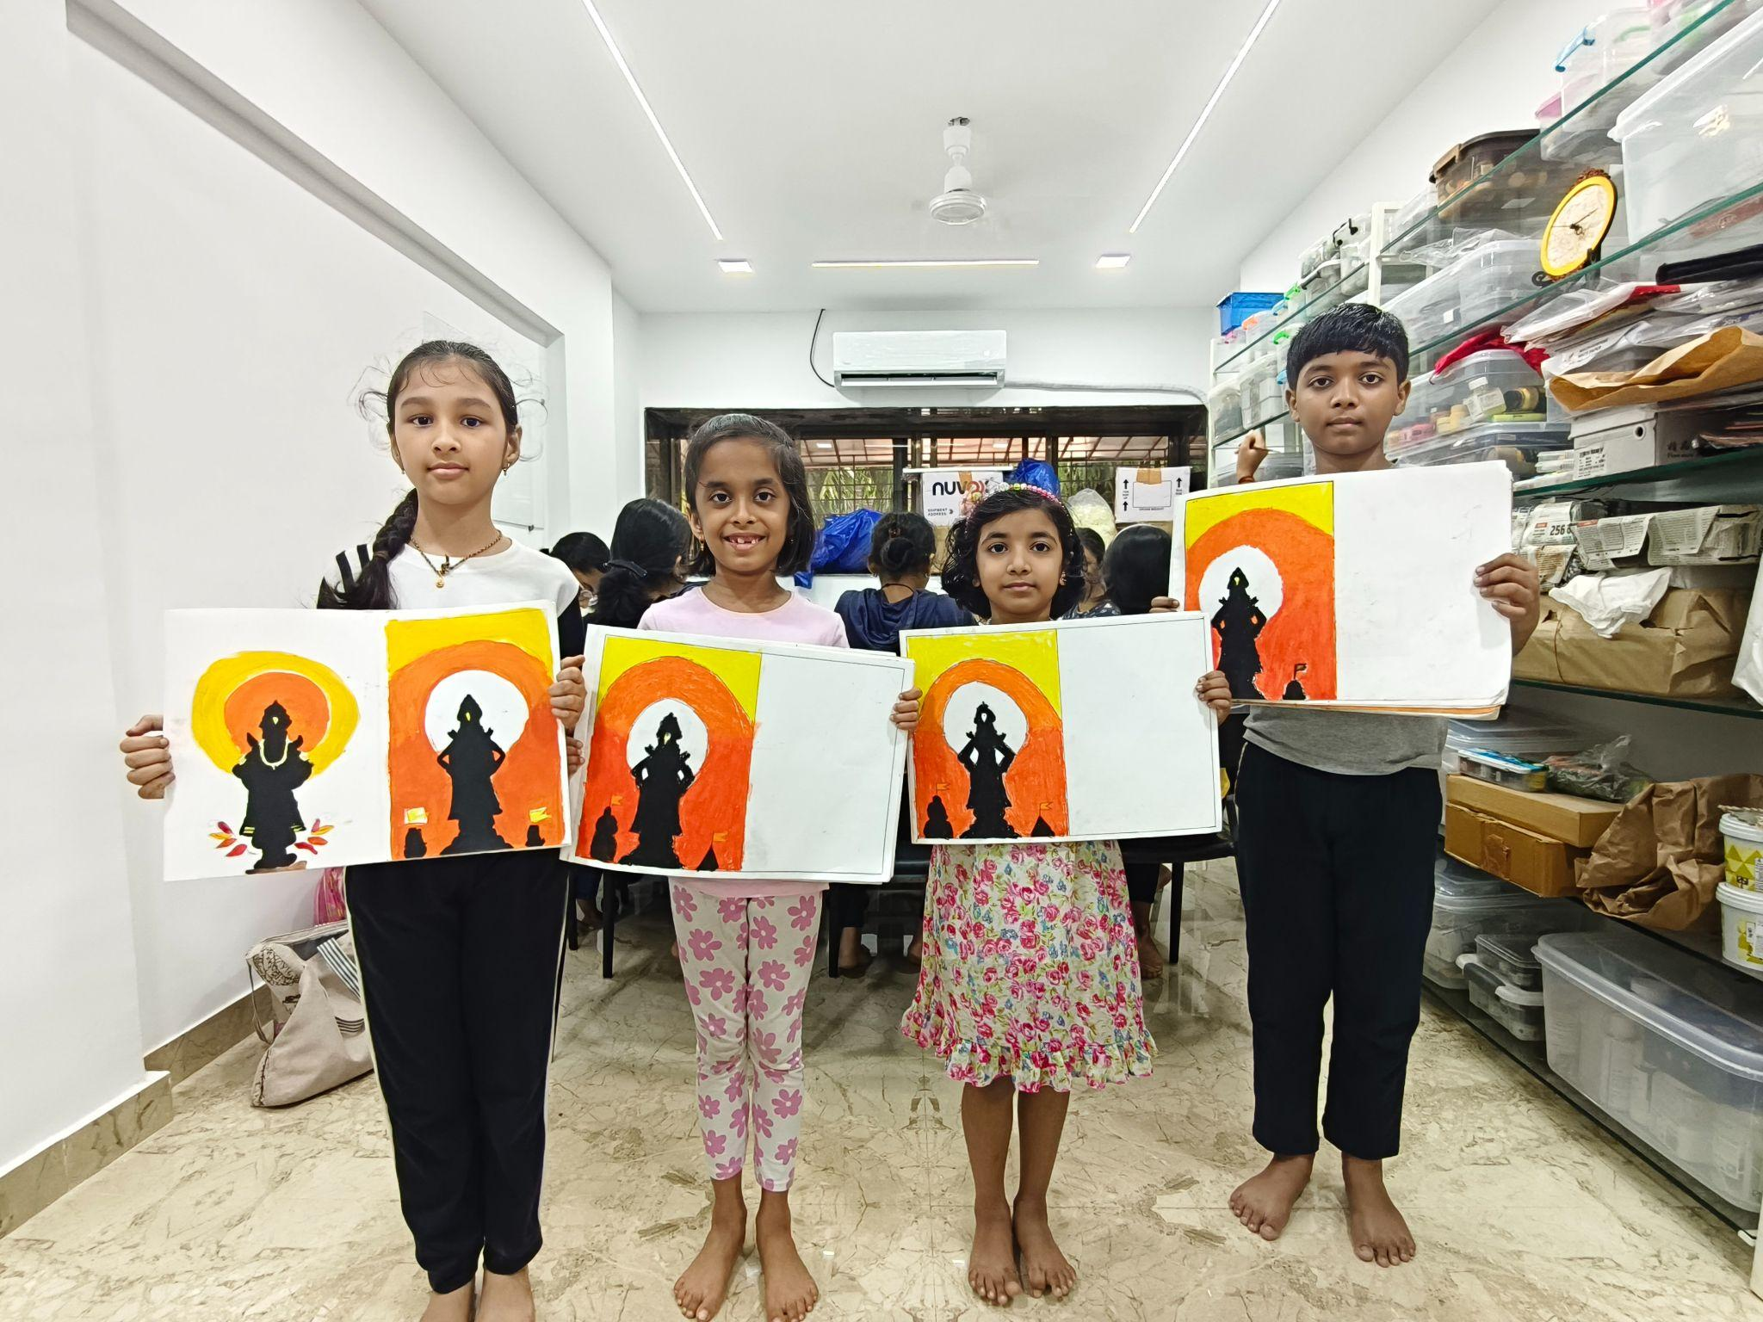

🖼️ Kids Canvas Painting Course
Age Group: 8+ Years
Give your child the experience of creating their own artwork on a real canvas.
Our Kids Canvas Painting Course takes students through the complete process of creating a canvas painting — from understanding materials and brush techniques to composition, layering, detailing and finishing.
During the course, children work on three different canvas paintings, helping them explore different subjects and painting styles.

Children Explore
- Introduction to canvas and painting materials
- Brush handling techniques
- Flat brush techniques
- Colour mixing
- Background creation
- Blending and layering
- Composition
- Landscape painting
- Abstract painting
- Living beings and creative art
- Detailing and finishing a canvas
The program encourages children to understand the painting process instead of simply copying a finished artwork.
At the end of the course, every child takes home their three completed canvas artworks.
Ideal for parents searching for: canvas painting classes for kids in Thane, acrylic painting classes for children, canvas art classes for 8+ years, kids painting courses in Thane West and art classes near Kolshet Road.

✏️ Memory Drawing – Human Figures Level 1 & 2
Age Group: 7+ Years
Memory drawing teaches children to transform their observations, memories and imagination into meaningful compositions.
Our Human Figure Memory Drawing program focuses on helping children understand how to draw people correctly and use human figures confidently while creating scenes from everyday life.

What Children Learn
- Basic human figure construction
- Understanding body proportions
- Male and female figures
- Children and adult figures
- Different body postures
- Sitting, standing, walking and running figures
- Facial expressions and gestures
- Figures in different activities
- Placement of multiple figures
- Background and surroundings
- Creating a complete scene
- Story-based and imagination-based compositions
Level 1 develops the basic understanding of human figures, while Level 2 focuses on movement, multiple figures and complete memory-drawing compositions.
This course can also provide a useful foundation for students developing their observational and composition skills for school-level drawing and art examinations.
Ideal for parents searching for: memory drawing classes in Thane, human figure drawing classes for kids, drawing exam preparation in Thane West, sketching classes for children and drawing classes for 7+ year olds.