Digital Design and Computer Organization Laboratory
UE19CS206
3rd Semester, Academic Year 2020-21
Date: 21/10/2021
Name :  Adarsh Kumar | SRN : PES2UG20CS016 | Section : C

Week # : 5

Title of the Program:

Code:
module reg16(input wire clk,reset,load,input wire [15:0]din,output wire [15:0]r);
dfrl d0(clk,reset,load,din[0],r[0]);
dfrl d1(clk,reset,load,din[1],r[1]);
dfrl d2(clk,reset,load,din[2],r[2]);
dfrl d3(clk,reset,load,din[3],r[3]);
dfrl d4(clk,reset,load,din[4],r[4]);
dfrl d5(clk,reset,load,din[5],r[5]);
dfrl d6(clk,reset,load,din[6],r[6]);
dfrl d7(clk,reset,load,din[7],r[7]);
dfrl d8(clk,reset,load,din[8],r[8]);
dfrl d9(clk,reset,load,din[9],r[9]);
dfrl d10(clk,reset,load,din[10],r[10]);
dfrl d11(clk,reset,load,din[11],r[11]);
dfrl d12(clk,reset,load,din[12],r[12]);
dfrl d13(clk,reset,load,din[13],r[13]);
dfrl d14(clk,reset,load,din[14],r[14]);
dfrl d15(clk,reset,load,din[15],r[15]);
endmodule

module mux128_16(input wire [15:0]i0,i1,i2,i3,i4,i5,i6,i7,input wire s0,s1,s2,output wire [15:0]o);

mux8 mx0({i0[0],i1[0],i2[0],i3[0],i4[0],i5[0],i6[0],i7[0]},s2,s1,s0,o[0]);
mux8 mx1({i0[1],i1[1],i2[1],i3[1],i4[1],i5[1],i6[1],i7[1]},s2,s1,s0,o[1]);
mux8 mx2({i0[2],i1[2],i2[2],i3[2],i4[2],i5[2],i6[2],i7[2]},s2,s1,s0,o[2]);
mux8 mx3({i0[3],i1[3],i2[3],i3[3],i4[3],i5[3],i6[3],i7[3]},s2,s1,s0,o[3]);
mux8 mx4({i0[4],i1[4],i2[4],i3[4],i4[4],i5[4],i6[4],i7[4]},s2,s1,s0,o[4]);
mux8 mx5({i0[5],i1[5],i2[5],i3[5],i4[5],i5[5],i6[5],i7[5]},s2,s1,s0,o[5]);
mux8 mx6({i0[6],i1[6],i2[6],i3[6],i4[6],i5[6],i6[6],i7[6]},s2,s1,s0,o[6]);
mux8 mx7({i0[7],i1[7],i2[7],i3[7],i4[7],i5[7],i6[7],i7[7]},s2,s1,s0,o[7]);
mux8 mx8({i0[8],i1[8],i2[8],i3[8],i4[8],i5[8],i6[8],i7[8]},s2,s1,s0,o[8]);
mux8 mx9({i0[9],i1[9],i2[9],i3[9],i4[9],i5[9],i6[9],i7[9]},s2,s1,s0,o[9]);
mux8 mx10({i0[10],i1[10],i2[10],i3[10],i4[10],i5[10],i6[10],i7[10]},s2,s1,s0,o[10]);
mux8 mx11({i0[11],i1[11],i2[11],i3[11],i4[11],i5[11],i6[11],i7[11]},s2,s1,s0,o[11]);
mux8 mx12({i0[12],i1[12],i2[12],i3[12],i4[12],i5[12],i6[12],i7[12]},s2,s1,s0,o[12]);
mux8 mx13({i0[13],i1[13],i2[13],i3[13],i4[13],i5[13],i6[13],i7[13]},s2,s1,s0,o[13]);
mux8 mx14({i0[14],i1[14],i2[14],i3[14],i4[14],i5[14],i6[14],i7[14]},s2,s1,s0,o[14]);
mux8 mx15({i0[15],i1[15],i2[15],i3[15],i4[15],i5[15],i6[15],i7[15]},s2,s1,s0,o[15]);

endmodule

module reg_file (input wire clk, reset, wr, input wire [2:0] rd_addr_a, rd_addr_b, wr_addr, input wire [15:0] d_in, output wire [15:0] d_out_a, d_out_b);

// Declare wires here
wire [0:7]load;
wire [0:15]r0,r1,r2,r3,r4,r5,r6,r7;
// Instantiate modules here

demux8 dmx(wr,wr_addr[2],wr_addr[1],wr_addr[0],load);

reg16 reg0(clk,reset,load[0],d_in,r0);
reg16 reg1(clk,reset,load[1],d_in,r1);
reg16 reg2(clk,reset,load[2],d_in,r2);
reg16 reg3(clk,reset,load[3],d_in,r3);
reg16 reg4(clk,reset,load[4],d_in,r4);
reg16 reg5(clk,reset,load[5],d_in,r5);
reg16 reg6(clk,reset,load[6],d_in,r6);
reg16 reg7(clk,reset,load[7],d_in,r7);

mux128_16 mm0(r0,r1,r2,r3,r4,r5,r6,r7,rd_addr_a[0],rd_addr_a[1],rd_addr_a[2],d_out_a);
mux128_16 mm1(r0,r1,r2,r3,r4,r5,r6,r7,rd_addr_b[0],rd_addr_b[1],rd_addr_b[2],d_out_b);

endmodule

module mux2for16(input wire [15:0] din_regular, alu_out, input wire selector, output wire [15:0]din_final);
mux2 m0(din_regular[0], alu_out[0], selector, din_final[0]);
mux2 m1(din_regular[1], alu_out[1], selector, din_final[1]);
mux2 m2(din_regular[2], alu_out[2], selector, din_final[2]);
mux2 m3(din_regular[3], alu_out[3], selector, din_final[3]);
mux2 m4(din_regular[4], alu_out[4], selector, din_final[4]);
mux2 m5(din_regular[5], alu_out[5], selector, din_final[5]);
mux2 m6(din_regular[6], alu_out[6], selector, din_final[6]);
mux2 m7(din_regular[7], alu_out[7], selector, din_final[7]);
mux2 m8(din_regular[8], alu_out[8], selector, din_final[8]);
mux2 m9(din_regular[9], alu_out[9], selector, din_final[9]);
mux2 m10(din_regular[10], alu_out[10], selector, din_final[10]);
mux2 m11(din_regular[11], alu_out[11], selector, din_final[11]);
mux2 m12(din_regular[12], alu_out[12], selector, din_final[12]);
mux2 m13(din_regular[13], alu_out[13], selector, din_final[13]);
mux2 m14(din_regular[14], alu_out[14], selector, din_final[14]);
mux2 m15(din_regular[15], alu_out[15], selector, din_final[15]);
endmodule

module reg_alu (input wire clk, reset, sel, wr, input wire [1:0] op, input wire [2:0] rd_addr_a,
rd_addr_b, wr_addr, input wire [15:0] d_in, output wire [15:0] d_out_a, d_out_b, output wire cout);
wire [15:0] alu_out;
wire [15:0] newdin;
mux2for16 select(d_in, alu_out, sel, newdin);
reg_file new_reg(clk, reset, wr, rd_addr_a, rd_addr_b, wr_addr, newdin, d_out_a, d_out_b);
alu calc(op, d_out_a, d_out_b, alu_out, cout);

endmodule
Output waveform

Terminal :
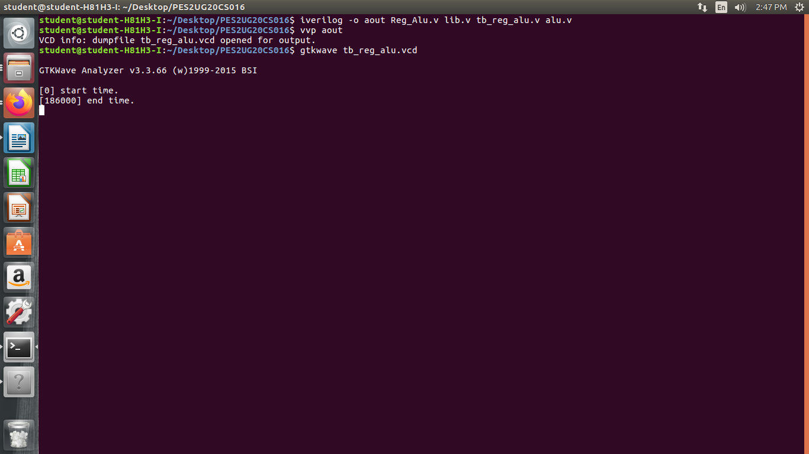

Wave Form :
