

**PES UNIVERSITY, BANGALORE**

**Department of Computer Science and Engineering**

**DBMS (UE20CS301)**

**Mini Project**

**Title of the Project: Petrol Pump Management System**

Submitted By:

Name: Adarsh Kumar

SRN: PES2UG20CS016

V Semester

Section- B

Short Description and Scope of the Project:

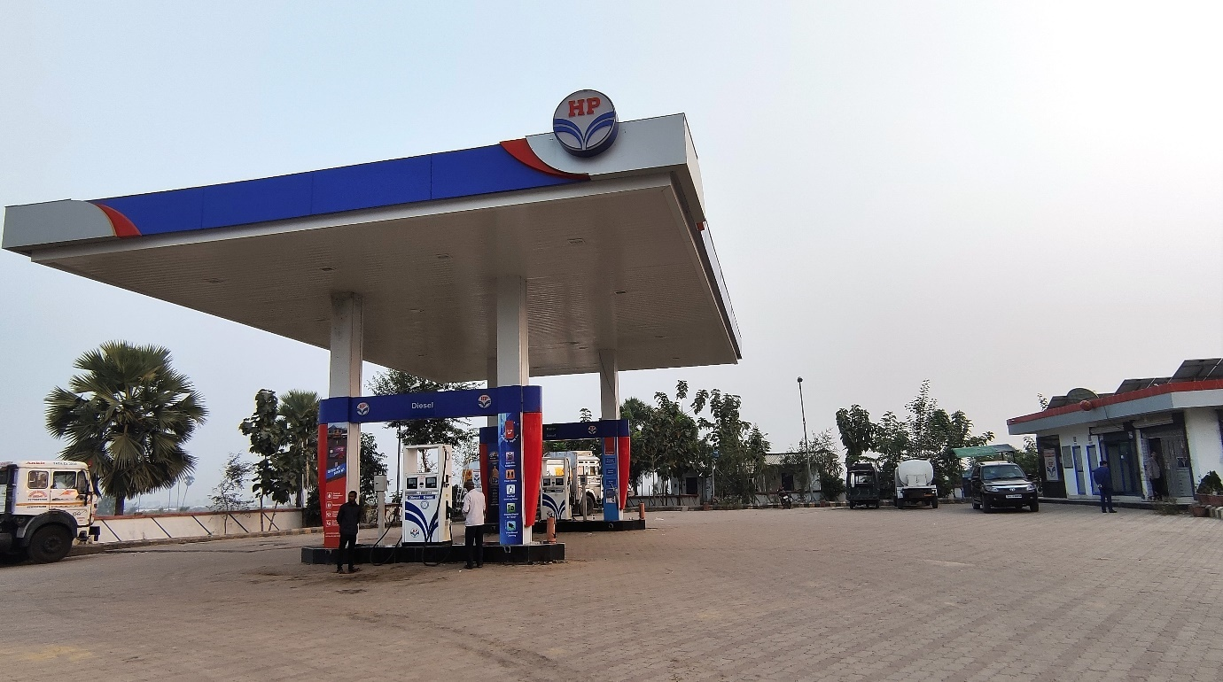

Oil and gas (O&G) industry contributes to the economic as one of the most important sectors by taking into advantages as being the most demanding, challenging and exciting engineering and technological advances which interests the engineers at large. As the O&G industry has become financially attractive yet risky to be implemented, it is important to look into the effective way of managing the O&G projects.

My Project is to maintain petrol pump data which will help Managers to manager their work with ease convenience.

Database management System (DBMS) is a software for creating and managing database. It provides users and programmers with a systematic way to create, retrieve, update and manage data.

This project will maintain data about Petrol Pumps in an area, their owners, Employees details working in that petrol, Customer detail so that a regular customer will get Goodies & Discount, Tanker details as well as Sales of a particular Petrol Pump.

This project uses MYSQL to store data and perform CRUD operations and Some of the famous libraries such as pandas and streamlit library for frontend to make User Interface interactive.

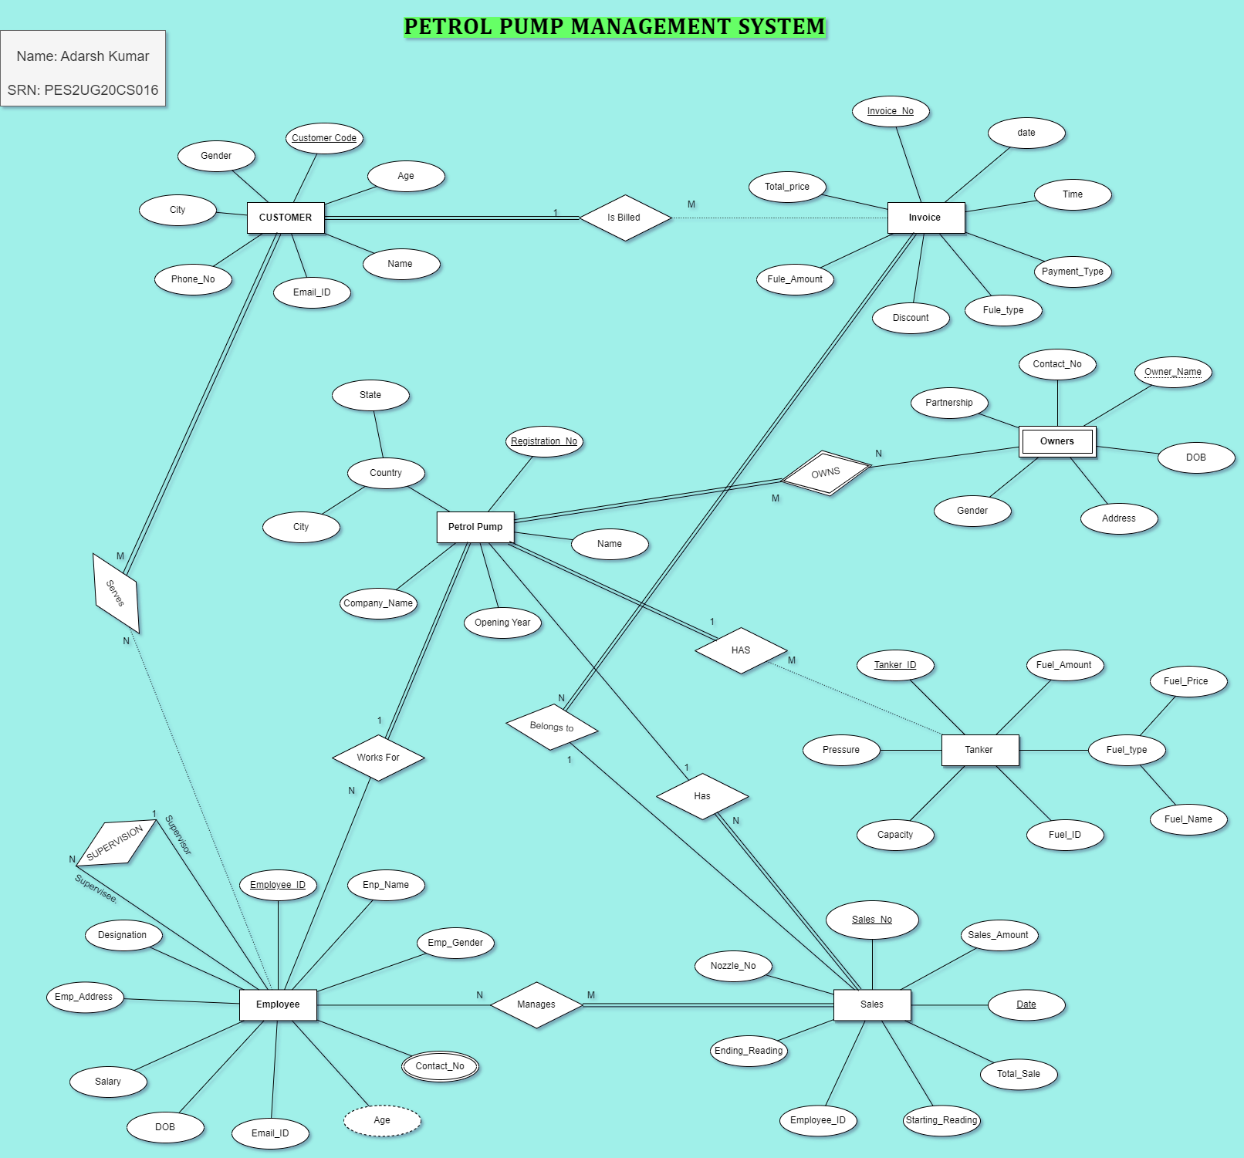ER Diagram:

Relational Schema:

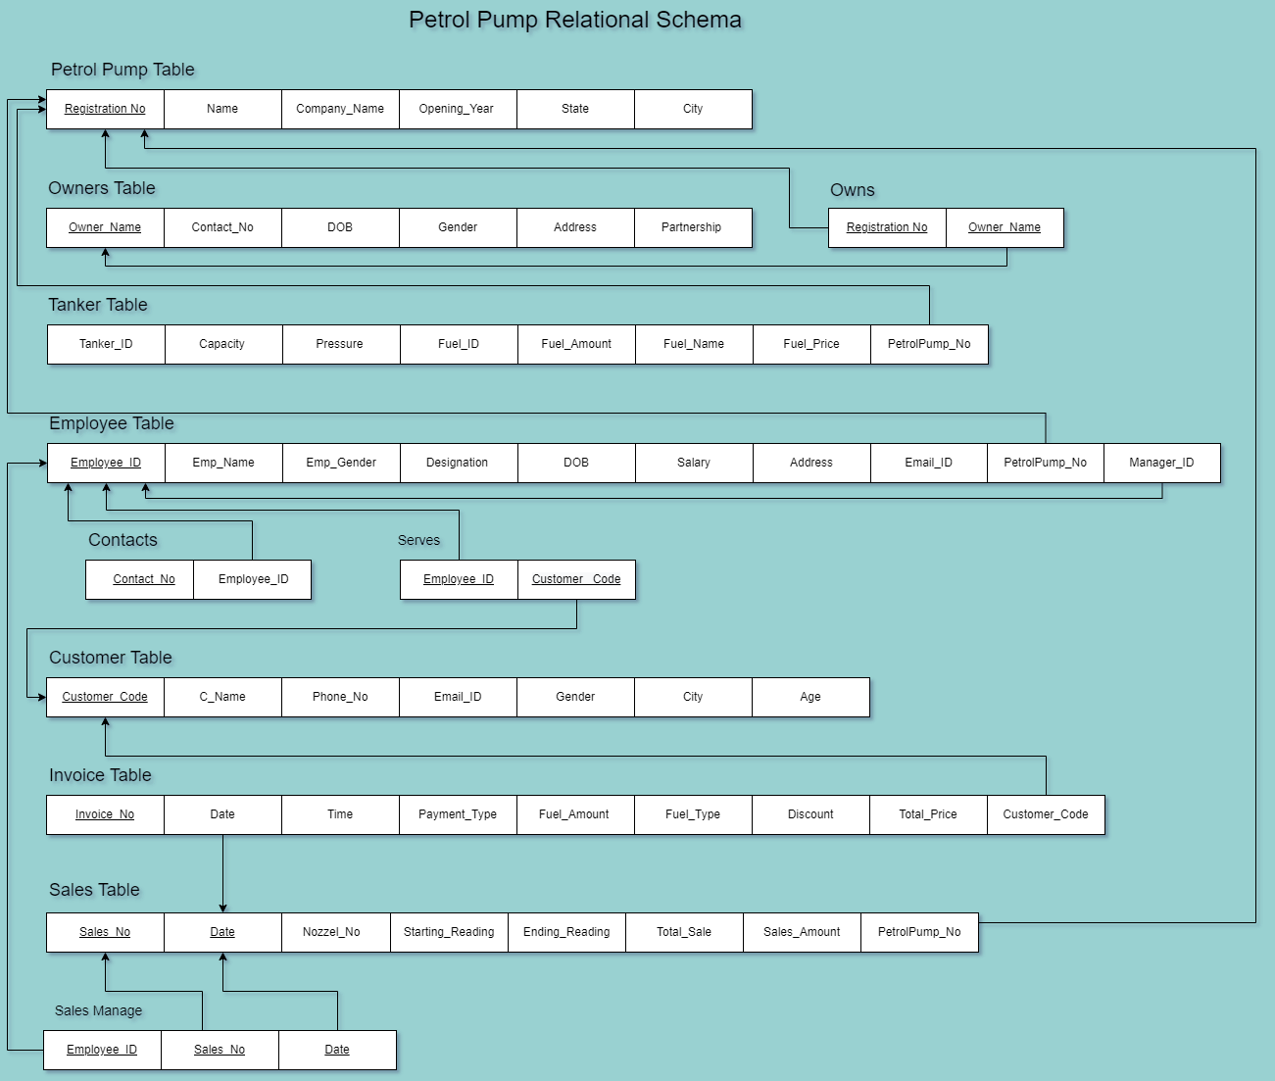

**DDL statements:**

Building the database & Populating the Database:

SET SQL_MODE = "NO_AUTO_VALUE_ON_ZERO";

START TRANSACTION;

SET time_zone = "+00:00";

CREATE TABLE IF NOT EXISTS `PetrolPump`(

   `Registration_No` varchar(10) NOT NULL,

   `Petrolpump_Name` varchar(50) NOT NULL,

   `Company_Name` varchar(30) DEFAULT NULL,

   `Opening_Year` int(5) DEFAULT NULL,

   `State` varchar(30) DEFAULT NULL,

   `City` varchar(40) NOT NULL,

   PRIMARY KEY(`Registration_No`)

) ENGINE=InnoDB DEFAULT CHARSET=utf8mb4;

INSERT INTO `PetrolPump` (`Registration_No`, `Petrolpump_Name`,`Company_Name`, `Opening_Year`, `State`, `City`) VALUES

('HPC805103', 'Sumaraj Petroleum', 'Hindustan Petroleum Corporation',2016,'Bihar','Hisua'),

('BP110054', 'Rajinder Service Station', 'Bharat Petroleum',2012,'Delhi','CENTRAL DELHI'),

('IOC560008', 'Madhu Enterprises', 'Indian Oil Corporation',2008,'Karnataka','Banglore'),

('OIL380013', 'Perusahaan Minyak and Gas Bumi', 'Oil India Limited',2006,'Gujarat','Ahmedabad'),

('RPL673573','Tamarassery Reliance Retail Outlet','Reliance Petroleum Limited',2013,'Kerala','Thamarasserry');

CREATE TABLE IF NOT EXISTS `Owners`(

   `Owner_Name` varchar(20) NOT NULL,

   `Contact_NO` char(10) NOT NULL,

   `DOB` date DEFAULT NULL,

   `Gender` char DEFAULT NULL,

   `Address` varchar(255) DEFAULT NULL,

   `Partnership` int(5) NOT NULL,

   PRIMARY KEY(`Owner_Name`)

) ENGINE=InnoDB DEFAULT CHARSET=utf8mb4;

INSERT INTO `Owners` (`Owner_Name`, `Contact_NO`, `DOB`, `Gender`, `Address`, `Partnership`) VALUES

('Pawan Kumar','9431073500', '1971-01-03', 'M', 'Friends colony more,Patna,Bihar',35 ),

('Avinash Shankar','8783249500','1973-07-15', 'M', 'Buddha colony,Patna,Bihar',25),

('Vikash Kumar Tarun', '7486249500', '1975-02-05','M','Tapeshwer Path,Boring road,Patna,Bihar',45),

('Nirmal Sethi', '6427894500', '1999-09-11','F','Pritam Nagar, Paldi, Ahmedabad, Gujarat',70),

('Neerja Bhanot', '5963154800','2000-02-24', 'F', 'Quarters, Sarojini Nagar,New Delhi',55);

CREATE TABLE IF NOT EXISTS `Tanker`(

   `Tanker_ID` varchar(10) NOT NULL,

   `Capacity` float(10) DEFAULT NULL,

   `pressure` float(10) DEFAULT NULL,

   `Fuel_ID` varchar(10) NOT NULL,

   `Fuel_Amount` float(15) DEFAULT NULL,

   `Fuel_Name` varchar(20) DEFAULT NULL,

   `Fuel_Price` float(5) NOT NULL,

   `Petrolpump_No`varchar(10) DEFAULT NULL,

   PRIMARY KEY(`Tanker_ID`)

) ENGINE=InnoDB DEFAULT CHARSET=utf8mb4;

INSERT INTO `Tanker` (`Tanker_ID`, `Capacity`, `pressure`, `Fuel_ID`,`Fuel_Amount`, `Fuel_Name`,  `Fuel_Price`, `Petrolpump_No`) VALUES

('BR6872', 5000,550,'A1234',513.50,'PetrolE10',101.72,'HPC805103'),

('JK2611', 1000,845,'L7363',238.24,'Kerosene',77.03,'OIL380013'),

('MP4928', 5000,1545,'K5363',1200.95,'CNG',99.50,'BP110054'),

('JH7523', 10000,3500,'Z6353',751.89,'Diesel',87.89,'HPC805103'),

('UP9875', 15000,785,'R4743',576.26,'Gasoline91',107.05,'OIL380013');

CREATE TABLE IF NOT EXISTS `Employee`(

   `Employee_ID` varchar(10) NOT NULL,

   `Emp_Name` varchar(30) NOT NULL,

   `Emp_Gender`char DEFAULT NULL,

   `Designation` varchar(10) DEFAULT NULL,

   `DOB` date DEFAULT NULL,

   `Salary` int(20) DEFAULT NULL,

   `Emp_Address` varchar(255) NOT NULL,

   `Email_ID`varchar(100) NOT NULL,

   `Petrolpump_No`varchar(10) DEFAULT NULL,

   `Manager_ID` varchar(10) DEFAULT NULL,

   PRIMARY KEY(`Employee_ID`)

) ENGINE=InnoDB DEFAULT CHARSET=utf8mb4;

INSERT INTO `Employee` (`Employee_ID`, `Emp_Name`, `Emp_Gender`, `Designation`, `DOB`, `Salary`, `Emp_Address`, `Email_ID`, `Petrolpump_No`, `Manager_ID`) VALUES

('FOED452','Sheela Reddy','F','FOOD MANAGEMENT','1989-11-28',45000,'dakbangla choraha,patna','sheela@gmail.com','HPC805103','MANG957'),

('DRHD746','Hima Ullal','F','COOKING','1995-04-18',25000,'Bikram Road, Patna','hima@gmail.com','HPC805103','FOED452'),

('MANG957','Aman kumar','M','MANAGER','1992-01-21',65000,'Boaring road, patna','Aman@outlook.com','HPC805103','MANG957'),

('FDNG652','Hradha Nayar','F','NOZZEL PERSON','1987-08-09',35000,'Pandit Bigha, Gaya','hradha@hotmail.com','HPC805103','FDEW353'),

('FDSNG43','Hemant','M','CLEANING','1995-01-23',20000,'Kanvada, Magrol road, Surat','hemant@gmail.com','OIL380013',NULL),

('SNGED76','Animesh','M','NOZZEL PERSON','1982-08-13',45000,'Industrial Development Area, Sector 16, Gurugram, Haryana' ,'animesh@gmail.com','OIL380013',NULL),

('FDEW353','Saideepak Reddy','M','NOZZEL PERSON','2000-06-30',40000,'Lodwadih, Topchanchi, Jharkhand','saideepak@outlook.com','HPC805103','MANG957');

CREATE TABLE IF NOT EXISTS `Customer`(

   `Customer_Code` varchar(10) NOT NULL,

   `C_Name` varchar(30) NOT NULL,

   `Phone_No`char(10) DEFAULT NULL,

   `Email_ID`varchar(100) DEFAULT NULL,

   `Gender`char DEFAULT NULL,

   `City` varchar(50) DEFAULT NULL,

   `Age` int(3) DEFAULT NULL,

   PRIMARY KEY(`Customer_Code`)

) ENGINE=InnoDB DEFAULT CHARSET=utf8mb4;

INSERT INTO `Customer` (`Customer_Code`, `C_Name`, `Phone_No`, `Email_ID`, `Gender`, `City`, `Age`) VALUES

('SFG252','Akash','6542589700','akash@gmail.com','M','Bihar', 27),

('GHE785','Praneet','7539514600','praneet@yahoo.com','M','Orissa',59),

('FJD253','Chetan','8426951300','chetan@hotmail.com','M','Bengalore', 24),

('OUI325','Ayush','7618425500','ayush@outlook.com','M','Kota',18),

('CGM235','Vinesh','6794324600','vines@pesu.pes.edu','M','Kolkata',54),

('BFR426','Anamika',9569731800,'anamika@gmai.com','F','Jharkhand',26);

CREATE TABLE IF NOT EXISTS `Invoice`(

   `Invoice_No` varchar(10) NOT NULL,

   `Date` date NOT NULL,

   `Payment_Type` varchar(20) NOT NULL,

   `Fuel_Amount` float(15) DEFAULT NULL,

   `Fuel_Type` varchar(15) DEFAULT NULL,

   `Discount` int(5) DEFAULT NULL,

   `Total_Price` float(10) NOT NULL,

   `Customer_Code` varchar(10) NULL,

   PRIMARY KEY(`Invoice_No`)

) ENGINE=InnoDB DEFAULT CHARSET=utf8mb4;

INSERT INTO `Invoice` (`Invoice_No`, `Date`, `Payment_Type`, `Fuel_Amount`, `Fuel_Type`, `Discount`, `Total_Price`, `Customer_Code`) VALUES

('XC34','2022-11-20','Cash',7,'PetrolE10',10,640.83,'BFR426'),

('NR43','2022-11-20','UPI', 5.4,'Gasoline91',NULL, 578.07,'GHE785'),

('MN34','2020-06-30','Credit Card', 15.8,'Diesel',7.5, 1284.51,'OUI325'),

('FG43','2022-10-27','UPI', 4.9,'Gasoline91',5, 498.32,'SFG252'),

('DS85','2019-08-19','Debit Card', 6.8,'Diesel',NULL, 597.65,'OUI325');

CREATE TABLE IF NOT EXISTS `Sales`(

   `Sales_No` varchar(10) NOT NULL,

   `Date` date NOT NULL,

   `Nozzel_No` int(4) NOT NULL,

   `Starting_Reading` int(7) NOT NULL,

   `Ending_Reading` int(7) NOT NULL,

   `Total_Sales` float(10) NOT NULL,

   `Sales_Amount` float(10) NOT NULL,

   `Petrolpump_No`varchar(10) DEFAULT NULL,

   PRIMARY KEY(`Sales_No`,`Date`)

) ENGINE=InnoDB DEFAULT CHARSET=utf8mb4;

INSERT INTO `Sales` (`Sales_No`, `Date`, `Nozzel_No`, `Starting_Reading`, `Ending_Reading`, `Total_Sales`, `Sales_Amount`, `Petrolpump_No`) VALUES

('FGHGE32','2022-11-20', 1, 45687,49782 , 17584.45, 106.52,'HPC805103'),

('MVBER67','2022-11-20', 2, 48325, 53842, 4253.45, 205.5,'OIL380013'),

('IUOSF98','2019-08-19', 2, 12757, 23454, 1254.71, 89.45,'HPC805103'),

('GDZJD24','2019-08-19', 1, 62725,68725 , 5466.45, 125.85,'OIL380013'),

('QWRGH87','2022-11-22', 3, 12758, 19758, 7854.65, 425.25,'HPC805103');

CREATE TABLE IF NOT EXISTS `Owns`(

   `Registration_No` varchar(10) NOT NULL,

   `Owner_Name` varchar(20) NOT NULL,

   PRIMARY KEY(`Registration_No`, `Owner_Name`)

) ENGINE=InnoDB DEFAULT CHARSET=utf8mb4;

INSERT INTO `Owns` (`Registration_No`,`Owner_Name`) VALUES

('HPC805103','Pawan Kumar'),

('HPC805103','Avinash Shankar'),

('HPC805103','Vikash Kumar Tarun'),

('OIL380013','Nirmal Sethi'),

('OIL380013','Vikash Kumar Tarun'),

('BP110054','Neerja Bhanot'),

('BP110054','Pawan Kumar');

CREATE TABLE IF NOT EXISTS `Contacts`(

   `Employee_ID` varchar(10) NOT NULL,

   `Contact_NO` char(10) NOT NULL,

   PRIMARY KEY(`Employee_ID`, `Contact_NO`)

) ENGINE=InnoDB DEFAULT CHARSET=utf8mb4;

INSERT INTO `Contacts` (`Employee_ID`, `Contact_NO`) VALUES

('MANG957','6299337300'),

('MANG957','8540074600'),

('FOED452','6256575800'),

('FOED452','9678225400'),

('FDSNG43','8312243800'),

('FDNG652','5249785500');

CREATE TABLE IF NOT EXISTS `Serves`(

   `Employee_ID` varchar(10) NOT NULL,

   `Customer_Code` varchar(10) NOT NULL,

   PRIMARY KEY(`Employee_ID`, `Customer_Code`)

) ENGINE=InnoDB DEFAULT CHARSET=utf8mb4;

INSERT INTO `Serves` (`Employee_ID`, `Customer_Code`) VALUES

('FDEW353','SFG252'),

('FDEW353','CGM235'),

('FDEW353','BFR426'),

('FDNG652','SFG252'),

('FDNG652','CGM235');

CREATE TABLE IF NOT EXISTS `Sales_Manage`(

   `Employee_ID` varchar(10) NOT NULL,

   `Sales_No` varchar(10) NOT NULL,

   `Date` date NOT NULL,

   PRIMARY KEY(`Employee_ID`, `Sales_No`, `Date`)

) ENGINE=InnoDB DEFAULT CHARSET=utf8mb4;

INSERT INTO `Sales_Manage`(`Employee_ID`, `Sales_No`, `Date`) VALUES

('FDEW353','FGHGE32','2022-11-20'),

('FDEW353','IUOSF98','2019-08-19'),

('FDNG652','QWRGH87','2022-11-22'),

('SNGED76','GDZJD24','2019-08-19'),

('SNGED76','MVBER67','2022-11-20');

COMMIT;

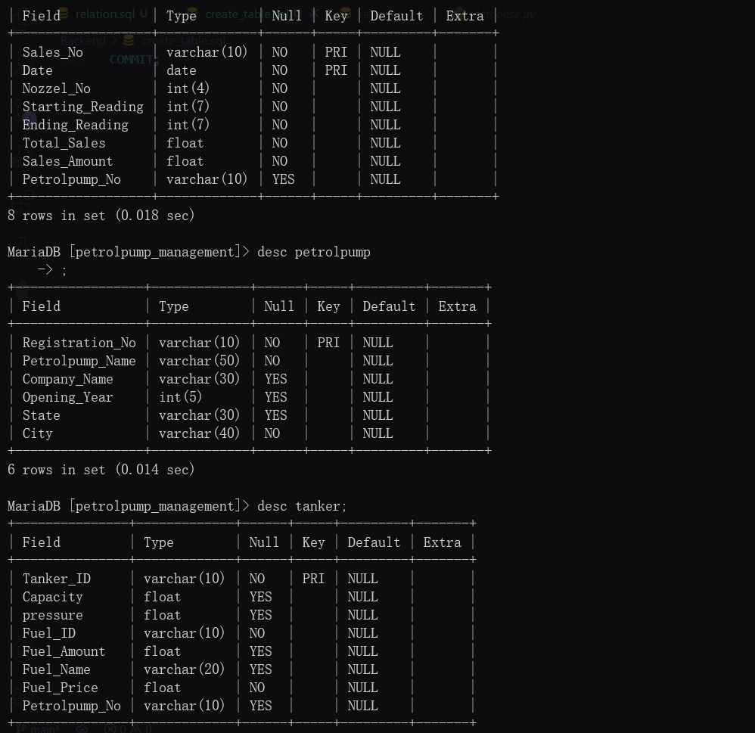

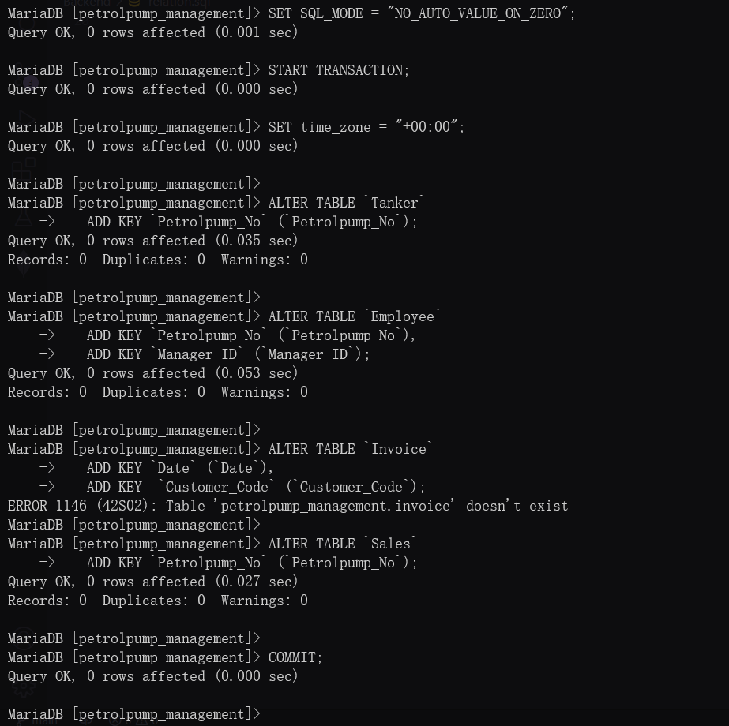

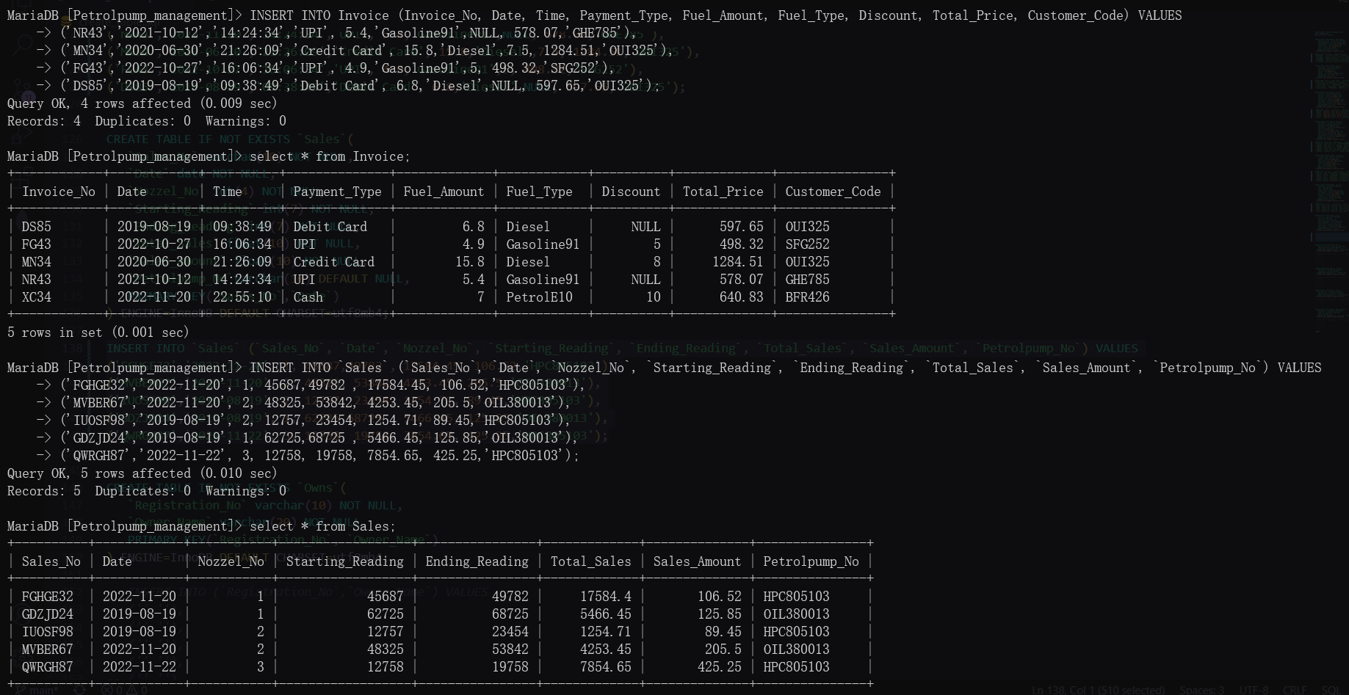

Join Queries

Showcase at least 4 join queries

Write the query in English Language, Show the equivalent SQL statement and also a screenshot of the query and the results

Q1) Find All the Registration No of Petrol pump Where Employee Works

Querry: SELECT PetrolPump.Registration_No FROM PetrolPump INNER JOIN Employee ON PetrolPump.Registration_No = Employee.Petrolpump_No;

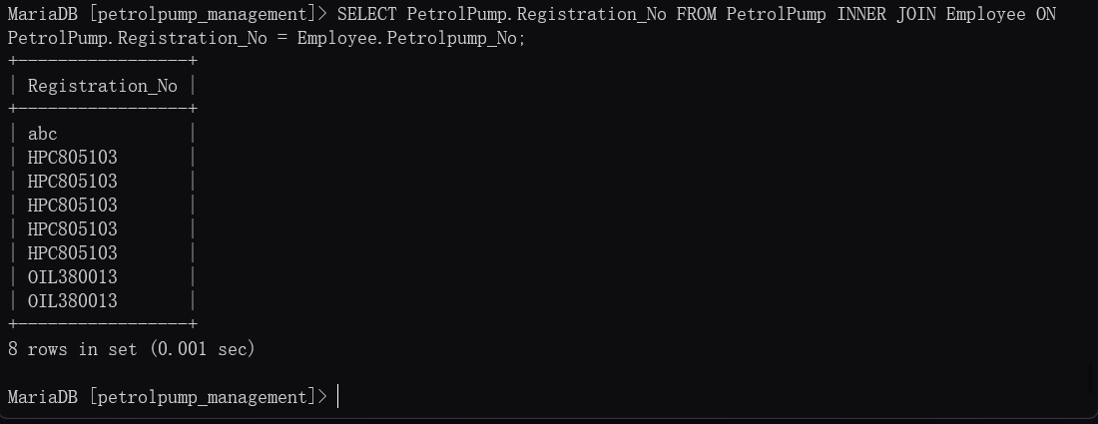

Q2)

Querry: SELECT Petrolpump.Registration_No FROM Petrolpump left join Employee on Petrolpump.Registration_No = Employee.Petrolpump_No WHERE Employee.Petrolpump_No is NULL;

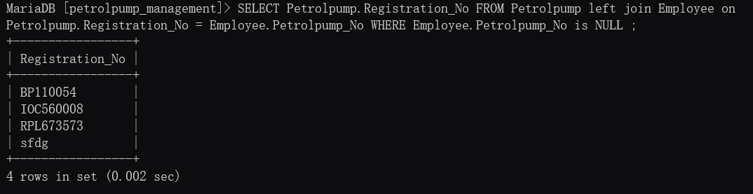

Q3)

Querry: SELECT PetrolPump.Registration_No FROM PetrolPump LEFT JOIN Employee ON PetrolPump.Registration_No = Employee.Petrolpump_No;

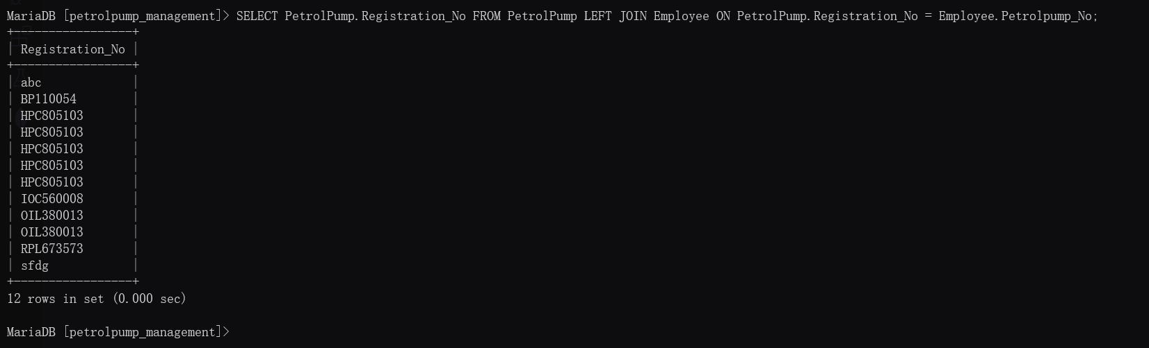

Q4)

Querry: SELECT Invoice.Invoice_No ,Invoice.Date ,Invoice.Payment_Type, Customer.C_Name , Customer.Phone_No FROM Invoice RIGHT OUTER JOIN Customer ON Customer.Customer_Code = Invoice.Customer_Code;

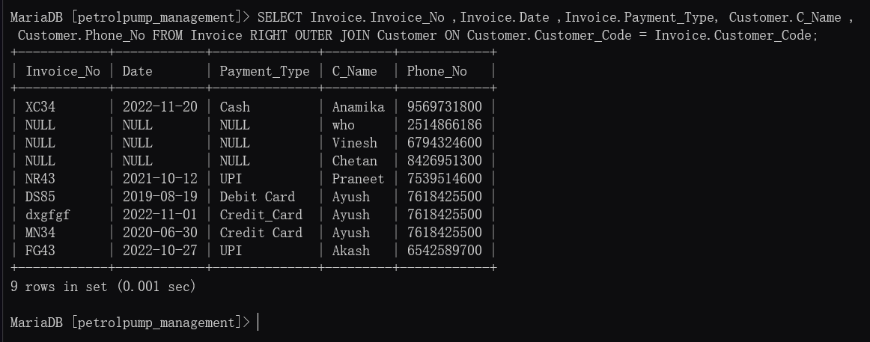

Aggregate Functions

Showcase at least 4 Aggregate function queries

Write the query in English Language, Show the equivalent SQL statement and also a screenshot of the query and the results

Q1) Find the Average age of the Male customers.

Query: SELECT avg(Age) from Customer where Gender='M';

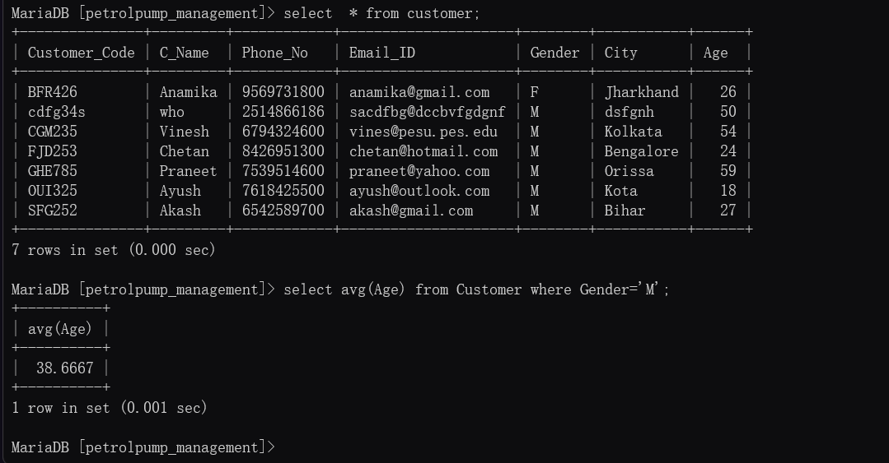

Q2) Find the name and age of Employee using the date of birth.

Query: SELECT Emp_Name, TIMESTAMPDIFF (YEAR, DOB, CURDATE()) AS age FROM Employee;

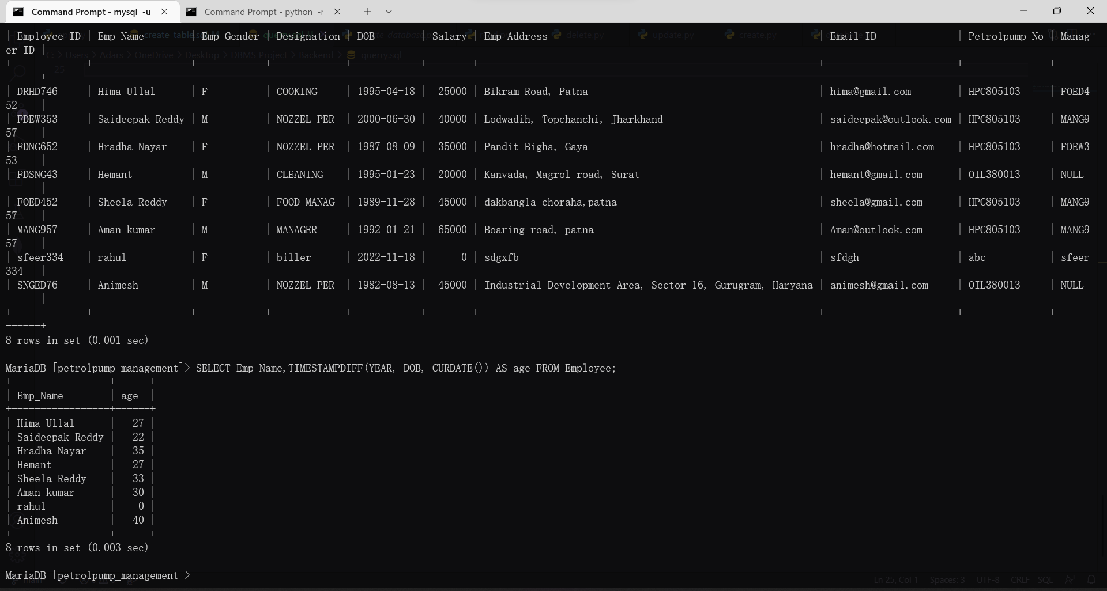

Q3) Find the Details of the Invoice Whose Total Prize is Maximum?

Query: SELECT *, max(Total_Price) from Invoice;

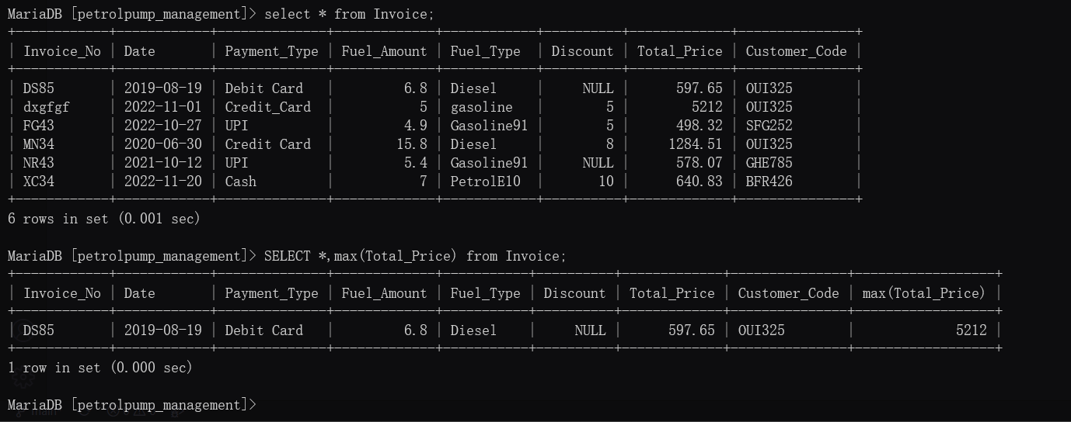

Q4) Get the details of Sales No, Sales Amount & Petrol pump No whose sales is maximum on 20 November, 2022

Query: SELECT Sales_No, Sales_Amount, Petrolpump_No, max(Sales_Amount) FROM Sales WHERE DATE='2022-11-20';

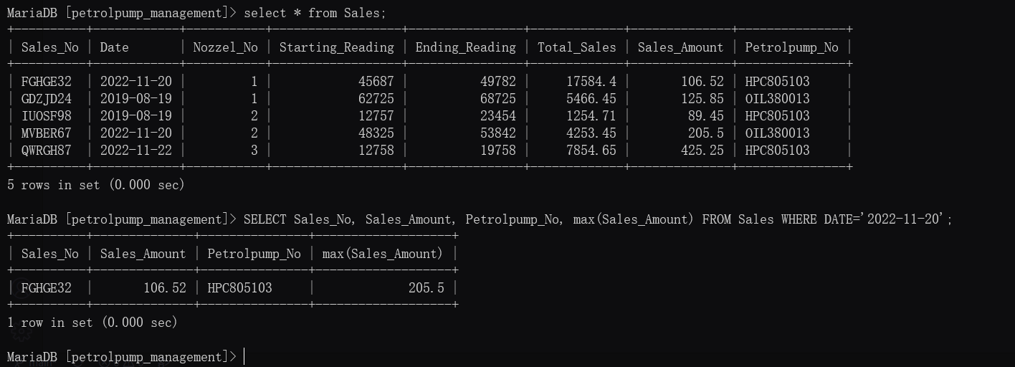

Set Operations

Showcase at least 4 Set Operations queries

Write the query in English Language, Show the equivalent SQL statement and also a screenshot of the query and the results.

Q 1) Get all the Unique names of Both the tables Owners and Employee

Querry: SELECT Owner_Name from Owners UNION SELECT EMP_Name from Employee;

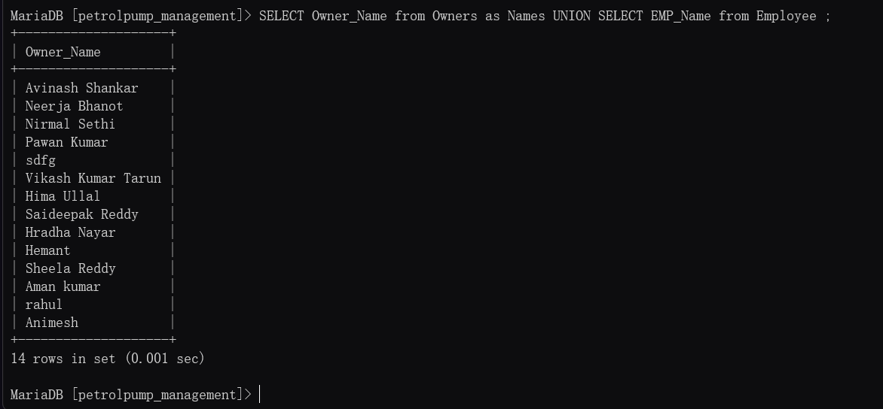

Q2) Find the Petrolpump Registration no which is Common Between both table Petrol pump and Employee?

Querry: SELECT Registration_No from Petrolpump INTERSECT SELECT Petrolpump_No from Employee;

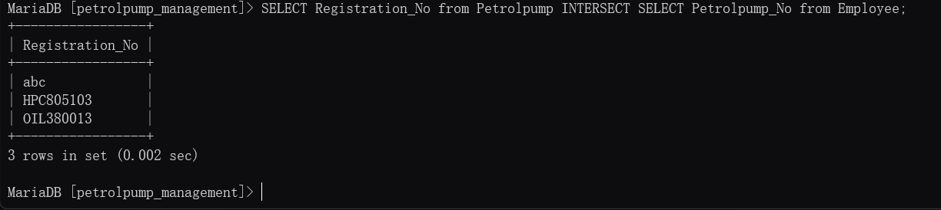

Q3)

Querry: SELECT Petrolpump_Name FROM Petrolpump where Registration_No IN(SELECT Petrolpump.Registration_No FROM Petrolpump left join Employee on Petrolpump.Registration_No = Employee.Petrolpump_No WHERE Employee.Petrolpump_No is NULL);

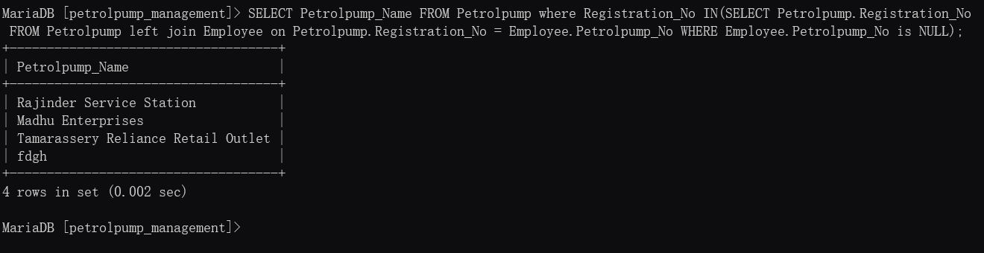

Q 4)

Querry: SELECT C_Name from Customer UNION SELECT Owner_Name from Owners;

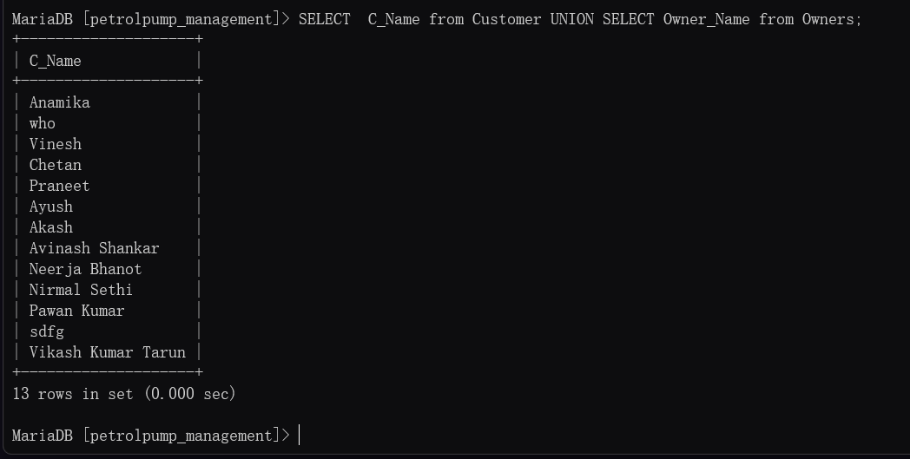

Functions and Procedures:

Create a Function and Procedure. State the objective of the function / Procedure. Run and display the results.

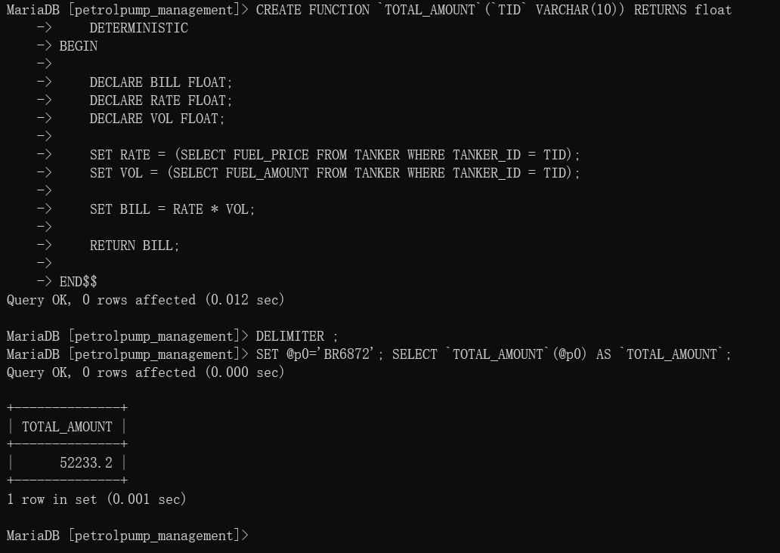

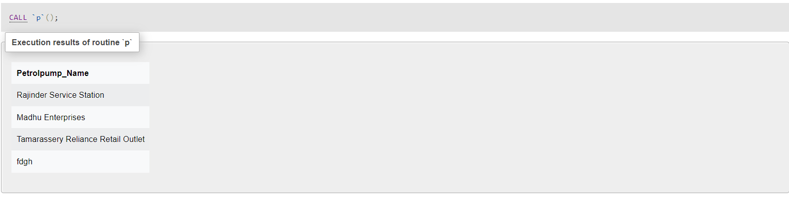

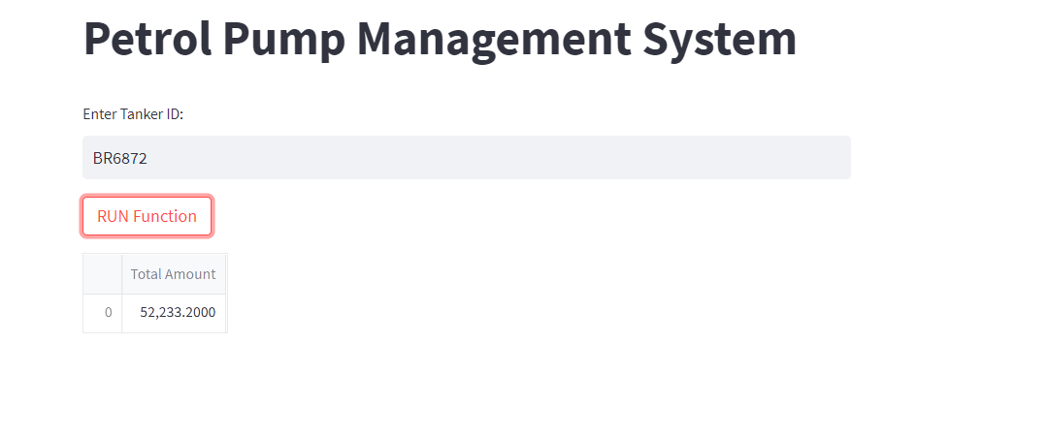

Triggers and Cursors:

Create a Trigger and a Cursor. State the objective. Run and display the results.

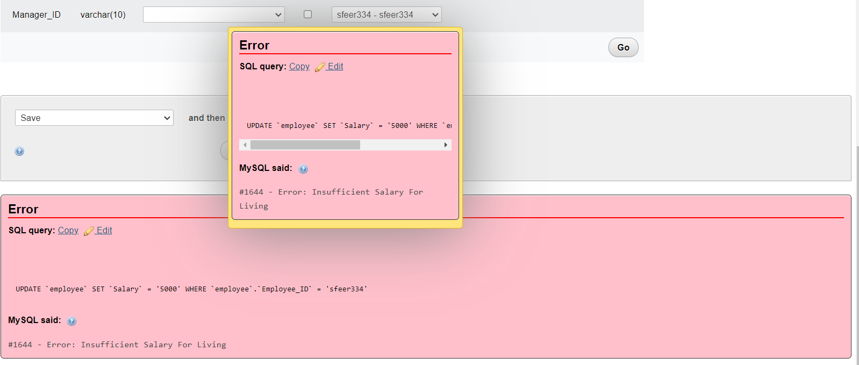

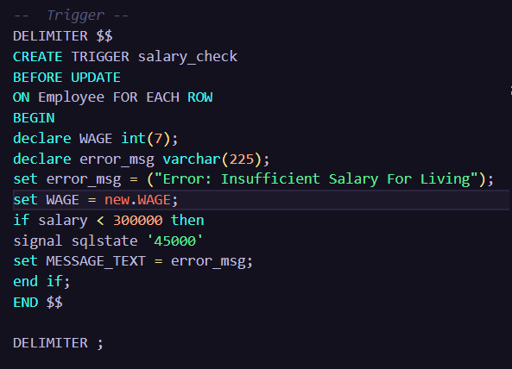

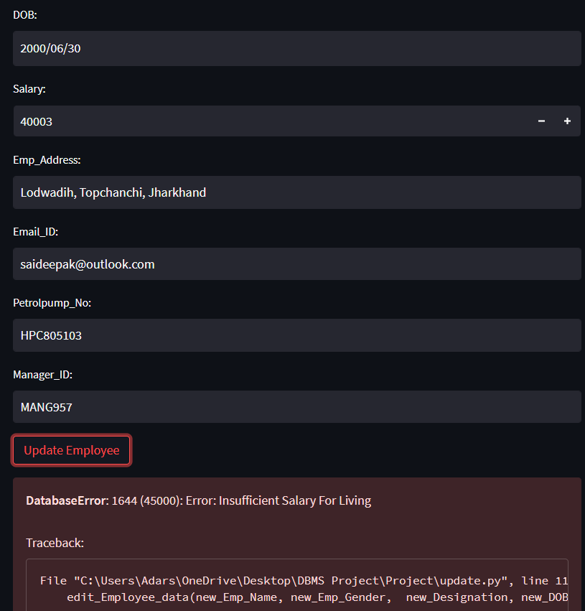

Developing a Frontend:

The frontend should support

1. Addition, Modification and Deletion of records from any chosen table

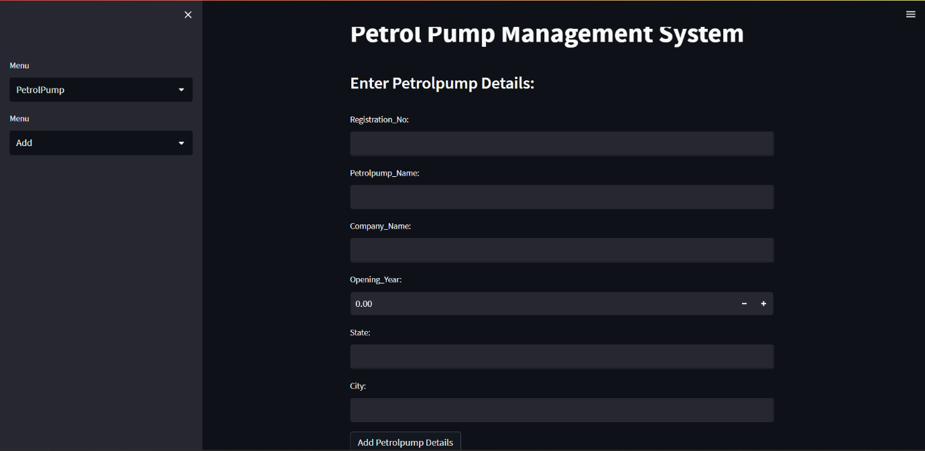

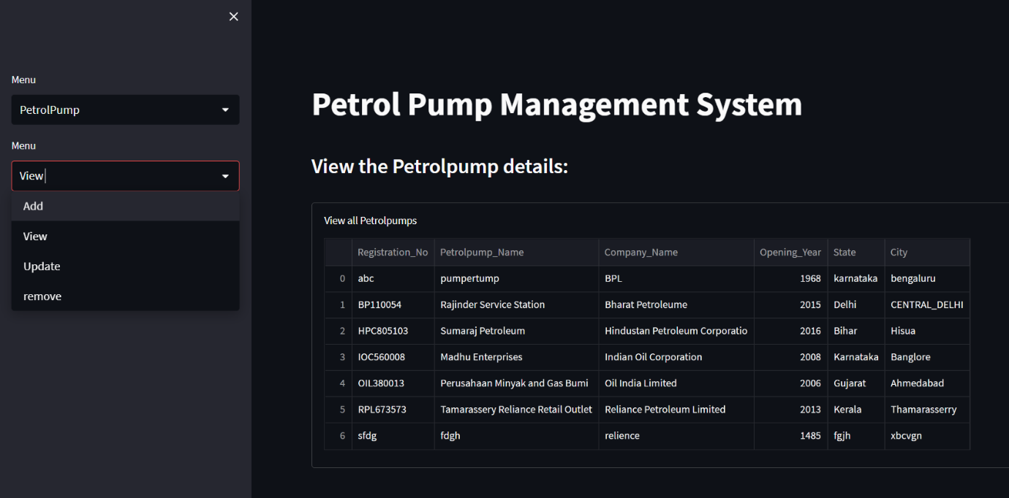

2. There should be a window to accept and run any SQL statement and display the result

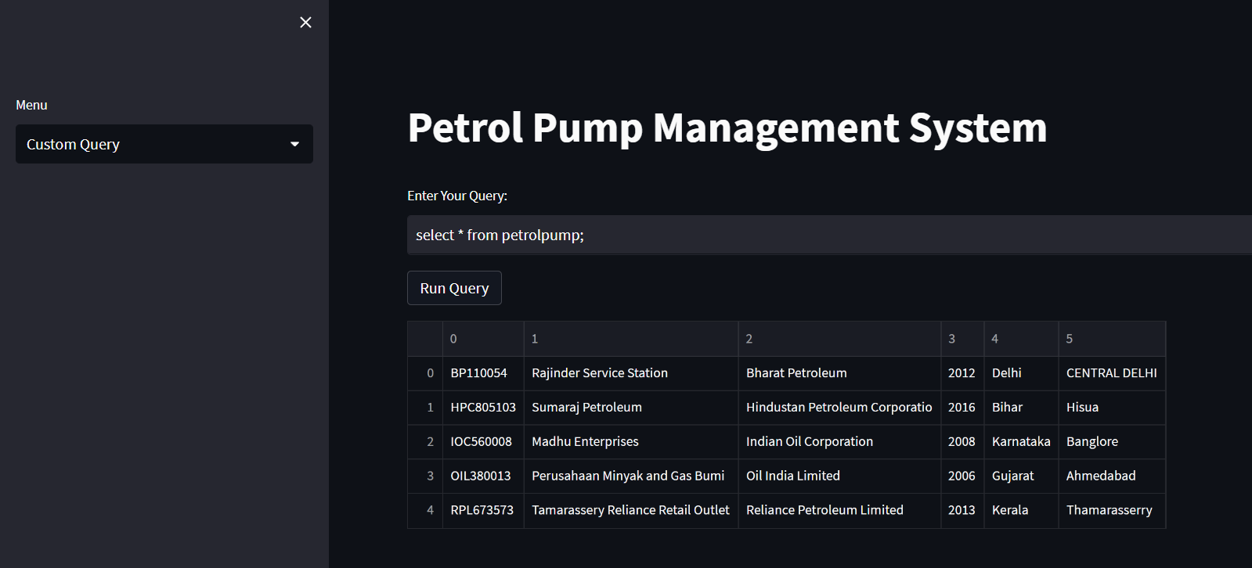

Modification:

Q) Create a procedure such that on call It should show the total sales and sales amount of a particulate month?

* Procedure

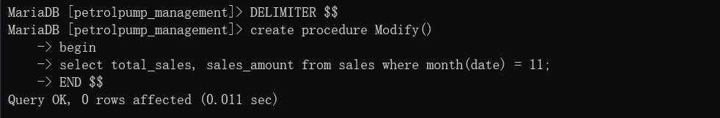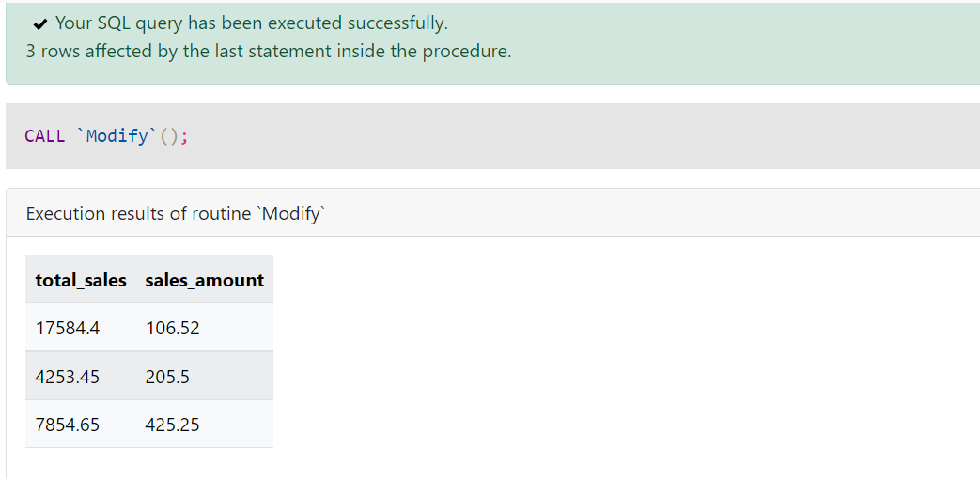

* Function

