ThinkTap
MVP V1 — Product Specification
Human Thought Operating System (HTOS) — V1 build
Voice-only capture · Zero manual structuring · AI organizes, not the user

1. Mission & Vision
This is the reason ThinkTap exists. Every decision in this document — including every scoping cut — is a step toward this, not a departure from it.
ThinkTap Mission Statement
Every person sees the world through a unique lens. Even when two people experience the exact same moment, the meaning they derive, the emotions they feel, the lessons they learn, and the ideas they generate are entirely their own. These unique perspectives are the very essence of humankind. They are the source of innovation, creativity, empathy, problem-solving, culture, research, storytelling, and progress itself. Yet billions of these original thoughts disappear every day — not because they lack value, but because capturing them requires too much effort. We believe that allowing humanity's unique perspectives to vanish without preserving them is an injustice to humanity.
ThinkTap exists to change that. Our mission is to make thought capture completely frictionless, allowing people to preserve the exact moment an idea is born before it fades away. With a single action, a thought can be captured without typing, organizing, reviewing, or interrupting the flow of life. Technology should adapt to the human mind — not force the human mind to adapt to technology. ThinkTap quietly preserves the moment while the idea is still alive.
We believe the future of human knowledge will not be shaped only by writers, filmmakers, founders, researchers, or creators. It will be shaped by every individual whose unique perspective deserves to be remembered. By preserving these authentic human thoughts at the moment they are created, ThinkTap aims to build a living archive of humanity's collective intelligence — one that inspires ideas, fuels creativity, advances knowledge, connects people, and creates value for generations to come. No meaningful thought should be lost simply because it was never captured.

1.1 What "HTOS" means
ThinkTap is the first implementation of a Human Thought Operating System (HTOS) — a long-term architectural identity, not a V1 feature. The way an operating system manages a computer's resources without ever becoming the author of what runs on it, HTOS organizes, preserves, and grows human thinking without ever becoming the author of that thinking.

1.2 Mission vs. V1 Hypothesis
The Mission is the permanent "why," kept separate from the narrower, testable Core Hypothesis (Section 2) so V1 stays small enough to actually ship, while the team stays oriented toward something bigger than a feature list.

2. Problem
People have thousands of valuable thoughts and lose most of them because there is no effortless way to capture an idea the moment it occurs. ThinkTap solves this with one narrow V1 capability: voice-only capture with zero manual structuring, followed by AI-driven organization so the thought can be found again using whatever fragments the user remembers.
Core Hypothesis (what V1 exists to test)
People will consistently capture authentic thoughts if the process is effortless, and those thoughts will become more valuable to them over time as they become easy to rediscover.
Initial user: filmmakers and creative storytellers.
Chosen for strategic reasons — constant fleeting inspiration, high cost of losing an idea — not technical ones. Nothing in the backend, data model, or AI architecture should be filmmaking-specific.

3. Product Principles

3.1 The 80/20 Framework
Core architecture principle
ThinkTap is an 80/20 system. The user contributes the irreplaceable 20% — their unique perspective, intent, context, interpretation, and aspiration. AI contributes the remaining 80% by organizing, connecting, expanding, retrieving, and surfacing opportunities, without ever replacing the original human signal.

3.2 Priority order — when in doubt
Before the detailed rules below, this is the order that resolves any conflict between them:
- Volume of authentic capture beats every other metric.
- Simplicity and low distraction beat feature richness.
- Authenticity beats completeness — preserve gaps and contradictions, don't fill them.
- The Human Signal always outranks AI output when the two are ever in tension.

3.3 Human Signal vs. AI Core Insight vs. AI Intelligence
Layer | What it is | Job
Human Signal | Exactly what the user said, preserved verbatim. | Source of truth. Permanent. Never modified, no matter how far the Intelligence layer travels from it.
AI Core Insight | A short, faithful recognition aid generated from one thought's Human Signal. | Help the user instantly remember why this one thought mattered. Never expands beyond what was said.
AI Intelligence | Background classification, connections, and open-ended possibility generation across one or many thoughts. | Reveal how far a thought could travel. No domain ceiling — see Section 3.5 for the actual boundary.

3.4 What each layer can and cannot do
Each layer has its own rules — they are not interchangeable, and a rule that's correct for one layer would be wrong applied to another.

Human Signal — capture only
DOES  - Records exactly what the user said.  - Performs light filler-word and grammar cleanup that doesn't change meaning. | NEVER  - Rewrites, summarizes, merges, or reinterprets the words.  - Infers or adds anything the user didn't actually say.

AI Core Insight — faithful compression of one thought
DOES  - Reflects only the single thought it was generated from.  - Helps the user instantly recognize why that one thought mattered. | NEVER  - Expands beyond that one thought's own content.  - Pulls in other thoughts, categories, or outside possibilities.  - Gets used as the retrieval index — search always runs on the Human Signal.

AI Intelligence — exploratory, multi-thought, unrestricted in reach
DOES  - Classifies and connects across the user's whole library.  - Recognizes when different phrasings point to the same concept, for matching and clustering purposes — without editing either original phrasing.  - Generates possibilities as far-reaching as the Relativity Rule allows (Section 3.5).  - Always labels its own output as optional and speculative. | NEVER  - Presents a generated direction as fact or certainty.  - Gets modified into, or treated as equal to, the Human Signal.  - Forces itself on the user — they always choose whether to open it.

3.5 The Relativity Rule — how far AI Intelligence is allowed to travel
This is the detailed version of the boundary named in Section 3.4 above, and it is not about domain distance:
The Relativity Rule
A leap can travel as far as it wants — domain distance is not the risk. The risk is losing the traceable thread back to the mechanism the human actually identified. Gold-standard leaps go far and stay recognizably connected to that mechanism, so the user can follow the logic even when they're surprised by where it landed. A leap that changes domain without carrying the thread with it isn't insight — it's a coincidence dressed up as one.

Do — the gold standard
Example: a parent
Signal: "He eats anything now if he grew it himself. I think ownership matters more than taste when it comes to kids and food." AI Intelligence generalizes the underlying mechanism — people commit more to what they helped create — into an employee engagement framework, a community-garden public health campaign, a UX design principle ("let users customize to drive adoption"), and a talk on ownership and behavior change. The domain jump is large (parenting to workplace design), but the thread — ownership drives commitment — is intact and immediately recognizable once stated.

Weak — technically correct, not a real leap
Example: a nurse
Signal: "Most people just want to be heard, not fixed. Healthcare undervalues listening as a skill." AI Intelligence extends this into training workshops, school curricula, and certification courses. This is correct but low-difficulty — "listening matters" was already domain-general in the original thought, so this barely counts as travel at all.

Don't — thread lost
Example: a business owner (do not repeat this pattern)
Signal: "A customer returned a product because the packaging made them feel guilty about the waste." A failed AI Intelligence leap treats this as evidence for medication adherence campaigns and student engagement programs. There is no traceable mechanism connecting "guilt about wasted packaging" to "taking medication" — the domain changed, but the thread didn't come with it. The Human Signal wasn't altered, and it still fails: relativity, not verbatim preservation, is what breaks here.

The same signal, done right
Example: same business owner, thread preserved
The real mechanism is guilt over unused or wasted value, not packaging specifically. Carried correctly: subscription cancellations often come from guilt about paying for something unused, not price. Restaurant "waste-conscious" portion options exist because diners feel guilty about leftovers. Charitable giving lapses from guilt about not seeing impact, not cost. None of these are retail — all of them are recognizably the same emotional mechanism, just relocated.
No matter how far a leap travels, the user always decides whether to absorb it
The Intelligence layer's only job is to reveal that a direction exists. It never becomes part of the record, and the user is never required to accept it, act on it, or even look at it. Not showing a direction the system found keeps the user in a box they didn't know they were in — showing it and letting them choose is the entire value of this layer.

4. Scope

4.1 In Scope — V1
- Voice capture of a thought (start/stop mechanism — Section 8, open decision).
- ThinkFlow — coaching prompt shown before capture (Section 7).
- Extraction of exactly two Human Signal fields: Source of Inspiration, Thought.
- AI Core Insight generation per captured thought — faithful, non-expansive.
- Basic hidden AI Intelligence tagging (simple classification only, not the deep relativity-driven expansion — see Section 9).
- Semantic search/retrieval over the full Human Signal.
- Search result cards: Source + Thought + AI Core Insight, each truncated to fit available space, ending in an ellipsis.
- Sorting: Best Match, Newest First, Oldest First, Recently Visited, Dormant Gems (basic heuristic).
- Expanded Thought View: full Source, full Thought, full AI Core Insight.
- One persistent, universal capture control — no separate "Continue Thinking" screen.
- Local-first storage for everyone; Free = permanent local, Subscriber = syncs to cloud.
- Free and Subscription pricing tiers (Section 10).
- Delete a thought; export data where supported (export gating — see Section 10, flagged for final confirmation).

4.2 Next Build Priority — not V1, but immediately after (Section 9)
- Deep AI Intelligence expansion (relativity-driven, cross-domain opportunity discovery).
- Retap — redesigned, content-specific daily resurfacing notifications.
Both are grouped as one build because they depend on the same underlying capability and were designed together — see Section 9 for the full specification and reasoning.

4.3 Deferred, further out (Section 12 — Future Vision)
- Human Signal fields beyond Source of Inspiration + Thought.
- Marketplace, publishing, licensing.
- Outcome-based content generation services (books, screenplays, patents).

4.4 Explicitly Out of Scope — V1
- Manual folders, tags, titles, or categorization of any kind.
- Editing or rewriting a captured Human Signal.
- Collaboration, sharing, comments, social features, team workspaces.
- AI co-writing or AI content generation of any kind.
- Knowledge graphs, relationship visualizations, analytics dashboards.
- Task management, calendar integration, third-party integrations, plugin ecosystem.

5. Core User Journey & Screens
V1 has three screens: Capture, Search, View. A single persistent capture control (floating button) is reachable from Search and View — tapping it always opens the exact same distraction-free Capture screen.
- Capture — speak; nothing else competes for attention. ThinkFlow sits as a single collapsed line unless it's one of the user's first few recordings.
- Search — type remembered fragments; results narrow progressively.
- View — read the three anchor fields in full; persistent capture button is always one tap away.
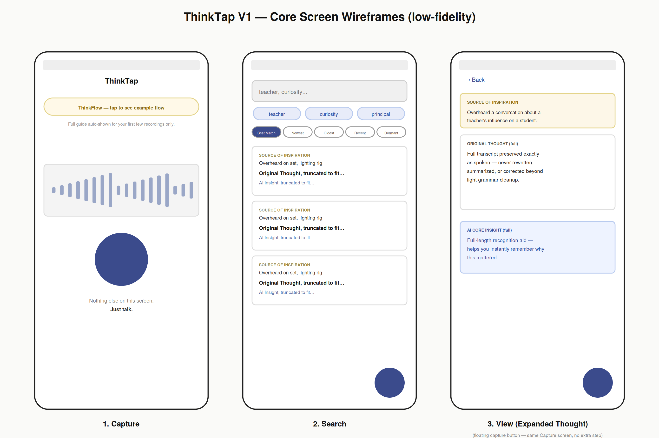
Low-fidelity reference wireframes — for team alignment, not final UI design.

6. Data Flow & Lifecycle

6.1 Data Flow
Principle: capture first, process later. A user's ability to preserve a thought must never depend on network connectivity or AI availability.
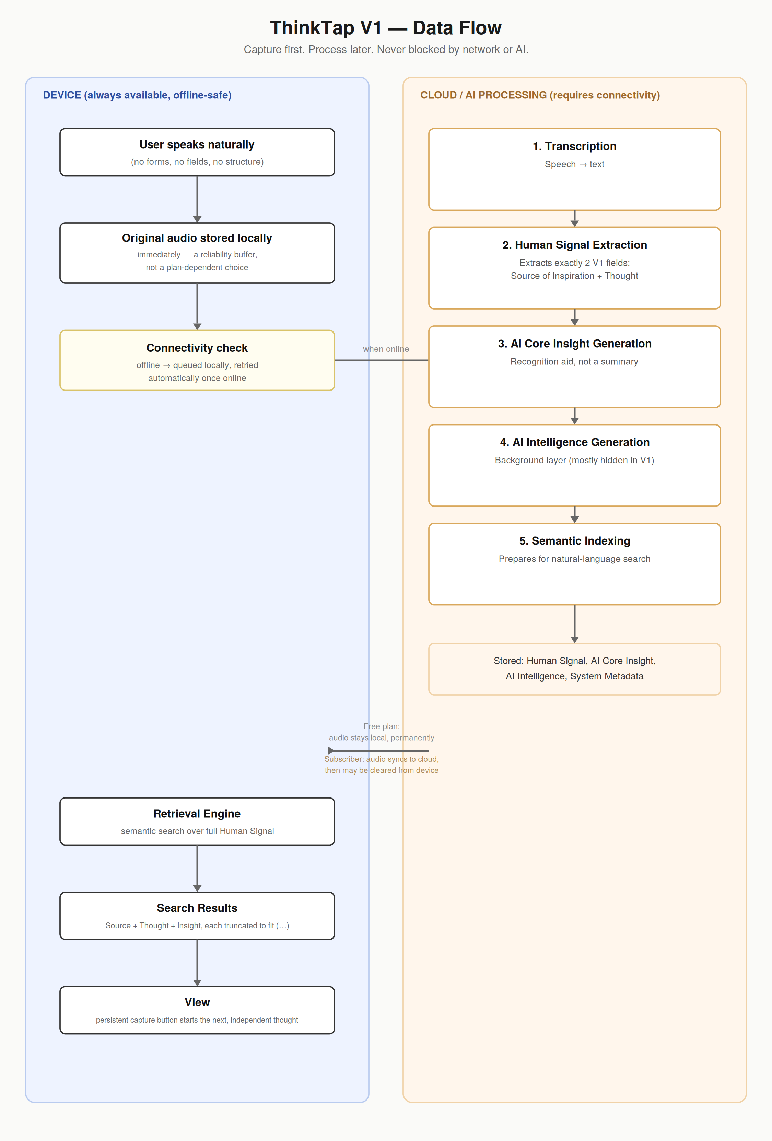

6.2 Thought Lifecycle
Every captured thought moves through the same six stages. The single rule that governs all of them: the Human Signal never changes — only the intelligence built around it evolves.
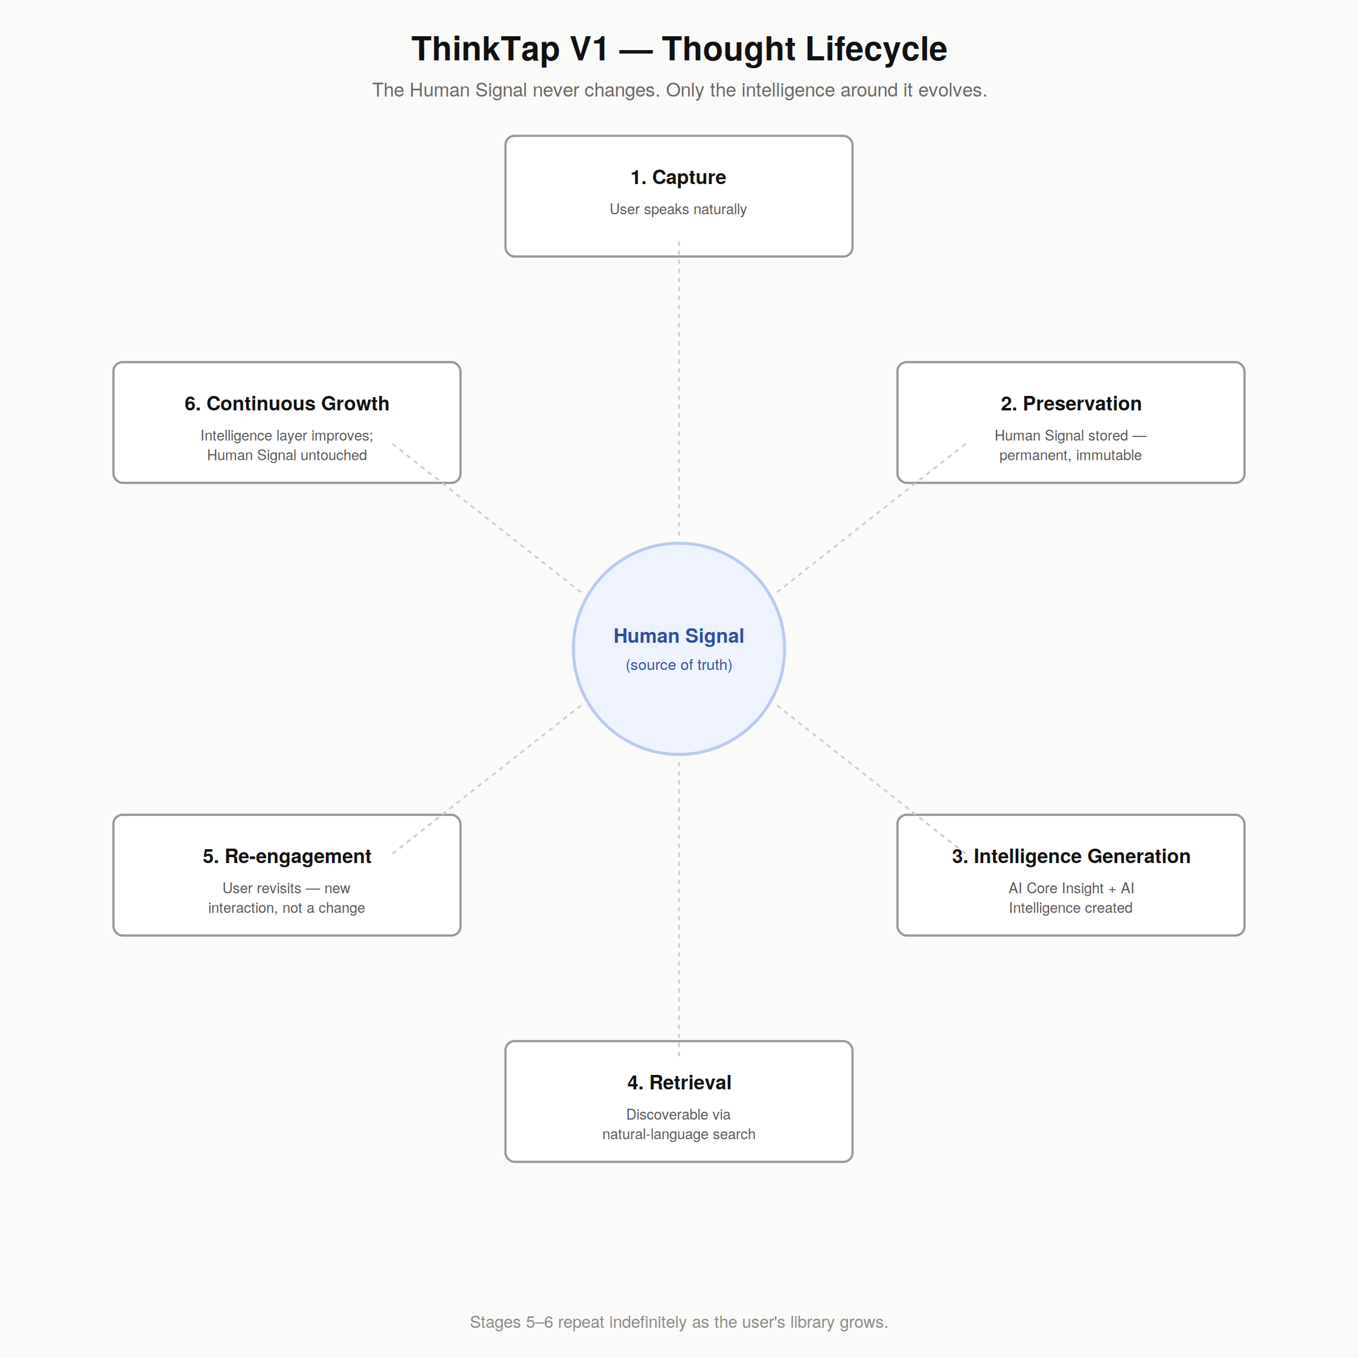
- Capture — user speaks naturally.
- Preservation — Human Signal stored permanently and immutably.
- Intelligence Generation — AI Core Insight and AI Intelligence are generated around it.
- Retrieval — discoverable through natural-language search.
- Re-engagement — each revisit is a new interaction, never a modification.
- Continuous Growth — future AI improvements can enrich the thought without the user ever recapturing or editing it.

6.3 Data Ownership — Private Vault
Every captured thought lives in the user's private vault by default. ThinkTap never publishes, shares, or exposes it without the user's explicit action.

7. Fields & Entities

7.1 Human Signal (user-authored — source of truth)
Field | Purpose | V1 Status
Thought | The original spoken idea, verbatim (light grammar/filler cleanup only, meaning never altered). | In scope
Source of Inspiration | What triggered the thought, when the user says so explicitly. | In scope
Reason, Potential Value, Connected Thoughts, Actionability, Expansion Paths | Richer context the user may naturally mention. | Deferred — stays inside the raw Thought text in V1, not extracted separately

See Section 9 for the single, real ThinkFlow prompt — shown both as the system's field-mapping illustration and as the exact text the user sees.

7.2 AI-Generated Layers
Entity | Purpose | Visible in V1 UI?
AI Core Insight | Recognition aid shown after Thought + Source — reconstructs why the thought mattered. Not a summary; truncated to fit available card space in search results. | Yes — search results (truncated) and Expanded View (full)
AI Intelligence — basic (V1) | Simple background classification only. No relativity-driven expansion in V1. | No — generated and stored, not exposed
AI Intelligence — deep (Next Build) | Full relativity-driven opportunity discovery. See Section 9. | Not in V1

7.3 System Metadata (invisible to user)
- Unique thought ID, capture timestamp, last-accessed timestamp.
- Processing status (queued / processing / complete).
- Version references for regenerable AI outputs.

8. Retrieval & Search
Search runs against the full Human Signal, not the AI Core Insight — the Insight is deliberately partial and must never be the retrieval index.
- Progressive refinement: user adds remembered fragments one at a time; results narrow with each addition.
- Sorting: Best Match (default), Newest First, Oldest First, Recently Visited, Dormant Gems (basic heuristic in V1).
- Search result card shows Source, Thought, and AI Core Insight — each independently truncated to whatever fits the available card space, ending in an ellipsis (…).
- Semantic matching recognizes different phrasings of the same concept — searching "Bollywood movie" also surfaces a thought that only ever said "movie in Bollywood." This is matching, not correction: neither original phrasing is ever changed, only recognized as related.
Free vs. paid split for this behavior
The matching itself is Free, for every user, no exception — per the Pricing Philosophy (Section 12.2), finding a thought you already captured is baseline retrieval working correctly, not a value-add. A free user must never miss their own thought just because they phrased the search differently than the original capture. What stays gated (Section 11) is the explicit surfacing of the connection itself — e.g. a View-screen callout or Retap notification saying "these two thoughts are related." Search quietly gets smarter for everyone; being told about the connection stays part of what you pay for.

9. ThinkFlow — "Speak to Your Future Self"
ThinkFlow shows you what a spoken thought can sound like — from what sparked it to where it might lead — so that when your future self hears it again, months or years from now, they instantly understand what you meant.
Shown in full automatically for a user's first few recordings. After that, it collapses to a single tappable line — "ThinkFlow — tap to see example flow" — the only other control on the Capture screen besides the mic. Tapping it re-opens the full text on demand.

Version 1 — field-mapping illustration (engineering reference only)
Shows how the same guidance below maps to the two V1 Human Signal fields. This bracketed version is never shown to the user — it exists purely so the team can see the connection between the prompt and what gets extracted.
For illustration only — not shown to the user this way
ThinkTap works best when you imagine you're talking to your future self — not to an AI, not to an audience, and not to write perfect notes.
When something sparks a thought, start by explaining what happened or what triggered the idea (Source of Inspiration). Then describe the thought or realization that came to you (Thought). Explain why it felt important to you (Potential Value). If it reminded you of something you've been thinking about before, mention that connection (Connected Thoughts). If you already know who it could help or what problem it might solve, mention that too (Actionability / Potential Value). If you have ideas on where this thought could grow in the future, share them (Expansion Paths).
If you don't know any of these yet, that's perfectly fine. ThinkTap is designed to grow with incomplete thoughts.
The richer the context you naturally provide, the more valuable your thoughts become when you revisit them months or years later.
Per Section 7.1, only the two bracketed terms Source of Inspiration and Thought are extracted as structured fields in V1. Potential Value, Connected Thoughts, Actionability, and Expansion Paths are shown here only to prove the mapping — everything the user says about them stays inside the raw Thought text.

Version 2 — exactly what the user sees
Same text, no brackets, no field names. This is what appears in the app, both automatically for the first few recordings and whenever ThinkFlow is tapped open afterward.
Load this exactly as written — the only prompt shown to the user
ThinkTap works best when you imagine you're talking to your future self — not to an AI, not to an audience, and not to write perfect notes.
When something sparks a thought, start by explaining what happened or what triggered the idea. Then describe the thought or realization that came to you. Explain why it felt important to you. If it reminded you of something you've been thinking about before, mention that connection. If you already know who it could help or what problem it might solve, mention that too. If you have ideas on where this thought could grow in the future, share them.
If you don't know any of these yet, that's perfectly fine. ThinkTap is designed to grow with incomplete thoughts.
The richer the context you naturally provide, the more valuable your thoughts become when you revisit them months or years later.
Purpose: not to teach users how to satisfy the AI, but to maximize capture of human signal. If the user still doesn't mention something, that's fine — the system records what exists and never infers the gap.

10. Capture Start/Stop Mechanism — Open Decision
Status: unresolved by design — requires engineering R&D before lock
Founder's target is fully hands-free (auto-start, auto-stop). This is not guaranteed achievable in V1 and must be tested, not assumed.

10.1 Start
- R&D whether always-listening background capture is technically and platform-feasible. iOS restricts third-party background microphone access outside Siri-level integration.
- Fallback if infeasible: single-tap trigger — lock-screen action button, hardware/power-button shortcut, or home-screen widget.

10.2 Stop
- Test silence detection (duration tuned so natural thinking pauses aren't misread as "done") against a fixed trigger phrase (e.g. "TT stop").
- Silence detection is the required fallback: language-agnostic, no false-trigger risk. Ship V1 with it working even if the trigger-phrase track isn't ready.

11. Next Build Priority — Deep Intelligence & Retap
Status: not V1 — the top priority immediately after. Pull forward into V1 only if backend/AI feasibility genuinely allows it without delaying launch.
This is a discussion point for the team, not a locked commitment. Flagging it in detail now so the architecture underneath V1 doesn't have to be reworked later to support it.

11.1 Deep AI Intelligence Expansion
The full relativity-driven capability described in Section 3.4 — taking a Human Signal and generating genuinely cross-domain opportunity directions, always keeping the traceable thread back to the original mechanism. This is the layer with real monetization weight: it's what makes a user feel "my one thought has this much potential," not just "my notes are organized."
- Governed entirely by the Relativity Rule (Section 3.4) and the AI Do's/Don'ts (Section 3.2) — never shown as fact, always optional, Human Signal never touched.
- Depends on a large enough personal library to generate genuine cross-thought connections — not meaningful on a handful of captures.

11.2 Retap — redesigned
Retap resurfaces specific, concrete previews from the user's own library — never a generic "come check in" reminder.
- Content examples: "Two of your thoughts could combine into a product concept," "This line reads like a ready-to-post quote," "This thought could expand in three directions."
- Fully free, no gate: low-cost, high-delight reveals (e.g. a polished quotable line) — given in full to free users, to prove the product works before anyone's asked to pay.
- Teased, gated: higher-value expansions (e.g. "this could become a product") — enough specificity to hook curiosity, full detail behind subscription.
- Default frequency: Daily, adjustable to Weekly or Off.
- Guarantee: never fires during active recording — triggered purely by app state (not mid-capture), not by whether the phone is idle elsewhere, which ThinkTap has no way to detect without violating Section 13's privacy principle.

Notification permission prompt
Enable Retap Alerts and let ThinkTap surprise you.

We promise Retap will never interrupt you while you're
capturing a thought.

Retap only appears when it has something genuinely
valuable to show you.

Turn it on to watch your thoughts grow, connect,
transform, and soar beyond what you ever imagined.

Where the "magic" surfaces
Where | What it shows | Free sees | Subscriber sees
Search result card | Small badge: "Connects to 2 other thoughts →" | Badge only | Tap to reveal the connection
View screen, below Core Insight | Collapsed line: "This thought may have more potential" | Line only, locked | Tap to expand full Opportunity list
On opening Search | Soft in-app banner: "3 new connections found this week" | Banner, locked detail | Tap to explore

12. Storage, Sync & Pricing

12.1 Storage — framed around privacy, not tiers
Free tier is positioned as a privacy choice, not a limitation: if you want to keep everything completely private, local storage is that option, in full, with no artificial cap on how much a user can capture. Cloud is mentioned only at the bottom of the premium feature list, briefly — sync mechanics live in the FAQ, not in the pitch.
- No hard ceiling on free-tier local storage. An artificial cap that blocks capture would contradict the "never disturb capture" principle.
- The natural ceiling free users eventually meet is their own device running out of space — already a real, organic reason to consider cloud, with no invented one needed.
- FAQ (linked clearly under pricing, not buried) explains sync mechanics: audio uploads once online, and — once safely synced — may be cleared from device storage.

12.2 Pricing Philosophy
Guiding principle
Never charge users to preserve their thinking. Charge only when ThinkTap significantly increases the value of that thinking. AI Intelligence is the product — not storage, not sync.

12.3 Pricing — V1
Plan | Includes
Free | Unlimited capture and retrieval, no storage cap  Full privacy — everything stays on-device  AI Core Insight  Basic Dormant Gems sorting  Some Retap reveals shown in full (Section 11.2)
ThinkTap Intelligence (subscription) | Deep AI Intelligence expansion (Section 11.1, once built)  Full Retap — all gated previews unlocked  Cross-thought pattern discovery and opportunity detection  Cloud backup and multi-device access (mentioned briefly — see FAQ for sync details)  Everything in Free

12.4 Export — flagged for final confirmation
Recommended: Free = capture, search, and view only; export is a subscription-only capability, consistent with the guiding principle above (export increases portability/value, rather than being required to preserve the thought itself). This is noted as a recommendation pending your explicit final confirmation — see Open Decisions Log.

13. Non-Functional Requirements

Reliability
Losing a captured thought is the highest-severity failure class in the system. A thought that vanishes can never be recreated.

Performance
Capture must feel instant. Any hesitation here directly suppresses the one metric that matters most: volume of captured thoughts.

Trust
Users must always be able to tell, without thinking about it, which words are theirs and which are AI-generated.

Privacy
Collect only what's required to operate; never expose a thought, or infer anything from behavior outside the app, without explicit user action.

Scalability
Retrieval quality, sorting, and responsiveness must hold from tens to thousands of captured thoughts without requiring a redesign.

14. Future Vision (explicitly not V1 or Next Build — distant context only)
Read this as roadmap context, not a build target
Nothing in this section is scoped, estimated, or scheduled.

14.1 Marketplace
- Private-first remains permanent default; publishing is always an explicit, later, reviewed decision.
- Publishing requires explicit consent and a separate Marketplace Agreement.

14.2 Long-Term Monetization
- Outcome-based services to investigate: licensing, book creation, screenplay generation, founder strategy, patent assistance.
These are content-generation and advisory services, outside ThinkTap's core principle that AI never generates content on the user's behalf. If pursued, they need their own product boundary.

14.3 Product Philosophy Guardrail
Default user mindset for every future feature: "I'm talking to my future self," not "I'm creating content for other people." HTOS grows by adding more ways to preserve and surface human perspective — never by adding ways to generate content that could pass as a person's own thinking.

15. Appendix — Master Field Architecture (Team Reference Only)
Full future-state field taxonomy, kept here for team context. None of this is V1 scope — Section 7 defines what V1 actually builds. This exists so the team can see where the AI Intelligence layer (Section 3.3, Section 9, Section 11) is headed.

15.1 Intelligence Layer — future fields (hidden by default)
Field | What it is | Why it exists
Thought Type | What kind of thinking this is. | Reusable cognitive classification, better clustering.
Domain / World | Which area of life it belongs to. | Universal organization, cross-domain retrieval.
Emotion | Dominant emotional state. | Emotional search.
Confidence | Estimated certainty. | Separates conviction from exploration.
Potential Value | Who may benefit. | Opportunity discovery.
Actionability | Possible next step. | Supports incubation.
Missing Pieces | What's absent from the thought. | Coaching, idea improvement.
Expansion Paths | Future formats the idea could take. | Creative leverage.
Connected Thoughts | Links across the user's library. | Long-term memory, discovery.
Originality Signals | Novelty estimate. | Surfaces distinct ideas, marketplace potential.
Intellectual Asset Score | Overall potential, internal ranking only. | Portfolio focus — never shown as a verdict.
Rarity | Uniqueness within the user's own history. | Identity/pattern discovery.
Momentum | Recurring themes over time. | Life-work detection.
Lifecycle Stage | Idea maturity. | Progress tracking.
Energy | Voice dynamics. | Additional context.

15.2 System Metadata — future fields
Field | What it is | Why it exists
Visibility | Private/Public. | Foundation for future marketplace, off by default.
Device | Capture source. | Reliability infrastructure.
Location (optional) | Context, only if permitted. | Reliability infrastructure.
Semantic Index | Search embeddings. | Reliability infrastructure.
Model Version | AI model provenance. | Reliability infrastructure — enables safe regeneration.

16. Open Decisions Log

16.1 Resolved this session
- ThinkFlow — final name for the coaching prompt, full script locked, collapse-to-one-line behavior specified.
- Relativity Rule adopted as the actual governing boundary for AI Intelligence — replacing the earlier, more conservative "extrapolation only" language.
- Three teaching examples locked (gardener = Do, nurse = weak, business owner = Don't + corrected Do version).
- Deep Intelligence + Retap grouped as "Next Build Priority," separated from both V1 scope and the more distant Future Vision.
- Retap revived from "deferred" status — redesigned around specific content previews, free/gated split, daily default, capture-time guarantee.
- Storage/pricing reframed: local storage positioned as a privacy choice, not a limitation; cloud mentioned briefly, sync detail moved to FAQ.
- Master Field Architecture doc folded in as a team-reference appendix, not V1 scope.

16.2 Still open — needs founder/team confirmation
- Export gating — recommended subscription-only, not yet explicitly confirmed (Section 12.4).
- Final capture start/stop mechanism — pending engineering R&D (Section 10).
- Multi-language scope for ThinkFlow and any trigger phrase.
- Exact threshold/heuristics for when Deep Intelligence has "enough library" to activate meaningfully.

