CUSTOMER DATA |  |  |  |  |  |  |  |  |  |  |  |  |  |  | INTERTEK DATA
Name: |  |  | ADNOC Onshore  P.O. Box 270, Abu Dhabi, UAE |  |  |  |  |  |  |  |  |  |  |  | Intertek Project No. |  |  |  |  | 106792-25
Address: |  |  |  |  |  |  |  |  |  |  |  |  |  |  | Client P.O./I.O. to Intertek: |  |  |  |  | -
Attn: |  |  | Islam Khalifa |  |  |  |  | Phone: |  |  | +971 0567857160 |  |  |  | Requisition No: |  |  |  |  | P30339B-RFI-INST-008-ARC-INT-KSB-0113
E-Mail: |  |  | i.khalifa@adco.ae |  |  |  |  |  |  |  |  |  |  |  | Date of Order: |  |  |  |  | 29-Jun-26
Copies to: |  |  |  |  |  |  |  |  |  |  |  |  |  |  | Intertek Contract Coordinator: |  |  |  |  | Chethan Ramesh
SUPPLIER/SUB-SUPPLIER DATA |  |  |  |  |  |  |  |  |  |  |  |  |  |  | INSPECTION INFORMATION
Inspection  Performed: |  |  | With Customer Supplier With Sub-Supplier |  |  |  |  |  |  |  |  |  |  |  | Date(s) of Visit(s): |  |  |  |  | 15/06/2026
P.O. No:  04108-PM-INST-008 |  |  | Change No: N/A |  |  |  |  |  |  | Requisition No: N/A
 |  |  |  |  |  |  |  |  |  |  |  |  |  |  | Date of Previous Visit: |  |  |  |  |  | N/A
Supplier: |  |  | KSB MIL CONTROLS LIMITED Meladoor, Annamanada - 680741, Kerala, India. |  |  |  |  |  |  |  |  |  |  |  | Date of Next Scheduled Visit: |  |  |  |  |  | 16/07/2026
 |  |  |  |  |  |  |  |  |  |  |  |  |  |  | P. O. Status: |  |  | Complete Incomplete
Supplier Job No: |  |  |  |  |  |  |  |  |  |  |  |  |  |  | Project Name:
Location: |  |  | Meladoor, Annamanada - 680741, Kerala, India |  |  |  |  |  |  |  |  |  |  |  | ADNOC SE AiP5 PROJECT (ON PLOT) – ASAB/SAHIL (PACKAGE 1)
Primary Contact: |  |  | Mr. Alex Davis (KSB MIL Contract Management) |  |  |  |  |  |  |  |  |  |  |  | Materials/Items Inspected:  Control Valve
Phone: | +91 480 2695832 |  |  |  | E-mail: |  | Alex.Davis@ksb.com
Sub-supplier: |  |  | xxxxxxxxxxxxxxx
Sub-Supplier Job No: |  |  | xxxxxxxxxxxxxxx
Location: |  |  | xxxxxxxxxxxxxxx
Primary Contact: |  |  | xxxxxxxxxxxxxxxxx |  |  |  |  |  |  |  |  |  |  |  | Pre-Inspection Meeting Summary Attached: |  |  |  |  |  |  | Yes No
Phone: | xxxxxxxxxxxxxxxxxx |  |  |  | E-mail: |  |  | xxxxxxxxxxxxxxxxxx |  |  |  |  |  |  | Summary Report Attached: |  |  |  |  |  |  | Yes No
INSPECTION DISPOSITION: |  |  |  | Accept |  |  | Nonconformance(s) Identified |  |  |  |  |  |  |  |  | Placed on Hold |  |  |  | Other (Explain)
INSPECTION SUMMARY AND CONCLUSION:
As per P30339B-RFI-INST-008-ARC-INT-KSB-0113, the scope of the visit included shell pressure test, DPT after machining, PMI and Surface Preparation & painting at M/s KSB Mil Control Ltd.
The inspection was conducted in accordance with ITP No. P30339B-30-99-52-4607, covering the inspection of Contol Valves and its Components. All inspection activities were carried out as per ITP Clause Nos. 6.1, 6.2,6.3,8.7 & 8.10
Day 1 (13/07/2026)
No.6.3: Positive Material Identification:– PMI conducted for the components of control valves
Result: Acceptable

Day 2 (14/07/2026)
No.6.2: DPT after machining:- Conducted DPT for the BONNET and BODY
Result: Acceptable
Day 3 (15/07/2026)
No.6.1: Shell Pressure Test:- Shell pressure test for
1. Valve SL no: - 25008081 (Job number CD13E072)
2. Valve SL no: - 25008076 (Job number CD13E032)
3.Valve SL no:- 25008077 (Job number CD13E033)with body and bonnet
Result:- Acceptable
No 6.2: DPT :- Conducted DPT for STEM and SEAT RING
Result:- Acceptable
RECOMMENDED ACTION:
INSPECTION TIME: |  |  | DAYS  HOURS |  |  | 1 |  |  |  |  |  | TRAVEL HOURS: | 5 |  |  |  |  |  | DISTANCE:  MI KM |  |  |  | 160 KM
Technical Specialist: |  | XXXXXXX |  |  | Date: |  |  |  | XXXXXXXX |  |  |  |  | Project Coordinator:
This report is made solely on the basis of the Client’s instructions and/or information and materials supplied. It is not intended to be a recommendation for any particular course of action. Intertek does not accept a duty of care or any other responsibility to any person other than the Client in respect of this report and only accepts liability to the Client insofar as is expressly contained in the terms and conditions governing Intertek's provision of services. Intertek makes no warranties or representations either express or implied with respect to this report save as provided for in those terms and conditions.

- ATTENDEES

NAME | COMPANY REPRESENTED | TITLE
Adarsh MS | InterTek OBO ADNOC | Inspection Engineer
Jithin KB | KTI OBO ARCHIRODON | Inspection Engineer
Kalicharan | TUV SUD OBO Vendor | Inspection Engineer

- MATERIALS

  - GENERIC MATERIALS

TAG / EQPT NO. | DESCRIPTION
14-01-FCV -0709-01 | 10''-41611 ASME #300 RF Gr WCC CV=750 37 18''-7A1
14-01-FCV-0710-01 | 10''-41611 ASME #300 RF Gr WCC CV=750 37 18''-7A1
14-01-TCV-0410-45 | 12''-41921 ASME #300 RF Gr WCC CV=1250 38 24''-7A2
16-01-PCV-2803-37A | 8''-41332 ASME #600 RF Gr LCC CV=255 37 18''H-8A
16-01-TCV -2813-58A | 8''-41932 ASME #1500 RF Gr LCC CV=400 38 24''-7A2
14-01-FCV-0710-01 | 10''-41611 ASME #300 RF Gr WCC CV=750 37 18''-7A1
14-01-PCV -0804-08A | 6''-41332 ASME #300 RF Gr WCC CV=210 37 18''-6A3

  - MATERIALS INSPECTED

PO ITEM NO. | TAG / SERIAL NO. | PRODUCT / MATERIAL / ITEM NAME | ORDERED QUANTITY | PRESENTED THIS VISIT | ACCEPTED  THIS VISIT | QUANTITY ACCEPTED TO DATE
7 | 14-01-FCV-0709-01 | Shell(BODY,BONNET) |  | 1 | 1 | 1
49 | 14-01-TCV-0410-45 | Shell(BODY,BONNET) |  | 1 | 1 | 1
8 | 14-01-FCV0710-01 | Shell(BODY,BONNET) |  | 1 | 1 | 1
 | 16-01-PCV-2803-37A | SEAT RING ,STEM |  | 1 | 1 | 1
 | 16-01-TCV -2813-58A | SEAT RING ,STEM |  | 1 | 1 | 1
 | 14-01-TCV-0410-45 | SEAT RING ,STEM |  | 1 | 1 | 1
 | 14-01-PCV -0804-08A | SEAT RING ,STEM |  | 1 | 1 | 1
 | 14-01-FCV-0710-01 | SEAT RING ,STEM |  | 1 | 1 | 1

- DOCUMENTS USED

DOCUMENT NO. | REVISION | TITLE | APPROVAL STATUS
P30339B-RFI-INST-008-ARC-INT-KSB-0113 | 0 | RFI | -
P30339B-30-99-52 4607 | B | ITP | 2
ASME Sec V | - | - | -
ASME B16.34 | - | - | -

- SCOPE OF INSPECTION

ITP LINE NO. | ITP ACTIVITY DESCRIPTION | ITEMS | RESULTS | CLAUSE
6.2 | Material check-DPT | SEAT RING ,STEM | Acceptable | W10%
6.1 | Shell Pressure test | Body and Bonnet | Acceptable | W100%

- EQUIPMENT AND INSTRUMENTATION USED (TO BE SUPPLIED BY SUPPLIER)

EQUIPMENT / INSTRUMENT DESCRIPTION | SERIAL NO | CALIBRATION CERT. NO. | EXPIRY DATE
Cleaner | 25M01 |  | Dec 2030
Penetrant | 24D27 |  | APR’29
Developer | 25F08 |  | November 2030
Stopwatch | MQC 599 | SLT/25/09/742/011 | 14-09-2026
Lux meter | M502 | SLT/26/04/480/032 | 16-04-2027
Leak Testing Machine | E114 | SLT/25/09/460/001 | 14-09-2026

- INSPECTION DETAILS
Visited M/s Fluid Controls Ltd on 06 Feb 2026 the inspection was conducted according to ITP- 11-56-93-4786 the inspection was carried out in accordance with the ITP.

ITP Clause No.6.2: Dye Penetration Test– DPT conducted for the components of control valves

1.Valve SI No:- 25008181 (Job number CD13E013)
• Conducted DPT for the SEAT RING and STEM
• No relevant surface-breaking defects were detected.
2. Valve SL no:- 25008073 (Job number CD13E020)
• Conducted DPT for the SEAT RING and STEM
• No relevant surface-breaking defects were detected.
3. Valve SL no:- 25008077 (Job number CD13E033)
• Conducted DPT for the SEAT RING and STEM
• No relevant surface-breaking defects were detected.

4.Valve SL no:- 25008079 (Job number CD13E060)
• Conducted DPT for the SEAT RING and STEM
• No relevant surface-breaking defects were detected.
5. Valve SL no:- 25008081 (Job number CD13E072)
• Conducted DPT for the SEAT RING and STEM
• No relevant surface-breaking defects were detected.

ITP Clause No.6.1: Shell Pressure Test– Shell Pressure Test conducted for the components of control valves
Shell pressure testing was carried out on the following valves with the body and bonnet assembled:
- Valve S/N: 25008076 (Job No. CD13E032)
- Valve S/N: 25008077 (Job No. CD13E033)
- Valve S/N: 25008081 (Job No. CD13E072)
Both valves were subjected to the specified shell pressure test, and no leakage was observed during the 10-minute holding period.

- NON-CONFORMANCES

NCR # | DESCRIPTION | DATE RAISED | DATE CLOSED
 | - | - | -

- QUALITY OBSERVATIONS

Item No. | Material Inspected: Control Valve
Observation Type: Positive Negative |  | Criticality: Critical Non-Critical
Category: Visual |  | Sub-Category: Visual Inspection
Further Comments: No visible surface defects observed

Item No. | Material Inspected: Choose an item.
Observation Type: Positive Negative |  | Criticality: Critical Non-Critical
Category: Choose an item. |  | Sub-Category: Marking / Tagging / Nameplate
Further Comments:

- ATTACHMENTS TO THIS REPORT

- As Per Attached Annexure list
- Calibration Certificates Reviewed & Signed.

- PHOTOGRAPHS
Inspection Photos.
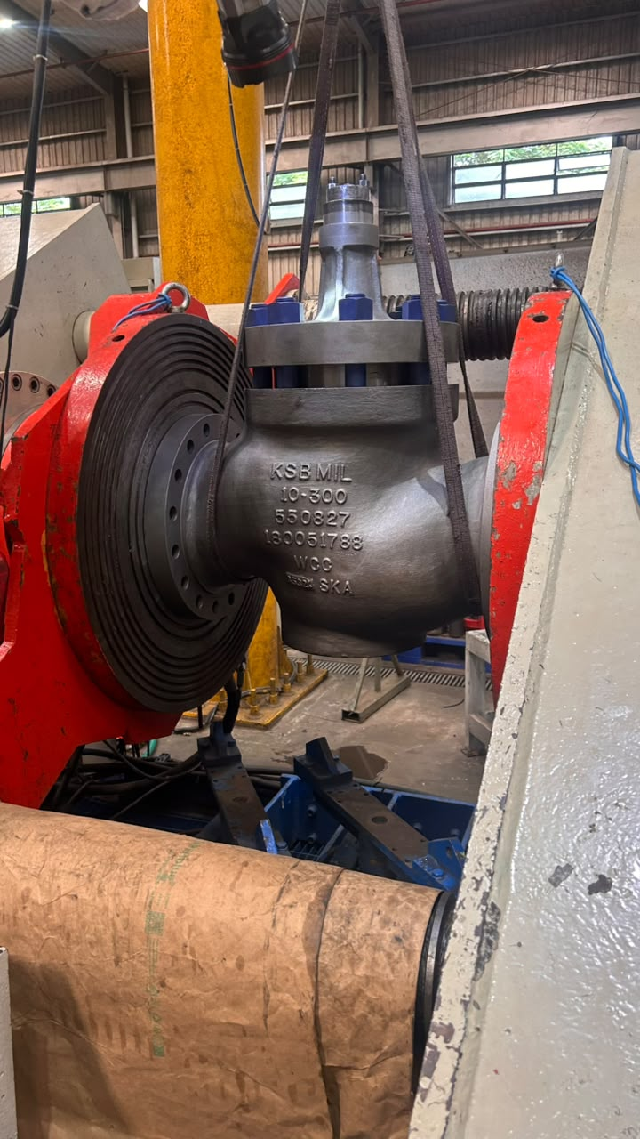 | 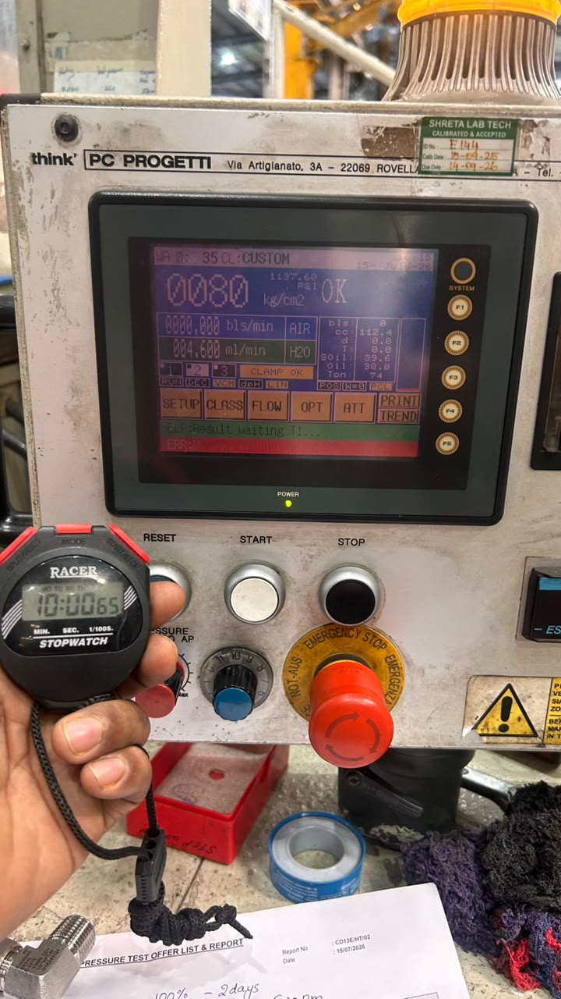
Pressure Test | Pressure Test
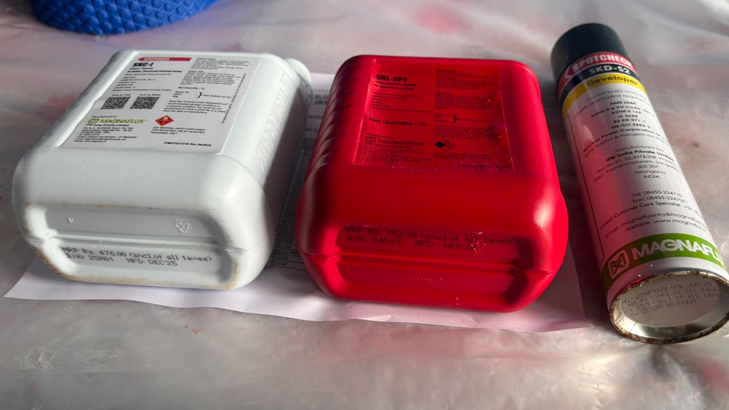 | /
Penetrant/ Cleaner / Developer Used | DPT Test- Penetrant applied
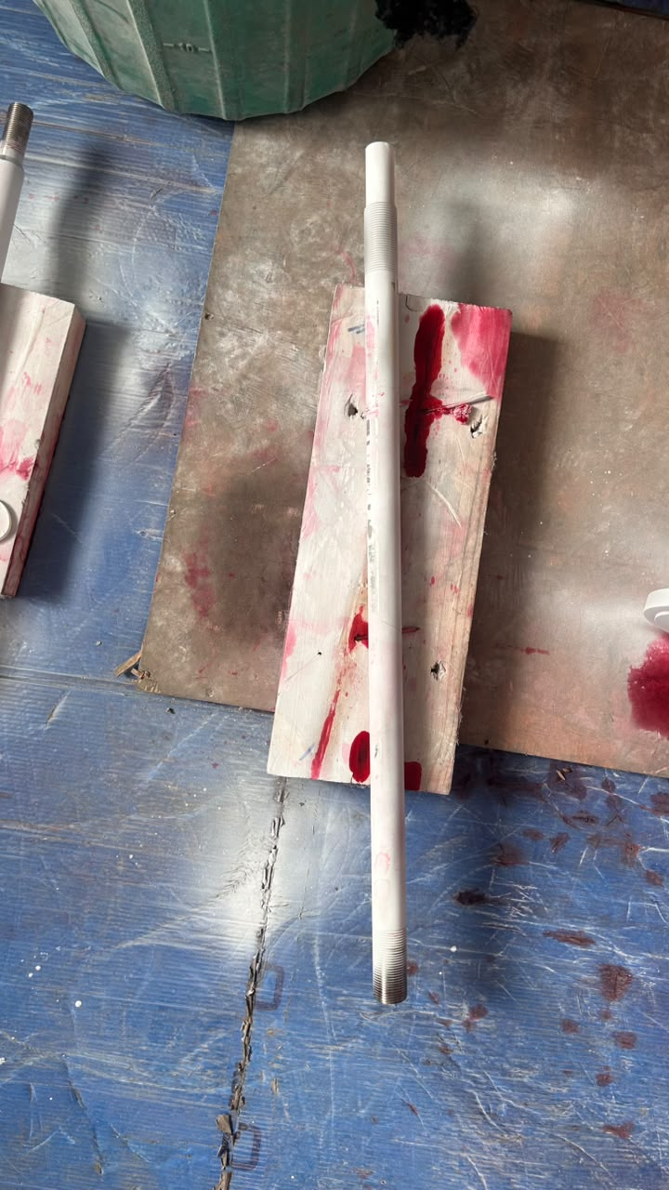 | 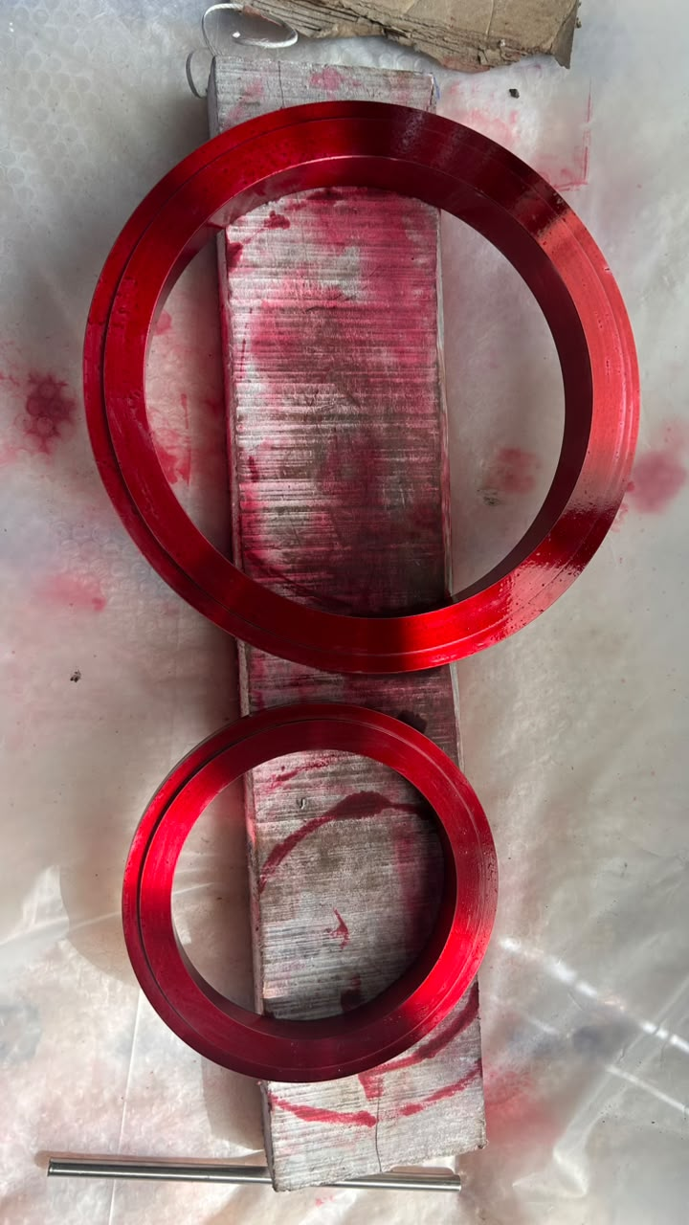
Developer applied | Penetrant applied
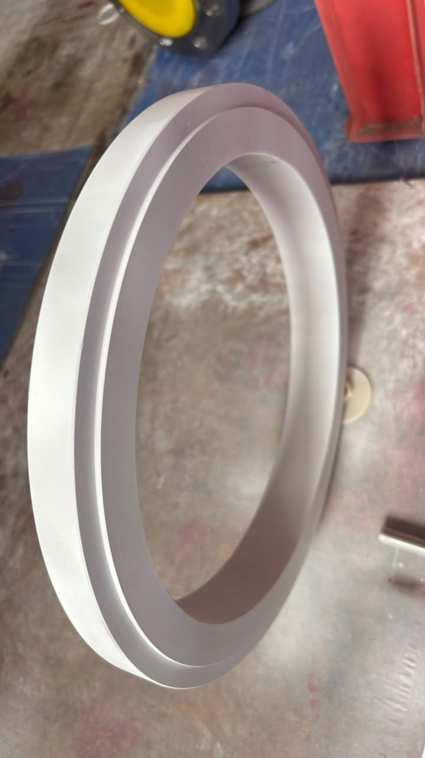 | 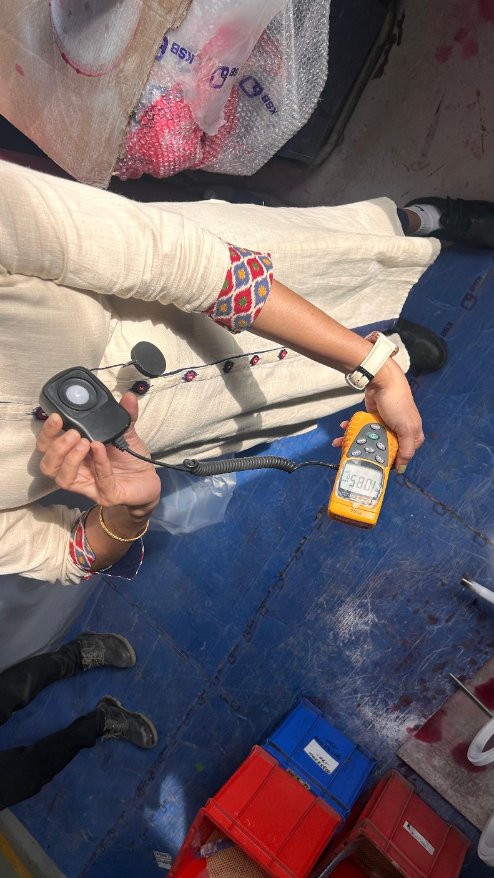
Developer applied | Lux Meter reading
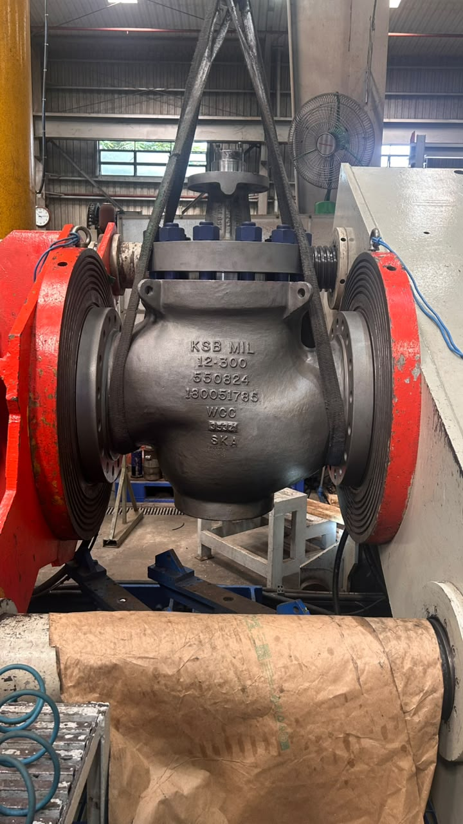 | 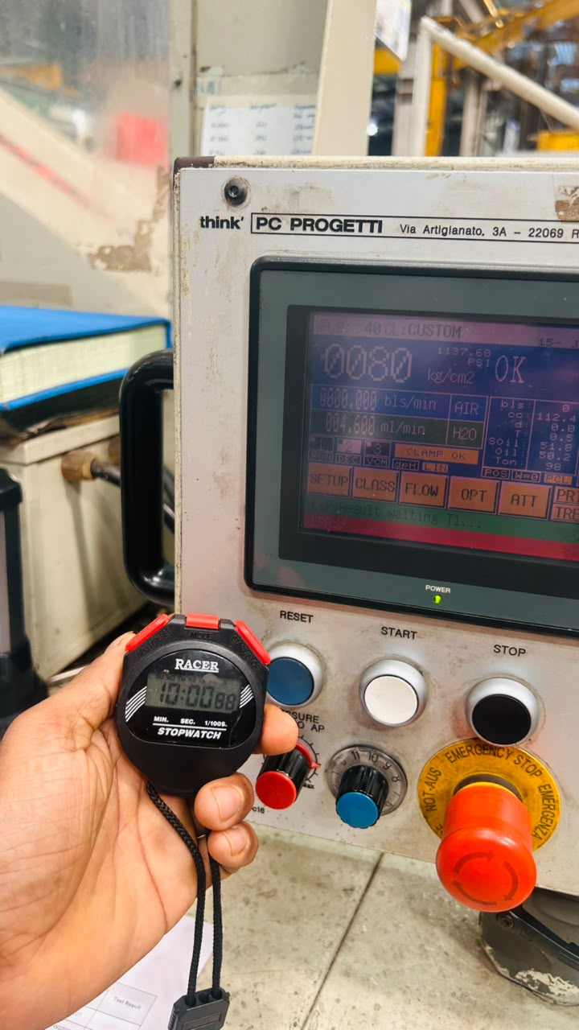
Pressure Test | Pressure Test

